LuCardioUNO v1.0 Specification

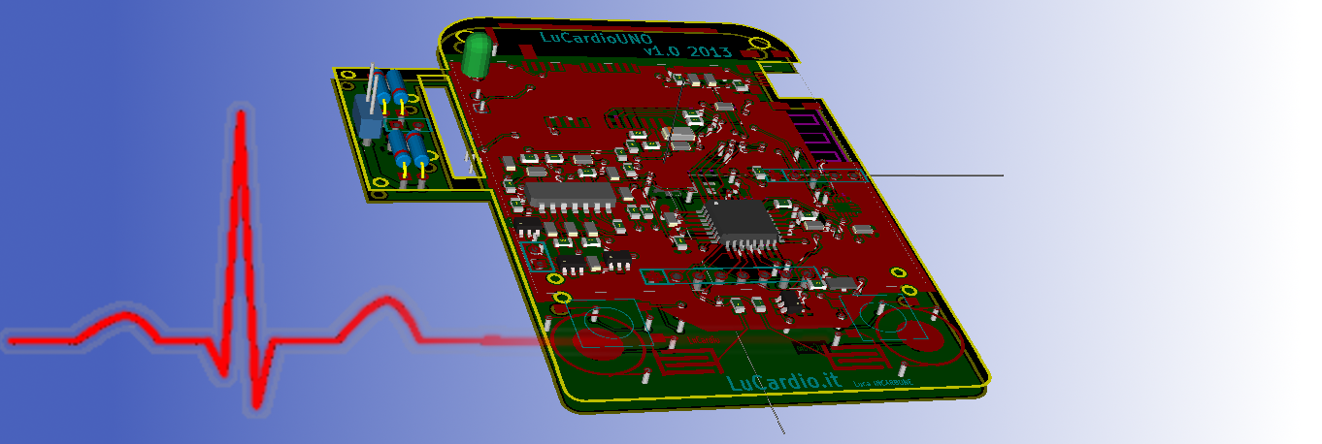
High level Fonctional Specifications
Tag | Specification | min | Typ | Max
1 | GENERAL SPECIFICATION
1.0 | Turn on time in recording mode | 5h | 8h | 10h
1.0.1 | Current consumption in recording mode |  |  | 150mA
1.0.2 | Battery capacity | 750mA/h | 1500mA/h | -
1.1 | Time to full recharge |  | 1h | 3h
1.2 | Fonctional Temperature Range | -10° | - | 40°
1.3 | Backlight duration |  | 3 sec
1.4 | Graphic LCD with back-light | LCD NOKIA 5510
1.5 | GPS Antenna (1.575 GHz) | Integrated on PCB
1.6 | Data Connectivity | Bluetooth
1.7 | Power Supply | USB Micro B
2 | ELECTRICAL SPECIFICATION
2.0.0 | Charging voltage | 4.7V | 5V | 6.2V
2.0.1 | Charging current | - | - | 1A
2.1 | System voltage |  | 3.3V
3 | PERFORMANCE SPECIFICATION
3.0.0 | Heart Rate Range | 20bpm | - | 220bpm
3.0.1 | Bike Speed Range | 1km/h | - | 100km/h
3.0.2 | Pedal Rate Range | 20 r/min | - | 200 r/min
3.1.1 | Refresh Data Temperature | - | 1 ref/s | -
3.1.2 | Recording Rate | - | 1 rec/s | -
3.1.3 | Refresh LCD output | - | 1 ref/s | -
4 | MECANICAL SPECIFICATION
4.1 | Touch button |  | 2
4.2 | Size of PCB (2 Layers) | Battery Size
4.3 | Standard plug I/O (idiot-proof)
4.3.1 | Charging/Pedal/Weel | USB Micro B
4.3.2 | ECG contacts | DX female
4.4.0 | Water proof
5 | HUMAN INTERFACE
5.0 | Menu interactive
5.1 | Screen data
5.2 | Android interface (via Bluetooth)

LCD data screen specification

Welcome screen
To be defined

Recording/Running Mode
Tag | Specification | min | Max | Unit
6.0 | Recording Screen
6.0.0 | Distance measure | 0 | 10'000 | m
6.0.0 | Distance measure | 10 | 999 | km
6.0.1 | Total distance measure | 0 | 9999999 | km
6.0.2 | Speed bike | 1 | 100 | km/h
6.0.3 | Temperature |  |  | °C
6.0.4 | Heart Rate (if over print --) | 20 | 220 | bpm
6.0.5 | Battery level | 3.7 | 4.2 | V
6.0.6 | Cronometre | 00:00:00
6.0.7 | Time | 00:00:00
6.0.6 | Pedal rate | 20 | 200 | rot/min
6.1 | Graphic Hysto filling with gliding FIFO (output filling from right to left)
6.1.0 | Deep hystory | 5 | 30 | min
6.1.1 | Horizontal Resolution | 40 | 48 | pixel
6.1.2 | Heart Rate range | 50 | 210 | bpm
6.1.3 | Speed Bike range | 10 | 80 | Km/h
6.1.4 | Heart Rate resolution | 10 | 5 | Bpm
6.1.5 | Speed Bike resolution | 10 | 5 | Km/h
6.1.6 | Distance, Speed,HeartRate
7 | Recording Screen ECG visualization mode
7.0.0 | Heart Rate (if over print --) | 20 | 220 | bpm
7.1.0 | Filling fifo from left to Right
7.2.0 | Resolution | 1/48 |  | s
7.3.0 | Distance,Speed,.HeartRate
8 | Recording Screen GPS mode
8.0.1 | Distance measure unit | 0 | 10 km | m
8.0.1 | Distance measure unit | 10 km | - | km
8.0.2 | Speed bike | 1 | 100 | km/h
8.0.3 | Temperature |  |  | °C
8.0.4 | Heart Rate (if over print --) | 20 | 220 | bpm
8.0.5 | Battery level | 3.7 | 4.2 | V
8.0.6 | Pedal rate | 20 | 200 | rot/min
8.1 | GPS info
8.1.0 | Speed | 0.1 | 1854 | km/h
8.1.1 | Latitude | ddmm.mmmm
8.1.2 | Longitude | dddmm.mmmm
8.1.3 | Satellites Used | 0 | 12 | sat
8.1.4 | Altitude | 0 | 18000 | meters
9 | Fonction Menu mode
9.0.0 | Starting record
9.0.1 | Recording Pause
9.0.2 | Stop Recording
9.1.0 | TurnON Bluetooth
9.1.1 | TurnOFF Bluetooth
9.2.0 | The selected function has to be Highlighted
9.3.0 | In the last row the arrow as to be plotted to rappresent the direction of selection correspond to touch buttons

Fonction Menu Mode
5.0.0 In this mode the user can activate recording stop it and other things. To move up or down there will be

Buttons
5.0.1 The mode and others functionallitys of LuCardio is driven by 2 touch buttons. The following true table specified the buttons effects.
From State | To STATE (condition below)
From State | GBTN |  | RBTN |  | RGBTN
RS | RS-GPS |  | RS-ECG |  | FMM
RS-ECG | RS |  | RS-GPS |  | FMM
RS-GPS | RS-ECG |  | RS |  | FMM
FMM | --- |  | --- |  | ---

5.0.2 Table describing effect of buttons.
STATE | GBTN |  | RBTN |  | RGBTN
RS | changeSTATE |  | changeSTATE |  | changeSTATE
RS-ECG | changeSTATE |  | changeSTATE |  | changeSTATE
RS-GPS | changeSTATE |  | changeSTATE |  | changeSTATE
FMM | HighlightedUP |  | HighlightedDOWN |  | Select

GBTN, RBTN and RGBTN
4.1.1 The capacitive button needs a basic coding to filter some possible effect with water. For this reason the button it will be considered pushed if two short touch are made.
Tag | specification | min | MAX | unit
4.1.2 | Duration of single touch | 0.1 | 0.5 | s
4.1.3 | Time between two touch | 0.1 | 1 | s
4.1.4 | Number of touch | 2

Android Interface
To Do

Data Recording
10.0.0 Data recording as to be recorded on file.csv with ';' as separator (for Excel is the standard column separation for csv importing.
10.0.1 All availeble data will be stored one per second in SD card (to be listed)
10.0.2 File name will be MMDDHHmm.CSV (month day hour minute .csv)

Function check_switch

Switch button
This function test both buttons and update the boolean value green_pushed and red_pushed.

This function have to work with two different schematics, first is the simple “switch” one, the capacitor C13, C14, C16, C17 and resistor R11 and R17 are not mounted and R14 and R15 have 0Ohms values.(C16 and C17 are shortcircuited too).
This will be selected by the no definition of BUTTON_touch.

In this case the function has to test the Vbutton pin value with following combination of output:
 | RedBTN '0' | RedBTN '1'
GreenBTN '0' |  | X
GreenBTN '1' | X
By this way is possible to determinate the update value for red_pushed and green_pushed.

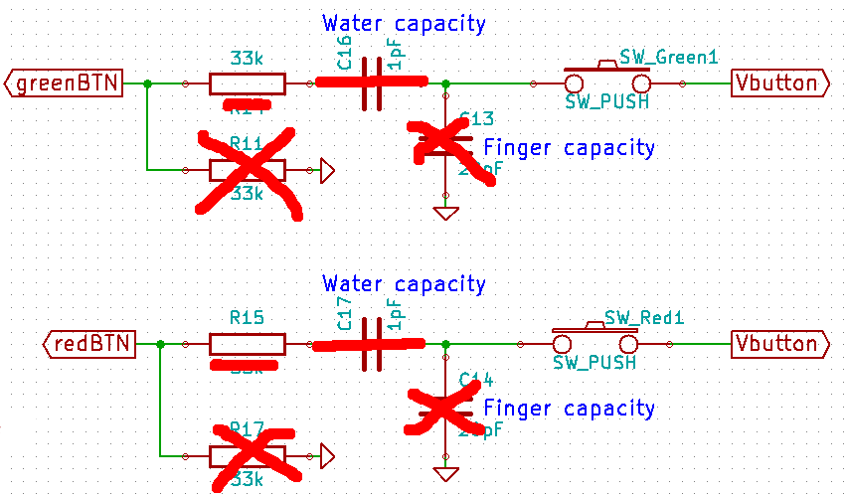
Or we can set Vbutton to HIGH value and test in the function the input for redBTN and greenBTN. In this case the pulldown resistor R11 and R17 is needed (and pull-down pin set-up in code).

Touch button
In the second case (BUTTON_touch is defined) the switchs are short-circuited, the resistence R11 and R17 are disconnected. In this function mode the output greenBTN and redBTN have to be driven by this way.
greenBTN | '0' | '1' | '1' | '1' | '0' | '0' | '0'
redBTN | '0' | '0' | '0' | '0' | '0' | '0' | '1'
Vbutton | read value | read value | read value | read value | r.v. | r.v. | r.v.
Treshold reach | no | no | no | yes | no | no | no

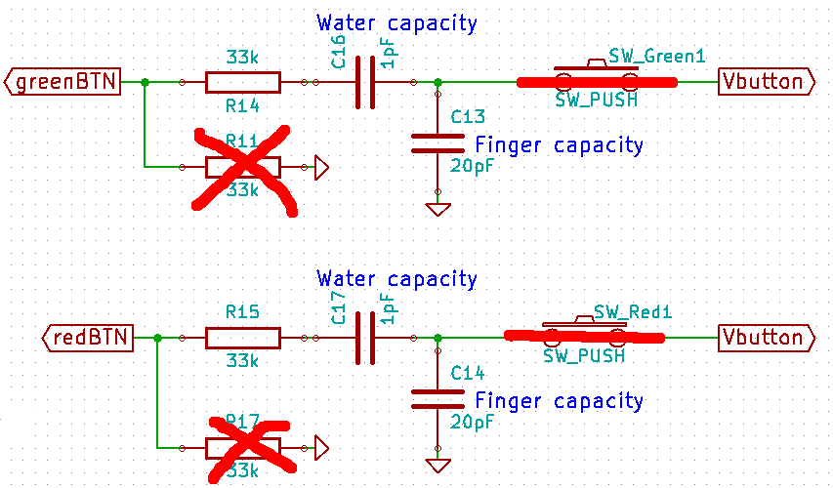
To found experimentally the clock period to wait from a checcking button to the other (wait for dechanging capacitor and the treshold to get the capacity variation du to finger).

List of case defined
Name | def | Not def
BUTTON_touch | Touch button are used | Simple switch used
INSTALLATION_PROCEDURE | Factory setup (RTC for ex.) | Normal

