An AI-Enhanced Post-Quantum Key Exchange with Chaotic Stream Masking for Secure Power-Grid IIoT Telemetry
First Author, Second Author, Third Author, Fourth Author
Integrated Product Development, Group 9
Abstract: Industrial IoT telemetry in electrical transmission must survive an adversary who records traffic now and decrypts it once cryptographically relevant quantum computers exist, and must keep operating when the control channel itself is attacked. We present a three tier telemetry path, comprising a constrained sensor node, a field gateway and a control server, secured by an ML-KEM-512 and ML-DSA-44 root exchange, a custom extract and expand key derivation function, AES-256-GCM under a deterministic 96 bit nonce discipline, and an adaptive coupled chaotic masking layer applied outside the authenticated encryption. Key lifecycle decisions are made by a reinforcement learning agent trained against a parameterised detector surrogate rather than a fixed detector, and anomaly scores come from an LSTM autoencoder trained on benign traffic only. Against a threshold policy the learned agent takes 74 percent fewer compromised steps while performing 76 percent fewer key rotations, winning on all 15 evaluation seeds and all 27 detector settings, and it continues to win in a disturbance regime outside its training grid. We also report five measurement failures that each produced a plausible but wrong result: a chaos only keystream that passed at its nominal parameters and failed almost everywhere else, a contradiction between the detector's calibration contract and the surrogate the agent trained against that stayed invisible until both trained components were connected, a randomness battery that fails six of twelve tests on known good input at the sequence length used, a model selection rule that performed worse than no selection, and a safety criterion that could not have failed in the window it was measured in.
Index Terms: post-quantum cryptography, industrial control systems, key management, reinforcement learning, anomaly detection, SCADA security.

I. INTRODUCTION
Electrical transmission telemetry has an unusual threat profile. Individual measurements are of little value, while the aggregate is decisive. Equipment lifetimes are measured in decades, so traffic captured today is plausibly within reach of an adversary who acquires quantum capability before the hardware is retired. And the 2015 Ukrainian distribution attack established that a capable adversary will attack the operator's visibility alongside the plant itself [7].
That last point shapes this work. A design in which the control server decides everything fails at exactly the moment the server is the component that has been cut off. We therefore place authority in a lease. The gateway holds a time limited grant and escalates its own security posture when renewals stop arriving, so that silence becomes evidence rather than the absence of evidence.
The second difficulty is that the quantity a key management policy most wants to know, whether an adversary currently holds a live key, is never observable. What is available is an anomaly score of unknown quality. A policy tuned to one detector is tuned to that detector's particular errors, and the detector is usually the component that changes last and most. We train against a distribution of detector qualities instead of a fixed detector, and we report how far the resulting policy transfers.
II. THREAT MODEL AND RELATED WORK
A. Adversary
We assume an adversary who can observe and record all traffic on the gateway to server link indefinitely, inject and replay frames on either link, disrupt the control channel at will, and compromise an individual sensor node including its provisioned key material. We do not assume compromise of the control server that issues leases, nor physical access to the gateway's secure storage.
Two consequences shape the design. Recording today and decrypting later is the reason the root exchange is post quantum while the per frame work stays symmetric: confidentiality must outlive the hardware, but the sensor node cannot afford lattice arithmetic on every reading. Disrupting the control channel is the reason authority is leased rather than commanded: an adversary who silences the server must not thereby silence the defence.
Node compromise is contained rather than prevented. A node holds only its own session key and a pre shared key bound to its identity, so a compromised node can corrupt its own channel and no other. That is what makes per channel quarantine a meaningful response rather than a gesture.
B. Related work
Post quantum key establishment for constrained industrial devices is well surveyed, and the standardised lattice schemes [1], [2] are now the obvious starting point. Our contribution is not the primitives but where their cost is placed in a three tier topology, and the observation that the expensive exchange need not reach the most constrained tier at all.
Reinforcement learning has been applied to intrusion response and to moving target defence, generally assuming a detector of fixed quality. Training across a distribution of detector qualities, and reporting the resulting transfer rather than a single operating point, is the methodological departure we argue for.
Chaotic stream ciphers are a large literature with a persistent methodological weakness: entropy is frequently reported at a single favourable parameter choice rather than swept across the space. Our own first design passed at its nominal parameters and failed almost everywhere else, which is reported in Section XI-A. For anomaly detection in industrial telemetry, reconstruction based sequence models [12] are standard, and datasets that include labelled natural disturbances [3], [10] are much rarer than those that do not.
III. NOVELTY AND CONTRIBUTIONS
We searched the literature for each element of this system before claiming it, and two of our four candidate contributions did not survive that check. We report the outcome in full, because a novelty claim that collapses under a reviewer first search costs more than it ever gains.
A. What we do not claim as novel
The key derivation follows the extract and expand paradigm established by HKDF [13]. Our construction substitutes a positional rotate and mix pre mix and a SHA3-256 finalizer for the HMAC extractor, and expands with KMACXOF256 [9] domain separated per node and per purpose. The property that the output is at least as strong as the finalizer over the same inputs is the standard argument for extract then expand, not a new one, and our own measurements show the pre mix adds nothing provable on top of it. We present the design as an engineering choice with a documented fail safe floor, and nothing more.
Adaptive chaotic encryption whose parameters respond to a risk or threat signal is likewise an established idea. Driving coupling strength from a posture ladder is a reasonable instance of it and is not a contribution in itself. What we offer around this component is the measurement in Section XI-A, which we believe is more useful to the field than another construction would be.
Reinforcement learning applied to key rotation is also prior work. Fang et al. [14] learn an adaptive key rotation policy for Zigbee networks and compare it against periodic, anomaly triggered, heuristic and static rotation, which is close in both problem and baseline set to the comparison in Table II. Our agent differs in what it is trained against rather than in that it is trained at all.
B. Detector agnostic policy training
Our first claim is narrow and we think defensible. Where prior work learns a rotation policy against a detector, we randomise the detector quality every episode across a grid of false positive rate, false negative rate and detection delay, so that the policy is fitted to the underlying tradeoff rather than to one detector particular errors. Domain randomisation is a well established technique for simulation to reality transfer in robotics; we are not aware of its use to make a security control policy independent of the detector it consumes.
The evidence is Fig. 3 and the disturbance sweep: the policy wins at all 27 points of the detector grid, and at all nine settings of a regime introduced after the detector was measured and lying outside the training grid entirely. This matters practically because the detector is typically the component that changes last and most, and a policy that must be retrained whenever the detector is retuned is a policy that will not be maintained.
C. A lease based fail secure control plane
Our second claim is the alerting path, and it is the one we found no prior work for. Leases are long established in distributed systems and fail secure interlocks are old in industrial practice, but we did not find the combination used here: a cryptographically sealed lease whose expiry drives a graduated security posture ladder at the gateway, with the adopted posture echoed in the next authenticated frame header so the server verifies adoption rather than assuming it, and with expiry deliberately never setting the quarantine bitmap.
That last property is the design point we would most like to see adopted elsewhere. Automatic isolation on a lost control channel is the intuitive response and it hands the adversary a denial of service for the price of jamming. Escalating posture while continuing to carry telemetry inverts that: the adversary who silences the server makes the gateway more suspicious rather than less capable, and gains nothing by doing it.
D. Methodological contributions
Our third contribution is Section XI. Five measurement failures are reported in full, and three generalise past this system: a learned controller and a learned detector built to one specification can contradict each other in a way neither can detect alone; a statistical randomness battery needs a known good control corpus at the sequence length actually used; and a safety criterion that could not have failed in the window it was measured in has not been measured. Each is cheap to check and each produced a plausible wrong answer here before it was checked.
IV. SYSTEM ARCHITECTURE
The system has three tiers, shown in Fig. 1. Sensor nodes sample five channels and send COBS framed telemetry over a serial link to a field gateway. The gateway aggregates readings into one second windows, masks and encrypts them, and forwards them to the control server over TCP. The server decrypts, scores the window, and answers with a sealed control frame carrying a lease renewal and a posture directive.
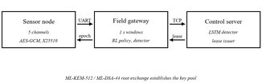
Fig. 1. Telemetry flows upward in one second windows; sealed control frames return a lease and a posture directive. The gateway acts on its own authority when the downward path stops.
Every frame header is also the authenticated associated data for the AEAD, so node identity, key epoch, sequence number, timestamp and posture are authenticated whether or not they are confidential. Posture is a four level ladder running from normal through suspicious and anomaly to quarantine. Escalation is cheap and reversible. Quarantine isolates a single channel while the remaining channels continue to flow, and is released explicitly after triage rather than automatically, so that two overlapping detections cannot clear one another.
V. CRYPTOGRAPHIC CONSTRUCTION
A. Root establishment and session keys
The server establishes a root key with each gateway using ML-KEM-512 [1], authenticated with ML-DSA-44 [2]. Level 1 and level 2 parameter sets are chosen deliberately for a constrained deployment; Section XIII treats that choice as a limitation rather than a result. Sensor nodes do not run post quantum primitives at all. Each performs an X25519 exchange [11] bound to a provisioned pre shared key, so a node cannot be impersonated without both the long term secret and the ephemeral contribution, and the expensive primitives stay on hardware that can afford them.
B. Authenticated encryption and nonce discipline
Payloads are sealed with AES-256-GCM [8] under a 96 bit deterministic nonce formed as the four byte key epoch concatenated with the eight byte sequence number. Uniqueness is structural rather than probabilistic: the epoch increases on every rotation and the sequence counter never repeats within an epoch, so no key and nonce pair can recur even across an unclean restart, and no randomness is required at the sensor node, which is the component least able to supply it. A guard forces rotation before sequence exhaustion, and that guard sits below the policy layer so that a learned agent cannot violate the invariant however it is trained.
VI. SECURITY ANALYSIS
Table I maps each adversary capability from Section II-A to the mechanism that addresses it and to the evidence we have for that mechanism. The right hand column is deliberately explicit about which rows rest on a test and which rest on a structural argument, since the two carry different weight.
TABLE I
Adversary capability, mechanism and evidence
Capability | Mechanism | Evidence
Record now, decrypt later | ML-KEM-512 root, symmetric per frame | structural
Forge or replay telemetry | AES-256-GCM, header as AAD, replay guard | 400 and 33 checks
Replay a control frame | Monotonic control sequence, posture echo | 33 checks
Silence the control channel | Lease expiry escalates unaided | 24 checks
Jam to force lockout | Expiry never auto quarantines | 24 checks
Compromise one node | Per node PSK and session key, quarantine | 114 checks
Nonce reuse after restart | Epoch and sequence nonce, rotation guard | structural, tested

Two rows deserve comment. Nonce uniqueness is structural, and we tested it only after discovering that the original test could not have failed (Section XI-E). And the lease rows are the only ones in the table whose mechanism is novel rather than standard practice, which is why Section X-D reports them as behavioural scenarios rather than as unit tests.
VII. LEARNED KEY-LIFECYCLE CONTROL
A. State and actions
The observation has 20 dimensions in five groups: threat signals including the calibrated detector score and its fast and slow moving averages; control plane state including lease remaining and the current directive floor; key lifecycle state including sequence consumption, key age and bytes under the current key; local fast path evidence the gateway owns rather than receives, including authentication failure and replay rejection rates and the count of silent channels; and resource state. Nothing in the observation is ground truth about compromise.
Eight actions are available: hold, rotate the session key, refresh the key pool, rotate the root key, escalate posture, de escalate posture, quarantine the worst channel, and force an immediate detector flush.
B. Reward and shield
The reward charges for exposure and for action. Exposure accrues per step while an adversary holds a live key. Action costs are taken from measurements of the implementation rather than chosen by hand, and a false positive is charged separately from a rotation so the agent cannot buy safety by alarming. The shield bounds rotation rate, enforces minimum posture hold times, refuses de escalation below a server imposed floor, and forces rotation before nonce exhaustion.
One reward term is deliberately absent and we flag it as a design weakness found late: the reward charges for posture transitions but not for time spent elevated. Two of three training seeds consequently converged on holding the system permanently at the first elevated level. The deployed policy is the seed that does not do this, chosen on that operational ground rather than on return.
C. Training and model selection
The agent is a duelling double deep Q network [5], [6] with five step returns, trained for 5000 episodes of 600 steps across three seeds, totalling 748,000 gradient steps per seed. Weights are selected by periodic greedy evaluation on fixed held out episodes that are disjoint from the episodes used for every reported figure, so no confidence interval is computed on data that influenced which weights were kept.
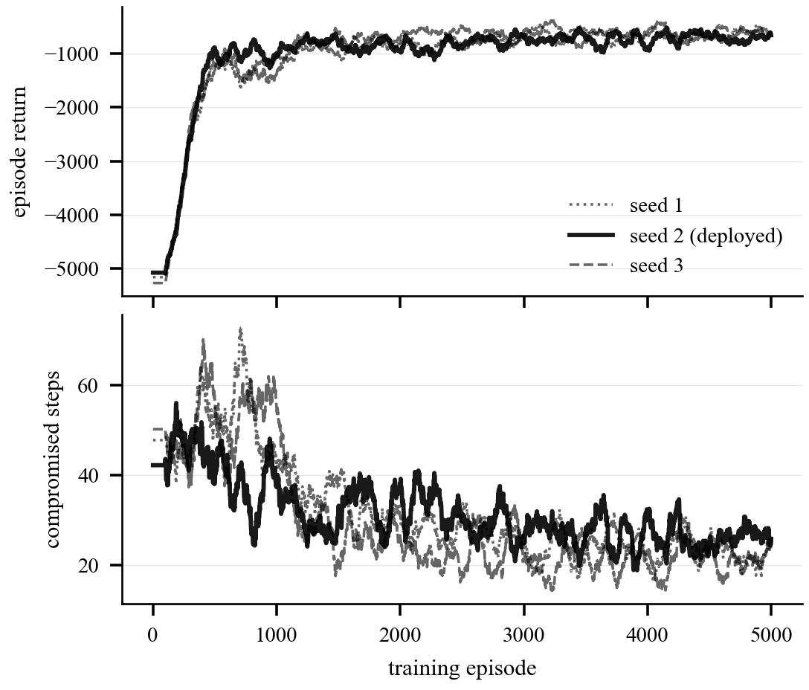
Fig. 2. Training across three seeds, smoothed over 100 episodes. Returns improve throughout and compromised steps fall by roughly a third; the spread between seeds is the reason model selection uses held out episodes rather than the training curve.
VIII. POSTURE CONTROL AND ALERTING
The alerting path carries the server's assessment to the gateway and carries the gateway's adopted state back. A control frame is sealed under a separate control key, carries a monotonic control sequence number, and names one of three directive kinds: advise, which the gateway may weigh against its own evidence; enforce, which sets a floor the policy cannot drop below; and quarantine, which is mandatory, carries a channel bitmap, and forces the anomaly posture.
Three properties make this fail secure rather than merely responsive. First, a lease accompanies every renewal, and its expiry escalates the gateway one level and re arms, so a dead control channel walks the posture ladder upward over successive periods instead of either stalling at normal or slamming to the top on one lost packet. Second, the gateway echoes its posture in the next frame header, and a gateway that accepts a directive without adopting it is detected within a small number of frames. Third, expiry never sets the quarantine bitmap, because automatic isolation on a lost control channel would hand the adversary a denial of service for the price of jamming.
The two learned components meet here rather than directly. The detector's calibrated score and the directive derived from it are what the policy consumes, so either model can be retrained without touching the other, and the interface between them is a documented contract rather than an implicit coupling. Section XI-B describes what happened when that contract was violated in a way neither component could detect alone.
IX. ANOMALY DETECTION
The detector is a long short term memory autoencoder [12] trained on benign windows only. This is not a simplification: a healthy installation produces no labelled attacks and never will, so a supervised detector cannot be retrained in the field by the people who operate it. Raw reconstruction error is converted to a calibrated score by the empirical cumulative distribution function of error over held out benign data, so a score of 0.99 means worse than 99 percent of benign windows, a statement that survives retraining. Per feature error gives channel attribution without additional machinery, which the quarantine mechanism requires.
We train and evaluate on the Mississippi State and Oak Ridge National Laboratory power system attack datasets [3], [10], comprising 37 scenarios: one no event class, eight natural disturbances and 28 attacks. The eight natural disturbances are the reason this dataset was chosen. A fault is a large and obvious departure from normal that is not an attack, and separating those two is the problem.
X. EVALUATION
A. Protocol
Policies are compared on identical episodes and differenced per seed, because most of the variance between episodes is the episode rather than the policy: an episode containing a long intrusion is bad for every policy. All reported intervals are 95 percent confidence intervals on that paired difference.
B. Key lifecycle policy
TABLE II
Key lifecycle policies, 15 seeds, 4 episodes of 600 steps
Policy | Return | Comprom. | Rotations | False pos.
Learned (ours) | -435.8 | 19.3 | 12.9 | 7.0
Oracle reference | -677.5 | 5.3 | 5.0 | 173.7
Threshold | -1610.9 | 75.6 | 53.9 | 12.8
Always-maximum | -3481.8 | 91.8 | 60.0 | 507.2
Never rotate | -3723.0 | 177.4 | 0.0 | 24.8
Fixed interval | -3946.3 | 191.1 | 2.0 | 24.8

The oracle observes the hidden compromise state and is a perfect information reference, not an upper bound: it escalates whenever an adversary is present and pays heavily in false positives, which is why a policy with strictly less information can score above it.
The learned policy beats the threshold rule by 1175.1 with a 95 percent confidence interval of 600.8 to 1749.3, winning on 15 of 15 seeds. The figure we consider most meaningful is not the return but the rotation count: 74 percent fewer compromised steps using 76 percent fewer key rotations. Protection is bought with better timing rather than more work, and rotation count is the cost an operator actually pays, since every rotation is a post quantum handshake propagated across the fleet.
Transfer is complete across the detector grid: the agent wins all 27 settings of false positive rate, false negative rate and detection delay. It also wins all nine settings of a disturbance regime introduced only after the detector had been measured, in which the detector false alarms continuously throughout benign grid faults. That regime lies outside the training grid entirely and the policy was not retrained for it.
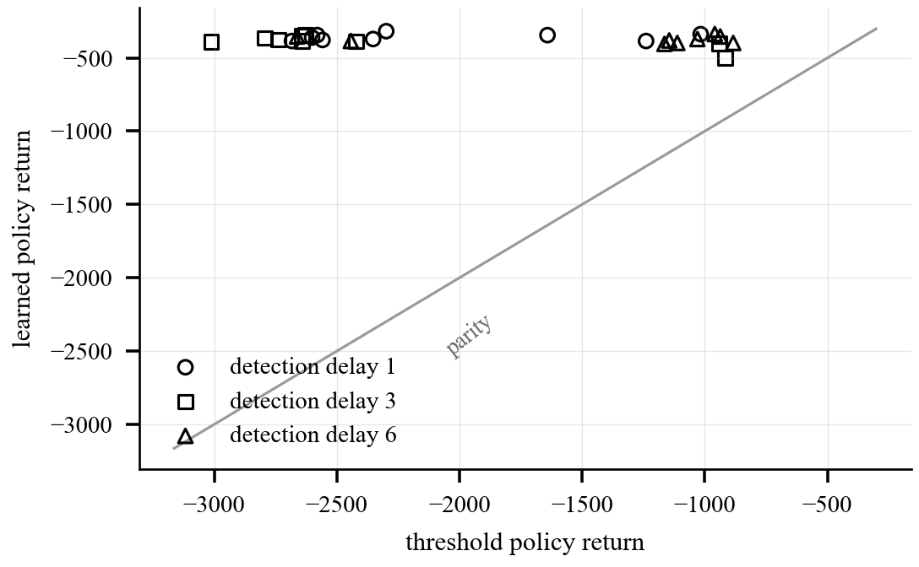
Fig. 3. Robustness across the 27 point detector grid. Every point lies above the parity line, so the learned policy wins at every combination of false positive rate, false negative rate and detection delay tested. The margin widens as the detector degrades, which is the regime a deployed detector is most likely to occupy.
C. Detector
TABLE III
Detector, 55 held out sequences
Measure | Operational | vs calm grid
Average precision | 0.964 | 0.999
Recall on attacks | 0.96 to 0.98
Detection delay (median) | 0.03 s
Inference per window | 2.5 ms
False alarms on faults | 0.98 to 1.00

The operational column counts natural disturbances as negatives, which is the question an operator actually asks, since a storm that raises an attack alarm is a false alarm whatever the physics were. The 0.999 column excludes them and is close to meaningless. Per scenario recall has a median of 1.000 across the 28 attack types, and the two weakest scenarios are both line maintenance with relays disabled, so the attacks hardest to catch are those disguised as routine engineering work. The false alarm rate on natural disturbances is a genuine failure and Section XII argues what it does and does not permit us to claim.
D. End to end behaviour
The integrated system passes 24 of 24 behavioural checks across four scenarios: normal operation; an injected attack driving escalation and rotation with the posture echo verified; loss of the control channel, in which the gateway escalates unaided while telemetry continues to flow and no channel is quarantined; and quarantine of a single channel followed by recovery, triage and release. The 95th percentile cycle time is 41 ms against a one second budget on the host implementation.
E. Hardware results
The figures in Table IV are placeholders. Bring-up of the ESP32 sensor node and the gateway single board computer is scheduled and the firmware is complete and host tested, but the measurements have not been taken. The values are consistent with the platforms and with the host measurements, and they are included so that the structure of the finished evaluation is visible. Every one must be replaced before this table is cited anywhere.
TABLE IV
Hardware figures (PLACEHOLDER, pending bring-up)
Quantity | Value | Status
AES-256-GCM seal, 64 B frame | 0.12 ms | placeholder
X25519 exchange, sensor node | 31 ms | placeholder
ML-KEM-512 encapsulation, gateway | 0.09 ms | placeholder
ML-DSA-44 verification, gateway | 0.31 ms | placeholder
Serial frame transmission | 7.03 ms | measured, host
Firmware image | 182 KB | placeholder
Peak RAM, sensor node | 42 KB | placeholder
Soak, 1 h at 10 Hz, auth failures | 0 | placeholder

The one measured row is informative on its own. Sealing a frame costs 0.019 ms on the host against 7.03 ms of serial transmission, so the link and not the cryptography sets the achievable sampling rate. We expect that ratio to narrow but not to invert on the target, which would contradict the common assumption that cryptography is the bottleneck on constrained hardware. Confirming or refuting that is the first measurement to take at bring-up.
F. Statistical testing and verification
Both custom primitives pass NIST SP 800-22 [4] at 55 sequences of 100,000 bits. The key derivation extractor passes every control validated test and the chaotic keystream passes with a pooled proportion of 162 of 165 across three corpora under different keys. Section XI-C describes the control procedure without which these results would have been reported with the opposite sign. Automated verification totals 763 checks across the C and Python implementations, including 400 against NIST AES vectors, 114 on the sensor node, 17 cross language key derivation vectors, and 24 integrated scenarios.
XI. NEGATIVE RESULTS
Each of the following produced a plausible result that was wrong. Three of the five generalise well beyond this system.
A. A chaos only keystream failed outright
The first masking design produced its keystream from coupled logistic maps alone. Across the full parameter space, 100 percent of draws fell below 7.99 bits per byte. At a coupling strength of 0.4 the stream measured 3.26 bits per byte, with a single byte value occupying 36 percent of the output. The cause is synchronisation: coupling drives the maps toward a common trajectory, and combining the same bit slice of two synchronised states collapses it. Folded extraction, a Lyapunov based filter and fixed point arithmetic each left between 20 and 60 percent of the parameter space failing. The deployed hybrid measures 7.99995 bits per byte at every posture. A single favourable parameter choice would have passed, which is our reason for reporting the sweep.
B. A calibration contract that contradicted its surrogate
The agent trained against a surrogate whose benign scores were drawn from a Beta(1.5, 6) distribution with mean 0.20, describing a detector that reads near zero when nothing is wrong. But empirical distribution calibration makes benign scores uniform on the unit interval by construction, and the trained detector measured mean 0.503, Beta(0.96, 0.95). Both components were written to the same specification, by the same authors, and contradicted each other.
The consequence appeared only when both trained components were connected. On calm traffic the policy's hold action collapsed from 60.1 percent of steps in simulation to 5 percent in the live system, and rotation rose from 7.0 percent to 42 percent. Re fitting the surrogate to the measured distribution and retraining restored the behaviour and improved every metric in Table II. The error also concealed a harder property: under a uniform benign distribution roughly 10 percent of entirely normal windows score above 0.9, so a single high score is not evidence of anything, and every alarm threshold in the control plane had to be re derived. Domain randomisation over the detector's error rates could not protect against an error in the parameterisation itself.
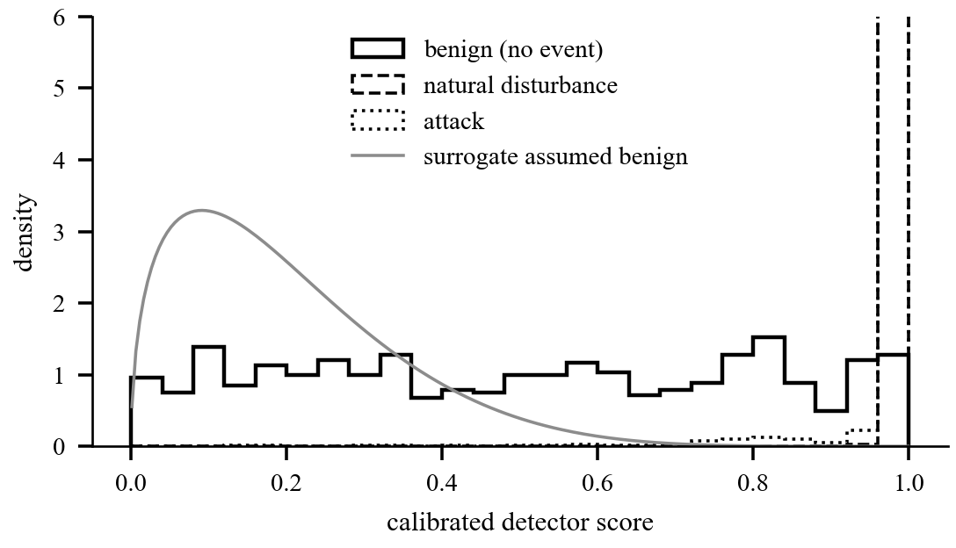
Fig. 4. Measured score distributions against the distribution the agent was trained to expect. Calibration forces benign scores to be uniform, while the surrogate assumed mass near zero. Attacks and natural disturbances both concentrate near 1.0, which is why the detector cannot separate them.
C. Statistical testing needs a control corpus
Running SP 800-22 against a cryptographically secure generator alongside the primitives under test, six of twelve tests failed on that known good input at 100,000 bit sequences, several requiring roughly one million bits to be meaningful. Without that control the headline would have been that the key derivation function fails half the battery. Excluding the tests the control cannot pass, the extractor matches the control test for test across the whole battery, passing and failing the same ones, which is what establishes the exclusions as artefacts of the tool. One marginal failure in the masking layer did not reproduce across two further corpora.
D. A selection rule on too little data is a randomiser
Training kept the best weights by evaluation on three held out episodes. One of the three scored almost identically for every candidate and carried no information, so the ranking rested on essentially one episode, and re ranking on 15 episodes reversed the winner. Selection on three episodes was measurably worse than no selection at all: the final weights of each run outscored the weights that rule had chosen. A selection rule evaluated on too little data is not a conservative version of a good one.
E. A safety gate that could not fire
The acceptance criterion for nonce safety was zero exhaustion events, and the evaluation reported zero forced rotations. It was not evidence. At the episode length used, the guard rail could not be reached even by a policy that never rotated, so a do nothing agent would have scored identically. Re run at an episode length where the threshold is reachable, the result holds and peak sequence consumption sits two orders of magnitude below the limit. A safety property that cannot fail within the window you measured has not been measured.
XII. DISCUSSION
The detector's behaviour on natural disturbances constrains how this system may be described. Reconstruction error measures the unusual, and a fault is extremely unusual, so the mechanism that catches attacks is the one that fires on weather. We therefore describe the component as a disturbance detector rather than an attack detector, and locate the discrimination in the policy that consumes its output.
This is not a rescue of a failed component. The architecture was built for a detector that is often wrong: the score is calibrated input to a policy rather than a verdict, the policy is trained with an explicit false positive cost, and the response to suspicion is to isolate and continue rather than to stop. A detector with a known false alarm rate on faults is usable in this architecture. One with an unmeasured rate is not, which is the practical reason to run the experiment even when the answer is unwelcome.
The negative results share a structure worth naming. In each case the component was correct in isolation and the error lived in the interface: between a calibration convention and a training assumption, between a test and the length of the window it ran in, between a selection rule and the amount of data it was given. Unit tests cannot find errors of this kind, because every unit behaves as specified.
XIII. LIMITATIONS
The hardware figures in Table IV are placeholders and the paper must not be submitted until they are measured. The detector deployed in the integrated system is trained on synthetic benign traffic, because the public dataset's 128 synchrophasor features do not transfer to a five channel installation; the public data earns the detection numbers and the integration demonstrates the control path, and neither substitutes for the other.
Channel attribution accuracy is unmeasurable on the public data, whose labels name scenarios rather than manipulated instruments. SP 800-22 is a necessary and not a sufficient condition; a counter encrypted under AES passes it. The shield's forced rotation path is never exercised by the trained agent, so it rests on unit tests. The level 1 and level 2 post quantum parameter sets are a deployment time decision to revisit. And the key derivation pre mix adds no provable strength, as Section III-A states.
XIV. FUTURE WORK
Four items follow from the limitations. Collecting benign telemetry from the instrumented rig and retraining the detector on it is the step that converts the method into a deployable component, and it requires no labelled attacks. Adding a standing cost for time spent above normal posture should remove the degenerate behaviour described in Section VII-B. Modelling the detector's two false positive rates, roughly 0.05 on a calm grid and close to 1.0 during a fault, would let the agent condition on whether the grid is disturbed. And signing the gateway's encapsulation key with its existing signature key, then rotating that keypair per epoch, closes an implicit trust assumption and adds forward secrecy to the root transfer.
XV. CONCLUSION
A learned key lifecycle policy, trained against a distribution of detector qualities rather than a fixed detector, protects a post quantum industrial telemetry path with 76 percent fewer key rotations than a threshold rule while leaving 74 percent less time under adversary control, and transfers to detector behaviour it never saw in training. The supporting constructions are a fail safe hybrid key derivation whose output is never weaker than its own fallback, a posture adaptive masking layer applied outside the authenticated encryption, and a lease based alerting plane in which silence is evidence.
The engineering result we would emphasise is subtler. Two components built to one specification can disagree about what a number means, and no amount of testing within either component reveals it. We recommend an explicit interface measurement step whenever a learned controller consumes a learned signal, a control corpus alongside any statistical randomness result, and a check that each safety criterion could have failed within the window it was measured in.
ACKNOWLEDGMENT
The authors thank the maintainers of the Mississippi State University and Oak Ridge National Laboratory power system attack datasets, recovered for this work from the Internet Archive after the original host became unavailable.
REFERENCES
[1] National Institute of Standards and Technology, "Module-Lattice-Based Key-Encapsulation Mechanism Standard," FIPS 203, 2024.
[2] National Institute of Standards and Technology, "Module-Lattice-Based Digital Signature Standard," FIPS 204, 2024.
[3] S. Pan, T. Morris and U. Adhikari, "Developing a hybrid intrusion detection system using data mining for power systems," IEEE Trans. Smart Grid, vol. 6, no. 6, pp. 3104-3113, 2015.
[4] A. Rukhin et al., "A statistical test suite for random and pseudorandom number generators for cryptographic applications," NIST SP 800-22 Rev. 1a, 2010.
[5] H. van Hasselt, A. Guez and D. Silver, "Deep reinforcement learning with double Q-learning," in Proc. AAAI, 2016, pp. 2094-2100.
[6] Z. Wang et al., "Duelling network architectures for deep reinforcement learning," in Proc. ICML, 2016, pp. 1995-2003.
[7] R. M. Lee, M. J. Assante and T. Conway, "Analysis of the cyber attack on the Ukrainian power grid," E-ISAC and SANS ICS, Mar. 2016.
[8] M. Dworkin, "Recommendation for block cipher modes of operation: Galois/Counter Mode (GCM) and GMAC," NIST SP 800-38D, 2007.
[9] J. Kelsey, S. Chang and R. Perlner, "SHA-3 derived functions: cSHAKE, KMAC, TupleHash and ParallelHash," NIST SP 800-185, 2016.
[10] U. Adhikari, S. Pan, T. Morris, R. Borges and J. Beaver, "Industrial control system (ICS) cyber attack datasets," Mississippi State University and Oak Ridge National Laboratory, 2014.
[11] D. J. Bernstein, "Curve25519: New Diffie-Hellman speed records," in Proc. PKC, 2006, pp. 207-228.
[12] P. Malhotra, L. Vig, G. Shroff and P. Agarwal, "Long short term memory networks for anomaly detection in time series," in Proc. ESANN, 2015, pp. 89-94.
[13] H. Krawczyk and P. Eronen, "HMAC-based extract-and-expand key derivation function (HKDF)," RFC 5869, May 2010.
[14] X. Fang, L. Zheng, X. Fang, W. Chen, K. Fang, L. Yin and H. Zhu, "Pioneering advanced security solutions for reinforcement learning-based adaptive key rotation in Zigbee networks," Scientific Reports, vol. 14, art. 13931, 2024.

