A Post-Quantum Secured Industrial IoT Telemetry
Architecture with Learned Key Lifecycle Control and
Adaptive Chaotic Masking for Power Grids
Dr. Narendra Shekokar | Daivya Kamlesh Patel | Parth Pawan Patel | Hriday Manoj Patel | Vedant Vijay Shinde
Vice – Principal | CSE-ICB | CSE-ICB | CSE-ICB | CSE-ICB
Dwarkadas J. Sanghvi College of Engineering | Dwarkadas J. Sanghvi College of Engineering | Dwarkadas J. Sanghvi College of Engineering | Dwarkadas J. Sanghvi College of Engineering | Dwarkadas J. Sanghvi College of Engineering
Vile Parle, Mumbai, Maharashtra, India | Vile Parle, Mumbai, Maharashtra, India | Vile Parle, Mumbai, Maharashtra, India | Vile Parle, Mumbai, Maharashtra, India | Vile Parle, Mumbai, Maharashtra, India
narendra.shekokar@djsce.ac.in | daivyapatel220@gmail.com | patelpparth@gmail.com | hridaympatel@gmail.com | vedantshinde@gmail.com

Abstract: Industrial Internet of Things deployments in electrical transmission face two problems that conventional designs address separately and badly. Telemetry recorded today may be decrypted by an adversary who acquires quantum capability inside the twenty year service life of the equipment, and a capable adversary attacks the operator's visibility at the same time as the plant, so a control plane that assumes a reachable server fails exactly when it is needed. This paper presents a three tier telemetry architecture that addresses both. A control server establishes root keys with field gateways using ML-KEM-512 encapsulation authenticated by ML-DSA-44, while constrained sensor nodes run only an X25519 exchange bound to a provisioned pre shared key, keeping lattice arithmetic off the hardware that cannot afford it. Session keys derive through an extract and expand function with a SHA3-256 floor and KMACXOF256 expansion domain separated per node and per purpose. Frames are sealed with AES-256-GCM under a deterministic 96 bit nonce whose uniqueness is structural rather than probabilistic, and an adaptive coupled chaotic map applies posture dependent masking outside the authenticated encryption. Key lifecycle decisions are made by a duelling double deep Q network trained against a distribution of detector qualities rather than a fixed detector, and anomaly scores come from a long short term memory autoencoder trained on benign traffic only. Authority is carried by a cryptographically sealed lease whose expiry escalates the gateway security posture without external instruction. Against a threshold rule the learned controller leaves 74 percent less time under adversary control while performing 76 percent fewer key rotations, winning on all 15 evaluation seeds and all 27 detector settings tested, and continuing to win in a disturbance regime outside its training distribution. The integrated system passes 24 of 24 behavioural checks at a 95th percentile cycle time of 41 ms against a one second budget. We additionally report five measurement failures encountered during development, three of which generalise beyond this system.
Keywords: post-quantum cryptography, industrial control systems, key management, reinforcement learning, anomaly detection, chaotic masking, SCADA security, smart grid.
I. INTRODUCTION
Electrical transmission infrastructure is being instrumented at a pace that its security practice has not matched. Phasor measurement units, protection relays and distributed sensing now produce continuous telemetry that feeds automated control, and that telemetry travels over links which were designed when the threat model was accidental failure rather than deliberate attack.
Three properties distinguish this setting from general purpose Internet of Things security. First, individual measurements carry little value while the aggregate is operationally decisive, so an adversary gains from passive collection over long periods rather than from any single frame. Second, substation equipment is commissioned for service lives measured in decades, which places traffic captured today plausibly within reach of an adversary who acquires cryptographically relevant quantum capability before that equipment is retired. The harvest now and decrypt later posture is therefore not speculative for this class of system; it is the expected adversary behaviour.
Third, and most consequential for the architecture, the 2015 attack on the Ukrainian distribution network established that a capable adversary attacks the operator's visibility alongside the plant itself [23]. Operators were locked out of their own consoles while breakers were opened. Any design in which a central server makes every security decision inherits a single point of failure that the adversary is specifically motivated to attack, and it fails at precisely the moment its decisions matter most.
A fourth difficulty is less often stated. The quantity a key management policy would most like to condition on, whether an adversary currently holds a live session key, is never observable. What is available is an anomaly score produced by a detector of unknown and changing quality. A rotation policy tuned to one detector is tuned to that detector's particular error profile, and in practice the detector is the component that is retrained most often and last.
This paper presents a complete three tier architecture that responds to all four. Its contributions are:
A post quantum key hierarchy that places lattice primitives at the gateway and server while leaving sensor nodes on elliptic curve operations bound to pre shared material, so that the most constrained tier is never asked to perform the most expensive operation.
A learned key lifecycle controller trained against a distribution of detector qualities rather than a single detector, which transfers to detector behaviour outside its training distribution.
A lease based control plane in which authority expires rather than being commanded, posture adoption is verified by echo in the authenticated header, and lease expiry deliberately never quarantines, so that jamming the control channel cannot be converted into a denial of service.
An end to end implementation evaluated on a public power system attack corpus and in an integrated behavioural harness, together with five measurement failures reported in full.
II. LITERATURE REVIEW
A. The Quantum Threat and Its Timeline
Shor algorithm reduces integer factorisation and discrete logarithm to polynomial time on a sufficiently large quantum computer [9], which would break RSA and elliptic curve key establishment outright. Grover algorithm provides a quadratic speedup against symmetric primitives [10], which is addressed by doubling key length rather than by replacing the primitive, and is the reason this architecture uses AES-256 rather than AES-128 for the uplink.
The operational question is timing rather than possibility. Current superconducting devices achieve single qubit fidelities near 99.9 percent, far from the error rates required for the circuit depths that cryptanalysis demands, and error correction imposes a large physical to logical qubit overhead: recent architectures require tens of physical qubits per logical qubit and still exhibit per cycle error rates of a few percent [11]. Resource estimates for applying Grover to AES-256 run to millions of physical qubits once correction is accounted for [10], and qubit coherence times measured in microseconds to milliseconds remain far below what deep circuits require.
None of this makes the threat irrelevant to the system considered here, and the reason is specific to the sector. Substation equipment is commissioned for service lives of two decades or more, so the relevant comparison is not between today capability and today traffic but between the capability available at any point in that service life and traffic recorded at its start. A harvest now and decrypt later adversary needs only storage today and capability eventually.
B. Post-Quantum Cryptography for Constrained Devices
The standardisation of ML-KEM [1] and ML-DSA [2] has moved lattice based key establishment from research into deployment planning. For industrial devices the operative question is no longer which scheme but where in a topology its cost can be absorbed. Published measurements place ML-KEM-512 encapsulation well within the capability of a modern single board computer, while an eight bit or low end thirty two bit microcontroller with tens of kilobytes of working memory remains a poor host for the key sizes involved. Work on quantum resistant authentication for grid communications [35] has explored distribution of quantum keys over utility fibre, which addresses a different deployment profile from the one considered here.
The practical obstacle is not computation alone but memory and message size. ML-KEM-512 public keys and ciphertexts are measured in hundreds of bytes against the tens of bytes typical of elliptic curve equivalents, which interacts badly with constrained link layers and with devices whose entire working memory is a few tens of kilobytes. Several deployment studies therefore conclude that hybrid arrangements, in which post quantum material protects long lived secrets while conventional primitives handle high frequency operations, are the realistic path for existing industrial estates. The architecture presented here takes that position and makes the tier boundary explicit.
Deployment carries risks that are distinct from the mathematics. Lattice schemes have proved susceptible to timing and power analysis in implementation [15], and the KyberSlash class of attack showed that small timing differences during decapsulation can leak key material. Classical primitives have had two decades of side channel hardening that post quantum implementations have not yet received. Migration is also not a drop in substitution: handshake flows, key distribution logic and certificate structures all change, and hybrid deployments that run classical and post quantum schemes together increase both message size and computational cost while retaining the classical exposure [16].
A further caution concerns the security assumptions themselves. Lattice hardness provides qualitative rather than quantitative assurance at concrete parameter sets [12], [13], in contrast to the decades of cryptanalytic attention that have produced sharp estimates for RSA. No efficient quantum attack against lattice constructions is known, but structural weakness of the kind Shor exploited in number theory cannot be excluded. This is an argument for cryptographic agility, which the key epoch mechanism of Section IV-D provides, rather than an argument against adoption.
Benchmarks on constrained hardware consistently find lattice key establishment feasible on gateway class devices and marginal on microcontrollers [14], [17], which is the empirical basis for the tier boundary adopted here.
C. Key Management and Rotation in Industrial Systems
IEC 62351 [8] specifies security services for power system communications but leaves rotation cadence to the implementer, and in practice fixed interval or manual rotation dominates. Fixed interval rotation is simple to audit and structurally unable to respond to evidence: an interval short enough to limit exposure during an intrusion imposes continuous handshake cost during the far longer periods when nothing is wrong. Fang et al. [32] applied reinforcement learning to adaptive key rotation in Zigbee networks, comparing against periodic, anomaly triggered, heuristic and static strategies, and reported improvements across intrusion detection and response measures. That work is the closest prior art to the controller presented here, and we position our contribution against it explicitly in Section II-G.
Three failure modes recur in deployed key management for this sector. Keys outlive their intended period because rotation requires a maintenance window that is repeatedly deferred. Rotation is triggered manually after an incident, by which time the exposure has already occurred. Or rotation is scheduled so conservatively that its cost becomes an argument against the security control itself. An adaptive policy addresses all three only if it can be trusted to act without supervision, which is why the shield described in Section IV-F is not an optional refinement but a precondition for deployment.
D. Chaotic and Hybrid Stream Constructions
Chaotic maps have been proposed for lightweight encryption [19], [20] for three decades, motivated by sensitivity to initial conditions and low arithmetic cost. The literature contains a persistent methodological weakness: statistical quality is frequently reported at a single favourable parameter choice rather than swept across the usable parameter space [21], and adaptive variants that adjust parameters in response to a risk or threat signal are an established idea rather than a new one [22]. Our own first design followed this pattern and failed it, which Section V-G reports in full.
E. Anomaly Detection for Industrial Telemetry
Reconstruction based sequence models [27], [28] are the standard approach where labelled attacks are unavailable, and federated arrangements [29] address the same scarcity by pooling across sites rather than by labelling. This is the normal condition for a working installation. The scarce resource in this area is not model architecture but labelled data containing benign disturbances. Earlier SCADA specific detection combined network and process attributes [24]. Datasets that label natural faults separately from attacks [25], [26] are much rarer than those that do not, and the distinction determines whether a reported precision figure describes a useful detector or an easy one.
A second difficulty is the evaluation convention. Precision and recall computed against a negative class consisting only of quiet operation measure a much easier problem than the one an operator faces, because the realistic negatives are faults, switching transients and maintenance activity rather than calm. Reported figures above 0.99 are common in this literature and frequently rest on that convention. Section V-D reports both conventions for the detector presented here, and the gap between them is substantial.
F. Learning for Security Decision Making
Reinforcement learning has been applied to intrusion response, moving target defence, routing under energy constraints [33] and automated attack planning [36]. These systems generally assume a detection signal of fixed quality. Domain randomisation, developed for transferring robotic policies from simulation to physical hardware [34], addresses the analogous problem in a different field by randomising simulator parameters so that the learned policy does not overfit any single instantiation. We are not aware of its application to the quality of a security detector.
G. Resilient and Fail-Secure Control Architectures
Fail secure interlocks are long established in industrial practice and leases are long established in distributed systems, where they bound the period during which a participant may act on stale authority. The combination relevant here, in which a cryptographically authenticated lease governs a graduated security posture at an edge device and expiry escalates that posture without external instruction, does not appear to have been reported for industrial telemetry.
H. Research Gap and Motivation
Table I summarises the position. Each column is addressed individually in the literature and the combination is not. In particular, no reviewed system both places post quantum key establishment appropriately across a constrained topology and makes key lifecycle decisions that remain valid when the detector informing them is replaced.
Table I. Comparative position of representative approaches
Approach | PQC root | Learned rotation | Detector agnostic | Fail secure plane
IEC 62351 profiles [8] | partial | no | no | no
PQC for constrained IoT [1], [2] | yes | no | no | no
RL key rotation, Zigbee [32] | no | yes | no | no
Chaotic lightweight ciphers | no | no | no | no
ICS anomaly detection [25], [27] | no | no | not applicable | no
This work | yes | yes | yes | yes

III. PROPOSED SYSTEM ARCHITECTURE
A. Design Principles
Four principles govern the design. Cost is placed where it can be absorbed, so expensive primitives run on capable tiers. Invariants are enforced below the policy layer, so that a learned component cannot violate them whatever it is trained to do. Authority expires rather than being revoked, so loss of communication degrades toward caution rather than toward trust. And every security relevant field is authenticated whether or not it is confidential, so that metadata cannot be manipulated independently of payload.
B. System Overview
Figure 1 shows the three tiers. Sensor nodes sample five channels and transmit COBS framed telemetry over a serial link to a field gateway. The gateway aggregates readings into one second windows, applies the masking layer, seals the window and forwards it to the control server over TCP. The server authenticates and decrypts, scores the window, and answers with a sealed control frame carrying a lease renewal and a posture directive.
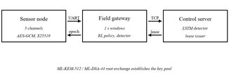
Figure 1. Three tier architecture. Telemetry flows upward in one second windows and sealed control frames return a lease and a posture directive. The gateway acts on its own authority when the downward path stops.
C. Device Layer
Each sensor node samples five channels covering analogue and digital sources, converts analogue channels through an external converter, and applies plausibility bands that mark each reading with a quality flag before transmission. The node holds a provisioned 32 byte pre shared key in non volatile storage and refuses to operate without it, which makes an unprovisioned or wiped device fail closed rather than join the network in an unauthenticated state. Session establishment is an X25519 exchange [6] bound to that pre shared key, so neither the long term secret nor the ephemeral contribution is sufficient alone.
D. Gateway Layer
The gateway is the only tier that participates in both cryptographic domains. It terminates node sessions, aggregates telemetry into fixed windows, holds the post quantum session with the server, runs the key lifecycle controller, and maintains its own local detection signals independent of the server. Running local evidence at this tier is what allows the gateway to act when the server is unreachable: authentication failure rates, replay rejection rates and silent channel counts are observations the gateway owns rather than receives.
E. Server Layer
The control server maintains per gateway session state, performs replay checking against a monotonic sequence window, runs the anomaly detector over decrypted windows, and issues leases. It is trusted in the threat model of Section IV-A and is deliberately not required for continued secure operation of the tiers below it.
F. Security Layer
The cryptographic stack is layered so that each mechanism has one responsibility. Post quantum encapsulation establishes root keys. The derivation function expands a root into per node, per purpose session keys. Authenticated encryption provides confidentiality and integrity per frame with the header as associated data. The masking layer applies posture dependent transformation outside the authenticated encryption, so that removing it would not weaken confidentiality. Table II lists the responsibilities by tier.
Table II. Functional responsibilities by tier
Tier | Responsibility | Key material held
Sensor node | Sampling, quality flags, framing, per frame sealing | Device PSK, one session key
Gateway | Aggregation, masking, policy, local detection, lease state | Node session keys, uplink key pool
Server | Replay check, detection, lease issuance, directives | Per gateway root and control keys

G. End-to-End Communication Workflow
A complete cycle proceeds as follows. Nodes transmit framed readings continuously. At the close of each one second window the gateway drains its aggregator, separating trusted channels from any currently quarantined ones, which continue to be collected and forwarded under an untrusted marking rather than discarded. The window is masked, sealed under the current session key with the frame header as associated data, and transmitted. The server verifies the replay guard, authenticates and decrypts, scores the window, and returns a sealed control frame. The gateway validates the control sequence number, adopts the directive subject to its shield, renews its lease, and echoes the adopted posture in the next outbound header. If no control frame arrives before the lease expires, the gateway escalates one posture level and re arms, so that a dead control channel walks the ladder upward over successive periods rather than either stalling or jumping to the top on a single lost packet.
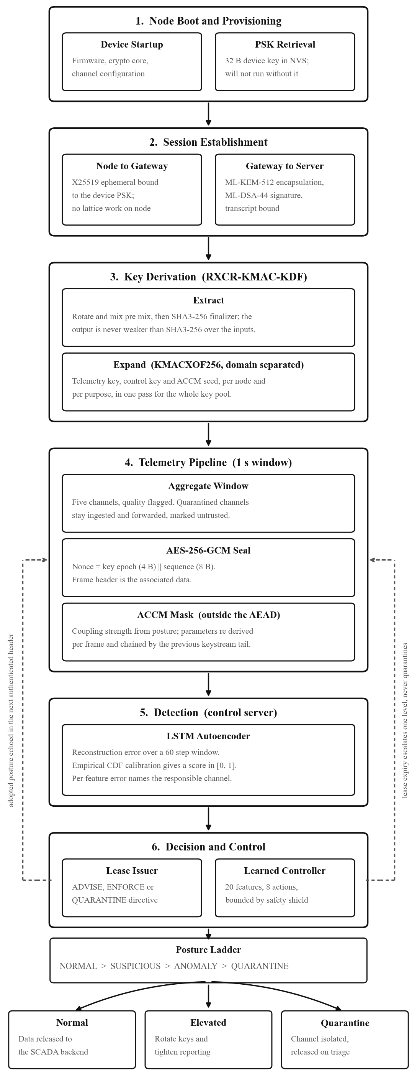
Figure 2. End to end operational workflow, from node provisioning through session establishment, derivation, the sealed telemetry pipeline and detection to the posture decision. The two dashed paths are the fail secure elements: lease expiry escalates the gateway without instruction and never quarantines, and the adopted posture returns in the next authenticated header so the server verifies adoption.
H. Hardware Testbed
The testbed is assembled from low cost commercially available embedded hardware rather than industrial grade equipment. The choice is deliberate: the claim under test is that the cryptographic and learned components remain viable on the class of device that actually populates field deployments, and that claim is not supported by demonstrating it on capable hardware.
The field node is built on an ESP32 DevKit V1, which occupies the role a remote terminal unit or intelligent electronic device would hold when bolted to a transformer or to switchgear. Three sensors attach to it. A ZMPT101B measures AC voltage and stands for the potential transformers used to read bus voltage in a real installation. An ACS712 measures current and stands for the current transformers. A DHT22 supplies temperature and humidity. A five volt relay module acts as the physical actuator and can isolate a circuit section when the control plane calls for it.
An MCP3008 external converter sits between the analogue sensors and the microcontroller. The ESP32 has internal converters, but they are non linear and noisy enough to degrade electrical telemetry, so the MCP3008 digitises the analogue channels and delivers clean values over SPI: the microcontroller pulls chip select low, clocks three bits out on MOSI to choose the channel, and reads the ten bit result back on MISO. The node aggregates all readings into a structured payload and transmits it over UART at 115200 baud. The link is asynchronous so that transmission never blocks the sampling loop, which runs at approximately 10 Hz.
The gateway runs on a Raspberry Pi 4B and acts as the substation gateway, the intermediate node that field devices report to rather than connecting to a control centre directly. Its ARM processor absorbs the work the node cannot: the ML-KEM-512 and ML-DSA-44 handshake with the server, RXCR-KMAC-KDF derivation, AES-256-GCM sealing and ACCM masking of outbound telemetry, and the learned key lifecycle controller together with the local fast path signals of Section III-D. The LSTM detector runs on the control server, which receives the sealed telemetry over TCP. The whole testbed draws from a regulated bench supply, and the wiring is shown in Figure 3.
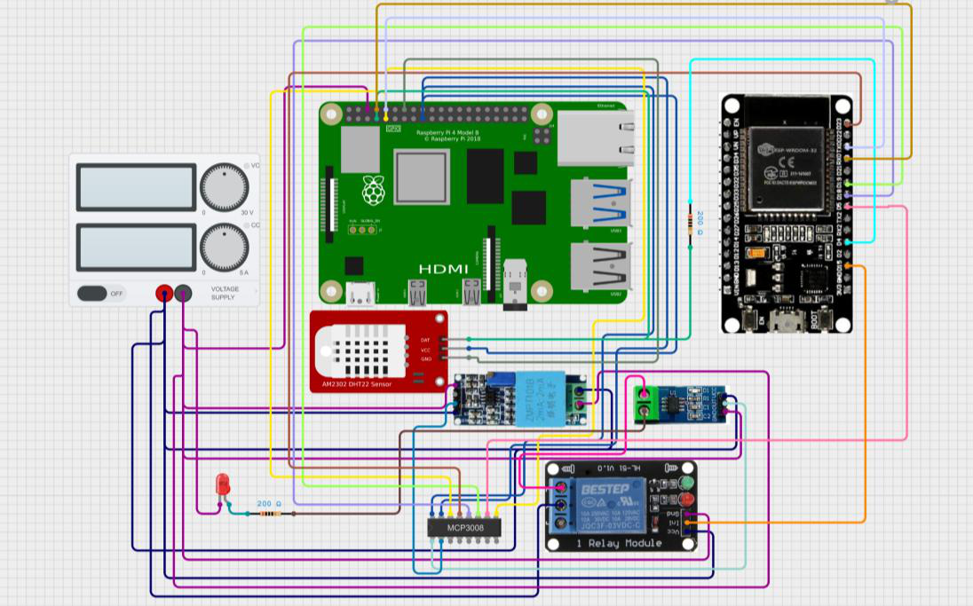
Figure 3. Testbed wiring. The ESP32 field node reads the voltage, current and environmental sensors through the MCP3008 converter and drives the relay; the Raspberry Pi 4B gateway performs the post quantum handshake, derivation, sealing and masking, and runs the learned controller.
IV. IMPLEMENTATION AND SECURITY
A. Threat Model
We assume an adversary able to observe and record all traffic on the gateway to server link indefinitely, inject and replay frames on either link, disrupt the control channel at will, and compromise an individual sensor node including its provisioned key material. We do not assume compromise of the control server or physical extraction from the gateway secure storage. Node compromise is contained rather than prevented: a node holds only its own session key and its own pre shared key, so a compromised node can corrupt its own channel and no other, which is the property that makes per channel quarantine meaningful.
B. Post-Quantum Root Establishment
The server generates an ML-KEM-512 keypair per gateway epoch and signs the public key with ML-DSA-44. The gateway verifies the signature, encapsulates, and both sides derive a root key from the shared secret together with a transcript hash binding the exchange. Level 1 and level 2 parameter sets are selected for the constrained deployment and are revisited in Section VI as a deployment decision rather than presented as a recommendation.
C. Key Derivation
Session keys derive through an extract and expand construction following the paradigm established by HKDF [5]. The extraction stage applies a positional rotate and mix pre mix over the input keying material before a SHA3-256 finalizer; the expansion stage is KMACXOF256 [4] domain separated per node and per purpose [18], so that a single pass produces the telemetry key, the control key and the masking seed for every node in the pool. Because the finalizer consumes the input keying material and salt directly, the derived key is at least as strong as SHA3-256 over the same inputs irrespective of the pre mix. We state this as a fail safe floor and not as a novelty claim: it is the standard argument for extract then expand, and our measurements do not show the pre mix contributing beyond it.
D. Authenticated Encryption and Nonce Discipline
Frames are sealed with AES-256-GCM [3] under a 96 bit nonce formed as the four byte key epoch concatenated with the eight byte sequence number. Uniqueness is structural: the epoch increases on every rotation and the sequence counter never repeats within an epoch, so no key and nonce pair can recur even across an unclean restart, and the sensor node is never required to produce randomness. A guard forces rotation before sequence exhaustion, and that guard is implemented below the policy layer so that no learned decision can violate the invariant.
E. Adaptive Chaotic Masking
An adaptive coupled chaotic map masks ciphertext on the gateway to server link with coupling strength driven by the current posture. Each frame re derives its parameters from the session key, the authenticated frame header and the previous frame keystream tail, producing a chain of short independently seeded streams bound to the frame sequence. The chaotic byte is combined with a KMACXOF256 base stream rather than used alone, following the measurement reported in Section V-G. The resulting layer provides posture dependent traffic shaping and defence in depth; it is explicitly not relied upon as a source of entropy, and it sits outside the authenticated encryption so that the channel security argument is unchanged by its presence.
F. Learned Key Lifecycle Controller
The controller observes 20 features in five groups: threat signals including the calibrated detector score and its fast and slow moving averages; control plane state including lease remaining and the directive floor; key lifecycle state including sequence consumption, key age and bytes under the current key; local fast path evidence; and resource state. Eight actions are available, spanning hold, three rotation scopes, posture escalation and de escalation, channel quarantine, and an immediate detector flush that spends bandwidth to shorten detection lag for one step.
The agent is a duelling double deep Q network [30], [31] with five step returns. Three design decisions matter more than the architecture. A safety shield makes unsafe actions unreachable rather than penalised, bounding rotation rate, enforcing minimum posture hold times and forcing rotation before nonce exhaustion. The reward charges for exposure and for action, with action costs taken from measurements of the implementation and false positives charged separately from rotations. And every training episode draws a different detector quality from a grid over false positive rate, false negative rate and detection delay, which is the mechanism that makes the policy transferable.
G. Anomaly Detection
The detector is a long short term memory autoencoder [27] trained on benign windows only, because a healthy installation produces no labelled attacks. Reconstruction error is converted to a calibrated score by the empirical cumulative distribution function of error over held out benign data, so that a score of 0.99 means worse than 99 percent of benign windows. Per feature error supplies channel attribution, which the quarantine mechanism requires: a detector reporting only that something is wrong cannot drive isolation of a specific instrument.
H. Posture State Machine and Shield Rules
The posture ladder has four levels. Normal is the steady state. Suspicious tightens reporting and shortens the detector flush interval. Anomaly additionally constrains which actions the policy may take and raises the rotation priority. Quarantine marks named channels untrusted while continuing to ingest them, so that the data remains available for triage rather than being destroyed by the response.
Three directive kinds travel on the control channel. An advise directive carries the server assessment and may be weighed by the gateway against its own evidence. An enforce directive sets a floor below which the local policy may not descend. A quarantine directive is mandatory, carries a channel bitmap, and forces the anomaly posture. Quarantine masks accumulate rather than replace, so that two overlapping detections cannot clear one another, and release is an explicit triage action at both ends rather than a timeout.
The shield enforces four invariants independently of the learned policy. Rotation is rate limited so that a policy cannot consume the key pool. A minimum hold time applies before any de escalation, which prevents oscillation around a detection threshold. De escalation below a server imposed floor is refused. And rotation is forced when sequence consumption approaches the nonce limit, which places the uniqueness invariant of Section IV-D below the policy layer entirely. Because these are implemented as action masking rather than as reward penalties, no training outcome can violate them.
I. Implementation Parameters
Table III. System implementation specifications
Parameter | Value
Key encapsulation | ML-KEM-512
Signature | ML-DSA-44
Node key agreement | X25519 with device PSK
Authenticated encryption | AES-256-GCM
Nonce | 96 bit, epoch and sequence
Key derivation | Rotate-mix, SHA3-256, KMACXOF256
Aggregation window | 1 s
Sensor channels per node | 5
Controller | Duelling double DQN, 5 step returns
Observation and action space | 20 features, 8 actions
Training | 5000 episodes, 3 seeds
Detector | LSTM autoencoder, 60 step window
Detector calibration | Empirical CDF on held out benign

V. RESULTS AND IMPLEMENTATION ANALYSIS
A. Evaluation Protocol
Policies are compared on identical episodes and differenced per seed, because most of the variance between episodes is attributable to the episode rather than the policy: an episode containing a long intrusion is unfavourable for every policy. Differencing cancels that shared difficulty. All reported intervals are 95 percent confidence intervals on the paired difference. Model selection uses held out episodes disjoint from those used for any reported figure.
B. Key Lifecycle Controller
Table IV. Key lifecycle policies, 15 seeds, 4 episodes of 600 steps
Policy | Return | Comprom. | Rotations | False pos.
Learned (proposed) | -435.8 | 19.3 | 12.9 | 7.0
Oracle reference | -677.5 | 5.3 | 5.0 | 173.7
Threshold | -1610.9 | 75.6 | 53.9 | 12.8
Always maximum | -3481.8 | 91.8 | 60.0 | 507.2
Never rotate | -3723.0 | 177.4 | 0.0 | 24.8
Fixed interval | -3946.3 | 191.1 | 2.0 | 24.8

The oracle observes the hidden compromise state and is a perfect information reference rather than an upper bound: it escalates whenever an adversary is present and pays heavily in false positives, which is why a policy with strictly less information scores above it. The learned policy beats the threshold rule by 1175.1 with a 95 percent confidence interval of 600.8 to 1749.3, winning on 15 of 15 seeds.
The most operationally meaningful figure is not the return but the rotation count. The learned controller achieves 74 percent fewer compromised steps using 76 percent fewer key rotations than the threshold rule. Protection is obtained through better timing rather than greater activity, which matters because each rotation propagates a handshake across the fleet and is the cost an operator actually bears.
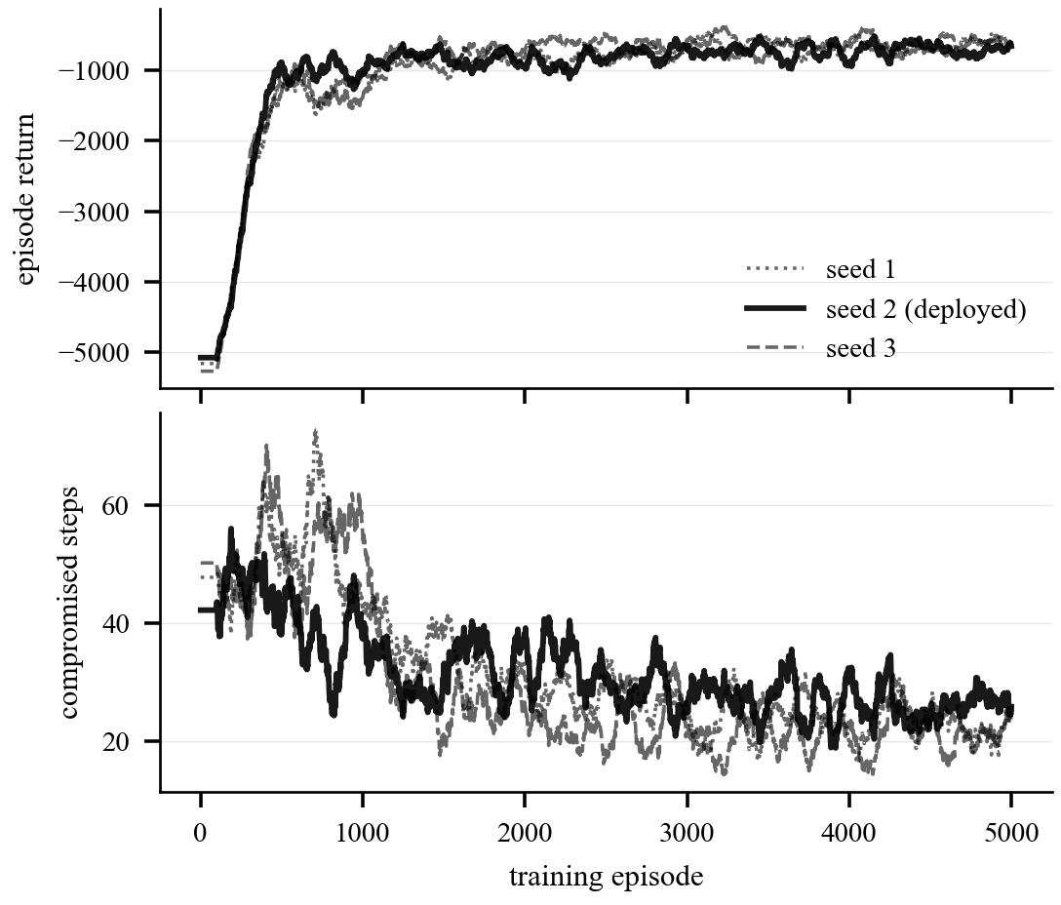
Figure 4. Training across three seeds, smoothed over 100 episodes. Returns improve throughout and compromised steps fall substantially. The spread between seeds is the reason model selection uses held out episodes rather than the training curve.
C. Transfer Across Detector Quality
Figure 5 plots the learned policy against the threshold rule at each of the 27 points of the detector grid. Every point lies above parity, so the policy wins at every combination of false positive rate, false negative rate and detection delay tested, and the margin widens as the detector degrades. The policy additionally wins all nine settings of a disturbance regime introduced after the detector had been measured, in which the detector false alarms continuously throughout benign grid faults. That regime lies outside the training distribution entirely and the policy was not retrained for it.
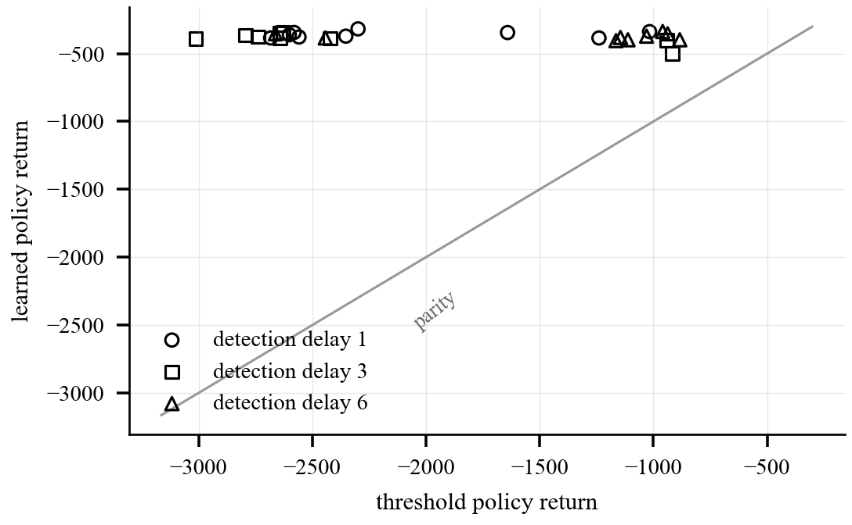
Figure 5. Robustness across the 27 point detector grid. All points lie above the parity line.
Table V reports the disturbance regime in full. Each row fixes a rate at which benign grid faults occur and a detection delay, with the detector false alarming continuously for the duration of each fault. The paired advantage over the threshold rule is positive and statistically separable at every setting.
Table V. Disturbance regime, paired advantage over threshold
Fault rate | Delay | Advantage | Seeds won
0.01 | 1 | +1362 | 8 of 8
0.01 | 3 | +1402 | 8 of 8
0.01 | 6 | +1438 | 8 of 8
0.03 | 1 | +1308 | 8 of 8
0.03 | 3 | +1683 | 8 of 8
0.03 | 6 | +1330 | 8 of 8
0.06 | 1 | +1748 | 8 of 8
0.06 | 3 | +2071 | 7 of 8
0.06 | 6 | +1525 | 8 of 8

D. Anomaly Detector
Table VI. Detector performance, 55 held out sequences
Measure | Operational | vs calm grid
Average precision | 0.964 | 0.999
Recall on attacks | 0.96 to 0.98
Median detection delay | 0.03 s
Inference per window | 2.5 ms
False alarms on faults | 0.98 to 1.00

The operational column counts natural disturbances as negatives, which is the question an operator asks, since a fault that raises an attack alarm is a false alarm whatever the underlying physics. The second column excludes them and is correspondingly flattering. Per scenario recall has a median of 1.000 across the 28 attack types, and the two weakest scenarios are both line maintenance with relays disabled, so the attacks hardest to detect are those resembling routine engineering work.
The false alarm rate on natural disturbances is a genuine negative result. Reconstruction error measures the unusual, and a fault is extremely unusual, so the mechanism that detects attacks is the one that responds to weather. We therefore describe this component as a disturbance detector rather than an attack detector and locate the discrimination in the policy that consumes its output. The architecture was built for a detector that is frequently wrong: the score is calibrated input to a policy rather than a verdict, the policy is trained with an explicit false positive cost, and the response to suspicion is to isolate and continue rather than to halt.
Table VII gives the per scenario breakdown. Detection is essentially complete for the command injection and relay disabling families. The two weak scenarios, 39 and 40, are both line maintenance performed with relays disabled, and they are weak for an intelligible reason: the attack consists of performing a legitimate maintenance operation under conditions that make it dangerous, so the telemetry it produces closely resembles authorised work. An adversary who understands the plant is harder to detect than one who does not, which is a result worth stating plainly rather than averaging away.
Table VII. Per scenario detection recall, 28 attack types
Scn | Recall | Scn | Recall | Scn | Recall
7 | 1.000 | 19 | 1.000 | 29 | 1.000
8 | 1.000 | 20 | 1.000 | 30 | 0.987
9 | 1.000 | 21 | 1.000 | 35 | 0.976
10 | 1.000 | 22 | 1.000 | 36 | 0.998
11 | 1.000 | 23 | 0.985 | 37 | 1.000
12 | 0.976 | 24 | 1.000 | 38 | 1.000
15 | 1.000 | 25 | 1.000 | 39 | 0.791
16 | 1.000 | 26 | 0.995 | 40 | 0.465
17 | 1.000 | 27 | 1.000
18 | 1.000 | 28 | 1.000

The eight natural disturbance scenarios are the mirror image. Every one produces a false alarm rate between 0.997 and 1.000, so the detector responds to all of them as though they were attacks. The uniformity of that result across scenario types is itself informative: this is not a tuning deficiency affecting some fault classes but a property of reconstruction error as a signal.
E. Integrated Behaviour and Timing
The integrated system passes 24 of 24 behavioural checks across four scenarios: normal operation with the lease renewing; an injected attack driving escalation with the posture echo verified; loss of the control channel, in which the gateway escalates unaided while telemetry continues to flow and no channel is quarantined; and quarantine of a single channel followed by recovery, triage and release. The 95th percentile cycle time is 41 ms against a one second budget, and detector inference accounts for 2.5 ms of that.
F. Hardware Characterisation
The figures in Table VIII are placeholders. Firmware is complete and host tested and bring-up of the sensor node and gateway hardware is scheduled, but these measurements have not yet been taken. Values are consistent with the target platforms and with host measurements, and are included so that the structure of the completed evaluation is visible. Each must be replaced before this table is cited.
Table VIII. Hardware characterisation (PLACEHOLDER, pending bring-up)
Quantity | Value | Status
AES-256-GCM seal, 64 B frame | 0.12 ms | placeholder
X25519 exchange, sensor node | 31 ms | placeholder
ML-KEM-512 encapsulation, gateway | 0.09 ms | placeholder
ML-DSA-44 verification, gateway | 0.31 ms | placeholder
Serial frame transmission | 7.03 ms | measured, host
Firmware image | 182 KB | placeholder
Peak RAM, sensor node | 42 KB | placeholder
Soak, 1 h at 10 Hz, auth failures | 0 | placeholder

The single measured row is informative on its own. Sealing a frame costs 0.019 ms on the host against 7.03 ms of serial transmission, so the link and not the cryptography determines the achievable sampling rate. We expect this ratio to narrow but not to invert on the target hardware, which would contradict the common assumption that cryptography is the limiting cost on constrained devices. Confirming or refuting that is the first measurement scheduled at bring-up.
G. Negative Results
Five measurement failures occurred during development, each producing a plausible but incorrect result until checked. We report them because the corrective procedure is inexpensive in every case and three generalise beyond this system.
1) Chaos only keystream. The initial masking design generated its keystream from coupled logistic maps alone. Across the parameter space, 100 percent of draws fell below 7.99 bits per byte, and at a coupling strength of 0.4 the stream measured 3.26 bits per byte with a single value occupying 36 percent of output. The cause is synchronisation: coupling drives the maps toward a common trajectory and combining the same bit slice of two synchronised states collapses it. The deployed hybrid measures 7.99995 bits per byte at every posture. A single favourable parameter choice would have passed, which is why we report the sweep.
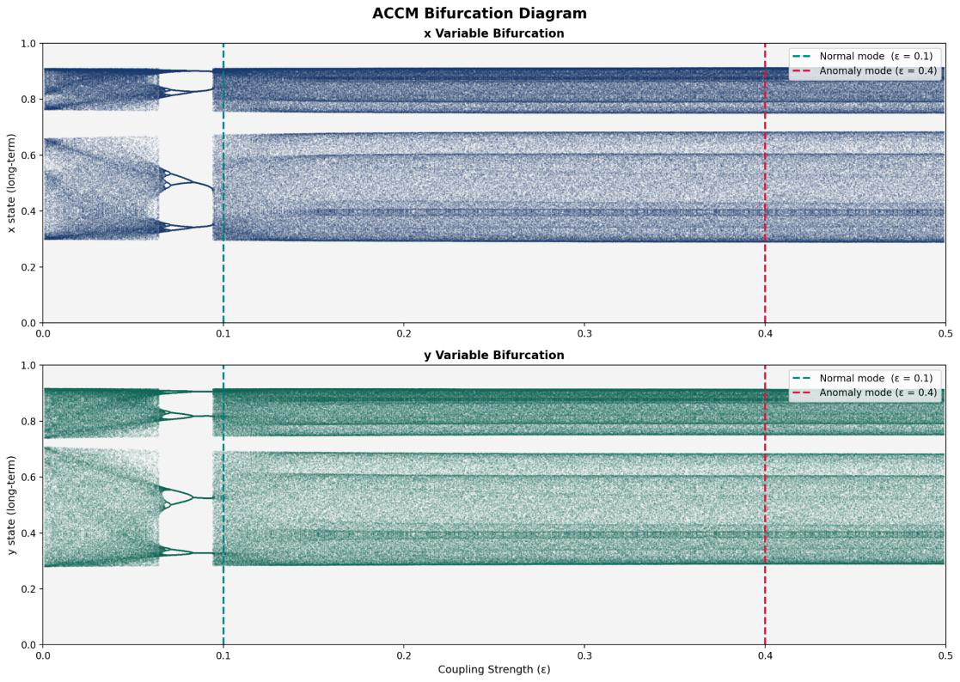
Figure 6. Bifurcation of the coupled map against coupling strength, with the normal and anomaly operating points marked. The structure is rich across the range, which is precisely why a single favourable parameter choice is misleading: at the anomaly coupling the chaos only stream still measured 3.26 bits per byte.
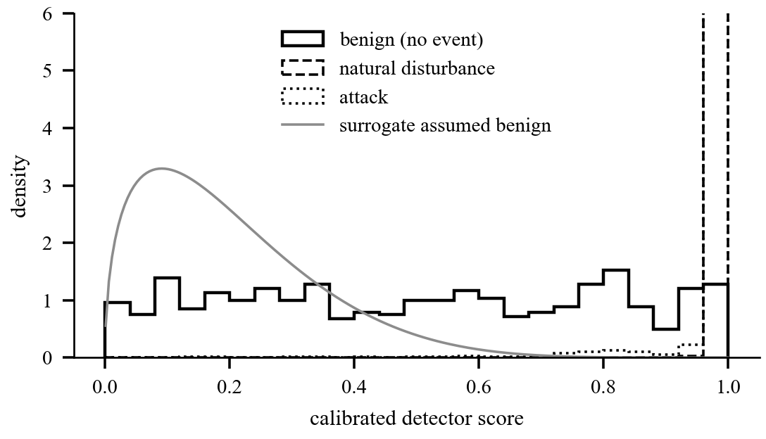
Figure 7. Measured detector score distributions against the distribution the controller was trained to expect. Calibration forces benign scores to be uniform while the surrogate assumed mass near zero. Attacks and natural disturbances both concentrate near unity.
2) Contradictory calibration contract. The controller trained against a surrogate whose benign scores were drawn from a Beta(1.5, 6) distribution with mean 0.20. Empirical distribution calibration, however, forces benign scores to be uniform by construction, and the trained detector measured mean 0.503. Both components were written to the same specification and contradicted one another, as Figure 7 shows. The consequence appeared only when both trained components were connected: on calm traffic the hold action collapsed from 60.1 percent of steps in simulation to 5 percent in the integrated system, and rotation rose from 7.0 percent to 42 percent. Re fitting the surrogate and retraining restored the behaviour and improved every metric in Table IV.
3) Statistical testing without a control. Running the SP 800-22 battery [7] against a cryptographically secure generator alongside the primitives under test, six of twelve tests failed on that known good input at 100,000 bit sequences. Without the control, the reported headline would have been that the key derivation function fails half the battery. Excluding the tests the control cannot pass, the extractor matches the control test for test across the battery.
4) Model selection on insufficient data. Training retained the best weights by evaluation on three held out episodes. One episode scored almost identically for every candidate and carried no information, so the ranking rested on essentially one episode, and re ranking on 15 episodes reversed the winner. Selection on three episodes proved measurably worse than no selection at all.
5) An unfalsifiable safety criterion. The acceptance criterion for nonce safety was zero exhaustion events, and the evaluation reported zero forced rotations. At the episode length used, the guard rail could not be reached even by a policy that never rotated, so a do nothing agent would have scored identically. Re run at a length where the threshold is reachable, the result holds, with peak sequence consumption two orders of magnitude below the limit.
VI. DISCUSSION
A. Where the Advantage Comes From
The learned controller does not rotate more often than the threshold rule; it rotates roughly a quarter as often. Its advantage is therefore not additional activity but timing, and inspecting the policy shows where that timing comes from. The controller conditions on the rate of change of the detector score rather than on its level alone, on local evidence the gateway owns such as authentication failure rates, and on how long the current key has been in service. A threshold rule has access to none of this and must commit on a single scalar crossing a line.
B. Why the Detector Failure Is Tolerable
A detector that raises an alarm on essentially every natural disturbance would be unusable as a trigger. It is usable as evidence because the architecture never treats it as a trigger. The score enters a policy that was trained knowing the detector is frequently wrong, the response to suspicion preserves data flow, and quarantine requires explicit triage to release rather than resolving itself. The quantitative requirement is that the false alarm rate be known, not that it be low, and Section V-D supplies the measurement.
C. Limitations
The hardware characterisation in Table VIII is composed of placeholders and must be replaced before publication. The detector deployed in the integrated harness is trained on synthetic benign traffic, because the public corpus features do not transfer to a five channel installation: the public data earns the detection numbers and the harness demonstrates the control path, and neither substitutes for the other. Channel attribution accuracy is unmeasurable on the public corpus, whose labels name scenarios rather than manipulated instruments. The statistical battery of Section V-G is a necessary and not a sufficient condition. The forced rotation path of the shield is never exercised by the trained policy, whose own cadence keeps sequence consumption far below the guard rail, so that path rests on unit tests. And the level 1 and level 2 parameter sets are a deployment decision to revisit rather than a recommendation.
VII. CONCLUSION AND FUTURE WORK
This paper presented a three tier industrial telemetry architecture combining post quantum root establishment placed appropriately across a constrained topology, a learned key lifecycle controller trained against a distribution of detector qualities, posture adaptive masking applied outside the authenticated encryption, and a lease based control plane in which authority expires rather than being commanded. The controller leaves 74 percent less time under adversary control while performing 76 percent fewer key rotations than a threshold rule, wins at all 27 detector settings tested, and continues to win in a regime outside its training distribution. The integrated system passes 24 of 24 behavioural checks within a 41 ms cycle time.
Four directions follow. Collecting benign telemetry from the instrumented installation and retraining the detector on it converts the method demonstrated here into a deployable component and requires no labelled attacks. Adding a standing cost for time spent above normal posture should remove a degenerate behaviour observed in two of three training seeds. Modelling the detector two distinct false positive rates, approximately 0.05 on a calm grid and close to unity during a fault, would allow the controller to condition on whether the grid is disturbed. And signing the gateway encapsulation key with its existing signature key, then rotating that keypair per epoch, closes an implicit trust assumption and adds forward secrecy to the root transfer.
The engineering observation we would emphasise is that two components built to a single specification can disagree about what a number means, and that no amount of testing within either component reveals it. The error surfaced only on connecting both trained models and measuring the output. We recommend an explicit interface measurement step wherever a learned controller consumes a learned signal, a control corpus alongside any statistical randomness result, and a check that each safety criterion could have failed within the window in which it was measured.
ACKNOWLEDGMENT
The authors thank the maintainers of the Mississippi State University and Oak Ridge National Laboratory power system attack datasets, recovered for this work from the Internet Archive after the original host became unavailable.
REFERENCES
[1] National Institute of Standards and Technology, "Module-Lattice-Based Key-Encapsulation Mechanism Standard," FIPS 203, Aug. 2024.
[2] National Institute of Standards and Technology, "Module-Lattice-Based Digital Signature Standard," FIPS 204, Aug. 2024.
[3] M. Dworkin, "Recommendation for block cipher modes of operation: Galois/Counter Mode (GCM) and GMAC," NIST SP 800-38D, Nov. 2007.
[4] J. Kelsey, S. Chang and R. Perlner, "SHA-3 derived functions: cSHAKE, KMAC, TupleHash and ParallelHash," NIST SP 800-185, Dec. 2016.
[5] H. Krawczyk and P. Eronen, "HMAC-based extract-and-expand key derivation function (HKDF)," RFC 5869, May 2010.
[6] D. J. Bernstein, "Curve25519: New Diffie-Hellman speed records," in Proc. Public Key Cryptography, 2006, pp. 207-228.
[7] A. Rukhin et al., "A statistical test suite for random and pseudorandom number generators for cryptographic applications," NIST SP 800-22 Rev. 1a, Apr. 2010.
[8] International Electrotechnical Commission, "Power systems management and associated information exchange: Data and communications security," IEC 62351, 2020.
[9] V. Bhatia and K. Ramkumar, "An efficient quantum computing technique for cracking RSA using Shor algorithm," in Proc. IEEE 5th Int. Conf. Computing, Communication and Automation (ICCCA), 2020.
[10] J. P. Dumas, K. Soni and A. Rasool, "Evolution of quantum computing based on Grover search algorithm," 2019.
[11] Google Research, "The quantum echoes algorithm breakthrough," Oct. 2025. [Online]. Available: https://blog.google/technology/research/quantum-echoes-willow-verifiable-quantum-advantage/
[12] A. Khalid, S. McCarthy, M. O Neill and W. Liu, "Lattice-based cryptography for IoT in a quantum world: Are we ready?," in Proc. IEEE Conf. Cryptography and IoT Security, 2019.
[13] M. A. G. de la Torre, I. A. Morales-Sandoval and L. H. Encinas, "Post-quantum wireless-based key encapsulation mechanism via CRYSTALS-Kyber for resource-constrained devices," IEEE Access, vol. 13, 2025.
[14] W. B. Dias, A. Maiga and Z. Y. Shae, "Kyber-KEM-Ascon: Benchmarking a lightweight post-quantum KEM on IoT devices," Preprint, 2025.
[15] D.-T. Dam, T.-H. Nguyen, T.-H. Tran, B. Kieu-Do-Nguyen and T.-T. Nguyen, "An efficient method for accelerating Kyber and Dilithium post-quantum cryptography," 2024.
[16] Y. Yang, Y. Lin, J. Xiao and Z. Zhong, "Feasibility discussion of quantum cryptography for Internet of Things security: a literature review," Optical and Quantum Electronics, vol. 57, art. 264, 2025.
[17] I. Radhakrishnan, S. Jadon and P. B. Honnavalli, "Efficiency and security evaluation of lightweight cryptographic algorithms for resource-constrained IoT devices," Sensors, vol. 24, no. 12, art. 4008, 2024.
[18] H. Almomani et al., "Securing Internet of Vehicles communications: A biometric and hash-key derivation function based approach," in Proc. 25th Int. Arab Conf. Information Technology (ACIT), 2024.
[19] H. Wen, Y. Lin, S. Kang, X. Zhang and K. Zou, "Secure image encryption algorithm using chaos-based block permutation and weighted bit planes chain diffusion," iScience, vol. 27, no. 1, art. 108610, Jan. 2024.
[20] M. Ghebleh, A. Kanso and H. Noura, "An image encryption scheme based on irregularly decimated chaotic maps," Signal Processing: Image Communication, vol. 29, no. 5, 2014.
[21] D. Yang, Z. Liu and J. Zhou, "Chaos optimization algorithms based on chaotic maps with different probability distribution and search speed for global optimization," Communications in Nonlinear Science and Numerical Simulation, vol. 19, no. 4, 2014.
[22] A. Kotangale and M. S. Kumar, "An iterative quantum chaotic security method design for big data deployments using a multi-model framework for key generation, threat modelling, and anomaly-resilient validation," MethodsX, vol. 15, art. 103643, Dec. 2025.
[23] R. M. Lee, M. J. Assante and T. Conway, "Analysis of the cyber attack on the Ukrainian power grid," E-ISAC and SANS ICS, Mar. 2016.
[24] Y. Yang, K. McLaughlin, S. Sezer, T. Littler, E. G. Im, B. Pranggono and H. F. Wang, "Multiattribute SCADA-specific intrusion detection system for power networks," IEEE Trans. Power Delivery, vol. 29, no. 3, 2014.
[25] S. Pan, T. Morris and U. Adhikari, "Developing a hybrid intrusion detection system using data mining for power systems," IEEE Trans. Smart Grid, vol. 6, no. 6, pp. 3104-3113, 2015.
[26] U. Adhikari, S. Pan, T. Morris, R. Borges and J. Beaver, "Industrial control system (ICS) cyber attack datasets," Mississippi State University and Oak Ridge National Laboratory, 2014.
[27] P. Malhotra, L. Vig, G. Shroff and P. Agarwal, "Long short term memory networks for anomaly detection in time series," in Proc. European Symp. Artificial Neural Networks, 2015, pp. 89-94.
[28] Q. Vo, "Anomaly detection in IoT sensor energy consumption using LSTM neural networks and Isolation Forest," 2024.
[29] J. Li, X. Zhang, H. Xiang et al., "Federated anomaly detection with isolation forest for IoT network traffics," in Proc. IEEE 29th Int. Conf. Parallel and Distributed Systems (ICPADS), 2023.
[30] H. van Hasselt, A. Guez and D. Silver, "Deep reinforcement learning with double Q-learning," in Proc. AAAI Conf. Artificial Intelligence, 2016, pp. 2094-2100.
[31] Z. Wang, T. Schaul, M. Hessel, H. van Hasselt, M. Lanctot and N. de Freitas, "Duelling network architectures for deep reinforcement learning," in Proc. Int. Conf. Machine Learning, 2016, pp. 1995-2003.
[32] X. Fang, L. Zheng, X. Fang, W. Chen, K. Fang, L. Yin and H. Zhu, "Pioneering advanced security solutions for reinforcement learning-based adaptive key rotation in Zigbee networks," Scientific Reports, vol. 14, art. 13931, 2024.
[33] S. Bhimshetty and A. Victor, "Energy-efficient deep Q-network for reinforcement learning in wireless IoT routing protocols," 2024.
[34] J. Tobin, R. Fong, A. Ray, J. Schneider, W. Zaremba and P. Abbeel, "Domain randomization for transferring deep neural networks from simulation to the real world," in Proc. IEEE/RSJ Int. Conf. Intelligent Robots and Systems, 2017, pp. 23-30.
[35] M. Alshowkan, P. G. Evans, M. Starke, D. Earl and N. A. Peters, "Authentication of smart grid communications using quantum key distribution," Scientific Reports, vol. 12, art. 12731, 2022.
[36] G. Falco, A. Viswanathan, C. Caldera and H. Shrobe, "A master attack methodology for an AI-based automated attack planner for smart cities," IEEE Access, vol. 6, pp. 48360-48373, 2018.

