BBW Product Design Document
Biomedical startup business AI agent platform - stakeholder discussion draft
Prepared for product review | August 25, 2026

Executive Summary
The current visual direction is retained: dark, high-technology, biomedical-adjacent, and clean. The public start page remains simple and chat-led. The logged-in workspace is simplified from many sidebar items into three primary product areas: Working Session, Company Info, and Community.

Primary Product Decisions
- Keep the public start page as a simple BBW chat entry with live biotech business news below it.
- Reduce logged-in sidebar complexity to three grouped tabs: Working Session, Company Info, and Community.
- Make Working Session the main AI operating surface, with New chat, History, and Plan execution as subviews.
- Make Company Info the founder dashboard for milestones, next steps, company stage, readiness, and business risk.
- Move logged-in news into the lower sidebar so market context is persistent without competing with the main workspace task.

Information Architecture
Area | Subitems | Purpose
Working Session | New chat, History, Plan execution | Run BBW conversations, restore prior topics, and execute exported plans.
Company Info | Dashboard | Summarize company health, milestones, stage, risks, and near-term operating work.
Community | My communities, Explore communities, Request community | Connect founders to relevant peer and expert communities.

Section Design

Start Page
The start page should remain the lowest-friction entry point. The first action is asking BBW a business question. Live biotech business news sits below the chat bar so it is visible but does not compete with the primary task.
Screenshot links: View screenshot 1

Working Session
New chat is the default and should feel closer to ChatGPT than a dashboard: the center of the page is a single BBW business prompt, one chat bar, and biotech startup prompt suggestions. Every chat starts as a session with a session id; follow-up questions keep that id until the user starts a new session. History lists reusable business topics. Plan execution converts agent work into a board of operating projects.
Screenshot links: View screenshot 1 | View screenshot 2 | View screenshot 3

Company Info
Company Info is the logged-in default. It gives founders a fast read on runway, lead asset, capital need, readiness, milestones, next-step checklist, stage progression, and risk signals.
Screenshot links: View screenshot 1

Community
Community is split into joined communities, discovery, and request flow. My Communities shows company cards for groups already joined. Explore Communities lists high-signal communities in the biomedical startup area. Request Community lets founders propose specialized groups.
Screenshot links: View screenshot 1 | View screenshot 2

News Placement
Logged-in news is placed in the lower sidebar. This uses otherwise empty navigation space, keeps the main page focused on the active task, and keeps biotech funding and market signals visible across workspace pages.
Screenshot links: View screenshot 1 | View screenshot 2

Screenshots

Figure 1. Start Page
Public entry page remains intentionally simple: brand, login/register, Gemini-like chat entry, and live biotech business news below the chat bar.
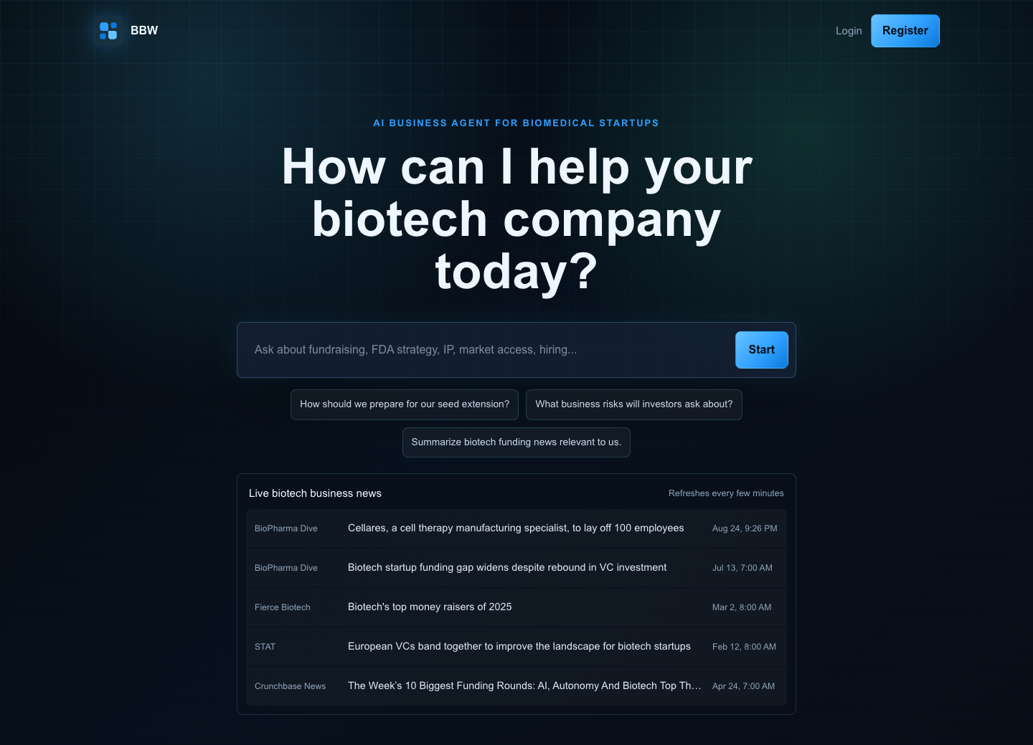

Figure 2. Company Info Dashboard
Logged-in default workspace focused on founder-operating signals: runway, lead asset, capital need, milestones, checklist, stage map, and risk signals. Biotech news lives persistently in the sidebar.
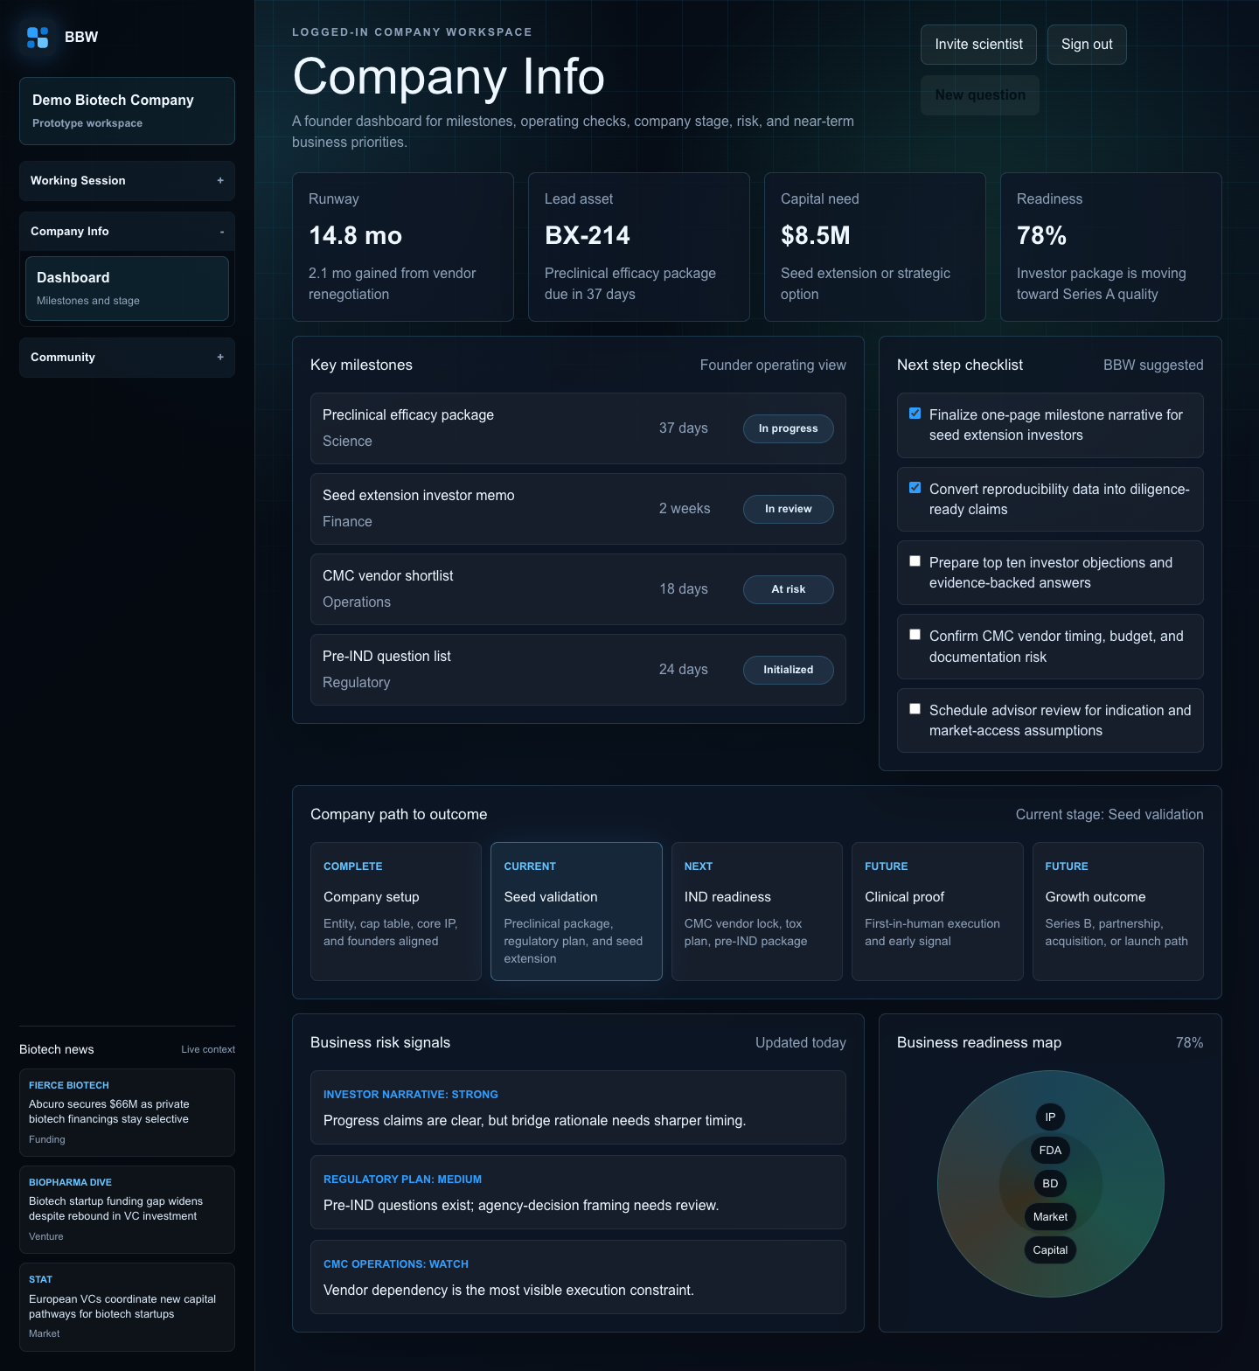

Figure 3. Working Session - New Chat
Default Working Session view uses a focused ChatGPT-style entry: mode toggle, large business-specific prompt, single chat bar, and biotech startup prompt suggestions.
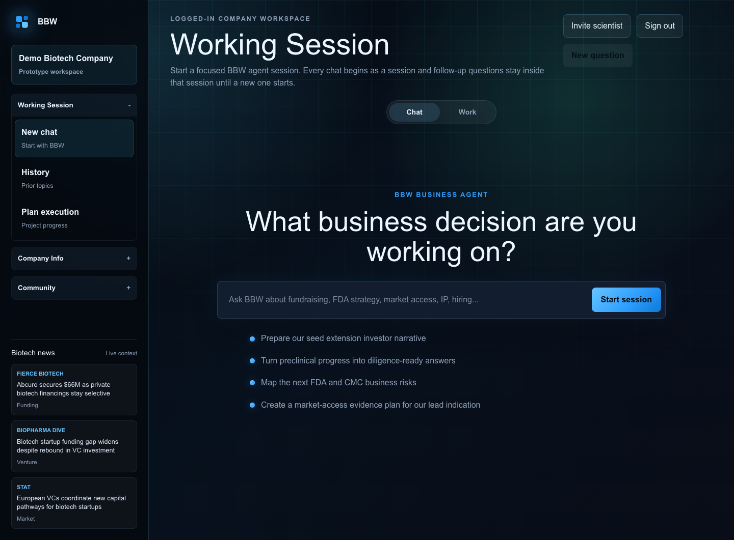

Figure 4. Working Session - History
History view presents prior business topics as reusable session context rather than a generic chat archive.
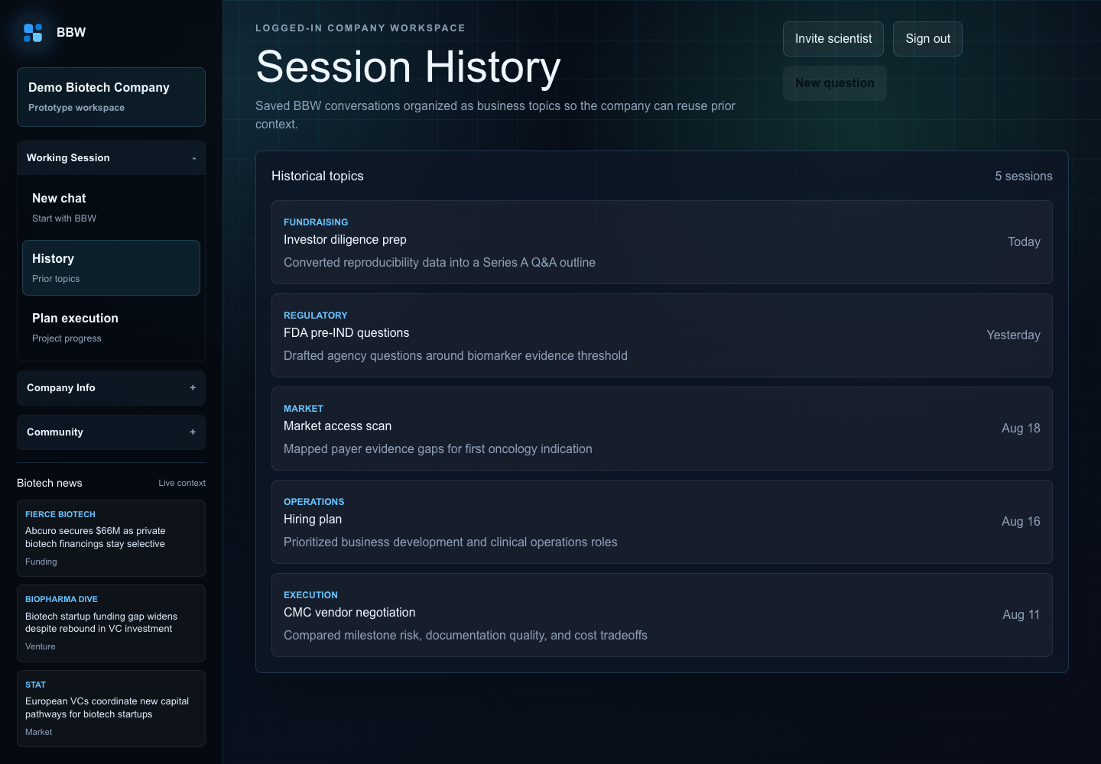

Figure 5. Working Session - Plan Execution
Plan Execution reuses the project progress board and groups exported work by Initialized, In Review, In Progress, and Complete.
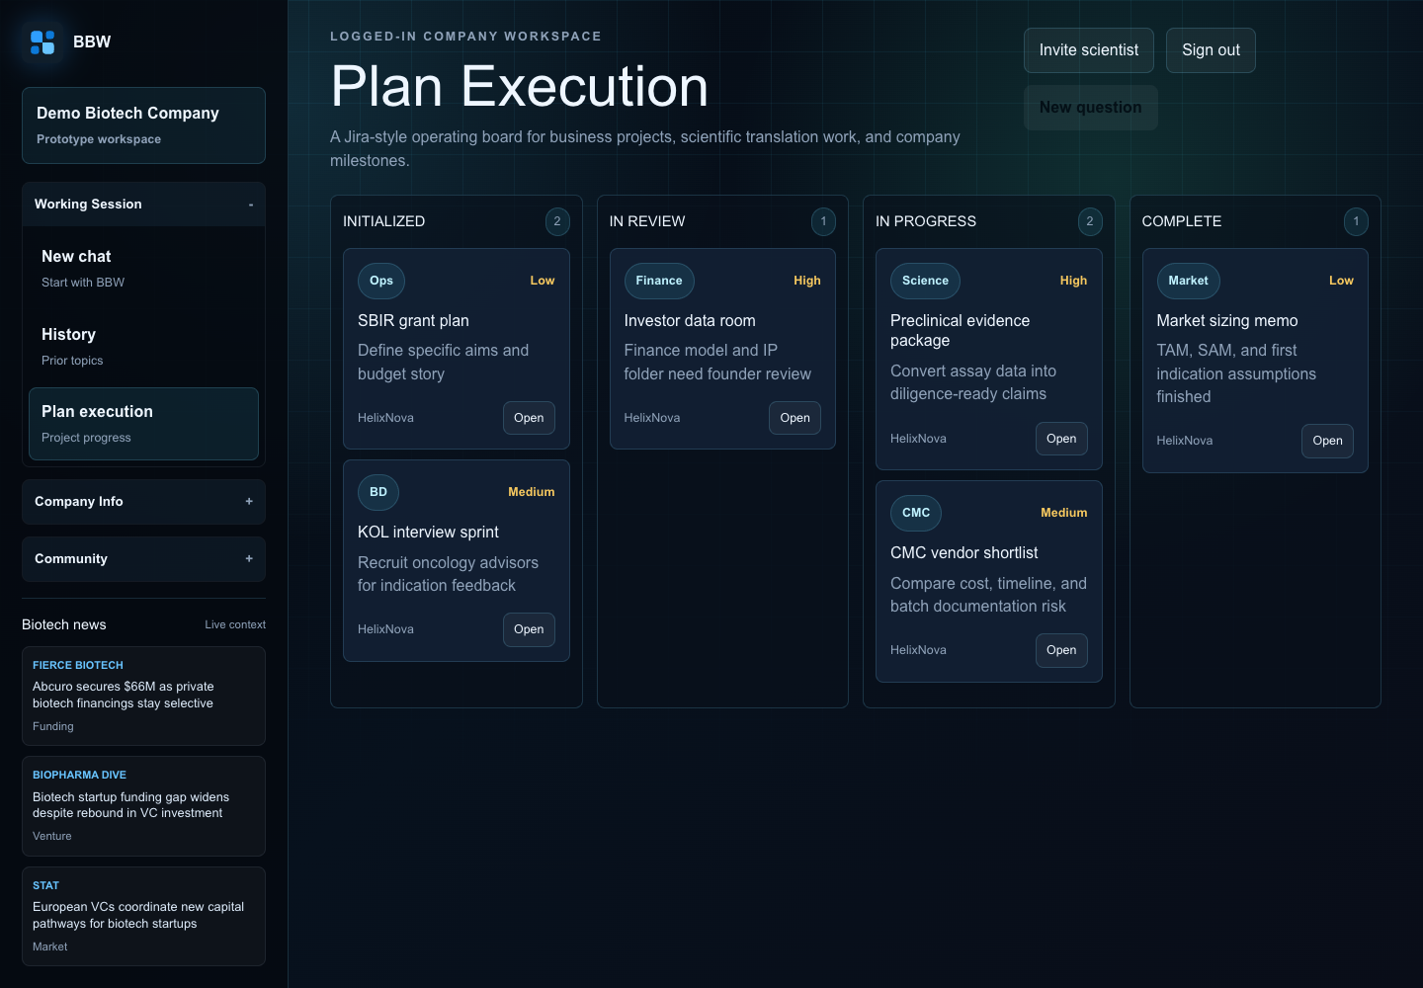

Figure 6. Community - My Communities
My Communities shows joined founder/operator groups as company cards with clear focus and member density.
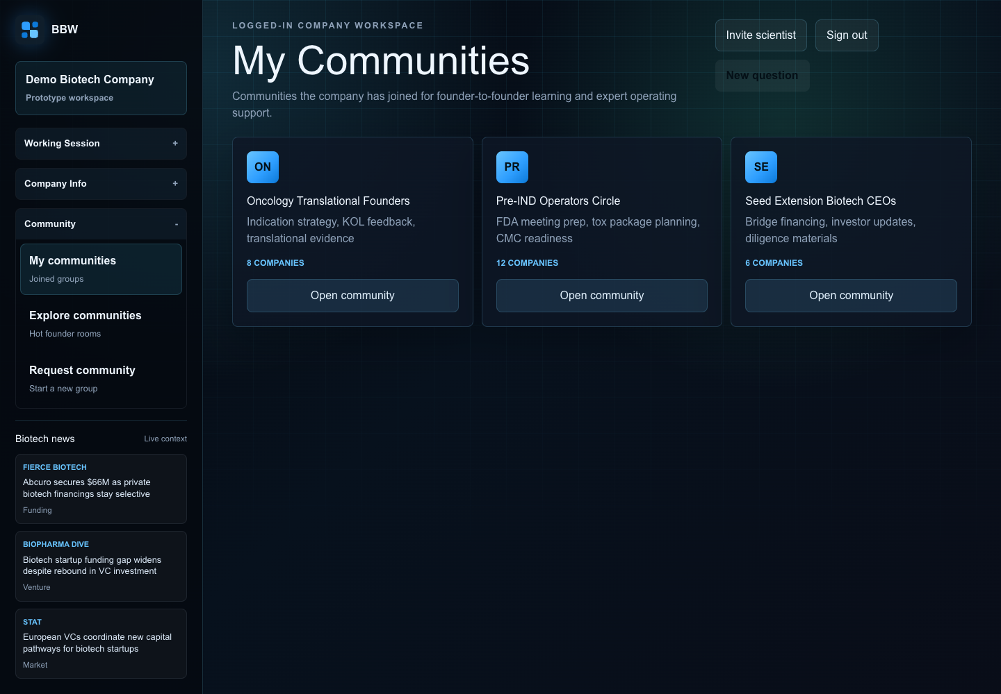

Figure 7. Community - Explore Communities
Explore Communities lists hot communities matched to biomedical startup needs.
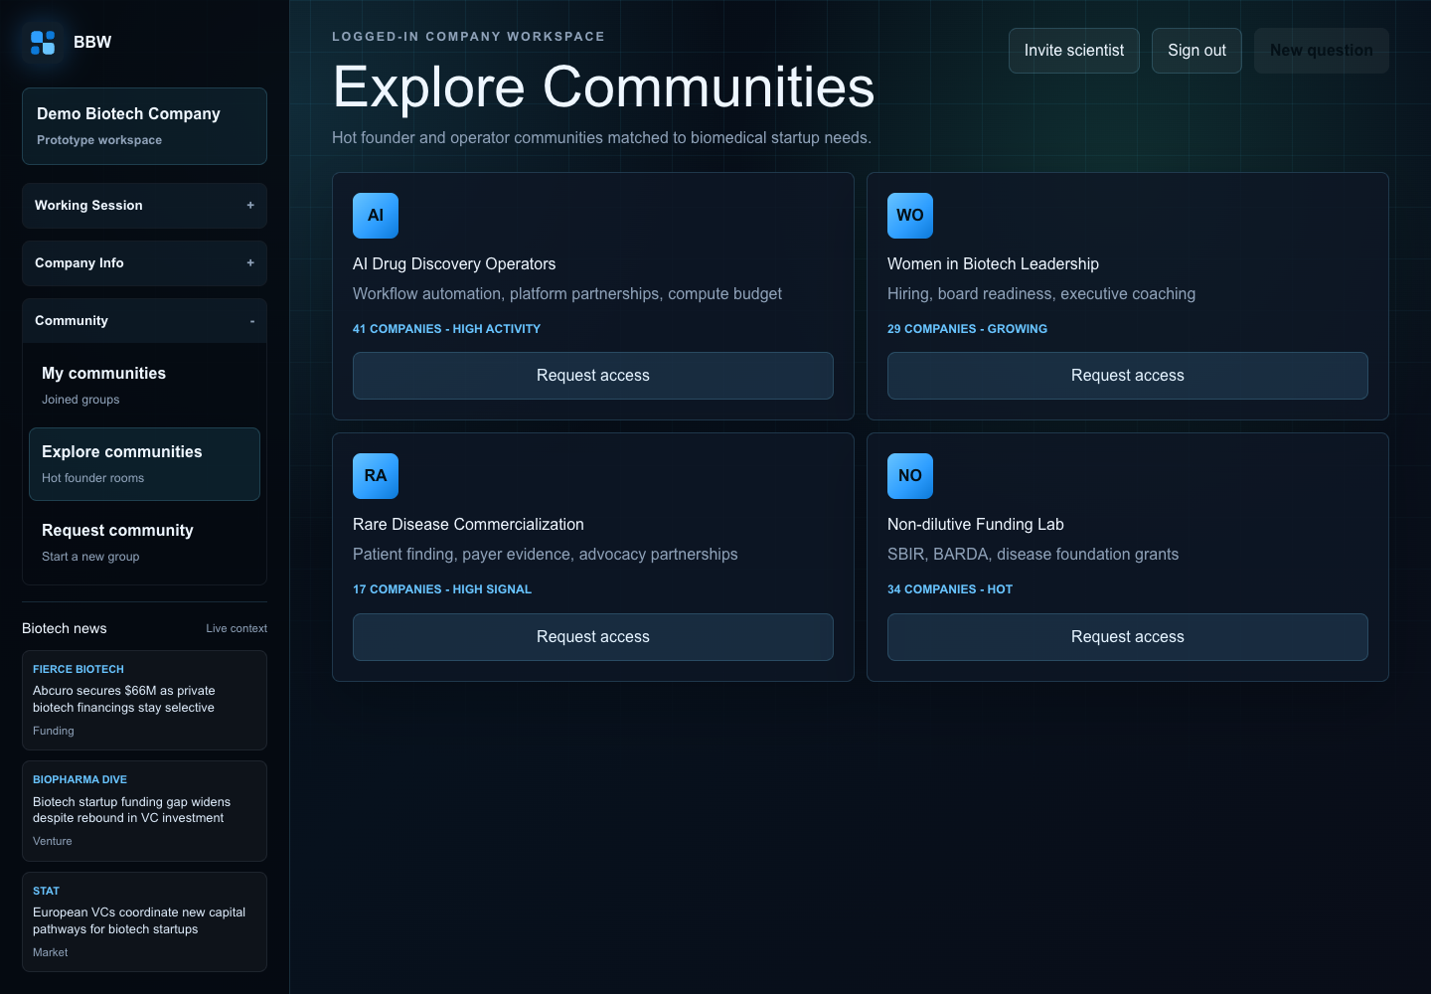

Discussion Questions
- Should Plan execution live only under Working Session, or should it become a top-level tab after the product matures?
- What company-stage fields are required for investor-ready BBW guidance?
- Should logged-in news be personalized by indication, modality, financing stage, and geography?
- What permissions are needed for scientists, founders, advisors, and investors in shared sessions?
- Which BBW outputs should be exportable first: projects, investor memos, checklists, or board updates?

