Link Github Repository:

<https://github.com/IncognicatJess/IncognicatJess.github.io.git>

Link Page:

<https://incognicatjess.github.io/>

Screenshots Install Dialog:

* Localhost

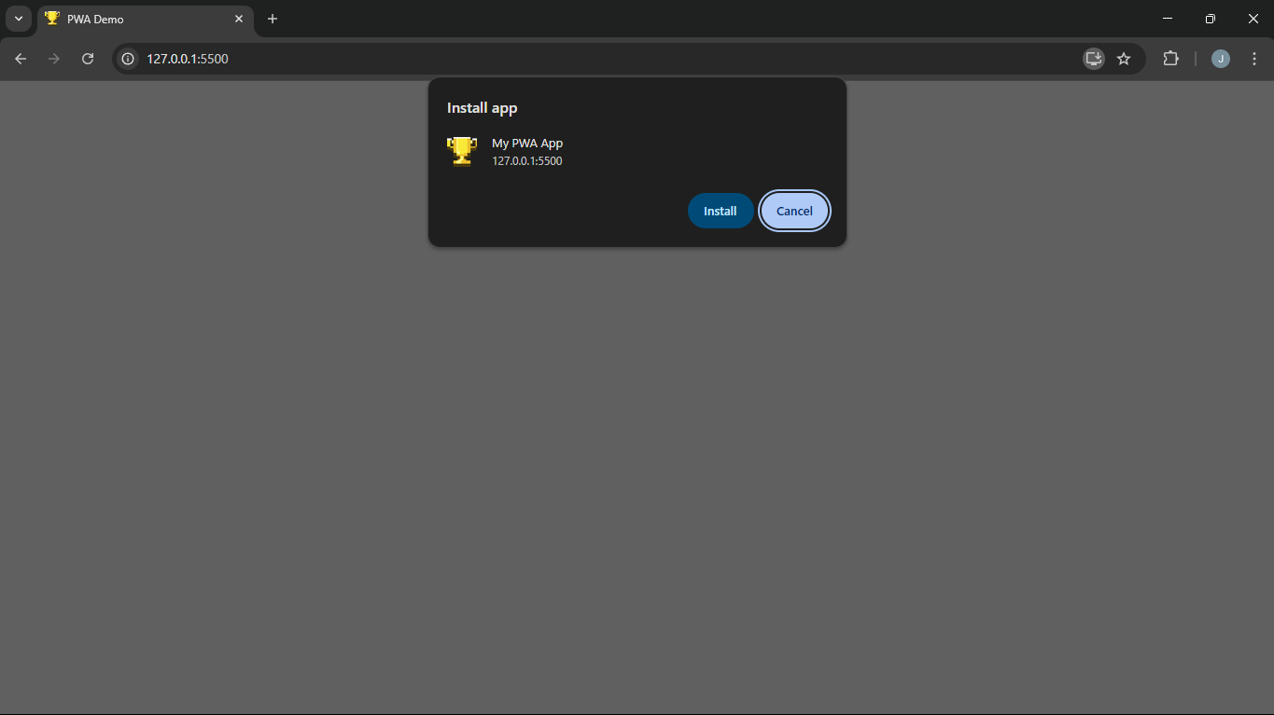

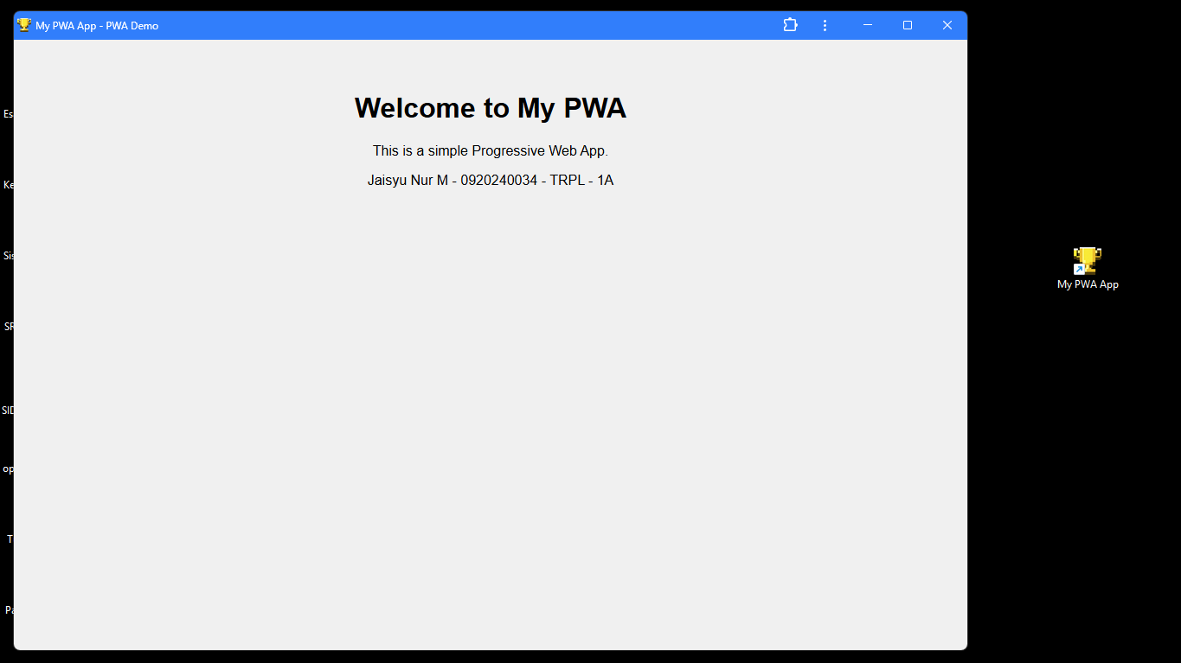

* Mengakses dengan link page github

