Benchmarking Classical Machine Learning Models for Shading-Fault Detection in Rooftop Photovoltaic Systems Using Real Sensor Data
Zablon Ombiro ^{a *}, Bernard Shibwaboª
ª School of Computing and Engineering Sciences, Strathmore University, Nairobi, Kenya

Abstract
Partial and uniform shading are among the most consequential faults in rooftop photovoltaic (PV) systems, because shaded cells dissipate rather than generate power and create a documented fire risk when undetected. Although classical machine learning classifiers are widely compared for PV fault detection, these comparisons are validated almost exclusively on simulated fault data. To bridge this gap, this work benchmarks seven classical and ensemble-tree classifiers for binary and three-tier severity classification on the Réunion dataset, a real 4 kW rooftop installation with physically staged shading faults. A leakage-aware 20,800-row subsample retaining all 17 fault episodes was evaluated with repeated group-aware nested cross-validation (fifteen paired outer folds), fold-internal synthetic minority oversampling and Wilcoxon tests with effect sizes. Random Forest and XGBoost achieved the highest accuracy (0.838 and 0.831) and Matthews correlation coefficient (MCC; 0.526 and 0.522), significantly exceeding k-nearest neighbours, the multi-layer perceptron and, on MCC, the support vector machine, yet were statistically indistinguishable from Logistic Regression and the Decision Tree (accuracy 0.820), indicating two performance tiers rather than a single best model. Shapley additive explanations identified PV-side voltage as a leading fault signal for six of seven classifiers, and oversampling reduced accuracy and MCC for five of seven. However, uniform and intermittent shading were detected less reliably (recall 0.50–0.60) than most partial-shading codes (≥ 0.95). Although the evaluation covers a single plant, the results provide a statistically validated basis for choosing interpretable classifiers in resource-constrained PV maintenance and identify severe-shading recall as the priority before deployment.
Keywords: Photovoltaic fault detection; Shading-fault classification; Classical machine learning; Class imbalance; Group-aware cross-validation; Comparative model evaluation;

1. Introduction
The economic and safety case for rooftop photovoltaic (PV) generation rests on sustained, well-monitored yield. Partial or uniform shading from structures, vegetation or moving obstructions forces shaded cells into reverse bias, so that they dissipate rather than generate power, and the resulting hotspot heating is a documented fire-risk pathway. Shading faults are nevertheless often invisible on an ordinary production dashboard, so without sensor-level classification the loss can remain undiagnosed for long periods, especially on smaller rooftop installations that lack utility-scale instrumentation.
Machine learning (ML) classifiers offer such sensor-level diagnosis, and classical and ensemble-tree methods, notably Random Forest and XGBoost, have become the de facto baselines for tabular PV monitoring data (Section 2). Multi-model comparisons of these classifiers have been reported for PV fault detection (Eldeghady et al., 2024; Khandeparkar et al., 2025; Mouleloued et al., 2025). Most, however, are validated only on simulated fault data, because real, fault-labelled monitoring data are rare: natural faults are sparse and expensive to instrument.
Real field data also introduce a methodological difficulty that simulated data do not. When faults are staged, each fault persists for a long, contiguous run, so adjacent readings are near-duplicates, and a naive random split places near-identical rows on both sides of the train/test boundary. A ranking obtained on simulated data therefore cannot be assumed to transfer to field conditions, and a ranking obtained on real data is credible only if this leakage is controlled.
Consequently, an important research gap remains. Previous studies have predominantly either ranked classifiers on simulated fault data or validated individual models on real monitoring data. The most comparable real-data comparison applies no group-aware leakage control, repeated significance testing or cross-model attribution (Toche Tchio et al., 2024). In particular, there is still limited evidence on which classical classifiers are statistically distinguishable when evaluated on real shading faults under a leakage-controlled protocol.
This work addresses this gap by benchmarking seven classical and ensemble-tree classifiers on the Réunion domestic rooftop PV dataset (Graillet et al., 2022), a rare public record in which shading faults were deliberately staged and logged on a real 4 kW installation. Unlike previous studies, which report point estimates on simulated data, this work groups every cross-validation split by fault episode and tests every pairwise difference for significance. The primary contribution does not lie in proposing a new classifier, but in establishing which classical classifiers are defensibly preferable on real shading-fault data.
Four research questions (RQs) guide the analysis:
- RQ1 (comparative accuracy). Under a common, group-aware, leakage-controlled protocol, which of the seven classifiers achieves the highest predictive performance, and is any observed difference statistically defensible rather than sampling noise?
- RQ2 (effect of class-imbalance correction). Does the synthetic minority oversampling technique (SMOTE), applied within the cross-validation training folds, change which classifier ranks highest, or only the absolute metric values while leaving the relative ranking unchanged, and does its effect differ by model family?
- RQ3 (feature influence and cross-model consistency). Which electrical signals and engineered features most strongly influence classifier decisions in shading-fault detection, and does that influence vary by model family?
- RQ4 (accuracy and interpretability). Is the added complexity of the less interpretable classifiers justified by a statistically significant gain over the interpretable baselines, or does a simpler model remain competitive, a question of direct relevance to PV operations and maintenance (O&M) teams with limited data-science capacity?
The main contributions of this work are: (i) a benchmark of seven classical and ensemble-tree classifiers on real, physically staged shading-fault data; (ii) a leakage-aware evaluation design that groups every cross-validation split by fault episode, made tractable on a multi-million-row record by documented subsampling; (iii) a statistically tested, multi-metric comparison with cross-model Shapley additive explanations (SHAP), which remain comparable across model families where native importance measures do not; and (iv) deployment-relevant implications for PV O&M, reinforced by a feature ablation and a per-fault-type analysis.

2. Related work
Classifier comparisons for PV fault detection are dominated by simulated data. Eldeghady et al. (2024), Khandeparkar et al. (2025) and Mouleloued et al. (2025) compare several supervised classifiers, including Random Forest and, in the second study, XGBoost, but report point estimates without cross-model significance testing. These studies confirm the ensembles as de facto tabular baselines while leaving real-data validation and statistical rigour open. The present study retains the same baselines but evaluates them on real staged faults under paired significance testing.
A parallel literature validates ensembles on real DC-side and multi-plant monitoring data (Chen et al., 2018; Dhibi et al., 2021; Harrou et al., 2022; Hussain et al., 2022), including nearly 70,000 readings from a 500 kWp system (Gaaloul et al., 2025). Related studies compare support vector machine (SVM) and XGBoost classifiers (Suliman et al., 2024) and a voting ensemble of logistic regression, decision tree and SVM learners (Yang and Ismail, 2022). Mellit and Kalogirou (2022) show that the advantage of ensembles over classical methods is measurable but not universal, which makes a statistically tested comparison necessary rather than optional.
The most comparable study applies a near-identical seven-classifier roster to real, low-cost-sensor data that include partial shading, but without group-aware leakage control, repeated significance testing or SHAP (Toche Tchio et al., 2024). Class imbalance and label quality have been addressed through RUSBoost (Adhya et al., 2023) and robust logistic regression on imperfect labels (Wang et al., 2023), and ensembles have been extended to thermal-image diagnosis (Krishna Veni et al., 2025) and an emulator testbed (Quiles-Cucarella et al., 2025).
None of these studies combines real data with a statistically powered, multi-classifier, multi-metric comparison. This work closes that gap with fifteen paired outer folds, six metrics and Wilcoxon tests qualified by effect sizes.
Studies on real PV field data remain rare and address different tasks. Kappler et al. (2024) couple a long short-term memory (LSTM) network with a one-diode model to forecast shading-aware power for an installation at the Karlsruhe Institute of Technology (KIT), which is forecasting rather than classification. The PVF-10 dataset provides real unmanned aerial vehicle thermal-infrared imagery (Wang et al., 2024a), which is image-based rather than electrical, and Graillet et al. (2022) publish the dataset used here as a descriptor without a classifier benchmark. This work supplies that missing benchmark for the Réunion record.
The classifiers compared here span distinct inductive biases: k-nearest neighbours (kNN; Cover and Hart, 1967) is non-parametric, the SVM (Cortes and Vapnik, 1995) is maximum-margin and kernelisable, the decision tree (Quinlan, 1986) is interpretable and impurity-based, the multi-layer perceptron (MLP; Rumelhart et al., 1986) is a neural baseline, and logistic regression is the interpretable reference. Random Forest (Breiman, 2001) and XGBoost (Chen and Guestrin, 2016) represent bagging and boosting, and XGBoost is also a default choice in microgrid fault detection (Patnaik et al., 2021) and smart-meter theft detection (Kawoosa et al., 2023).
Two adjacent literatures inform the design. A hybrid of a convolutional neural network (CNN) and a bidirectional gated recurrent unit (Bi-GRU) trained on simulated data (Amiri et al., 2024) motivates the sequence-aware extension left to future work. A comparison of explainability instruments for PV fault detection (Utama et al., 2023) motivates the use of SHAP, because native measures such as a logistic coefficient and a tree's impurity reduction are not comparable across model families.
SHAP is used for the same reason in wind-turbine power attribution (Cakiroglu et al., 2024), a seven-model PV forecasting comparison (Zheng et al., 2026), bearing-fault attribution (Bindingsbø et al., 2023; Santos et al., 2024) and battery health estimation (Hossen et al., 2026), so its use here follows established practice rather than introducing a new device.
Accuracy is unreliable under class imbalance, whereas the Matthews correlation coefficient (MCC) is symmetric across classes and error types (Chicco and Jurman, 2020). SMOTE (Chawla et al., 2002) is the reference resampling method, but its benefit is classifier-dependent (Swana et al., 2022; Maldonado-Correa et al., 2024), and in transformer fault diagnosis it helps tree ensembles specifically (Prasojo et al., 2023; Wang et al., 2024b).
Classifier comparison follows Demšar (2006). Nested cross-validation is justified when the hyperparameter space is small relative to the data (Wainer and Cawley, 2021), effect sizes (Kerby, 2014) answer the Bayesian critique of null-hypothesis testing (Benavoli et al., 2017), and all-pairwise tests require either a multiple-comparisons correction or a constrained scope (García and Herrera, 2008).
Despite this growing body of work, most existing studies fall short of a real-data, statistically validated classifier benchmark for PV shading faults. Specifically, there is a lack of approaches that:
- evaluate classical classifiers on real, physically staged shading faults;
- control episode-level leakage through group-aware cross-validation;
- test classifier differences across repeated, paired folds with effect sizes; and
- compare feature attributions across model families on a common scale.
To address this gap, the present work evaluates seven classifiers on real staged-shading data under episode-grouped nested cross-validation, paired significance testing and cross-model SHAP attribution. A comparative analysis of relevant prior studies and how this work advances the state of the art is summarized in Table 1.
Table 1
Comparative analysis of related work and the present contribution.
Study | Approach and domain | Limitations | Contribution of this work
Eldeghady et al. (2024) | PV fault diagnosis; supervised classification of simulated PV array fault data | Multi-model but accuracy-focused; no significance testing | Real staged-fault data; six metrics with paired significance testing and effect sizes
Khandeparkar et al. (2025) | PV electrical fault detection; supervised classification of simulated fault signatures (4 fault types) | Five models including Random Forest and XGBoost; accuracy only; no significance testing | Same ensemble baselines evaluated on real data under repeated, paired testing
Mouleloued et al. (2025) | PV fault diagnosis; supervised classification of a seven-class fault dataset | Five models including Random Forest; accuracy-focused; no significance testing | Multi-metric comparison including MCC and AUC-ROC, with significance testing
Toche Tchio et al. (2024) | PV fault diagnosis; supervised classification of real, low-cost-sensor PV data including partial shading | Seven models including Random Forest, SVM and Logistic Regression; no group-aware leakage control, repeated significance testing or SHAP | Episode-grouped cross-validation, repeated Wilcoxon testing and cross-model SHAP attribution
Amiri et al. (2024) | PV fault diagnosis with deep learning; CNN and Bi-GRU hybrid on simulated PV model data | Single hybrid deep-learning model; not a classical ML benchmark | Classical and ensemble benchmark on real data; sequence models identified as future work
Utama et al. (2023) | Explainability for PV fault detection; comparison of explanation instruments including SHAP | Not a classifier benchmark; data not the focus | SHAP applied across seven classifiers on a common scale
Kappler et al. (2024) | PV shading and power forecasting; LSTM combined with a physical model on a real installation (KIT) | Forecasting and power-loss correction with a single hybrid approach; not a classifier benchmark | Discrete shading-fault classification with a multi-model comparison
Graillet et al. (2022) | PV dataset description; real staged-shading plant (Réunion) | Data descriptor; no classifier reported | Supervised benchmark of seven classifiers on this dataset

As summarized in Table 1, existing studies address either classifier comparison on simulated data or the validation and description of individual approaches on real data, but none combines real staged-fault data, episode-level leakage control, statistically tested multi-metric comparison and cross-model attribution. The approach proposed in this work bridges this gap by combining all four.

3. Methodology
To answer RQ1 to RQ4, a methodological framework was defined encompassing four core elements: the real dataset and its leakage-aware subsampling (Section 3.1); feature engineering and class-imbalance handling (Section 3.2); the seven classifiers and their nested tuning (Section 3.3); and an evaluation protocol with paired statistical testing (Section 3.4), implemented as described in Section 3.5. Together, these components ensure that every reported difference is measured on unseen fault episodes.
The most comparable real-data benchmark applies no group-aware leakage control (Toche Tchio et al., 2024), although staged faults produce long runs of near-duplicate readings. This framework closes that gap by treating every contiguous fault or no-fault episode as an indivisible unit, from subsampling to cross-validation.

3.1. Dataset and target construction
This study uses the electrical-production log of inverter 1 from the Réunion domestic rooftop PV plant dataset (Graillet et al., 2022): a 4 kW, 24-module, 26°-tilt installation in a tropical climate, logged at approximately 0.2 Hz across seven channels, namely PV-side current (I_{a}), grid-injected current (I_{g}), grid-injected energy (E_{g}), grid frequency (F_{g}), grid-injected power (P_{g}), PV-side voltage (V_{a}) and grid voltage (V_{g}). Shading faults were physically staged and logged with an explicit fault code, so the ground truth is a directly recorded experimental condition rather than an inferred one.
The raw file contains 2,988,798 rows spanning 1 October 2021 to 13 April 2023 (559 days), and Table 2 gives the fault-code distribution before subsampling. Because no-fault rows account for 97.17% of the record, a classifier that never predicted a fault would exceed 97% accuracy on the raw data, so accuracy alone cannot serve as the evaluation criterion.
Table 2
Full-dataset fault-code distribution (2,988,798 rows, 1 October 2021 to 13 April 2023), computed before any subsampling.
Fault code | Description | Rows | Share of rows
0.0 | No fault | 2,904,284 | 97.17%
1.0 | Uniform shading (entire line obscured) | 6,318 | 0.21%
2.1 | Constant partial shading, 1 whole module | 2,148 | 0.07%
2.2 | Constant partial shading, 2 whole modules | 2,460 | 0.08%
2.3 | Constant partial shading, 3 whole modules | 3,287 | 0.11%
3.1 | Constant partial shading, 1/3 of a module | 2,717 | 0.09%
3.2 | Constant partial shading, 2/3 of a module | 6,292 | 0.21%
4.0 | Intermittent partial shading (shadow moves with the sun) | 61,292 | 2.05%

Fault-labelled rows (2.83%) cluster into 35 contiguous same-state runs, 18 no-fault runs and 17 fault episodes, inside one staged window of about 3.5 months. Adjacent rows within an episode are near-duplicates recorded seconds apart, so a random split would leak near-identical rows across the train/test boundary; every row therefore carries an episode identifier that serves as an indivisible cross-validation group.
Nested cross-validation of seven classifiers is also intractable on about three million rows with commodity hardware, and a weighted loss, balanced bagging or distributed training would either leave the runtime problem unsolved or exceed the single-machine reproducibility target. The pipeline therefore caps each episode at 400 rows (fault) or 2,000 rows (no fault), with a 15,000-row ceiling on no-fault rows, while retaining all 17 fault episodes.
The resulting benchmark has 20,800 rows across 24 episodes (14,000 no-fault, 4,000 constant-partial-shading and 2,800 severe-tier rows) and a fault prevalence of 32.7%. Because this prevalence differs sharply from the 2.83% of the full record, all reported metrics describe the capped benchmark, a scope restated in Sections 5.9 and 6.
Each sample is a feature vector x_{i} ∈ ℝ²⁹ with label y_{i} and episode g_{i}. The seven classifiers are seven hypothesis classes for a function f with f(x_{i}) = ŷ_{i}, fitted on identical (x_{i}, y_{i}, g_{i}) triples under one protocol, so performance differences can be attributed to the hypothesis class rather than to the data.
The binary label is read directly from the staged fault column (y_{i} = 0 for code 0.0, otherwise 1), which avoids the noise of a threshold-derived label. A three-tier label groups the codes by shading extent (Graillet et al., 2022, Table 3): Tier 0, no fault (0.0); Tier 1, constant partial shading (2.1, 2.2, 2.3, 3.1 and 3.2); and Tier 2, severe shading (1.0, uniform; 4.0, intermittent). This grouping is a modelling choice rather than dataset-native truth, which is why both schemes are reported in parallel.

3.2. Feature engineering and class-imbalance handling
All 29 features are computed strictly within each episode. Beyond the seven raw channels, four instantaneous features capture physical mismatch: the current ratio I_{g}/I_{a}, the conversion ratio P_{g}/(V_{a}·I_{a}), the frequency deviation |F_{g} − 50| and the inverter-stage voltage difference V_{g} − V_{a}. Sixteen rolling-window features are the means μ_{w} and standard deviations σ_{w} of P_{g}, I_{a}, V_{g} and F_{g} over w = 5 and 10 samples (about 30 and 60 s), encoding the hypothesis that shading is a sustained deviation, and two first differences, ΔP_{g} and ΔI_{a}, capture the rate of change.
Standardisation is fitted on the training fold only and applied to Logistic Regression, kNN, the SVM and the MLP, whereas the three tree-based models use the raw scale. SMOTE is applied within each training fold through the imbalanced-learn library with three nearest neighbours, reflecting the small number of rows in each retained fault episode. Every run is repeated without SMOTE, so that its effect on the ranking, and not only on absolute metrics, can be isolated (RQ2).

3.3. Classifiers and hyperparameter tuning
Seven classifiers are compared, five classical and largely interpretable models and two ensemble-tree methods, with the following decision functions.
(1) Logistic Regression (baseline). The fault probability is a logistic function of a linear score with weights w and bias b:
$$P(y = 1 | x) = \frac{1}{1 + exp(-(w · x + b))}$$
(2) k-Nearest Neighbours (Cover and Hart, 1967). The prediction is the majority class among the k nearest training samples, N_{k}(x):
$$ŷ(x) = majority-class\left\{y_{j} : j ∈ N_{k}(x)\right\}$$
(3) Decision Tree (Quinlan, 1986). Each split maximises the reduction in impurity from the parent node to its size-weighted child nodes:
$${split}^{*} = {argmax}_{split} \left[Impurity(parent) - \sum{(|child| / |parent|) · Impurity(child)}\right]$$
(4) Support Vector Machine (Cortes and Vapnik, 1995) with a radial basis function (RBF) kernel. The decision function is a kernel-weighted sum with coefficients α_{i} and kernel K:
$$f(x) = \operatorname{sign}\left(\sum_{i}{α_{i} y_{i} K(x_{i}, x)} + b\right)$$
(5) Multi-Layer Perceptron (Rumelhart et al., 1986). A hidden layer (W₁, b₁, activation φ) feeds an output layer (W₂, b₂, activation σ):
$$ŷ = σ\left(W_{2} · φ(W_{1} · x + b_{1}) + b_{2}\right)$$
(6) Random Forest (Breiman, 2001). Trees T_{b} grown on bootstrap resamples with random feature subsets vote by majority, which reduces single-tree variance:
$$ŷ(x) = majority-class\left\{T_{b}(x) : b = 1, …, B\right\}$$
(7) XGBoost (Chen and Guestrin, 2016). Gradient-boosted trees f_{m} are added sequentially to fit the residual error under a loss l, with Ω regularising complexity:
$$ŷ(x) = \sum_{m}{f_{m}(x)}, f_{m} = \underset{f_{m}}{arg min}\sum_{i}{l\left(y_{i}, ŷ_{i}^{\left(m-1\right)} + f_{m}\left(x_{i}\right)\right)} + Ω\left(f_{m}\right)$$
Table 3 compares the classifiers on operational dimensions, because interpretability and tuning burden determine whether an O&M team can maintain a model (Section 5.4).
Table 3
Qualitative comparison of the seven classifiers.
Model | Decision boundary | Native interpretability | Key hyperparameters
Logistic Regression | Linear | High (readable coefficients) | Regularisation strength C
k-Nearest Neighbours | Piecewise, local | Low (no global model) | Neighbours k, weighting, distance metric
Decision Tree | Axis-aligned, piecewise | High (readable rules) | Maximum depth, minimum samples per leaf
SVM (RBF) | Non-linear (kernel) | Low | C, kernel width γ
Multi-Layer Perceptron | Non-linear, distributed | Very low (black box) | Hidden units, α, learning rate
Random Forest | Ensemble of bagged trees | Medium (feature importances only) | Number of trees, depth, minimum samples per leaf
XGBoost | Ensemble of boosted trees | Medium (feature importances only) | Number of trees, depth, learning rate

Hyperparameters are selected by randomised search nested inside each outer training fold, with an inner group-aware k-fold split (at least two folds) scored on macro-averaged F1, so the outer test fold never informs model selection. Fifteen configurations are drawn per outer fold, or all where the space is smaller (six for Logistic Regression). Table 4 lists the search space and Table 5 the configuration selected most often under the primary condition.
Table 4
Randomised-search hyperparameter space per model (15 draws per outer fold, or exhaustive where the space is smaller).
Model | Search space
Logistic Regression | C ∈ {0.001, 0.01, 0.1, 1, 10, 100}; L2 penalty (6 configurations, all evaluated)
k-Nearest Neighbours | Neighbours k ∈ {3, 5, 11, 21, 31, 51}; weighting ∈ {uniform, distance}; Minkowski power q ∈ {1, 2}
Decision Tree | Maximum depth ∈ {3, 4, 6, 8, 12, 16, ∞}; minimum samples per leaf ∈ {1, 5, 10, 20}; split criterion ∈ {Gini, entropy}
SVM (RBF) | C ∈ {0.1, 1, 10, 100}; kernel width γ ∈ {scale heuristic, auto heuristic, 0.001, 0.01, 0.1}
MLP | Hidden-layer sizes ∈ {(16), (32), (64), (16, 8), (32, 16)}; L2 penalty α ∈ {10⁻⁴, 10⁻³, 10⁻², 10⁻¹}; initial learning rate ∈ {5 × 10⁻⁴, 10⁻³, 10⁻²}
Random Forest | Number of trees ∈ {100, 200, 300}; maximum depth ∈ {∞, 8, 16}; minimum samples per leaf ∈ {1, 5, 10}; features per split ∈ {√d, log₂ d}
XGBoost | Number of trees ∈ {100, 300, 500}; maximum depth ∈ {3, 6, 9}; learning rate ∈ {0.01, 0.05, 0.1, 0.3}; row and column subsampling ratios ∈ {0.7, 0.85, 1.0}
Note. d denotes the number of input features; q is the exponent of the Minkowski distance (q = 1, Manhattan; q = 2, Euclidean).
Table 5
Modal hyperparameter configuration per model under the primary condition (binary scheme, with SMOTE), across 15 outer-fold searches.
Model | Modal configuration
Logistic Regression | C = 0.001; L2 penalty
k-Nearest Neighbours | k = 3; Minkowski power q = 1; uniform weighting
Decision Tree | Maximum depth = 3; minimum samples per leaf = 1; Gini criterion
SVM (RBF) | C = 0.1; γ = 0.01
MLP | One hidden layer of 64 units; α = 0.0001; initial learning rate = 0.0005
Random Forest | 300 trees; maximum depth = 8; minimum samples per leaf = 10; features per split = log₂ d
XGBoost | 100 trees; maximum depth = 3; learning rate = 0.01; row subsampling = 0.7; column subsampling = 0.85

The modal configurations carry a consistent regularisation signal: Logistic Regression selects its strongest permitted penalty (C = 0.001), the Decision Tree and XGBoost select a maximum depth of 3, and Random Forest selects a minimum leaf size of 10. These choices indicate that simpler models generalise better on this 20,800-row benchmark, consistent with the small number of distinct fault episodes available for learning.

3.4. Evaluation protocol and statistical testing
The outer loop is group-aware five-fold cross-validation, stratified by class and grouped by episode, repeated three times with different seeds to give fifteen paired outer folds. Five folds rather than ten are used because only 17 fault episodes exist, and five is the largest number that leaves enough fault episodes on both sides of every split. Crossing 7 classifiers, 2 label schemes and 2 resampling conditions gives 28 runs that share identical outer partitions within a repeat, so differences between conditions are not confounded with partitioning.
The binary scheme with SMOTE is the primary condition, answering RQ1 and RQ4, and the remaining 27 runs supply robustness checks. Accuracy is the primary but not the sole metric, because accuracy and F1 can misrepresent quality under imbalance (Chicco and Jurman, 2020). With TP, TN, FP and FN denoting true positives, true negatives, false positives and false negatives:
$$Accuracy = \frac{TP + TN}{TP + TN + FP + FN}$$
$$Precision = \frac{TP}{TP + FP} Recall = \frac{TP}{TP + FN} F1 = 2 · \frac{Precision · Recall}{Precision + Recall}$$
$$MCC = \frac{TP·TN - FP·FN}{\sqrt{(TP+FP)(TP+FN)(TN+FP)(TN+FN)}}$$
Precision, recall and F1 refer to the fault class under the binary scheme and are macro-averaged under the tier scheme, and the area under the receiver operating characteristic curve (AUC-ROC) measures threshold-independent discrimination. Following Demšar (2006), Wilcoxon signed-rank tests on accuracy and MCC use all fifteen paired folds, with a matched-pairs rank-biserial effect size (Kerby, 2014) for every significant p-value. Results are read on five axes: point performance and fold variability, discrimination, statistical defensibility, robustness to label scheme and resampling, and the operational criteria of Table 3.

3.5. Implementation and reproducibility
All experiments run on a single CPU-only machine with open-source Python libraries (Table 6). A fixed seed (42) governs SMOTE and every classifier, with each repeat using the seed plus its repeat index. The full run took 26,666 s (7.4 h) and the separate SHAP computation about 1.5–2 h, driven by kNN, the SVM and the MLP, for which no closed-form SHAP algorithm exists, so the benchmark is reproducible without specialised hardware. The complete pipeline is openly available (see Data availability).
Table 6
Software and hardware environment.
Component | Version
Python | 3 (author's workstation)
pandas | ≥ 2.0
NumPy | ≥ 1.24
scikit-learn | ≥ 1.3
imbalanced-learn | ≥ 0.11
SciPy (Wilcoxon testing) | ≥ 1.10
matplotlib | ≥ 3.7
XGBoost | ≥ 2.0 (ensemble classifier, Section 3.3)
SHAP | ≥ 0.44 (feature attribution, Section 4.4)
Hardware | CPU only; all classifiers run unmodified on commodity laptop hardware; no GPU required

4. Results

4.1. Primary comparison
Table 7 reports the mean and standard deviation over the fifteen paired folds for the primary condition, and Fig. 1 summarises the six metrics.
Table 7
Comparative performance of the seven classifiers (binary label, with SMOTE, 15 paired folds; mean ± standard deviation).
Model | Accuracy | Precision | Recall | F1 | MCC | AUC-ROC
Logistic Regression | 0.820 ± .124 | 0.776 ± .269 | 0.766 ± .275 | 0.741 ± .231 | 0.483 ± .378 | 0.893 ± .170
k-Nearest Neighbours | 0.772 ± .137 | 0.707 ± .293 | 0.689 ± .273 | 0.663 ± .238 | 0.388 ± .342 | 0.822 ± .172
Decision Tree | 0.820 ± .175 | 0.806 ± .282 | 0.773 ± .276 | 0.764 ± .252 | 0.500 ± .420 | 0.861 ± .198
SVM (RBF) | 0.800 ± .130 | 0.784 ± .272 | 0.667 ± .266 | 0.690 ± .237 | 0.435 ± .354 | 0.846 ± .179
MLP | 0.757 ± .196 | 0.712 ± .314 | 0.702 ± .299 | 0.670 ± .261 | 0.387 ± .416 | 0.820 ± .230
Random Forest | 0.838 ± .156 | 0.844 ± .267 | 0.744 ± .297 | 0.759 ± .256 | 0.526 ± .416 | 0.859 ± .260
XGBoost | 0.831 ± .153 | 0.822 ± .257 | 0.755 ± .272 | 0.767 ± .232 | 0.522 ± .404 | 0.870 ± .250

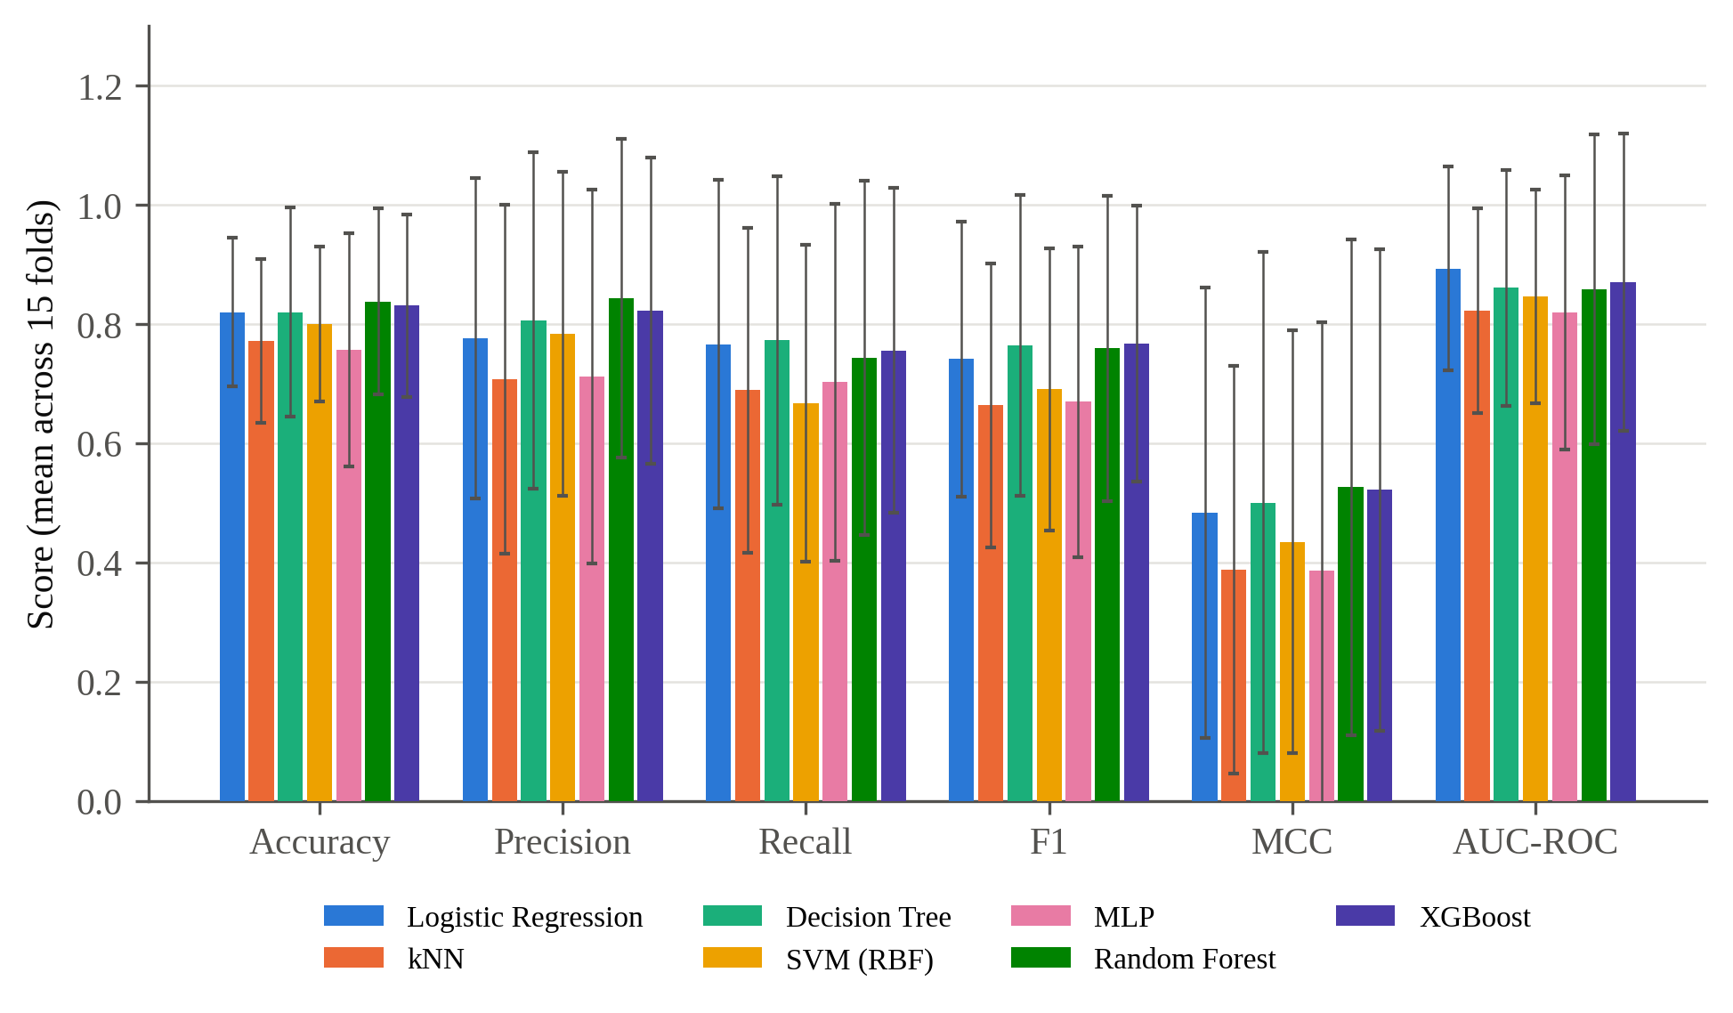
Fig. 1. Comparative performance of the seven classifiers across six metrics (binary scheme, with SMOTE); error bars show the fold-wise standard deviation.
Random Forest attains the highest accuracy (0.838) and MCC (0.526), closely followed by XGBoost (0.831 and 0.522), indicating that the two ensembles extract the most discriminative signal from the electrical channels. Logistic Regression and the Decision Tree follow at 0.820 (MCC 0.483 and 0.500, respectively), a margin small enough that its significance must be tested (Section 4.3). kNN, the SVM and the MLP trail (0.772, 0.800 and 0.757), and their MCC deficit relative to Random Forest (0.09 to 0.14) is roughly twice their accuracy deficit, showing that accuracy understates their weakness.
Fold-wise standard deviations are large throughout (Random Forest: accuracy 0.838 ± .156, MCC 0.526 ± .416), reflecting differences in difficulty between held-out episodes (Section 5.6), so point estimates alone cannot rank the classifiers. AUC-ROC orders the models differently, with Logistic Regression highest (0.893), ahead of XGBoost (0.870) and the Decision Tree (0.861), so the linear baseline separates the classes well across thresholds despite its lower accuracy at the default threshold.
Table 8
Comparative performance without SMOTE (binary label, 15 paired folds; mean ± standard deviation).
Model | Accuracy | Precision | Recall | F1 | MCC | AUC-ROC
Logistic Regression | 0.830 ± .149 | 0.824 ± .265 | 0.742 ± .289 | 0.751 ± .248 | 0.511 ± .406 | 0.901 ± .170
k-Nearest Neighbours | 0.792 ± .146 | 0.763 ± .278 | 0.693 ± .288 | 0.687 ± .239 | 0.439 ± .362 | 0.849 ± .177
Decision Tree | 0.823 ± .189 | 0.818 ± .290 | 0.778 ± .278 | 0.773 ± .261 | 0.516 ± .442 | 0.878 ± .206
SVM (RBF) | 0.805 ± .141 | 0.819 ± .268 | 0.657 ± .261 | 0.700 ± .234 | 0.456 ± .363 | 0.841 ± .175
MLP | 0.788 ± .180 | 0.763 ± .294 | 0.722 ± .291 | 0.709 ± .252 | 0.451 ± .404 | 0.854 ± .220
Random Forest | 0.839 ± .157 | 0.852 ± .263 | 0.739 ± .296 | 0.761 ± .255 | 0.531 ± .416 | 0.861 ± .253
XGBoost | 0.814 ± .171 | 0.824 ± .287 | 0.727 ± .269 | 0.747 ± .249 | 0.508 ± .415 | 0.846 ± .258

Without SMOTE (Table 8), Random Forest remains the most accurate classifier (0.839; MCC 0.531) and Logistic Regression rises to 0.830, overtaking XGBoost (0.814). Removing SMOTE raises accuracy for five classifiers, leaves Random Forest essentially unchanged and lowers it only for XGBoost, so resampling does not help on this benchmark in general.

4.2. Confusion matrices
Table 9 and Fig. 2 give the pooled confusion matrices, each covering 62,400 out-of-fold predictions per model (20,800 rows × three repeats). Random Forest and XGBoost produce the fewest false positives (2,801 and 3,021), which explains their higher precision and means they would trigger the fewest unnecessary inspections. The SVM produces the most false negatives (6,420) and the lowest recall (0.667), so its boundary is biased toward under-flagging faults, the more hazardous error given the fire risk of undetected shading.
Table 9
Pooled confusion-matrix counts per classifier (binary scheme, with SMOTE; positive class = fault; each row sums to 62,400).
Model | TN | FP | FN | TP
Logistic Regression | 36,778 | 5,222 | 4,471 | 15,929
k-Nearest Neighbours | 35,138 | 6,862 | 6,019 | 14,381
Decision Tree | 37,415 | 4,585 | 4,454 | 15,946
SVM (RBF) | 37,546 | 4,454 | 6,420 | 13,980
MLP | 34,871 | 7,129 | 5,914 | 14,486
Random Forest | 39,199 | 2,801 | 5,026 | 15,374
XGBoost | 38,979 | 3,021 | 4,883 | 15,517

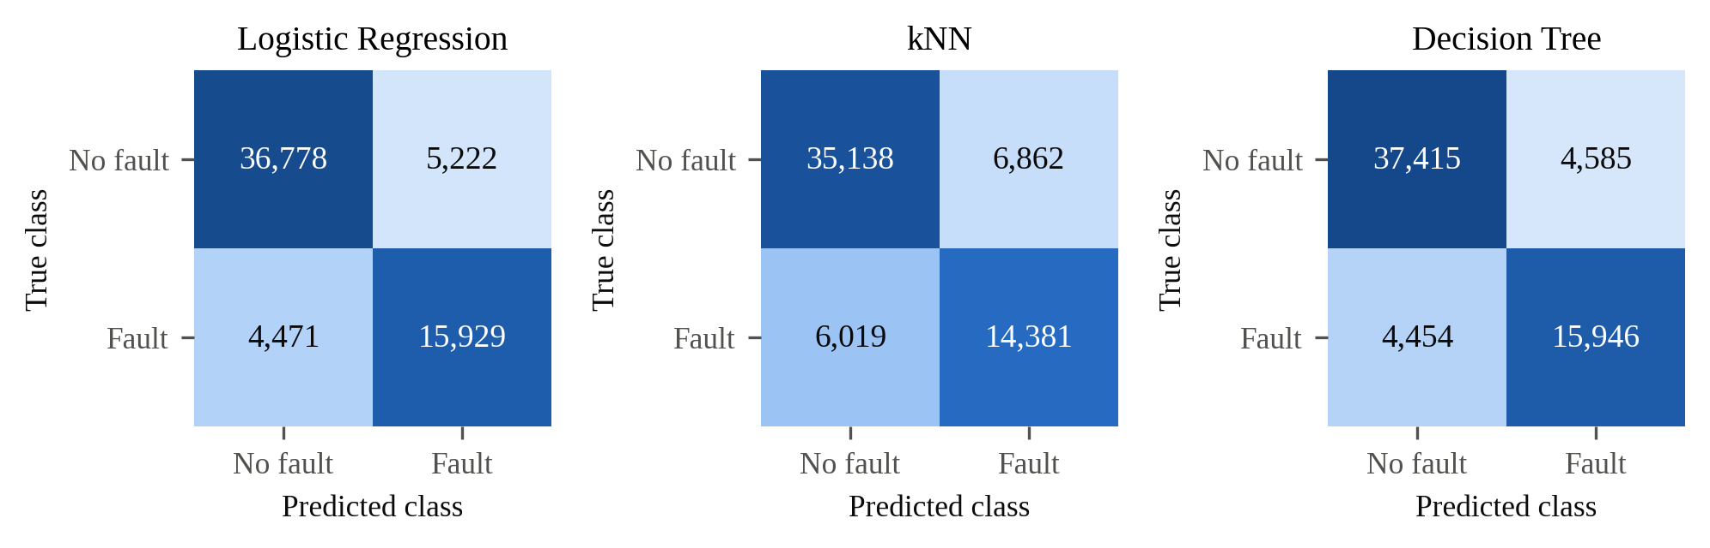
(a)
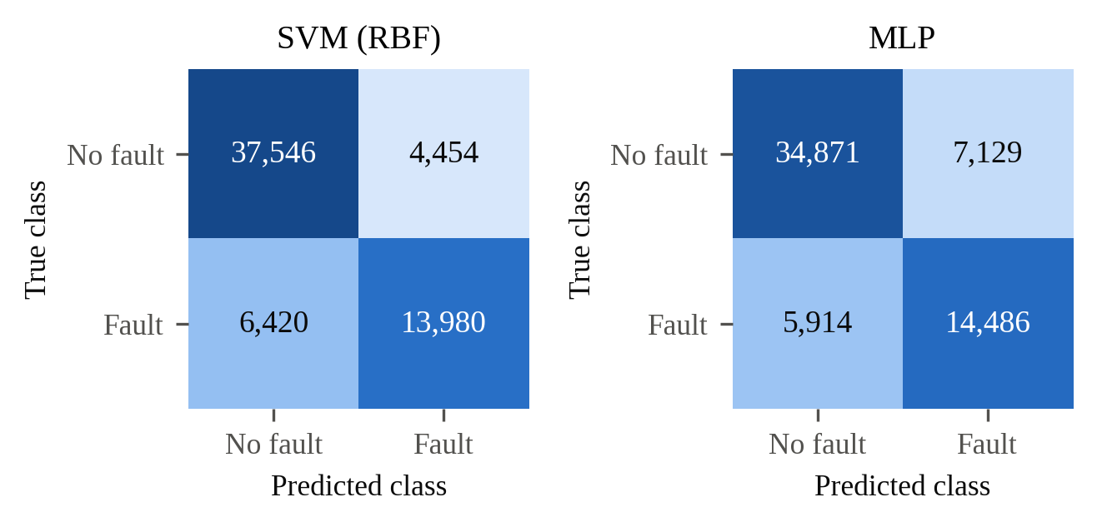
(b)
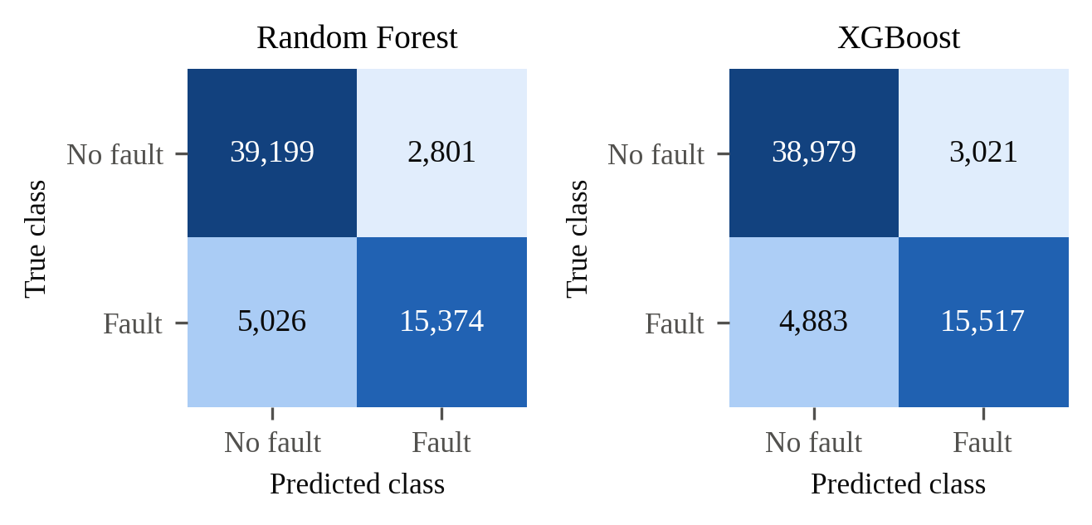
(c)
Fig. 2. Pooled confusion matrices (binary scheme, with SMOTE; positive class = fault): (a) Logistic Regression, kNN and Decision Tree; (b) SVM and MLP; (c) Random Forest and XGBoost.

4.3. Statistical significance
Table 10 reports the paired Wilcoxon p-values on accuracy. Random Forest significantly outperforms kNN (p < .001, r = −.93) and the MLP (p < .001, r = −1.0), as does XGBoost (p = .009, r = −.79; p = .010, r = −.73), and the large effect sizes show that these differences are consistent across folds. No comparison involving Logistic Regression is significant, nor is any comparison between the Decision Tree and the ensembles (all p ≥ .599 among these four), so the accuracy lead of the ensembles over the two interpretable models lies within sampling variability.
Table 10
Pairwise Wilcoxon signed-rank tests on accuracy (15 paired folds; upper triangle only, as the matrix is symmetric).
Classifier | kNN | Decision Tree | SVM | MLP | Random Forest | XGBoost
Logistic Regression | 0.055 | 0.599 | 0.055 | 0.277 | 0.720 | 0.847
k-Nearest Neighbours |  | 0.151 | 0.188 | 1.000 | <0.001** (r = −.93) | 0.009** (r = −.79)
Decision Tree |  |  | 0.303 | 0.095 | 0.679 | 0.975
SVM (RBF) |  |  |  | 0.421 | 0.121 | 0.121
MLP |  |  |  |  | <0.001** (r = −1.0) | 0.010* (r = −.73)
Random Forest |  |  |  |  |  | 0.421
Note. * p < .05; ** p < .01; r is the matched-pairs rank-biserial effect size, reported for significant comparisons (|r| ≥ .8 is conventionally large).
The MCC tests sharpen this pattern: Random Forest and XGBoost significantly exceed kNN (p = .003, r = −1.0), the MLP (p = .006 and .026) and the SVM (p = .021 and .016), and the Decision Tree also exceeds kNN (p = .041), whereas no comparison involving Logistic Regression, and none between the Decision Tree and either ensemble, is significant. The classifiers therefore form two tiers, which Section 5.1 interprets.

4.4. Feature attribution
Fig. 3 reports the mean absolute SHAP value per feature (Lundberg and Lee, 2017), which, unlike a logistic coefficient or a tree's impurity reduction, is defined identically across model families.
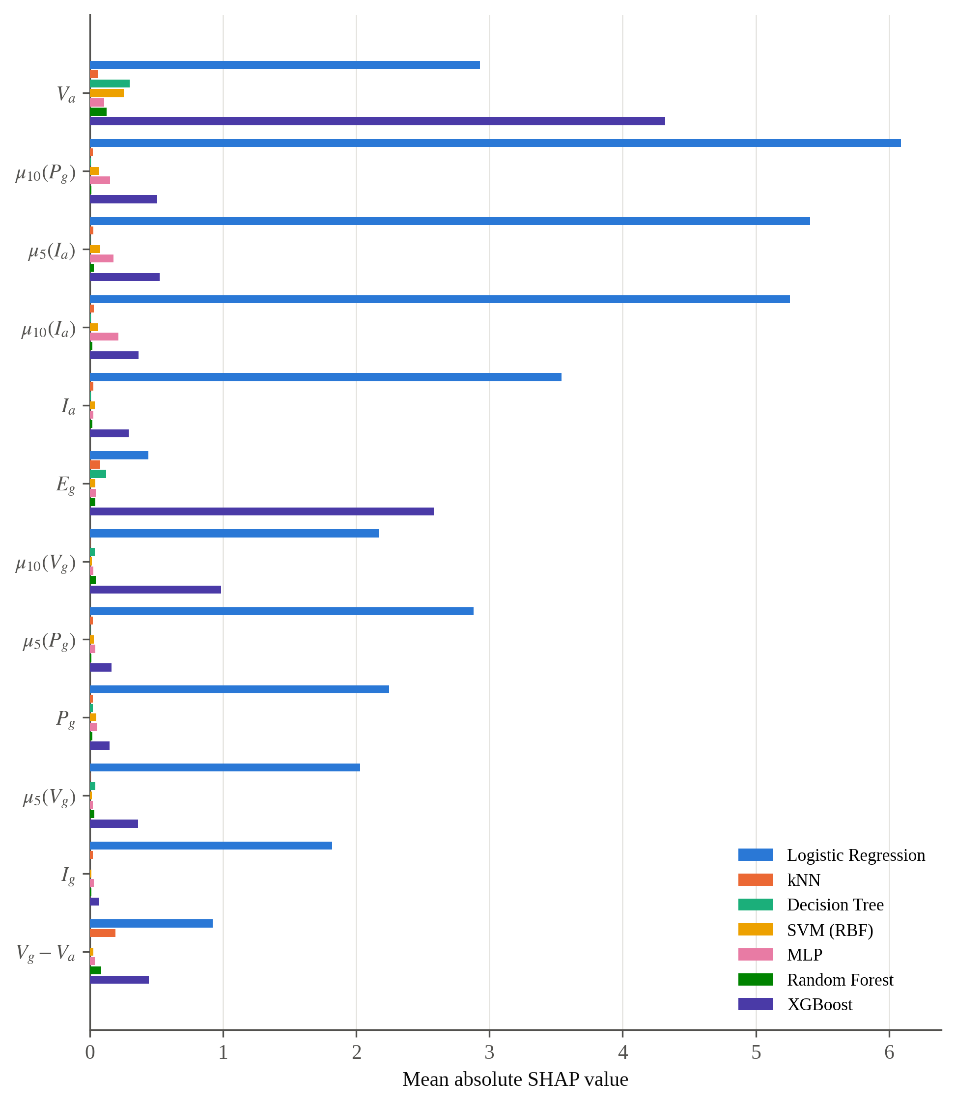
Fig. 3. Mean absolute SHAP value for the twelve features with the largest summed attribution, all seven classifiers (binary scheme, with SMOTE); μ_{w}(·) denotes a w-sample rolling mean.
V_{a} is highly ranked for six of seven classifiers: first for the Decision Tree, Random Forest, XGBoost and the SVM, third for kNN (behind V_{g} − V_{a} and E_{g}) and fourth for the MLP, indicating that PV-side voltage carries the dominant shading signal. Logistic Regression is the exception, favouring μ₁₀(P_{g}), μ₅(I_{a}) and μ₁₀(I_{a}) and ranking V_{a} fifth. Summed across classifiers, the leading attributions are V_{a}, μ₁₀(P_{g}), μ₅(I_{a}), μ₁₀(I_{a}), I_{a} and E_{g}, an ordering weighted toward Logistic Regression, whose attributions are the largest in magnitude.

4.5. Label-scheme and resampling ablation
Table 11 compares the binary and three-tier schemes with SMOTE. Every classifier loses accuracy and MCC on the three-tier scheme, confirming that separating constant from severe shading is harder than detecting a fault, and the ensembles retain the highest tier accuracy (XGBoost 0.746, Random Forest 0.741) and MCC (0.477 and 0.465). The SVM degrades least (7.2 accuracy points; MCC 0.435 to 0.428) and the Decision Tree and Logistic Regression most (20.0 and 17.0 points), so the SVM is the most robust to the finer-grained task (Fig. 5).
Table 11
Ablation of the label scheme: binary versus three-tier, both with SMOTE.
Model | Accuracy (binary) | Accuracy (tier) | MCC (binary) | MCC (tier)
Logistic Regression | 0.820 | 0.650 | 0.483 | 0.339
k-Nearest Neighbours | 0.772 | 0.664 | 0.388 | 0.328
Decision Tree | 0.820 | 0.619 | 0.500 | 0.338
SVM (RBF) | 0.800 | 0.728 | 0.435 | 0.428
MLP | 0.757 | 0.624 | 0.387 | 0.295
Random Forest | 0.838 | 0.741 | 0.526 | 0.465
XGBoost | 0.831 | 0.746 | 0.522 | 0.477

Fig. 4 shows that SMOTE lowers binary MCC for five of seven classifiers, most for the MLP (−0.064) and kNN (−0.051), leaves Random Forest essentially unchanged (−0.004) and raises it only for XGBoost (+0.014), so the benefit of oversampling is confined to the boosted ensemble.
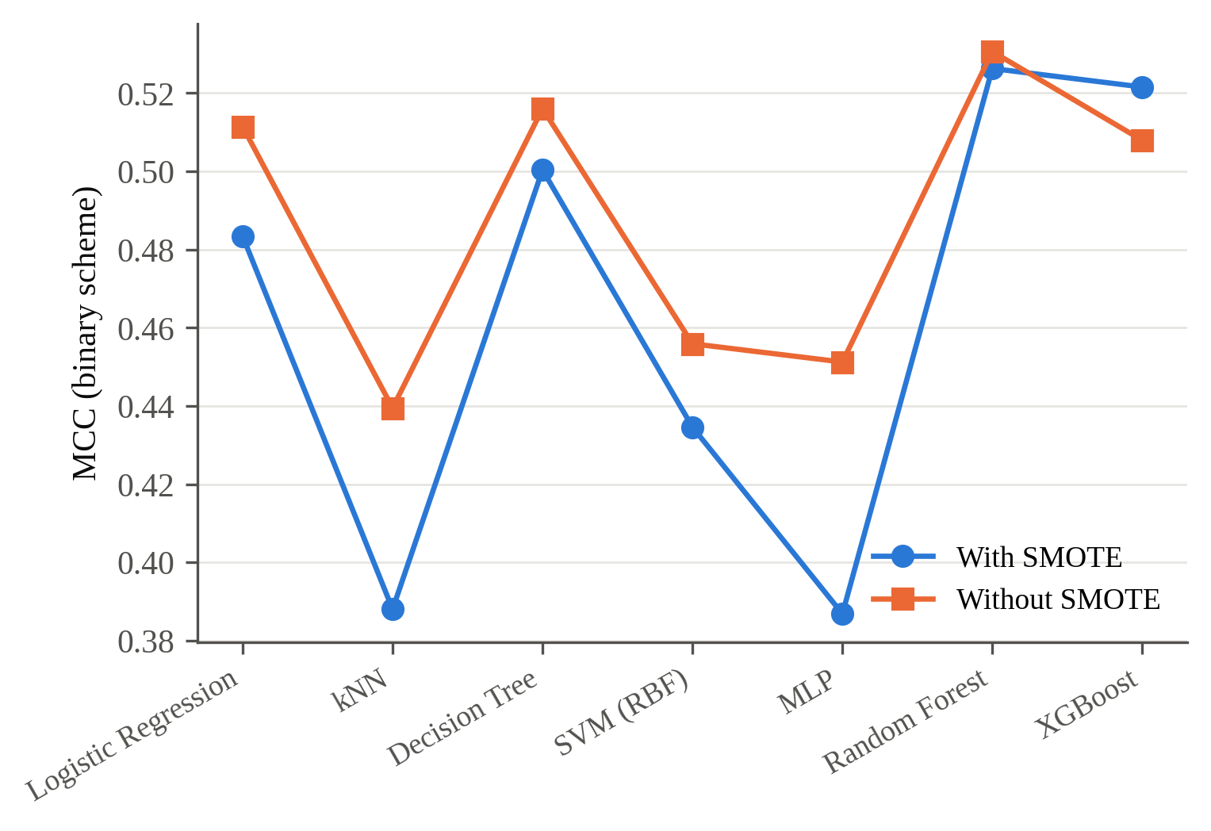
Fig. 4. Effect of SMOTE on MCC under the binary label scheme.
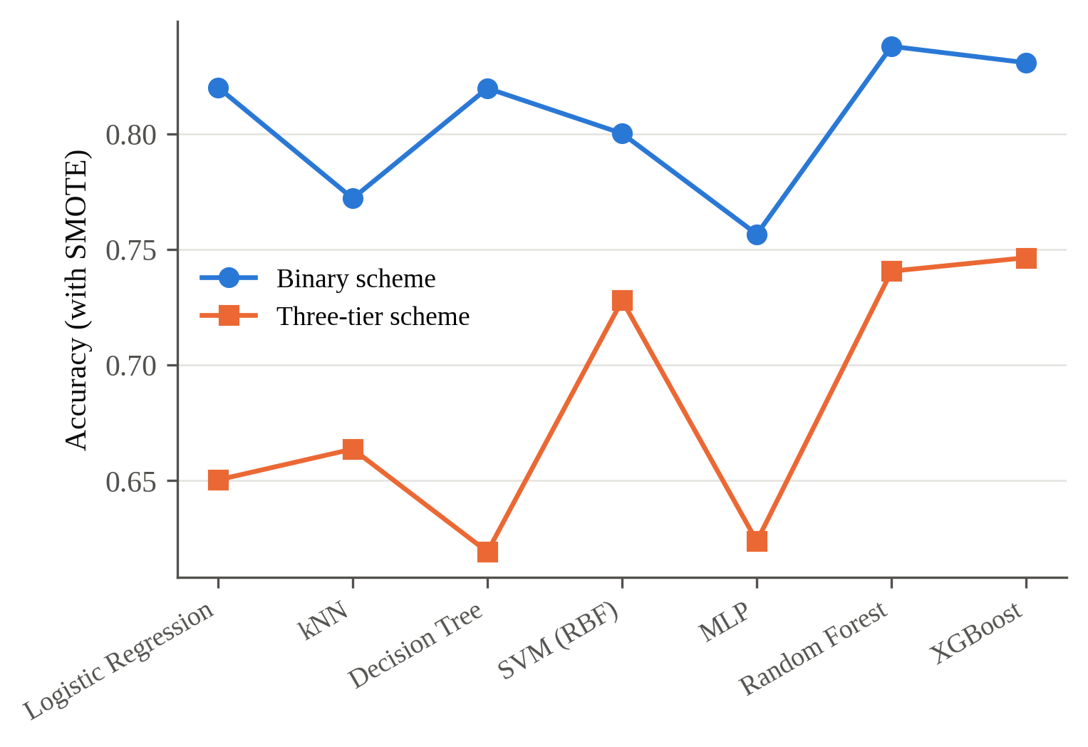
Fig. 5. Accuracy under the binary and three-tier label schemes, with SMOTE.

4.6. Feature ablation
Table 12 isolates the contribution of the 22 engineered features with a Random Forest ablation that fixes the modal hyperparameters of Table 5 and varies only the feature set: (A) the seven raw channels, (B) the 18 temporal features and (C) all 29 features.
Table 12
Random Forest feature ablation (binary scheme with SMOTE, fixed modal hyperparameters, 15 paired folds; mean ± standard deviation).
Configuration | Features | Accuracy | MCC | AUC-ROC
A: raw electrical only | 7 | 0.821 ± .171 | 0.504 ± .423 | 0.870 ± .201
B: engineered temporal only | 18 | 0.743 ± .092 | 0.366 ± .295 | 0.860 ± .223
C: combined (primary condition) | 29 | 0.839 ± .156 | 0.528 ± .417 | 0.858 ± .260

Configuration C (0.839; MCC 0.528) reproduces the Random Forest row of Table 7 (0.838; 0.526), validating the protocol. Raw channels alone (A: 0.821; 0.504) recover most of that performance, whereas temporal features alone (B: 0.743; 0.366) perform markedly worse, a 16.2-point MCC deficit relative to C. AUC-ROC varies little across configurations (0.858 to 0.870), indicating that the feature set changes default-threshold decisions more than the underlying ranking of samples.

4.7. Per-fault-type performance
Table 13 reports the recall of the binary Random Forest classifier per fault code, and Table 14 the multiclass precision, recall and F1 per tier, both from pooled out-of-fold predictions.
Table 13
Per-fault-code recall (specificity for the no-fault row) of the binary Random Forest classifier, pooled out-of-fold predictions across 15 folds.
Fault code | Description | Pooled rows | Recall or specificity
0.0 | No fault (specificity) | 42,000 | 0.935
1.0 | Uniform shading | 2,400 | 0.501
2.1 | Constant partial shading, 1 module | 1,200 | 0.999
2.2 | Constant partial shading, 2 modules | 1,200 | 1.000
2.3 | Constant partial shading, 3 modules | 1,200 | 0.007
3.1 | Constant partial shading, 1/3 module | 3,600 | 0.947
3.2 | Constant partial shading, 2/3 module | 4,800 | 1.000
4.0 | Intermittent (moving-shadow) shading | 6,000 | 0.595

Table 14
Multiclass precision, recall and F1 per severity tier (Section 3.1) for Random Forest, pooled out-of-fold predictions across 15 folds (macro-averaged F1 = 0.564; accuracy = 0.768).
Tier | Precision | Recall | F1 | Pooled rows
No fault | 0.885 | 0.933 | 0.909 | 42,000
Constant partial shading | 0.557 | 0.621 | 0.587 | 12,000
Severe (uniform or intermittent) | 0.272 | 0.154 | 0.197 | 8,400

Code 2.3 (three whole modules) is detected almost not at all (recall 0.007), although its neighbours 2.1 and 2.2 are detected almost perfectly (0.999 and 1.000), an isolated anomaly rather than a graded trend. The two severe-tier codes, uniform (0.501) and intermittent (0.595) shading, are detected markedly less reliably than most constant-partial-shading codes, and the severe tier has the lowest recall (0.154) and precision (0.272) of the three tiers, the opposite of what the severity ordering would suggest.

5. Discussion

5.1. Comparative accuracy (RQ1)
Random Forest and XGBoost lead on accuracy and MCC, Logistic Regression and the Decision Tree follow closely, and kNN, the SVM and the MLP trail. The Wilcoxon tests show that the ensembles significantly outperform kNN and the MLP (p ≤ .03, r ≥ .73) and the SVM on MCC (p ≤ .03), but not Logistic Regression or the Decision Tree. The central comparative finding is therefore a two-tier structure, four statistically indistinguishable classifiers above a significantly weaker three, rather than a single winner.

5.2. Effect of class-imbalance correction (RQ2)
SMOTE reduces accuracy and MCC for five of seven classifiers: most for Logistic Regression and the Decision Tree on the tier scheme (MCC −14.4 and −18.9 points), moderately for kNN and the MLP and mildly for the SVM, whereas Random Forest is unaffected (MCC change below 0.005) and XGBoost is modestly helped (+0.014 and +0.017 MCC). A likely cause is that fault episodes are long runs of near-duplicate readings, so interpolation adds little genuine boundary information and distorts distance-based, margin-based and single-tree learners more than a decorrelated ensemble.
SMOTE should therefore not be applied by default without checking model family and class balance (32.7% fault in the benchmark), a caution also reported for machine-fault and wind-turbine supervisory control and data acquisition (SCADA) classification (Swana et al., 2022; Maldonado-Correa et al., 2024).

5.3. Feature influence and cross-model consistency (RQ3)
SHAP answers RQ3 directly: V_{a} ranks at or near the top for six of seven classifiers, and Logistic Regression alone relies on rolling-window power and current statistics, plausibly because a linear boundary needs several smoothed inputs to approximate a single voltage split. The feature ablation corroborates this independently, since raw channels alone recover most of the combined performance while temporal features alone lose 16.2 MCC points (Table 12). The engineered block is therefore additive but not essential, and V_{a} with its companion channels carries most of the classification-relevant information.
This dominance has a physical basis. In series-wired strings, a shaded cell's reduced photocurrent limits the string current and forces a bypass-diode voltage step, and shading reshapes the power-voltage curve into multiple local maxima, so maximum power point tracking (MPPT) can settle at a lower-voltage operating point. Both mechanisms appear directly in V_{a}, consistent with Graillet et al. (2022) and the one-diode modelling of Kappler et al. (2024).

5.4. Interpretability and operational implications (RQ4)
Because Random Forest and XGBoost are not significantly better than Logistic Regression or the Decision Tree, their complexity and opacity buy no defensible advantage over the interpretable baselines, only over the SVM, kNN and the MLP. For an O&M team, Logistic Regression and the Decision Tree are also the lightest to operate: they depend on a single regularisation parameter or a finite rule sequence (Table 3), retrain quickly and can be audited without a data-science background, whereas the ensembles expose no reasoning without SHAP and carry a heavier maintenance burden.
The recommendation is therefore to start with Logistic Regression or the Decision Tree, neither being clearly preferable on the present evidence, and to adopt an ensemble only where a team can maintain it together with SHAP explanations.

5.5. Accuracy and MCC within the upper tier
Accuracy and MCC agree on the two tiers but disagree within the upper one: Logistic Regression edges the Decision Tree on accuracy (0.8200 against 0.8197, effectively a tie), whereas the Decision Tree leads on MCC (0.500 against 0.483). The Decision Tree makes fewer false positives (4,585 against 5,222) at a near-identical false-negative count (4,454 against 4,471), a more balanced error profile that MCC, being symmetric across classes and error types, rewards more than accuracy does.

5.6. Variability across fault episodes
The large fold-wise standard deviations arise because only 17 fault episodes exist, so each outer fold tests three to four episodes whose type varies, and Table 13 shows that some episode types are detected almost perfectly and others far less reliably. A fold's difficulty therefore depends on which episodes it holds out. This, rather than classifier instability, drives the variability, and it is why the repeated 3 × 5 design and paired testing matter: pairing compares all classifiers on the same held-out episodes.

5.7. Exclusion of meteorological variables
A companion file records irradiance and temperature, and it is omitted deliberately for three reasons. First, the seven electrical channels are logged by any grid-tied inverter's own metering, whereas dedicated irradiance and temperature instrumentation is a materially larger investment for the small, under-instrumented installations targeted here. Second, the objective is electrical-only fault detection, not attribution to a meteorological cause. Third, electrical-only detection fits the retrofit scenario of adding detection to deployed rooftop PV without new sensors. The exclusion is therefore a deployability trade-off rather than an omission.

5.8. Per-fault-type detection
Table 13 does not confirm that the fault codes with the largest production loss are the easiest to detect; for two of three severity tiers the pattern runs the other way. The near-zero recall of code 2.3 may reflect sparsity: only 3,287 code-2.3 rows exist in the full dataset (Table 2), so its retained episode may resemble surrounding segments, and SMOTE interpolation would then reinforce whichever boundary the few real examples defined. This explanation is unconfirmed, and the anomaly requires per-episode inspection before the classifier is trusted on that fault type.
The weaker detection of the severe tier admits two testable hypotheses. Intermittent shading is a moving shadow, so many of its rows may be recorded while no cell is obscured, mechanically depressing recall; uniform shading of an entire line may instead settle, after MPPT re-optimisation, at a voltage within the normal range, muting the V_{a} deviation on which the classifiers rely most. Neither hypothesis is established here. What is established is that the two fault types most tied to the fire-risk motivation are detected least reliably, which qualifies rather than undermines the recommendation of Section 5.4.

5.9. Validity and scope of the findings
Although the results support a two-tier ranking, they should be interpreted within the scope of the experimental assumptions. Three controls address internal leakage: standardisation fitted on the training fold only, SMOTE applied strictly within the training fold, and nested tuning that never uses the outer test fold (Wainer and Cawley, 2021). Because every temporal feature and every split is computed at the episode level, no episode is divided between training and test data. For construct validity, the binary label is recorded rather than thresholded, and the three-tier modelling choice is mitigated by reporting both schemes.
Statistically, all 28 runs are reported, summarised in Tables 7, 8 and 11 and provided in full with the code, and significance testing is limited to the comparisons the research questions require, which avoids an unconstrained test set needing a multiple-comparisons correction (Demšar, 2006).
A single five-fold Wilcoxon test has limited power for anything short of a large effect. Repeating the outer split three times raises the paired sample from 5 to 15, but the repeats share the same 17 fault episodes and are correlated, so the gain in power is real but qualified. It nonetheless resolves real structure (Section 4.3) rather than the uniformly null result an underpowered design risks, and non-significant comparisons are reported as such, with effect sizes available for independent judgement.
Externally, the data reflect one plant, one geography and one staging protocol, with all fault episodes inside a 3.5-month window of a 559-day deployment, so fault-labelled seasonal diversity is narrower than no-fault diversity. The results therefore provide evidence of the relative ranking of classical classifiers on real staged shading faults, rather than performance values expected at every PV installation.

5.10. Responsible deployment
A classifier taken into operational monitoring would inform maintenance dispatch and, for severe or uniform shading, a safety-relevant decision, so a false negative and a false positive carry different stakes. The concern is concrete here: Random Forest's recall on the two severe-tier codes (0.50 and 0.60) is well below that on most constant-partial-shading codes (mostly ≥ 0.95) and lower still at tier level (0.154), so a system built on these classifiers without further work would miss a materially larger share of the fault type that motivates this study on safety grounds.
Before deployment, the classifiers would require validation across more plants, climates and module technologies; a human-in-the-loop process in which output supports but never automates dispatch or de-energisation; monitoring for distribution shift caused by soiling, degradation and seasonal irradiance; and transparency to owners about each alert's basis, with a mechanism to query or override it. None of these steps is undertaken here, as this study is a comparative benchmark rather than a deployable system.

6. Conclusions and future work
This work presented a benchmark of seven classical and ensemble-tree classifiers for PV shading-fault classification on real, physically staged fault data, addressing the reliance of the literature on simulated faults.
By grouping every cross-validation split at the episode level and testing every pairwise difference across fifteen paired folds, this study demonstrates that the classifiers separate into a statistically indistinguishable upper tier (Random Forest, XGBoost, Logistic Regression and the Decision Tree) and a significantly weaker lower tier (kNN, the SVM and the MLP). Episode-level grouping is required because near-duplicate readings within long fault episodes would otherwise inflate performance, and because neither ensemble significantly outperforms the interpretable baselines, the practical recommendation for resource-constrained O&M teams favours the interpretable models.
By comparing SHAP attributions across model families and ablating the feature set, the study shows that PV-side voltage is the dominant fault signal for six of seven classifiers and that this dominance is not an artefact of the engineered features. By contrasting runs with and without SMOTE, it shows that oversampling reduced accuracy and MCC for five of seven classifiers, left Random Forest unaffected and marginally helped XGBoost, so it should not be applied by default. The per-fault analysis further reveals that uniform and intermittent shading are detected markedly less reliably than most constant-partial-shading codes.
Despite these results, several limitations should be acknowledged. First, the metrics describe the capped benchmark of about 20,800 rows rather than the full 2.99-million-row, 2.83%-fault population, a deliberate trade-off for tractability. Second, the findings are specific to one plant, geography and staging protocol within a 3.5-month window and should not be generalised without re-validation. Third, this is a single-dataset study, because real, staged, fault-labelled PV data are rare. In addition, the three-tier scheme is checked only against the binary scheme, not against alternative groupings of the eight fault codes.
Moreover, the comparison is restricted to classical and ensemble-tree methods, leaving sequence-aware deep learning such as LSTMs and one-dimensional CNNs to future work. A pooled ROC-curve figure is not reproduced, because only scalar per-fold AUC-ROC values were stored. The companion meteorological file is not used (Section 5.7). The feature ablation and per-fault breakdown cover Random Forest alone and leave two open findings, the code-2.3 anomaly and the weak severe-tier recall. Finally, any deployed version would first require the safeguards of Section 5.10.
Future work will therefore replicate the benchmark on other real, fault-labelled PV datasets as they become available, extend it to sequence-aware deep learning, incorporate the meteorological data, investigate the code-2.3 anomaly and the severe-tier weakness given their fire-risk relevance, and extend the ablation and per-fault analyses beyond Random Forest. Overall, the work shows that, on real staged-fault data and under leakage-controlled, statistically tested evaluation, interpretable classical classifiers remain competitive with ensembles for PV shading-fault detection, while severe-shading recall remains the priority before operational use.

Declaration of generative AI and AI-assisted technologies in the writing process
During the preparation of this work, the first author used ChatGPT to assist with drafting and revising prose and copy-editing for concision, under the author's direction and specification. The authors reviewed, verified and edited all AI-assisted output against the underlying experimental data and take full responsibility for the content of this publication.

CRediT authorship contribution statement
Zablon Ombiro: Conceptualization, Methodology, Software, Validation, Formal analysis, Investigation, Data curation, Writing – original draft, Writing – review & editing, Visualization.
Bernard Shibwabo: Supervision and Reviewing and Validation of the experimentations, the manuscript writing.

Declaration of competing interest
The authors declare that they have no known competing financial interests or personal relationships that could have appeared to influence the work reported in this paper.

Data availability
The dataset analysed in this study is publicly available in the Zenodo repository associated with Graillet et al. (2022). The data-preparation, modelling and analysis pipeline developed for this study is openly available in a public GitHub repository https://github.com/IncognitoGK9/pv-fault-benchmark

Acknowledgements
The authors thank the Department of Computing, Strathmore University, for the academic guidance and computing resources that supported this study.

Funding
This research received no external funding.

References
Adhya, D., Chatterjee, S., Chakraborty, A.K., 2023. Diagnosis of PV array faults using RUSBoost. Journal of Control, Automation and Electrical Systems 34 (1), 157–165. https://doi.org/10.1007/s40313-022-00947-6
Amiri, A.F., Kichou, S., Oudira, H., Chouder, A., Silvestre, S., 2024. Fault detection and diagnosis of a photovoltaic system based on deep learning using the combination of a convolutional neural network (CNN) and bidirectional gated recurrent unit (Bi-GRU). Sustainability 16 (3), 1012. https://doi.org/10.3390/su16031012
Benavoli, A., Corani, G., Demšar, J., Zaffalon, M., 2017. Time for a change: a tutorial for comparing multiple classifiers through Bayesian analysis. Journal of Machine Learning Research 18 (1), 1–36.
Bindingsbø, O.T., Singh, M., Øvsthus, K., Keprate, A., 2023. Fault detection of a wind turbine generator bearing using interpretable machine learning. Frontiers in Energy Research 11, 1284676. https://doi.org/10.3389/fenrg.2023.1284676
Breiman, L., 2001. Random forests. Machine Learning 45 (1), 5–32. https://doi.org/10.1023/A:1010933404324
Cakiroglu, C., Demir, S., Ozdemir, M.H., Aylak, B.L., Sariisik, G., Abualigah, L., 2024. Data-driven interpretable ensemble learning methods for the prediction of wind turbine power incorporating SHAP analysis. Expert Systems with Applications 237 (Part A), 121464. https://doi.org/10.1016/j.eswa.2023.121464
Chawla, N.V., Bowyer, K.W., Hall, L.O., Kegelmeyer, W.P., 2002. SMOTE: synthetic minority over-sampling technique. Journal of Artificial Intelligence Research 16, 321–357. https://doi.org/10.1613/jair.953
Chen, T., Guestrin, C., 2016. XGBoost: a scalable tree boosting system. In: Proceedings of the 22nd ACM SIGKDD International Conference on Knowledge Discovery and Data Mining, pp. 785–794. https://doi.org/10.1145/2939672.2939785
Chen, Z., Han, F., Wu, L., Yu, J., Cheng, S., Lin, P., Chen, H., 2018. Random forest based intelligent fault diagnosis for PV arrays using array voltage and string currents. Energy Conversion and Management 178, 250–264. https://doi.org/10.1016/j.enconman.2018.10.040
Chicco, D., Jurman, G., 2020. The advantages of the Matthews correlation coefficient (MCC) over F1 score and accuracy in binary classification evaluation. BMC Genomics 21, 6. https://doi.org/10.1186/s12864-019-6413-7
Cortes, C., Vapnik, V., 1995. Support-vector networks. Machine Learning 20 (3), 273–297. https://doi.org/10.1007/BF00994018
Cover, T., Hart, P., 1967. Nearest neighbor pattern classification. IEEE Transactions on Information Theory 13 (1), 21–27. https://doi.org/10.1109/TIT.1967.1053964
Demšar, J., 2006. Statistical comparisons of classifiers over multiple data sets. Journal of Machine Learning Research 7, 1–30.
Dhibi, K., Mansouri, M., Bouzrara, K., Nounou, H., Nounou, M., 2021. An enhanced ensemble learning-based fault detection and diagnosis for grid-connected PV systems. IEEE Access 9, 155622–155633. https://doi.org/10.1109/ACCESS.2021.3128749
Eldeghady, G.S., Kamal, H.A., Hassan, M.A.M., 2024. Comparative analysis of the performance of supervised learning algorithms for photovoltaic system fault diagnosis. Science and Technology for Energy Transition 79, 27. https://doi.org/10.2516/stet/2024024
Gaaloul, Y., Kechiche, O.B.H.B., Oudira, H., Chouder, A., Hamouda, M., Silvestre, S., Kichou, S., 2025. Faults detection and diagnosis of a large-scale PV system by analyzing power losses and electric indicators computed using random forest and KNN-based prediction models. Energies 18 (10), 2482. https://doi.org/10.3390/en18102482
García, S., Herrera, F., 2008. An extension on “statistical comparisons of classifiers over multiple data sets” for all pairwise comparisons. Journal of Machine Learning Research 9, 2677–2694.
Graillet, A., Lebreton, C., Tang, C., Kbidi, F., Jegado, T., Damour, C., Benne, M., 2022. Electrical production data of a domestic grid-connected rooftop PV plant in normal and shading faults conditions associated with solar and meteorological data in a tropical climate. Data in Brief 46, 108723. https://doi.org/10.1016/j.dib.2022.108723. Dataset: https://doi.org/10.5281/zenodo.7828879
Harrou, F., Taghezouit, B., Khadraoui, S., Dairi, A., Sun, Y., Hadj Arab, A., 2022. Ensemble learning techniques-based monitoring charts for fault detection in photovoltaic systems. Energies 15 (18), 6716. https://doi.org/10.3390/en15186716
Hossen, M.S., Sarker, M.T., Ramasamy, G., Eng, N.E., 2026. Physics-informed and explainable machine learning for state-of-health estimation of second-life lithium-ion batteries under sparse cycling. Batteries 12 (5), 149. https://doi.org/10.3390/batteries12050149
Hussain, M., Al-Aqrabi, H., Hill, R., 2022. Statistical analysis and development of an ensemble-based machine learning model for photovoltaic fault detection. Energies 15 (15), 5492. https://doi.org/10.3390/en15155492
Kappler, T., Starosta, A.S., Munzke, N., Schwarz, B., Hiller, M., 2024. Detection of shading for short-term power forecasting of photovoltaic systems using machine learning techniques. EPJ Photovoltaics 15, 17. https://doi.org/10.1051/epjpv/2024013
Kawoosa, A.I., Prashar, D., Faheem, M., Jha, N., Khan, A., 2023. Using machine learning ensemble method for detection of energy theft in smart meters. IET Generation, Transmission & Distribution 17 (21), 4794–4809. https://doi.org/10.1049/gtd2.12997
Kerby, D.S., 2014. The simple difference formula: an approach to teaching nonparametric correlation. Comprehensive Psychology 3, 1. https://doi.org/10.2466/11.IT.3.1
Khandeparkar, V., Shreshtha, Ramu, S.K., 2025. Effectiveness of supervised machine learning models for electrical fault detection in solar PV systems. Scientific Reports 15, 34919. https://doi.org/10.1038/s41598-025-18802-4
Krishna Veni, K.S., Senthil Kumar, N., Gnanavadivel, J., 2025. Non-invasive health status diagnosis of solar PV panel using ensemble classifier. Electrical Engineering 107 (5), 5447–5459. https://doi.org/10.1007/s00202-024-02760-7
Lundberg, S.M., Lee, S.-I., 2017. A unified approach to interpreting model predictions. Advances in Neural Information Processing Systems 30, 4765–4774.
Maldonado-Correa, J., Valdiviezo-Condolo, M., Artigao, E., Martín-Martínez, S., Gómez-Lázaro, E., 2024. Classification of highly imbalanced supervisory control and data acquisition data for fault detection of wind turbine generators. Energies 17 (7), 1590. https://doi.org/10.3390/en17071590
Mellit, A., Kalogirou, S., 2022. Assessment of machine learning and ensemble methods for fault diagnosis of photovoltaic systems. Renewable Energy 184, 1074–1090. https://doi.org/10.1016/j.renene.2021.11.125
Mouleloued, Y., Kara, K., Chouder, A., Aouaichia, A., Silvestre, S., 2025. Euclidean distance-based tree algorithm for fault detection and diagnosis in photovoltaic systems. Energies 18 (7), 1773. https://doi.org/10.3390/en18071773
Ombiro, H., 2026. pv-fault-benchmark: source code for benchmarking classical machine learning models for shading-fault detection in rooftop PV systems. GitHub repository. https://github.com/IncognitoGK9/pv-fault-benchmark
Patnaik, B., Mishra, M., Bansal, R.C., Jena, R.K., 2021. MODWT-XGBoost based smart energy solution for fault detection and classification in a smart microgrid. Applied Energy 285, 116457. https://doi.org/10.1016/j.apenergy.2021.116457
Prasojo, R.A., Putra, M.A.A., Ekojono, Apriyani, M.E., Rahmanto, A.N., Ghoneim, S.S.M., Mahmoud, K., Lehtonen, M., Darwish, M.M.F., 2023. Precise transformer fault diagnosis via random forest model enhanced by synthetic minority over-sampling technique. Electric Power Systems Research 220, 109361. https://doi.org/10.1016/j.epsr.2023.109361
Quiles-Cucarella, E., Sánchez-Roca, P., Agustí-Mercader, I., 2025. Performance optimization of machine-learning algorithms for fault detection and diagnosis in PV systems. Electronics 14 (9), 1709. https://doi.org/10.3390/electronics14091709
Quinlan, J.R., 1986. Induction of decision trees. Machine Learning 1 (1), 81–106. https://doi.org/10.1007/BF00116251
Rumelhart, D.E., Hinton, G.E., Williams, R.J., 1986. Learning representations by back-propagating errors. Nature 323 (6088), 533–536. https://doi.org/10.1038/323533a0
Santos, M.R., Guedes, A., Sanchez-Gendriz, I., 2024. SHapley Additive exPlanations (SHAP) for efficient feature selection in rolling bearing fault diagnosis. Machine Learning and Knowledge Extraction 6 (1), 316–341. https://doi.org/10.3390/make6010016
Suliman, F., Anayi, F., Packianather, M., 2024. Electrical faults analysis and detection in photovoltaic arrays based on machine learning classifiers. Sustainability 16 (3), 1102. https://doi.org/10.3390/su16031102
Swana, E.F., Doorsamy, W., Bokoro, P., 2022. Tomek link and SMOTE approaches for machine fault classification with an imbalanced dataset. Sensors 22 (9), 3246. https://doi.org/10.3390/s22093246
Toche Tchio, G.M., Kenfack, J., Voufo, J., Abessolo Mindzie, Y., Fouedjou Njoya, B., Ouro-Djobo, S.S., 2024. Diagnosing faults in a photovoltaic system using the Extra Trees ensemble algorithm. AIMS Energy 12 (4), 727–750. https://doi.org/10.3934/energy.2024034
Utama, C., Meske, C., Schneider, J., Schlatmann, R., Ulbrich, C., 2023. Explainable artificial intelligence for photovoltaic fault detection: a comparison of instruments. Solar Energy 249, 139–151. https://doi.org/10.1016/j.solener.2022.11.018
Wainer, J., Cawley, G., 2021. Nested cross-validation when selecting classifiers is overzealous for most practical applications. Expert Systems with Applications 182, 115222. https://doi.org/10.1016/j.eswa.2021.115222
Wang, B., Chen, Q., Wang, M., Chen, Y., Zhang, Z., Liu, X., Gao, W., Zhang, Y., Zhang, H., 2024a. PVF-10: a high-resolution unmanned aerial vehicle thermal infrared image dataset for fine-grained photovoltaic fault classification. Applied Energy 376 (Part A), 124187. https://doi.org/10.1016/j.apenergy.2024.124187
Wang, L., Chi, J., Ding, Y., Yao, H., Guo, Q., Yang, H., 2024b. Transformer fault diagnosis method based on SMOTE and NGO-GBDT. Scientific Reports 14, 7179. https://doi.org/10.1038/s41598-024-57509-w
Wang, M., Xu, X., Yan, Z., 2023. Online fault diagnosis of PV array considering label errors based on distributionally robust logistic regression. Renewable Energy 203, 68–80. https://doi.org/10.1016/j.renene.2022.11.126
Yang, N.-C., Ismail, H., 2022. Voting-based ensemble learning algorithm for fault detection in photovoltaic systems under different weather conditions. Mathematics 10 (2), 285. https://doi.org/10.3390/math10020285
Zheng, Q., Zhang, Y., Wang, Z., Lei, X., Guo, J., Wang, F., Zhu, R., 2026. Bayesian optimisation-based solar power forecasting model and its analysis of interpretability. Sustainability 18 (9), 4568. https://doi.org/10.3390/su18094568

