Benchmarking Classical Machine Learning Models for Shading-Fault Detection in Rooftop Photovoltaic Systems Using Real Sensor Data
Abstract
Partial or uniform shading is a common, operationally significant PV fault — shaded cells dissipate rather than generate power and are a documented fire-risk pathway if undetected. Classical-ML PV fault studies are, with rare exception, validated only on simulated data. This study closes that gap using the real Réunion rooftop PV dataset (Graillet et al., 2022) — a 4kW plant with physically staged, logged shading faults — benchmarking seven classifiers under nested cross-validation. Random Forest and XGBoost lead (accuracy 0.838/0.831; MCC 0.526/0.522) in a two-tier structure, indistinguishable from Logistic Regression/Decision Tree but significantly ahead of kNN, MLP, and SVM.
Gap
Existing classical-ML PV shading-fault studies are, with rare exception, evaluated only on simulated data. It is unclear how these classifiers, and corrections like SMOTE, perform on real, physically staged faults, or whether they agree on which sensor signals drive predictions.
Problem
On real, physically staged shading faults, classical classifiers may:
- fail to generalise as reliably as their simulated-data benchmarks suggest
- respond inconsistently to standard class-imbalance correction (SMOTE)
- rely on different sensor features depending on model family, undermining a single “most important feature” claim
Approach
We evaluate seven classical classifiers across four controlled comparisons:
- Primary Benchmark (Binary, SMOTE): Seven classifiers under nested CV on the primary fault/no-fault condition
- Severity-Tier Robustness (Tier scheme): Same classifiers re-evaluated on three-tier fault severity
- Resampling Ablation (No SMOTE): Same runs without SMOTE, isolating its effect on accuracy and MCC
- Cross-Model Feature Attribution (SHAP): SHAP analysis testing feature-attribution consistency across model families
Contribution
This study does not propose a new model or benchmark methodology. Instead, it demonstrates that:
- classical classifiers on real shading-fault data form a two-tier structure — Random Forest/XGBoost ahead of kNN, MLP, and SVM, but statistically tied with Logistic Regression/Decision Tree — not a single best model
- SMOTE is not a safe default: it reduces accuracy/MCC for five of seven classifiers, leaves Random Forest unchanged, and only marginally helps XGBoost
- cross-model feature attribution (SHAP) is largely, but not universally, consistent, depending on:
  - model family (trees/ensembles favour instantaneous voltage; Logistic Regression favours rolling-window statistics)
  - label scheme (binary vs. three-tier severity)
  - resampling condition (with vs. without SMOTE)
The key contribution is therefore to demonstrate, on real rather than simulated shading-fault data, that classical-model comparison outcomes for PV fault detection are conditional on label scheme, resampling choice, and feature-attribution method — not settled by accuracy alone.

Key Preliminary Results
Comparative Performance Across Classifiers | Effect of SMOTE on MCC
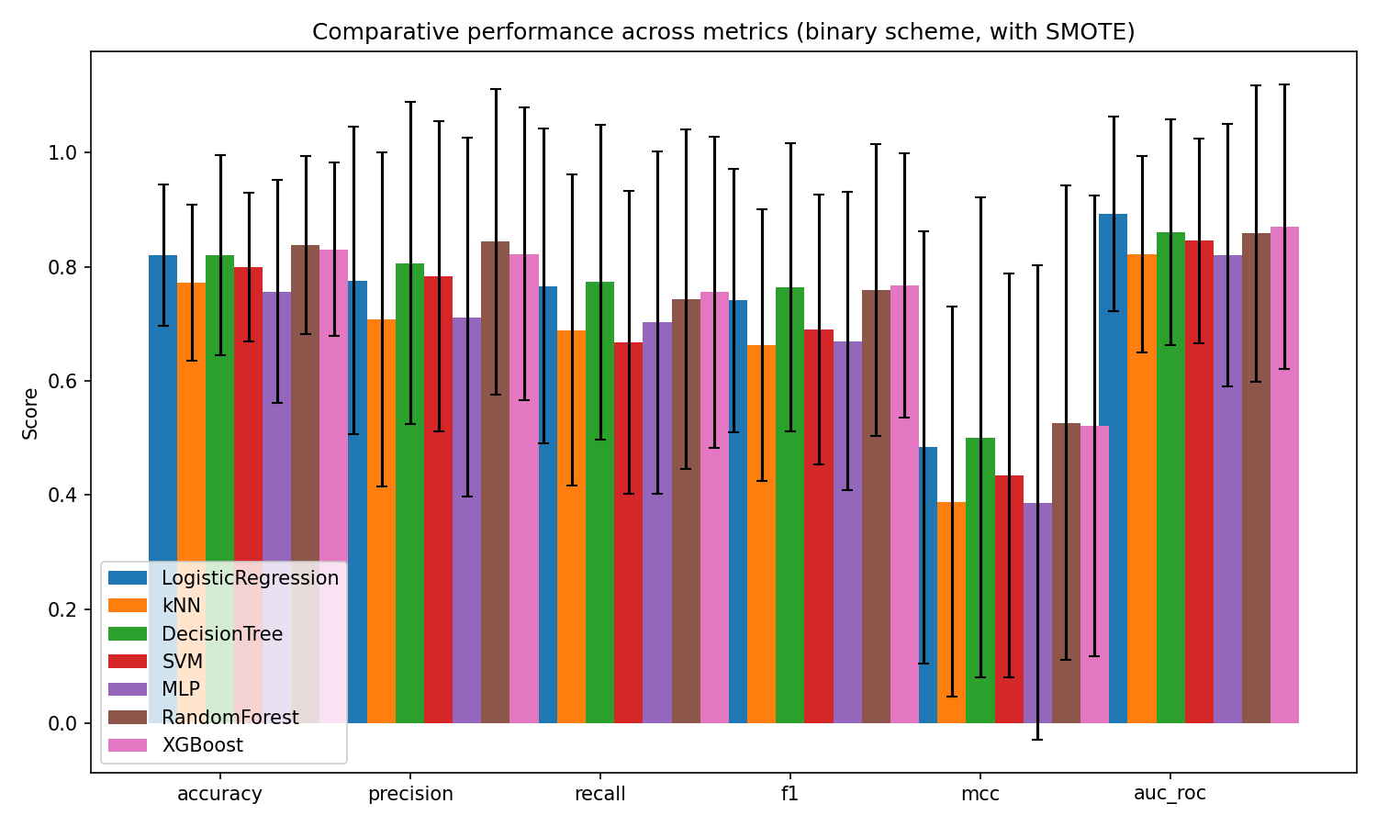  Figure 1: Comparative Performance Across Six Metrics (Binary, SMOTE) | 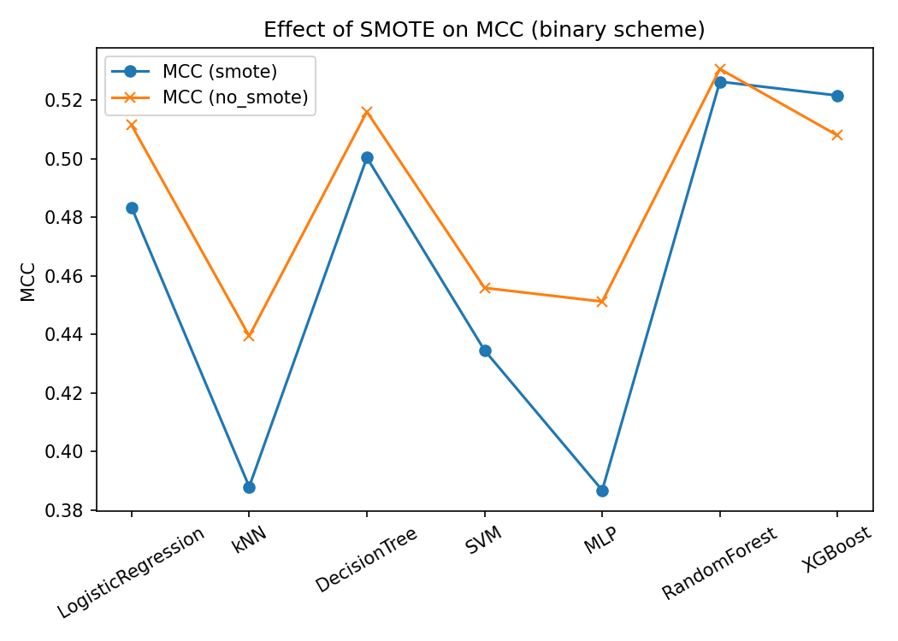  Figure 2: Effect of SMOTE on MCC, Binary Label Scheme
Accuracy: Random Forest: 0.838; XGBoost: 0.831; Logistic Regression / Decision Tree: 0.820; SVM: 0.800; kNN: 0.772; MLP: 0.757 | MCC change under SMOTE: MLP: −0.064; kNN: −0.051; SVM: −0.021; Decision Tree: −0.016; Logistic Regression: −0.028; Random Forest: −0.004 (unchanged); XGBoost: +0.014 (only increase)

The figure shows Random Forest and XGBoost leading on accuracy and MCC, with Logistic Regression and the Decision Tree statistically indistinguishable from them despite lower point estimates, and k-Nearest Neighbours, the SVM, and the MLP trailing significantly behind, indicating a two-tier performance structure rather than a single best model.
The figure shows MCC falling under SMOTE for five of seven classifiers, most severely for the MLP and k-Nearest Neighbours, while Random Forest remains essentially unchanged and XGBoost is the only classifier SMOTE improves, cautioning against applying SMOTE by default.

