Two-Step Heart Disease Screening with a “Not Sure” Option: Classical Classifiers, Stacking and Prevalence-Adjusted Referral Rules
Ombiro Zablon B. Handson 225446 · Lawrence Kasera 111780
School of Computing and Engineering Sciences, Strathmore University, Nairobi, Kenya
Advanced Machine Learning - Class Assignment · October 2026
Abstract — Heart disease is a leading cause of death, and where specialists and exercise-test equipment are limited, patients must first be sorted with inexpensive measurements. Using the Heart Failure Prediction dataset (918 patients, 11 features), we compare seven classical and neural classifiers and two ensembles on accuracy under nested, repeated stratified cross-validation (3 × 10 outer folds, 5-fold inner tuning). The accuracy-weighted soft vote was highest (87.72 ± 3.14 %), but the leading methods did not differ significantly (soft vote versus random forest, corrected t-test p = 0.66). We therefore propose a two-step screening system built on stacking. Step 1 uses five inexpensive inputs and returns Low risk, High risk or Not sure; Step 2 adds the examination results. Cut-offs are set from training-fold out-of-fold scores only, and results are adjusted to the target prevalence. At an assumed 5 % prevalence, the system needed 521 equipment tests per 1,000 patients instead of 1,000 and sent 2.9 sick patients per 1,000 home (95 % interval 2.1–4.1), against 10.9 for a fixed 0.5 cutoff at Step 1; 332 per 1,000 remained “not sure”. In leave-one-site-out checks the Step 1 cut-off did not transfer reliably (up to 11.3 % of sick patients sent home at one site). The data are a single, referral-enriched, historical sample, and the system has no clinical validation.
Keywords — heart disease screening; classical machine learning; stacking; abstention; prevalence shift; nested cross-validation.

1. Introduction
Cardiovascular diseases caused an estimated 19.8 million deaths in 2022, about 32 % of all deaths worldwide [1]. About 5 in 100 adults in the United States (4.9 %) report coronary heart disease [2]. Many cases are found late, although the risk is visible in routine measurements: age, blood pressure, chest-pain history, blood sugar and cholesterol. We take as a design premise, not as a measured fact, that in many clinics a heart specialist and exercise-test equipment are not available to every patient with a complaint, so the first decision is who needs the equipment test and how soon. Risk charts address a version of this problem and have been applied in Kenya [3, 4]; they give one score from population cohorts and no way to say that a patient cannot be classified from the inputs at hand.
Machine-learning studies of the Heart Failure Prediction dataset report accuracies of 85–93 % [5, 6, 7], mostly from one random split. Accuracy, however, treats the two errors alike. In screening, the dangerous error is a sick patient sent home. The question is therefore not only which classifier is most accurate, but whether a classifier can be arranged so that cheap measurements decide first, uncertain patients receive more tests, and the number of sick patients sent home is controlled.
Problem. Given the 11 clinical inputs of 918 patients, classify heart disease, compare supervised methods fairly, and test an improvement. Proposed solution. A two-step screening system (Fig. 1): Step 1 uses five inputs available in a basic clinic and returns Low risk (home), High risk (urgent tests) or Not sure (tests, normal priority); Step 2 adds the examination results and returns Low risk, High risk or Still not sure (specialist decides). Our contributions are:
- A leakage-free benchmark of nine methods (seven single models, a soft vote and stacking) with corrected significance tests [8, 9].
- A two-step system whose calibration, cut-offs and “not sure” bands come from training-fold out-of-fold scores, with a pre-specified rule for each design choice and prevalence-adjusted results [10].
- An evaluation against two baselines, five prevalence scenarios and leave-one-site-out validation on the original UCI files [11], reporting where the approach fails.
Section 2 reviews related work, Section 3 describes the data, Section 4 the methodology, Section 5 the results, Section 6 discusses limits and Section 7 concludes.

2. Related Works
Three recent studies use this dataset. Zeng [5] compared logistic regression, decision tree, random forest, k-NN and SVM and reported random forest best at 88 %. Qumsiyeh et al. [6] imputed zero cholesterol and blood-pressure values and reported hold-out accuracies of 85.1–91.7 %. Zhang et al. [7] reported up to 92.6 % with a deep network. All three rely on a single split and report accuracy only. For tabular data of this size, tree ensembles generally match or exceed neural networks [12], which is why we include a small neural network only as a check. Table 1 places the other building blocks.
The methods differ in what they assume. Logistic regression is a linear, interpretable baseline [13]; a single decision tree is readable but unstable [14]; a random forest averages many trees to reduce variance [15]; k-NN and the RBF-kernel SVM are local and kernel methods that depend on feature scaling [16, 17]; gradient boosting fits trees in sequence [18]; stacking learns how to combine the others [19]. With 918 patients and 11 mostly low-cardinality inputs, strong models are likely to make correlated errors, so little may be gained by combining them; the results in Section 5 test this.
Table 1. Comparative study: related work and how this paper uses it.
Topic | Representative work | Relevance to this paper
Same dataset | Zeng [5]; Qumsiyeh et al. [6]; Zhang et al. [7] | Accuracy comparisons on one split; no referral or “not sure” output. We re-run the comparison under repeated nested cross-validation.
Risk charts | WHO charts [3]; Nairobi application [4] | Cheap inputs, one fixed score. Our Step 1 is a learned counterpart with an explicit “not sure” band.
Spectrum bias | Ransohoff and Feinstein [20] | Test performance depends on the patient mix. Our sample is referral-enriched; we report prevalence scenarios.
Prior shift, calibration | Saerens et al. [10]; Van Calster et al. [21]; Guo et al. [22] | Odds are re-weighted to a new prevalence; probabilities must be calibrated to be read as risk.
Abstention | Vovk et al. [23]; Angelopoulos and Bates [24] | Conformal cut-offs give coverage guarantees; compared here with an empirical two-threshold rule.
Ensembles | Wolpert [19] | Stacking learns how to combine models; used as our proposed scorer.
In short, prior work on this dataset ranks classifiers by accuracy; the screening literature supplies calibration, prevalence adjustment and abstention. We combine the two and measure the result in screening terms: tests needed, sick patients sent home and patients left “not sure”.

3. Dataset and Problem Statement
The dataset [25] pools several 1980s cohorts, including the four held in the UCI repository [11]. It has 918 rows, 11 predictors and a binary target, HeartDisease, equal to 1 for 508 patients (55.3 %) and 0 for 410. Table 2 lists the predictors and their group: Group A is what a basic clinic can record, Group B needs an ECG or exercise test.
Table 2. Predictors (n = 918). Group A: basic clinic; Group B: examination tests.
Feature | Group | Description | Values / range
Age | A | Age (years) | 28 – 77
Sex | A | Sex | M (725), F (193)
ChestPainType | A | Chest pain type | ASY (496), NAP (203), ATA (173), TA (46)
RestingBP | A | Resting blood pressure (mm Hg) | 0 – 200 (1 zero)
FastingBS | A | Fasting blood sugar > 120 mg/dl | 0 (704), 1 (214)
Cholesterol | A* | Serum cholesterol (mg/dl) | 0 – 603 (172 zeros)
RestingECG | B | Resting ECG result | Normal (552), LVH (188), ST (178)
MaxHR | B | Maximum heart rate (bpm) | 60 – 202
ExerciseAngina | B | Exercise-induced angina | N (547), Y (371)
Oldpeak | B | ST depression (mm) | −2.6 – 6.2
ST_Slope | B | Peak-exercise ST slope | Flat (460), Up (395), Down (63)
A* marks cholesterol, which needs a blood test and is used only in Step 2. 172 patients (18.7 %) have Cholesterol = 0, a placeholder for an unmeasured value, and one has RestingBP = 0. Zero cholesterol is associated with disease in 88.4 % of these patients against 47.7 % of the rest. In the UCI files all 172 zeros come from two sites (Switzerland 123, VA Long Beach 49), so the zero indicates the recording site as much as a clinical fact; we therefore treat zeros as missing, impute the training-fold median, and add no missing-value indicator [26].
Formal problem. With inputs x and label y ∈ {0, 1}, we first seek a classifier maximising accuracy,
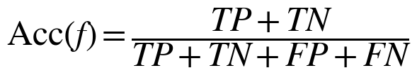 (1)
following the assignment, and then a screening rule that maps x to {Low, High, Not sure} so that few sick patients are sent home and few healthy patients receive the equipment test.

4. Methodology

4.1 Pre-processing and input sets
Categorical inputs are one-hot encoded and numeric inputs standardised inside a scikit-learn pipeline [27], fitted on training data only. Five configurations are used: F_raw (all 11 inputs, zeros kept as values, the common practice and the main comparison), F_ind (zeros imputed plus a missing-value flag), F_imp (zeros imputed; used for Step 2), A_nochol (Group A without cholesterol; used for Step 1) and A_chol (Group A with cholesterol). A_chol replaces A_nochol at Step 1 only if it raises the stacking AUROC by at least 0.01 (pre-specified).

4.2 Classifiers
Seven single models are tuned by 5-fold inner grid search on accuracy: logistic regression (LR) [13], decision tree (DT) [14], random forest (RF) [15], k-NN [16], RBF-kernel SVM [17], histogram gradient boosting (GBM) [18] and a small multilayer perceptron (MLP). Two ensembles combine the six classical models. The accuracy-weighted soft vote (SOFT) sets each model’s weight by a softmax of its inner accuracy a_{m} with temperature τ = 0.01, fixed before any outer evaluation,
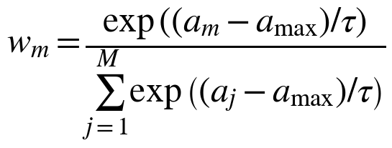 (2)
and the vote is the weighted average of the models’ probabilities, thresholded at 0.5,
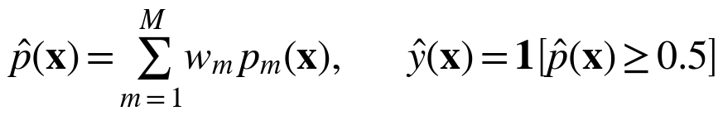 (3)
Stacking (STACK) fits a logistic-regression combiner on the logits of the six models’ inner out-of-fold probabilities p̃_{m} [19],
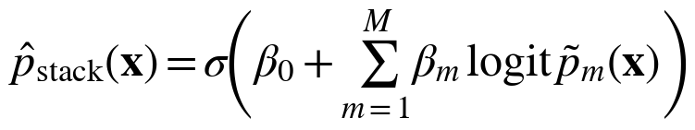 (4)
so the combiner never sees a probability from a model that was fitted on the same patient.
Table 3. Hyper-parameter grids searched by the inner 5-fold cross-validation (scripts/common.py); other settings are scikit-learn defaults.
Model | Hyper-parameters searched | Grid size
LR | C ∈ {0.01, 0.1, 1, 10, 100} | 5
DT | max_depth ∈ {3, 4, 5, 6, 8, None}; min_samples_leaf ∈ {1, 5, 10, 20} | 24
RF | 200 trees; max_features ∈ {sqrt, 0.5}; min_samples_leaf ∈ {1, 3} | 4
k-NN | k ∈ {3, 5, 7, 9, 11, 15, 21, 25}; weights ∈ {uniform, distance} | 16
SVM | RBF kernel; C ∈ {0.1, 1, 10}; γ ∈ {scale, 0.01, 0.1} | 9
GBM | max_leaf_nodes ∈ {7, 15}; learning_rate ∈ {0.03, 0.1}; max_iter ∈ {100, 200} | 8
MLP | hidden layers ∈ {(16), (32, 16)}; L2 penalty ∈ {0.001, 0.01} | 4

4.3 Evaluation protocol and train/test split
The outer loop is stratified 10-fold cross-validation repeated 3 times (30 test folds of about 92 patients). Inside each training fold, a stratified 5-fold grid search selects hyper-parameters, produces the out-of-fold probabilities used for stacking, calibration and cut-offs, and the model is refitted and evaluated once on the held-out fold, so tuning never touches test data [28]. A single stratified 80/20 hold-out (734 training, 184 test patients) is also reported for comparison with the literature. The random seed is 42. A unit test flips the test labels and checks that predictions do not change, which would expose any leakage. The “best” method is fixed before the results: the highest mean outer-fold accuracy on F_raw, ties of under 0.1 point broken by AUROC.

4.4 Two-step screening system
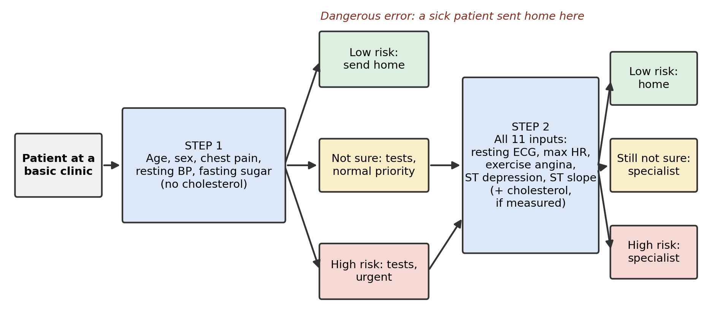
Figure 1. Two-step screening system. The dangerous error is a sick patient sent home at Step 1.
Each step scores a patient with STACK, then applies Platt scaling [29] fitted on out-of-fold scores, and finally a prior-shift correction [10] from the dataset prevalence π_{s} = 55.3 % to a target prevalence π_{t},
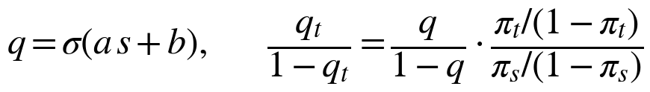 (5)
where s is the stacking score. Sensitivity and specificity do not change under this correction (assuming the class-conditional distributions stay fixed); predictive values, flag rates and counts per 1,000 do. We report π_{t} = 2, 5, 10, 20 % and the dataset’s own 55.3 %; 5 % is the reference, close to the US figure [2]. The decision rule is
(6)
where t_{L} is the largest score with at most 1 − s of the sick out-of-fold patients below it (release level s = 95 % at Step 1, with 90 and 98 % as sensitivity analysis; 98 % at Step 2) and t_{H} the smallest score with at most 5 % of the healthy patients above it. Patients between the cut-offs, or where the cut-offs cross, are Not sure. A conformal alternative sets the cut-offs by class-conditional (Mondrian) conformal calibration with the finite-sample correction [23, 24]; the mechanism is chosen by a pre-specified rule: both coverages at least 0.94, then the smaller Step 1 “not sure” share, a tie (under 0.5 point) going to the simpler two-threshold rule. Cholesterol is optional at Step 2: empty or zero is treated as missing and imputed. Intervals are 95 % Wilson intervals on class-conditional rates [30].

4.5 Statistical testing
Equal performance of the nine methods is tested with the Friedman test on per-fold ranks [9, 31]. Pairwise differences use the corrected resampled t-test [8], with d_{j} the per-fold difference, d̄ its mean, σ̂² its variance and J = 30,
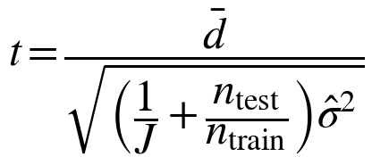 (7)
compared with Student’s t on 29 degrees of freedom; Wilcoxon p-values are also computed. α = 0.05.

5. Results
Software: Python 3.12.11 | scikit-learn 1.9.1 | pandas 3.1.0 | numpy 2.5.4 | scipy 1.18.1 | matplotlib 3.11.2 | joblib 1.6.0. The full pipeline ran in 679 s on a 12-core Mac (terminal log); the earlier five-model benchmark is reproduced within 0.2 accuracy points (for example RF 87.43 against 87.32 %; docs/DECISIONS.md).

5.1 Classification results for all methods
Table 4. All methods on the 11 inputs (F_raw): mean ± sd over 30 outer folds, 80/20 hold-out accuracy, and other metrics (fold means). Best CV accuracy in bold. Source: results/table_main.csv, table_holdout.csv.
Method | CV acc. (%) | Hold-out (%) | AUROC | Sens. | Spec. | Brier | ECE raw → cal.
Logistic regression | 86.42 ± 3.23 | 89.13 | 0.926 | 0.894 | 0.827 | 0.105 | 0.023 → 0.012
Decision tree | 83.98 ± 3.28 | 78.80 | 0.898 | 0.867 | 0.807 | 0.122 | 0.045 → 0.047
Random forest | 87.43 ± 3.54 | 90.22 | 0.931 | 0.914 | 0.825 | 0.100 | 0.033 → 0.029
k-NN | 86.71 ± 3.48 | 90.22 | 0.925 | 0.896 | 0.831 | 0.111 | 0.038 → 0.080
SVM (RBF) | 86.78 ± 3.59 | 89.67 | 0.930 | 0.906 | 0.820 | 0.101 | 0.017 → 0.018
Gradient boosting | 87.00 ± 3.23 | 89.13 | 0.931 | 0.898 | 0.835 | 0.099 | 0.021 → 0.018
MLP (small) | 86.16 ± 3.87 | 89.13 | 0.930 | 0.889 | 0.828 | 0.100 | 0.039 → 0.031
Soft vote (first proposal) | 87.72 ± 3.14 | 91.30 | 0.934 | 0.909 | 0.837 | 0.096 | 0.023 → 0.017
Stacking (final proposal) | 87.54 ± 3.04 | 90.22 | 0.935 | 0.908 | 0.835 | 0.096 | 0.017 → 0.018
The best method under the rule in §4.3 is the accuracy-weighted soft vote (87.72 %), followed by stacking (87.54 %) and random forest (87.43 %); the decision tree trails (83.98 %). The Friedman test rejects equal performance (χ² = 56.25, p = 2.5 × 10⁻⁹), driven mainly by the tree. Among the leading methods the differences are not significant: soft vote versus random forest Δ = 0.29 points (p = 0.66); stacking versus random forest Δ = 0.11 (p = 0.85); stacking versus soft vote Δ = −0.18 (p = 0.66). Hold-out accuracies are 2–4 points higher than the cross-validated means for every model except the tree, which is 5 points lower, and they reorder the models, as expected from a 184-patient test set (binomial standard error about 2.4 points). On this evidence accuracy cannot separate the strong methods. Handling of zero cholesterol matters little for the ensembles: the soft vote reaches 87.72 % raw, 87.76 % with the indicator, and 87.40 % with imputation alone (results/summary.md); only logistic regression gains clearly from the indicator (86.42 to 87.32 %).
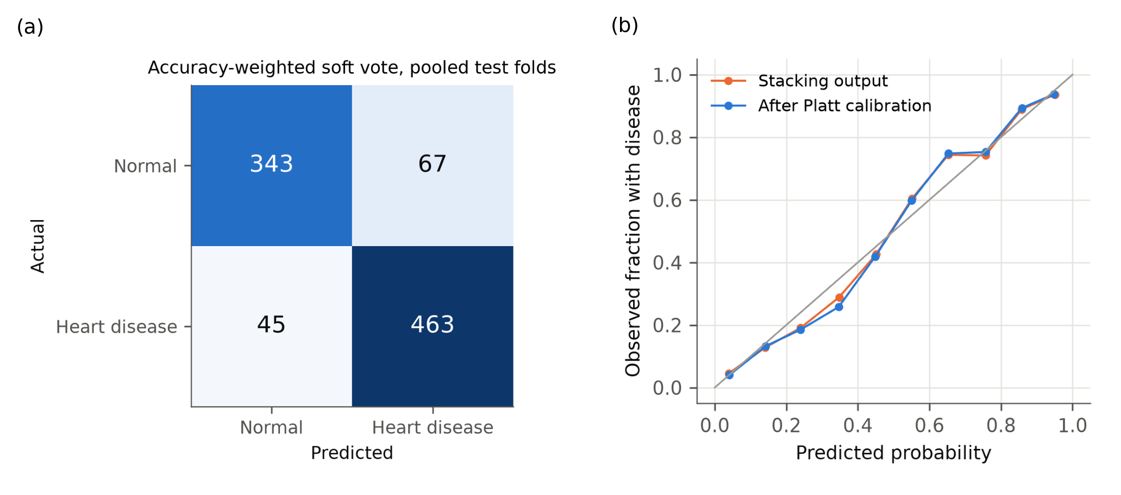
Figure 2. (a) Confusion matrix of the best method (Accuracy-weighted soft vote), pooled over the test folds of one repetition (n = 918): accuracy 87.8 %, sensitivity 91.1 %, specificity 83.7 %. (b) Reliability of the stacking score before and after Platt scaling.

5.2 Which inputs matter, and the choice of Step 1
Adding inputs in clinical order (Fig. 3) shows that chest pain gives the first large gain (LR AUROC 0.732 to 0.844), resting blood pressure and the blood tests add little (−0.001 and +0.014 for LR; +0.013 and +0.027 for RF), the resting ECG adds nothing (−0.001 and −0.002), and the exercise group adds the most (+0.066 and +0.079). Step 1 with five Group A inputs reaches STACK AUROC 0.853 (accuracy 77.78 ± 3.31 %); adding cholesterol raises AUROC to 0.858 (accuracy 79.27 ± 3.73 %), a gain of 0.005, below the 0.01 threshold, so Step 1 excludes it. Step 2 with all inputs reaches AUROC 0.929 (accuracy 87.32 ± 3.52 %). Step 1 alone is therefore a weak classifier, which is why a “not sure” option is needed.
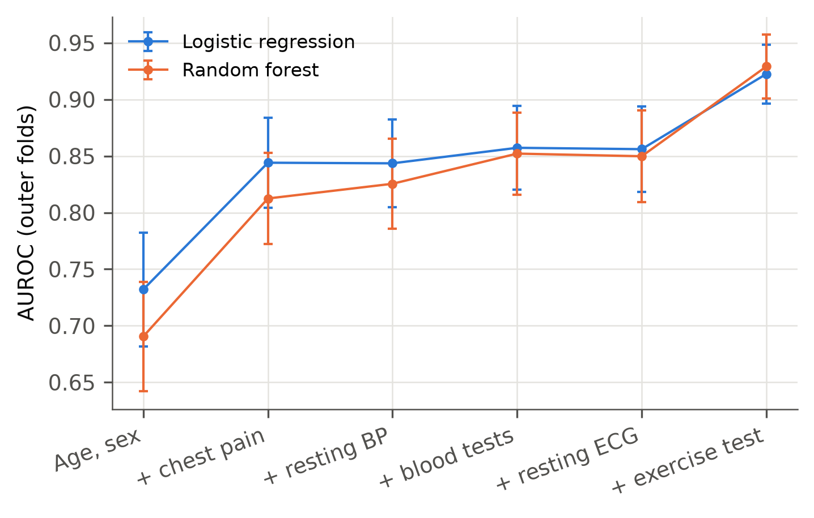
Figure 3. Outer-fold AUROC (mean ± sd) as inputs are added, for logistic regression and random forest.

5.3 Two-step system
Table 5 gives the system at the 5 % reference prevalence; each row adds or removes one component, so the table is also the ablation of the proposal. Per 1,000 patients screened, the two-step system with Step 1 released at 95 % sensitivity sends 521 patients for equipment tests (479 fewer than testing everyone) and sends 2.9 sick patients home (2.0 at Step 1), final sensitivity 94.2 %. The fixed 0.5 cutoff at Step 1 needs fewer tests (317) but misses 10.9, about 3.8 times as many. Testing everyone and keeping the “not sure” band misses fewer (1.1) but needs 1,000 tests and leaves 433 patients not sure. Raising the Step 1 release level from 90 to 98 % lowers missed cases (5.2 to 2.2) and raises tests (408 to 706). Of every 1,000 patients, 78 are called High risk with positive predictive value 0.38, and 332 end Not sure. At Step 1, 4.0 % of sick and 50.2 % of healthy patients are sent home; overall 61.8 % of healthy patients go home and 33.1 % are left not sure.
Table 5. Systems at 5 % prevalence, per 1,000 patients screened (stacking scorer). Source: results/table_system.csv.
System | Tests | Sick sent home (95 % interval) | Sens. (%) | High risk | PPV | Not sure
Two-step, Step 1 release at 90% sensitivity | 408 | 5.2 (4.0–6.7) | 89.6 | 78 | 0.38 | 284
Two-step, Step 1 release at 95% sensitivity | 521 | 2.9 (2.1–4.1) | 94.2 | 78 | 0.38 | 332
Two-step, Step 1 release at 98% sensitivity | 706 | 2.2 (1.5–3.3) | 95.6 | 78 | 0.38 | 378
Fixed 0.5 cutoff at Step 1, forced 0.5 at Step 2 | 317 | 10.9 (9.2–12.8) | 78.1 | 156 | 0.25 | 0
Test everyone, forced 0.5 | 1000 | 4.7 (3.6–6.1) | 90.6 | 204 | 0.22 | 0
Test everyone, Step 2 with not-sure band | 1000 | 1.1 (0.7–2.0) | 97.7 | 78 | 0.38 | 433
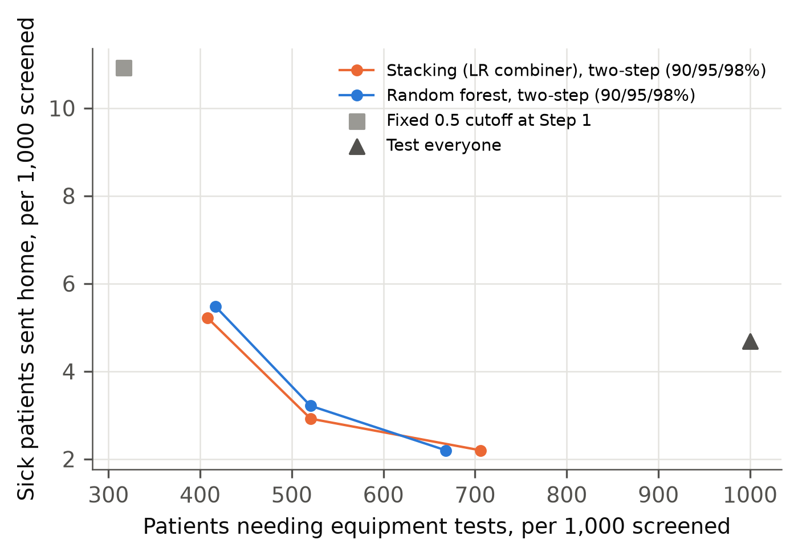
Figure 4. Sick patients sent home against patients needing equipment tests, per 1,000 at 5 % prevalence: two-step systems at Step 1 release levels of 90, 95 and 98 % (stacking and random forest) and the two baselines.
Prevalence changes the predictive values and counts, not the rates (Table 6). At 2 % prevalence the system sends home 1.2 sick patients per 1,000 with PPV 0.19; at 20 %, 11.7 with PPV 0.74. Using the dataset’s own prevalence (55.3 %) would overstate PPV (0.94) for a general clinic.
Table 6. Two-step system (Step 1 release 95 %) by assumed prevalence, per 1,000 patients.
Prevalence | Tests | Sick sent home (95 % interval) | High risk | PPV | NPV | Not sure
2% | 507 | 1.2 (0.8–1.6) | 62 | 0.19 | 0.998 | 331
5% (reference) | 521 | 2.9 (2.1–4.1) | 78 | 0.38 | 0.995 | 332
10% | 544 | 5.8 (4.1–8.2) | 106 | 0.56 | 0.990 | 332
20% | 590 | 11.7 (8.2–16.5) | 160 | 0.74 | 0.977 | 334
55.3% (dataset) | 753 | 32.3 (22.8–45.5) | 353 | 0.94 | 0.895 | 339

5.4 Calibration and the “not sure” mechanism
Platt scaling changes little: stacking Brier 0.100 before and 0.100 after, ECE 0.025 and 0.028 on F_imp; for k-NN it worsens ECE (0.038 to 0.080). The two cut-off mechanisms were close at Step 1: the empirical two-threshold rule leaves 96.0 % of sick patients out of the Low group and 95.0 % of healthy ones out of the High group, with 52.4 % Not sure; the conformal rule gives 96.0 %, 95.6 % and 53.4 %. The gap in the “not sure” share is under 2 points, and the pre-specified rule selects the two-threshold rule, which also has the smaller final “not sure” share (33.9 against 36.3 %).

5.5 Leave-one-site-out validation
To test transfer to a new hospital, models were trained on three UCI sites and applied to the fourth, with cut-offs from the training sites (Table 7; results/table_site_validation.csv). AUROC ranges from 0.721 to 0.848 at Step 1 and 0.725 to 0.872 at Step 2. The Step 1 cut-off, designed to send at most 5 % of sick patients home, sends 11.3 % home at the Hungarian site, where prevalence is lowest; Step 2 releases no further sick patients at any site. Healthy patients sent home range from 19.6 % to 65.4 % and the Not sure share from 37.8 % to 69.1 %.
Table 7. Leave-one-site-out results (stacking, Step 1 release 95 %).
Held-out site | Patients (prev.) | AUROC Step 1 | AUROC Step 2 | Sick sent home (%) | Healthy sent home (%) | Not sure (%)
Cleveland | 303 (46%) | 0.824 | 0.868 | 5.0 | 42.7 | 64.0
Hungarian | 294 (36%) | 0.848 | 0.872 | 11.3 | 65.4 | 37.8
Switzerland | 123 (93%) | 0.783 | 0.748 | 4.3 | 25.0 | 69.1
VA Long Beach | 200 (74%) | 0.721 | 0.725 | 0.0 | 19.6 | 51.0

5.6 Web application
The system is available as a web application at https://two-step-heart-screening.streamlit.app/, built with Streamlit from the code in the submitted archive. Fig. 5 shows it on a phone-sized screen, the setting of a basic clinic. Each screen asks only for the inputs of its step, rejects values outside plausible ranges, and returns Low risk, High risk or Not sure with a plain instruction. It also shows the estimated risk at the chosen prevalence and, at Step 1, the share of sick patients that cross-validation sent home. The sidebar sets the assumed prevalence and the Step 1 safety level, and cholesterol can be marked as not measured at Step 2. The values in the figure are the form’s default example values, not a real patient. The application carries the warning that it is a research prototype and not for clinical use.
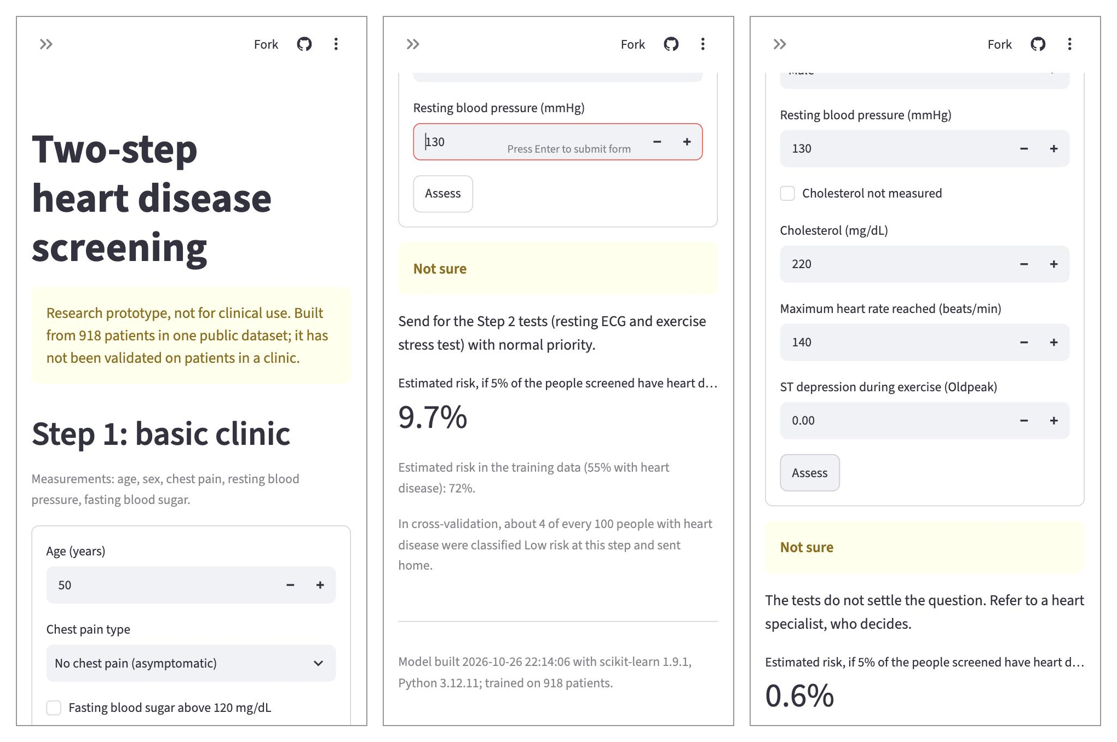
Figure 5. Mobile view of the application, left to right: title, warning and Step 1 form; Step 1 result (Not sure, send for the Step 2 tests); Step 2 result (Not sure, refer to a specialist).

6. Discussion and Limitations
What the evidence supports. Accuracy does not separate the strong methods: the best (soft vote, 87.72 %) is not significantly better than random forest or stacking. The value of the proposal is in screening measures, not accuracy: against a fixed 0.5 cutoff at Step 1 it sends home about 3.8 times fewer sick patients, and against testing everyone it needs 479 fewer equipment tests per 1,000 at a cost of 1.8 extra sick patients sent home per 1,000. This is a trade-off, not a free gain, and about one patient in three (332 per 1,000) still ends Not sure. The input ladder agrees with clinical practice: chest pain and the exercise test carry the signal, the resting ECG adds nothing in this data.
Why abstention. A forced 0.5 decision after testing everyone misses 4.7 sick patients per 1,000; adding the “not sure” band lowers this to 1.1 by moving 433 patients to the specialist. Abstention does not remove error; it moves it into a referral queue whose size is the price. In the two-step system, the final outcomes among sick patients are 59.6 % High risk, 34.6 % Not sure and 5.8 % Low risk.
Why accuracy ties. All models see the same 11 inputs, and the input ladder shows that most of the signal sits in a few of them (chest pain, exercise test), so a likely explanation is that the strong models make largely the same errors and a combination has little to correct. We did not measure error overlap directly (not yet measured).
Limitations. (1) One dataset, pooled from 1980s cohorts, with no clinical validation; the web application is a research prototype. (2) The sample is referral-enriched, so spectrum bias [20] applies: prior-shift correction fixes the prevalence, not the case mix. (3) Chest-pain type depends on how the question is asked. (4) The cholesterol signal is entangled with the recording site (§3). (5) The 5 % reference is a US figure [2]; no Kenyan prevalence is used. (6) Leave-one-site-out results show the Step 1 cut-off does not transfer cleanly, so local recalibration would be needed. (7) The “not sure” share of about one third is high.

7. Conclusion
Under repeated nested cross-validation, the soft vote, stacking and random forest are statistically tied on accuracy (about 87.72 %), and only the decision tree is clearly worse. A two-step screening system built on stacking answers a different question: at 5 % prevalence it needs 521 tests per 1,000 patients and sends 2.9 sick patients home, between the cheap fixed-cutoff pathway (317 tests, 10.9 missed) and testing everyone (1,000 tests, 4.7 missed with a forced decision). The approach fails to transfer cleanly across sites and leaves a third of patients not sure, so it supports a research prototype, not clinical use. Next steps are external validation on a local cohort and recalibration of the Step 1 cut-off per site.

References
[1] World Health Organization, "Cardiovascular diseases (CVDs)," Fact sheet, 31 Jul. 2025. [Online]. Available: https://www.who.int/news-room/fact-sheets/detail/cardiovascular-diseases-(cvds)
[2] Centers for Disease Control and Prevention, "Heart disease facts," National Center for Chronic Disease Prevention and Health Promotion, accessed Oct. 2026. [Online]. Available: https://www.cdc.gov/heart-disease/data-research/facts-stats/index.html
[3] WHO CVD Risk Chart Working Group, "World Health Organization cardiovascular disease risk charts: Revised models to estimate risk in 21 global regions," Lancet Glob. Health, vol. 7, no. 10, pp. e1332–e1345, 2019.
[4] A. Vusirikala, F. Wekesah, C. Kyobutungi, and O. Oyebode, "Assessment of cardiovascular risk in a slum population in Kenya: Use of World Health Organisation/International Society of Hypertension (WHO/ISH) risk prediction charts — secondary analyses of a household survey," BMJ Open, vol. 9, no. 9, Art. no. e029304, 2019, doi: 10.1136/bmjopen-2019-029304.
[5] Y. Zeng, "Prediction and feature importance analysis for heart failure using machine learning techniques," Trans. Comput. Sci. Intell. Syst. Res., vol. 5, pp. 790–796, 2024, doi: 10.62051/jp1b7v45.
[6] E. Qumsiyeh, Q. Al-Wirdian, and N. S. Ersoz, "Leveraging clinical data for early heart disease prediction: A machine learning approach with interpretability analysis," Biomed. Eng. Comput. Biol., vol. 17, Art. no. 11795972261446822, 2026, doi: 10.1177/11795972261446822.
[7] Z. Zhang, D. Li, J. Zhao, H. Ma, F. Wang, and Q. Hao, "Enhanced prediction of cardiovascular disease through integrated machine learning models combining clinical and demographic characteristics," Diagnostics, vol. 16, no. 10, Art. no. 1572, 2026, doi: 10.3390/diagnostics16101572.
[8] C. Nadeau and Y. Bengio, "Inference for the generalization error," Mach. Learn., vol. 52, no. 3, pp. 239–281, 2003.
[9] J. Demšar, "Statistical comparisons of classifiers over multiple data sets," J. Mach. Learn. Res., vol. 7, pp. 1–30, 2006.
[10] M. Saerens, P. Latinne, and C. Decaestecker, "Adjusting the outputs of a classifier to new a priori probabilities: A simple procedure," Neural Comput., vol. 14, no. 1, pp. 21–41, 2002.
[11] A. Janosi, W. Steinbrunn, M. Pfisterer, and R. Detrano, "Heart Disease," UCI Machine Learning Repository, 1988, doi: 10.24432/C52P4X.
[12] L. Grinsztajn, E. Oyallon, and G. Varoquaux, "Why do tree-based models still outperform deep learning on typical tabular data?" in Proc. NeurIPS 2022 Datasets and Benchmarks Track, 2022, arXiv:2207.08815.
[13] D. R. Cox, "The regression analysis of binary sequences," J. R. Stat. Soc. Ser. B, vol. 20, no. 2, pp. 215–242, 1958.
[14] L. Breiman, J. H. Friedman, R. A. Olshen, and C. J. Stone, Classification and Regression Trees. Belmont, CA, USA: Wadsworth, 1984.
[15] L. Breiman, "Random forests," Mach. Learn., vol. 45, no. 1, pp. 5–32, 2001.
[16] T. Cover and P. Hart, "Nearest neighbor pattern classification," IEEE Trans. Inf. Theory, vol. 13, no. 1, pp. 21–27, 1967.
[17] C. Cortes and V. Vapnik, "Support-vector networks," Mach. Learn., vol. 20, no. 3, pp. 273–297, 1995.
[18] J. H. Friedman, "Greedy function approximation: A gradient boosting machine," Ann. Statist., vol. 29, no. 5, pp. 1189–1232, 2001.
[19] D. H. Wolpert, "Stacked generalization," Neural Netw., vol. 5, no. 2, pp. 241–259, 1992.
[20] D. F. Ransohoff and A. R. Feinstein, "Problems of spectrum and bias in evaluating the efficacy of diagnostic tests," N. Engl. J. Med., vol. 299, no. 17, pp. 926–930, 1978.
[21] B. Van Calster et al., "Calibration: The Achilles heel of predictive analytics," BMC Med., vol. 17, Art. no. 230, 2019.
[22] C. Guo, G. Pleiss, Y. Sun, and K. Q. Weinberger, "On calibration of modern neural networks," in Proc. 34th Int. Conf. Mach. Learn. (ICML), PMLR vol. 70, 2017, pp. 1321–1330.
[23] V. Vovk, A. Gammerman, and G. Shafer, Algorithmic Learning in a Random World. New York, NY, USA: Springer, 2005.
[24] A. N. Angelopoulos and S. Bates, "A gentle introduction to conformal prediction and distribution-free uncertainty quantification," Found. Trends Mach. Learn., vol. 16, no. 4, pp. 494–591, 2023.
[25] fedesoriano, "Heart Failure Prediction Dataset," Kaggle, Sep. 2021. [Online]. Available: https://www.kaggle.com/datasets/fedesoriano/heart-failure-prediction
[26] M. Sperrin, G. P. Martin, R. Sisk, and N. Peek, "Missing data should be handled differently for prediction than for description or causal explanation," J. Clin. Epidemiol., vol. 125, pp. 183–187, 2020.
[27] F. Pedregosa et al., "Scikit-learn: Machine learning in Python," J. Mach. Learn. Res., vol. 12, pp. 2825–2830, 2011.
[28] G. C. Cawley and N. L. C. Talbot, "On over-fitting in model selection and subsequent selection bias in performance evaluation," J. Mach. Learn. Res., vol. 11, pp. 2079–2107, 2010.
[29] J. C. Platt, "Probabilistic outputs for support vector machines and comparisons to regularized likelihood methods," in Advances in Large Margin Classifiers, A. J. Smola, P. Bartlett, B. Schölkopf, and D. Schuurmans, Eds. Cambridge, MA, USA: MIT Press, 1999, pp. 61–74.
[30] E. B. Wilson, "Probable inference, the law of succession, and statistical inference," J. Am. Stat. Assoc., vol. 22, no. 158, pp. 209–212, 1927.
[31] M. Friedman, "The use of ranks to avoid the assumption of normality implicit in the analysis of variance," J. Am. Stat. Assoc., vol. 32, no. 200, pp. 675–701, 1937.

Appendix A. Reproducibility
Folders: scripts/ (common.py, 02_train_models.py, 03_ladder.py, 04_evaluate.py, 05_site_validation.py, 06_export_models.py, run_all.py), app/ (Streamlit application), tests/ (26 tests), results/ and figures/. From the project folder, bash run_local.sh runs everything in a local virtual environment (about 11 minutes on a 12-core Mac), --test runs the tests, --app starts the application and --site repeats the site validation. Versions are pinned in requirements.txt; seed 42.

