Temperature conversion GUI

# Wireframe

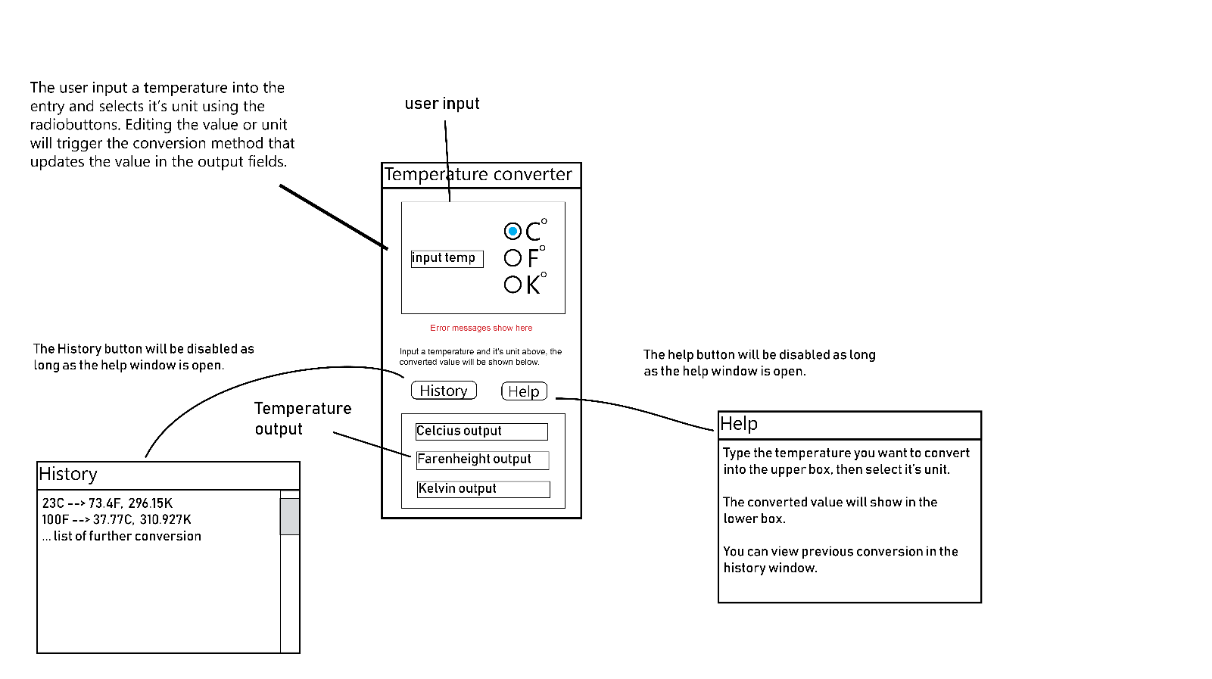

# Initial Trello plan

# History window

## Testing plan

|  |  |  |
| --- | --- | --- |
| **Action** | **Expected outcome** | **Pass** |
| Clicking help button on main window | The help window appears and the help button is disabled |  |
| Clicking help button while help window is open. | Nothing happens |  |
| Closing main window with help window open | Both windows close, process terminates |  |
| Close help window | Help window closes and the help button is enabled. |  |

Testing video:

[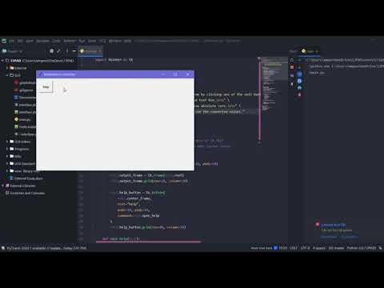](https://www.youtube.com/embed/2tK1w166Gvs?feature=oembed)

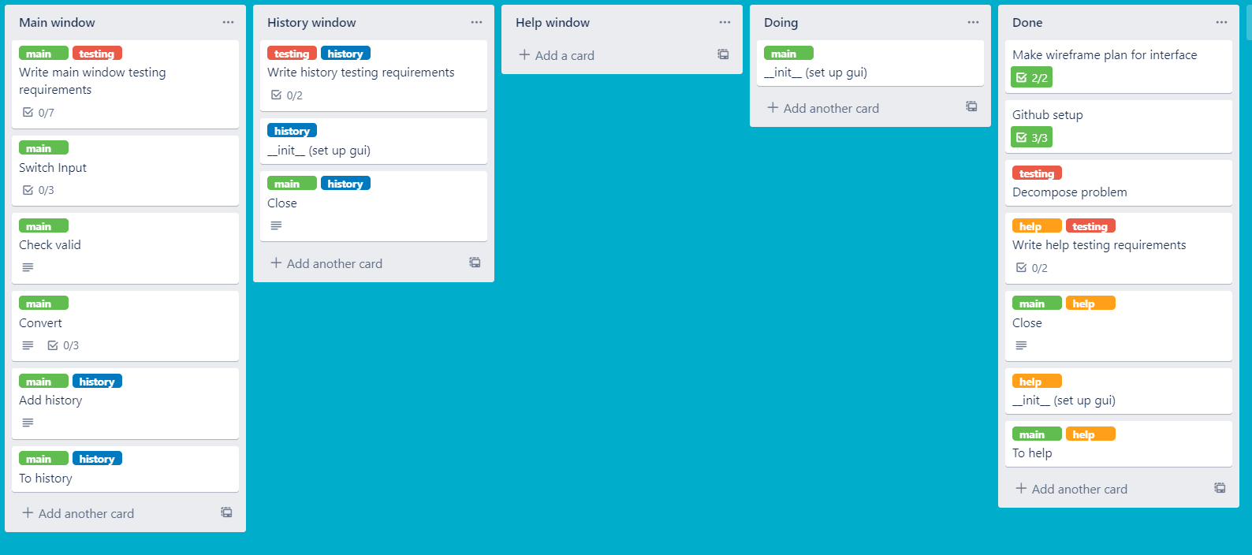

# Main window

## Testing requirements

|  |  |  |
| --- | --- | --- |
| **Action** | **Expected output** | **Pass** |
| Clicking help button | Opens the help window. See help window testing for more. |  |
| Typing in a valid temperature | Updates the output values correctly |  |
| Inputting a non-numerical value for temperature | Error message says invalid input |  |
| Correcting an invalid input | Error message goes away, correct values are displayed |  |
| Inputting a temperature below 0K | Error message says below absolute zero |  |
| Changing the input unit | Output values update to correct values or shows error message if temp is below 0K |  |
| Clicking history button | Opens history window |  |

[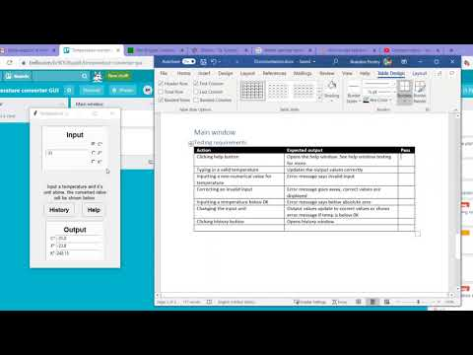](https://www.youtube.com/embed/PSS1K56VkWA?feature=oembed)

