Temperature conversion GUI

# Wireframe

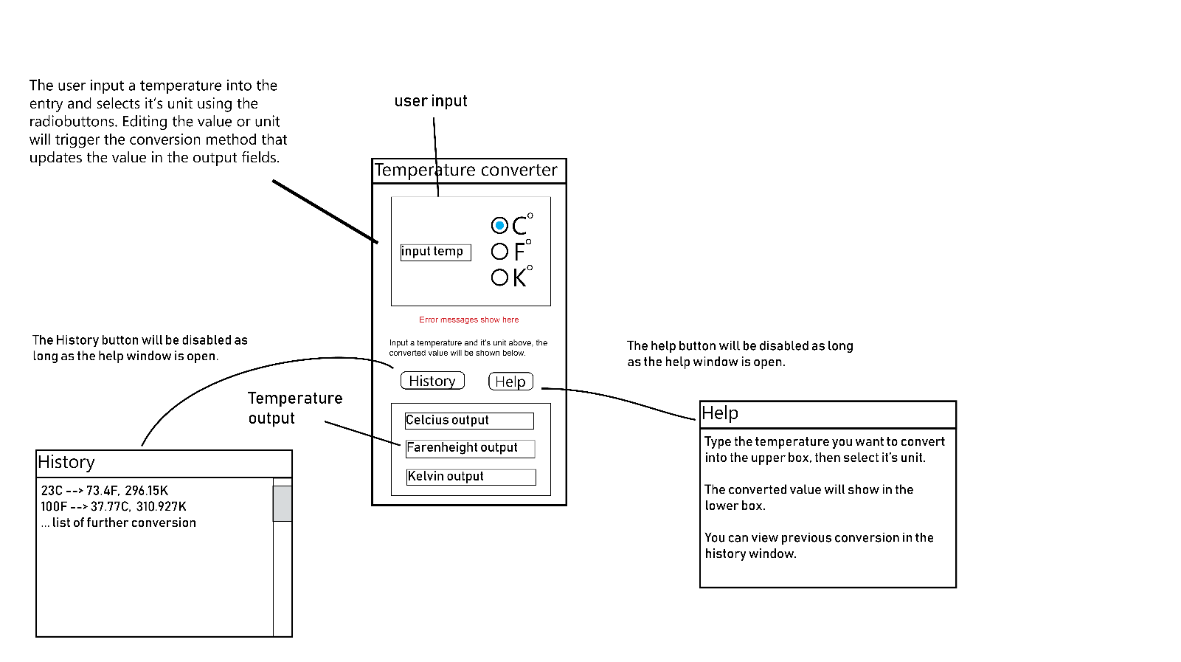

# Initial Trello plan

# History window

## Testing plan

|  |  |  |
| --- | --- | --- |
| **Action** | **Expected outcome** | **Pass** |
| Clicking help button on main window | The help window appears and the help button is disabled |  |
| Clicking help button while help window is open. | Nothing happens |  |
| Closing main window with help window open | Both windows close, process terminates |  |
| Close help window | Help window closes and the help button is enabled. |  |

Testing video:

[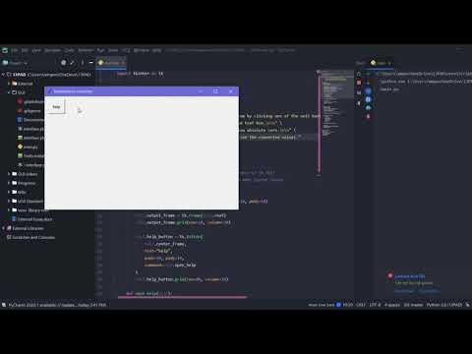](https://www.youtube.com/embed/2tK1w166Gvs?feature=oembed)

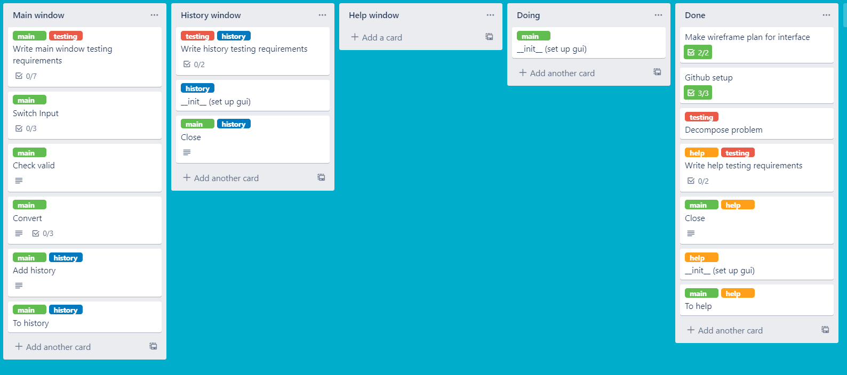

# Main window

## Testing requirements

|  |  |  |
| --- | --- | --- |
| **Action** | **Expected output** | **Pass** |
| Clicking help button | Opens the help window. See help window testing for more. |  |
| Typing in a valid temperature | Updates the output values correctly |  |
| Inputting a non-numerical value for temperature | Error message says invalid input |  |
| Correcting an invalid input | Error message goes away, correct values are displayed |  |
| Inputting a temperature below 0K | Error message says below absolute zero |  |
| Changing the input unit | Output values update to correct values or shows error message if temp is below 0K |  |
|  |  |  |

[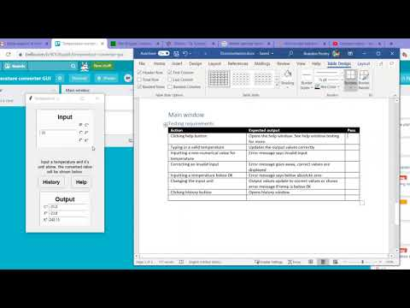](https://www.youtube.com/embed/PSS1K56VkWA?feature=oembed)

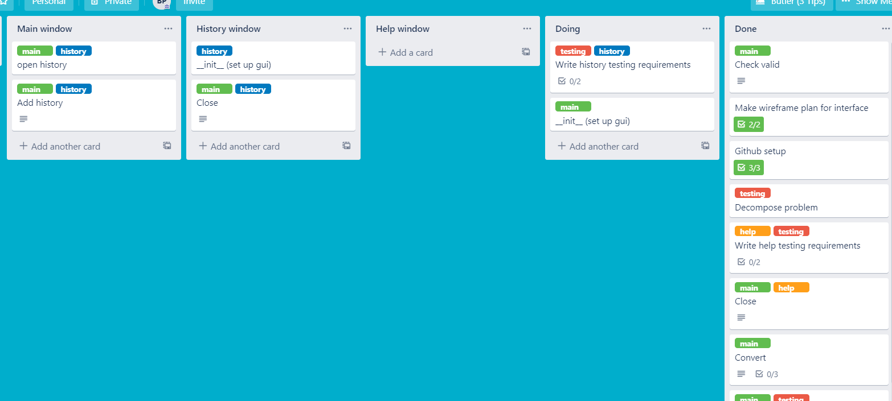

# History window

In my initial plan each calculation would be added to history when the user pressed the button to do the conversion. This doesn’t work in my current implementation as the conversion is done whenever the user types a character into the input so if I saved to history each time a conversion was done I would make an entry every time a character was pressed.

To fix this issue I added a save button that would allow the user to add a character to history when they think it is necessary. My initial plan would have ensured that every conversion is saved so the user will always be able to find the previous conversion they are looking for. My current system is open to the user forgetting to save an important conversion which is an issue but I think that this is a good compromise considering the time saved by automatically doing conversions.

## Testing plan

|  |  |  |
| --- | --- | --- |
| **Action** | **Expected output** | **Pass** |
| Press history window button | History button Is disabled. History window opens showing past calculations |  |
| Press save button (on main window) | Saves calculation to history and shows on history window. |  |
| Close history window | History button is enabled. History window closes. |  |