

ST. CECILIA’S COLLEGE-CEBU, INC.
LASSO Supervised School
Ward II, Poblacion Minglanilla, Cebu

BARANGAY DOCUMENT REQUEST SYSTEM

AUTHOR
BULAGAO, JAN KLYDE
BSIT – 2D

Table of Contents
- Introduction
- System Overview
- User Roles
- Significance
- Stakeholders
- Features and Functions
- User Manual
- Troubleshooting

INTRODUCTION
The Barangay Document Request System is a console-based application designed to streamline and digitize the process of requesting, processing, and managing barangay documents. This system eliminates the need for manual paperwork and reduces processing time by providing an efficient platform for residents to submit document requests online and for barangay officials to manage these requests systematically.
Built using Java and SQLite database, this system provides a secure and organized way to handle document requests such as Barangay Clearance, Certificates of Residency, Indigency Certificates, and other barangay-issued documents.

The Barangay Document Request System is a role-based application that supports three main user types:
- Residents - Community members who request documents
- Officials - Barangay staff who process and approve requests
The system maintains a centralized database that stores:
- User accounts and credentials
- Document types and fees
- Request records and status tracking
- Approval logs and history

User Roles
1. Residents
Primary Function: Request barangay documents online
Capabilities:
- Register for an account (requires approval)
- Log in to their personal account
- Browse available documents and their fees
- Submit document requests with purpose/reason
- View request history and status
- Follow up or cancel pending requests
- Update personal information and password
Limitations:
- Cannot access other residents' information
- Cannot approve their own requests
- Must wait for official approval to access the system
2. Officials/Admin
Primary Function: Manage the system and process document requests
Capabilities:
- Full access to all system features
- Register new users directly (approved automatically)
- Approve or deny resident registrations
- Process document requests (approve/deny)
- Manage user accounts (update, delete, disable/enable)
- Manage document types and fees
- View all system logs and reports
- Track who approved each request
Limitations:
- Responsible for maintaining data accuracy
- Must provide name when approving/denying requests

Significance

For Residents:

Convenience - Request documents from home without visiting the barangay hall

Time-Saving - No need to queue or wait in person

Transparency - Track request status in real-time

24/7 Access - Submit requests anytime

Digital Records - Maintain personal request history

For Barangay Officials:

Efficiency - Process multiple requests faster

Organization - Centralized database for all requests

Accountability - Track who approved each request

Reporting - Generate logs and statistics easily

Reduced Paperwork - Less manual filing and storage

For the Community:

Modernization - Brings barangay services into the digital age

Accessibility - Makes services available to more residents

Transparency - Clear process and status tracking

Environmental Impact - Reduces paper usage

Stakeholders
Primary Stakeholders:
- Barangay Residents
  - End-users who benefit from convenient document request services
  - Includes working professionals, students, senior citizens, and all community members
- Barangay Officials
  - Barangay Captain
  - Barangay Secretary
  - Barangay Council Members
  - Administrative Staff
Secondary Stakeholders:
- System Developers/IT Support
  - Maintain and update the system
  - Provide technical support
- Government Agencies
  - May require access to statistics and reports
  - Oversee barangay operations

- Future Stakeholders
  - Other barangays that may adopt the system
  - Software vendors or service providers

D. FLOWCHART
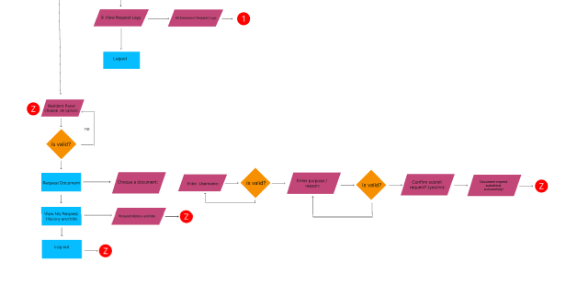
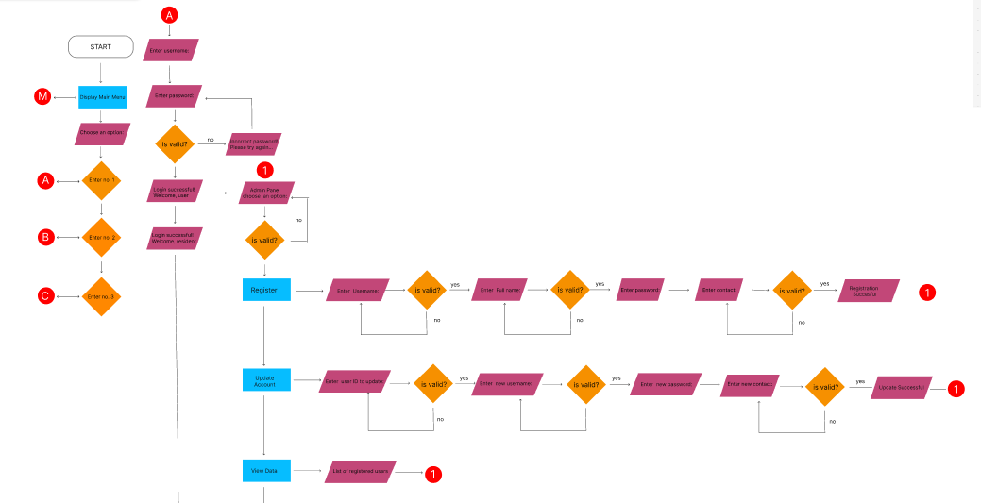
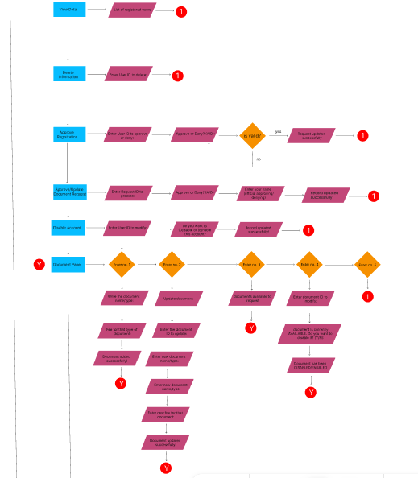
For the Better View: https://www.figma.com/board/87PabSL9I58ZHLzmIHDjZw/Bulagao?node-id=0-1&p=f&t=z80i0pW6TP2IxItf-0

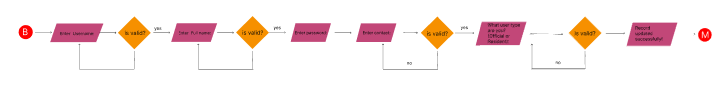

Features and Functions
Core Features:
1. User Registration & Authentication
- Online registration for residents
- Secure login system with username and password
- Role-based access control
- Account approval workflow
- Password protection
2. Document Management
- Add, update, and view document types
- Set and modify document fees
- Enable/disable document availability
- Track document request history
3. Request Processing
- Submit document requests with purpose
- View request status (Pending, Approved, Denied, Cancelled)
- Track request date and time
- Record approval authority
4. User Management
- Create, update, and delete user accounts
- Approve or deny registrations
- Disable or enable accounts
- Validate unique usernames, full names, and contact numbers
- Enforce 11-digit contact number format
5. Dashboard Interfaces
- Resident Dashboard:
  - Request documents
  - View request history
  - Follow up or cancel requests
  - Update personal details
- Official/Admin Dashboard:
  - Approve registrations
  - Process document requests
  - Manage users and documents
  - View system logs
6. Data Validation
- Unique username validation
- Unique full name validation
- Unique contact number validation
- 11-digit contact number format enforcement
- ID existence verification before operations
7. Audit Trail
- Log all document requests
- Record approval/denial decisions
- Track who processed each request
- Maintain request history

User Manual
This manual provides step-by-step instructions on how to use the Barangay Document Request System
A. Registering
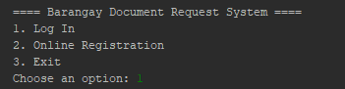

Step 1: Select Registration
- At the main menu, type 2 and press Enter to start the registration process.
Step 2: Enter User Information
You will be asked to provide the following details:
- Username
- Full Name
- Password
- Contact Number
- User Type (Official or Resident)
Example:
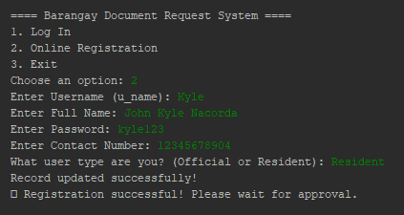

Step 3: Wait for Approval
- Once registration is complete, your account will be reviewed by the system administrator.
- You cannot log in yet until your account is approved.

B. Logging In
After your account has been approved, return to the main menu:
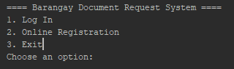
Step 1: Select Log In
- Type 1 and press Enter.
Step 2: Enter Your Credentials
- Provide the username and password you created.
Example:
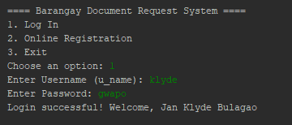
If you enter incorrect login information:

3. Requesting a Document
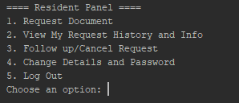
Once logged in, the system will display a user menu, for example

Step 1: Choose Request Document
- Type 1 and press Enter.
Step 2: Select Document Type
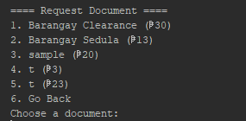

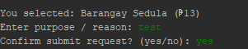
Step 3: Fill reason for requesting and confirm

4.2 View My Request History and Info
Available when you select option 2.
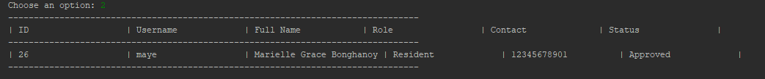
4.3 Follow Up/Cancel Request
Available when you select option 3.
Step 1: View Your Requests
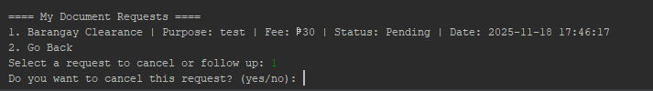Note: Only cancellation is available. For follow-ups, contact your barangay admin directly.

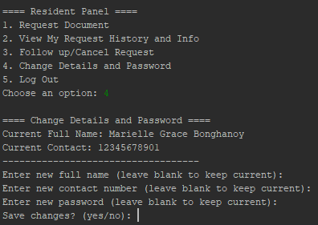
Important:
- Contact number must be exactly 11 digits
- Blank fields keep the current value
- Changes are immediate

4.5 Log Out
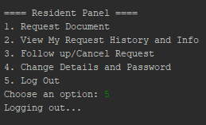
5. Admin/Official Panel Features
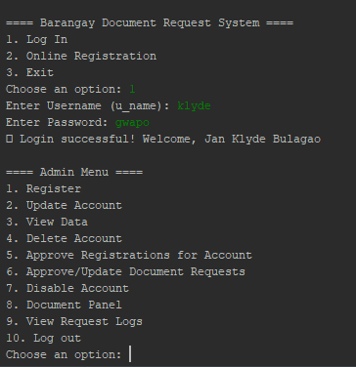
Step 1: Choose Your Action
Type a number (1-10) and press Enter.

5.1 Register
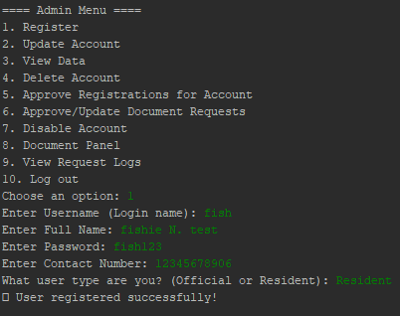

5.2 Update Account
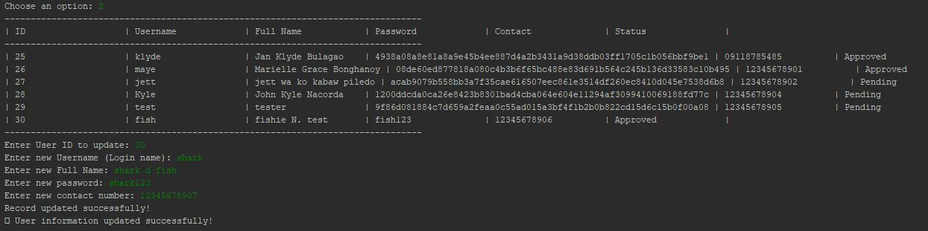
5.3 View Data
Available when you select option 3.
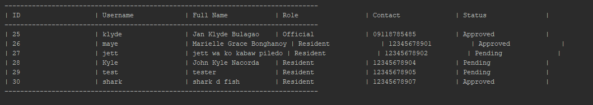

5.4 Delete Account
Available when you select option 4.
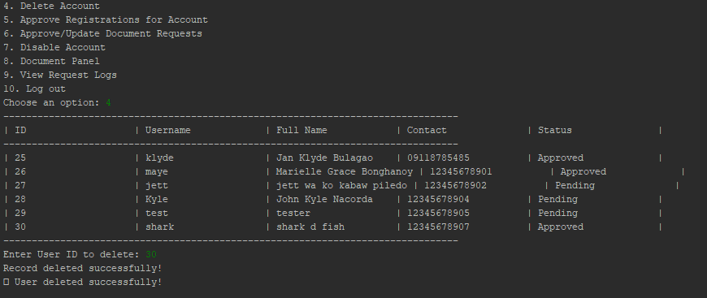Warning: This action is permanent and cannot be undone.

5.5 Approve Registrations for Account
Available when you select option 5.
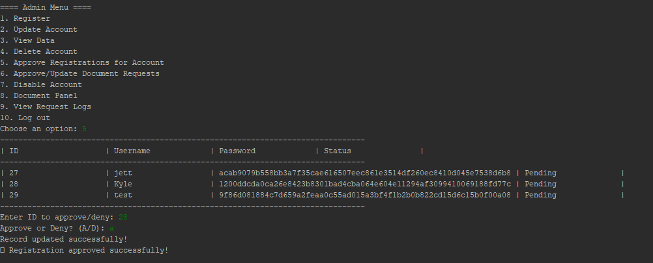

5.6 Approve/Update Document Requests
Available when you select option 6.
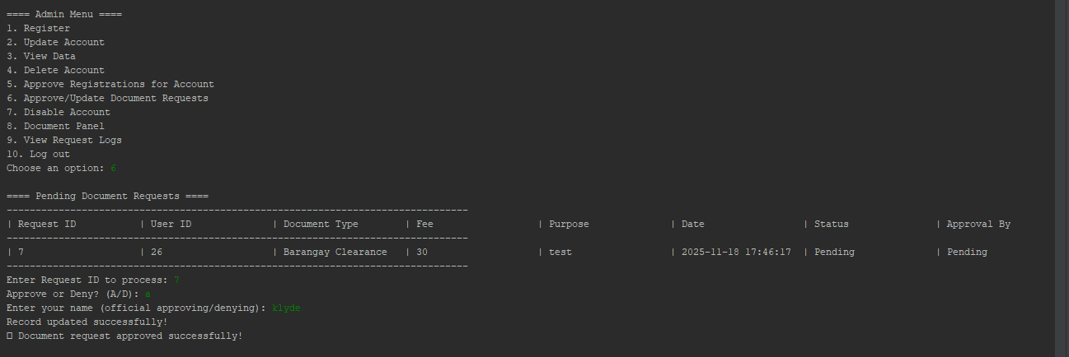
5.7 Disable Account
Available when you select option 7.
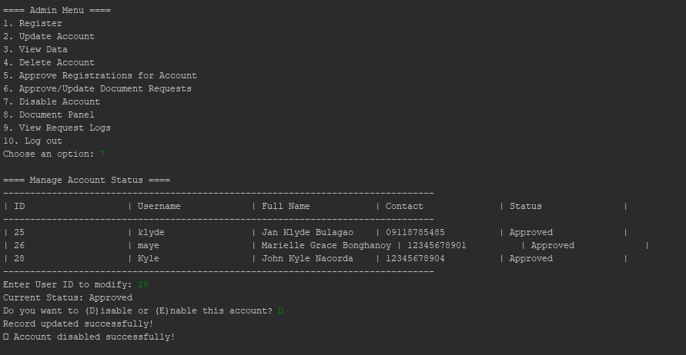Note: Disabled accounts cannot log in. Users will see "Your account has been disabled" message.

5.8 Document Panel
Available when you select option 8.
Opens a sub-menu:
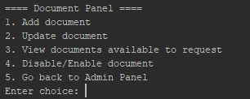
Select option 1.
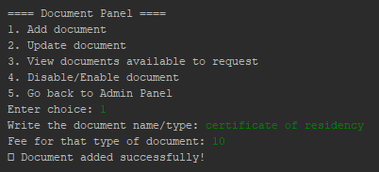
5.8.2 Update Document
Select option 2.
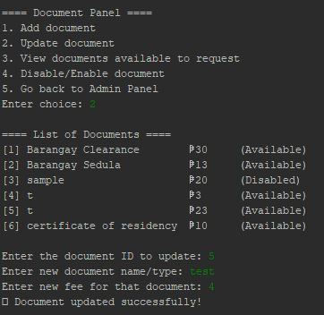
5.8.3 View Documents Available to Request
Select option 3.
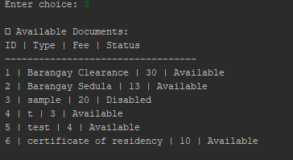

5.8.4 Disable/Enable Document
Select option 4.
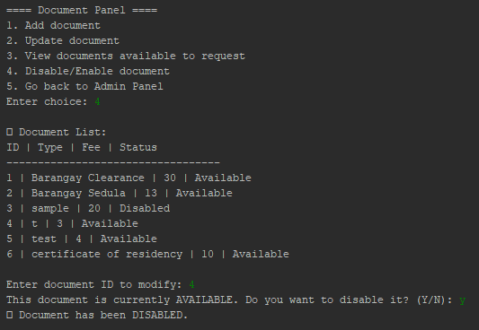
5.8.5 Go Back to Admin Panel
Select option 5 to return to the main Admin Menu.

5.9 View Request Logs
Available when you select option 9.
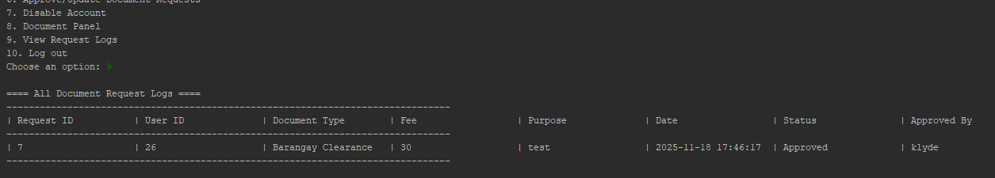

5.10 Log Out
Select option 10 to return to the main menu.
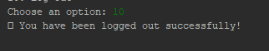

6. System Status Reference
Account Status Types
Status | Meaning | Can Log In?
Pending | Awaiting admin approval | ❌ No
Approved | Active account | ✅ Yes
Denied | Registration rejected | ❌ No
Disabled | Temporarily deactivated | ❌ No
Document Request Status Types
Status | Meaning | Who Can Set
Pending | Awaiting admin review | System (automatic)
Approved | Request accepted | Admin/Official
Denied | Request rejected | Admin/Official
Cancelled | User cancelled | Resident
Document Availability Status
Status | Meaning | Visible to Residents?
Available | Can be requested | ✅ Yes
Disabled | Temporarily unavailable | ❌ No

7. Common Error Messages
Error Message | Cause | Solution
❌ Username not found! | Username doesn't exist | Check spelling or register
❌ Incorrect password! | Wrong password | Re-enter correct password
⏳ Your account is still pending approval | Account not approved yet | Wait for admin approval
❌ Your account has been disabled | Account deactivated | Contact admin
❌ Username already exists! | Username taken | Choose different username
❌ Contact number already exists! | Phone number registered | Use different contact
❌ Invalid contact number! | Not 11 digits | Enter 11-digit number
❌ ID not found! | Invalid ID entered | Enter valid ID from list
❌ Only choose 'Official' or 'Resident' | Invalid user type | Type "Official" or "Resident"

8. Quick Tips
For Residents:
- Verify contact information is correct
- Check request status regularly
- Cancel unneeded requests
- Provide clear, specific purposes
For Admins/Officials:
- Review pending registrations daily
- Process document requests promptly
- Use "Disable" instead of "Delete" for temporary restrictions
- Review request logs regularly
- Keep document types and fees updated
- Record your name accurately when processing requests

9. Quick Reference
Main Menu Options:
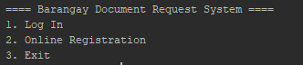

Resident Panel Options:
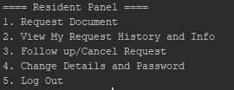
Admin Panel Options:
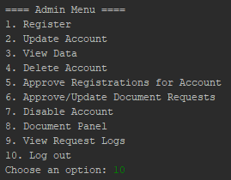
Document Panel Options:
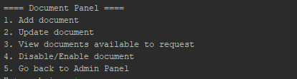

ERD ( ENTITY-RELATIONSHIP DIAGRAM)
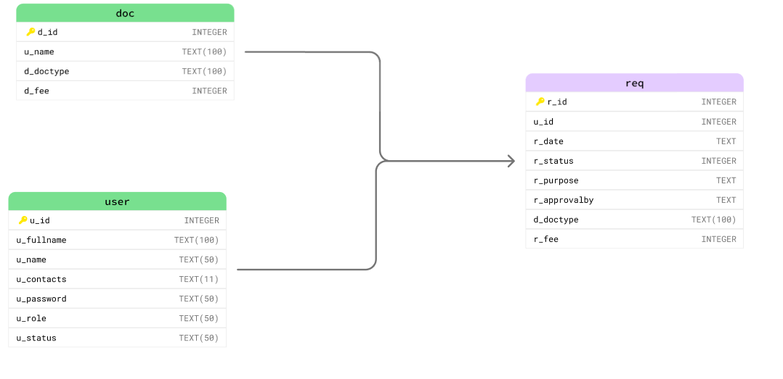

DATA DICTIONARY

tbl_user

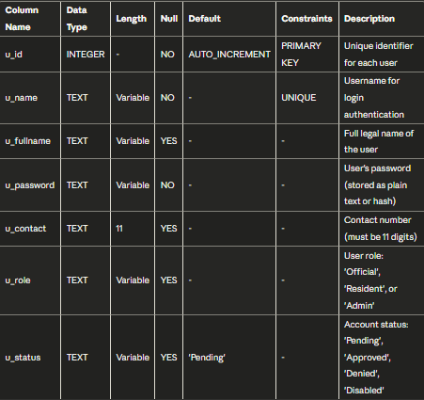

tbl_penalty

tbl_req

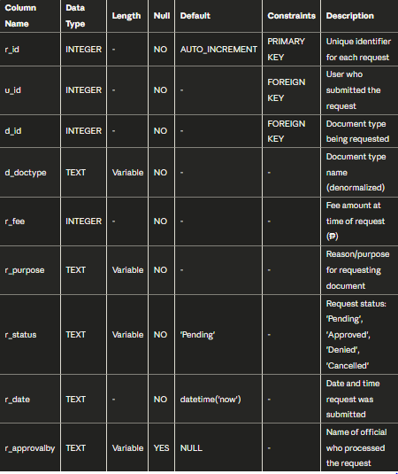
tbl_doc
