Index
Important Note 2
Quick Guide (not recommended) 2
Detailed Guide (recommended) 4
What is IEEE PCVI? 4
Key Features 5
Supported Soundslots 5
How to use IEEE PCVI 6
1. Download 6
2. Unzip 6
3. Verify Contents 7
4. Renaming Character Voice Sound Files 7
4.1 Base Name 7
4.2 Postfix 8
5. Moving and Organizing Sound Files 8
5.1 Copy Files 8
5.2 Automatic Distribution 9
6. Building the Mod 11
6.1 Generate WeiDU Code and Edit Voice Prompts 11
7. Finalizing the Mod 13
8. Testing your Mod 14
8.1 Installing Your Mod 14
8.2 TLK Repair (Optional) 14
8.3 When to Apply TLK Repair 15

Important Note
It is recommended to use the online guide/information which should be located on the repository wiki. This document should only be used in an emergency when there is no internet connection or the wiki for the official repository is missing for some reason.
This document may not be maintained or may be maintained very rarely!!

Quick Guide (not recommended)
- Download: Get the latest release version of IEEE PCVI
- Extract: Unzip the file.
- Sound Files: Copy the sound files for your desired language (e.g., for German, copy to IEEE-Player-Character-Voice-Installer-<version>\vox\de_DE, for English, copy to IEEE-Player-Character-Voice-Installer-<version>\vox\en_US). Supported soundsets are listed here BGEE, SoD, IWDEE, BG2EE (or in the detailed guide).
Editing Create_and_Distribute.bat:
- Open: Use a text editor (e.g. Notepad++) to open Create_and_Distribute.bat.
- Base Name: Change Set soundsetName[0]=!_DEMO to match the base name of your sound files (e.g., if files start with myName<postfix>, replace with myName). If you have multiple base names, add more lines like Set soundsetName[x]=<name>, ensuring unique and non-overlapping names (max 6 characters).
- Language: Change Set languages[0]=en_US to your desired language code (e.g., de_DE for German). If offering both English and German, add Set languages[1]=de_DE below.
- Customization Text: Change Set en_US[0]=!_Demo(Complete):Female Robot to the desired display name in the customization menu (e.g. Set en_US[0]=MyVoice:Warrior). Use Set de_DE[y] for German names (y is an index number for the array.).
- Save: Save changes to Create_and_Distribute.bat.
Building the Mod:
- Run Script: Double-click Create_and_Distribute.bat to process sound files and generate WeiDU code.
- Edit InitAllSlotNumbers.tpa: In relevant language folders (e.g., IEEE-Player-Character-Voice-Installer-<version>\de_DE), replace TODOs in InitAllSlotNumbers.tpa with sound file descriptions according to the comments. Save the file.
- Save: Save changes to InitAllSlotNumbers.tpa.

- Edit !_moduleNames.tra: In the same folders, change @1=~Mod-Name~ in
!_moduleNames.tra to your chosen mod name (e.g., @1=~My_Voice_Collection~). Save the file.
- Save: Save changes to !_moduleNames.tra.
- Open: Open setup-Your_Mod_Name.tp2 in a text editor.
- Information: Edit the "Information" section with your desired mod details.
- Language: If offering only one language, delete the unused "Languages" area. Keep both if offering multiple languages.
- Save: Save changes to setup-Your_Mod_Name.tp2.
Finalizing the Mod:
- Rename: Rename setup-Your_Mod_Name.tp2 to your chosen mod name
(e.g. setup-My_Custom_Voices.tp2).
- Rename Folder: Rename the IEEE-Player-Character-Voice-Installer-<version> folder to your desired mod name.
- Rename Executable: Rename setup-Your_Mod_Name.exe to a fitting name
(e.g., setup-My_Custom_Voices.exe).
- Delete Unneeded Files: Delete the following files:
- Create_and_Distribute.bat
- You can delete this file.txt in:
  - ...\vox\en_US\wav
  - ...\vox\en_US\sound
  - ...\vox\de_DE\wav
  - ...\vox\de_DE\sound
- README.md
- You can delete every file in the guide folder and replace it with your own guide(s)

Note: This quick guide assumes basic familiarity with modding tools and concepts, particularly the WeiDU installer.

Detailed Guide (recommended)

What is IEEE PCVI?
IEEE PCVI, short for "Infinity Engine Enhanced Edition Player-Character-Voice-Installer", is a system designed to install pre-recorded sound files into Infinity Engine games. However, it excludes Planescape Torment Enhanced Edition as its main character already has a unique voice. The games which are supported, are:
- BGEE (Baldur’s Gate Enhanced Edition)
- SoD (Siege of Dragonspear)
- IWDEE (Icewind Dale Enhanced Edition)
- BG2EE (Baldur’s Gate 2 Enhanced Edition)
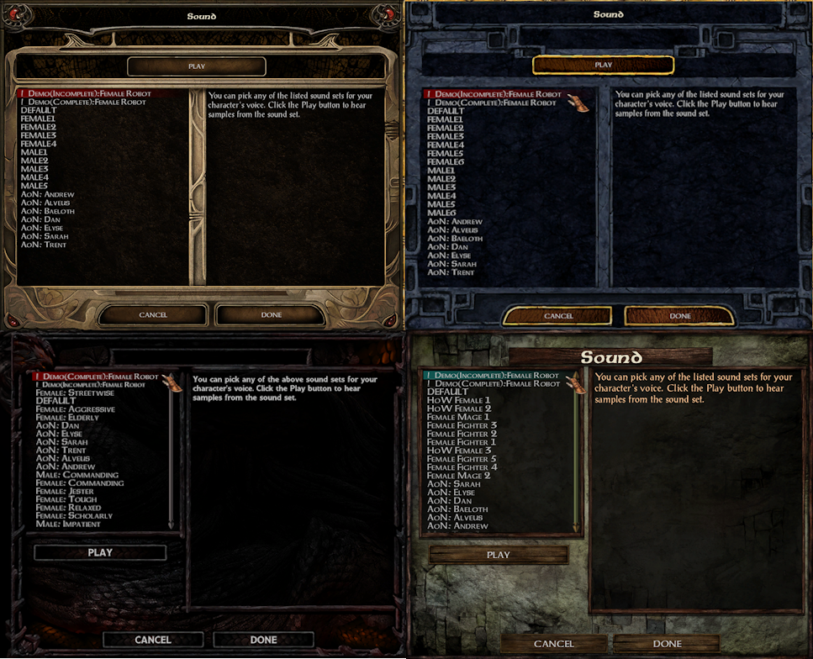
Figure1: Sound customization menues (BGEE2, BGEE, SoD, IWDEE)

Key Features
- Installs pre-made sound files for player character voices. It is capable of installing WAV and OGG sound files. This renames OGG file extensions to WAV file extensions.
- Optionally scans "dialog.tlk" with the installed soundset and automatically repairs any incompatible "strref" entries, ensuring seamless integration with the selected voice pack.
- Serves as a template for creating custom player character voice sets.
- Requires minimal coding knowledge

Supported Soundslots
IEEE PCVI mainly targets soundslots used by the original Infinity Engine games in their selectable voice sets within the character customization menu.
It uses the unofficial soundset convention for advanced sound slots, ensuring compatibility with sound files developed under this standard.
If you are interested installing more voice lines for the player character, an alternative system is the soundset installation tool.
The supported sound slots as a list for the individual games are marked with Postfix and their meaning can be found in the “guides” folder or online:
Postfixes
Online-Links to postfix tables:

BG:EE (Baldur's Gate:Enhanced Edition)

SoD (Siege of Dragonspear)

BG2:EE (Baldur's Gate 2:Enhanced Edition)

IWD:EE (Icewind Dale:Enhanced Edition)

b | l_
c | i
d | j
a | k
8 | 0_
9 | 1_
g_ | 2_
h_ | 3_
l | W
m | z
e | 1
n | 2
o | 3
p | 4
q | 5
r | 6
f | 7
g | s
h | t
0 | u
k_ | v

How to use IEEE PCVI

1. Download
- Get the latest release version of IEEE PCVI. (See example in Figure2)
- You'll find it as a file named IEEE-Player-Character-Voice-Installer--<version>.zip.
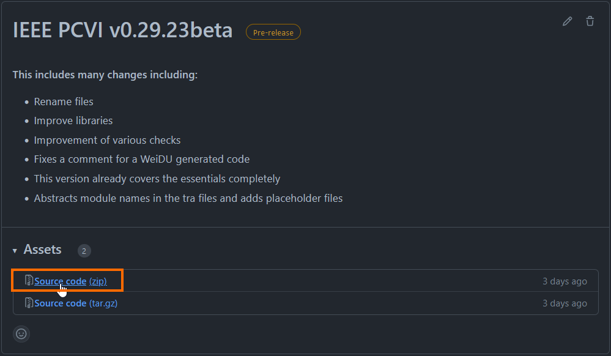
Figure2

2. Unzip
- Extract the contents of the zip file.
- Inside, you'll find a folder with the same name as the zip file (as an example, see Figure3).
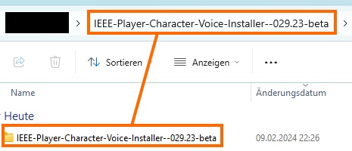
Figure3

3. Verify Contents
- Open the extracted folder. It should at least contain the files shown in Figure 4. These are the most important ones as IEEE PCVI would not function properly without them. If there are additional files and folders not shown in Figure 4, they were most likely added later and should not affect functionality. It should be safe to delete these added files and folders.
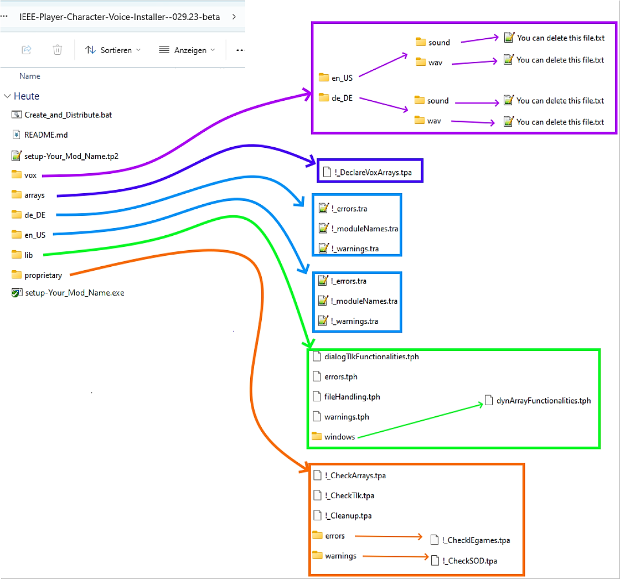
Figure4

4. Renaming Character Voice Sound Files
To customize voice sound files, you'll need to rename them using a base name and a postfix.

4.1 Base Name
- Choose a unique base name (maximum 6 characters) for each selectable voice in the game's sound customization menu.
- Example: !_DEMO for the custom character voice.

4.2 Postfix
- Add a postfix to the base name to define specific sound files.
- Example: !_DEMOb for the sound played when selecting the custom character as party leader.
Naming Rules
Base names cannot be subsets of other base names. Here follows an example:
Basename 1 | Basename 2 | Condition
!_DEMO | !_D | Not Allowed, !_D is a subset of !_DEMO
!_DEMO | !_DU | Allowed !_DU is not a subset of !_DEMO
The reason for this restriction is to prevent duplication in the game's sound customization menu.

5. Moving and Organizing Sound Files

5.1 Copy Files
- Once you've renamed your sound files, move them to the appropriate language folder within the ...\vox directory.
- Example: German files go to ...\vox\de_DE, English files go to ...\vox\en_US (see Figure5 for a visual example).
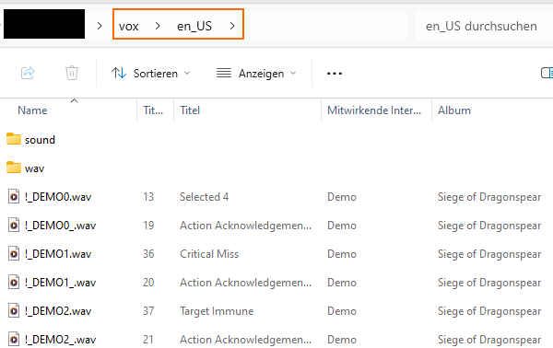
Figure5

5.2 Automatic Distribution
The script handles distributing files to sound and wav subfolders within each language folder.
- sound: Files with official postfixes.
- wav: Files with unofficial postfixes.
- Code: The script also generates new WeiDU code files for further integration.
Before proceeding, you need to edit the Create_and_Distribute.bat file:
- Use a code editor like Notepad++ to open the file.
- Find the section labeled INIT Soundset File Names (see Figure6 for an example).
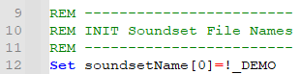
Figure6
- Replace !_DEMO with your desired base name.
- For multiple base names, add additional lines following the format
Set soundsetName[x]=<base name>, where x is the index number (1 for the second name, etc.). Refer to Figure7 for an example of how the configuration should look with two base names.
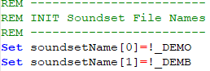
Figure7

- Find the section labeled INIT Languages (see Figure8 for an example).
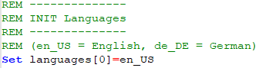
Figure8
- Replace en_US with your desired language code. For example, use de_DE for German. If your custom voices support multiple languages, add new lines below the first one following the same format Set languages[x]=<language code> where x is the index number starting from 1 for the second language.
For example(see Figure9), to add German, you would include the line Set languages[1]=de_DE.
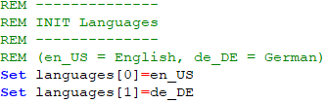
Figure9
- Refer to the README.md file or online resources for a list of supported languages.
- Find the section labeled INIT Soundset Custom Names (see Figure10 for an example).
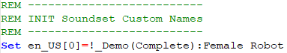
Figure10
- This section explains how to define the names displayed for your custom voices in the character customization menu (see Figure 11 for an example with two voices).
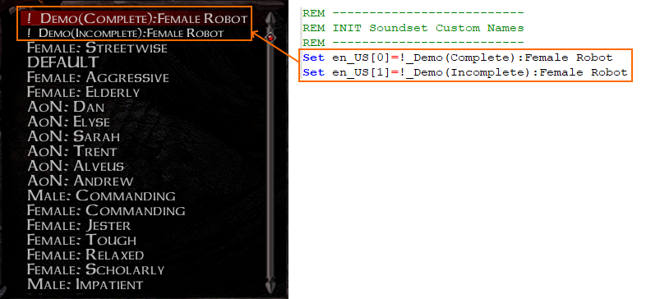
Figure11
- Use the following format to set custom voice names for each language:
Set <language code>[x]=<custom voice name>
  - <language code>: Replace with the appropriate code (e.g., en_US for English, de_DE for German).
  - x: The index value representing the voice number in the menu (0 for the first, 1 for the second, etc.).
  - <custom voice name>: The desired name for the voice in that language.
- Refer to Figure12 for an example of how to configure names for two custom voices in both English and German.
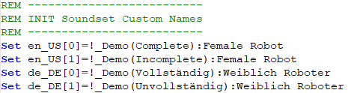
Figure12
  - The index value x starts at 0 and increments by 1 for each voice within a language.
  - Ensure the number of voice names matches the number of custom voices you have created.
- Save changes to Create_and_Distribute.bat.

6. Building the Mod

6.1 Generate WeiDU Code and Edit Voice Prompts
- Double-click Create_and_Distribute.bat to process sound files and generate WeiDU code.
- Depending on your script configuration, you'll find two .tpa files(see Figure13) in the relevant language folder (e.g., de_DE or en_US).
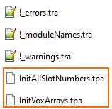
Figure13
- Open InitVoxArrays.tpa with a code editor like Notepad++. (Figure14 shows an example of its content.)
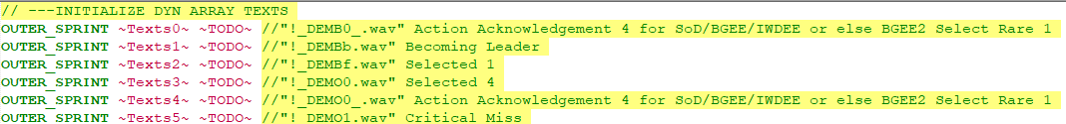
Figure14

- For each line containing ~TODO~, enter the text you want your custom voice to speak. For example, replace OUTER_SPRINT ~Texts0~ ~Yes, I will do as you say!~ with your desired phrase.
- Look for comments starting with //... to understand what kind of text is expected for each line. These comments often mention the sound file name (including base name and postfix) and provide context (e.g., "Selected 1").
- If you have sound files for more than one language, repeat steps 3-5 for each generated InitAllSlotNumbers.tpa file in the respective language folder.
- Refer to the provided links ( BGEE, SoD, IWDEE, BG2EE) or the postfix tables in the guide folder for more information about sound files.
- Save changes to !_moduleNames.tra.
- In the same folders, change @1=~Mod-Name~ in
!_moduleNames.tra to your chosen mod name (e.g., @1=~My_Voice_Collection~). Figure15 shows the path and the files content.
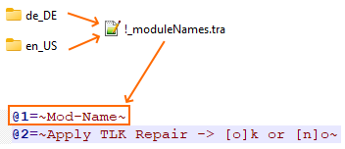
Figure15
- Save changes to !_moduleNames.tra.
- Open setup-Your_Mod_Name.tp2 in a text editor.
- Edit the "Information" section with your desired mod details.
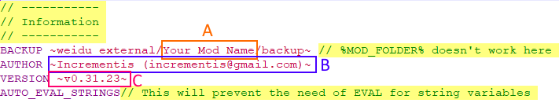
Figure16
  - A: This is the mod name. A backup is saved here.
  - B: Your name and contact details come here
  - C: The version number of your mod

- If offering only one language, delete the unused "Languages" area. Keep all the ones you need if offering multiple languages. See Figure17 for language areas(e.g., delete A or B or keep them both).
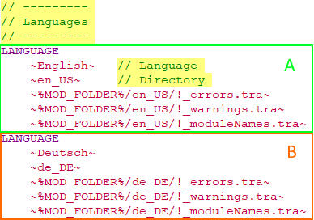
Figure17
- Save changes to setup-Your_Mod_Name.tp2.

7. Finalizing the Mod
- Rename setup-Your_Mod_Name.tp2 to your chosen mod name
- (e.g. setup-My_Custom_Voices.tp2).
- Rename the IEEE-Player-Character-Voice-Installer-<version> folder to your desired mod name.
- Rename setup-Your_Mod_Name.exe to a fitting name
- (e.g., setup-My_Custom_Voices.exe).
- Delete the following files:
- Create_and_Distribute.bat
- You can delete this file.txt in:
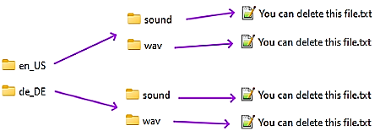
  - ...\vox\en_US\wav
  - ...\vox\en_US\sound
  - ...\vox\de_DE\wav
  - ...\vox\de_DE\sound
- README.md
- You can delete every file in the guide folder and replace it with your own guide(s)

8. Testing your Mod

8.1 Installing Your Mod
- Move your entire mod folder (example in Figure18) into your main game directory.
- Locate the file named setup-Your_Mod_Name.exe inside your copied mod folder (e.g., renamed in Figure18 to setup-Demo_SoD.exe). Copy this file directly into your main game directory and then run it. This will initiate the mod installation.
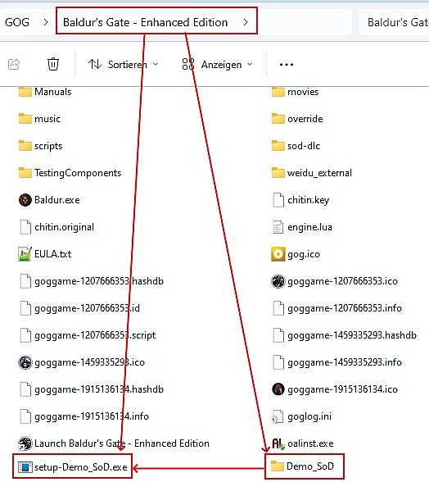
Figure18

8.2 TLK Repair (Optional)
This step is only required if you've manually edited text in InitVoxArrays.tpa outside of this guide (e.g., correcting typos). Skip it for your first installation (see example in see Figure19).
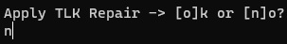
Figure19: Press „n“ for not to repair

8.3 When to Apply TLK Repair
- You finished your mod and distributed it (e.g., on GitHub). You later realize text needs fixing in InitVoxArrays.tpa due to accidental changes.
Applying TLK Repair will ONLY repair relevant text in your game's dialog.tlk file that matches your mod's sound file names. This prevents accidental changes and keeps dialog.tlk lean.
Note: Repairing a large dialog.tlk can take time. Expect longer times for bigger mods. (E.g., on my machine, repairing a MegaMod-sized dialog.tlk with nearly 700,000 entries took 3 minutes 40 seconds. 700,000 entries is seven times the size of BG2EE dialog.tlk entries..)

My System Specs (for reference):
WeiDU: Version 24900
Operating System: Microsoft Windows 11 Home
System Manufacturer: Acer
Processor: 12th Gen Intel(R) Core(TM) i7-12700F
RAM: 16 GB

Congratulations! You've reached the end of this guide.

