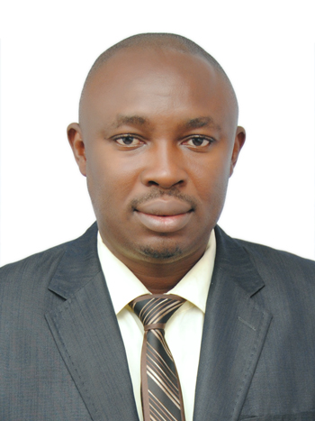
Proposed Position: Consultant Hydrogeology /Hydrogeophysics /Hydrogeochemistry /
Environmental Geology /Soil, Sediment and Water Quality Expert

Name of Firm: Pioneer Geoservices Limited
Name of Staff: Prof. Akobundu N. Amadi
Profession: Consultant/Researcher
Date of Birth: 4th April, 1976
Years with Firm/Entity: Two years
Nationality: Nigeria
Membership in Professional Societies:
- Member, Council of Nigerian Mining Engineers and Geoscientists (COMEG-2008-921)
- Member, Nigerian Mining and Geosciences Society (NMGS-C-2007-3376)
- Member, International Association of Hydrogeologists (IAH-2008-123198)
- Member, Nigerian Association of Hydrogeologists (NAH-CH-2007-0489)
- Member, Nigerian Association for Engineering Geology and the Environment (NAEGE-C-2019-171)
- Member, International Medical Geologist Association - Nigeria (IMGA-P-2019-034)
- Member, Society of Exploration Geophysicists (SEG-A-2008-176869)
- Member, Society of Petroleum Engineers (SPE-2003-3159504)
- Member, Nigerian Society of Mining Engineers (NSME-A-2014-0118)
- Member, Ghana Institution of Geoscientists (GhIG-2019-738)
Detailed Tasks Assigned: Hydrogeology; Hydrogeophysics; Hydrogeochemistry; Medical Geology; Environmental Geology; Water Resources Utilization and Management; Soil, Sediments and Water Quality Study; Coastline, Coastal Aquifers and Shallow Aquifers Vulnerability Study; Transboundary Surface Water Resources Management; Sustainable Management of Groundwater and Shared Aquifer Systems and Basins
Keynote Speaker/Lead Paper Presenter at Professional Conference
1. Lead Paper Presenter on the Topic: ‘Use of Geological Materials Enhanced with Plastic Waste Additives in the Production of High Performance Pavement Blocks for Road Construction’ at the 9th Annual International Conference and Exhibitions of the Nigerian Association Engineering Geology and the Environment, with the Theme: Engineering Geology for Sustainable Highway Pavement and Buildings in a Changing Global Climate, held between 15th – 19th September, 2024 at Casoni International Hotels & Suites LTD, Port-Harcourt.
2. Lead Paper Presenter on the Topic ‘Integration of Smart Technologies (ST) and Artificial Intelligence in Groundwater Management’ at 35th Annual International Conference and Exhibitions of the Nigerian Association of Hydrogeologists (NAH), with the Theme: Groundwater Development and Regulatory Framework in Nigeria, held between 3rd to 8th November, 2024 at the Grand Central Hotel, Bompai Road, Nasarawa GRA, Kano.
Key Qualifications:
- Project Coordinator, Agro-Climatic Resilience in Semi-Arid Landscape (ACReSAL) Project for Niger State, (World Bank Sponsored Programme), April 10th, 2024 to date.

- Lead Consultant, Agro-Climatic Resilience in Semi-Arid Landscape (ACReSAL) Project for Niger State, Nigeria April 10th , 2024 to date

- Lead Hydrogeologist/Engineering Geologist, Aerial and Geotechnical Survey for Niger State Irrigation Project, May 19th , 2024 to date

- Lead Geologist, Raw Materials Research and Development Council (RMRDC) field data and sample collection, July 6th to August 26th, 2024.

- Consultant Hydrogeologist, Groundwater Evalution in Obbo and Magwi, Eastern Equatoria State, South Sudan, June 20th to July 10th, 2023.

- Lead Geologist, Environmental and Social Impact Assessment (ESIA) for the NNPC Power Plant Gwagwalada, Federal Capital Territory, Abuja, June 12th to July 8th, 2022.

- Lead Geoscientist, Environmental and Social Impact Assessment (ESIA) for the Construction of African Medical Centre of Excellence at Cadastral Zone C22, Federal Capital Territory, Abuja, Marcg 13th to May 8th, 2022.

- Consultant Hydrogeologist, NNPC-IBBU-FUT-FES-Bida Basin Environmental Baseline Study (EBS)/Environmental Impact Assessment (EIA), August 30th to September 10th, 2021.

- Consultant Environmental Geologist, Environmental Impact Assessment of Naturally Occurring Radioactive Materials (NORM) in Rock, Soils, Groundwater and Plants in Mika and Mayolope Areas, North-Eastern Nigeria, April 20th to June 10th. 2021.

- Consultant Environmental Geologist, Environmental Impact Assessment and Engineering Characterization of Pavement Blocks Produced from Plastic Wastes, October 5th 2019 to February, 2020.
- Consultant Geologist, Environmental and Social Impact Assessment and Reserve Evaluation for Graphite and Manganese Ore Deposits within Kagara and Tashan-Kade Area, Niger State, April 5th to June10th, 2019.

- Consultant Environmental Geologist, Environmental Impact and Remediation Study of Lepidolite/Lithum Mining in Niger and Nasarawa States, Northcentral Nigeria, February 5th to April 3rd 2018.

- Lead Hydrogeologist, Environmental and Health Impacts Evaluation on the use of Mercury and Cyanide in Artisanal Gold Mining in Nigeria: A Case Study of Niger and Zamfara States, May 4th to 24th October, 2007.

- Lead Researcher/Hydrogeologist, Environmental Evaluation and Comparative Study on the occurrence of Fluoride in Langtang, Hong and Zango Communities, Northern Nigeria, March 2016 to May, 2016.

- Consultant Geologist, Environmental and Socio-economic Impact Assessment of Nigerian Coal Deposits as raw materials for the production of New Brand of Smokeless Fuel, IBBU-TetFund-National Grant-Project, January, 2016 to June, 2016.

- Lead Researcher/Hydrogeologist, Environmental Hydrogeochemical Study of Soil, Sediment and Water Quality along Owerri-Aba-Port-Harcourt Axis of Eastern Niger Delta, Nigeria, November 2014.

- Lead Researcher/Hydrogeologist, Comparative Study on the Impact of Industrialization on Groundwater Quality in Aba and Onitsha, Southeastern Nigeria, February 2nd to 8th 2013.

Specialized Training
International (Within the last 10 years)
S/NO | TITLE | VENUE | YEAR
1 | African Water Resources Mobility Network (AWaRMN) Program, an Intra-Africa Academic Mobility Scheme Sponsored by the European Union | Fairway Hotel, Kampala, Uganda | 2024
2 | Staff Mobility, African Water Resources Mobility Network (AWaRMN) Program, an Intra-Africa Academic Mobility Scheme Sponsored by the European Union | Department of Geology and Petroleum Studies, Makerere University,  Kampala, Uganda | 2024
3 | World Water Week | Stockholm, Sweden | 2021
4 | Annual International Conference of the Ghana Institution of Geoscientists (GhIG) | University of Mines and Technology, Tarkwa, Ghana | 2019
5 | 4th International Conference on Civil, Environmental, Geology and Mining Engineering | Double Tree, Hilton, Trabzon, Turkey | 2019
6 | Workshop on Structural Geology and Global Tectonics with emphasis on Lithosphere Evolution and Mantle Geodynamics | Karadeniz Technical University, Trabzon, Turkey | 2019
7 | 2nd International Association of Engineering Geology Africa Regional Congress | Hotel De Bently, Utako District, Abuja, Nigeria | 2019
8 | International Conference on Water Africa and West Africa Building and Construction | International Conference Centre, Abuja, Nigeria | 2016
9 | Biennial Groundwater Division Conference and Exhibition | Durban, South Africa | 2013

NATIONAL (within the last 10 years)

S/NO | TITLE | VENUE | YEAR
1 | INEC Collation Officer for Presidential, National Assembly (Senate and House of Representative), Governorship and State House of Assembly Elections | Iku-South-1 Ward Collation Centre, Mandalla, Suleja Local Government Area | 2023
2 | Chairman, National University Commission (NUC) Ad-Hoc Accreditation Panel to Evaluate Geology Programme in Nigerian Public and Private Universities | Department of Geology at Gombe State University, Kano University of Science &Technology, Skyline University of Nigeria, Yobe State University, Ebonyi State University, and Gregory University Uturu. | 2019 to 2023
3 | NUC Resource Person on Verification Exercise on Proposed Undergraduate Programme in Michael Okpara University of Agriculture, Umudike | Department of Geology | 2023
4 | NUC Resource Person on Verification Exercise for Proposed Postgraduate Programmes at Al-Hikmah University | Department of Chemical & Geological Sciences | 2019
5 | Workshop on Capacity Building in Basic Field and Laboratory Practices in Geochemical Research | International Conference Centre, University of Ibadan, Nigeria | 2021
6 | Facilitator, National Open University of Nigeria, Minna Study Centre | Environmental Sciences Program | 2020
7 | Stakeholders’ Workshop for the preparation of the Strategic Environmental and Social Assessment (SESA) of the Mineral Sector Support for Economic Diversification Project (MinDiver), World Bank Assisted Project, Ministry of Mines and Steel Development, Abuja | Hotel De Bentley, Plot 892 Ngozi Okonjo-Iweala Street, Utako District, Abuja, Nigeria | 2019
8 | 26th Regular Meeting of the National Council on Water Resources organized by Federal Ministry of Water Resources | Justice Idris Legbo Kutigi International Conference Centre, Minna, Nigeria | 2019
9 | 31st Annual National Conference and Workshop of Nigerian Association of Hydrogeologist | Vichi Gate Hotel, Ihama Road, Benin City, Nigeria | 2019
10 | Workshop on Research Grant Proposal Writing organized by Directorate for Research, Innovation and Development, FUT-Minna | Caverton Hall,  FUT-Minna, Nigeria | 2016
11 | Instructional Leadership Actions Towards Institutional Effectiveness organized by Quality Assurance and Productivity Unit, FUT-Minna | Bosso Campus, FUT-Minna, Nigeria | 2016
12 | Research Methodology and Statistical Analysis | IBB University, Lapai, Nigeria | 2016
13 | Electronic Teaching and e-Learning Platform | IBB University, Lapai, Nigeria | 2015
14 | Turnitin Workshop for Nigerian Universities | University of Ibadan, Nigeria | 2014
15 | Advanced Seismic Interpretation and Sequences Stratigraphy Course using dGB OpendTech and Plugins organized by SAPETRO and DANVIC CONCEPTS LTD | Department of Geology, FUT Minna, Nigeria | 2012
16 | Entrepreneurship training course organized by Competency based Economies through Formation of Enterprise (CEFE) | Department of Geology, FUT Minna, Nigeria | 2012

Education:
- 2009 – 2014 PhD Geology (Hydrogeology) Federal University of Technology, Minna
- 2005 – 2007 MTech Geology (Hydrogeology) Federal University of Technology, Minna
- 1999 – 2004 BTech Geology (Second Class Upper Honours), Federal University of Technology, Minna
- 1989 – 1994 SSCE, Nguru Umuaro Secondary School, Nguru, Owerri
- 1982 – 1988 FSLC Community Primary School Umuekwune, Owerri

Employment Record:
- Professor of Hydrogeology/ Environmental Geology/ Engineering Geology, Federal University of Technology, Minna, Nigeria  - Associate Professor, Federal University of Technology, Minna, Nigeria | Oct. 2020 to date  Oct 2017 to 2020
- Senior Lecturer, Federal University of Technology, Minna, Nigeria | Oct 2014 –Oct 2017
- Lecturer I, Federal University of Technology, Minna, Nigeria | Oct 2011 – Oct 2014
- Lecturer II, Federal University of Technology, Minna, Nigeria | Oct 2007 – Oct 2011
- Assistant Lecturer, Federal University of Technology, Minna, Nigeria | Nov 2005 – Oct 2007
- Site Hydrogeologist Dammes Nig. LTD (NYSC) | Oct 2004 – Sept 2005

Languages:
English- Excellent, Ibo- Excellent, Hausa-Fair.

Certification:
I, the undersigned, certify that to the best of my knowledge and belief, these data correctly describe me, my qualifications, and my experience.

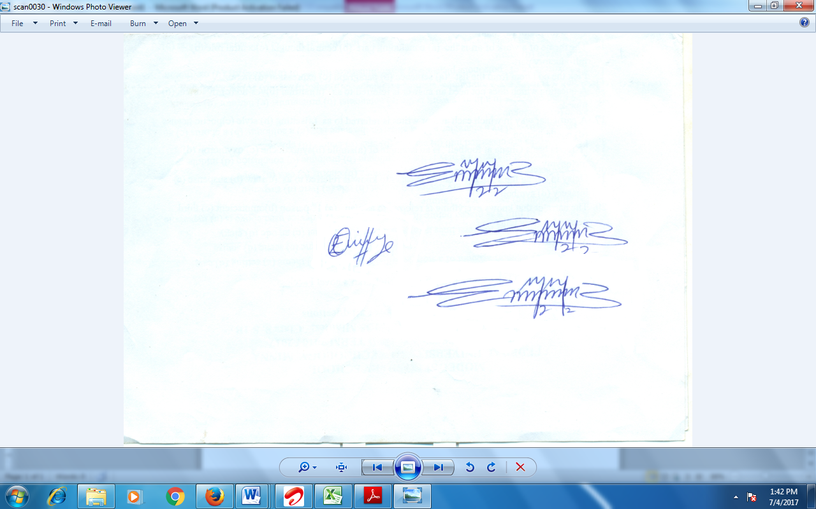 14/10/2024

