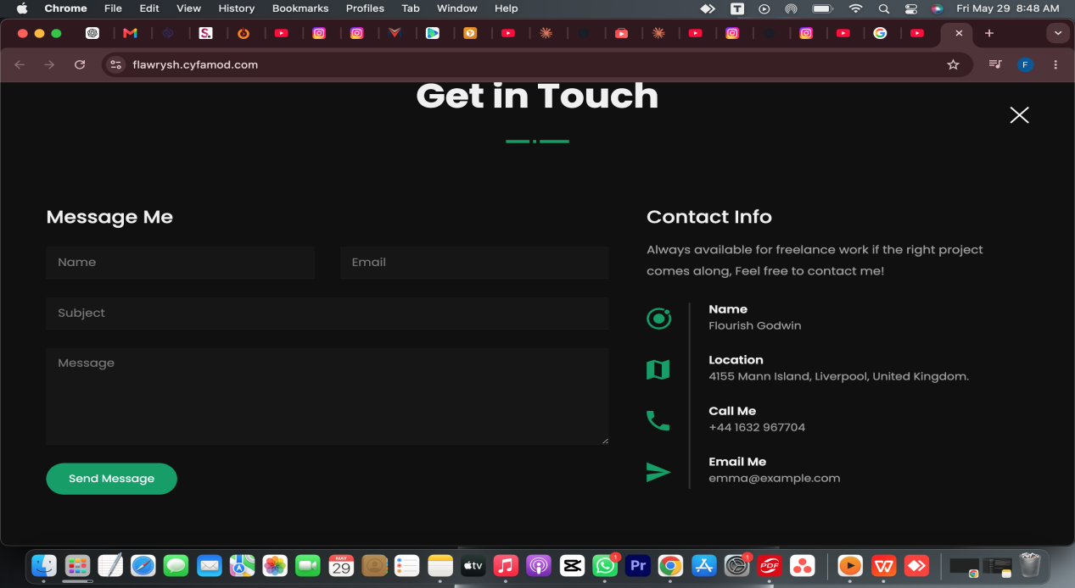
Name: Flourish Chiamaka Godwin
Location: Abuja Nigeria
Email: flourishgodwin2424@gmail.com

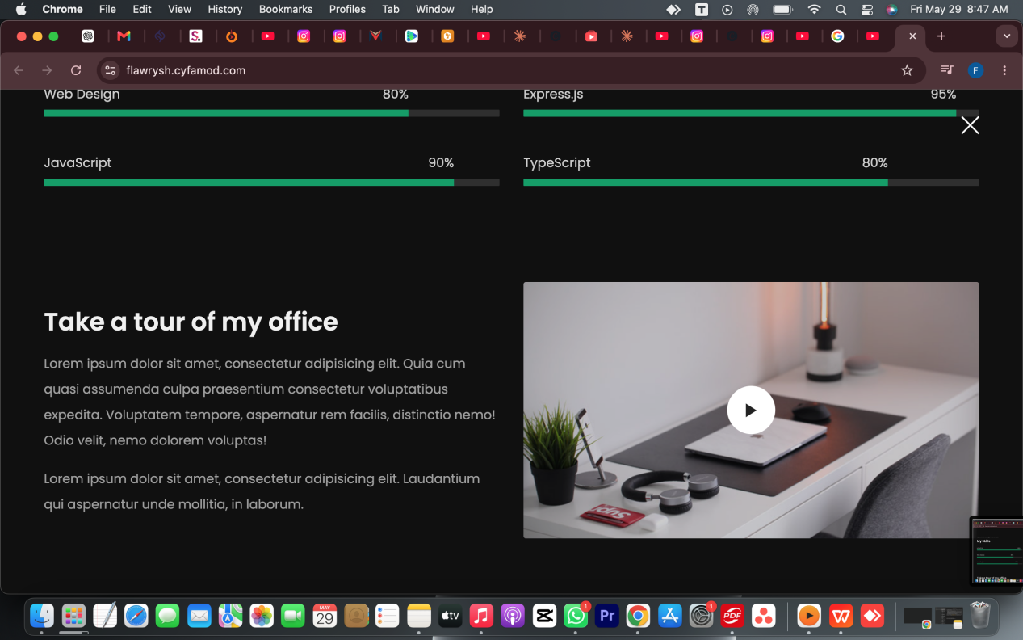
I DON’T THINK THE OFFICE TOUR IS NEEDED
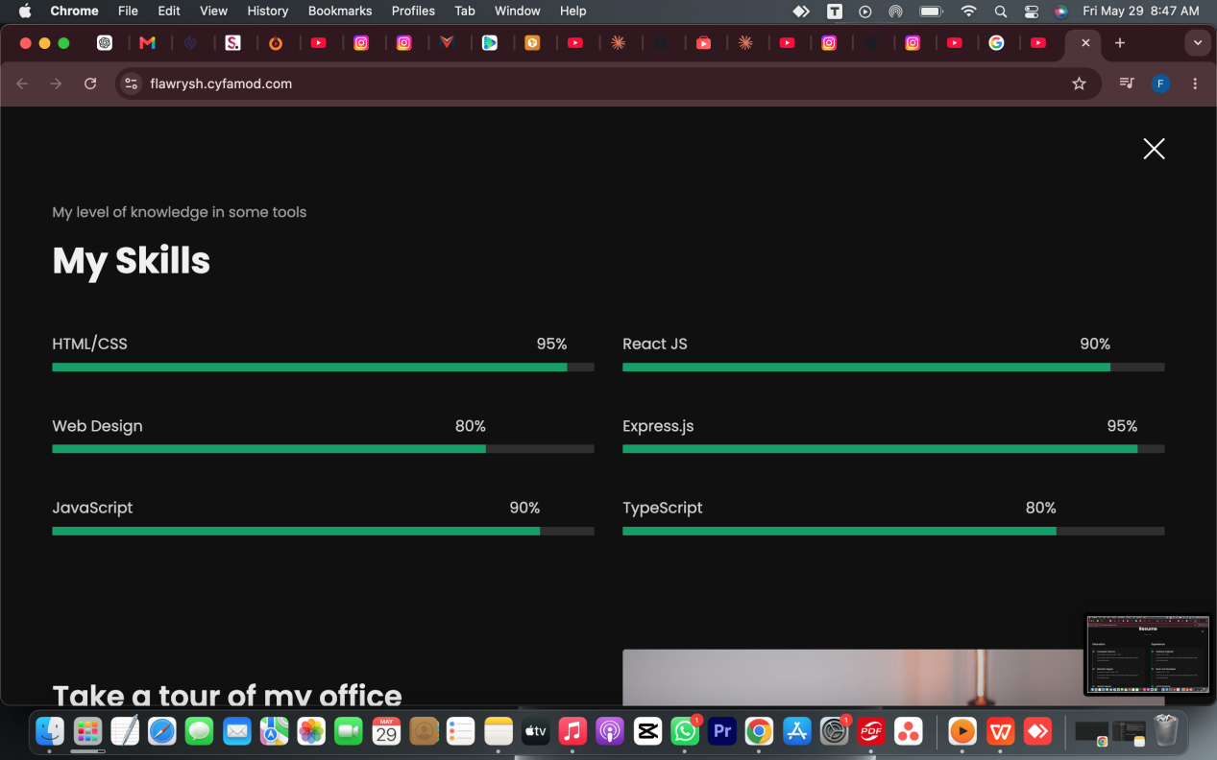
SKILLS: Adobe premiere pro, capcut, canva, davinci resolve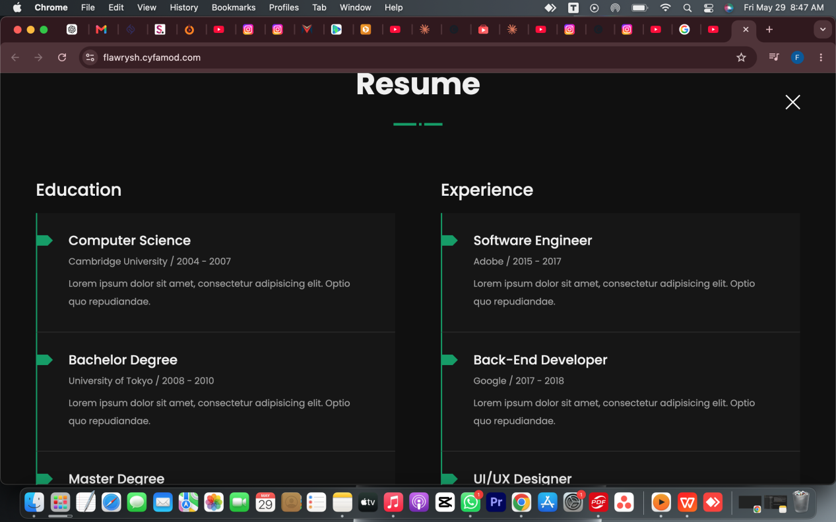I’ll send in my resume for you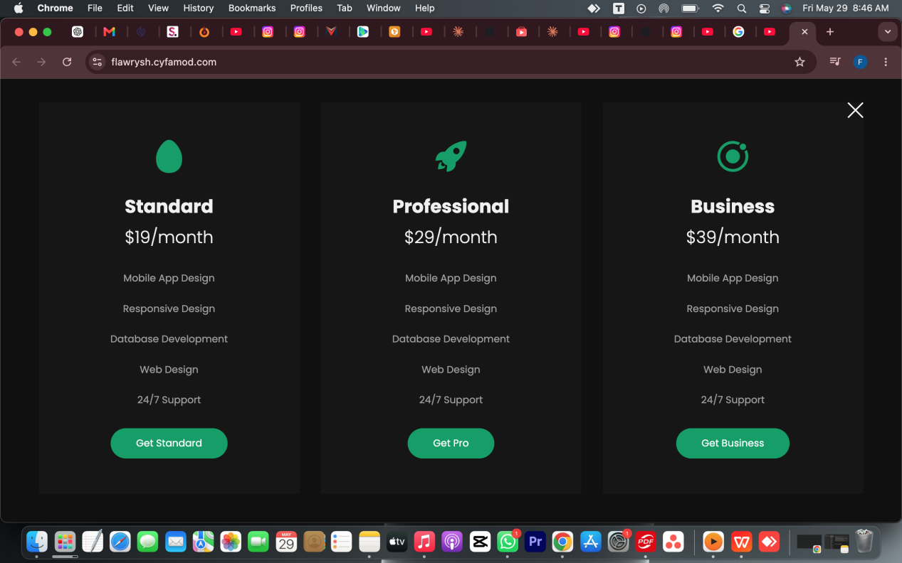
You can remove this side or put contact for rate card 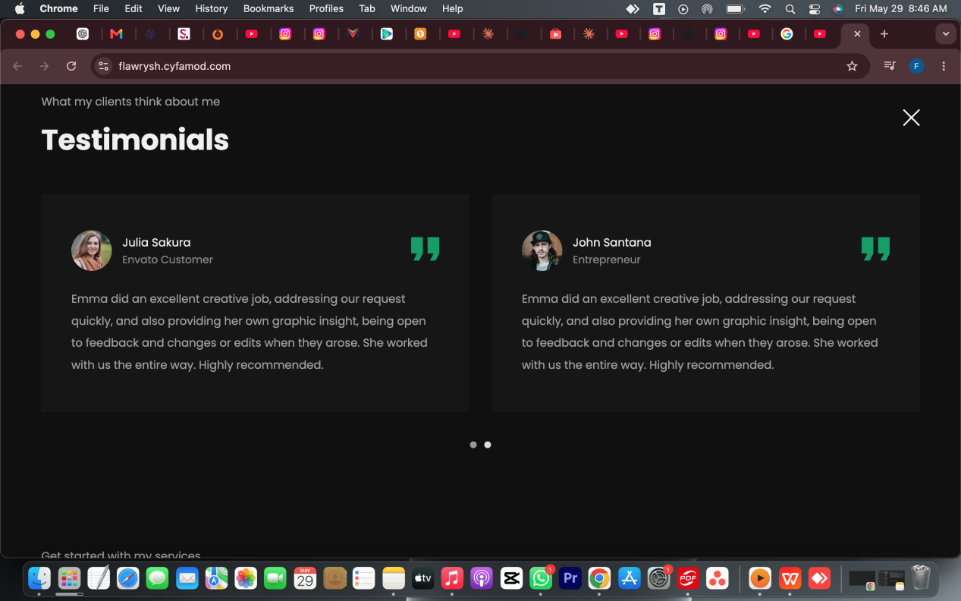You can forge one for this part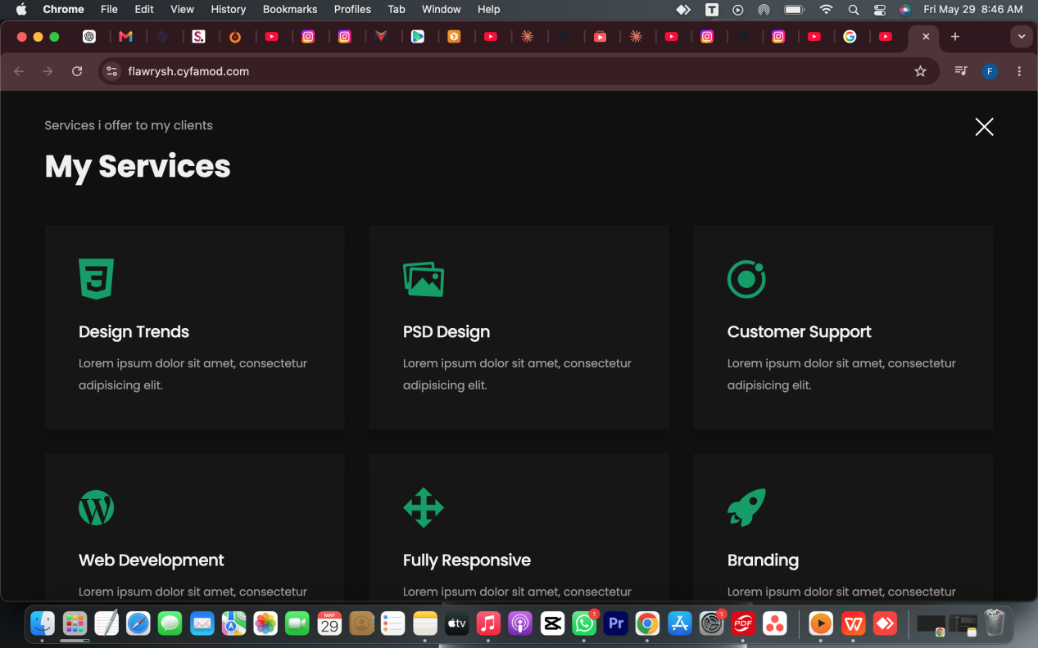
Podcast, short form, lifestyle, documentary, weddings, events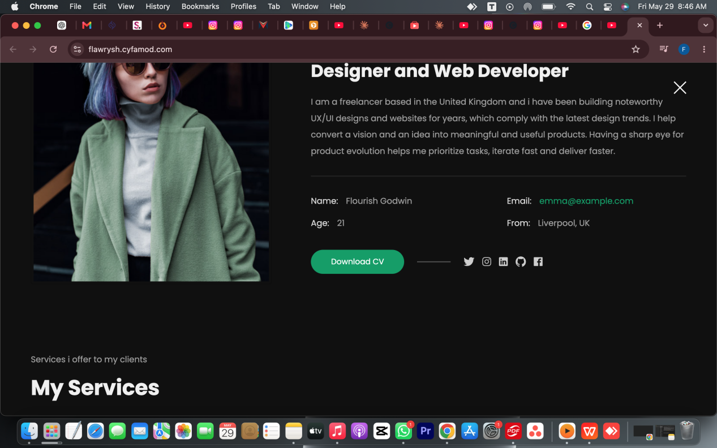
Remove the age. Then instead of from you can put location
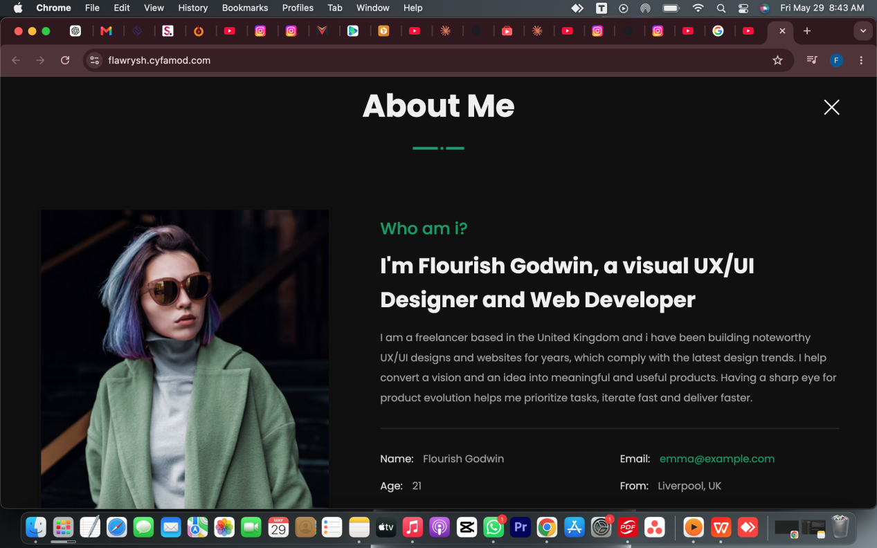
I’m flourish Godwin, a video editor and content creator.

I’m a creative video editor with a passion for turning raw footage into compelling stories that connect. With a strong background in editing podcast clips, short-form content, and lifestyle/documentary videos, I bring a sharp eye for pacing, emotion, and rhythm to every project.
Whether I’m crafting a five-minute mini-doc, podcast or editing lifestyle videos for YouTube, I focus on clean visuals, clear pacing, and storytelling that resonates.
I’m skilled in tools like Premiere Pro and CapCut. I’m excited to work on dynamic projects, grow my editing skills, and continue telling stories that inspire.

