**Screenshots:**

form1.html

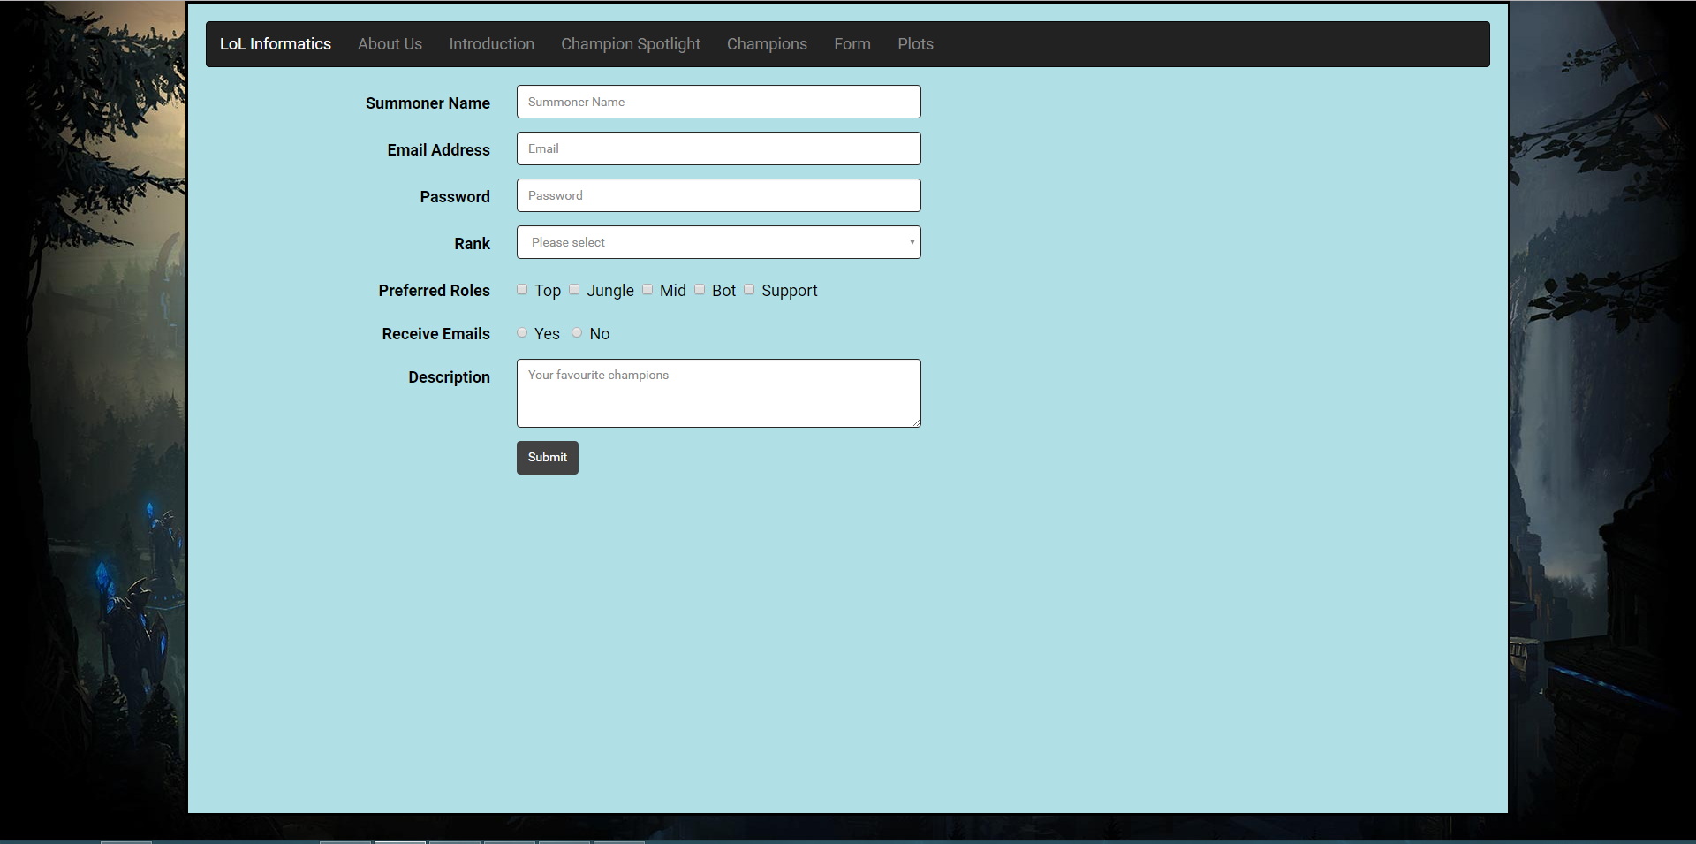

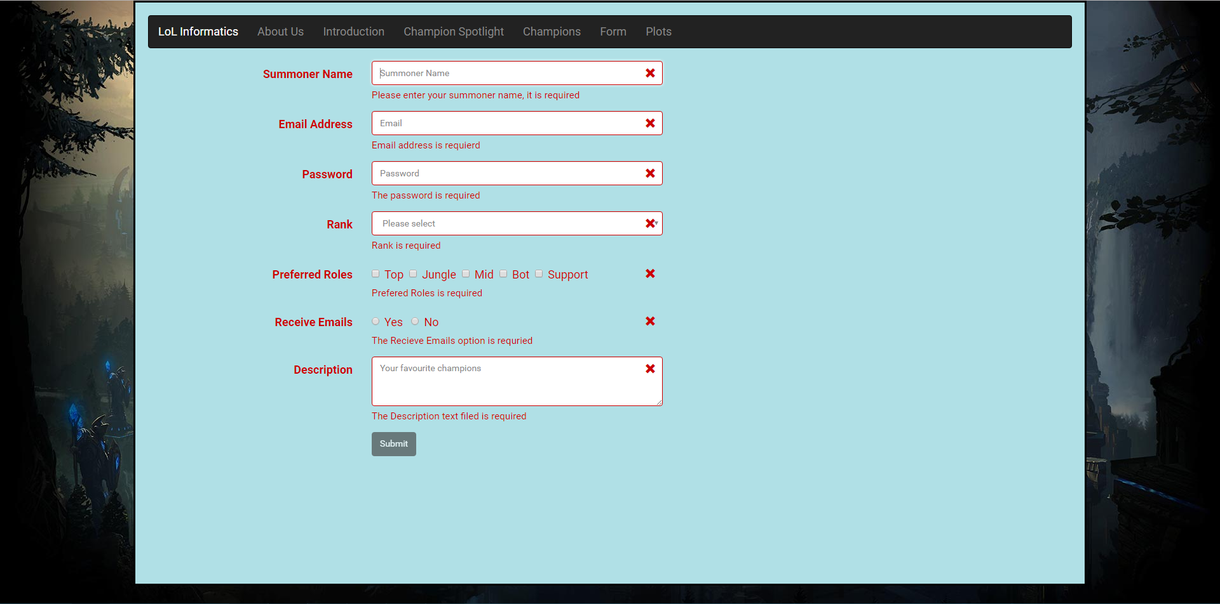

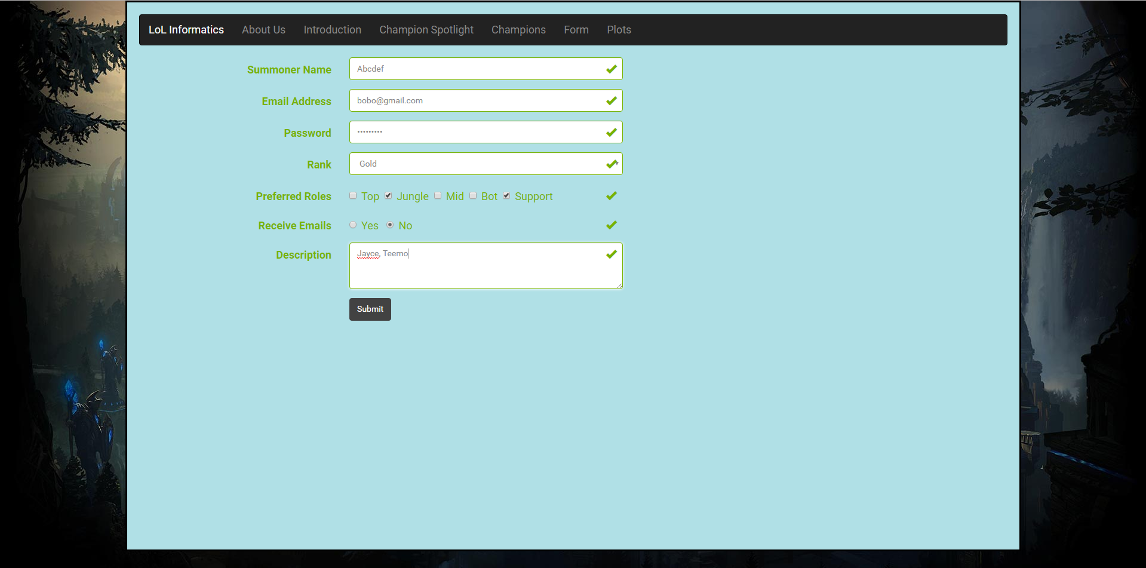

Plots.html

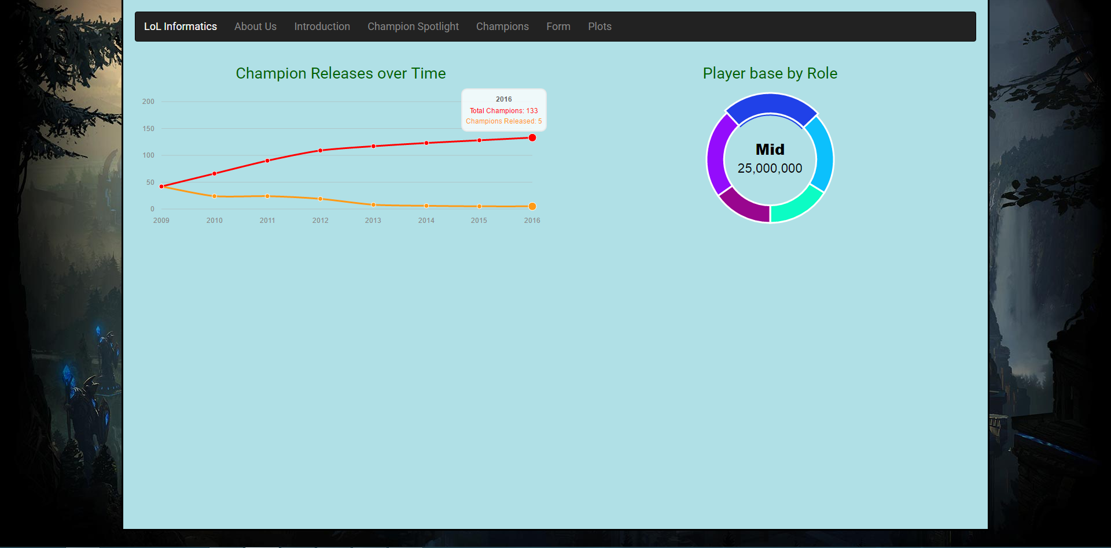

**Code:**

form1.html

<!DOCTYPE html>

<html lang="en">

<head>

<meta charset="utf-8">

<meta http-equiv="X-UA-Compatible" content="IE=edge">

<meta name="viewport" content="width=device-width, initial-scale=1">

<!-- The above 3 meta tags *must* come first in the head; any other head content must come *after* these tags -->

<title>LoL Informatics - Form</title>

<!-- Bootstrap -->

<link href="css/bootstrap.css" rel="stylesheet">

<link href="css/formValidation.min.css" rel="stylesheet">

<link href="css/morris.css" rel="stylesheet">

<!-- Custom CSS -->

<link href="css/MyCSS.css" rel="stylesheet">

<!-- HTML5 shim and Respond.js for IE8 support of HTML5 elements and media queries -->

<!-- WARNING: Respond.js doesn't work if you view the page via file:// -->

<!--[if lt IE 9]>

<script src="js/html5shiv.min.js"></script>

<script src="js/respond.min.js"></script>

<![endif]-->

</head>

<body>

<!-- YOUR CONTENT HERE -->

<div class="Pwrap2" style="background-color:powderblue;">

<nav class="navbar navbar-inverse">

<div class="container-fluid">

<div class="navbar-header">

<button type="button" class="navbar-toggle collapsed" data-toggle="collapse" data-target="#bs-example-navbar-collapse-2">

<span class="sr-only">Toggle navigation</span>

<span class="icon-bar"></span>

<span class="icon-bar"></span>

<span class="icon-bar"></span>

</button>

<a class="navbar-brand" href="index.html">LoL Informatics</a>

</div>

<div class="collapse navbar-collapse" id="bs-example-navbar-collapse-2">

<ul class="nav navbar-nav">

<li><a href="index.html">About Us</a></li>

<li><a href="index.html#Introduction">Introduction <span class="sr-only">(current)</span></a></li>

<li><a href="index.html#ChampionSpotlight">Champion Spotlight</a></li>

<li><a href="index.html#Champions">Champions</a></li>

<li><a href="form.html">Form</a></li>

<li><a href="plots.html">Plots</a>

<li>

</ul>

</div>

</div>

</nav>

<div class="container">

<form id="demoform" class="form-horizontal" method="post">

<div class="form-group">

<label for="summoner" class="col-sm-2 control-label">Summoner Name</label>

<div class="col-sm-5">

<input type="text" class="form-control" id="summoner" name="summoner" placeholder="Summoner Name">

</div>

</div>

<div class="form-group">

<label for="email" class="col-sm-2 control-label">Email Address</label>

<div class="col-sm-5">

<input type="email" class="form-control" id="email" name="email" placeholder="Email">

</div>

</div>

<div class="form-group">

<label for="passwrd" class="col-sm-2 control-label">Password</label>

<div class="col-sm-5">

<input type="password" class="form-control" id="passwrd" name="passwrd" placeholder="Password">

</div>

</div>

<div class="form-group">

<label for="Dropdown" class="col-sm-2 control-label">Rank</label>

<div class="col-sm-5">

<select class="form-control" type="Dropdown" id="Dropdown" name="Dropdown">

<option value="" selected disabled>Please select</option>

<option>Unranked</option>

<option>Bronze</option>

<option>Silver</option>

<option>Gold</option>

<option>Platinum</option>

<option>Diamond</option>

<option>Master</option>

<option>Challenger</option>

</select>

</div>

</div>

<div class="form-group">

<label for="checkbox[]" class="col-sm-2 control-label">Preferred Roles</label>

<div class="col-sm-5">

<div class="checkbox">

<label>

<input type="checkbox" id="checkbox[]" name="checkbox[]" value="top">Top&nbsp

</label>

<label>

<input type="checkbox" id="checkbox[]" name="checkbox[]" value="jungle">Jungle&nbsp

</label>

<label>

<input type="checkbox" id="checkbox[]" name="checkbox[]" value="mid">Mid&nbsp

</label>

<label>

<input type="checkbox" id="checkbox[]" name="checkbox[]" value="bot">Bot&nbsp

</label>

<label>

<input type="checkbox" id="checkbox[]" name="checkbox[]" value="support">Support

</label>

</div>

</div>

</div>

<div class="form-group">

<label for="availability" class="col-sm-2 control-label">Receive Emails</label>

<div class="col-sm-5">

<div class="radio">

<label><input type="radio" id="availability" name="availability" value="yes" /> Yes &nbsp</label>

<label><input type="radio" id="availability" name="availability" value="no" /> No</label>

</div>

</div>

</div>

<div class="form-group">

<label for="description" class="col-sm-2 control-label">Description</label>

<div class="col-sm-5">

<textarea class="form-control" placeholder="Your favourite champions" rows="3" id="description" name="description"></textarea>

</div>

</div>

<div class="form-group">

<div class="col-sm-offset-2 col-sm-5">

<button type="submit" class="btn btn-default">Submit</button>

</div>

</div>

</div>

</form>

</div>

<!-- jQuery (necessary for Bootstrap's JavaScript plugins) -->

<script src="js/jquery.min.js"></script>

<!-- Include all compiled plugins (below), or include individual files as needed -->

<script src="js/bootstrap.min.js"></script>

<script src="js/formValidation.min.js"></script>

<script src="js/framework/bootstrap.min.js"></script>

<script src="js/raphael-min.js"></script>

<script src="js/morris.min.js"></script>

?

<script>

//validation script

$(document).ready(function() {

$('#demoform').formValidation({

framework: 'bootstrap',

icon: {

valid: 'glyphicon glyphicon-ok',

invalid: 'glyphicon glyphicon-remove',

validating: 'glyphicon glyphicon-refresh'

},

fields: {

summoner: {

validators: {

notEmpty: {

message: 'Please enter your summoner name, it is required'

},

stringLength: {

min: 4,

max: 10,

message: 'The name must be more than 4 and less than 10 characters long'

},

regexp: {

regexp: /^[a-zA-Z0-9_]+$/,

message: 'The name can only consist of alphabetical, number and underscore'

}

}

},

email: {

validators: {

notEmpty: {

message: 'Email address is requierd'

},

emailAddress: {

message: 'The input is not a valid email address'

}

}

},

passwrd: {

validators: {

notEmpty: {

message: 'The password is required'

},

different: {

field: 'summoner',

message: 'The password cannot be the same as username'

},

stringLength: {

min: 6,

max: 18,

message: 'The password must be more than 6 characterse long and less than 18 characters long'

}

}

},

Dropdown: {

validators: {

notEmpty: {

message: 'Rank is required'

}

}

},

'checkbox[]': {

validators: {

notEmpty: {

message: 'Prefered Roles is required'

}

}

},

availability: {

validators: {

notEmpty: {

message: 'The Recieve Emails option is requried'

}

}

},

description: {

validators: {

notEmpty: {

message: 'The Description text filed is required'

}

}

}

}

});

});

</script>

</body>

</html>

plots.html

<!DOCTYPE html>

<html lang="en">

<head>

<meta charset="utf-8">

<meta http-equiv="X-UA-Compatible" content="IE=edge">

<meta name="viewport" content="width=device-width, initial-scale=1">

<!-- The above 3 meta tags *must* come first in the head; any other head content must come *after* these tags -->

<title>LoL Informatics - Plots</title>

<!-- Bootstrap -->

<link href="css/bootstrap.css" rel="stylesheet">

<link href="css/formValidation.min.css" rel="stylesheet">

<link href="css/morris.css" rel="stylesheet">

<link rel="stylesheet" href="//cdnjs.cloudflare.com/ajax/libs/morris.js/0.5.1/morris.css">

<!-- Custom CSS -->

<link href="css/MyCSS.css" rel="stylesheet">

<!-- HTML5 shim and Respond.js for IE8 support of HTML5 elements and media queries -->

<!-- WARNING: Respond.js doesn't work if you view the page via file:// -->

<!--[if lt IE 9]>

<script src="js/html5shiv.min.js"></script>

<script src="js/respond.min.js"></script>

<![endif]-->

</head>

<body>

<!-- YOUR CONTENT HERE -->

<div class="Pwrap2" style="background-color:powderblue;">

<nav class="navbar navbar-inverse">

<div class="container-fluid">

<div class="navbar-header">

<button type="button" class="navbar-toggle collapsed" data-toggle="collapse" data-target="#bs-example-navbar-collapse-2">

<span class="sr-only">Toggle navigation</span>

<span class="icon-bar"></span>

<span class="icon-bar"></span>

<span class="icon-bar"></span>

</button>

<a class="navbar-brand" href="index.html">LoL Informatics</a>

</div>

<div class="collapse navbar-collapse" id="bs-example-navbar-collapse-2">

<ul class="nav navbar-nav">

<li><a href="index.html">About Us</a></li>

<li><a href="index.html#Introduction">Introduction <span class="sr-only">(current)</span></a></li>

<li><a href="index.html#ChampionSpotlight">Champion Spotlight</a></li>

<li><a href="index.html#Champions">Champions</a></li>

<li><a href="form.html">Form</a></li>

<li><a href="plots.html">Plots</a>

<li>

</ul>

</div>

</div>

</nav>

<div class="row">

<div class="col-md-6">

<h2>Champion Releases over Time</h2>

<div id="firstChart" style="height: 250px;"></div>

</div>

<div class="col-md-6">

<h2>Player base by Role</h2>

<div id="secondChart" style="height: 250px;"></div>

</div>

</div>

<!-- jQuery (necessary for Bootstrap's JavaScript plugins) -->

<script src="js/jquery.min.js"></script>

<!-- Include all compiled plugins (below), or include individual files as needed -->

<script src="js/bootstrap.min.js"></script>

<script src="js/formValidation.min.js"></script>

<script src="js/framework/bootstrap.min.js"></script>

<script src="js/raphael-min.js"></script>

<script src="js/morris.min.js"></script>

<script src="//ajax.googleapis.com/ajax/libs/jquery/1.9.0/jquery.min.js"></script>

<script src="//cdnjs.cloudflare.com/ajax/libs/raphael/2.1.0/raphael-min.js"></script>

<script src="//cdnjs.cloudflare.com/ajax/libs/morris.js/0.5.1/morris.min.js"></script>

<script>

//plots script

$(document).ready(function() {

Morris.Line({

element: 'firstChart',

data: [{

y: '2009',

a: 42,

b: 42

}, {

y: '2010',

a: 24,

b: 66

}, {

y: '2011',

a: 24,

b: 90

}, {

y: '2012',

a: 19,

b: 109

}, {

y: '2013',

a: 8,

b: 117

}, {

y: '2014',

a: 6,

b: 123

}, {

y: '2015',

a: 5,

b: 128

}, {

y: '2016',

a: 5,

b: 133

}],

xkey: 'y',

ykeys: ['b', 'a'],

labels: ['Total Champions', 'Champions Released'],

lineColors: ['#ff0000', '#ff9a16']

});

Morris.Donut({

element: 'secondChart',

data: [{

label: "Top",

value: 16000000

}, {

label: "Jungle",

value: 21000000

}, {

label: "Mid",

value: 25000000

}, {

label: "Bot",

value: 23000000

}, {

label: "Support",

value: 15000000

}],

colors: ['#0cfcc4', '#0cc0fc', '#2041e8', '#940cfc', '#99068f']

});

});

</script>

</body>

</html>

MyCSS.css

h1 {

color: darkblue;

font-weight: bold;

}

.nodot {

list-style-type: none;

font-size: 120%;

}

.pad-below {

padding-bottom: 1%;

}

.Pwrap2 {

width: 1500px;

height: 97vh; /* max 1000 height or it will look bad, lowest is 550 */

margin: 0 auto;

border-style: solid ;

background-color: white;

padding-top: 20px;

padding-right: 20px;

padding-bottom: 20px;

padding-left: 20px;

}

.Pwrap {

width: 1500px;

height: 100%; /* max 1000 height or it will look bad, lowest is 550 */

margin: 0 auto;

border-style: solid ;

background-color: white;

padding-top: 20px;

padding-right: 20px;

padding-bottom: 20px;

padding-left: 20px;

}

.tablerowhead {

font-weight: bold;

color: #d63939;

}

.tablerowheadname {

font-weight: bold;

color: white;

}

.abilityname {

color: #db5220;

}

.role {

font-weight: bold;

}

.archetype {

font-weight: normal;

}

body {

background-image: url("../images/background.jpg");

background-repeat: no-repeat;;

}

h2 {

color: darkgreen;

text-align: center;

font-size: 1.5em;

}