Innovation: **Thermal Floater**Dated: **July 10th, 2021**Applicant: **Sparsh**, India, Patna (Bihar)  
D.O.B. of Applicant: **10th May, 2005**  
E-Mail Address: [**sparshnirav@gmail.com**](mailto:sparshnirav@gmail.com)

Class: **XII**  
Telephone No.: **9431612288**School: **Radiant International School**

.

**Table of Contents**

**Index** **1**

**Abstract** **2**

**Background Of The Invention** **2 - 3**

Problem Statement 2

Benefits Of The Thermal Floater 3

**Breakdown Of The Prototype** **4 - 7**

Prototype Design 4

Heatsink Implementation 5

**Feasibility Of The Concept** **8 - 13**

Calculations & Formulas 8

Energy Output 10

Prototype Pricing 12

Business Model 12

Key Partners 13

Future Vision 13

Target Customers 13

Customer Relationships 13

Revenue Model 13

**3D Renders** **14 - 15**

Layered 3D View 14

Longitudinal 3D View 15

Cross-Sectional 3D View 15

**References** **16**

**Abstract**

The thermal floater includes a unified floating structure that is formed of a horizontal mesh of one or more horizontal support segments connected in a matrix pattern, with light rays being diverged and concentrated at the Peltier modules for generating electricity from the thermal heat of the Sun and a cable system connected to the one or more arrays of thermal modules for supplying power to utility and an off-grid facility.

.

**Background of the Invention**

Among various energy sources, the need for green and clean energy is inevitable given the increasing level of greenhouse gas emissions and depleting conventional resources such as coal and oil. Further, renewable energy is a practical and environmentally-conscious alternative to traditional electricity production means. In the wake of this, the government of different countries such as India, the USA, Australia, etc., are adopting policies to support and enhance the footprints of rooftop installations and land-based solar panel installations. However, the rooftop installations and land-based installations are associated with several issues and limitations.

One of the most significant advantages of floating thermal modules is that the installations don't require any land space. For instance, the land requirement for installing thermal farms is enormous, and for a large power facility, the condition is much more significant. In many countries like Japan and Singapore, the land resource is scarce. A premium cost is attached for even a tiny piece of land. The land can be utilized for several better commercial purposes other than for solar thermal array installations.

Similarly, for developing nations like India and many Asian countries, where most of the land is fertile and is used for agricultural purposes, it is difficult to spare a substantial land area except for few pockets of unproductive land for purposes like thermal power generation. Most of these thermal module installations can take unused space on bodies of water, such as hydroelectric dam reservoirs, wastewater treatment ponds, or drinking water reservoirs. This will allow the landowners to use an area that wouldn't otherwise be used. Rather than getting a thermal module installation in sunny land, that could potentially serve another purpose down the line.

In addition to that, the long coastline of developing countries such as India, China, and African nations offer a vast possibility of installing such floating thermal platforms that can address the problem of land availability for harvesting thermal energy from the sun and can generate a huge amount of power to meet the growing energy demand. Moreover, numerous irrigation canals, dams, reservoirs, lakes, and ponds spread across the countries offer a vast potential to tap renewable energy through this innovative floating platform.

It is a known fact that there are some significant environmental benefits when it comes to renewable energy, and floating thermal modules certainly will play a role in contributing to the ecological benefits. With the thermal floater module installations, the water doesn't only have a cooling effect on the solar-thermal-powered systems, but it works the other way as well. The thermal floater module installation provides shade to the body of water and reduces the evaporation from these ponds, reservoirs, and lakes. This is an excellent environmental benefit of solar-thermal energy in areas that are more susceptible to droughts, as water loss due to evaporation can add up over time and contribute to a shortage.

The shade that the thermal floater modules can produce will help reduce algae that bloom in the freshwater. The algae can be a little dangerous for human health if they occur in a source of drinking water, and it can also lead to the death of plants and animals that live in the water. The floating thermal modules are a clean source of renewable energy. The use of renewable energy technologies helps decrease greenhouse gas emissions and all of the other pollutants that they put in the atmosphere, leaving a positive impact on the environment and human health.

Concluding the background of the invention, I theorize an ideal model for a prototype whose sketch can be as follows:

**The Prototype**

According to the current prototype, the design of the thermal floater is simplistic and is made up of readily available tubular members. The module's design is such that it requires the least amount of material and most miniature waterplane area and still able to achieve high stability to make it a structure that can be used over any water body. Such floating platforms can be installed in calm waters and the ocean because the system is strong enough to support its load in clear water and the ocean's harsh dynamic environment of waves and wind. The platform is designed to maintain its stability while floating even in damaged conditions under the influence of environmental loads such as wind, waves, and currents.

The thermal floater can be installed easily on any kind of inland water body such as lakes, reservoirs, ponds, irrigation canals, dams or on coastal water zones for a sustained long time period through easy mooring system. Further, many such units can be combined together to develop a huge floating solar facility thereby multiplying the power generation capacity.

The thermal floater consists of structurally stable tubes to float on the surface attached to frame of the body. For any thermoelectric generator design, it is always desirable to maximize the applied temperature differential in order to minimize the total number of modules in the system. So, a concave mirror is fitted onto the frames in such a way that one side of the mirror may be attached to one or more hinges connected to the one side of the frame thereby allowing it to rotate freely about the hinge axis and to orient the concave mirror at a desired angle of inclination. It diverts the light coming from the sun towards a convex lens of appropriate focal length which converges the light rays onto a surface that can withstand the heat and is thermally conductive. The following is a list of the thermal conductivity of several potential materials suitable for the same:

|  |  |  |
| --- | --- | --- |
| S. No. | Material | Range for Heat Conduction |
| 1 | Stainless steel | 16 W/mK |
| 2 | Pyrolytic Graphite | 50 W/mK |
| 3 | Silver | 700 – 1750 W/mK |
| 4 | Copper | 400 W/mK |
| 5 | Aluminium | 385 W/mK |

I chose to use sheets of silver concerning the above table due to its high heat conduction range. It further conducts the heat down to the graphite sheets that act as a thermal compound for the Thermoelectric Peltier and is separated by fiberglass to redirect the heat towards the Peltier.

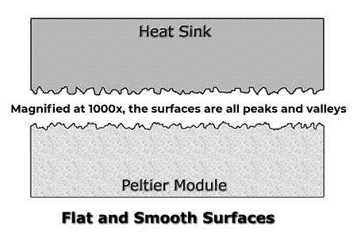

The graphite foil has to be applied because when take a look at Microscopic Surfaces Even when you have two “flat and smooth” surfaces, they are far from truly flat or smooth.  The diagram shows what’s really going on at a microscopic scale.

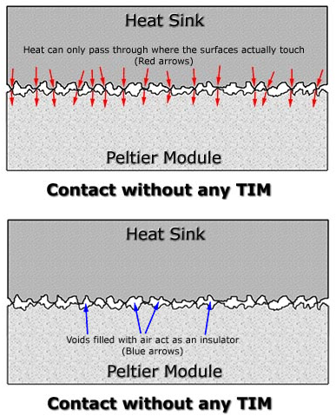As you can see, the two surfaces may look flat and smooth, but in reality, when examined under magnification, they consist of “hills”, “peaks”, and “valleys”.  When these two surfaces are brought into contact with one another, only the peaks make contact.  It has been calculated that the average amount of contact between any two smooth surfaces is in reality only 5%. The other 95% are voids. The image shows how the remaining valleys create voids through which heat energy can barely pass through, in effect creating an insulated area – not the ideal thermal interface.

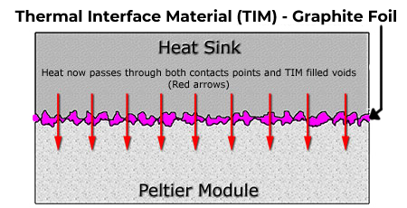A Graphite Foil TIM has been pre-applied to both sides of the TEG. (It is dark grey in color) The purpose of this TIM is to fill the valleys and gaps with a compressible material that has a much higher thermal conductivity (ability to transfer heat) than the air gaps it replaces.  This essentially makes the entire interface transfer heat instead of just where the peaks were contacting.  The following image shows how the situation has been dramatically improved

The Thermoelectric Peltier is a famous electric module widely used in old refrigerators, the thermoelectric generator, and cooler work on the Seebeck Principle. It can be used to produce an electric current. The Seebeck Effect states that electric current is produced when two dissimilar metals (such as bismuth and telluride) are joined; one side of their junction is cooled while the other is heated.

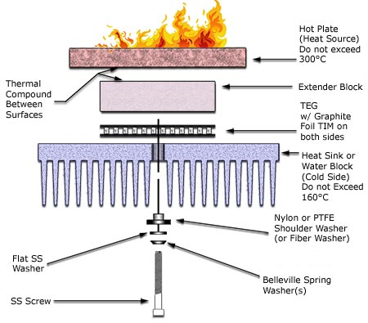So, the Thermoelectric Peltier converts the thermal energy into a high-power output with voltages enough for powering various household devices. Since the Thermoelectric Peltier needs temperature differential to function and produce electricity, the cooling mechanism is attached to a heatsink that is further in contact with the water body. Following is the method of mounting the thermoelectric Peltier:

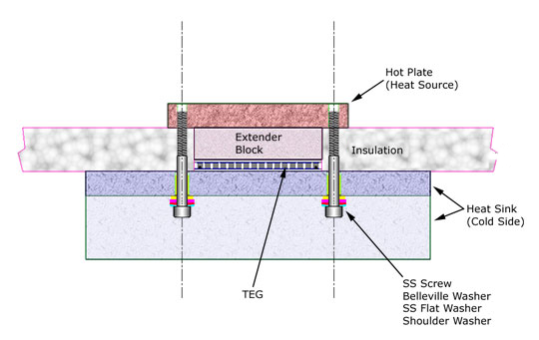

Same as other electronics, with higher temperatures, come with decreased power outputs. The efficiency of a Peltier tends to decrease as the temperatures rise, which can be concerning to a decreased output. The bodies of water that host the floating thermal modules will help the solar-thermal powered systems cool down, which implements that the floating thermal module installation will increase the efficiency of the Peltier in the hot climates than they otherwise would.

Due to the modular design, the thermal floater can be deployed at specific locations with the right configuration and/or "kit". Further, the modular concept of the thermal floating modules provides ease and portability for assembly, installation, operation and removal of similar units of same or different capacity.

Finally, the cable laying operation is executed, wherein the cables may be connected to all the thermal floater modules and routed to the appropriate reception point located onshore or offshore. The deployed state is reached when the fully integrated floating thermal modules fitted with cable system floats on water and is appropriately moored to the nearby points. Further, in the deployed state, the power supply has to be connected to a nearby reception point located onshore or offshore.

**Feasibility of The Thermal Floater**

In order to determine the feasibility of using heat from the Sun in a thermal-solar platform, calculations had to be performed. Before performing the calculations, some formulas and a brief overview has to be known. The Seebeck voltage at the circuit junctions can be written as:

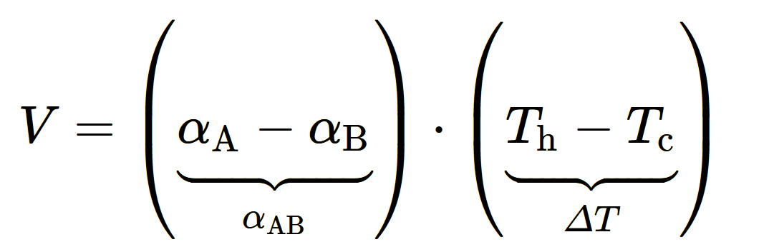

where *α*A and *α*B are the Seebeck coefficients for the conductors A and B, in V·K−1. The Seebeck coefficient *α*AB, the temperature gradient ∇T, and the electric field E are written under the following relationship:

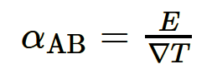

The *Thomson effect* affirms that in any conductive material in which the electrical current flows in the presence of a temperature difference between two ends, heat is also released or absorbed. The Thomson heat released or absorbed is given as:

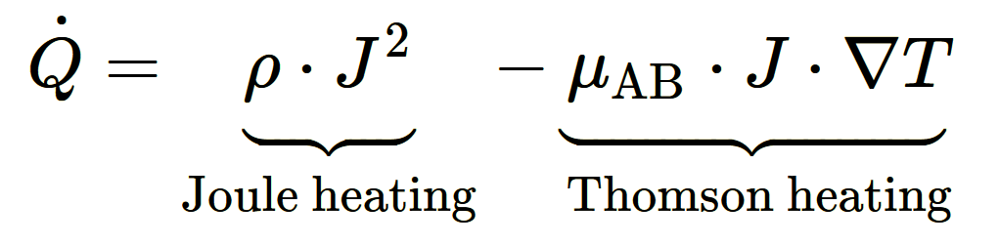

where *ρ=1σ* is the electrical resistivity in [Ω⋅m], *σ* is the electrical conductivity in [S⋅m−1], J is the current density in [A⋅m−2], *μ*AB is the Thomson coefficient in [V·K−1], and ∇T is ∇T =dT/dx is the temperature gradient along the conductor in [K].

The input electrical current in the circuit is:

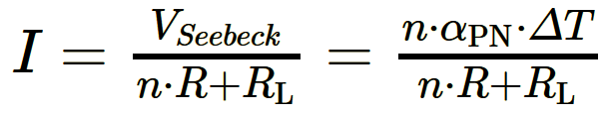

where the load resistance RL is connected to the output of the circuit where the electric output power generated by TEG is consumed; the Seebeck voltage is VSeebeck = VP − VN = *α*PN · ΔT. The relationship between VSeebeck and ΔT is non-linear, therefore *α*PN depends on temperature.

The electric output power delivered by TEG to the load is:

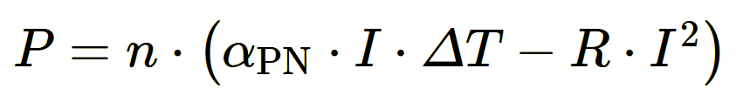

On the other side, the electric output power absorbed by the load (considering the conventional sign, with the current flowing) is:



The electric output power absorbed by the load resistance RL is:

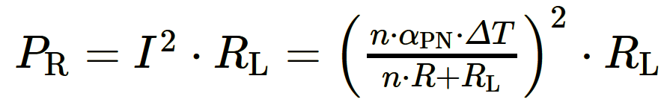

The maximum electric output power of a TEG is obtained when the electrical output power is maximised with respect to the electric current:

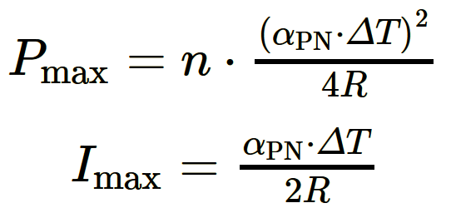

TEG's maximum electrical output power is obtained if the load resistance is equal to the equivalent internal resistance of the thermoelectric couples in series.

Acknowledging all of the formulas above, the output and feasibility of this prototype can easily be determined. The thermoelectric module used in this product has 241 couples, made up of Bismuth Telluride-based thermoelectric material, is rated to a maximum of 320°C continuous, and is lapped of ceramic (Al2O3) faces. The Peltier has an average conversion efficiency of 11 – 12%. Currently, research has successfully developed Peltiers that are 30-36% efficient, but it is not available in the market.

To calculate the energy output of the Peltier module, the environmental conditions have to be taken into consideration. The Sun gives out an average of 400 Watts per sq. meter in broad daylight. On a typical sunny day, when the light is concentrated using a convex lens, it reaches a temperature of 425°F - 475°F or an average of 220°C, which at continuous heating of a silver sheet can get as hot as 320 - 335°C.

Since the heat received by the Sun needs to be retained, molten salt or sand can be put above the silver sheet at the focal point of the convex lens. As we know that sand and molten salt can retain heat for very long amounts of time even after not being supplied with heat, the module can stay up and produce energy for 5 hours and 30 minutes longer than usual. The greenhouse effect is formed in the container will help it last long compared with its competitor for solar energy, the solar panels.

Taking the average temperature of lakes, rivers, and sizeable stagnant water bodies, which comes to about 20°C, we obtain ΔT to be at 300°C. Here is the output of the volts and amps given under different conditions.

**Volts Output**

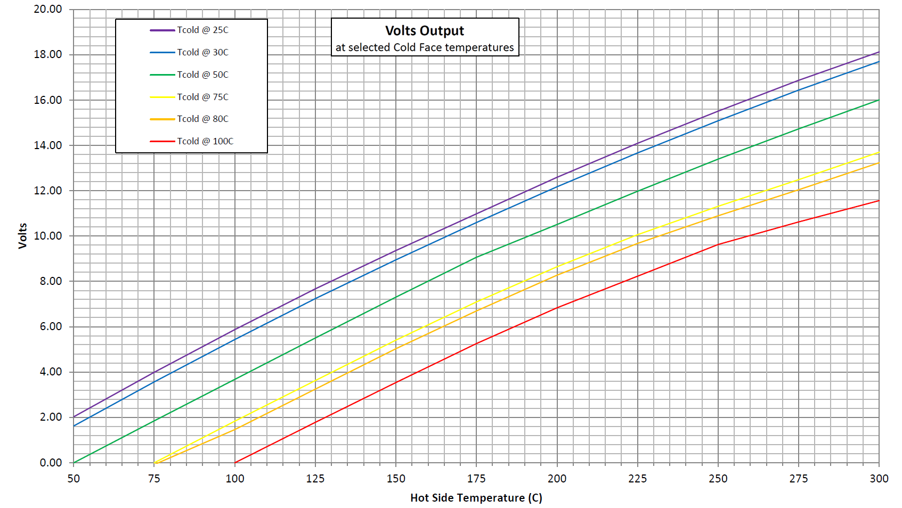

**Amps Output**

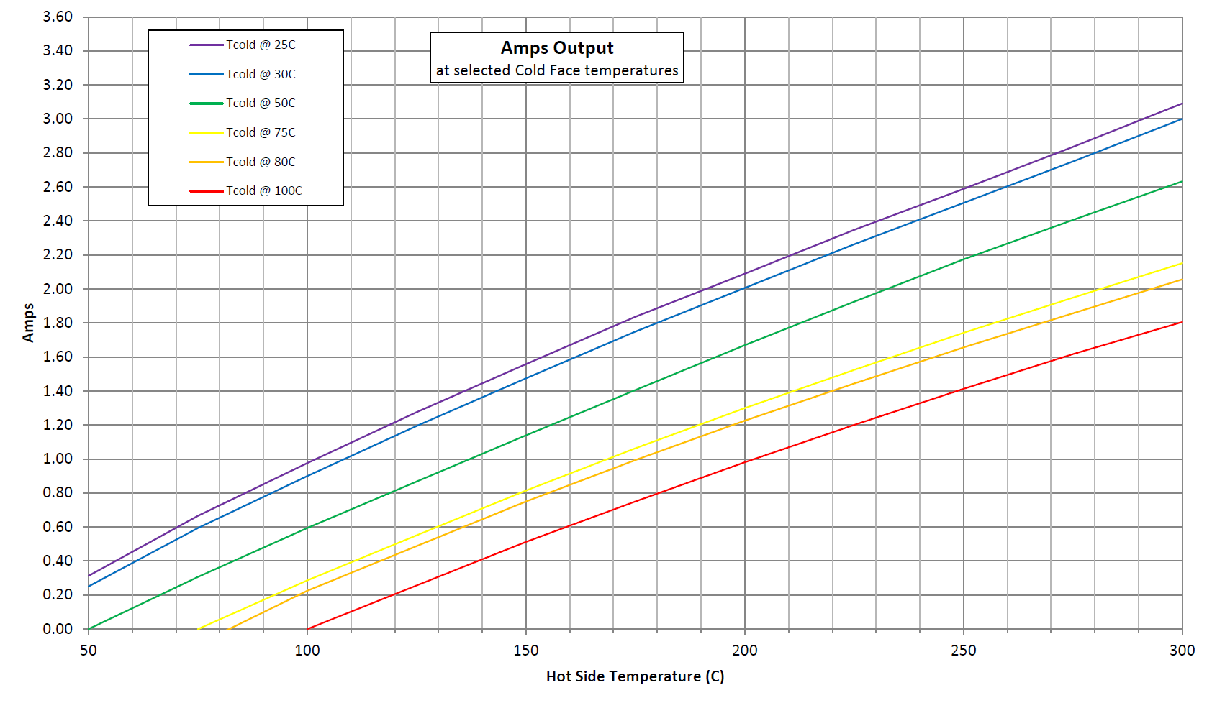

Concerning the above data and the formulas and calculating, Thermoelectric Peltier used herein such conditions gives out 18.2V and 3.00 Amps, resulting in 54.6 Watts in one hour (under 1.2-ohms and 2.4-ohms thermocouple resistance). Moreover, with an average of 7 hours of bright sunlight and 5 hours 30 mins of heat released by the sand slowly, the energy generated can be around 682.5 Watts per day. Keeping in mind that this is the power production by a single module which is just 15 cm by 15 cm, while a typical solar panel is 1.5 m by 1.06 m.

Converting its dimensions to match its output with its competition, with a ratio of 70.5 in dimensions to a single solar panel that produces 300W per hour and 3 kWh per day, the energy generated by this single giant module will come out to be about 9-10 kWh per day. The modules would be connected in parallel to form the giant module to obtain less resistance as well as the failure of one module would not affect the rest of the circuit.

This has many other benefits compared to other competitors. It’s more environmentally friendly as most of its materials are recyclable & non-toxic, and the materials used here are more durable than the materials used in Solar Panels.

The floating solar platform is robust, easy to fabricate and install, safe and economical to build and operate. It is easy to relocate and has a long operational life with less maintenance.

|  |  |  |  |
| --- | --- | --- | --- |
| S.No. | Component Name | Price per pcs [in ₹] | Price per pcs in Bulk Amount (1000 pcs) [in ₹] |
| 1 | Silver Sheet x2 [13 cm by 13 cm] | 113.00 | 88.65 |
| 2 | Convex Lens | 150.00 | 103.00 |
| 3 | Concave Mirror | 120.00 | 74.38 |
| 4 | SP1848 Thermoelectric Peltier | 184.85 | 92.54 |
| 5 | Sheet Metal Casing and Air Tube | 53.84 | 35.89 |
| 6 | Heatsink | 132.50 | 89.00 |
|  | Total | ₹754.20 | ₹483.50 |

As can be seen from the above price charts, the price of a single module can be brought down to a pretty affordable range when bulk manufactured. Although the price of a giant module combined with the smaller modules in parallel is more than the cost of a solar panel, that is the price to pay 3x more energy production in the same limited amount of area. The product can be even more efficient and applicable for rooftop systems by applying cooling methods such as liquid metal cooling, which will boost its cooling efficiency. Such cooling methods are still in development but will soon be available to use here readily.

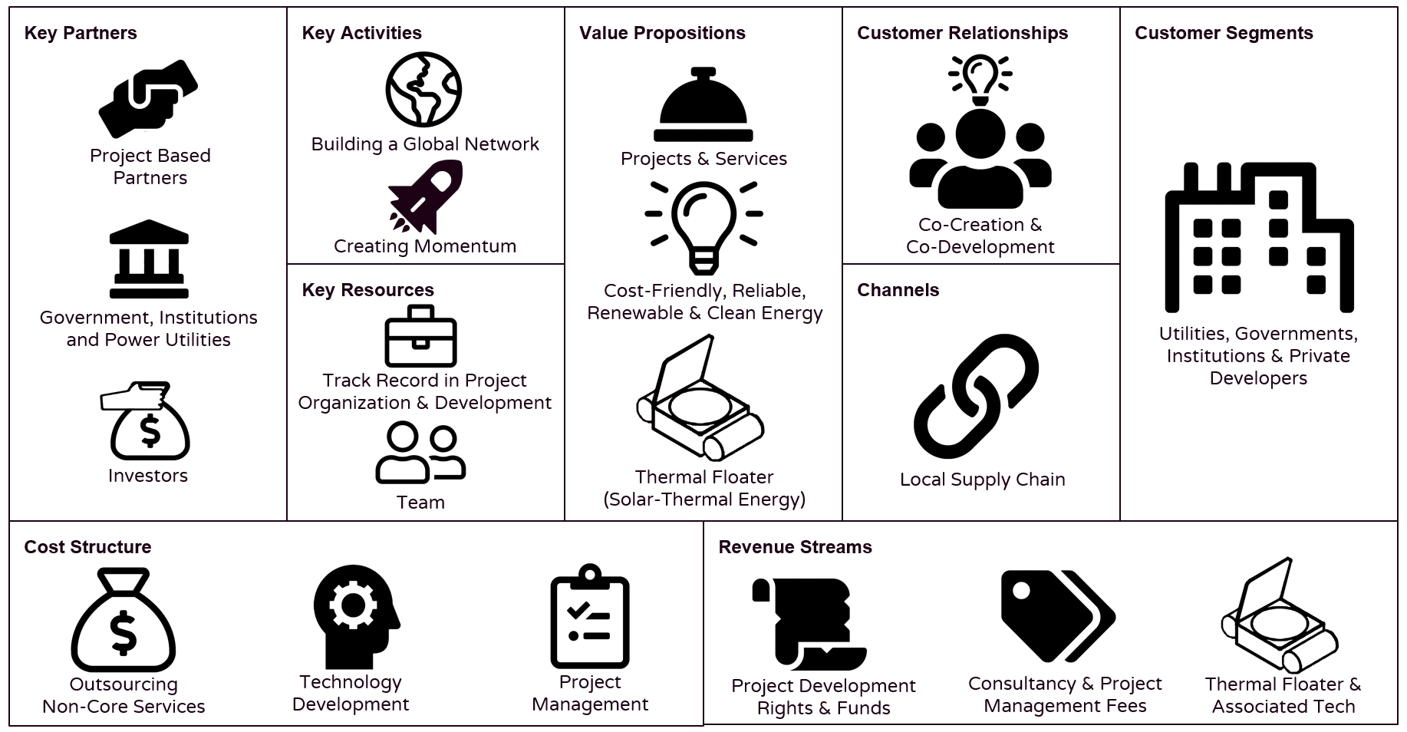Here can be the business model of such concept:

The key partners here would be the power facility grids and utilities, institutions, governments and investors, and project-based partners to help achieve the key activities and deliver value to the customers. I would plan for a vision to spread green and renewable energy throughout the world by the end of the decade by building a global network and creating momentum.

For achieving the vision, essential resources would be needed to create a team and track the organization and department records. In addition, the business will be providing its main product. This thermal floater would be three times more efficient, reliable, and environmentally friendly than its present solar renewable energy competitor, the Solar Panels.

The product would appeal to targeted customers, the power utilities, governments, institutions, and private developers. It can also be quite useful for generating electricity in remote parts/military bases/ research bases in islands where delivering electricity is highly expensive and producing electricity locally can have detrimental effects on the environment.

The customers will interact throughout the entire supply chain to make renewable energy successful and actively build a global network supplemented with strong local partners.

As the thermal floater would consist of various modules, the prices would be significantly low when bulk manufactured rather than individual manufacturing. And by using industrial-level techniques, the cost would be even lower, which puts it at a significant advantage compared to the rest of the renewable technologies in the market.

Moreover, the price of the small modules would be pretty low to be affordable even for the middle-class people, which will allow us a large user base. The product would also be desirable to compel the existing users to be satisfied with the product, leading other users to buy it.

The revenue earned would also be put back into the business and composited into fairly distributed prices for product manufacturing, Digital Marketing, Reserve Fund, Miscellaneous expenses, and the rest would be the earnings.

With all the data available, a sketch, as well as a render of the Floating Thermal Module, can be made with the help of the required tools:

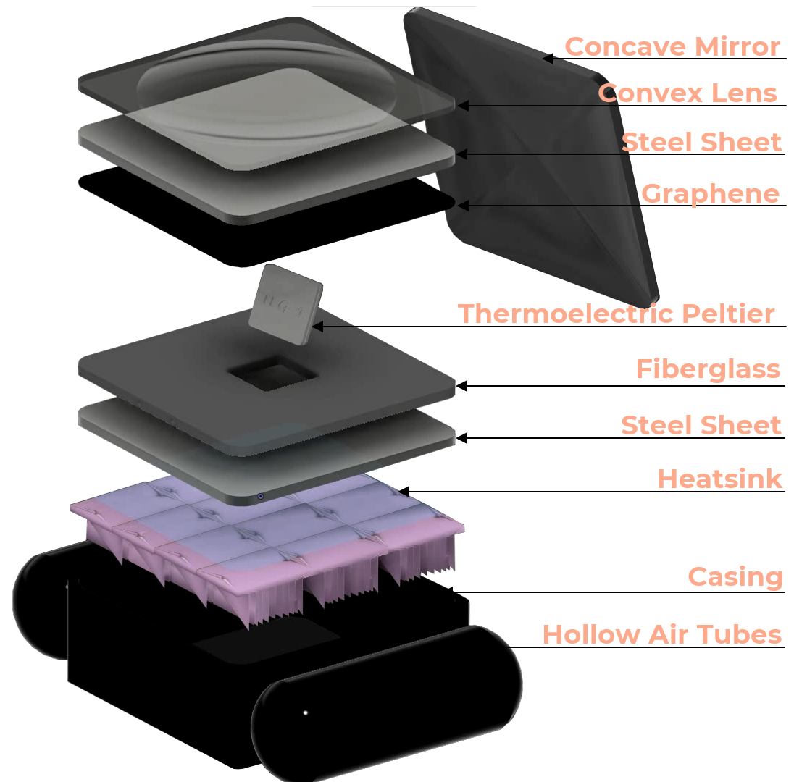

**To show the internal components**

**3D Layered Render**

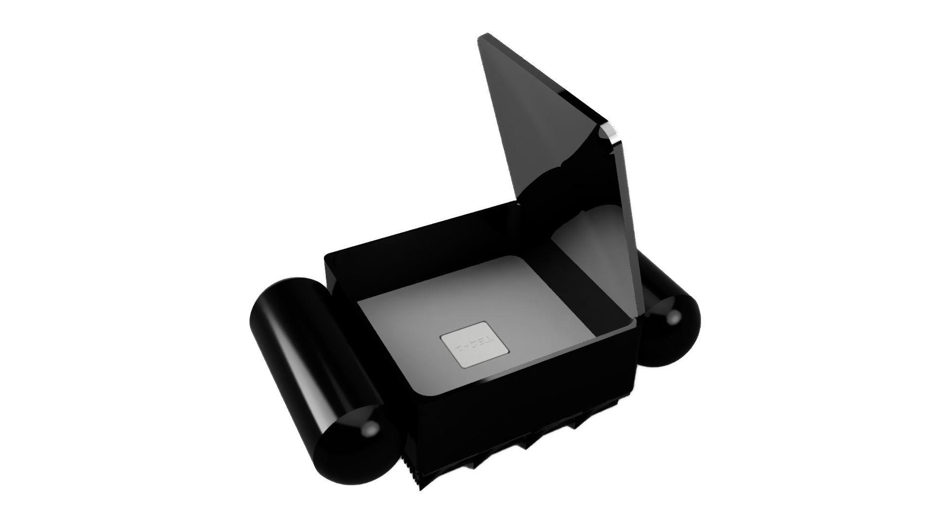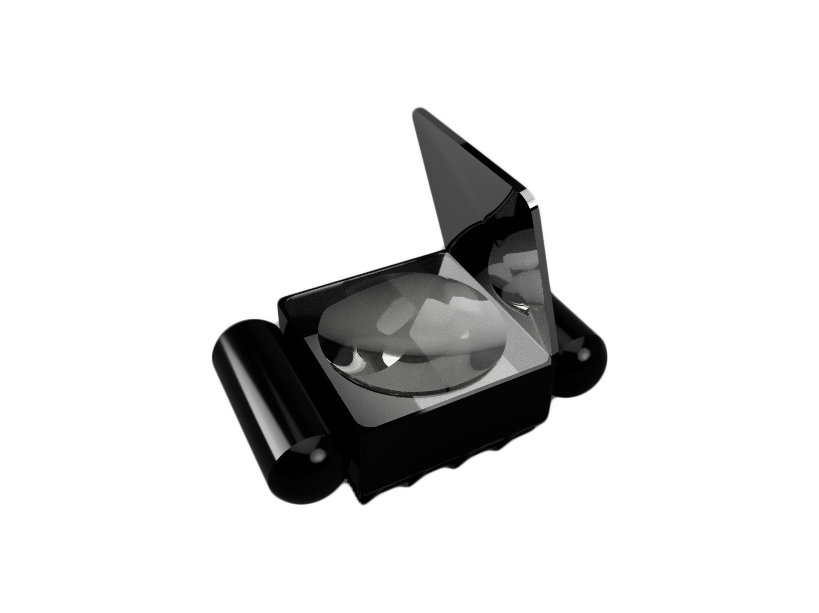

**Cross - Sectional view of the Module:**

**Longitudinal view of the Module:**

**References**

1. LaGrandeur J, Crane B and Eder A 2005 DEER Conference (Chicago/IL) LaGrandeur, J., Crane, D., Eder, A. 2005. Vehicle Fuel Economy Improvement through Thermoelectric Waste Heat Recovery, DEER Conference, 2005, Chicago, IL, USA
2. Hsiao, Y.Y., Chang, W.C., Chen, S.L. 2010. A mathematic model of thermoelectric module with applications on waste heat recovery from automobile engine. Energy, 35:1447-1454
3. Niu, X,, Yu, J., Wang, S. 2009. Experimental study on low-temperature waste heat thermoelectric generator. J. of Power Sources, 188(2): 621-626
4. Calculation Methods for Thermoelectric Generator Performance By Fuqiang Cheng, September 6th 2016Published: December 21st 2016 DOI: 10.5772/65596
5. Liang, G., Zhou, J. and Huang, Z. 2011. Analytical model of parallel thermoelectric generator. Applied Energy, 88: 5193-5199
6. Rowe, D. 2005. Thermoelectrics Handbook: Macro to Nano. Boca Raton, FL: CRC Press. USA Punnachaiya, P., Kovitcharoenkul, P. and Thong-aram, D. 2010. Development of low-grade waste heat thermoelectric power generator. Songklanakarin J.Sci.Technol, 32(3): 307-313
7. The 2nd International Joint Conference on Science and Technology (IJCST) 2017 IOP Publishing IOP Conf. Series: Journal of Physics: Conf. Series 953 (2018) 012090 doi :10.1088/1742-6596/953/1/012090 Technical Feasibility Evaluation on The Use of A Peltier Thermoelectric Module to Recover Automobile Exhaust Heat.
8. Thermoelectric Energy Harvesting: Basic Principles and Applications By Diana Enescu Published: January 21st 2019 DOI:10.5772/intechopen.83495