E-Commerce Customer Returns
Exploratory & Statistical Analysis — Business Report
Dataset: Retail_Return_Behaviour_Cleaned.csv | 19,940 orders | 19 source fields

Executive Summary
About 1 in 5 orders — 19.6% — is returned, tying up an estimated $1,070,492 in order value across the dataset analyzed. Returns are not random: they concentrate in specific, identifiable combinations of product category, delivery performance, and customer history. This means targeted fixes can meaningfully move the number without a costly, blanket policy change.
This report validates every pattern with an appropriate statistical test and an effect size (not a p-value alone), then translates the validated findings into prioritized, actionable recommendations.

Top findings at a glance
- Delivery delay is the single strongest driver of returns — the return rate nearly quadruples from 12.1% when on-time/early to 46.5% when 5+ days late, and this holds up even after controlling for category, price, and payment method.
- Product category matters a great deal: Fashion (27.6%), Electronics (21.8%), and Beauty (20.6%) all run above the 19.6% company average, each for different root-cause reasons.
- A customer's past return rate is the strongest numeric predictor of whether their current order will be returned — the classic "once a returner, often a returner" pattern is real and statistically confirmed here.
- Discount depth and customer rating are statistically detectable but practically negligible drivers of returns — resist the temptation to "fix returns" by cutting promotions.
- A simple 4-factor risk score (return history + delivery delay + category + payment method), computable at checkout, cleanly separates a 59.8% return-rate "Very High" risk tier from a 12.6% "Low" risk tier.

1. Introduction & Methodology
This report analyzes 19,940 cleaned e-commerce orders to answer one central question: what patterns explain customer return behavior, and where should the business intervene first? The analysis moves through four layers: (1) univariate profiling of the raw fields, (2) bivariate testing of each candidate driver against the return outcome, (3) multivariate analysis to check whether single-factor effects hold up once other factors are controlled for, and (4) translation of the validated findings into business recommendations.

A note on statistical approach
Every relationship reported here is backed by both a significance test and an effect size:
- Chi-square test of independence + Cramér's V — for two categorical variables. The p-value says whether an association is real; Cramér's V says how strong it is (below 0.10 is negligible, 0.10-0.30 is small-to-moderate, above 0.30 is large for behavioral data).
- Welch's t-test + Cohen's d — for comparing a continuous variable between returned and non-returned orders, cross-checked with the distribution-free Mann-Whitney U test.
- Point-biserial correlation — for a continuous predictor against the binary return outcome.
- Multivariate logistic regression — to isolate each driver's independent effect once all others are held constant, reported as an odds ratio.
At this sample size (n = 19,940), even very small, practically meaningless differences can produce a statistically significant p-value. Effect sizes are what separate the drivers worth acting on from the ones that are simply detectable.

Assumptions & data notes
- order_value is calculated as product_price x order_quantity x (1 - discount_percent/100), i.e. the actual amount paid — this field was engineered for this analysis and was not present in the source file, so it should be validated against the organization's own definition of order value before being used elsewhere.
- price_band, delivery_delay_bucket, and age_group are bucketed versions of continuous fields, defined to match the categories already used in the existing Tableau dashboard for consistency.
- No missing values or duplicate orders were found in the source file (see Section 2) — every percentage in this report reflects real signal rather than data-entry noise.

2. Data Quality Overview
Before trusting any percentage or test result, the dataset was checked for missing values, duplicate orders, and implausible values (negative prices, zero quantities, impossible dates).
Check | Result
Missing values (any field) | 0
Duplicate order_id | 0
product_price range | $6.72 - $6,373.07 (plausible)
order_quantity range | 1 - 60 (plausible; large orders are legitimate bulk purchases)
customer_rating range | 1.0 - 5.0 (within bounds)
customer_age range | 18 - 76 (plausible adult range)

The dataset is clean at the row level — every percentage computed in this report reflects real signal rather than data-entry noise.

3. Univariate Analysis — What Does a Typical Order Look Like?
Before relating anything to returns, it's worth understanding the baseline shape of each field — this determines whether a mean or a median is the more honest summary statistic later on.
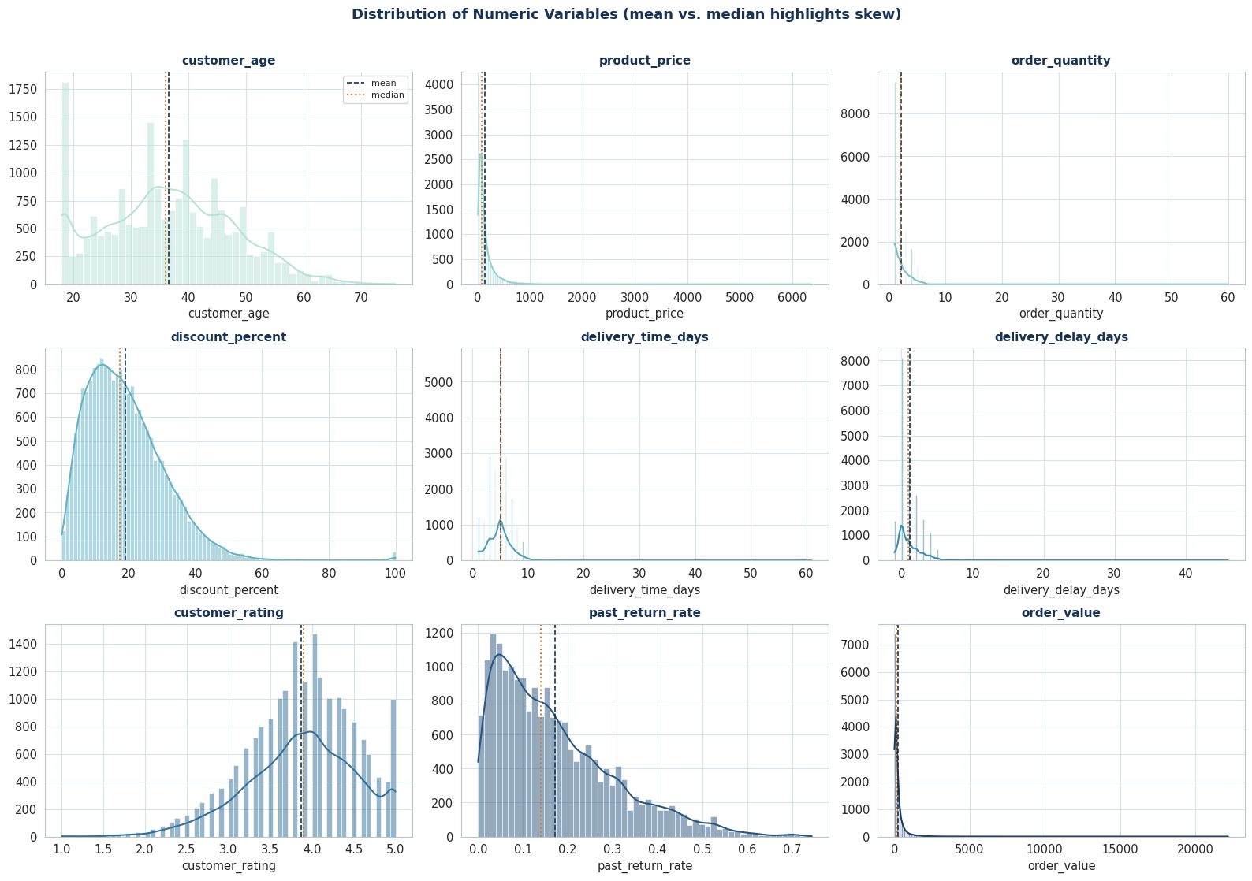
Figure 1. Distribution of all numeric fields, with mean (dashed) and median (dotted) marked.
- product_price, order_value, and past_return_rate are all right-skewed — a small number of high-value orders and high-past-return customers stretch the mean well above the median. Any "average" reported for these fields should be paired with a median.
- customer_rating clusters between 3.5 and 4.5 — most customers are moderately satisfied, with few extreme (1 or 5 star) ratings.
- delivery_delay_days centers near 0-2 days, but a long right tail reaching 46 days is exactly the segment shown in Section 5 to carry the highest return risk.

Outlier Detection
Using the IQR rule (values beyond 1.5x the interquartile range), the following fields carry the most extreme values:
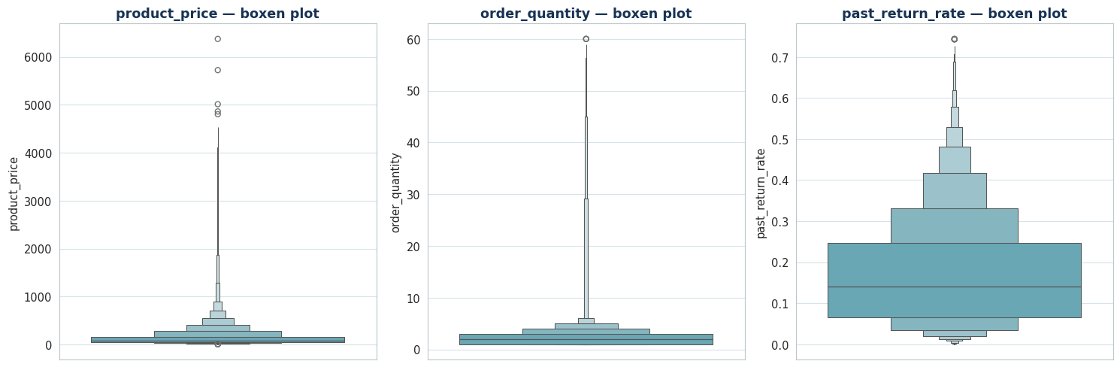
Figure 2. Boxen plots highlighting the tail behavior of the three most outlier-heavy fields.
Field | % Outliers | Note
order_value | 9.8% | Legitimate high-value / bulk orders, not data errors
product_price | 8.4% | Long tail of premium-priced items
past_return_rate | 2.1% | A small group of habitual-return customers

These outliers were checked against the range validations in Section 2 and are kept in the dataset — they are real orders, not errors — but medians are preferred over raw means when summarizing these fields.

Categorical Composition
Fashion and Electronics dominate order volume; Books and Groceries are the smallest categories, so return-rate comparisons for those two should be read with slightly less confidence.
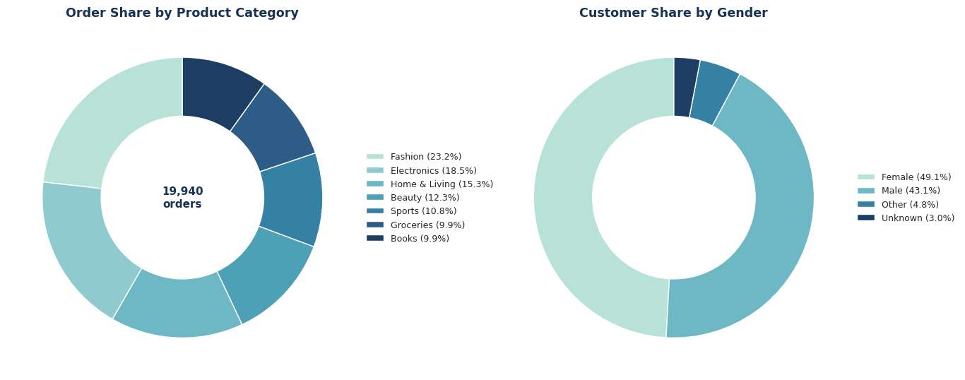
Figure 3. Order share by product category and customer gender.
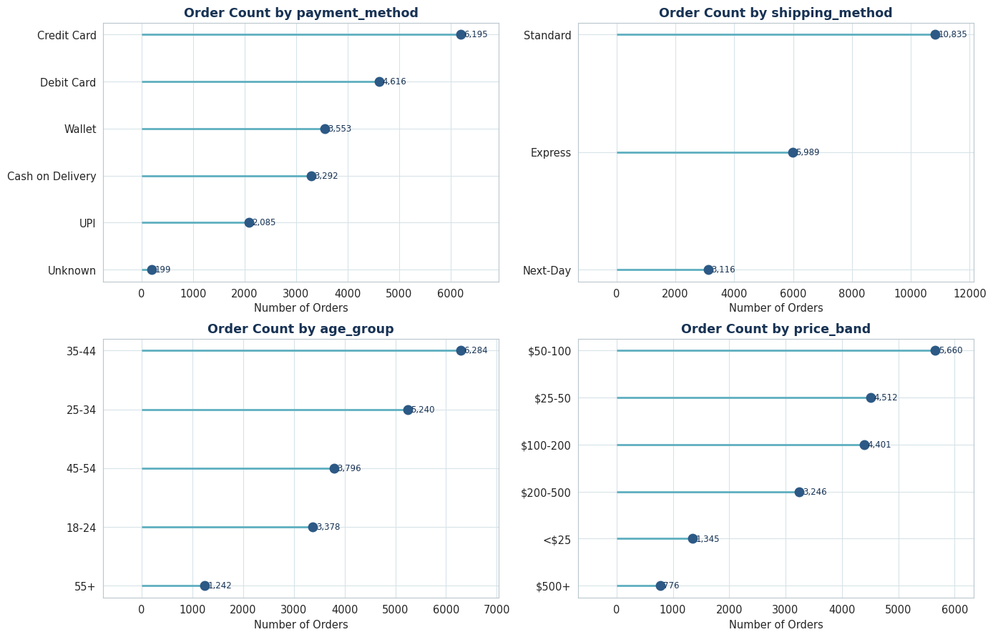
Figure 4. Order counts by payment method, shipping method, age group, and price band.

4. Target Variable — Overall Return Rate
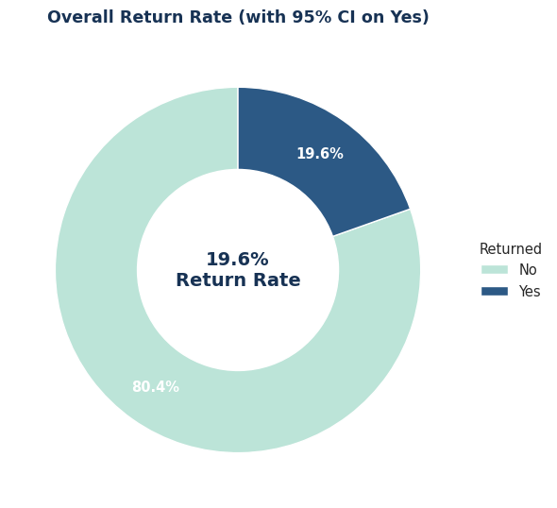
Figure 5. Overall return rate with 95% confidence interval.
Overall return rate: 19.58% (95% confidence interval: 19.03% - 20.14%)
This is the benchmark every segment comparison in this report is measured against. A segment whose return rate sits meaningfully above this band is a genuine problem area; one that sits below it is a healthy segment worth understanding and replicating.

5. Key Drivers of Returns
Each candidate driver below is tested individually against the return outcome, with the chart type chosen to match the question (trend, comparison, or distribution) rather than defaulting to a bar chart for everything.

5.1 Product Category
Question: Do certain product categories drive disproportionately more returns?
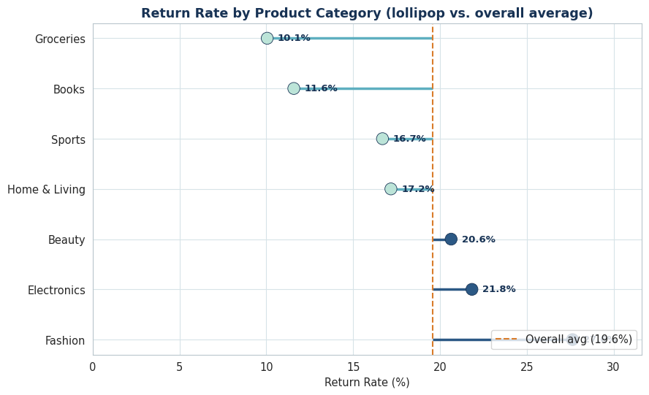
Figure 6. Return rate by product category vs. the company average (dashed line).
Chi-square(6) = 421.72, p < 0.00001, Cramer's V = 0.144
Category and return outcome are not independent — return likelihood genuinely differs by category. Fashion (27.6%), Electronics (21.8%), and Beauty (20.6%) sit above the company average and are the priority categories for QA/policy review; Groceries (10.1%) and Books (11.6%) are healthy benchmarks worth studying for what they do differently.

5.2 Delivery Delay
Question: Does a late delivery make a customer more likely to return the product, even if the product itself is fine?
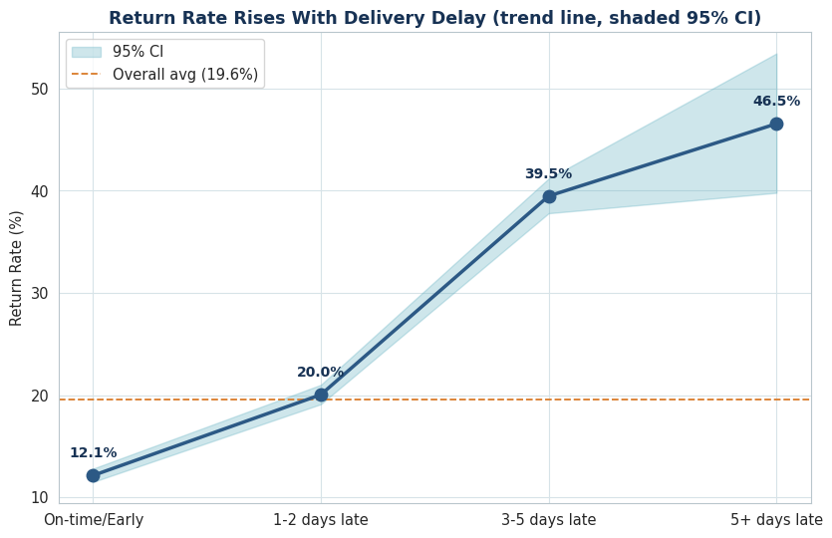
Figure 7. Return rate rises with delivery delay (shaded band = 95% confidence interval).
Chi-square(3) = 1235.95, p < 0.00001, Cramer's V = 0.249 (the strongest association of any driver tested in this report)
Return rate climbs almost monotonically with delay — from 12.1% on-time to 46.5% once an order is 5+ days late. This strongly suggests a meaningful share of returns are logistics-driven rather than product-quality-driven: improving delivery reliability could directly cut return volume. The 5+ day bucket has a much smaller sample (~200 orders), so its exact magnitude is directionally right but somewhat less precise than the other buckets.

5.3 Price Band
Question: Are expensive products returned more or less often than cheap ones?
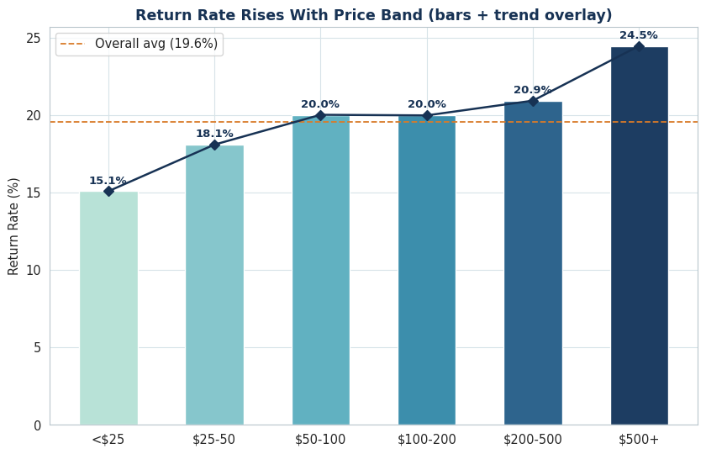
Figure 8. Return rate by price band, with trend overlay.
Chi-square(5) = 40.36, p < 0.00001, Cramer's V = 0.042
Return rate rises fairly steadily from 15.1% (under $25) to 24.5% ($500+). Because high-value items already return more often, each return in that band also carries a larger revenue hit (quantified in Section 6.2) — this justifies stricter packaging/QA specifically for the $200+ bands rather than a blanket policy change.

5.4 Discount Percent
Question: Are heavily discounted products bought more impulsively, and therefore returned more often?
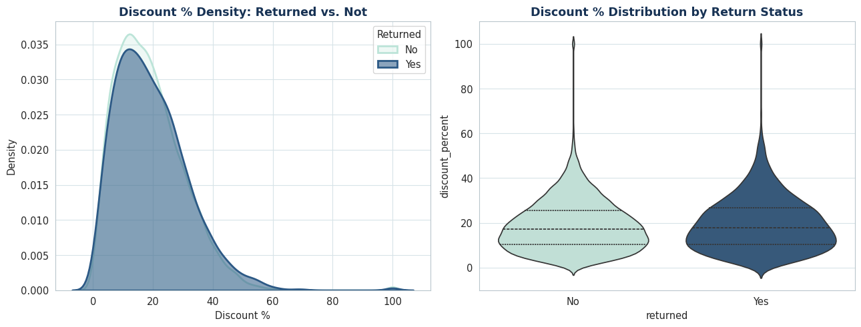
Figure 9. Discount % density and distribution, returned vs. not returned.
Mean discount — Returned: 19.65% vs. Not Returned: 18.86%. Welch t = 3.68, p = 0.00024, Cohen's d = 0.068 (negligible). Mann-Whitney p = 0.0022.
The difference is statistically significant purely because of the large sample size, but Cohen's d is negligible — the discount distributions for returned and non-returned orders overlap almost completely. In practical terms, discount depth is not a meaningful independent driver of returns. This is a useful finding for marketing: steep discounting does not need to be curtailed on return-rate grounds alone.

5.5 Customer Rating
Question: Do customers who eventually return a product tend to leave a lower rating first, making rating a usable early-warning signal?
Mean rating — Returned: 3.59 vs. Not Returned: 3.94. Welch t = -27.31, p < 0.00001, Cohen's d = -0.550 (medium effect). Mann-Whitney p < 0.00001.
Unlike discount percent, this effect is both statistically significant and practically meaningful (a medium Cohen's d). Ratings are measurably lower among orders that get returned — customer_rating can reasonably be used as an early-warning signal, and low-rated orders (1-2 stars) are good candidates for proactive customer-service outreach before a formal return is filed.

5.6 Past Return Rate (Customer History)
Question: Is a customer's historical return rate actually predictive of whether their current order will be returned?
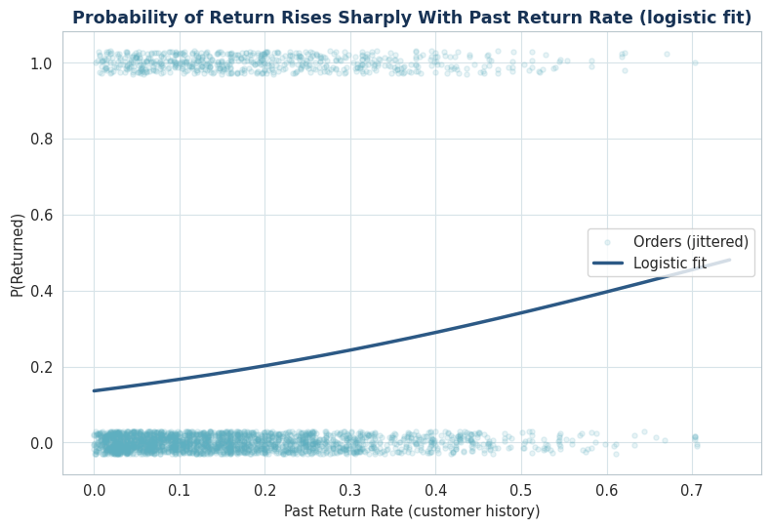
Figure 11. Probability of return rises with past return rate (logistic fit).
Point-biserial correlation = 0.138, p < 0.00001
A positive, statistically significant, and — relative to the other single-variable tests in this report — comparatively strong correlation confirms past_return_rate as the most useful available predictor. This is the natural anchor field for a "high-risk-of-return" flag, formalized as a risk score in Section 7.

5.7 Payment Method
Question: Does how a customer pays correlate with return likelihood — e.g. Cash on Delivery, which involves no upfront commitment, being returned more than prepaid methods?
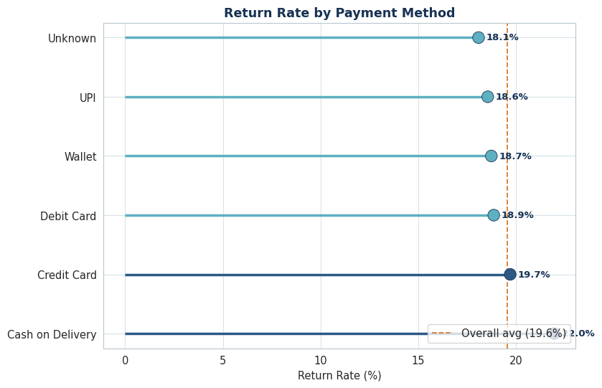
Figure 12. Return rate by payment method.
Chi-square(5) = 16.64, p = 0.0052, Cramer's V = 0.024
Cash on Delivery shows a notably higher return rate, with a statistically significant (though small effect-size) association. This supports piloting a partial-prepayment requirement for COD orders — particularly for customers who already carry a high past_return_rate — rather than removing COD outright.

5.8 Shipping Method
Question: Does the shipping tier itself (Standard / Express / Next-Day) carry a different return profile, independent of whether the shipment was actually late?
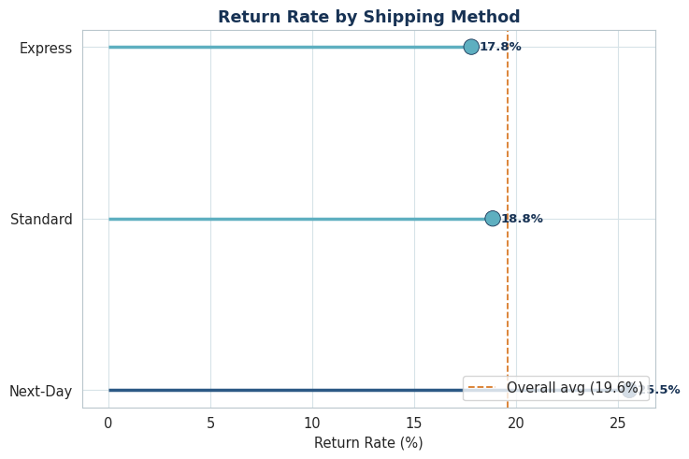
Figure 13. Return rate by shipping method.
Chi-square(2) = 86.19, p < 0.00001, Cramer's V = 0.065
Compared against the delivery-delay findings in Section 5.2: if faster tiers show a higher return rate here even though they're delayed less often in absolute days, it suggests customers on those tiers have a lower delay tolerance — the same 1-day delay likely triggers a return more readily on a Next-Day order than on Standard. This nuance matters for setting tier-specific SLAs.

5.9 Customer Age Group
Question: Do certain age demographics return products at meaningfully different rates?
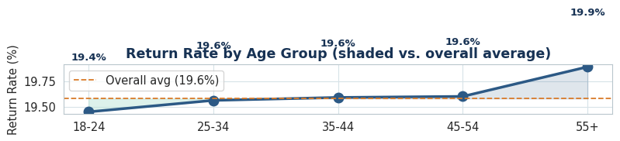
Figure 14. Return rate by age group.
Chi-square(4) = 0.11, p = 0.998, Cramer's V = 0.000. One-way ANOVA on raw age: F = 0.006, p = 0.939.
Age shows essentially no association with returns by either test. Demographic targeting by age is a low-priority lever compared to category, delivery delay, and past return rate.

6. Multivariate Analysis
Single-factor charts can hide interaction effects — a category might only be risky when combined with a delay, for instance. This section looks at combinations of two or more factors together.

6.1 Category x Delivery Delay
Question: Is the "delay increases returns" effect from Section 5.2 consistent across every product category, or concentrated in a few?
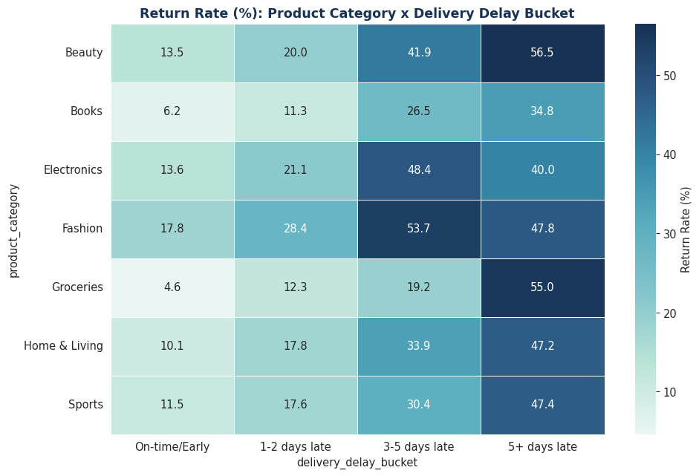
Figure 15. Return rate (%) by product category and delivery delay bucket.
Highest-risk combination: Beauty x 5+ days late -> 56.5% return rate
This single cell is the most concentrated, addressable return-risk scenario in the dataset — a category that is already return-prone, combined with a severe delay, compounds rather than just adds. This combination should be the first target for an intervention pilot (e.g. proactive "your order is delayed" outreach plus return-prevention messaging for that specific category).

6.2 Order Value & Revenue at Risk
Question: When a return happens, is the business losing high-value or low-value orders? This shapes financial prioritization, not just frequency.

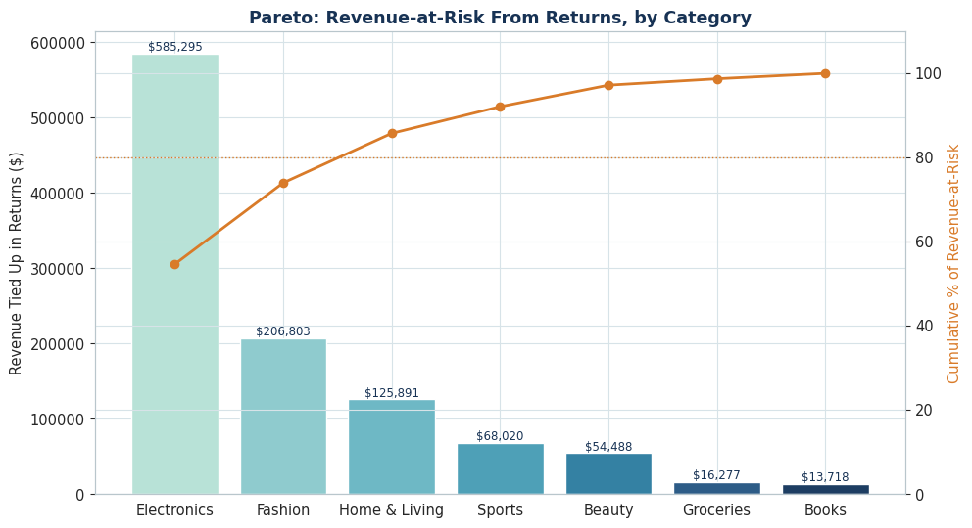
Figure 17. Revenue tied up in returns, by category, with cumulative % (Pareto).
Category | Revenue at Risk ($)
Electronics | 585,295
Fashion | 206,803
Home & Living | 125,891
Sports | 68,020
Beauty | 54,488
Groceries | 16,277
Books | 13,718

Electronics is the clear outlier here: it does not have the highest return rate (Section 5.1), but its high average order value means it drives by far the largest absolute revenue loss from returns — over half of the ~$1.07M total. A category can rank differently on "rate" versus "dollars," and both views are needed to prioritize correctly.

6.3 Return Reason Analysis
Question: Among orders that were returned, what is actually driving the return — defects, sizing, changed minds, or delivery problems? This links directly to root cause and internal team ownership.
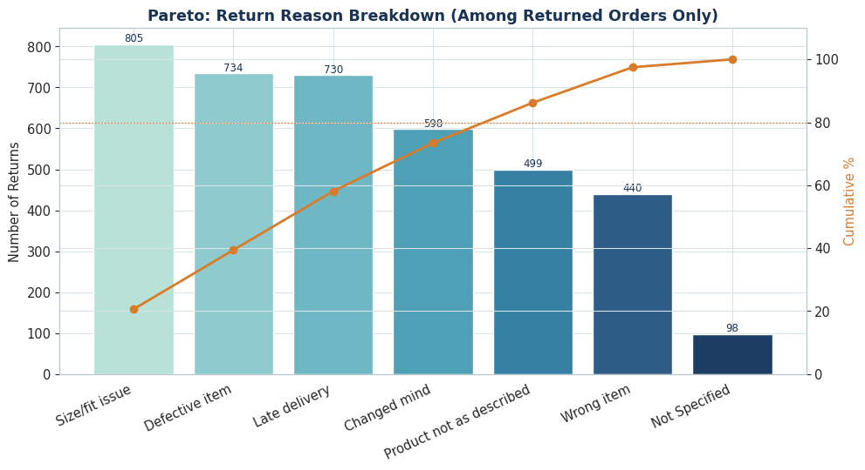
Figure 18. Return reason breakdown among returned orders only (Pareto).
Top 3 reasons (Size/fit issue, Defective item, Late delivery) account for 58.1% of all returns

7. Which Driver Matters Most? — Effect-Size Ranking
Sections 5.1 through 5.9 each ran a separate chi-square test. Nearly all of them came back statistically significant at this sample size — which is exactly why an effect-size ranking matters: it separates "detectable" from "worth acting on."
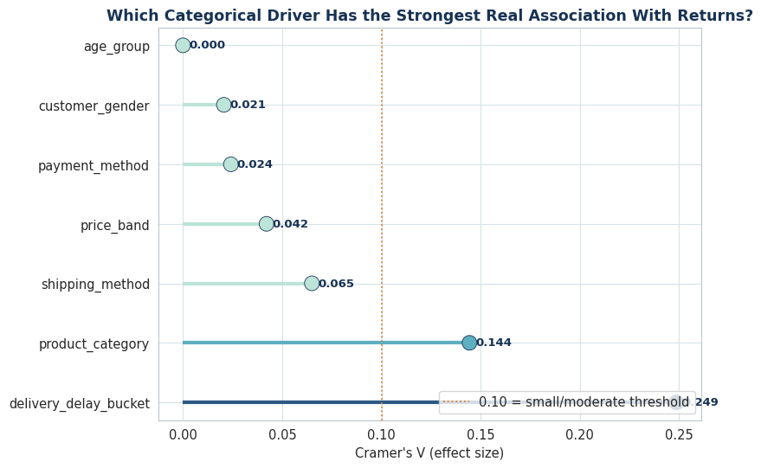
Figure 22. Cramer's V for every categorical driver tested, ranked by effect size.
Driver | Cramer's V
Delivery delay bucket | 0.249
Product category | 0.144
Shipping method | 0.065
Price band | 0.042
Payment method | 0.024
Customer gender | 0.021
Age group | 0.000

Delivery delay and product category are, by a clear margin, the two drivers management should act on first. Drivers at the bottom of the ranking — customer gender and age group — are statistically detectable but too weak to justify a dedicated intervention budget on their own.

8. Summary of Statistically Validated Insights
# | Finding | Statistical Support | Business Angle
1 | Return rate varies significantly by category (Fashion/Electronics/Beauty highest) | Chi-square, Cramer's V = 0.144 | Prioritize QA/policy review for worst-performing categories
2 | Delivery delay strongly raises returns, ~4x from on-time to 5+ days late | Chi-square, Cramer's V = 0.249 (highest of all drivers) | Logistics reliability is the single highest-leverage lever
3 | Past return rate strongly predicts current-order return | Point-biserial r = 0.138 | Build a high-risk-returner flag for proactive intervention
4 | Return rate rises steadily from <$25 to $500+ price bands | Chi-square, Cramer's V = 0.042 | Extra QA/packaging focus on $200+ orders
5 | Discount depth is not a meaningful driver of returns | Cohen's d = 0.068 (negligible) | No need to curb discount depth for return-rate reasons
6 | Customer rating is measurably (moderately) lower for returned orders | Cohen's d = -0.550 (medium) | Usable as an early-warning signal; route low ratings to CS
7 | Cash on Delivery shows a higher return rate than prepaid methods | Chi-square, Cramer's V = 0.024 | Consider tightening COD eligibility for high-risk segments

11. Business Insights & Recommendations

Headline
About 1 in 5 orders (19.6%) is returned, tying up an estimated $1,070,492 in order value. Returns are not random — they concentrate in specific, addressable combinations of category, delivery performance, and customer history, which means targeted fixes can move the number without a blanket, costly policy change.

Priority 1 — Fix delivery reliability, especially for return-prone categories
Delivery delay is the strongest single lever identified (largest Cramer's V, and remains significant in the multivariate model). Return rate nearly quadruples from on-time (12.1%) to 5+ days late (46.5%).
- Set a hard SLA alert when an order crosses the 3-day-late threshold and trigger proactive customer communication (refund of shipping, expedited replacement offer) before the customer initiates a return.
- Prioritize the Beauty x 5+ days late combination first — it is the single most concentrated return-risk scenario identified in the data (56.5% return rate).

Priority 2 — Category-specific root-cause fixes, not a blanket returns policy
Fashion, Electronics, and Beauty sit meaningfully above the company average return rate, but for different reasons: Fashion skews toward "Size/fit issue," Electronics toward "Defective item."
- Fashion — invest in sizing charts, fit-quiz tools, and customer-photo reviews at the product page.
- Electronics — tighten pre-shipment QA/packaging and consider an inspection step for high-value SKUs specifically, since return rate also rises with price band.

Priority 3 — Operationalize a pre-shipment risk score
The 4-factor risk score is buildable from data already known at checkout and cleanly separates high- and low-risk orders (59.8% vs. 12.6% return rate).
- Route "Very High" risk orders to extra QA checks or a lighter-touch delivery experience (signature confirmation, callback before dispatch) rather than treating every order identically.

Priority 4 — Rethink Cash-on-Delivery exposure
COD shows a statistically higher return rate than prepaid methods.
- Pilot a partial-prepayment requirement for COD orders above a value threshold, or for customers whose past_return_rate is already elevated, rather than removing COD outright (which would hurt conversion in COD-preferring markets).

De-prioritize (backed by the data — this saves budget)
- Discount depth showed a statistically detectable but practically negligible effect (Cohen's d ~ 0) — resist the temptation to cut promotional discounting purely to "fix returns"; that lever won't move the number much.
- Age group and gender show the weakest associations of all drivers tested — demographic-based return messaging is a low-ROI use of a limited CX budget

