IndCasting backend structure
A file-by-file map for a NestJS API server, built around IndCasting's actual features: talent/seeker profiles, casting calls, applications, messaging, and media.

What each tool does, in plain terms
Before the file map — a quick, plain-English explanation of every tool used in this project. No jargon.
- NestJS: A framework — a starter kit of structure and rules for building the backend, so you're not organizing everything from scratch.
- TypeScript: The language we write the backend in — like JavaScript, but it checks your code for mistakes before it runs.
- PostgreSQL: The database where all the real data lives — user accounts, job posts, applications, messages.
- TypeORM: A translator between our code and the database, so we write TypeScript instead of raw database queries.
- Passport + JWT: Checks who's logged in by reading a login token attached to each request.
- bcrypt: Scrambles passwords before saving them, so even we can't see a user's real password.
- class-validator: Automatically checks that incoming data (like a signup form) is filled in correctly before we use it.
- Redis: A super-fast temporary storage layer — used for things that need to be quick, like login sessions and message delivery.
- BullMQ: A to-do list for slow tasks (like sending an email) so they run in the background instead of making the user wait.
- Socket.IO: Lets messages and notifications appear instantly, without the user refreshing the page.
- Cloudinary: Stores and manages uploaded photos and videos (portfolios, headshots, reels) and can resize them automatically.
- multer: Reads uploaded files (like a resume or photo) when a user submits them through a form.
- Resend: Sends emails on our behalf — like "your application was accepted."
- web-push: Sends alert notifications straight to a user's phone or browser, even if the app isn't open.
- helmet: A basic security guard — blocks a few common, sneaky attacks automatically.
- Throttler: Stops one person from spamming the server with too many requests too fast.
- compression: Shrinks data before sending it, so pages load faster.
- pino: Keeps a clean, organized diary of everything the server does, useful for finding problems later.
- Jest + supertest: Automatically tests our code to catch bugs before they reach real users.
- Hosting (Railway/Render/AWS): The company that keeps our servers running and online, so users can actually reach the app.
- Managed Redis/Postgres: A version of Redis and Postgres that someone else manages for us, so we don't have to fix it ourselves at 2am.
- CDN (Cloudflare): Copies of our images and files placed closer to each user, so things load faster no matter where they are.

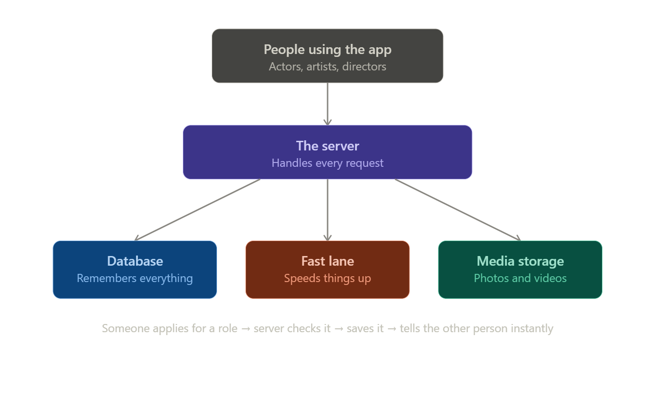

1. Top-level folder tree
This is the whole repo. Everything below expands one branch of this tree at a time.
indcasting-api/
├── src/
│ ├── main.ts
│ ├── app.module.ts
│ ├── config/
│ ├── common/
│ │ ├── decorators/
│ │ ├── filters/
│ │ ├── guards/
│ │ ├── interceptors/
│ │ └── pipes/
│ ├── database/
│ │ └── migrations/
│ ├── auth/
│ ├── users/
│ ├── talent-profiles/
│ ├── casting-calls/
│ ├── applications/
│ ├── messaging/
│ ├── notifications/
│ ├── media/
│ ├── reviews/
│ └── worker/
├── test/
├── .env
├── .env.example
├── nest-cli.json
├── tsconfig.json
└── package.json

2. Entry point and root module
File | Purpose | Contains
main.ts | Boots the app. | Creates the Nest app, applies global pipes/filters, enables CORS, sets the API prefix (e.g. /api/v1), starts listening on process.env.PORT.
app.module.ts | Root module — wires every feature module together. | @Module({ imports: [ConfigModule, AuthModule, UsersModule, TalentProfilesModule, CastingCallsModule, ApplicationsModule, MessagingModule, NotificationsModule, MediaModule, ReviewsModule] })
app.controller.ts | Health check only. | A single GET /health route for load balancer checks — nothing business-related lives here.

3. config/ — environment and typed settings
Nothing outside this folder should call process.env directly. Every other module imports typed config instead, so a wrong or missing env var fails at boot, not at 2am in production.
File | Purpose | Contains
configuration.ts | One function returning a nested object of every setting the app needs. | database url, jwt secrets + expiry, redis url, s3/cloudinary keys, cors origins, rate-limit thresholds.
validation.schema.ts | A Joi (or Zod) schema the app validates .env against on startup. | Marks which vars are required vs optional, catches a missing DATABASE_URL before the app even starts.

4. common/ — code shared by every feature module
If two or more feature modules would otherwise duplicate a guard, pipe, or filter, it belongs here instead.
File | Purpose | Contains
guards/jwt-auth.guard.ts | Blocks a request unless it has a valid JWT. | Applied globally or per-route with @UseGuards(JwtAuthGuard).
guards/roles.guard.ts | Blocks a request unless the user's role matches what the route requires. | Reads a @Roles('seeker') decorator set on the route and compares it to the JWT payload's role.
decorators/roles.decorator.ts | Custom decorator used to tag routes with allowed roles. | export const Roles = (...roles) => SetMetadata('roles', roles)
decorators/current-user.decorator.ts | Pulls the authenticated user off the request into a controller argument. | Lets a controller write getProfile(@CurrentUser() user) instead of reading req.user manually.
filters/http-exception.filter.ts | Catches every thrown error and formats one consistent JSON error shape. | { statusCode, message, error, timestamp } — so the frontend never has to guess the error format.
interceptors/logging.interceptor.ts | Logs method, route, and response time for every request. | Wraps the request handler, logs before and after.
pipes/validation.pipe.ts | Runs class-validator against incoming DTOs and rejects bad payloads with 400s. | Usually just Nest's built-in ValidationPipe registered globally in main.ts — a custom file is only needed for non-default behaviour.

5. database/ — Postgres connection and migrations
File | Purpose | Contains
database.module.ts | Configures TypeORM (or Prisma) with the connection string from config/. | Exports the connection so every feature module's *.module.ts can inject repositories.
migrations/*.ts | One file per schema change, timestamped. | e.g. 1710000000000-CreateUsersTable.ts, 1710000100000-AddApplicationsTable.ts — never edit an already-run migration, always add a new one.

6. auth/ — login, tokens, sessions
File | Purpose | Contains
auth.module.ts | Wires the controller, service, and JWT strategy together. | Imports PassportModule and JwtModule with the secret/expiry from config.
auth.controller.ts | Exposes the auth-related HTTP routes. | POST /auth/register, POST /auth/login, POST /auth/refresh, POST /auth/logout.
auth.service.ts | The actual logic: hashing passwords, verifying credentials, issuing tokens. | bcrypt compare on login, signs access + refresh JWTs, stores refresh token hash for revocation.
strategies/jwt.strategy.ts | Tells Passport how to extract and validate a JWT from an incoming request. | Reads the token from the Authorization header or an httpOnly cookie, verifies signature, returns the payload.
dto/login.dto.ts / register.dto.ts | Shape and validation rules for request bodies. | class LoginDto { @IsEmail() email; @MinLength(8) password; }

7. users/ — accounts shared by both talent and seekers
This module owns the base account record. Role-specific details (skills, company name) live in talent-profiles/, not here.
File | Purpose | Contains
users.controller.ts | Account-level routes. | GET /users/me, PATCH /users/me, DELETE /users/me.
users.service.ts | CRUD against the users table, plus role assignment. | createUser(), findByEmail(), updateRole().
entities/user.entity.ts | The Postgres table definition. | id, email, passwordHash, role (enum: talent | seeker | admin), createdAt.
dto/update-user.dto.ts | What fields a user is allowed to patch on their own account. | Deliberately excludes role and passwordHash — those get their own protected endpoints.

8. talent-profiles/ — actor and makeup artist profiles
File | Purpose | Contains
talent-profiles.controller.ts | Profile CRUD and public browsing. | GET /talent (search/filter), GET /talent/:id, PATCH /talent/me, POST /talent/me/resume.
talent-profiles.service.ts | Business logic for building and searching profiles. | buildSearchQuery() turns filters (location, skills, budget) into a typed Postgres query — this is where advanced search lives.
entities/talent-profile.entity.ts | The profile table, one-to-one with users. | bio, skills (jsonb array), location, dayRate, availability, portfolioUrls (jsonb), resumeUrl.
dto/search-talent.dto.ts | Validates and types the incoming query params for search. | location?, skills?: string[], minBudget?, maxBudget?, page?, limit?.

9. casting-calls/ — job postings
File | Purpose | Contains
casting-calls.controller.ts | Posting and browsing casting calls. | POST /casting-calls (seeker only), GET /casting-calls, GET /casting-calls/:id, PATCH/DELETE for the owner.
casting-calls.service.ts | Ownership checks and listing logic. | Confirms req.user.id matches the posting's seekerId before allowing edit/delete.
entities/casting-call.entity.ts | The job posting table. | title, description, budgetMin, budgetMax, location, requirements (jsonb), seekerId (FK), status (open | closed), createdAt.
dto/create-casting-call.dto.ts | Validation for a new posting. | @IsNotEmpty() title, @IsNumber() budgetMin/Max, @IsArray() requirements.

10. applications/ — talent applying to casting calls
File | Purpose | Contains
applications.controller.ts | Apply, withdraw, and review applications. | POST /casting-calls/:id/applications, GET /applications/mine, PATCH /applications/:id/status (seeker only).
applications.service.ts | State machine for an application's lifecycle. | Enforces valid transitions: submitted → shortlisted → accepted/rejected. Also fires a notification on every status change.
entities/application.entity.ts | Links a talent profile to a casting call. | castingCallId (FK), talentId (FK), coverLetter, portfolioSnapshot, status, appliedAt.
dto/create-application.dto.ts | What a talent submits when applying. | @IsString() coverLetter; portfolio attachments referenced by media ID, not re-uploaded.

11. messaging/ — real-time chat
File | Purpose | Contains
messaging.gateway.ts | The Socket.IO gateway — this is the WebSocket entry point. | @SubscribeMessage('sendMessage') handlers; on connect, authenticates the socket using the same JWT strategy as REST.
messaging.service.ts | Persists messages and resolves conversation threads. | saveMessage(), getConversation(userA, userB), marks messages read.
entities/message.entity.ts | One row per message. | conversationId, senderId, recipientId, body, readAt, createdAt.
adapters/redis-io.adapter.ts | Lets Socket.IO work across multiple server instances. | Registered once in main.ts — without this, a message only reaches users connected to the same server process.

12. notifications/ — alerts for applications, messages, jobs
File | Purpose | Contains
notifications.service.ts | Central place every other module calls to notify a user. | notify(userId, type, payload) — decides whether to push a websocket event, queue an email, or both.
notifications.processor.ts | A BullMQ processor that consumes the notification queue. | Runs in the worker/ process, not the API process — sends the actual email via a provider like SES or Resend.
entities/notification.entity.ts | In-app notification feed, separate from email delivery. | userId, type, payload (jsonb), readAt, createdAt.

13. media/ — uploads to S3 / Cloudinary
File | Purpose | Contains
media.controller.ts | Handles file uploads and returns storage URLs. | POST /media/upload — accepts multipart form data, never accepts a raw file path from the client.
media.service.ts | Talks to the storage provider's SDK. | Generates a signed upload URL or streams the file to Cloudinary, validates file type/size before accepting.
entities/media-asset.entity.ts | Tracks what was uploaded and by whom, independent of where it's used. | ownerId, url, type (image | video | pdf), sizeBytes, createdAt.

14. reviews/ — ratings between talent and seekers
File | Purpose | Contains
reviews.controller.ts | Leave and read reviews after a completed job. | POST /applications/:id/review, GET /talent/:id/reviews.
reviews.service.ts | Enforces that a review can only follow a completed application. | Checks application.status === 'completed' before allowing a review to be created.
entities/review.entity.ts | One review row per completed application. | applicationId, reviewerId, revieweeId, rating (1–5), comment, createdAt.

15. worker/ — background jobs, separate process
This is not a NestJS module inside the API app — it's a second, smaller Nest application that shares the same entities and BullMQ queue definitions, deployed and scaled independently of the API server.
File | Purpose | Contains
worker/main.ts | Boots a standalone process that only consumes queues. | No HTTP server, no controllers — just NestFactory.createApplicationContext().
worker/processors/*.ts | One processor per job type. | email.processor.ts, video-transcode.processor.ts, digest.processor.ts.

16. How a request actually flows through this
Concrete example — a talent applies to a casting call:
- 1. Client sends POST /casting-calls/42/applications with a JWT.
- 2. JwtAuthGuard (common/guards) verifies the token before the request reaches any controller code.
- 3. applications.controller.ts receives the validated CreateApplicationDto and calls applications.service.ts.
- 4. applications.service.ts checks the casting call is still open, creates the application row via TypeORM, and calls notifications.service.ts.
- 5. notifications.service.ts pushes a live event through messaging.gateway.ts to the seeker if they're online, and queues an email job in Redis via BullMQ.
- 6. worker/processors/email.processor.ts picks up that job asynchronously and sends the email — the original HTTP request already returned a 201 long before this runs.

17. Naming conventions worth locking in early
- kebab-case.type.ts for every file — talent-profiles.service.ts, not TalentProfilesService.ts.
- One entity, one DTO folder, one controller, one service per feature module — resist merging small modules together even when a module feels tiny at first.
- Services never import other modules' repositories directly — if applications.service.ts needs data from talent-profiles, it calls TalentProfilesService, not the TalentProfile repository. Keeps ownership of each table with one module.
- DTOs are the only thing that crosses the HTTP boundary — controllers never accept or return raw entities.

18. Packages and services we'll actually use
Concrete picks, not categories — this is what goes in package.json and what accounts to create, mapped to the module that owns it.

18.1 Core framework and language
File | Purpose | Contains
@nestjs/core, @nestjs/common | The framework itself. | Every module imports from these — modules, controllers, decorators, DI.
typescript, ts-node | Language and dev-time execution. | NestJS is TypeScript-first; this isn't optional.
@nestjs/config | Loads and validates .env. | Used inside config/configuration.ts and config/validation.schema.ts.

18.2 Database
File | Purpose | Contains
@nestjs/typeorm, typeorm, pg | ORM and Postgres driver. | database/database.module.ts, every *.entity.ts file.
typeorm-extension or typeorm CLI | Runs and generates migrations. | database/migrations/*.ts.

18.3 Auth
File | Purpose | Contains
@nestjs/passport, passport, passport-jwt | JWT strategy and guard plumbing. | auth/strategies/jwt.strategy.ts, common/guards/jwt-auth.guard.ts.
@nestjs/jwt | Signs and verifies access/refresh tokens. | auth/auth.service.ts.
bcrypt | Password hashing. | auth/auth.service.ts — never store plain passwords.
class-validator, class-transformer | DTO validation. | Every dto/*.ts file across every module.

18.4 Cache, queues, real-time
File | Purpose | Contains
ioredis | Redis client. | Backs caching, BullMQ, and the Socket.IO adapter.
@nestjs/bullmq, bullmq | Job queue on top of Redis. | notifications/notifications.processor.ts, worker/processors/*.ts.
@nestjs/websockets, @nestjs/platform-socket.io, socket.io | Real-time messaging. | messaging/messaging.gateway.ts.
@socket.io/redis-adapter | Lets Socket.IO scale across instances. | messaging/adapters/redis-io.adapter.ts.

18.5 Media storage
File | Purpose | Contains
cloudinary | SDK for Cloudinary uploads and transforms. | media/media.service.ts — built-in thumbnailing and image transforms, no pipeline to build.
multer, @nestjs/platform-express | Parses incoming multipart file uploads. | media/media.controller.ts.

18.6 Notifications (outbound)
File | Purpose | Contains
resend or @sendgrid/mail | Transactional email. | worker/processors/email.processor.ts — Resend has a simpler API and generous free tier; SendGrid is the more established enterprise option.
web-push | Browser push notifications. | notifications/notifications.service.ts, if you want job-alert pushes beyond in-app + email.

18.7 Cross-cutting infrastructure
File | Purpose | Contains
helmet | Sets safe HTTP headers. | Registered once in main.ts.
@nestjs/throttler | Rate limiting. | Registered globally in app.module.ts, tunable per route.
compression | Gzips responses. | Registered in main.ts.
winston or pino + nestjs-pino | Structured logging. | Used inside common/interceptors/logging.interceptor.ts.

18.8 Testing
File | Purpose | Contains
jest, @nestjs/testing | Unit and integration tests. | Ships with the Nest CLI scaffold by default — one *.spec.ts per service/controller.
supertest | HTTP assertions against a running Nest app. | test/*.e2e-spec.ts.

18.9 Deployment and infra (not npm packages)
File | Purpose | Contains
Railway, Render, or AWS ECS/Fargate | Hosts the API and worker processes. | Two deployable units from this repo: the API app and worker/ as a separate process/service.
Neon, Supabase, or AWS RDS | Managed Postgres. | Whichever gives you the easiest read-replica story once you're past MVP scale.
Upstash or a managed Redis add-on | Managed Redis. | Backs cache, BullMQ, and the Socket.IO adapter — one instance covers all three at this scale.
Cloudflare or CloudFront | CDN in front of the Next.js frontend and media URLs. | Not part of this repo — configured at the DNS/hosting layer.

Appendix: alternatives we considered
These aren't part of the plan above — just other options worth knowing about in case priorities change later.
- Prisma (instead of TypeORM): A different way to talk to the database. Instead of TypeORM's style, you write your schema in one file and it generates ready-made code for you. Easier migrations, but a bigger shift from how NestJS normally works.
- Auth0 / Firebase Auth (instead of building our own login): A service that handles logins for you instead of building it yourself. Faster to set up, but it costs money per user once you pass a free limit, and you don't own the login system.
- Amazon S3 (instead of Cloudinary): A place to store uploaded files, like Cloudinary, but more hands-on — you build the resizing and thumbnail logic yourself. Usually cheaper once you have a lot of users.

