Report
EECS 3221 – Assignment 2 – Jia Xu

POSIX Threads – Implementation of New_Alarm_Mutex.C

Group 6 - Team Members:
Aggrim Arora
Arnesh Dawar
Inderpal Dhillon
Rui Huang
Xiahan Chen

Index

- POSIX 3

- pthreads in Linux 4

- Dependencies for New_Alarm_Mutex.C 6

- Design Requirements for New_Alarm_Mutex.C 7

- High-level view of the design of New_Alarm_Mutex.C 9

- Issues/Difficulties Encountered While Implementing the Design 11

- Testing and Outputs 12

- Acknowledgements 13

POSIX
Portable Operating System Interface (POSIX) is an application programming interface for UNIX systems. A program written using POSIX standards can easily be ported to other UNIX derivates (like Linux). It extends the ANSI C programming language and defines the following features:
- POSIX.1 (core services)
- Process creation and control
- Signals
- Pipe operations
- C Library
- POSIX.1b (Real-Time extensions)
- Priority Scheduling
- Real-Time signals
- Message passing
- Shared Memory
- Asynchronous and Synchronous I/O
- POSIX1.c (thread extensions)
- Control, creation and cleanup
- Scheduling
- Synchronization
- POSIX.2 (Shell and Utilities)
- Command interpreter

Pthreads
Pthreads allow the execution of multiple tasks that overlap in time. At any instance, a thread is in one of the four basic states:
- Ready: able to run but is waiting for a processor or has just been started/unblocked/pre-empted by another process
- Running: in execution
- Blocked: is not able to run because it is waiting for a condition variable, to lock a mutex, or waiting for an /O operation to complete
- Terminated: has terminated by returning from its start function or by calling pthread_exit.
Once terminated, a thread is recycled. Detailed analysis:
- Creation
The initial thread of a process is created when the process is created. Additional threads can be created on a Pthreads system by calling thread_create. As soon as a thread is created, its state is ready.
- Startup
Once a thread has been created, it starts executing machine instructions. It starts with the execution of the thread start function specified in the pthread_create.
- Running and Blocking
A thread goes to sleep when the required resource is not available (blocked) or because it has been pre-empted by another thread. Most of its active life is spent in three stages: ready, running and blocked. When a thread attempts to lock a mutex that is currently locked, it becomes blocked. It is made ready for execution as soon as it is unblocked (some other thread unlocks the mutex and the current thread locks it again).

- Termination
A thread usually terminates by returning from its start function. Another way to terminate a thread is by calling the pthread_exit or pthread_cancel function. If a thread is already detached, it moves to the next step immediately, recycling. On the other hand, if a thread returns a specific value, the value can then be extracted by using the pthread_join function that also specifies the next thread to be executed and to which the return value is passed.

Dependencies for New_Alarm_Mutex.c

- pthread.h
The pthread.h file consists of a number of constants and prototypes for the Pthreads functions
- errors.h
The errors.h file consists of headers and some error checking functions.
- time.h
Used to get the time since EPOCH for the alarm functionality

Design Requirements for New_Alarm_Mutex.C

Main Thread:
Allocating 1 thread for input parsing to make sure the commands received are valid and then follow them up with the appropriate request.
The two requests handled by the main thread are:
- Start_Alarm
- Change_Alarm
Our design required a simple method of determining a valid input and performing the corresponding action based on aforementioned input. We made a design choice to accomplish this in the most straightforward manner possible, by comparing the input from stdin to defined string constants, which represent valid inputs. We prevent invalid commands and print an error message.
Alarm Thread:
Responsible for maintaining as many as 3 display threads for every alarm that is added to the list by the requests from main thread.
We required a new list to keep track of the alarms assigned to each display thread, that would not interfere with the alarm list. As a result, we would be unable to modify the alarm->link reference as that would change the alarmlist.
To accomplish this, we first tried using a simple array of alarm_t structs. However, several design flaws were apparent. The most glaring one was that the array would have fixed size, and thus our program would only support a fixed number of alarms per thread.
In order to fix the issues we initially encountered, we changed our design to utilize a new struct which represented the list of alarms. We assign such a struct to each display thread, and each one contains a reference to the next alarm in the list.
Before assigning an alarm to one of the three threads, we first check to see that, in fact, 3 threads exist. If they do not, we create a new display_alarm_thread and assign the alarm to it. If they do exist, then we simply add to the thread with the shortest list of alarms assigned to it. We do this in the most obvious manner, as we encountered no issues in our design when implementing this part.
Display Threads:
Periodically prints the details of the alarm it has been assigned by the alarm thread until its reaches its expiry time when it is killed by the alarm thread.
We decided to implement the periodical printing by looping across the list assigned to each display thread. We simply print out an update per alarm assigned to the thread, then have the thread sleep for 5 seconds.

High-Level View of New_Alarm_Mutex.C

Our main thread initially creates the alarm thread, and then runs a main loop which is constantly waiting for input.
When a valid command is received we either allocate space for a new alarm or change an existing alarm. When we allocate space for a new alarm, we then lock the mutex, create a new alarm, update the alarm list and then unlock the mutex again.
The reason for this is that the alarm thread, once created, will constantly be checking for an alarm to take off of the head of the list. It will sleep between checks, allowing the main thread to add to the list via inputs (Start_Alarm command). The alarm list is the mutual exchange variable. We must always lock the mutex, access or update it, and then unlock the mutex.
Once we add an alarm to the alarm list, the alarm list will then assign it to a display thread based upon the number of currently running display threads. If this number is less than 3, a new display thread will be created, and the alarm will be assigned to it. Otherwise, it will be assigned to the display thread with the least number of alarms assigned to it.
The alarm thread is also responsible for removing expired alarms and printing their message upon completion. When an alarm expires, the alarm thread should remove it and also update the corresponding display thread's list. If a display thread no longer has any alarms assigned to it, that thread is killed.
Once an alarm is in the display thread, it needs to be printed every 5 seconds which is accomplished by having the display thread loop across its list of alarms and printing off their time & message. Once complete, the thread sleeps for 5 seconds.
This high-level view is represented in the diagram on the following page.
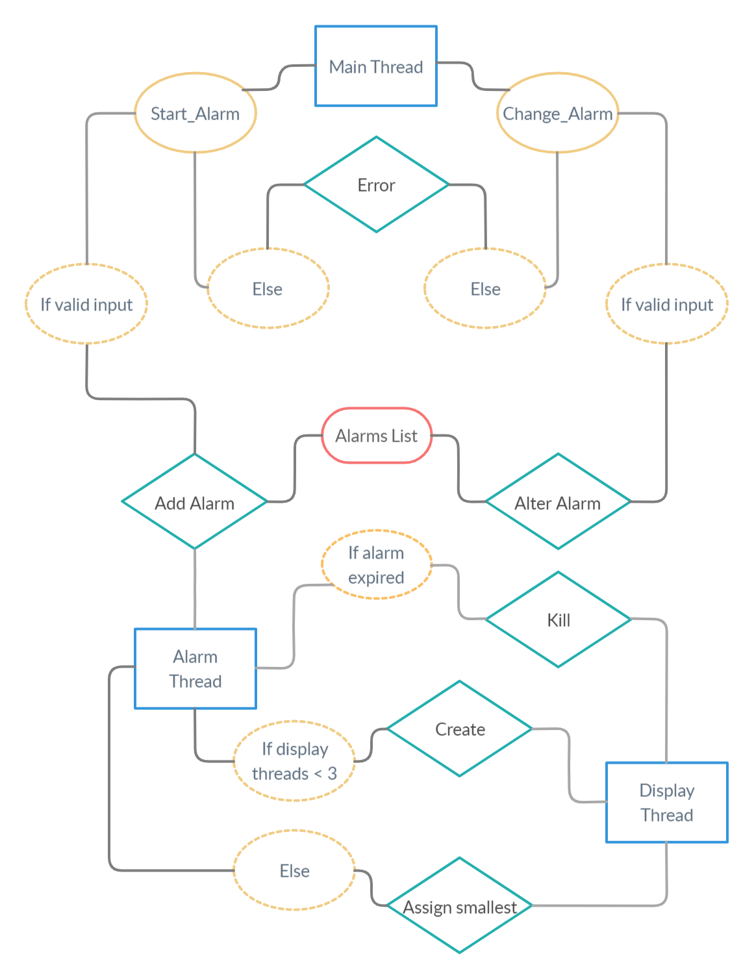

Issues and Difficulties Encountered While Implementing the Design

Some of the issues that we faced while implementing the design were deciding which data structure to use in order to store the list of alarms per display thread.
As was discussed in the design section of the report, we initially decided to use a simple array as it seemed to be the most straightforward solution. However, we quickly ran into the problem of it not being expandable.
In addition to this, we couldn't just update the link of the alarm in the display thread without having an unintended effect on another part of the code (alarm thread).
As a result, we considered modifying the alarm_t structure or creating a new linked list structure. We made a design choice of creating a new list structure since it would preserve the code originally given and more accurately represented the data and requirements. We did not want to change the original structure more than necessary.
We did not really encounter any other issues or difficulties implementing our design as we generally chose the most straightforward, efficient, and fastest methods of implementation.

Testing and Outputs

Alarm 1 Inserted by Main Thread 140122056603456 Into Alarm List at 1582542850: 20 a
Alarm Thread Created New Display Alarm Thread 140122039887616 For Alarm(1) at 0: 20 a.
Alarm (1) Printed by Alarm Display Thread 140122039887616 at 1582542830: 20 a.
Start_Alarm(Alarm (1) Printed by Alarm Display Thread 140122039887616 at 1582542835: 20 a.
Alarm 10 Inserted by Main Thread 140122056603456 Into Alarm List at 1582542859: 20 b
Alarm Thread Created New Display Alarm Thread 140122031494912 For Alarm(10) at 1582542830: 20 b.
Alarm (10) Printed by Alarm Display Thread 140122031494912 at 1582542839: 20 b.
Alarm (1) Printed by Alarm Display Thread 140122039887616 at 1582542840: 20 a.
Alarm (10) Printed by Alarm Display Thread 140122031494912 at 1582542844: 20 b.
Alarm (1) Printed by Alarm Display Thread 140122039887616 at 1582542845: 20 a.
Start_Alarm (10) Printed by Alarm Display Thread 140122031494912 at 1582542849: 20 b.
Alarm Thread Terminated Display Thread 140122039887616 at 1582542850.
Alarm (10) Printed by Alarm Display Thread 140122031494912 at 1582542854: 20 b.
Alarm 2 Inserted by Main Thread 140122056603456 Into Alarm List at 1582542869: 10 b
Alarm Thread Created New Display Alarm Thread 140122020914944 For Alarm(2) at 1582542839: 10 b.
Alarm (2) Printed by Alarm Display Thread 140122020914944 at 1582542859: 10 b.
Alarm Thread Terminated Display Thread 140122031494912 at 1582542859.
Alarm (2) Printed by Alarm Display Thread 140122020914944 at 1582542864: 10 b.
Alarm Thread Terminated Display Thread 140122020914944 at 1582542869.

Acknowledgements

This program was written as a part of the course EECS 3221 with Professor Jia Xu of the EECS department of York University, according to the specs entailed in 3221M_W20_Assignment_2.pdf.

POSIX threads and the library pthreads.h is a part of the operating system standards POSIX itemized by IEEE Computer Society.

ANSI C is a standard for the language C published by American National Standards Institute and the International Organization for Standardization, and this program is written in compliance to this standard.

