**Name: Inderjit**

**ID: 3157436**

**Title: Online Appointment**

**Task 1 - Identify the problem**

**Call Discussion with Client: Bhupinder**

**Information of the client:** Bhupinder is setting up appointments with the various doctors at the Medicare facility. Till date,he is maintaining all his records of all the patients and all the doctors manually. But he has reached me, to ease down his work i.e providing him help by making an application for the work he is doing.

**Primary objective of the project:** As Bhupinder needs a software to enter details of the patients, whose appointment was fixed, which doctors they have visited and what medicines doctors have prescribed to that particular patient. And even details of the doctor such as their attending day or timings of the particular day or weekend. And how many patients that attended in a day etc.

**Task 2 - Define and document requirements**

Requirement of The Software

Scope of Work

**Features:** The Medicare facility needs a software for setting up day to day appointments of the patients with the doctors at the time suitable for both patients and the doctors. To make the work of Bhupinder easy and proper a software is to be made which may have all the records he needs. The patients will also get benefit of the software as the previous system of booking appointments was manual and was a tedious job and led to setting appointments which were difficult to first schedule and if needed to reschedule.

**Functional Requirements:** The patient's detailed history is to be entered in the software, so a table of patients is to be created for maintaining their database. It contains all the information about when the patient first visited the hospital, which doctor was appointed to him, which medicines he has been prescribed and for what duration.

Also a module of doctors is to be created for booking appointments of the patients, the information of which doctor is available, at which time, day should be readily available to him for properly booking the appointments. Also a login should be given for customers to have access to their medical records.

Non-functional requirements: As the patients can book the appointment via their login ids along with getting their medical records on their accounts, a database should be such that it can store such amount of data, which can be retrieved easily by the patients and Bhupinder himself. So the information in the software needs to be correct and reliable and should be updated on day to day basis or hourly basis whichever is convenient and needed.

**Time:** It will take minimum 20 days to complete.

|  |  |
| --- | --- |
| Part 1(Planning) | 02 |
| Part 2(Requirements) | 06 |
| Part 3(Designing) | 02 |
| Part 4(Development) | 8 |
| Part 5(Testing) | 4 |

**The 4 essential steps of the Risk Management Process are:**

1. Identify the risk.

2. Assess the risk.

3. Treat the risk.

4. Monitor and Report on the risk.

Cost: we would charge the cost $850. We are going to divide the payments in different-2 parts.

|  |  |
| --- | --- |
| Part 1(Planning) | $150 |
| Part 2(Requirements) | $100 |
| Part 3(Designing) | $200 |
| Part 4(Development) | $250 |
| Part 5(Testing) | $150 |

**Project Management:** Managing a project is no easy feat, no matter what the scale and scope are. From planning the minutia to handling the ever-changing demands of clients to shipping the deliverables on time, there’s a lot that can go wrong. When you divide the project into manageable stages, each with its own goals and deliverables, it’s easier to control the project and the quality of the output.

**Gantt Chart:**

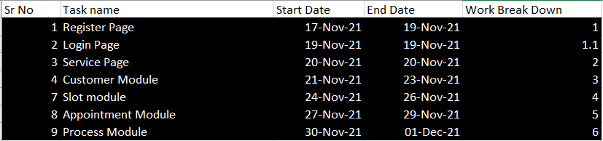

**Task 3 - Design mockups**

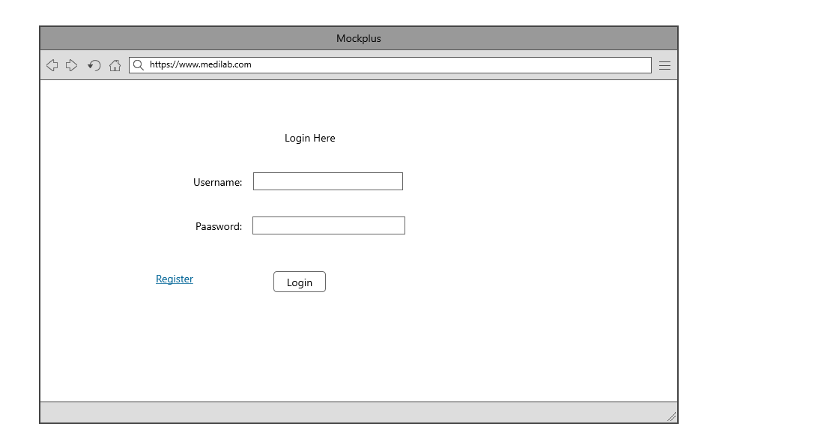

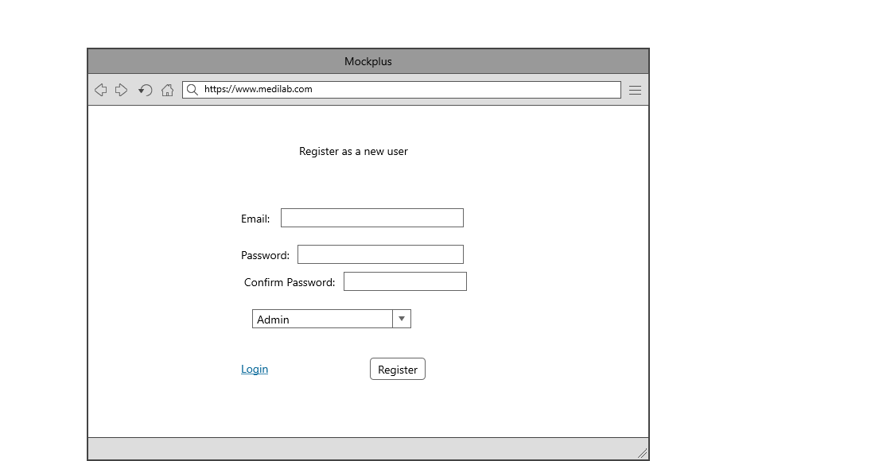

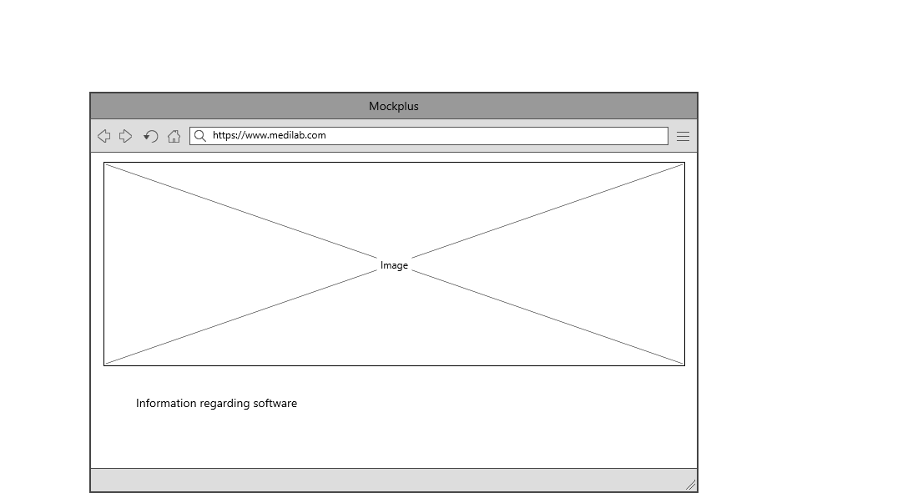

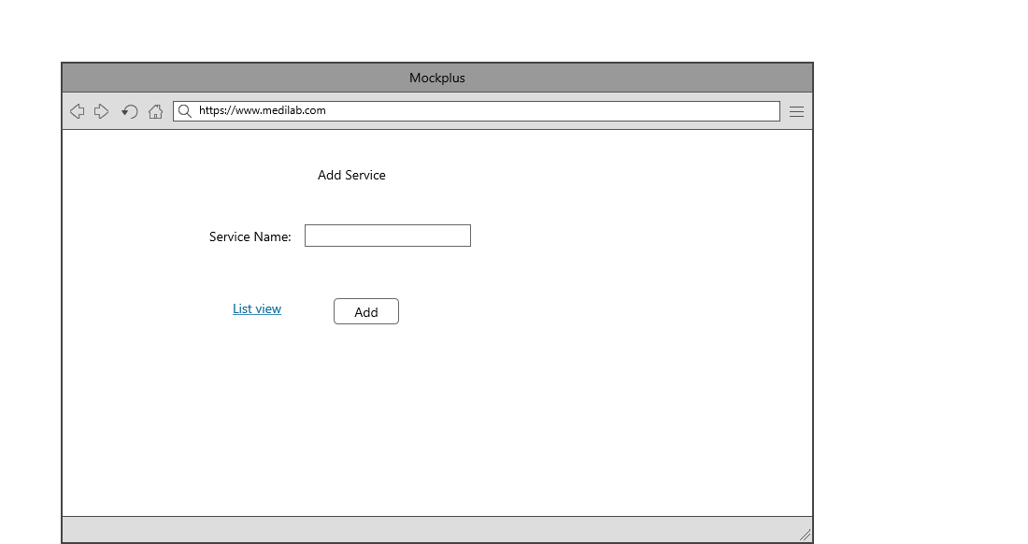

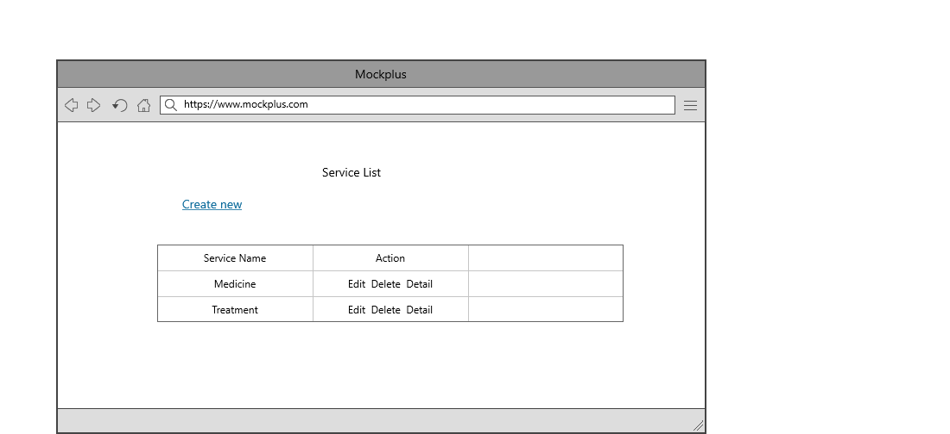

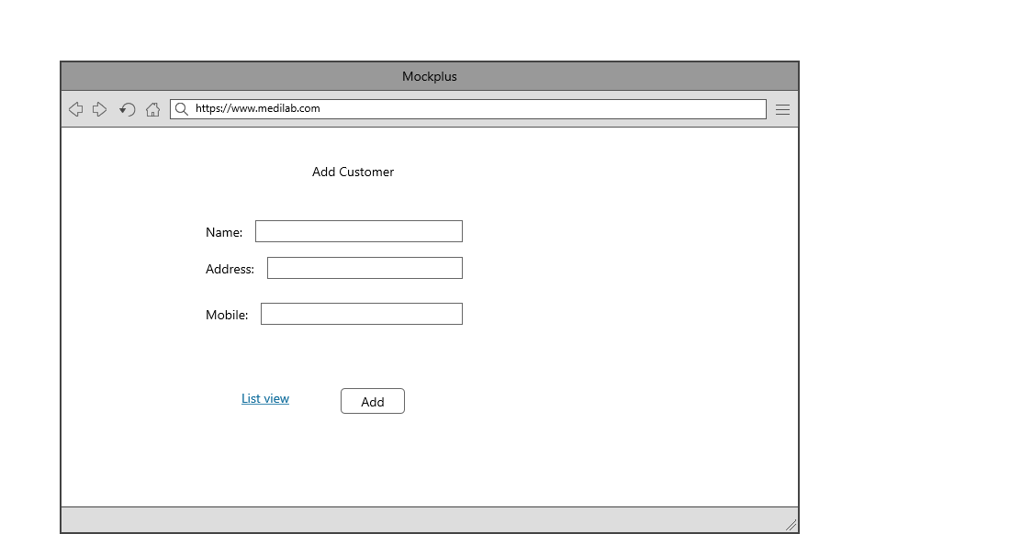

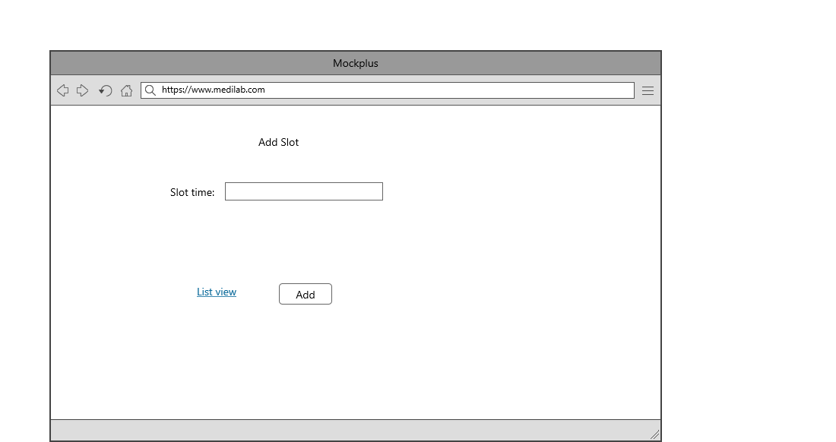

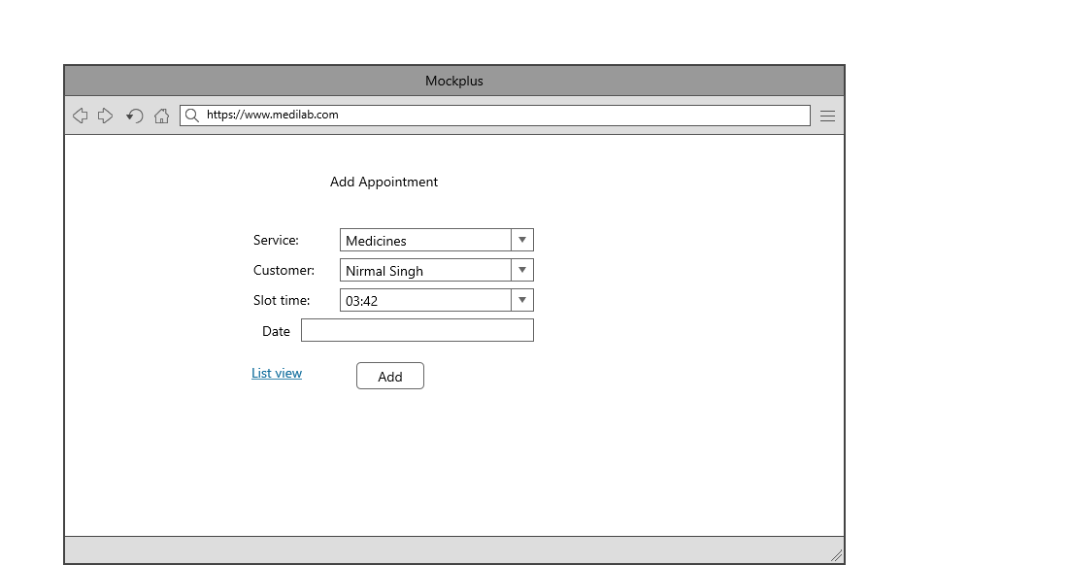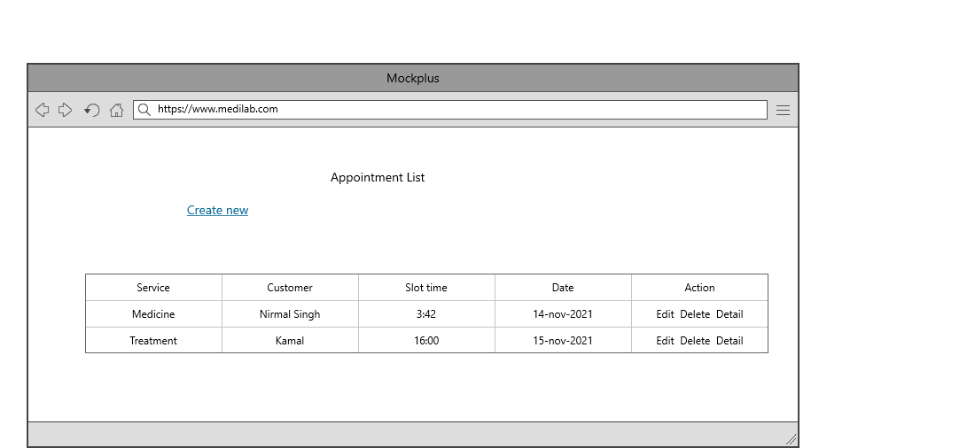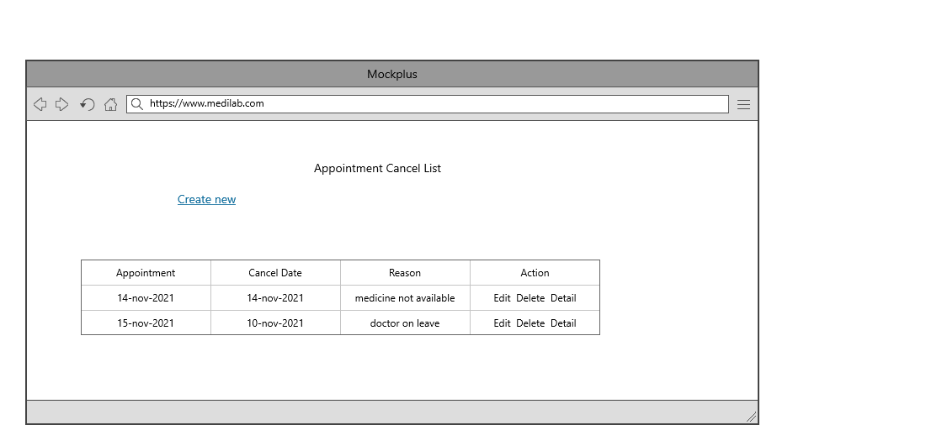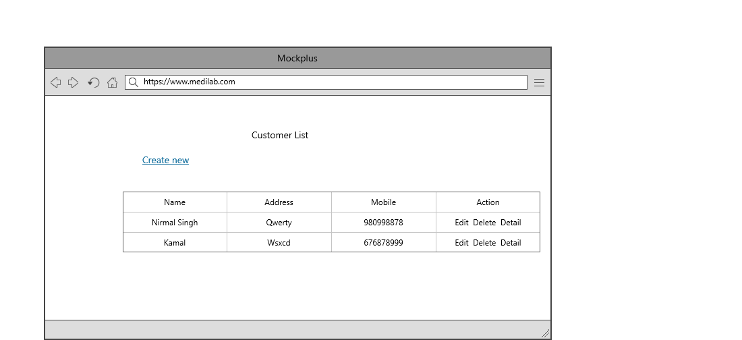

Colour Scheme: Blue , Black, White and green for whole theme.

## Task 5- usability testing

|  |  |  |  |  |  |
| --- | --- | --- | --- | --- | --- |
| **User #** | **Login form** | **Customer Module** | **Appointment Module** | **Pass / Fail / Not executed / Suspended** | **Reviews** |
| Bhupinder | completed as expected | This module works Excellent | As Expected perfect | Pass | All modules are ok |
| Kamal | might be more attractive | Seems nice to access this | should some changes and expand more | Pass | Login form should be more attractive |
| Rajan | This module is looking good | This is perfect module | I can book appointments through this module properly. | Pass | all modules are as expected |

**Task 6 - Meet with your client**

**Client Meeting:**

|  |
| --- |
| **Meeting Details** |
| * **Date and time: 26-Oct-2021** * **Location: Newzealand** |
| **Attendees: Bhupinder and Inderjit** |
| **Agenda: Discussion of Software of Medicare System** |
| **Discussion (Important Points): Written on this document sheet regarding the requirements of the software.** |
| **My To Dos (Actions): Firstly I have to make the mockups of the application. Then Starting the application after the next meeting.** |
| **Questions requiring Follow- Up: Discussion of the mock ups** |
| **Comments: Bhupinder is good person and he described regarding software very wisely.** |
| **Next meeting**  **Date and Time: 1- Nov-2021 1:00 Pm**  **Location: Newzealand**  **Agenda: Showing the mock ups to the client and discussion about further development.** |

**Appendix 3**

**Client Review Form**

My developer’s name: Inderjit

This form is intended to let you review the communication skills of your developer for this assignment. Your review will partly count towards their final mark. Do not take into account technical skills.

# Grading scale

You must grade your developer for each item listed in the tables below. 1 being the lowest, 5 the highest.

|  |  |  |  |  |
| --- | --- | --- | --- | --- |
| **1** | **2** | **3** | **4** | **5** |
| Strongly disagree | Disagree | Ok | Agree | Strongly agree |

# Review your developer

|  |  |  |
| --- | --- | --- |
| **Item** | **Grade** | **Comment** |
| Communicated clearly and effectively | 3 |  |
| Kept you informed of the progress | 4 |  |
| Met timelines | 3 |  |
| Responded promptly to problems | 4 |  |
| Met overall project objectives | 5 |  |
| Was open to new ideas and suggestions | 3 |  |
| Was easy to work with | 3 |  |

Comments

Provide any extra comments on your developer’s communication skills and professionalism.

Inder is good person and he has good knowledge of coding.

## Signed by Client

|  |  |
| --- | --- |
| **Signature: Bhupinder** | **Date: 15-nov-2021** |
| **Name: Bhupinder** | **Title:Online Appointment** |
| **Contact details (email/Tel):** | |

**Task 7- Presentation**

[**2021-11-26 09.17.23 Level-6 March 2021 Intake\video2310881027.mp4**](2021-11-26%2009.17.23%20Level-6%20March%202021%20Intake/video2310881027.mp4)

**Task 8 - Software development life cycle stages**

**Planning :- I**n this step, we are putting together all the tools to consider the scope and gravitas needed to pursue the software or project we want. The awareness of our customer’s requirements and how much capital, time, and resources we can contribute to their product’s success is also known as a “feasibility report.” And when we are in the preparation process, the three things that are mandatory to keep in mind are:

**Requirement :-** Next in the System development life cycle is the requirement. The team ensures the project requirements of the end-users of the system. The company needs to connect with IT departments to express the new technology and improvement criteria.

**Software Design and prototyping :-** In this phase, the requirement gathered in the SRS document is used as an input and software architecture that is used for implementing system development is derived.

***Output Screens***

**1. Register Page: -** This is Register page in which You can register new user

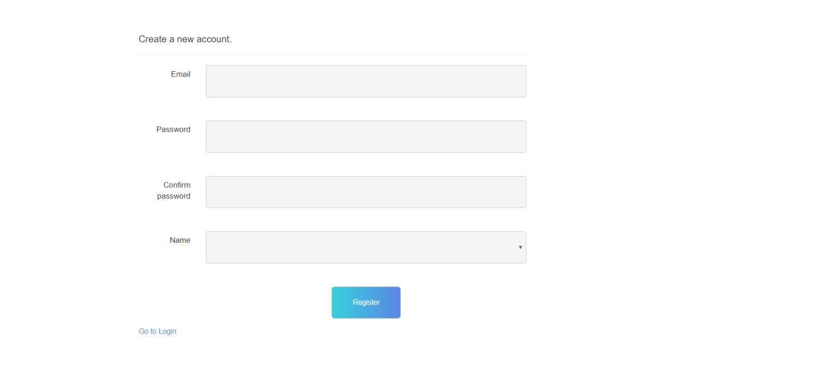

**2. Login Page: -** This is Login page of our website. In this page I can login as a Admin and As a Manager.

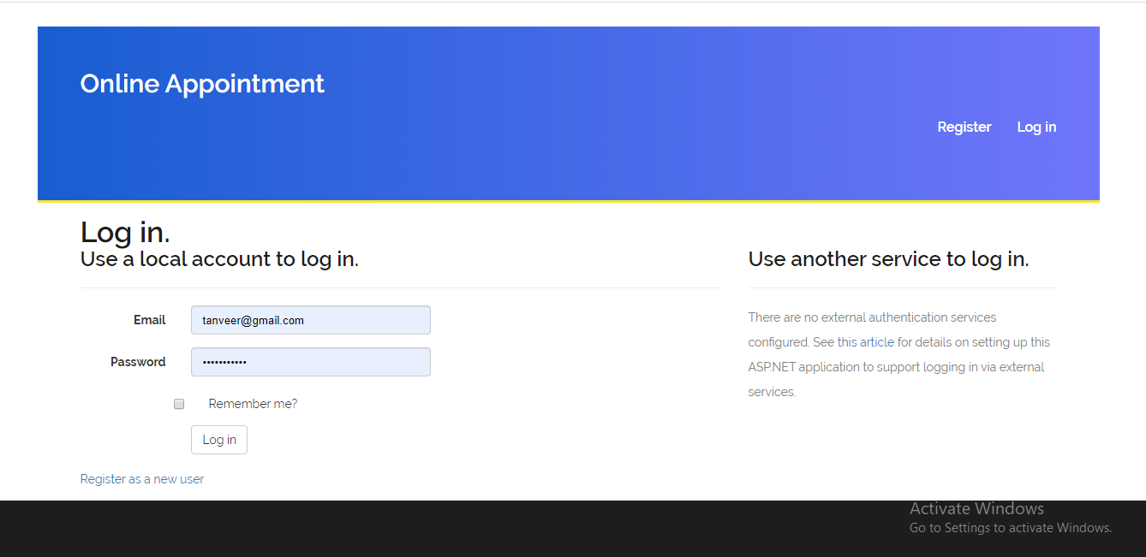

**3. Admin Login**: When admin logins then he can access the all modules of website. Which are shown in the picture.

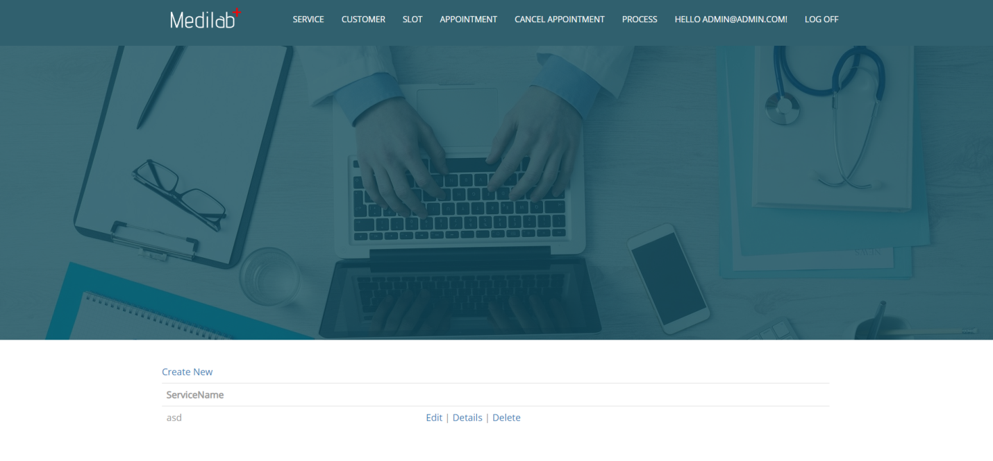

**4. Service: -**  Here I can show the service in my website. And clicking on the create new link I can create the service. Edit and delete service are also available here.



**5. Customer: -**  Here I can show the customer in my website. And clicking on the create new link I can create the customer. Edit and delete customer are also available here.

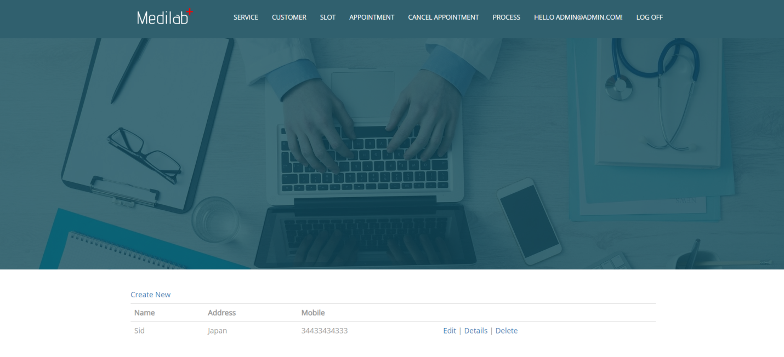

**6. Slot: -**  Here I can show the slot in my website. And clicking on the create new link I can create the slot. Edit and delete slot are also available here.

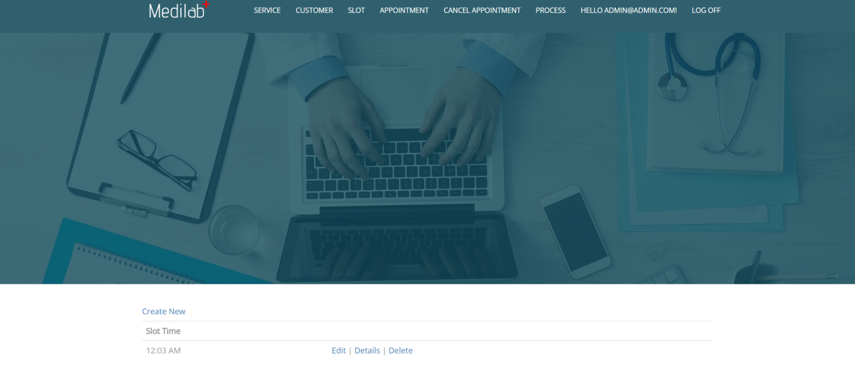

**7. Appointment -**  Here I can show the appointment in my website. And clicking on the create new link I can create the appointment. Edit and delete appointment are also available here.

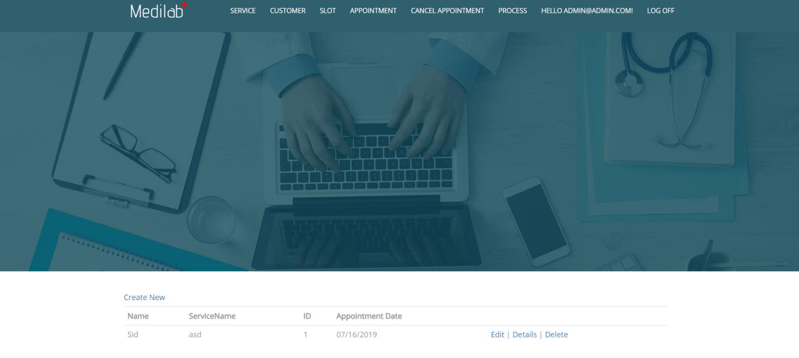

**8. Cancel appointment: -**  Here I can show the cancel appointment in my website. And clicking on the create new link I can create the cancel appointment. Edit and delete cancel appointment are also available here.

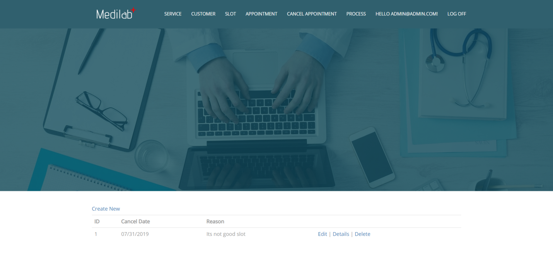

**9. Process: -**  Here I can show the process in my website. And clicking on the create new link I can create the process. Edit and delete process are also available here.

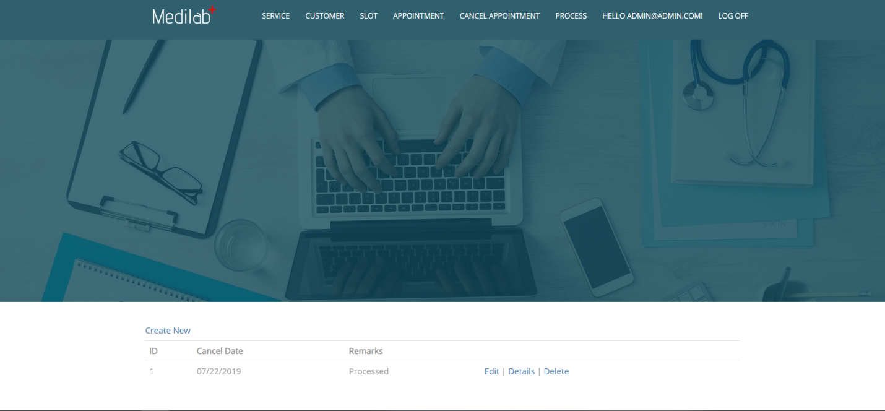

**Software Development:** When the design process of the software is over, the next step will be the coding. In this step, developers start constructing the whole framework using the programming language chosen to write code. Tasks are divided into units or modules in the coding process and allocated to the specific developers. Coding is the enormous step of the SDLC.

**Testing:** When the coding is complete, testing begins, and the modules are released for evaluation as software testing is necessary to avoid any bugs. The created software is extensively reviewed during this process, and any issues found are assigned to developers to repair them.

**Task 9- Project management**

Whether you’re working on a small project with modest business goals or a large, multi-departmental initiative with sweeping corporate implications, an understanding of the project management life cycle is essential.

**1. Initiation**

First, you need to identify a business need, problem, or opportunity and brainstorm ways that your team can meet this need, solve this problem, or seize this opportunity. During this step, you figure out an objective for your project, determine whether the project is feasible, and identify the major deliverables for the project.

**2. Planning**

Once the project is approved to move forward based on your business case, statement of work, or project initiation document, you move into the planning phase.

**3. Execution**

You’ve received business approval, developed a plan, and built your team. Now it’s time to get to work. The execution phase turns your plan into action. The project manager’s job in this phase of the project management life cycle is to keep work on track, organize team members, manage timelines, and make sure the work is done according to the original plan.

**4. Closure**

Once your team has completed work on a project, you enter the closure phase. In the closure phase, you provide final deliverables, release project resources, and determine the success of the project. Just because the major project work is over, that doesn’t mean the project manager’s job is done—there are still important things to do, including evaluating what did and did not work with the project.