PUT API
For single row update
From the local SAP server: Goto /OSE16N and search this table
Name of the table ZSALES_ORDER.
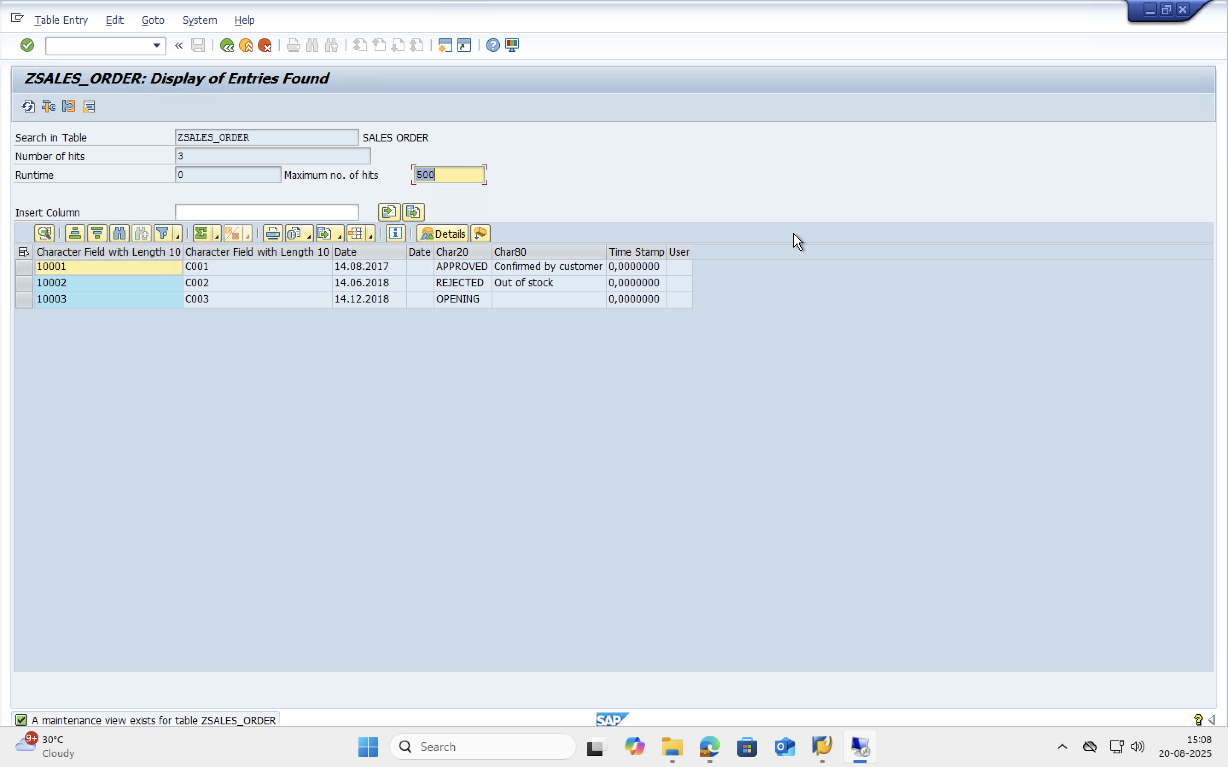
Now lets go to SAP’s gateway Client i.e., (/OSEGW) Select ZSO_UPDATE_DEMO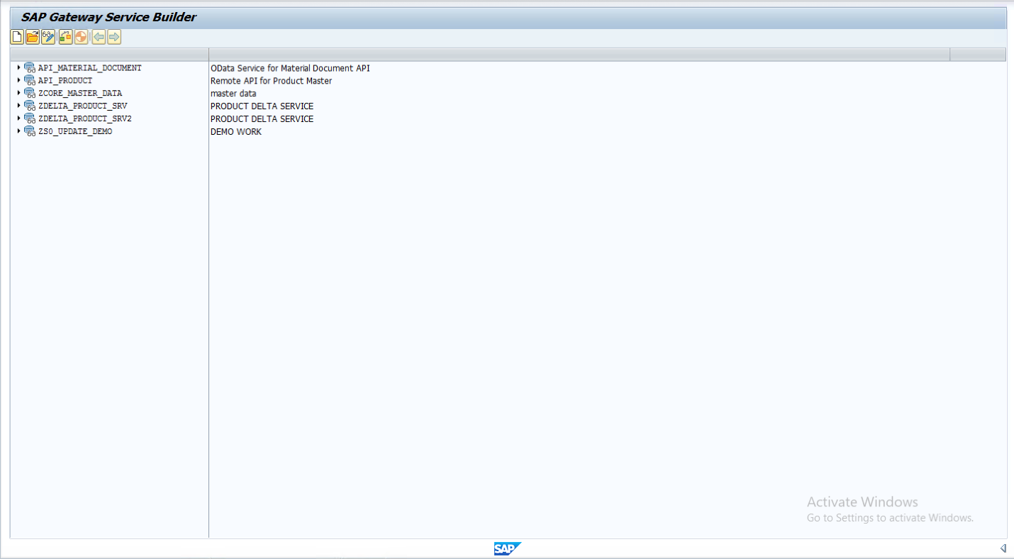
And goto SAP GATEWAY CLIENT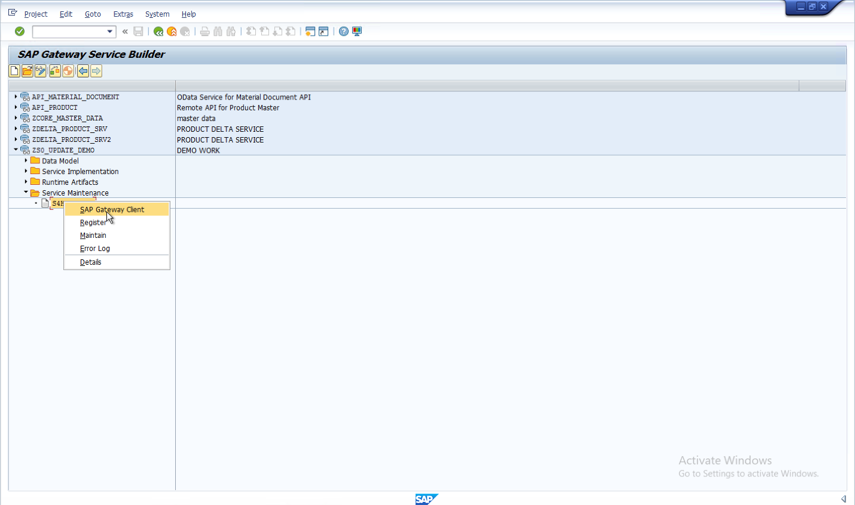
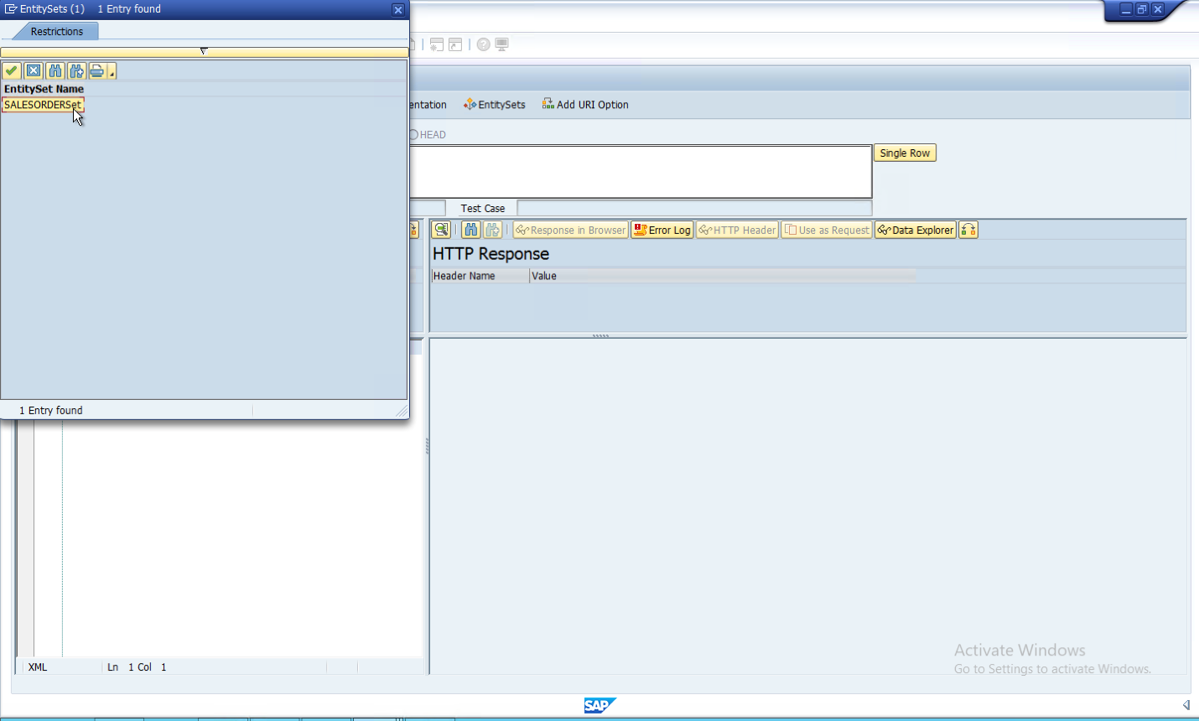And then select the Entitysets by clicking on that and select salesOrderSet
Now give the payload and execute 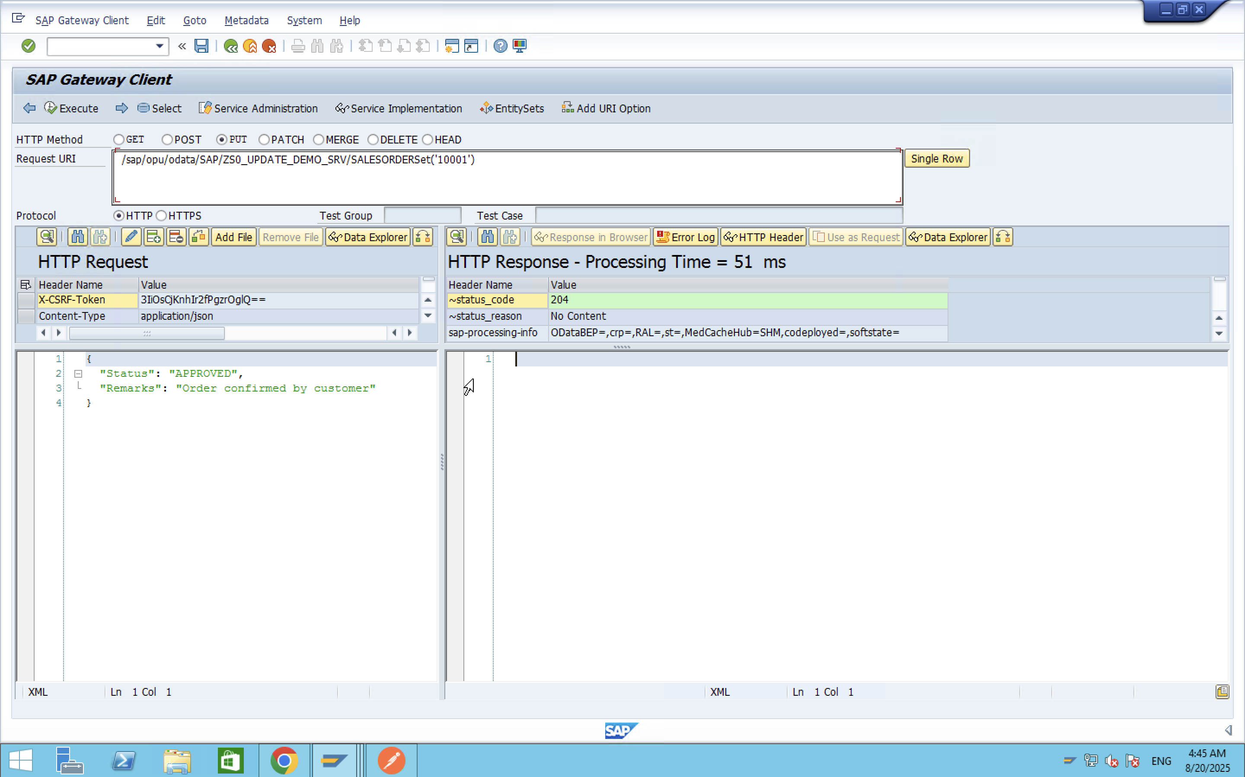
Now the status in SAP is fine we are able to update the table as we can see above the table is updated go to /ose16n and search for the table ZSALES_ORDER.
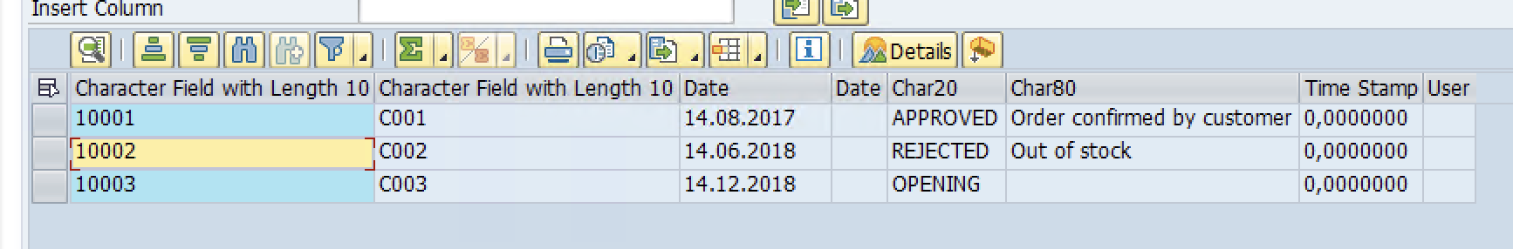
The payload we used for the request purpose is
{
"Status": "APPROVED",
"Remarks": "Order confirmed by customer"
}
This payload is in JSON format

From the Postman:
Above u can see the current status of the table
Now lets get into postman
The API i used to call the data from postman is
http://96.79.18.154:8000/sap/opu/odata/SAP/ZS0_UPDATE_DEMO_SRV/SALESORDERSet('10002')
Now go to postman put this API in postman and then put head in that first and then go to headers and put key as ‘X-CSRF-Token’ and value as fetch then you will get a CSRF token and then put that CSRF token in the value and the activate PUT instead of HEAD.
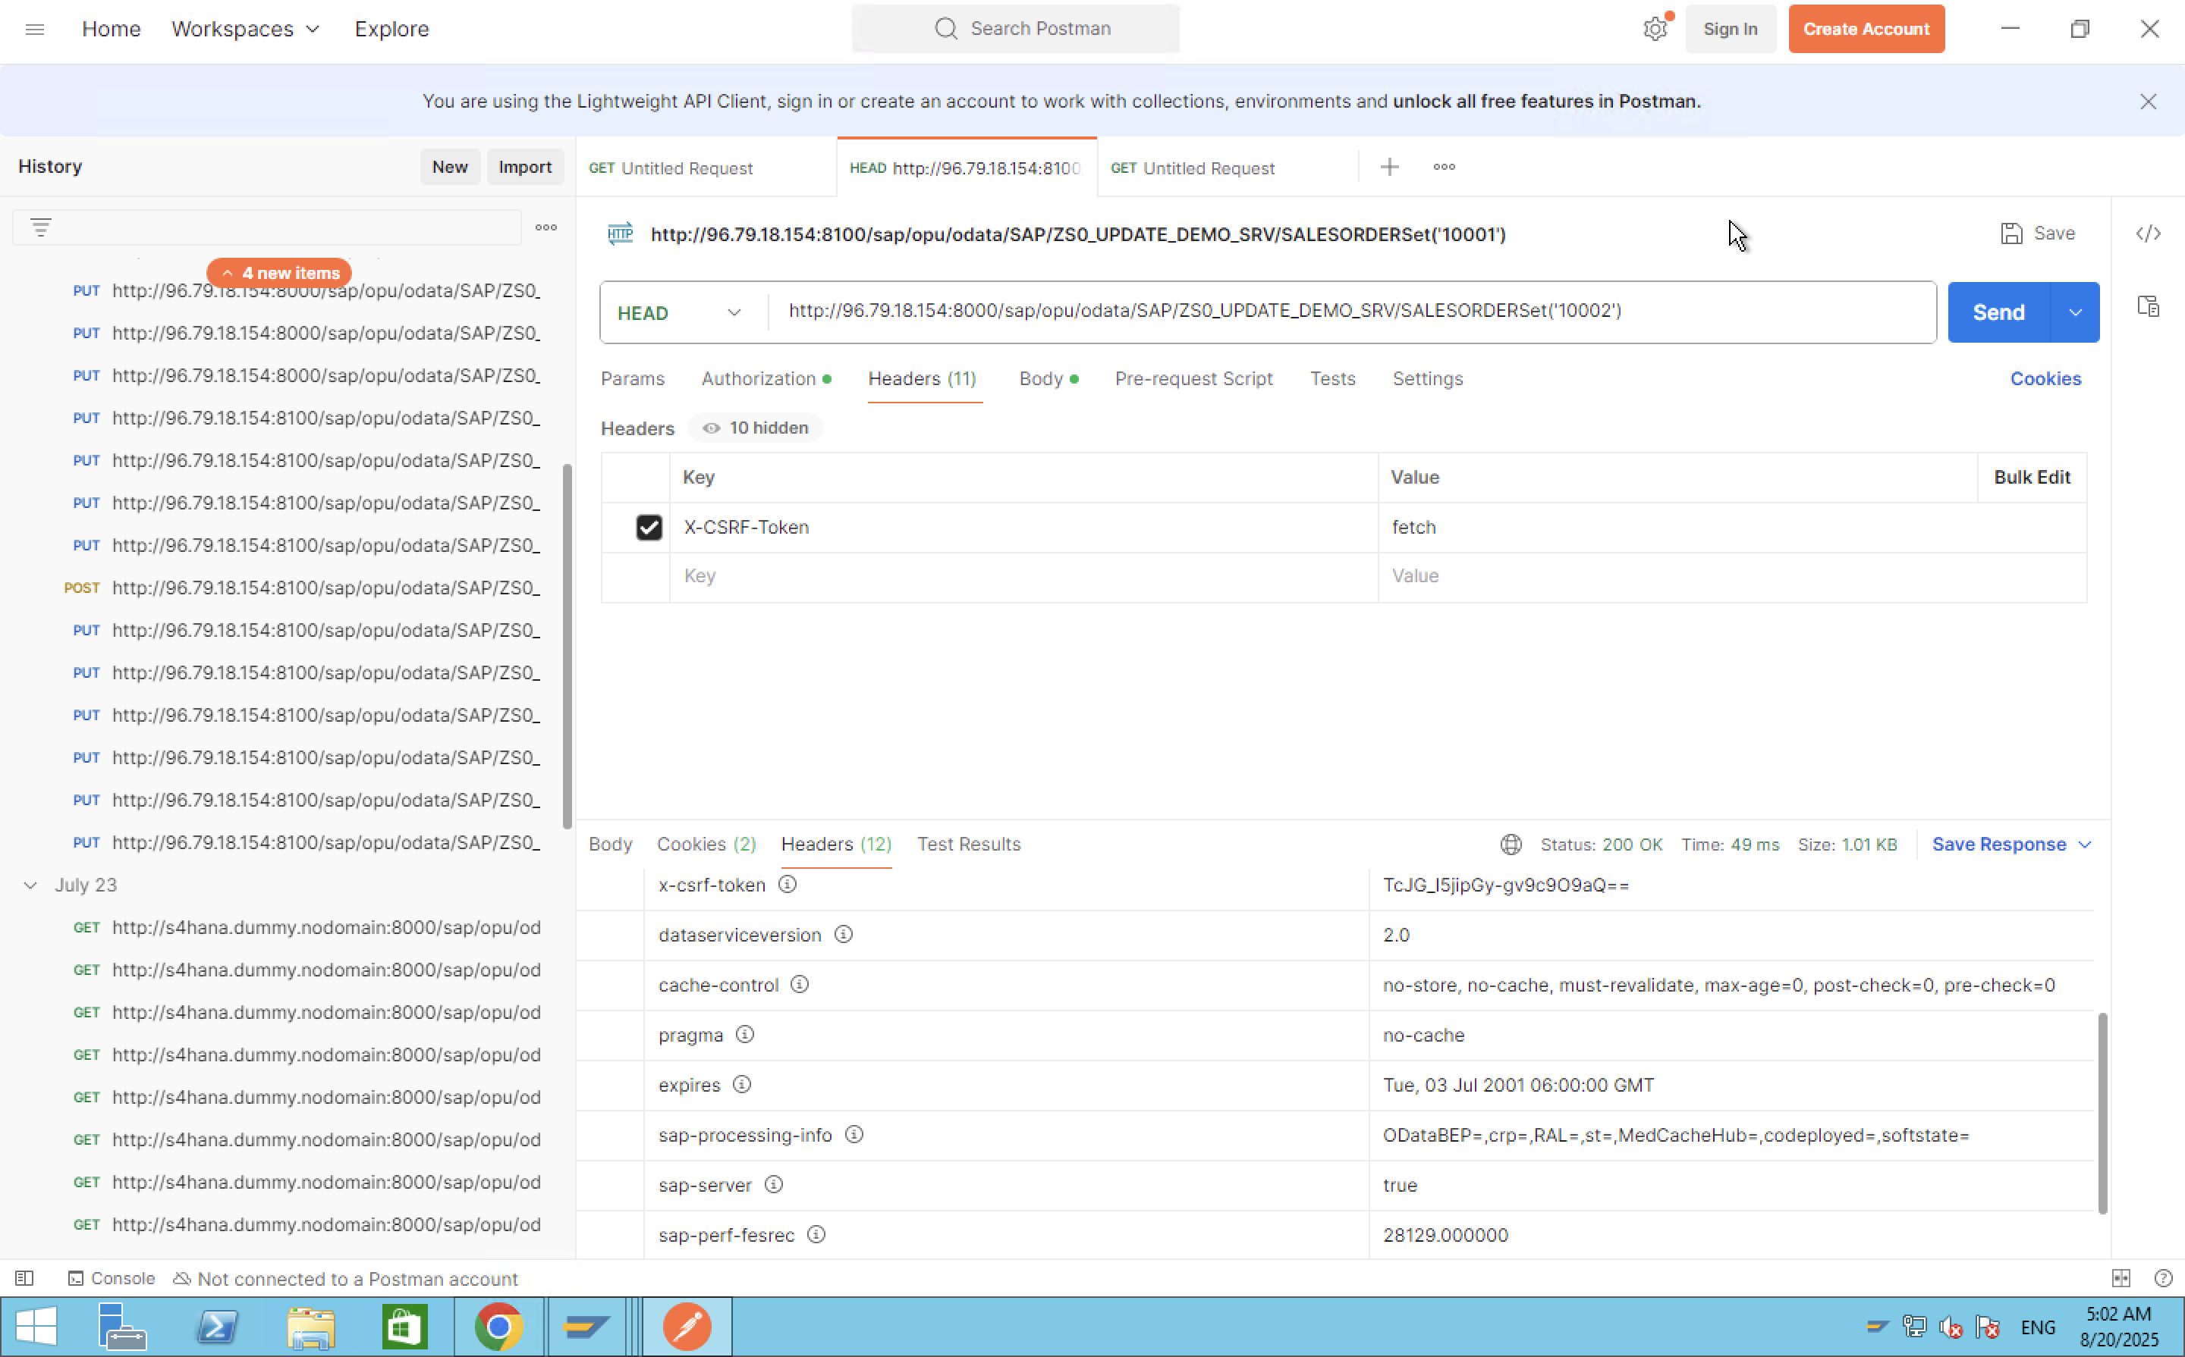

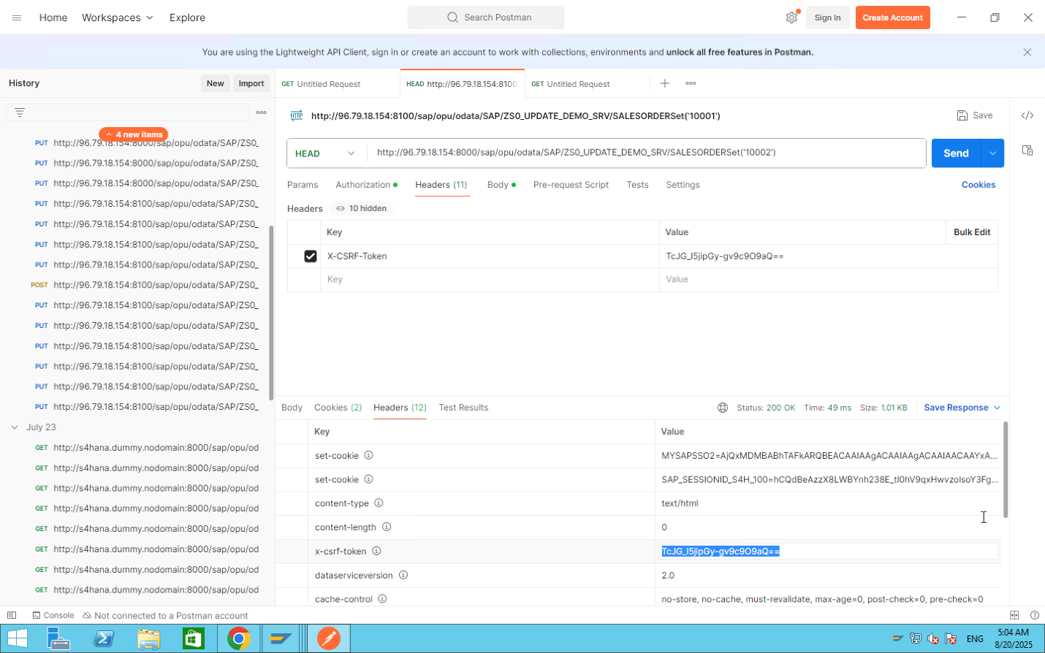
The body i have given is
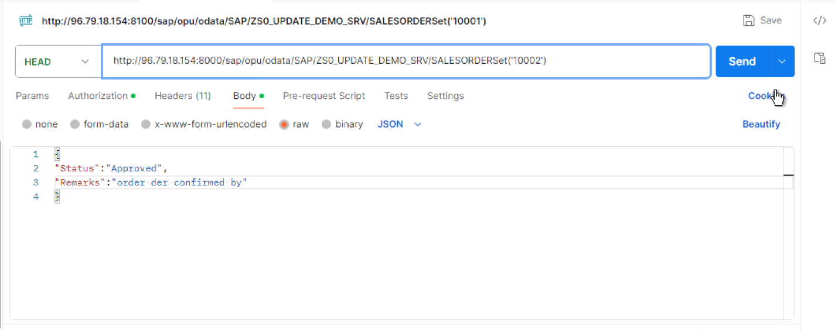
Now after running this API we will that in the SAP server that the status of the table zsales_order which is having sales order ID SO_ID=10002 will be updated.
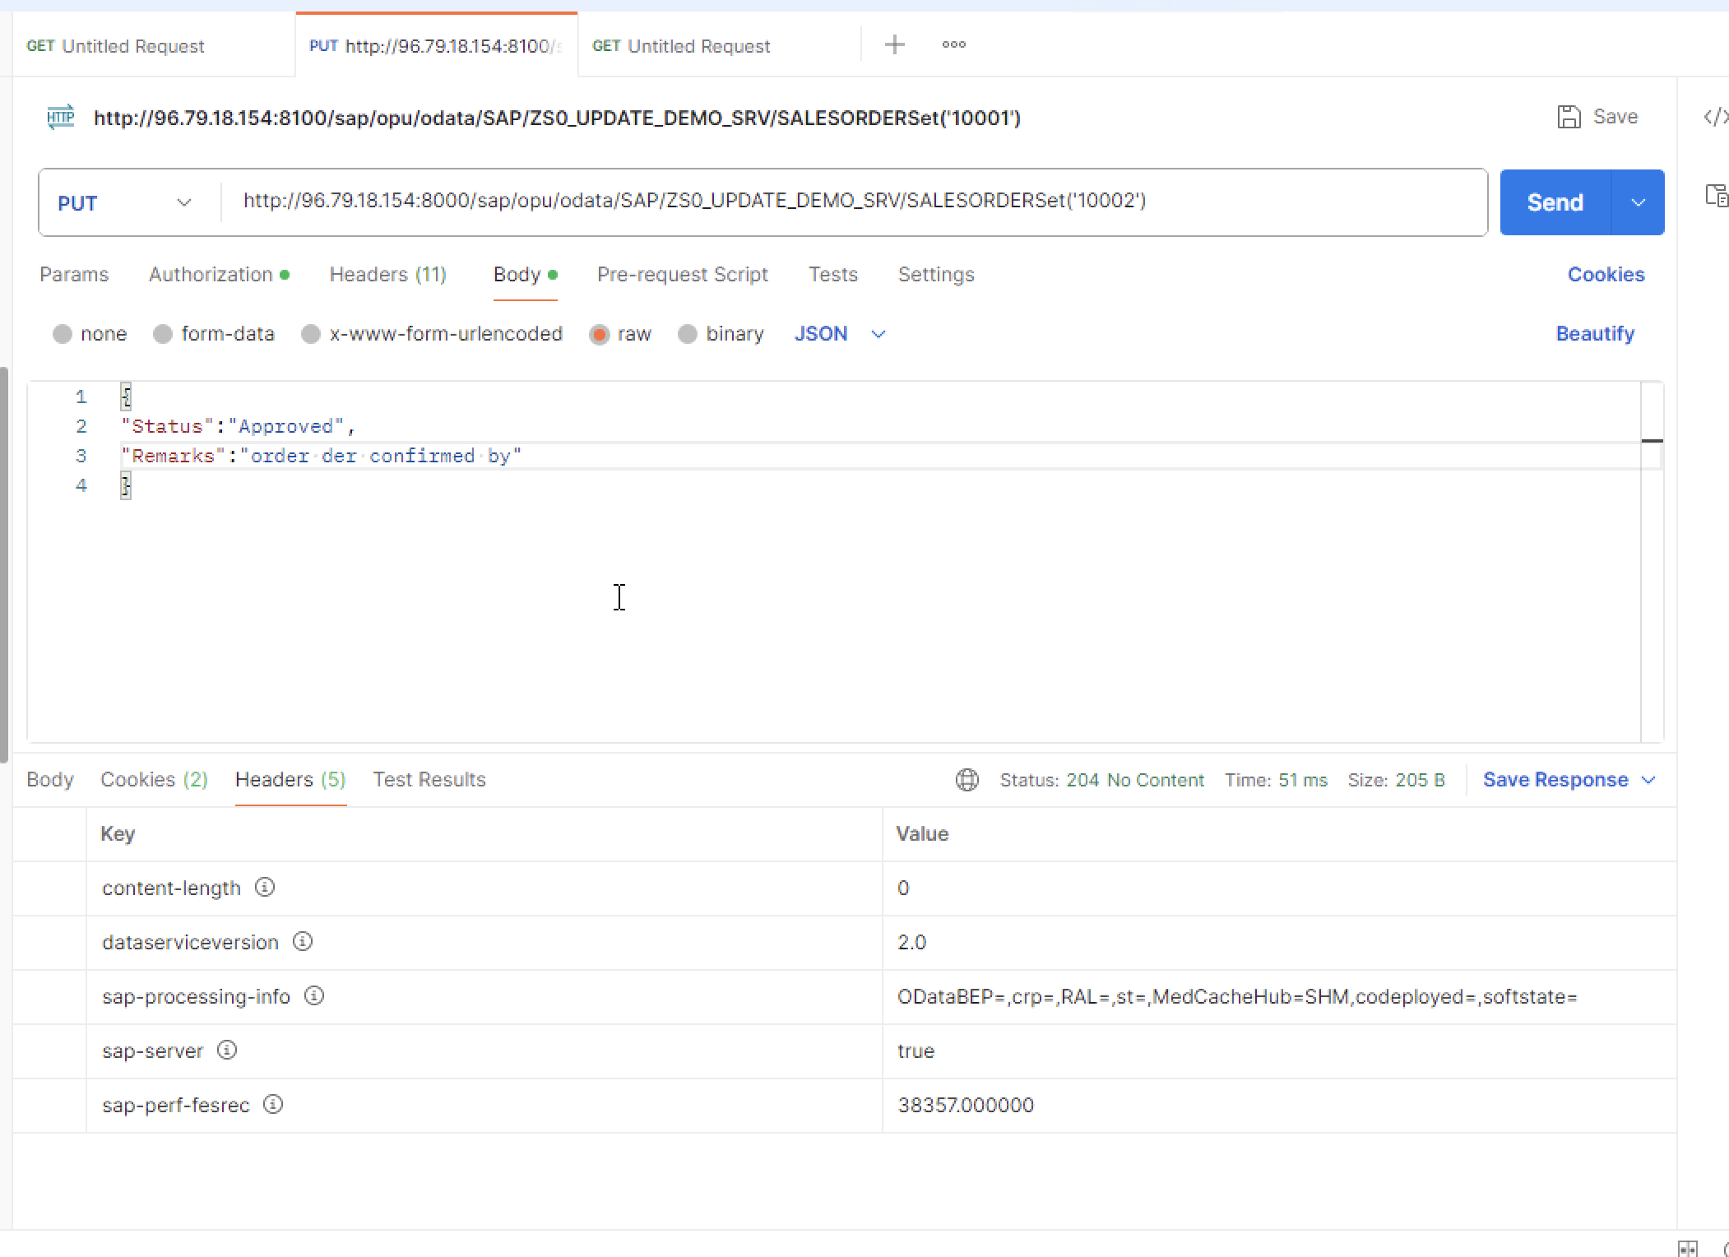
As you can see the status is 204 that means the data is updated now we will move to SAP and check whether data is updated or not.
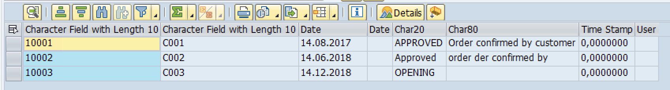For mass update:
From the local SAP server:
Now we will update multiple records this is the current status of the table and now we are going for batch processingNow go to SAP gateway client there set to POST and then add the batch in header and then you can add the changsets in payload
Click on URI options in gateway client of SAP
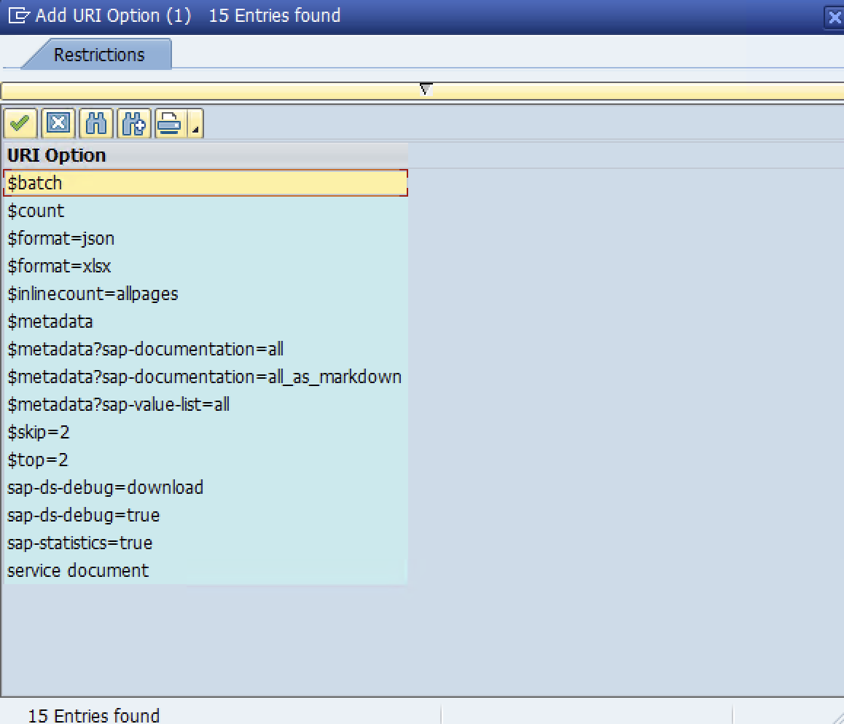
And select batch there after go to the header and add the batch name over there and there write the payload
The payload we have used for this is shown above :
--batch_123 Content-Type: multipart/mixed; boundary=changeset_1
--changeset_1 Content-Type: application/http Content-Transfer-Encoding: binary
PATCH SALESORDERSet('10001') HTTP/1.1 Content-Type: application/json
{ "Status": "APPROVED", "Remarks": "Confirmed by customer" }
--changeset_1-- --batch_123 Content-Type: multipart/mixed; boundary=changeset_2
--changeset_2 Content-Type: application/http Content-Transfer-Encoding: binary
PATCH SALESORDERSet('10002') HTTP/1.1 Content-Type: application/json
{ "Status": "REJECTED", "Remarks": "Out of stock" }
--changeset_2-- --batch_123--

Now you can see the 202 status
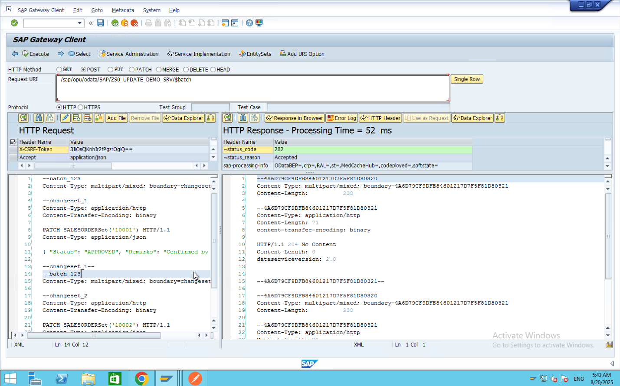
Finally the status is accepted and then and now you can see the status of the table
Now you can see the two rows are automatically updated
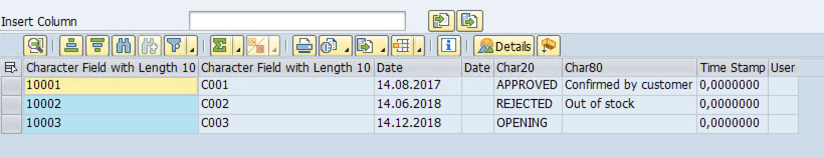
Finally you can see the changes in the table.
From the Postman:
Above u can see the current status of the table

Now go to postman and put this API in the postman
http://96.79.18.154:8000/sap/opu/odata/SAP/ZS0_UPDATE_DEMO_SRV/$batch
Now set head and in headers tab put key as ‘X-CSRF-Token' and value as fetch and click on send you will get a CSRF token and then put that in the value of CSRF token and then add another entry in headers tab as key will be Content-Type and value as ‘multipart /mixed; boundary = batch_123
And give the same body as defined in the above explanation of SAP Server
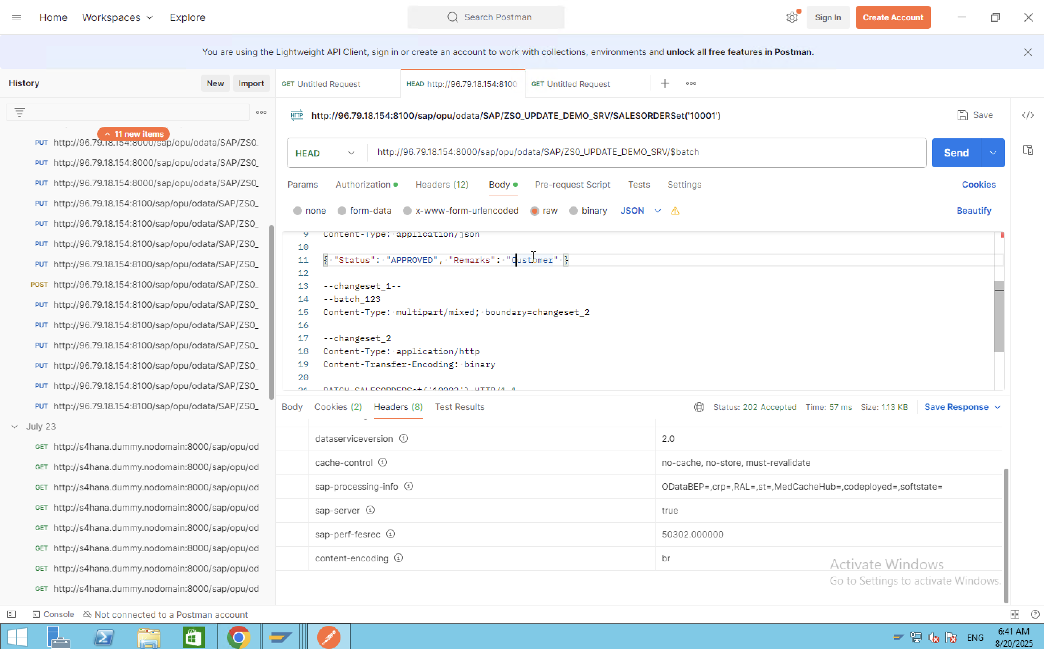
And then click on send you will get status as 202 i.e., accepted
After that finally you will see the data in table of SAP is Updated as shown above
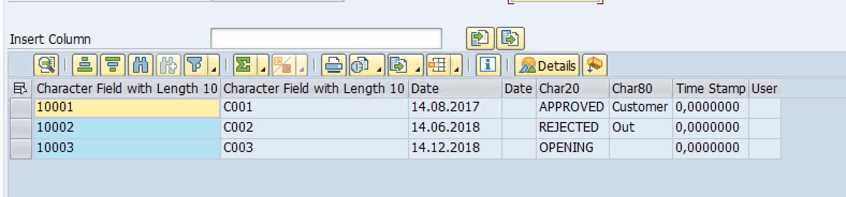

Single or Mass Update of Data using OData API with Java –
1. Prerequisites
Before starting, make sure you have the following installed:
- Java Development Kit (JDK 8 or later)
Check installation with:
  - java -version
  - javac -version
- Apache Maven (build tool & dependency manager)
Download - apache-maven-3.9.11-bin.zip
Extract the zip file to a folder, e.g., C:\Program Files\Apache\Maven\apache-maven-3.9.11
Set Environment Variables –
Open Environment Variables
- Press Win + R, type sysdm.cpl, and press Enter.
- Go to Advanced → Environment Variables.
- Inside System variables, click New and set –
  - Variable name: MAVEN_HOME
  - Variable value: the Maven folder path (e.g., C:\Program Files\Apache\Maven\apache-maven-3.9.11)
- Click OK.
Update Path
- In System variables, find Path, select it, and click Edit.
- Click New, and add:
- C:\Program Files\Apache\Maven\apache-maven-3.9.11\bin

- Click OK to save.
Check installation with:
- mvn -v
- VS Code (or IntelliJ/Eclipse, but this guide uses VS Code)
  - Install Java Extension Pack from VS Code marketplace.
  - Install Maven for Java extension (optional but recommended).
2. Project Setup in VS Code
- Create a folder OData and open it in VS Code.
- Go to search bar, inside File, click on New File -> New java project ->Maven create for archetype -> create a basic Maven project directly.
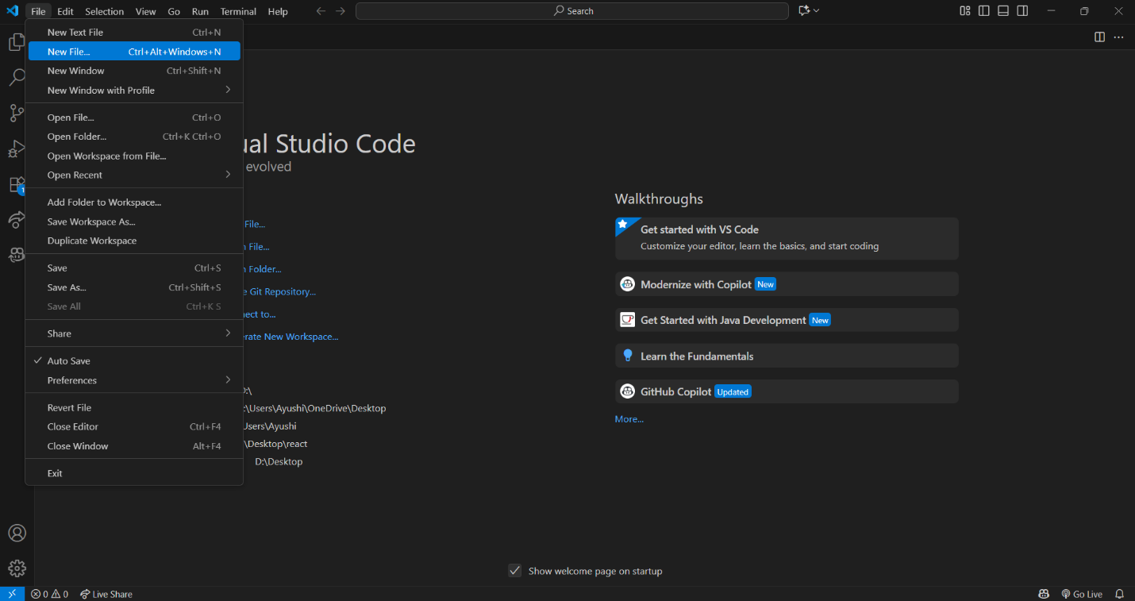
- In place of example you can set the name as you want, in my case it is sapodata and then press enter
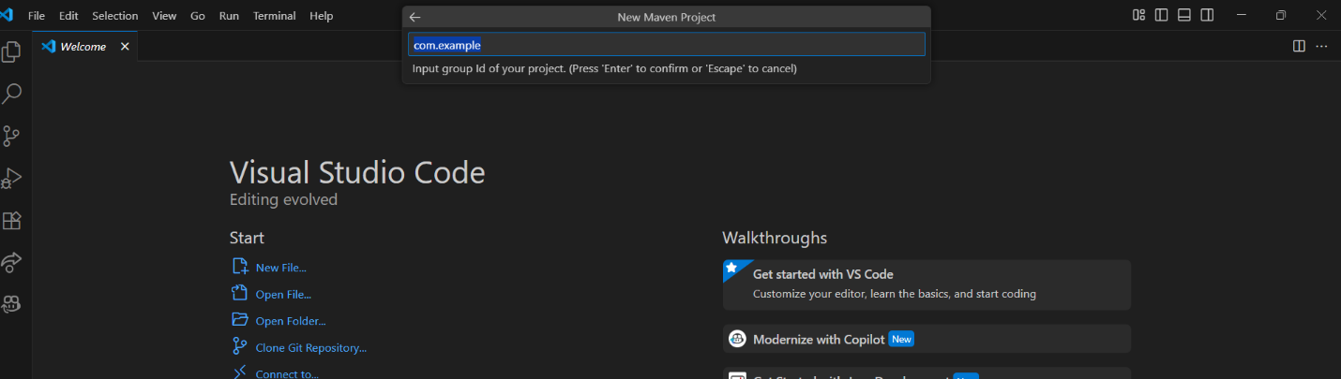
- Then set the sapodata in place of “demo” or enter.
- You have a structure like this-
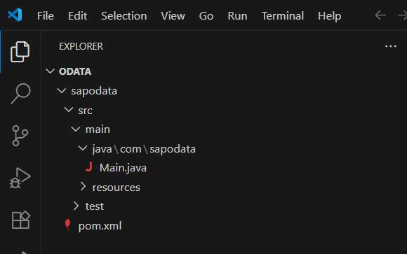
- Replace Main.java with odata_mass_PUT.java and replace this pom.xml with my pom.xml file.
- And add material_data(1).xlsx in C:\OData\sapodata\ and do changes in excel sheet as you want either for single row or for multiple rows.
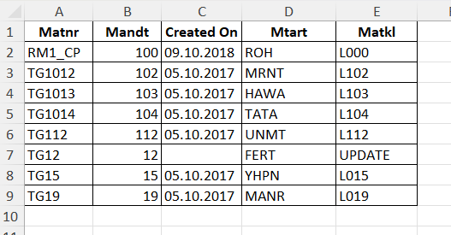
- Final structure will be like –
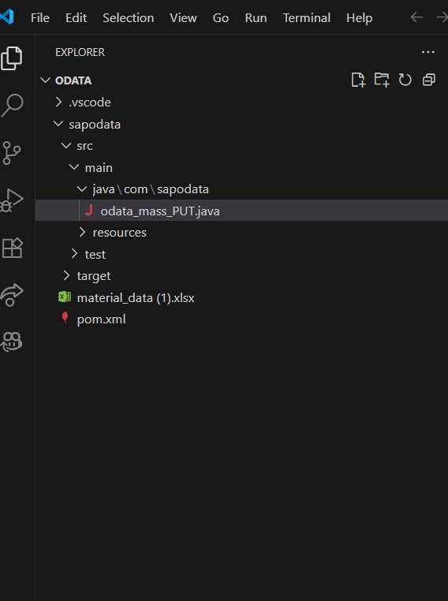

3. Commands to run –
- download dependencies –
mvn clean install

- Compile:
mvn compile
- Run:
mvn "exec:java" "-Dexec.mainClass=com.sapodata.odata_mass_PUT"
- You will be prompted for username & password, then the script will:
- Fetch CSRF token
- Loop over Excel rows
- Send PUT requests to OData service
- Print results for each material.

