Crud Operation Project setup:

1. Frontend application is built in Angular (CrudApp)
2. For DB connectivity, we built web api (Crud API).
3. Execute below db script to create database and table/procedure’s which will be used in project. Below is the db script:



1. Please add connection string in web config file of CRUD API before starting project.

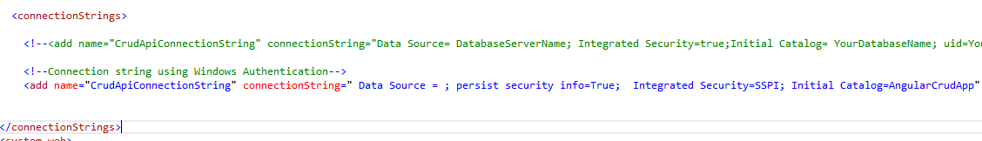

1. 1st screen :Home page, to add/updated/delete country will be shown as below:

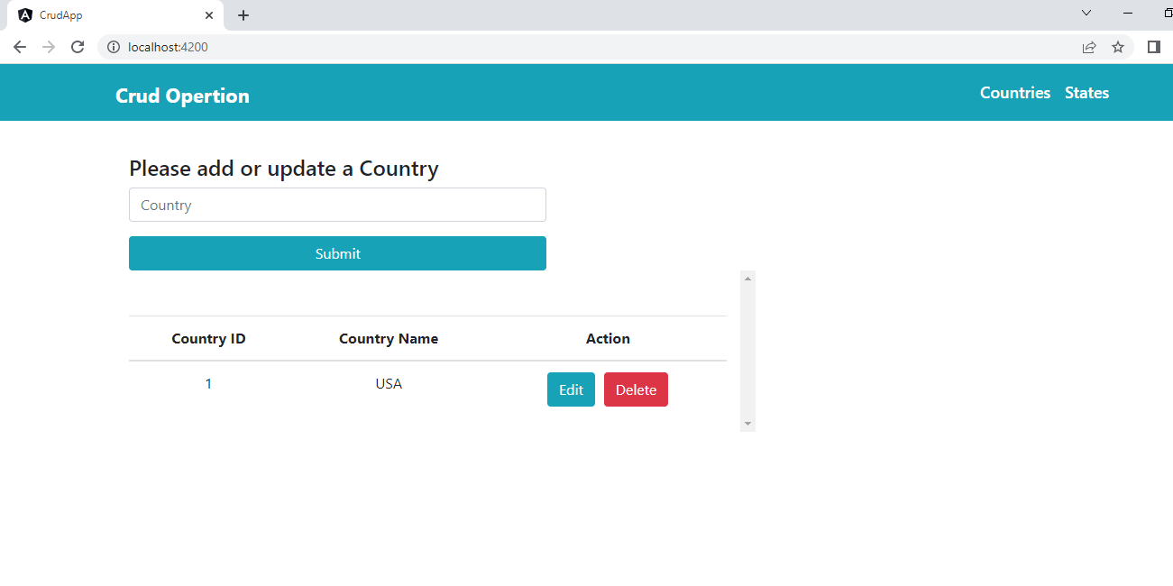

1. 2nd Screen: to add/update/delete states is shown as below :

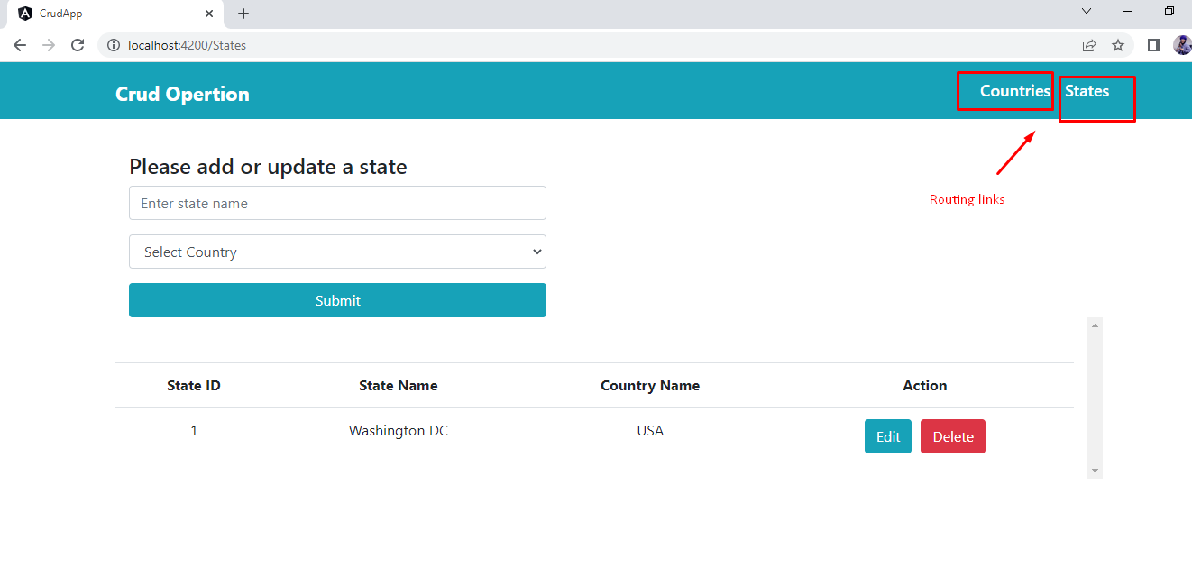

1. Below is the db structure for above application:

