**Assignment 3 (Git)**

Problem Statement

Business challenge/requirement

Pandora Travel Co. has branches in almost every nook and corner of the world and with $20 billion transactions globally, every down time results in massive losses. Multiple developers are working from remote locations and are having trouble coordinating with each other. The code deployment ratio is 100:10, hence the developers need a robust Source Control Management System with strong branching and merging features. Git suits their needs perfectly.

You are to demonstrate the use of Git by using a sample project and showing how multiple developers, working from remote locations can work in Git.

**Solution**

**1. Create pull request**

**2. Merge 2 branches**

**3. Check difference in 2 branches**



**4. Delete remote repository**



**5. Generating pull request from UI**

**7. Resolve Conflicts and merge from UI**

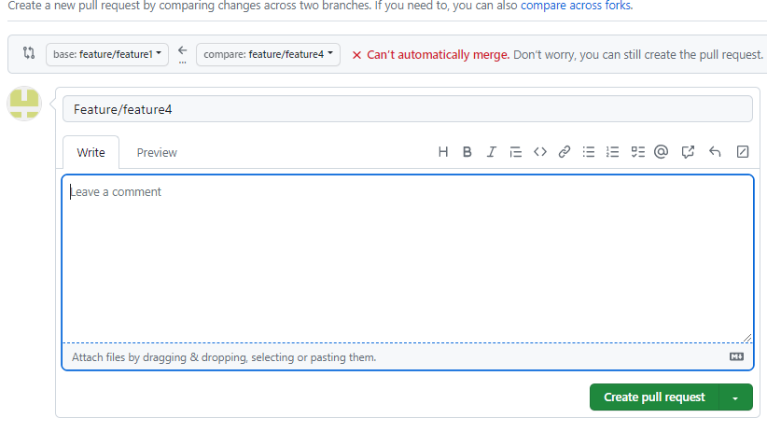



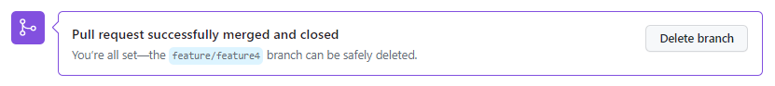

**7. Merging from GIT Bash**

**8. Use reset command to revert the changes**



**9 Delete unnecessary branches if you created earlier**

