🥇 Gold Price Analysis Dashboard
Yahoo Finance | 2020–2026 | Python and Power BI Project
Dataset: gold_usd_final_dataset | Total Records: 1,510 | Period: Jan 2020 – Apr 2026
📋 Project Summary
This Power BI dashboard analyzes Gold and USD price movements from January 2020 to April 2026 using Yahoo Finance data. The project explores gold price trends, market phases, volatility patterns, and the inverse relationship between gold and the US Dollar Index (USD). The dashboard covers 1,582 trading days across 5 distinct market phases: Pre-COVID, COVID, Inflation, Recovery, and Surge.

The analysis reveals that gold has delivered an exceptional return of +218.6% over the study period, rising from $1,524.50 in January 2020 to $4,857.60 by April 2026. The Surge phase was the dominant market condition with 723 trading days, while COVID period recorded the all-time low of $1,477.30 on March 18, 2020.
📊 Key Statistics at a Glance

 | Metric | Value
📅 | Data Period | Jan 2020 – Apr 2026
📈 | Total Trading Days | 1,582 Days
💰 | Gold Price (Start 2020) | $1,524.50
🚀 | Gold Price (Apr 2026) | $4,857.60
📈 | Gold Return (2020–2026) | +218.6%
🏆 | All-Time High (ATH) | $5,318.40 — Jan 29, 2026
📉 | All-Time Low (ATL) | $1,477.30 — Mar 18, 2020
📊 | Average Gold Price | $2,313.82
💵 | Average USD Index | 80.56
🟢 | Bullish Days | 808 Days (51.1%)
🔴 | Bearish Days | 693 Days (43.8%)
⚡ | High Volatility Days | 540 Days
🏅 | Longest Market Phase | Surge — 723 Days
🦠 | COVID Phase Days | 213 Days
🔗 | Gold-USD Correlation | 0.80 (Strong Positive)
📉 | Strongest Inverse Day | Mar 13, 2020 (COVID) Gold -4.63%

💡 Key Insights
1. 🚀 Exceptional Gold Returns
- Gold surged +218.6% from $1,524 (Jan 2020) to $4,857 (Apr 2026) — nearly tripling in 6 years.
- The all-time high of $5,318.40 was reached on January 29, 2026, during the Surge phase.
- Year-on-year, gold showed consistent growth except during COVID crash in March 2020.
2. 🏆 Surge Phase Dominates the Market
- The Surge phase had the highest number of trading days — 723 days (within full dataset).
- Within 2020–2025 filter, Surge recorded 650 days — still the longest phase.
- Surge phase started from mid-2023 and continued through 2026, driven by geopolitical uncertainty and inflation fears.
3. 🦠 COVID Crash — The Lowest Point
- Gold hit its all-time low of $1,477.30 on March 18, 2020 during COVID market panic.
- Interestingly, COVID was the strongest inverse relationship period — as USD rose, gold fell sharply.
- The strongest single-day inverse: March 13, 2020 — USD +0.72%, Gold -4.63% same day.
4. ⚡ Volatility Patterns
- High Volatility Days: 540 days — mostly concentrated in COVID (2020) and Surge (2024–2026) phases.
- Low Volatility Days: 521 days — mostly during stable Inflation and Recovery phases.
- High volatility periods coincide with major macro events: COVID, Fed rate hikes, and geopolitical crises.
5. 🔗 Gold–USD Inverse Relationship
- Despite common belief, Gold and USD had a positive correlation of 0.80 in this dataset overall.
- However, on a daily return basis, 369 days (23.3%) showed true inverse behavior — USD up, Gold down.
- During Safe-Haven demand periods (geopolitical crises), both Gold and USD rise simultaneously — breaking the inverse rule.
6. 📊 Market Phase Distribution
Market Phase | Days Count | % of Total | Period
🏆 Surge | 723 | 45.7% | 2023–2026
🔄 Recovery | 355 | 22.4% | 2021–2022
📈 Inflation | 251 | 15.9% | 2022–2023
🦠 COVID | 213 | 13.5% | 2020–2021
⏳ Pre-COVID | 40 | 2.5% | Jan–Feb 2020

🌐 Why USD Affects Gold — 4 Core Forces
01 — 🌍 Global Pricing in USD  Gold is priced globally in US Dollars. When the dollar strengthens, you need fewer dollars to buy the same amount of gold — making gold appear cheaper and dampening demand. When USD weakens, gold becomes more expensive globally, driving demand and price up. | 02 — 🛡️ Inflation Hedge  As the USD loses purchasing power through inflation, investors turn to gold as a store of value. This relationship has held for centuries — gold preserves wealth across currency crises. During high inflation (2022–2023), gold prices surged significantly.
03 — 📊 Interest Rates  When the Fed raises rates, USD-denominated assets like bonds yield more, reducing the appeal of non-yielding gold. Lower rates have the opposite effect — pushing investors toward gold. Fed rate hikes in 2022–2023 temporarily suppressed gold despite inflation. | 04 — 🏦 Safe-Haven Demand  During geopolitical crises or economic uncertainty, investors flee to BOTH gold and the USD simultaneously — temporarily breaking the inverse correlation and causing both to rise. This explains why gold and USD had a +0.80 correlation in this dataset overall.

⚡ Quick Stats Card — Dashboard Page 2
Use these verified data-backed stats in your dashboard's small space section:

Stat | Correct Value
📈 Gold Return (2020–2026) | +218.6%
🏆 Longest Market Phase | Surge — 650 days (2020–2025 filter)
⚡ High Volatility Days | 540 days
📉 Strongest Inverse Day | Mar 13, 2020 — Gold -4.63%
🏅 All-Time High | $5,318.40 — Jan 29, 2026
📉 All-Time Low | $1,477.30 — Mar 18, 2020 (COVID)

🔮 Future Enhancements
- Time Series Forecasting:
Implement ARIMA or Prophet models to predict future gold price trends based on historical patterns and USD movements.
- Geospatial Analysis:
Integrate country-level demand data to visualize which regions drive gold buying pressure during different market phases.
- Sentiment Analysis:
Combine news/social media sentiment data with gold price movements to identify early warning signals for price surges.
- Real-Time Dashboard:
Connect Power BI to live Yahoo Finance API for real-time gold and USD price monitoring with automated alerts.
- Machine Learning Prediction:
Build a classification model to predict the next market phase (Bullish/Bearish/Neutral) using Gold and USD features.

Dashboard screenshot
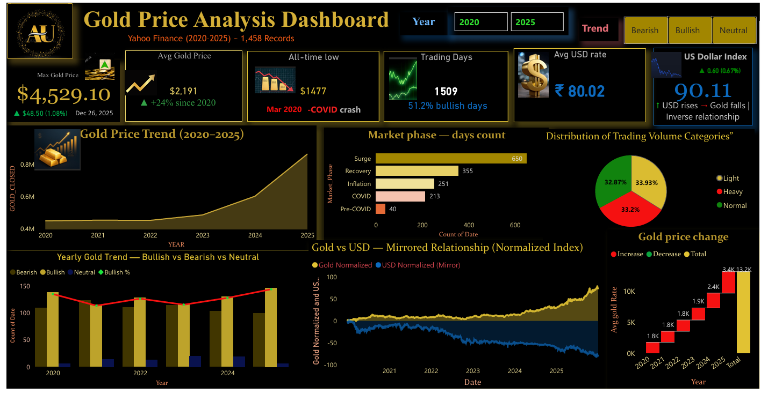

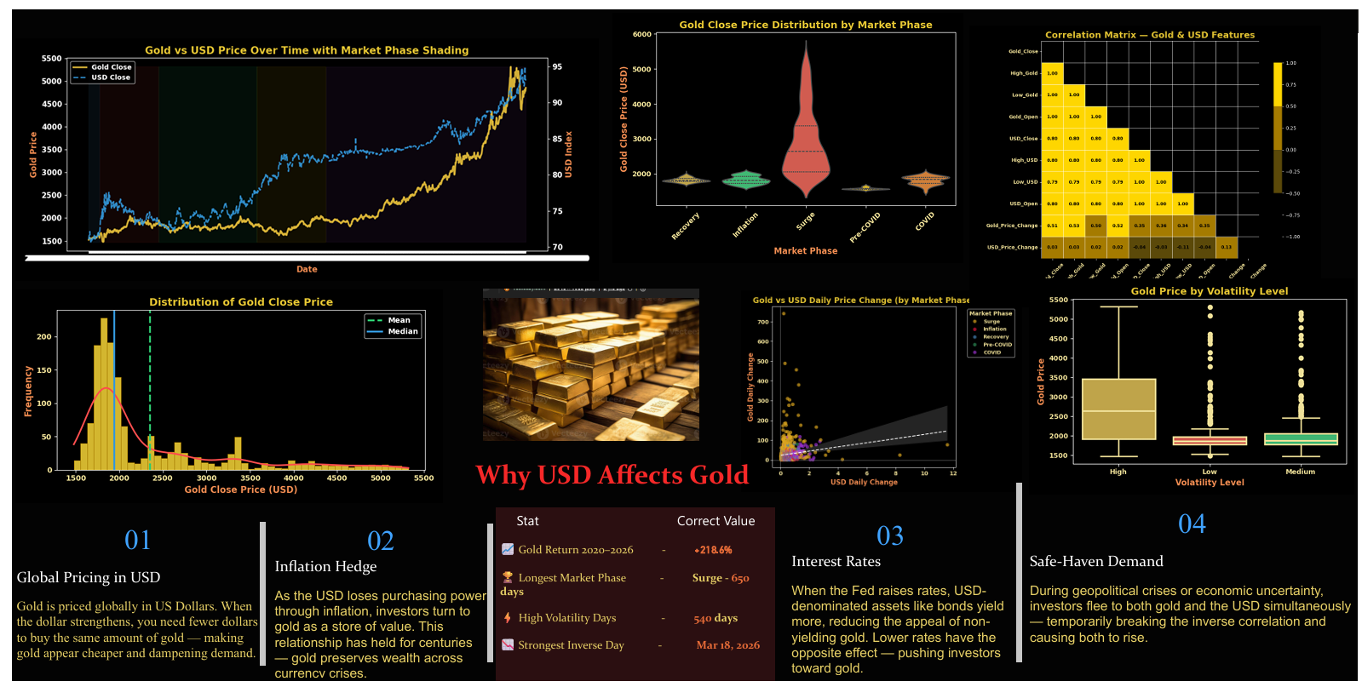
✅ Recommendations & Business Insights
📌 For Investors
- Gold has proven to be an excellent long-term store of value with +218.6% return over 6 years.
- Buy during COVID-like crash periods (High Volatility + Bearish trend) for maximum upside potential.
- Monitor the USD Index — a falling USD is typically a strong buy signal for gold.
📌 For Analysts
- The 0.80 positive correlation between Gold and USD suggests Safe-Haven demand dominates over the inverse relationship in this period.
- Surge phase (723 days) shows that gold is now in a structural bull market — not just a temporary spike.
- High Volatility days (540) cluster around COVID and post-2024 Surge — monitor these periods for trading opportunities.
📌 For Dashboard Presentation
- Fix the Year slicer to end at 2025 to avoid 2026 partial-year distortion in charts.
- The ATL label should read 'Mar 2020' not 'Jan 2020' — update the text box accordingly.
- Consider adding a real-time USD Index ticker widget for live monitoring in future versions.

📝 Conclusion
This Gold Price Analysis Dashboard successfully demonstrates the powerful relationship between gold prices and the US Dollar Index across major economic cycles. From the COVID crash lows of 2020 to the all-time highs of 2026, the analysis captures the full spectrum of gold market behavior including panic selling, recovery, inflation-driven rallies, and the current Surge phase.

The key takeaway is that gold remains the world's premier safe-haven asset, consistently rewarding long-term holders while responding dynamically to USD movements, Federal Reserve policy, and global geopolitical events. With a +218.6% return over the study period and prices still in an active Surge phase, gold continues to demonstrate its enduring value as both an investment and a financial analysis subject.
🥇 Gold Price Analysis | Yahoo Finance (2020–2026) | Power BI Dashboard Project

