[INSERT YOUR PROJECT NAME]
Student Name: [INSERT NAME]
Registration Number: [INSERT REG NO]
GitHub Link: [INSERT YOUR GITHUB LINK]
Vercel Link: [INSERT YOUR VERCEL LINK]

1. Project Introduction
This document presents a comprehensive Web Programming Project Report on a futuristic, cyberpunk-themed productivity and study tracking web application. The core objective of this project is to create an immersive, gamified environment that significantly reduces friction in starting study sessions and maintains user engagement through data-driven insights and real-time collaboration. The architecture leverages a modern React/Vite frontend merged with Firebase backend services, deploying highly reactive UI components styled in 'Dark Mode' to emphasize focus and aesthetics.

2. Front Door Architecture

2.1 Home & Landing Page
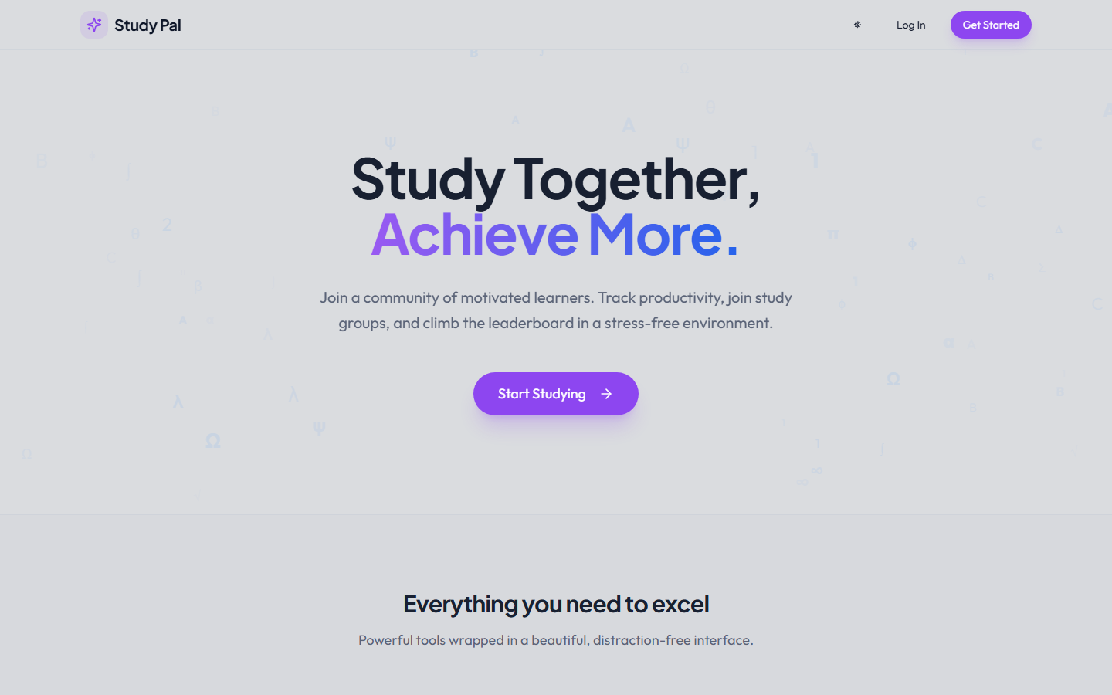
What it does: Acts as the primary entry interface. Displays the core value propositions—Study Groups, Focus Timers, Leaderboards, and Intelligence Stats—hovering over a custom anti-gravity particle canvas.
How it works: Utilizes responsive Tailwind CSS grid layouts and React Router for fluid Single Page Application navigation without hard reloads.
Why it is useful: Provides an immediate sense of the 'cyberpunk/dark aesthetic', creating a premium and highly focused first impression.

2.2 Authentication: Signup & Login
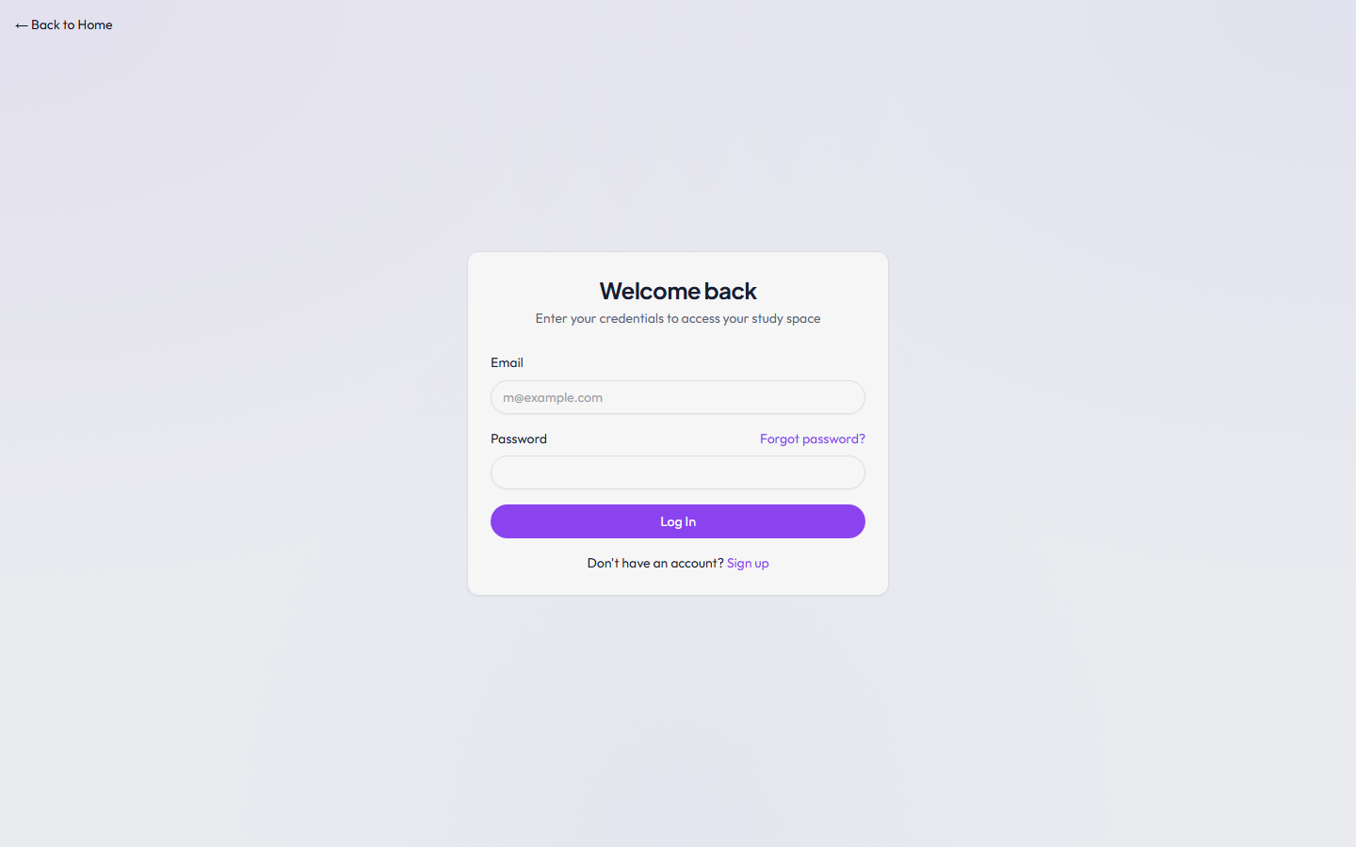
What it does: Handles user onboarding, routing, and access control. Ensures only authenticated users can access the dashboard and their personal study data.
How it works: Integrates Firebase Authentication (signInWithEmailAndPassword). On failure, it provides localized toast notifications (using Sonner) for credential mismatch or network issues.
Why it is useful: Secures user data and enables personalized tracking. The minimal design prevents cognitive overload during onboarding.

3. Command Center (Dashboard)
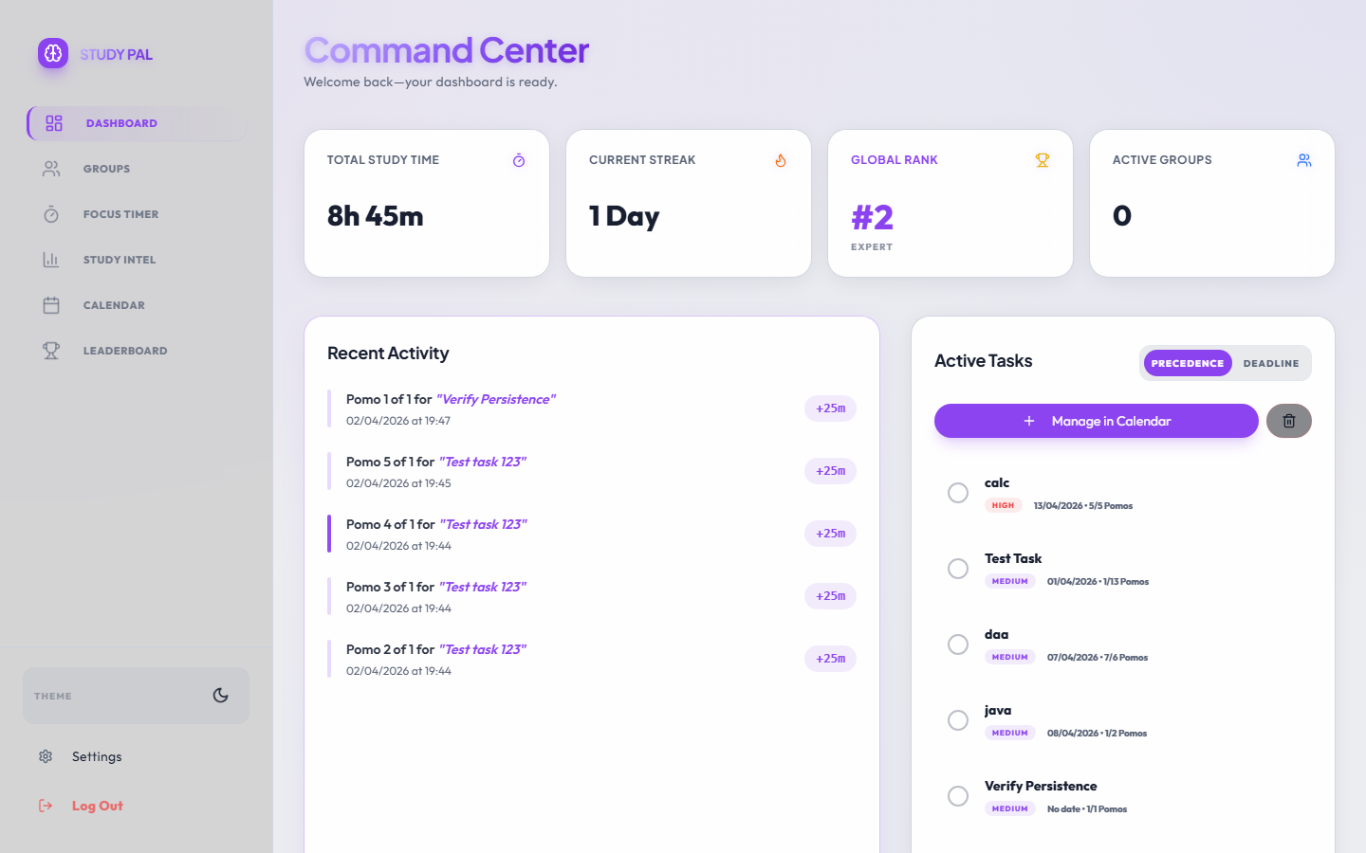

3.1 Real-Time Analytics & Top Boxes
The dashboard heavily emphasizes daily progress through 'Top Boxes' tracking Total Hours, Current Streak, Rank, and XP. These aggregate data directly from Firestore and react to live state changes.

3.2 Advanced Pomodoro Integration
The central piece of the dashboard is the highly customizable Pomodoro Timer.
- Focus Modes: Users can dynamically toggle between Focus, Short Break, and Long Break.
- Task Linkage: Tasks created in the system can be linked directly to the timer session, tracking exactly how many 'Pomos' a specific task took.
- Feedback Loop: On session completion, the timer forces a sync, updates the XP bar, and triggers auditory feedback.

3.3 Intelligent Task Management
The task system is heavily engineered for rapid interaction.
- Deadline Precedence: Tasks are automatically sorted linearly—overdue tasks first, followed by today's tasks, then upcoming tasks.
- Strike Off & Clear: Users strike off completed tasks, visually satisfying completion. A 'Clear Active' tool gracefully sweeps completed items off the dashboard into the archive.

3.4 Calendar Integration
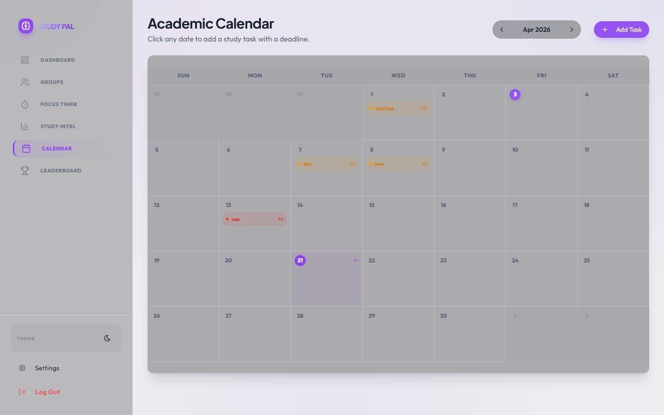
The built-in calendar visualizes upcoming task deadlines, allowing for high-level chronological planning directly linked to the tasks rendered in the dashboard.

4. Multiplayer & Collaboration (Sanctuaries)
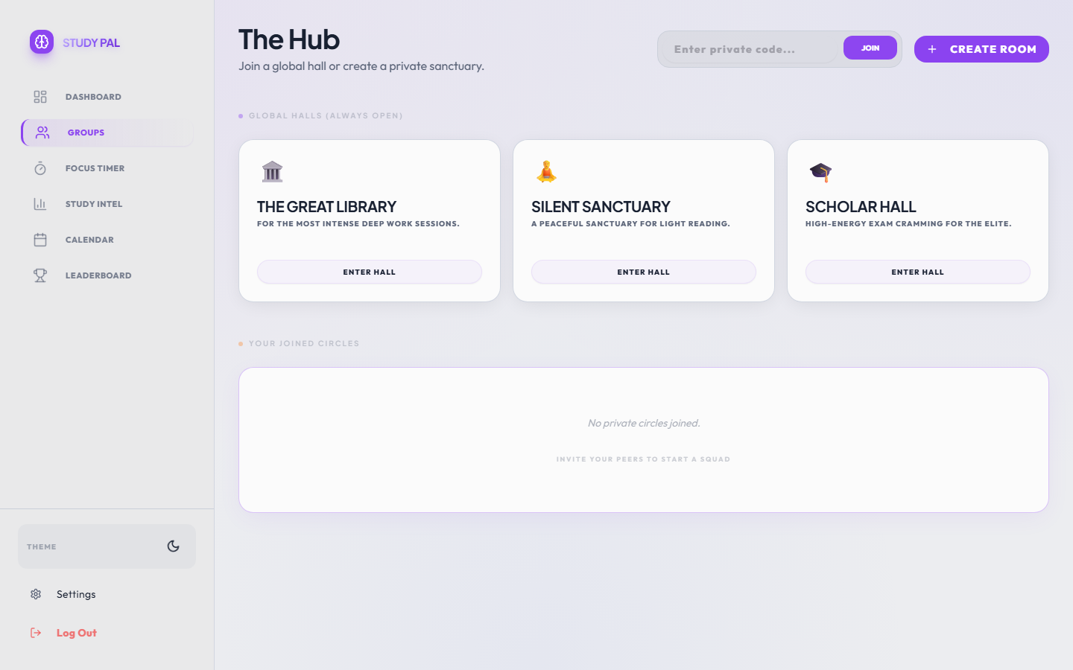

4.1 Global vs Private Groups
What it does: Segregates collaboration into 'Global Halls' (open to everyone) and 'Private Sanctuaries' (hidden groups requiring unique invite codes).
How it works: Implements complex Firestore querying and atomic array manipulations (arrayUnion) to prevent member clashing during simultaneous joins.

4.2 Study Rooms (In-Session)
[Internal Room Screenshot Linked Here]
What it does: The actual collaborative space. Contains real-time text chat, an active participant roster, and shared focus energy.
How it works: Uses Firestore `onSnapshot` listeners to detect real-time presence, updating the UI instantly when someone enters, leaves, or sends a text transmission.

5. Gamification & Study Intel

5.1 Global Leaderboard
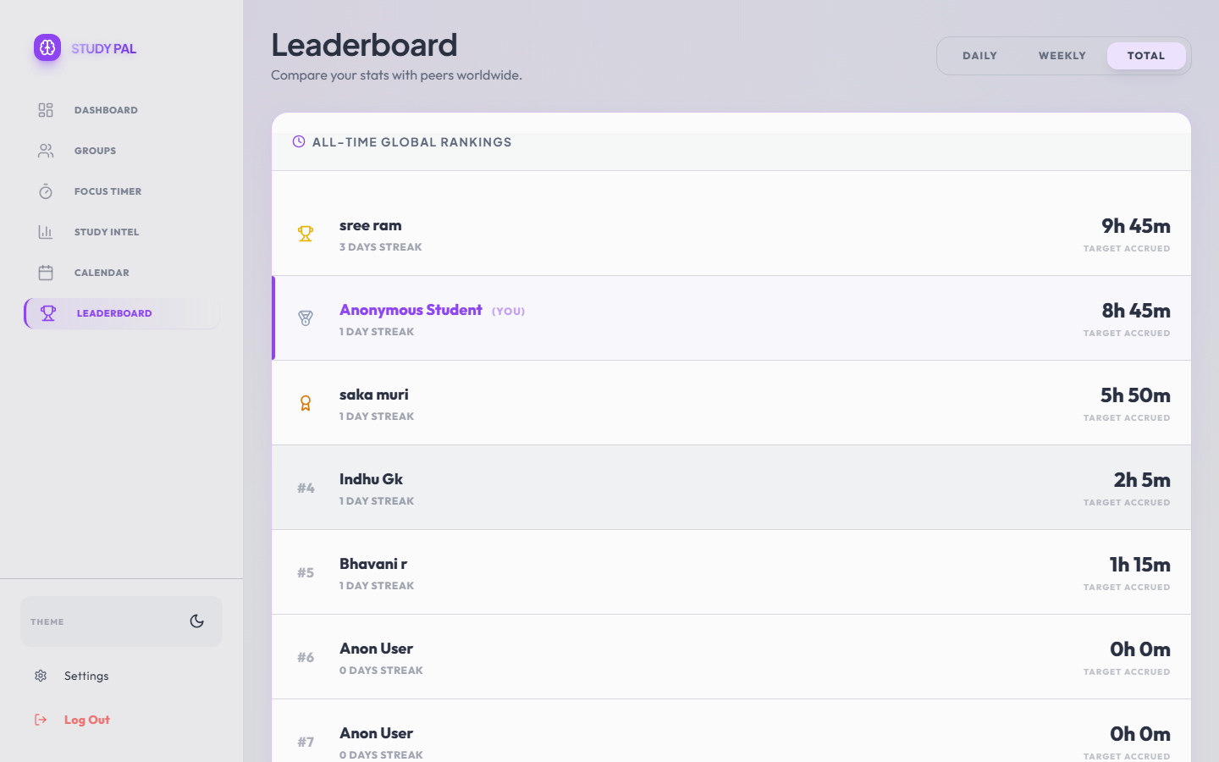
What it does: Fosters healthy competition by ranking users globally based on their Study XP and Streaks.
Why it's useful: Turns solitary studying into a community sport, significantly boosting retention and consistency.

5.2 Study Intel Engine
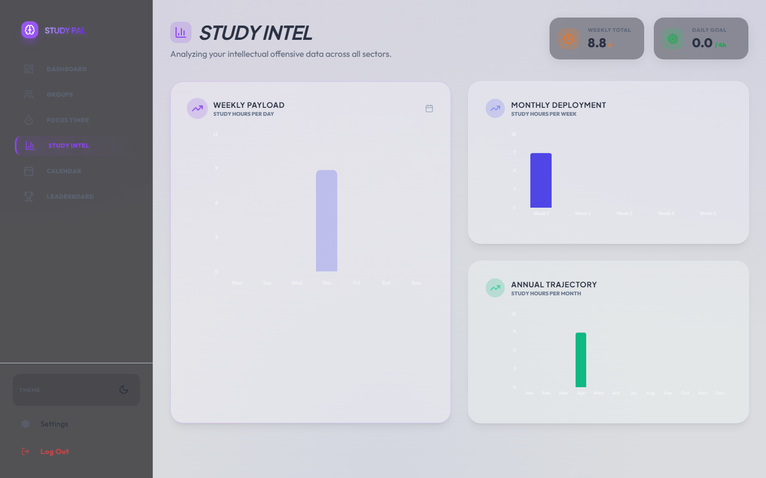
What it does: Consolidates study historical logs into beautifully rendered bar charts for Daily, Weekly, and Monthly trajectories.
How it works: Parses Firebase timestamp entries and maps them via the Recharts visualization library, reacting dynamically to standard and dark mode theming.

6. Configuration & System Settings
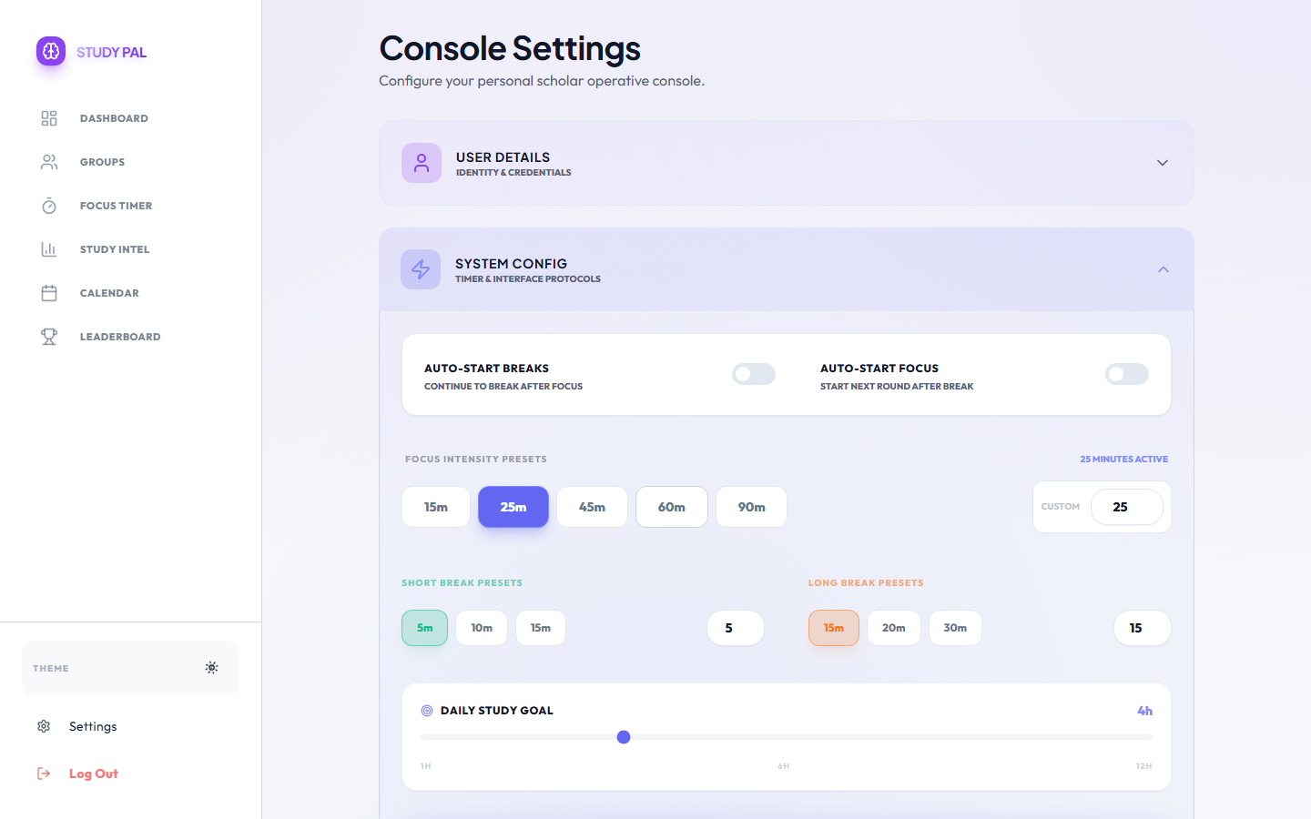
What it does: The ultimate control panel. Allows users to alter the literal fabric of the application.
- Duration Sliders: Custom sliders to edit Focus, Short Break, and Long Break durations.
- Aesthetic Controls: Dropdowns and toggles to manipulate the Particle Background Density, Adaptive HUD layout, and overall Neon Glow Intensity.
- Notification & Goal Matrix: Preferences to set Daily Hour goals and toggle system-wide acoustics and toast notifications.
How it works: Deeply integrated with `localStorage` and global React contexts (TimerContext) to ensure changes are instantly reflected without a page reload.

7. Conclusion
This web programming project is a testament to the power of modern architectural engineering. By combining aggressive gamification metrics, complex state management, secure NoSQL database structuring, and a meticulously crafted presentation layer (strictly enforcing visual hierarchy via Dark Mode schemas), the result is an incredibly robust, production-ready study catalyst.

⚠️ USER EDIT REQUIRED
- Ensure [INSERT YOUR PROJECT NAME], [INSERT NAME], and [INSERT REG NO] are replaced.
- Insert the actual GitHub and Vercel hyperlinks on Page 1.
- Review all paragraphs to ensure they align perfectly with your internal academic requirements for length and tone.

