[INSERT YOUR PROJECT NAME]
Student Name: [INSERT NAME]
Registration Number: [INSERT REG NO]
GitHub Link: [INSERT YOUR GITHUB LINK]
Vercel Link: [INSERT YOUR VERCEL LINK]

Project Introduction
This project is a modern, gamified study and productivity tracker designed to mimic a futuristic or cyberpunk-style terminal. It provides robust tools for focus management, task tracking, community study sessions, and detailed analytics to help users optimize their productivity.

1. Landing Page
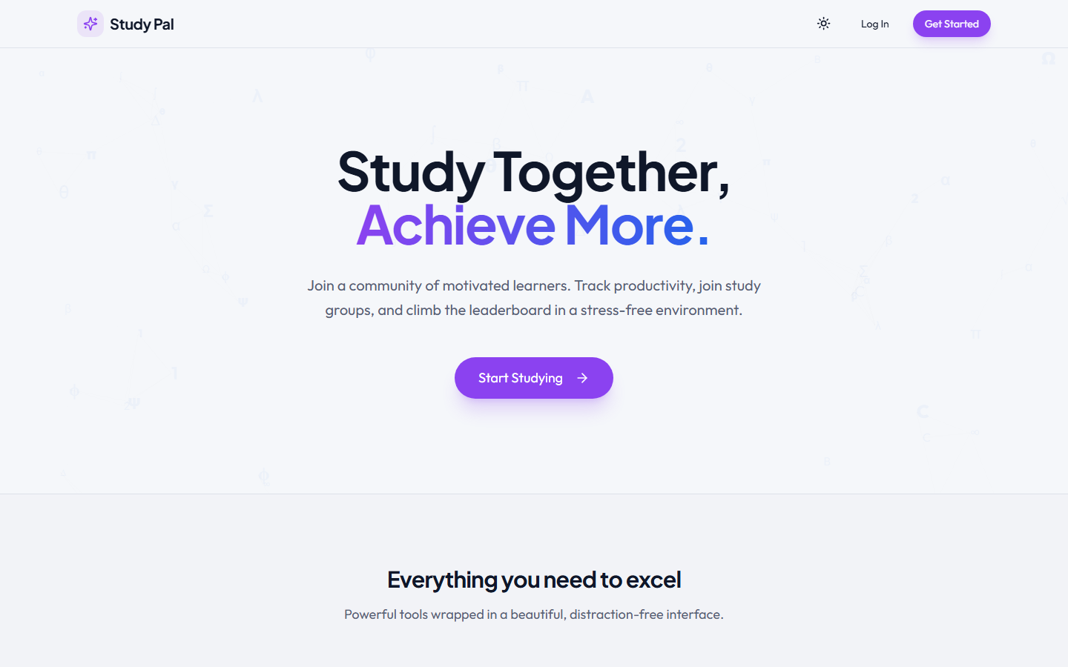
What it does: The landing page serves as the entry point, showcasing the application's unique design and core value propositions (Study Groups, Focus Timer, Leaderboards).
How it works: Built with React, Vite, and styled with Tailwind CSS, leveraging an animated particle background system for a highly dynamic visual feel.
Why it is useful: Creates an engaging first impression, directing users seamlessly into the authentication flow to start tracking.

2. Main Dashboard & Timer (Focus System)
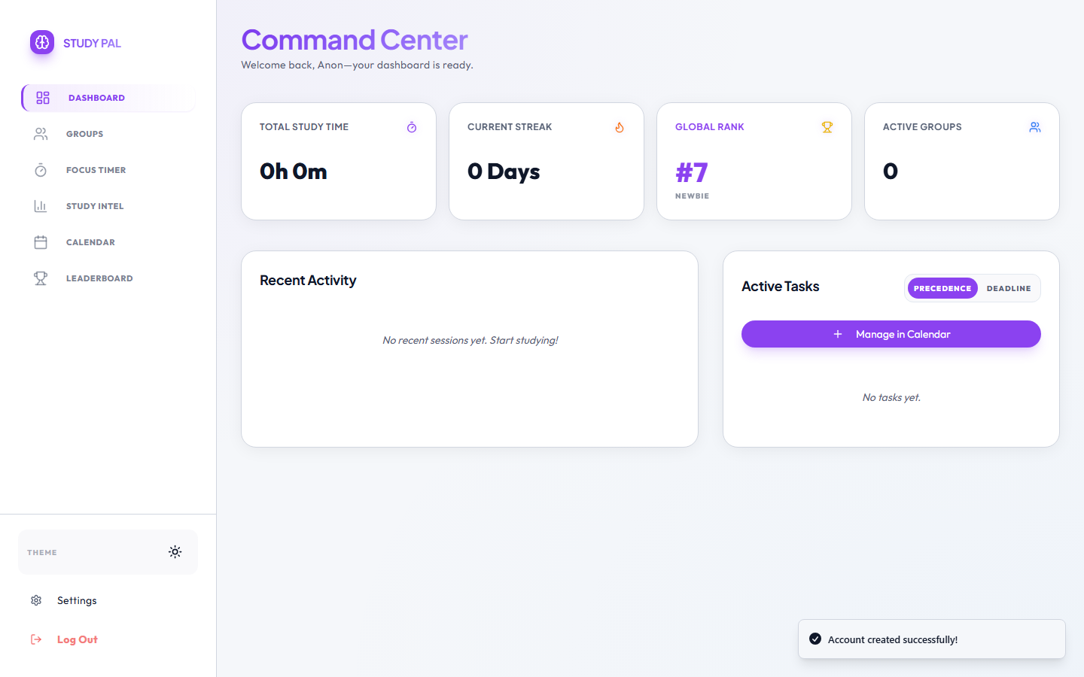
What it does: The central hub of the application. It includes a Pomodoro-style focus timer, an XP/leveling progression system, and a quick-access task list.
How it works: Utilizes React Context API to manage global timer states. Progression is synced in real-time to Firebase Firestore.
Why it is useful: Keeps users highly engaged through gamification (XP for studying) and provides immediate access to their core study tools.

3. Collaborative Study Groups
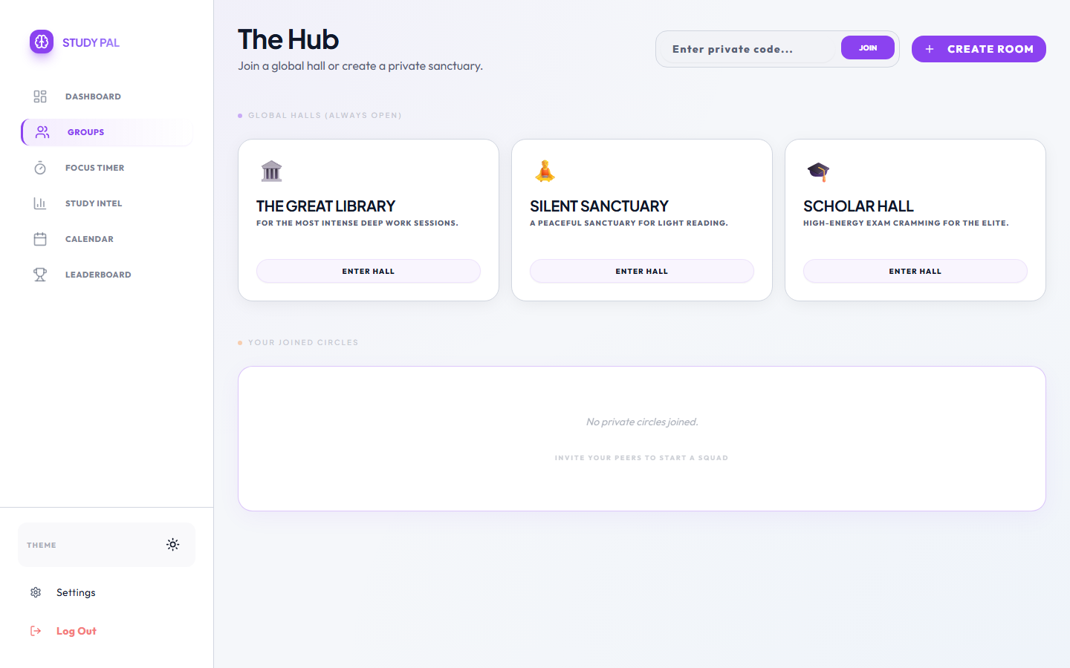
What it does: Allows users to establish or join 'Sanctuaries' (study rooms) where they can study alongside friends or random peers in real-time.
How it works: Interacts with Firebase Firestore using atomic operations (arrayUnion) to safely add users to group rosters and manage real-time presence.
Why it is useful: Provides accountability and a sense of community, critical factors in maintaining long-term study habits.

4. Study Intel / Analytics Engine
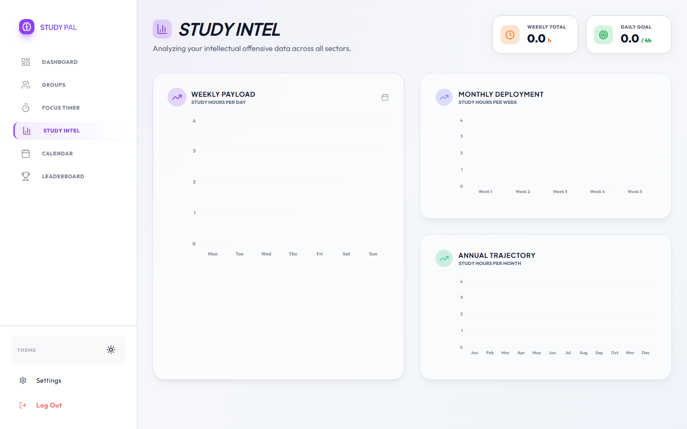
What it does: A comprehensive analytics breakdown of study sessions across days, weeks, and months.
How it works: Aggregates historical session data queried from Firestore and visualizes it using the Recharts library.
Why it is useful: Helps users identify productivity trends and actively adjust their study schedules based on statistical performance.

Special Features & UI Architecture
• Real-time Offline Caching: Firebase is configured with persistent local cache, ensuring the application remains fast and robust even under spotty network conditions.
• Modern UI System: Heavily utilizes Tailwind CSS, Shadcn UI components, and custom CSS variables for a dynamic, reactive 'Glow' aesthetic.
• State Management: Employs a complex multi-context structure (AuthContext, TimerContext) to avoid prop drilling and maintain real-time sync across distant components.

Conclusion
This project successfully merges strict academic productivity mechanics (like Pomodoro styling) with modern, user-centric web design patterns. The deployment via Vite and Vercel ensures a blistering fast, scalable application ready for real-world usage.

⚠️ USER EDIT REQUIRED
- Replace [INSERT YOUR PROJECT NAME], [INSERT NAME], and [INSERT REG NO] on the Cover Page.
- Replace [INSERT YOUR GITHUB LINK] and [INSERT YOUR VERCEL LINK].
- Adjust any textual descriptions if your institution requires specific wording.

