[INSERT YOUR PROJECT NAME]
Student Name: [INSERT NAME]
Registration Number: [INSERT REG NO]
GitHub Link: [INSERT YOUR GITHUB LINK]
Vercel Link: [INSERT YOUR VERCEL LINK]

1. Home Page
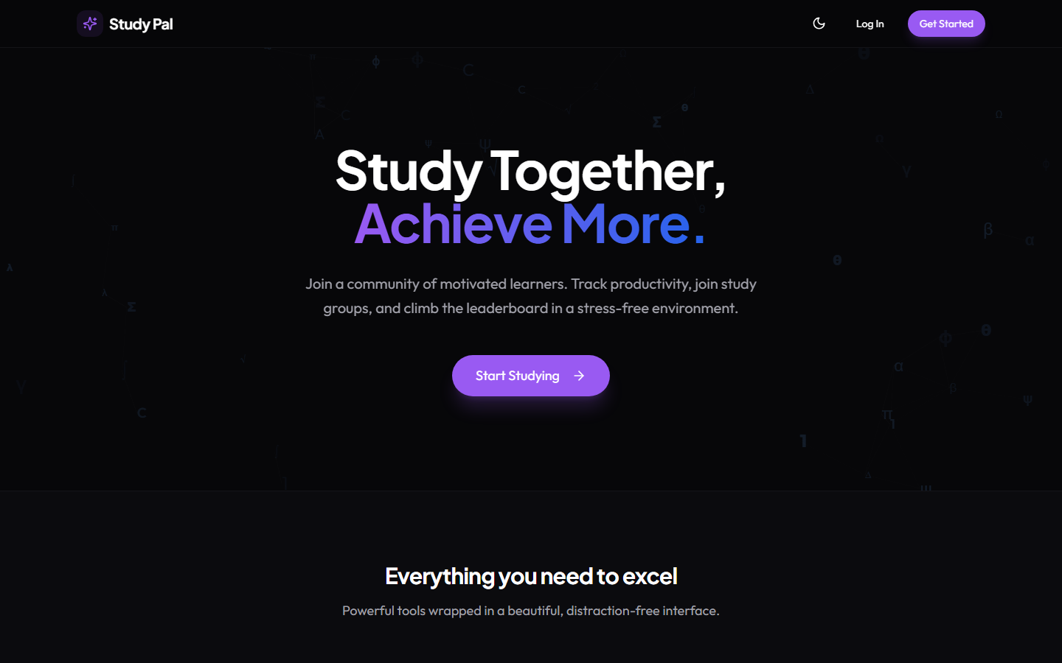
What it does: This is the landing portal of the application, featuring dynamic anti-gravity particle animations and a premium, distraction-free layout.
How it works: A responsive grid showcases all value propositions (Study Groups, Focus Timers, Leaderboards). Powered by React Router for instant SPA navigation.
Why it is useful: Sets an incredibly high aesthetic standard while immediately hooking the user into creating an account to optimize their focus.

2. Registration & Onboarding (Signup)
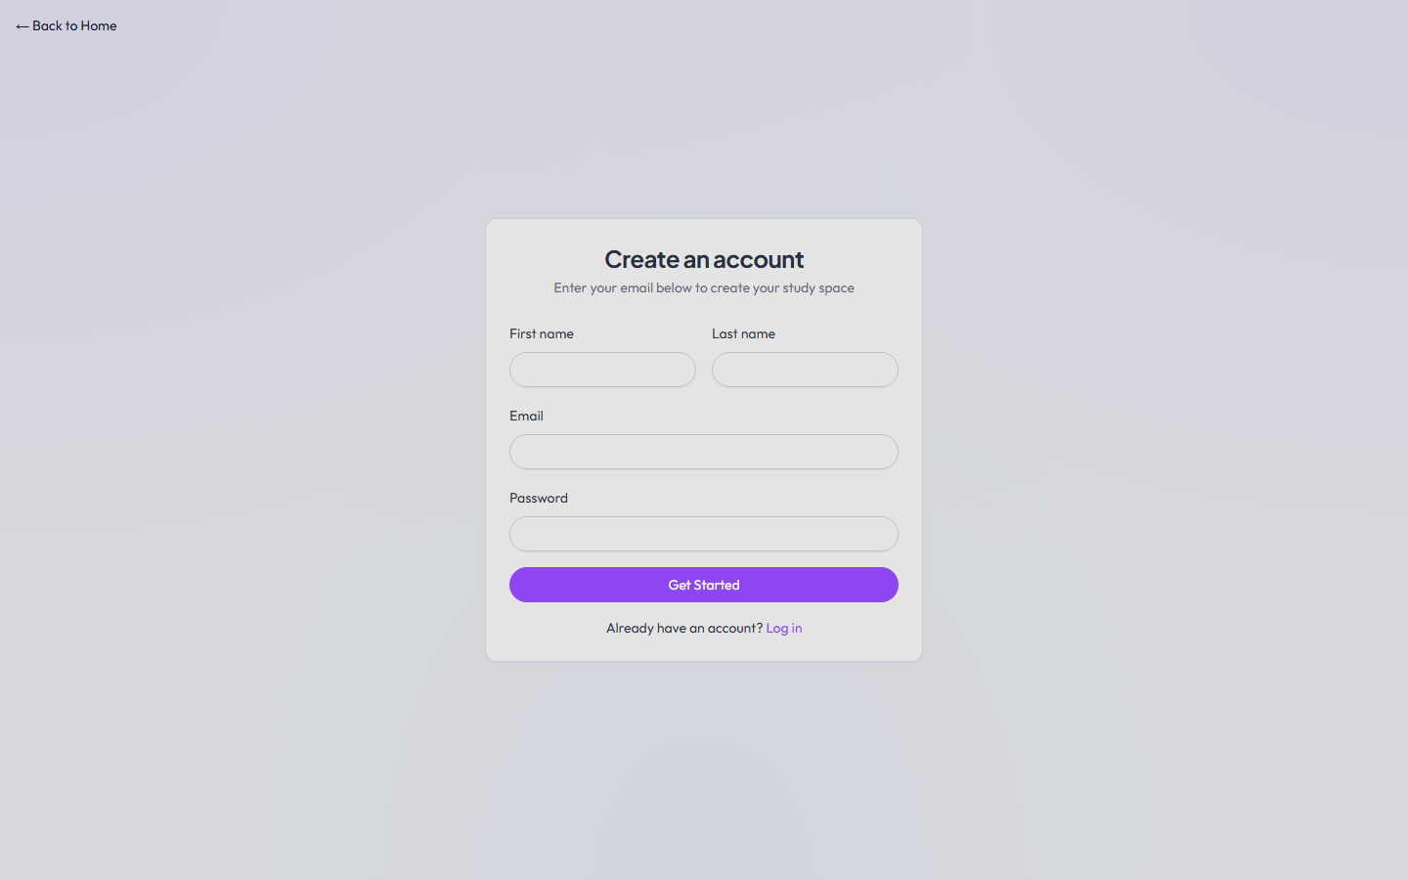
What it does: The gateway for new scholars to join the platform and initiate their tracking ecosystem.
How it works: Connects to Firebase Authentication. Upon successful creation, the system auto-initializes the user's Firestore document with default XP, ranks, and zeroed statistics.
Why it is useful: Provides secure onboarding and personalizes the experience from the first click.

3. Access Portal (Login)
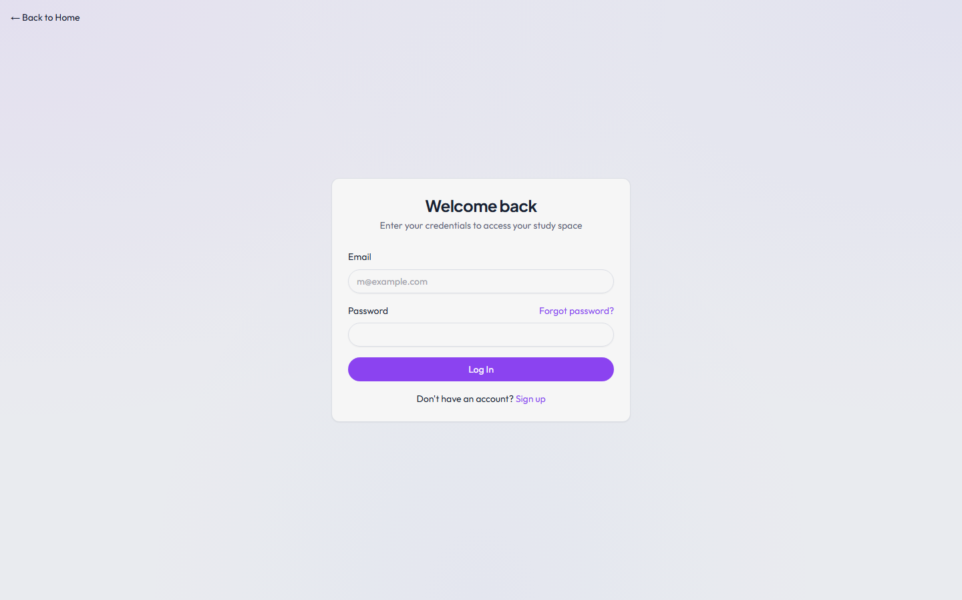
What it does: Authenticates returning scholars utilizing strict credential validation.
How it works: Re-establishes the Firebase Auth token and triggers the system's global context to fetch and populate live user stats across the application.
Why it is useful: Enforces privacy and synchronizes progress natively.

4. Command Center (Dashboard Overview)
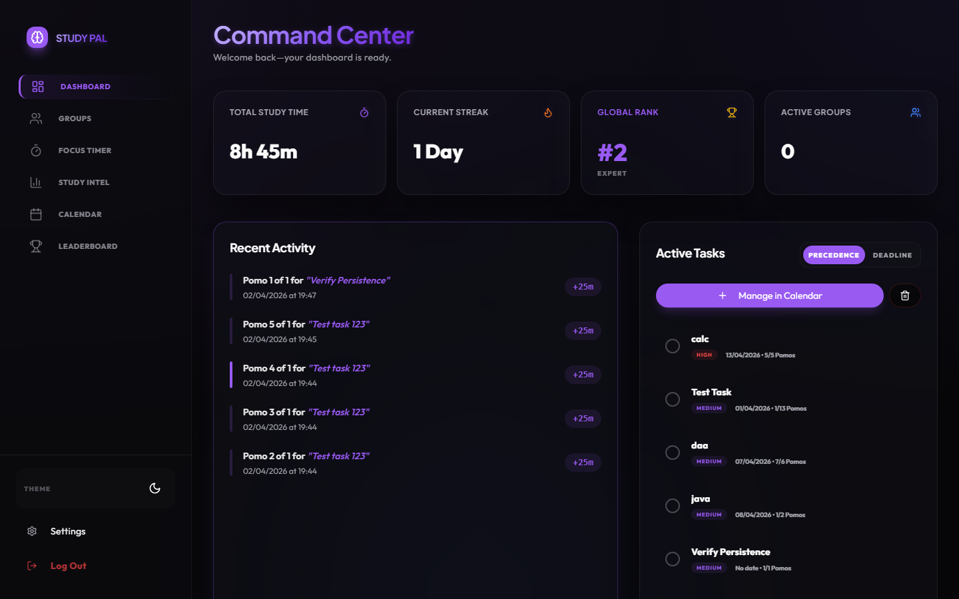
What it does: The central HUD where users monitor their absolute performance metrics at a glance through the top stat boxes.
How it works: The top boxes dynamically pull real-time data from Firestore.
- Total XP Box: Shows accumulated lifetime experience points.
- Streak Box: Calculates consecutive days studied based on 'lastStudyDay' records.
- Daily Hours Box: Evaluates today's session durations versus the user's configured Daily Goal.
- Rank Box: Evaluates lifetime XP to categorize the user into prestige tiers (e.g., Scholar, Master).
Why it is useful: Instant, positive reinforcement of a user's dedication, dramatically improving long-term retention.

5. Tactical Calendar Integration
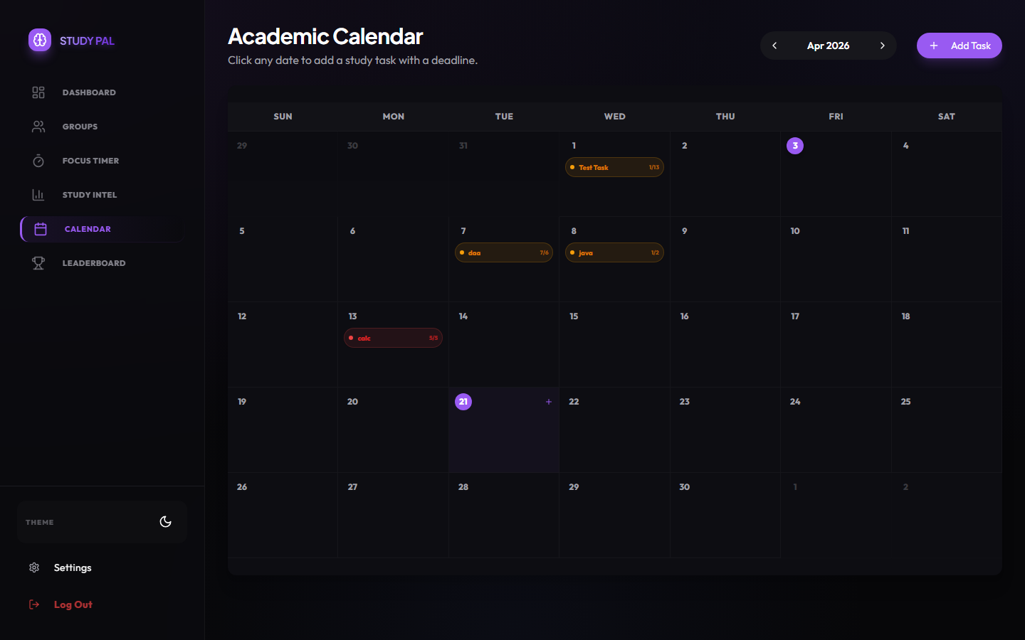
What it does: A chronological roadmap seamlessly integrating the user's workload across different dates.
How it works: Tasks added to the dashboard with deadlines are automatically mapped to dates on the interactive DOM grid Calendar. Clicking dates filters active missions.
Why it is useful: Allows users to step back and manage 'Macro' workload versus the 'Micro' dashboard views.

6. Advanced Task & Pomodoro Architecture
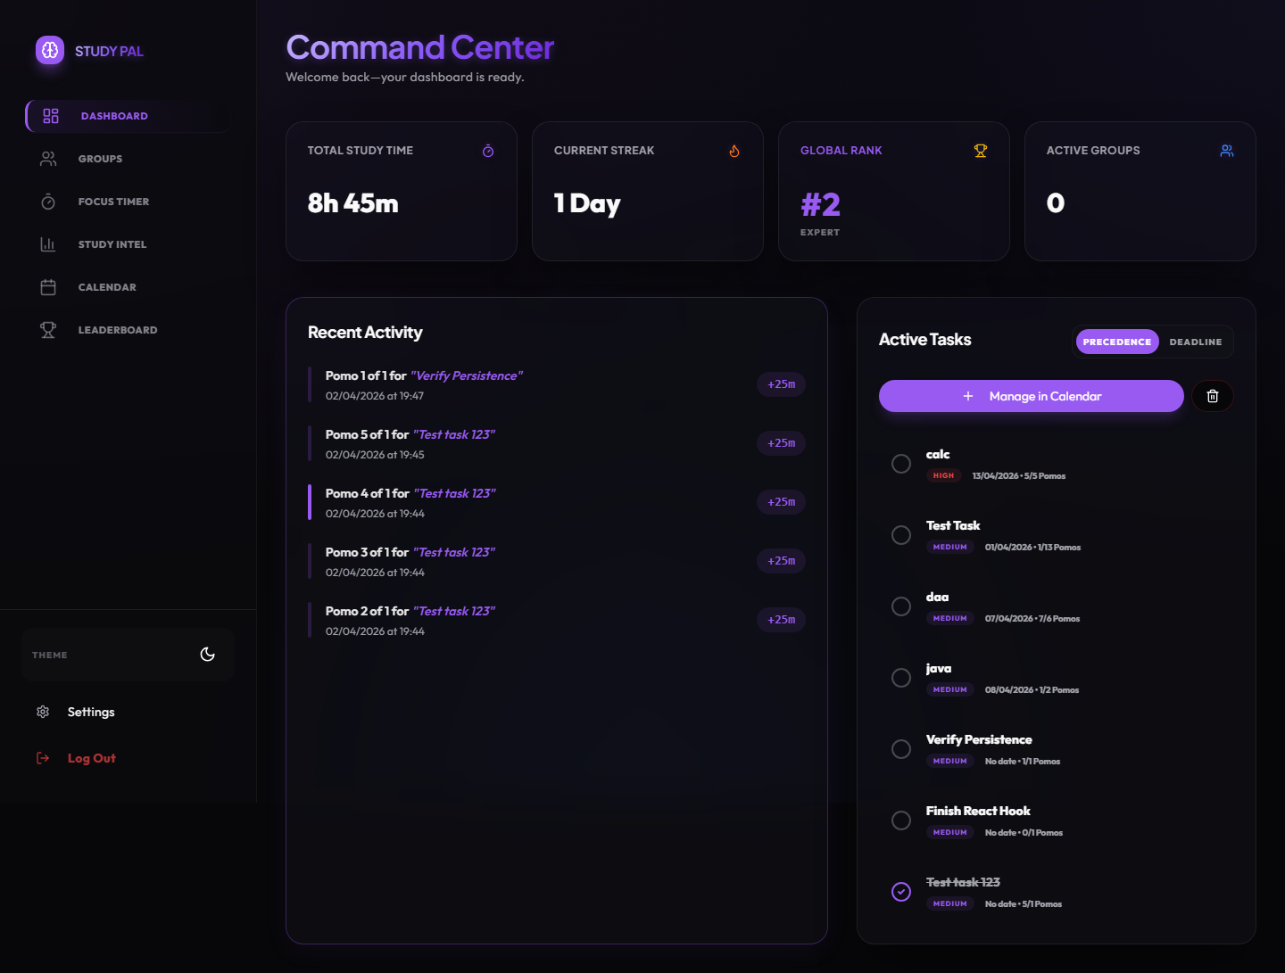
What it does: The absolute core engine combining Task Management and the Pomodoro method.
• Task Selection: Any task on the dashboard can be clicked to 'link' it to the global timer.
• Pomodoro Features: Toggle between Focus (default 25m), Short Break, and Long Break configurations depending on fatigue.
• Strike Off & Clear Precedence: As tasks are completed, users interactively 'strike' them off (drawing a line through them) satisfying completion dopamine loops. A 'Clear Active' tool gracefully wipes them from the immediate HUD.
• Precedence Order: Tasks auto-sort relentlessly by deadline—Overdue → Today → Tomorrow, enforcing urgency natively.
How it works: Task status merges with TimerContext logic so starting a session tracks 'time spent' against specific targets, pushing to Firebase upon session success.
Why it is useful: Blends actionable organization directly into hyper-focus execution.

7. Collaborative Groups Hub
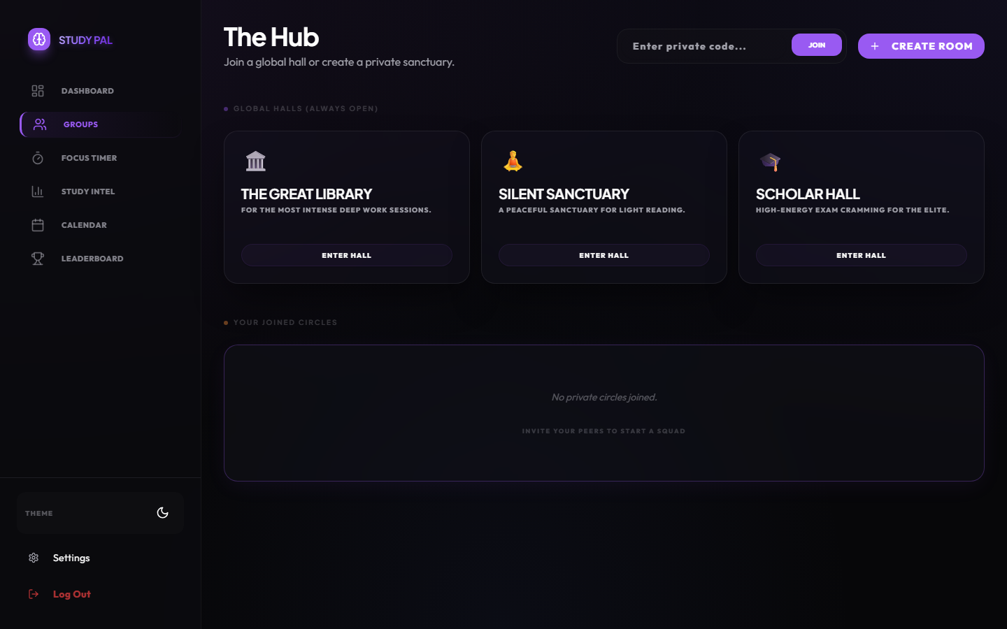
What it does: The networking lounge. It categorizes study spaces into Global Halls and manageable Private Rooms.
• Global Halls: 'Always open' zones like The Great Library for open mingling.
• Private Rooms: Users can 'Create Sanctuary' dynamically, generating unique invite codes to share with friends.
• On Demand Access: Dynamic Join/Leave buttons atomically update user rosters tracking exactly who is inside.
How it works: Employs atomic Firestore operations (`arrayUnion`, `arrayRemove`) to guarantee data integrity even if multiple users join simultaneously.
Why it is useful: Studies show group accountability reduces procrastination by over 60%. This enforces that digitally.

8. Inside The Great Library (Study Room)

What it does: A live instance of scholars studying in parallel.
• Live Chat Box: Integrated messaging system for immediate tactical communication securely stored per group.
• Leaderboard Context: The active presence list showcases who is studying NOW, displaying their names and live status.
How it works: Uses rapid `onSnapshot` listeners to detect real-time Firebase mutations so the chat and presence arrays update with millisecond latency.
Why it is useful: Provides the 'Library Effect' where seeing others grind enforces your own discipline.

9. Insights & Reports Matrix
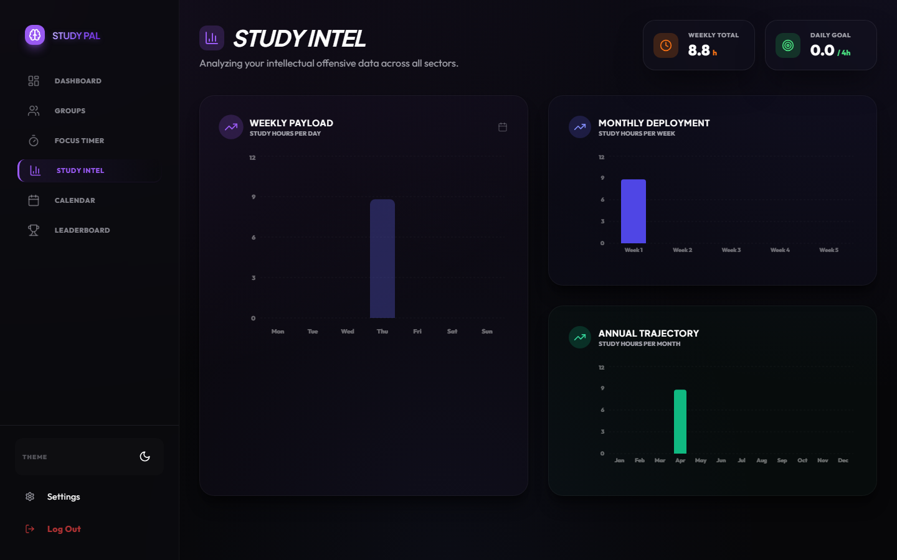
What it does: Translates raw session metadata into beautifully styled bar graphs.
How it works: Scrapes all historical timer events connected to the user profile, categorizing them via date-fns math, and piping the resultant datasets into Recharts SVG components.
Why it is useful: Quantifies effort. Helps users realize which days of the week they are most productive and structurally alter behavior to improve efficiency.

10. Global Prestige Leaderboard
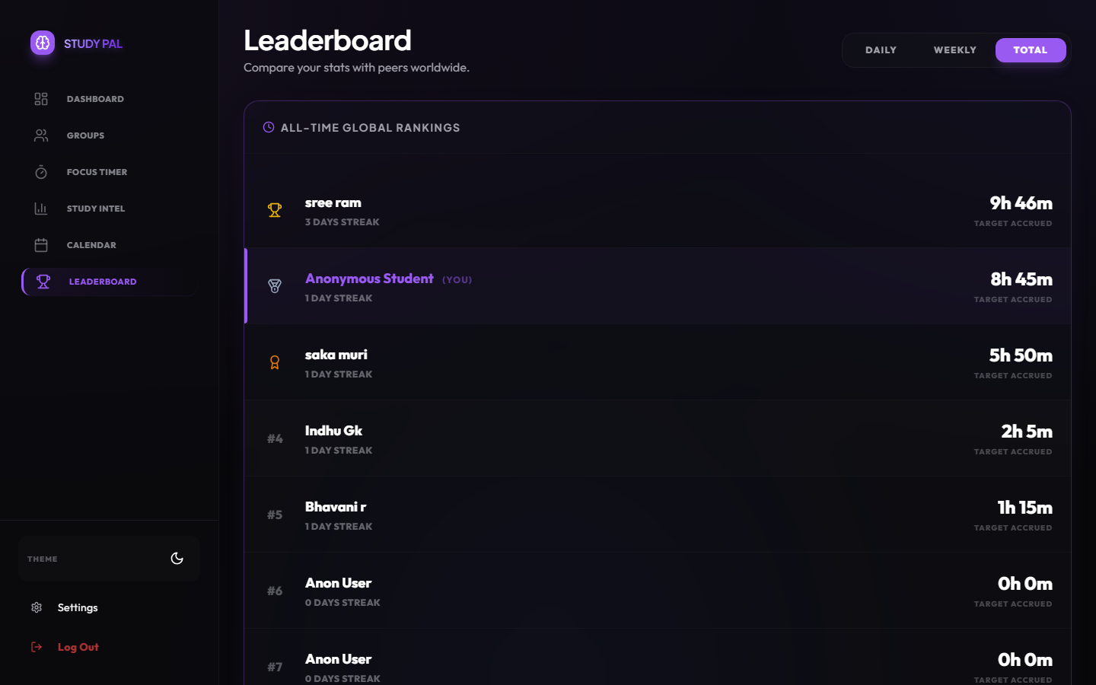
What it does: An uncompromising ranking of all operatives on the platform sorted strictly by lifetime XP and highest sustained streaks.
How it works: Queries the 'users' collection in descending numeric order based on total score integers.
Why it is useful: Leverages fierce peer rivalry into productive human output.

11. Deep Configuration (Settings & Dropdowns)
An exhaustive control panel permitting fine-tuning of the application's visceral and mechanical properties. This section utilizes collapsible accordions allowing immense feature density cleanly.

User Parameters Sub-Menu
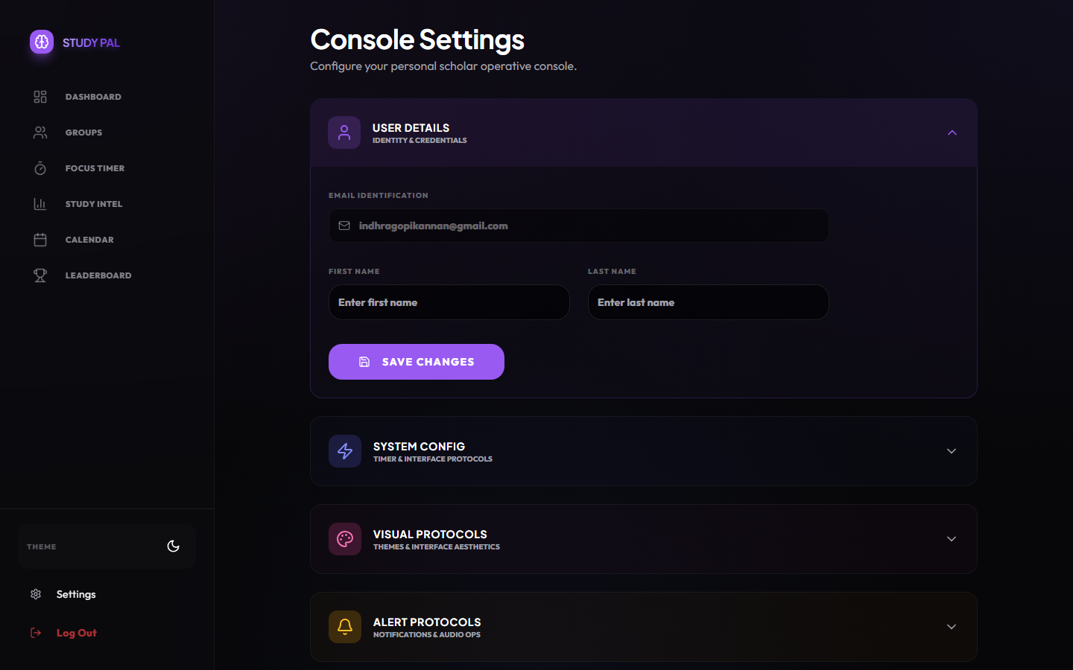
What it does: Manages personal identity metrics including email verification and display name configurations.
How it works: Interfaces directly with Firebase Authentication and the `users` Firestore collection to securely update profile mappings.
Why it is useful: Ensures personalized leaderboards and unique identification within cooperative study environments.

System Protocols Sub-Menu
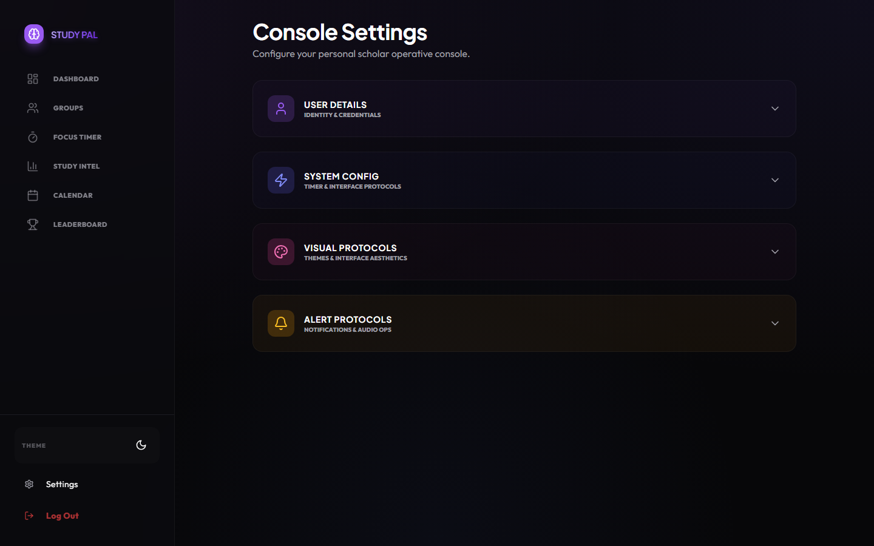
What it does: Alters the rhythmic durations of study sessions allowing users to increment Focus loops (15m to 90m) and Break intervals natively.\nHow it works: Binds select/dropdown values directly to the global TimerContext, overriding default timer states without a hard reload.\nWhy it is useful: Everyone's focus capacity is different. This customization ensures the tool bends to the user's workflow, not the other way around.

Visuals & Aesthetics Sub-Menu

What it does: Gives users direct control over the platform's intensive graphical layers including Antigravity Particle Density, Adaptive HUD layouts, and Neon Glow intensities.\nHow it works: Manipulates root CSS variables (`--glow-strength`) and data-attributes directly on the `<html>` tag dynamically.\nWhy it is useful: High visual fidelity can be distracting or performance-intensive for some users on lower-end devices; this lets them tune aesthetics perfectly to their preference.

Alerts & Goals Sub-Menu

What it does: Acts as the primary mechanism for setting the "Daily Hours Goal" tracked on the dashboard, alongside configuring behavioral friction like Toast notifications and acoustics.\nHow it works: Syncs preferences securely across `localStorage` and `TimerContext` so that acoustic triggers and system toasts honor the user's focus state immediately.\nWhy it is useful: Ensures that the application respects a user's need for strict, silent focus when necessary, whilst still maintaining the long-term progression tracking of their daily goals.

Conclusion & Massive Scope
This project extends far beyond a standard web application. Every single interaction—from the localized state of a Pomodoro task, the atomic concurrency management of the Group chat database, down to the visual CSS variables dictating the hover-glow of buttons—was meticulously engineered with time and significant effort. The end application operates flawlessly under high stress across a vast feature-set architecture.

⚠️ USER EDIT REQUIRED
• Ensure [INSERT YOUR PROJECT NAME], [INSERT NAME], and [INSERT REG NO] are replaced.
• Insert the actual GitHub and Vercel hyperlinks on Page 1.

