Reverse ARP is a networking protocol used by a client machine in a local area network to request its Internet Protocol address (IPv4) from the gateway-router’s ARP table. The network administrator creates a table in gateway-router, which is used to map the MAC address to corresponding IP address.  
When a new machine is setup or any machine which don’t have memory to store IP address, needs an IP address for its own use. So the machine sends a RARP broadcast packet which contains its own MAC address in both sender and receiver hardware address field.

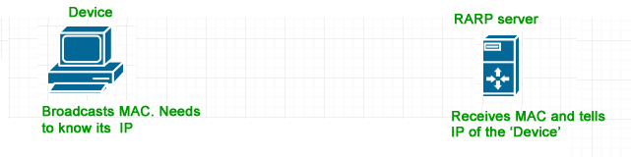

A special host configured inside the local area network, called as RARP-server is responsible to reply for these kind of broadcast packets. Now the RARP server attempt to find out the entry in IP to MAC address mapping table. If any entry matches in table, RARP server send the response packet to the requesting device along with IP address.

* LAN technologies like Ethernet, Ethernet II, Token Ring and Fiber Distributed Data Interface (FDDI) support the Address Resolution Protocol.
* RARP is not being used in today’s networks. Because we have much great featured protocols like BOOTP (Bootstrap Protocol) and DHCP( Dynamic Host Configuration Protocol)