**CHAPTER 1**

**INTRODUCTION**

* 1. **AIM**

The scope of the project is to make easy interaction between the system and the user. The basic idea is to make the system recognize the users’ location and in turn respond with the news based on the location. The aim is to build a windows phone application based news reader through which people can read the headlines based on the location.

* 1. **PROBLEM STATEMENT**

The Location Based News Reader displays news based on the user’s location. It gets the user’s coordinates and detects the location, using which it displays news specific to that location. There are existing news readers which displays all the important news from all over the world. This can prove as a hindrance when the user needs news specific to a particular location, to know more about some local event. Our application aims to eliminate this hindrance, by providing filtered news using Really Simple Syndication (RSS) feeds. Additionally, the news reader has an option for providing news as speech output for visually impaired people.

* 1. **DESCRIPTION**

The Location Based News Reader is an application for the Windows Phone platform, specifically for the Windows Phone 8 OS and higher. The application initially asks the user permission to access the user’s location, to not infringe upon the user’s privacy. The coordinates of the user are obtained in the first page and location is detected using the coordinates. After obtaining the location, the user has four options in the application bar

1. To display the news.
2. To display the news categorically.
3. To give coordinates manually.
4. To display nearby places using map.

When the user selects the news option, the news specific to that location is obtained using RSS feeds and displayed. When the user selects the category option, the categorical news specific to that location is obtained using RSS feeds and displayed. When the user selects the manual option, the coordinates are obtained from the user, the location is detected using the coordinates and news is displayed specific to that location. When the user selects the nearby option, a map is displayed pointing to the user’s current location. In the news page, there is an additional provision to output the news in speech format. This helps visually impaired people to know the news. The RSS feeds are obtained from various news websites. In the manual input page, again there is an application bar with options to display the news and category wise news.

**CHAPTER 2**

**LITERATURE SURVEY**

**2.1 EXISTING SYSTEM**

In the existing system, RSS feeds are obtained on location basis and are parsed to obtain the news for the mobile users. RSS feeds are fetched from the pre stored URLs of the popular news providing Web services and location is tracked with the help of GPS in the mobile. The overview of the proposed system is, a category is assigned to each RSS news item using text categorization techniques; Geolocation data is assigned to each RSS news item using Geoparsing techniques. News items are indexed by category and Geolocation are stored in the server repository. The client application can request news items from the web service by sending its Geolocation data and the desired category of news items. The proposed web service delivers location- based, categorized news items. The client is a mobile application which requests the web service to provide specific news items based on predefined categories and Geolocation of the client; the retrieved items are displayed on a user-friendly interface.

**2.1.1 DISADVANTAGES**

Currently, the prototype only delivers sports, politics and science news; however, it can be improved by further categorizing news items into sub-categories, for example, sports can be sub-categorized into cricket, football, formula one, golf and horse racing. The prototype filters the results by country; however, more specific geolocation is also feasible. The fineness of the geolocation will result in fewer news items being selected which might not be advantageous. Also the news is displayed as a mere text which would be a drawback for visually impaired people.

**2.2 PROPOSED SYSTEM**

Referring the existing system, some major enhancements are done in this project. The received RSS feeds are parsed to get the news content and this content is shown in the form of text. Also, Speech synthesis is done for visually impaired people. In addition to news alerts, this project concentrates in providing information about the user’s nearby places of interest like hotels, colleges , schools ,restaurants etc within a specified range. User’s location is shown in the map with the help of a pushpin and he/she can find the route to the destination of his/her choice. The news items can also be shared with friends via SMS or it can be uploaded in social networking sites like Facebook, Twitter etc.

**2.2.1 ADVANTAGES**

Speech Synthesis is done, which would help visually impaired/uneducated people to know about the latest news. The current location is shown in the map with pushpin which would help to know the exact location of the user. Newbie to an unknown location can find his/her nearby places of interest. Provides exact route between source and destination given by user. Covers wide range of sub-categories of news feeds like business, sports, entertainment, education etc. Also, news can be shared via SMS and can be uploaded in social networking sites.

**CHAPTER 3**

**SYSTEM ANALYSIS**

**3.1 FEASIBILITY STUDY**

The main objective of feasibility study is to test the Technical, operational and economical for adding new modules and debugging old running system. All system is feasible for adding new modules and debugging old running system.

There are aspects in the feasibility study portion of the preliminary investigation:

* Technical feasibility
* Economic feasibility
* Operational feasibility

**3.1.1 TECHNICAL FEASIBILITY**

This study is carried out to check the technical feasibility, that is, the technical requirements of the system. The only technical requirement needed for this project is Windows Phone. The requirements here are very modest because the system here supports very basic Windows Phone which is 8 and above.

So, this system is technically feasible because it needs only Windows Phone with a basic version.

**3.1.2 ECONOMIC FEASIBILITY**

Economic feasibility is the most frequently used method for evaluating the effectiveness of the proposed system. More commonly known as cost-benefit analysis, the procedure that costs for a proposed system and weights them against the tangible and intangible benefits of the system. The system is cost effective because it is freely available as windows phone application and can be downloaded at free of cost from the internet.

The system is economically feasible because the users can freely download and install the application on their phones and can run it.

Needs Analysis

Initial Screening

Market and Demand Analysis

Impact Assessment

Financial and Economic Analysis

Technical Analysis

Alternative Project

Analysis

Project Change Required

**Fig. 3.1 Feasibility Analysis**

**3.1.3 OPERATIONAL FEASIBILITY**

The aspect of the study is to check the level of acceptance of the system by the user. This includes the process of training the user to use the system efficiently. This system will not threaten the user instead it is friendly in its operation. All the user needs to have is an Internet connection provided to his mobile. The system is operationally feasible because the user can run the application just by clicking on the icon present there and then continue reading the local headlines.

**3.2 HARDWARE USED**

* System    :   Core I3 processor
* Hard Disk  :   100 GB
* Ram    :   2 GB
* Graphics : 1 GB Radeon
* Device : Windows phone 8 device

**3.3 SOFTWARE USED**

* Operating system   : Windows 8 pro 64-bit
* SDK : Microsoft Visual Studio 2012
* Coding Language  : C#,XAML
* Front End Tool : XAML
* Emulator : Windows phone 8 SDK

**CHAPTER 4**

**DETAILED DESIGN**

**4.1 SYSTEM ARCHITECTURE**

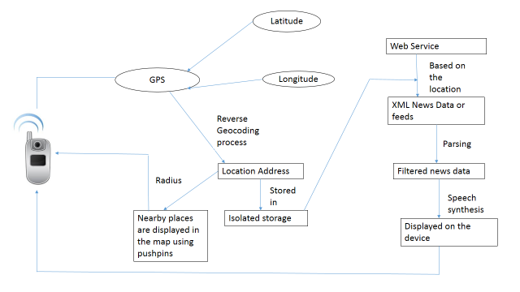

**Fig 4.1: System Architecture of Geocoding**

**4.2 DATA FLOW DIAGRAM**

**4.2.1 LEVEL 0**

Reverse GeoCoding process

Positional data in XML format

Absolute location is obtained

Latitude

Longitude

Parsing

**Fig 4.2: Level 0**

**4.2.2 LEVEL 1**

Web Service

(XML format)

Downloading news data

News data in XML format is obtained

Parsing

Extracted news data

**Fig 4.3: Level 1**

**4.2.3 LEVEL 2**

Speech synthesis

Filtered news based on categories, sub-categories and user’s location

News feeds

User Location

Filtering

**Fig 4.4: Level 2**

**4.2.4 LEVEL 3**

Automatic search for user’s location

Landmarks are displayed using pushpin

Manual search

Displays landmarks within a certain radius

**Fig 4.5: Level 3**

**4.2.5 LEVEL 4:**

Sharing the news via SMS

News

Sharing the news via SMS

**Fig 4.6: Level 4**

**4.3 UML DIAGRAMS**

The Unified Modelling Language (UML) is a general purpose modelling language in the field of software engineering. The basic level provides a set of graphic notation techniques to create visual methods of object-oriented software-intensive systems. Object-oriented analysis and design (OOAD) is a software engineering approach that models a system as a group of interacting objects.

**4.3.1 USE CASE DIAGRAM**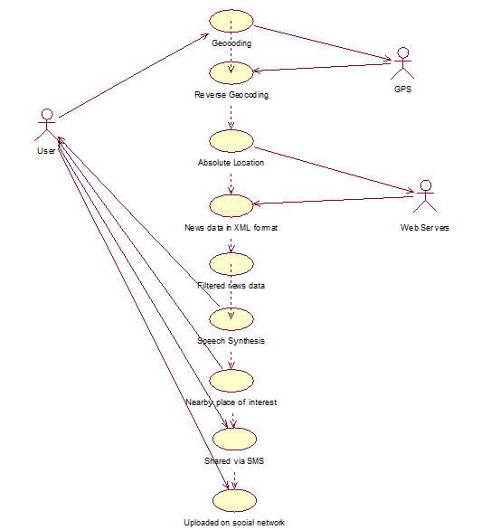

**Fig 4.7: Use Case Diagram**

Use case describe the interaction between one or more actors and the system itself, represented as a sequence of simple steps that take part in a sequence of activities in a dialog with the system to achieve goal.

There are three actors who are user, gps and web server necessary to run the application. The various functions of these actors like storing, entering, updating and retrieving the details are represented through use cases.

* + 1. **SEQUENCE DIAGRAM**

A Sequence diagram is an interaction diagram that shows how processes operate with one another and what is their order. It is a construct of a Message Sequence Chart. A sequence diagram shows object interactions arranged in time sequence. It depicts the objects and classes involved in the scenario and the sequence of messages exchanged between the objects needed to carry out the functionality of the scenario. Sequence diagrams are typically associated with use case realizations in the Logical View of the system under development. Sequence diagrams are sometimes called event diagrams or event scenarios.

A Sequence diagram shows, as parallel vertical lines different processes or objects that live simultaneously, and, as horizontal arrows, the messages exchanged between them, in the order in which they occur. This allows the specification of simple runtime scenarios in a graphical manner.

The actions such as entering the details, storing and so on are expressed in a sequential order through vertical lines. The exchange of data between the actors(user, system and database) are represented by a set of horizontal lines.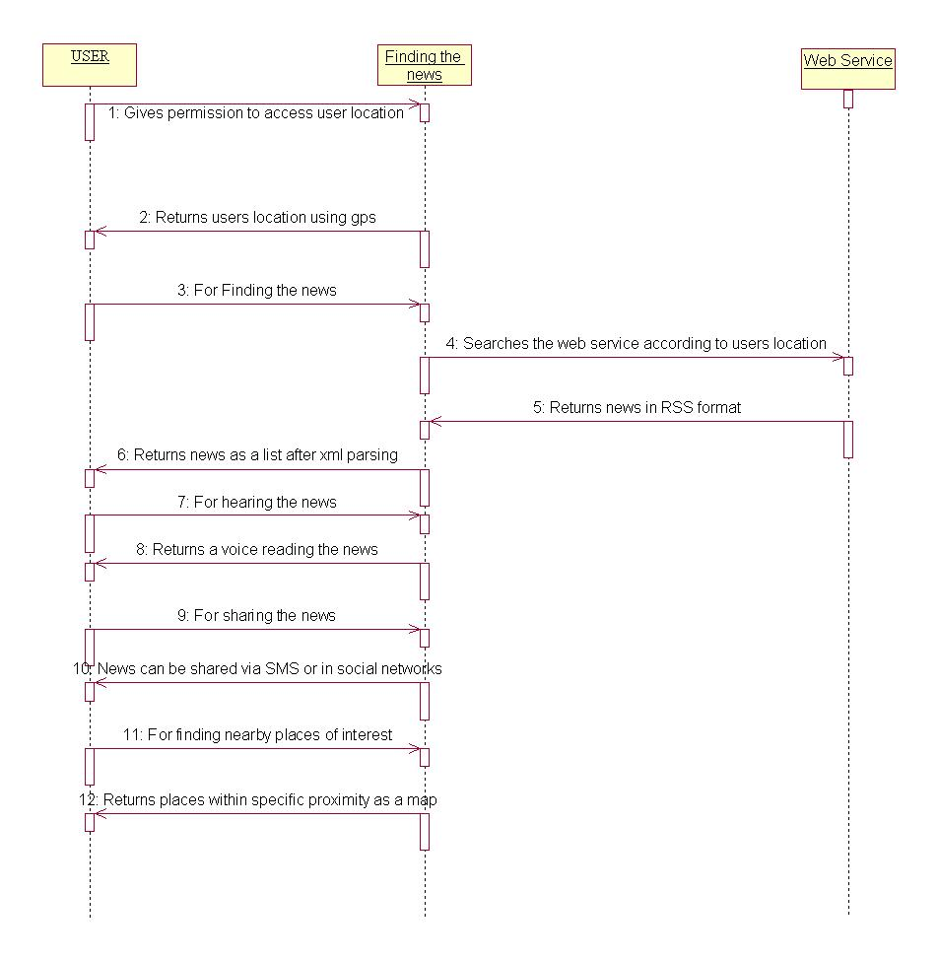

**Fig 4.8: Sequence Diagram**

**4.3.3 ACTIVITY DIAGRAM**

Activity diagram are graphical representation of workflows of stepwise activities and actions with support for choice, iteration and concurrency. In the Unified Modelling Language, activity diagrams can be used to describe the business and operational step-by-step workflows of components in a system. An activity diagram shows the overall flow of control.

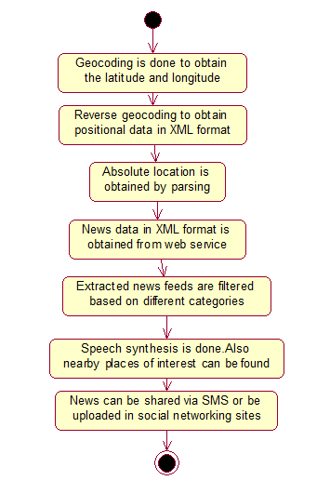

**Fig 4.9: Activity Diagram**

The set of activities that takes place among the actors is represented through activity diagram. It has a start and stop state which indicates the user to start and stop the activity respectively. The sequence of activities are represented through arrow marks.

**4.3.4 COLLABORATION DIAGRAM**

A Collaboration diagram is easily represented by modelling objects in a system and representing the association between the objects as links. The interaction between the objects is denoted by arrows. To identify the sequence of invocation of these objects, a number is placed next to each of arrows.

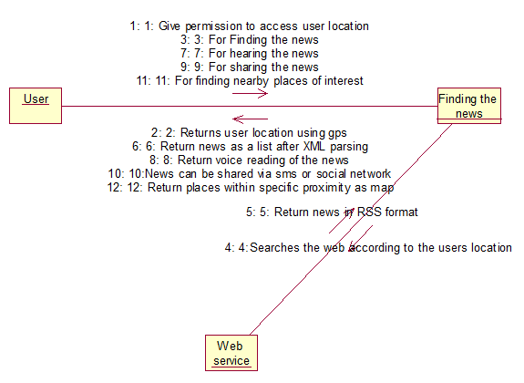

**Fig 4.10: Collaboration Diagram**

According to the sequence diagram drawn, an automatic collaboration diagram would be generated which again indicates the relationship among the actors.

**4.3.5 CLASS DIAGRAM**

Class Diagram provides an overview of the target system by describing the objects and classes inside the system and the relationships between them. It provides a wide variety of usages; from modelling the domain-specific data structure to detailed design of the target system. With the share model facilities, you can reuse your class model in the interaction diagram for modelling the detailed design of the dynamic behaviour. The Form Diagram allows you to generate diagram automatically with user-defined scope.

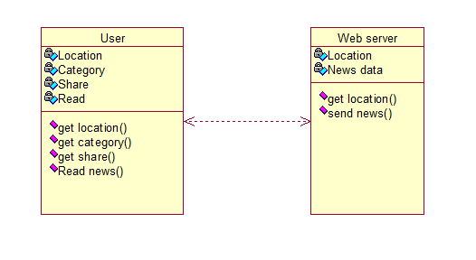

**Fig 4.11: Class Diagram**

Class diagram describes the attributes and operations of different actors.

Eg: For actor user the attributes are name, gender, source and destination and the operations are entering the details and payment.

**CHAPTER 5**

**IMPLEMENTATION AND TESTING**

**5.1 IMPLEMENTATION**

This project deals with interactionbetween the user and the system through GPS to read the local headlines. It is an windows phone based application. The very beginning step of our project is to obtain the current location of the user based on the GPS data. The data obtained from the user is sent to the web server to fetch the headlines based on the location. This is done by looking up the RSS feed for the specific location of the user. Once this process is completed the user can go to the next page using “news” button where the user is provided with a list of top headlines for the specific location of the user.

When the user clicks the ‘category’ icon the system will display the user’s available categories which the user has to select by clicking the needed category button. The system recognizes the user’s choice and searches the web for the respective RSS feed. The list of headlines based on the users choice is displayed. Next, the system will display the option for sharing and reading the news. If the user selects the sharing option two choices are provided for sharing on social media and by MMS. The system offers the option of reading the headlines off the screen. The user has to select the ‘read news’ button from the options menu on the bottom of the screen.

**5.1.1 GEOCODING**

**Geocoding** is the process of finding associated geographic coordinates (often expressed as latitude and longitude) from other geographic data, such as street addresses, or ZIP codes (postal codes). With geographic coordinates the features can be mapped and entered into Geographic Information Systems, or the coordinates can be embedded into media such as digital photographs via geotagging.

In this module, the latitude and longitude are obtained using the GPS. These values are stored in the form of strings for further usage. The default or current location of the user is obtained in this process.

**5.1.2 REVERSE GEOCODING**

**Reverse geocoding** is the process of back (reverse) coding of a point location (latitude, longitude) to a readable address or place name. This permits the identification of nearby street addresses, places, and/or area subdivisions such as neighborhoods, county, state, or country. Combined with geocoding and routing services, reverse geocoding is a critical component of mobile location-based services and Enhanced 911 to convert a coordinate obtained by GPS to a readable street address which is easier to understand by the end user.

Reverse geocoding can be carried out systematically by services which process a coordinate similarly to the geocoding process. For example, when a GPS coordinate is entered the street address is interpolated from a range assigned to the road segment in a reference dataset that the point is nearest to. If the user provides a coordinate near the midpoint of a segment that starts with address 1 and ends with 100, the returned street address will be somewhere near 50. This approach to reverse geocoding does not return actual addresses, only estimates of what should be there based on the predetermined range. Alternatively, coordinates for reverse geocoding can also be selected on an interactive map, or extracted from static maps by [georeferencing](http://en.wikipedia.org/wiki/Georeference" \o "Georeference) them in a GIS with predefined spatial layers to determine the coordinates of a displayed point. Many of the same limitations of geocoding are similar with reverse geocoding.

In this module, the reverse geocoding process is done in order to convert the latitude and longitude into positional data in XML format. This data is further parsed to obtain the absolute location of the user. Parsing is done in order to remove unwanted data from the XML format.

**5.1.3 OBTAINING NEWS FROM RSS FEEDS**

RSS stands for Really Simple Syndication. It enables publishers to syndicate data automatically. A standard XML file format ensures compatibility with many different machines/programs. RSS feeds also benefit users who want to receive timely updates from favorite websites or to aggregate data from many sites.

Subscribing to a website RSS removes the need for the user to manually check the web site for new content. Instead, their browser constantly monitors the site and informs the user of any updates. The browser can also be commanded to automatically download the new data for the user.

Each web service provides RSS feeds in XML format. These are downloaded and now the news data is obtained in the XML format. Further, parsing is done in order to obtain the extracted news data.

**5.1.4 MAPPING NEWS FEED TO USER LOCATION**

As mentioned earlier the user’s location is obtained using the Geocoding and the reverse Geocoding process. Simultaneously the news data is obtained from RSS feeds which are parsed to result in the extracted news data.

Now, the user location and the extracted news data are filtered based on the categories such as business, sports, entertainment etc. These are further divided into sub-categories like cricket, football , formula one, basketball etc in the field of sports and so on. Additional sub-categories such as Top rated, most shared, most viewed, most recent etc are also provided.

In order to aid the visually impaired people, Speech synthesizer API is used to perform speech synthesis to read out the text.

**5.1.5 LOCATING NEARBY PLACES OF INTEREST**

This application not only provides filtered news based on the location but also has an additional feature i.e, nearby places of interest can be found. The automatic search for the user’s location enables it to search for the nearby places. Based on the user’s current location it displays the landmarks within the specified radius. The nearby places locating feature is really helpful for people who are new to a certain area. For better clarity the exact location of the user is shown in the form of a pushpin. The locations of the nearby places of interest are also displayed in the map. The route to the specified destination is also provided.

**5.1.6 SHARING THE NEWS**

The filtered news item can be shared with friends and other social circles. The extracted news item is converted into mere text and it can be shared via SMS. This will help the people who do not possess a Windows Phone 8.The news data can also be uploaded in social networking sites such as Facebook and Twitter. This feature shows the flexibility of this application as the news can be shared with everyone.

**5.2 TESTING**

Testing is an important phase that focuses on an empirical investigation in which the results describe the quality of the system. It cannot confirm system functions properly under all conditions but can establish that it fails under specific conditions. The prime purpose of testing is to guarantee that system successfully built and tested in the development phase meets all the requirements and design parameters.

TEST PLANNING

TEST ANALYSIS

TEST CASE IDENTIFICATION

TEST EXECUTION

FINAL TESTING

IMPLEMENTATION

**Fig 5.1 Process of Testing**

**5.2.1 UNIT TESTING**

**MAIN PAGE TESTING:**

The main page of the application is the page where the user obtains the current location by using GPS.

Table 5.1 Main

|  |  |  |  |  |
| --- | --- | --- | --- | --- |
| **No** | **Test Case** | **Expected Output** | **Observed Output** | **Result** |
| 1 | User clicks in the ‘Get Location’ button | Current location should be displayed | Current location is displayed | Pass |
| 2 | User clicks in the ‘Get Location’ button without GPS | Error message should be displayed | Error message is displayed | Pass |

**NEWS PAGE TESTING:**

News page is the page displaying the news when the news button is displayed.

Table 5.2 News

|  |  |  |  |  |
| --- | --- | --- | --- | --- |
| **No** | **Test Case** | **Expected Output** | **Observed Output** | **Result** |
| 1 | User clicks on the news button | News should be displayed | News is displayed | Pass |
| 2 | User clicks on the news button without internet | Error message should be displayed | Error message is displayed | Pass |

**CATEGORY PAGE TESTING:**

The category page is the application page where the user selects a specific category from the various categories displayed.

Table 5.3 Category

|  |  |  |  |  |
| --- | --- | --- | --- | --- |
| **No** | **Test Case** | **Expected Output** | **Observed Output** | **Result** |
| 1 | User clicks on the category news button | News based on the category should be displayed | News based on the category is displayed | Pass |
| 2 | User clicks on the category news button without internet | Error message should be displayed | Error message is displayed | Pass |

**5.2.2 INTEGRATION TESTING:**

Integration testing checks whether the application integrates well with the social media and SMS sharing services.

Table 5.4 Integration testing

|  |  |  |  |  |
| --- | --- | --- | --- | --- |
| **No** | **Test Case** | **Expected Output** | **Observed Output** | **Result** |
| 1 | News display is successful | Should be able to share the news | News can be shared | Pass |
| 2 | News display is unsuccessful | An error message should be displayed | An error message is displayed and cannot share the news | Pass |

**5.2.3 FUNCTIONAL TESTING:**

Functional testing checks whether the there is correct exchange of data between the windows phone application and the web server.

Table 5.5 Functional Testing

|  |  |  |  |  |
| --- | --- | --- | --- | --- |
| **No** | **Test Case** | **Expected Output** | **Observed Output** | **Result** |
| 1 | Required details are sent to the server | News should be collected and displayed | News is collected and displayed | Pass |
| 2 | Device is not connected to the internet and details cannot be sent | An error message should be displayed | Error message is displayed | Pass |

**5.2.4 ACCEPTANCE TESTING**

Acceptance testing checks whether the windows phone application responds correspondingly when the location is valid and when it is invalid.

Table 5.6 Acceptance Testing

|  |  |  |  |  |
| --- | --- | --- | --- | --- |
| **No** | **Test Case** | **Expected Output** | **Observed Output** | **Result** |
| 1 | Current location is valid | News should be displayed | News is displayed | Pass |
| 2 | Current location is not valid | An error message should be displayed | Error message is displayed | Pass |

**5.3 TEST PLAN**

The project is tested to verify its correctness and identify the bugs. The test plan includes the various test cases that acts as the set of conditions or variables that determine whether the corresponding feature in the system is working as it originally established to do so. When this test plan is executed, the errors spotted are rectified and the final testing yields following result.

**5.4 TEST ANALYSIS**

In this phase of testing, the requirements for software testing are analysed and later its feasibility is determined. In the feasibility study the possibility of project development is found through suitable test cases.

**5.5 RESULT**

The application is tested and found to function as expected with no errors. This application provides an interface for the users to read the headlines based on the users location.

**CHAPTER 6**

**CONCLUSION AND FUTURE ENHANCEMENT**

**6.1 CONCLUSION**

The mobile users are increasing at a steady rate and this location based geo feed will certainly help them in getting updated about the latest news. The sub-categories provided for the news items will ensure faster and a more organized viewing. The additional facility of being able to share the news item will enable the user to share the news with whomsoever he/she likes via SMS or Social Networking sites. Also to know about a particular location or to find nearby places of interest, this project would certainly be of utmost utility.

**6.2 FUTURE ENHANCEMENT**

In future, we would like to add features to enhance the news feeds. We would like to add more sub-categories and provide an option for the user to save the obtained news feed to a particular date, so that he can retrieve the news in offline mode for later use. Also, we are planning to provide options for the user to choose voice and language of his/her choice. Since for sending the news via SMS, one should have a working SMS plan, we are trying to save the news as a file and send the same using Bluetooth technology, which makes it easy as it reduces the cost of sending an SMS. We would also like to bring changes in the design of the project to make it more user friendly and bring in better user experience.

**APPENDIX-A**

**SAMPLE SOURCE CODE**

**GEOCODING:**

using System;

using System.Collections.Generic;

using System.Linq;

using System.Net;

using System.Windows;

using System.Windows.Controls;

using System.Windows.Navigation;

using Microsoft.Phone.Controls;

using Microsoft.Phone.Shell;

using sdkLocationWP8CS.Resources;

using System.Threading.Tasks;

using Windows.Devices.Geolocation;

using System.IO.IsolatedStorage;

using Microsoft.Phone.Maps.Services;

using System.Device.Location;

using System.Xml.Linq;

public class GraphGen extends HttpServlet {

private async void OneShotLocation_Click(object sender, RoutedEventArgs e)

{

this.busy.IsRunning = true;

istrue = true;

if ((bool)IsolatedStorageSettings.ApplicationSettings["LocationConsent"] != true)

{

// The user has opted out of Location.

StatusTextBlock.Text = "You have opted out of location. Use the app bar to turn location back on";

return;

}

Geolocator geolocator = new Geolocator();

geolocator.DesiredAccuracyInMeters = 50;

try

{

// Request the current position

Geoposition geoposition = await geolocator.GetGeopositionAsync(

maximumAge: TimeSpan.FromMinutes(5),

timeout: TimeSpan.FromSeconds(10)

);

LatitudeTextBlock.Text= geoposition.Coordinate.Latitude.ToString("0.00");

LongitudeTextBlock.Text= = geoposition.Coordinate.Longitude.ToString("0.00");

busy.Visibility = Visibility.Collapsed;

lati.Visibility = Visibility.Visible;

longi.Visibility = Visibility.Visible;

status.Visibility = Visibility.Visible;

lat = Convert.ToDouble(LatitudeTextBlock.Text);

lon = Convert.ToDouble(LongitudeTextBlock.Text);

StatusTextBlock.Text = "location obtained";

getaddress();

}

catch (Exception ex)

{

if ((uint)ex.HResult == 0x80004004)

{

// the application does not have the right capability or the location master switch is off

StatusTextBlock.Text = "location is disabled in phone settings.";

}

//else

{

// something else happened acquring the location

}

}

}

**REVERSEGEOCODING:**

using System;

using System.Collections.Generic;

using System.Linq;

using System.Net;

using System.Windows;

using System.Windows.Controls;

using System.Windows.Navigation;

using Microsoft.Phone.Controls;

using Microsoft.Phone.Shell;

using sdkLocationWP8CS.Resources;

using System.Threading.Tasks;

using Windows.Devices.Geolocation;

using System.IO.IsolatedStorage;

using Microsoft.Phone.Maps.Services;

using System.Device.Location;

using System.Xml.Linq;

public void getaddress()

{

List<MapLocation> locations;

ReverseGeocodeQuery query = new ReverseGeocodeQuery();

query.GeoCoordinate = new GeoCoordinate(lat, lon);

query.QueryCompleted += (s, e) =>

{

if (e.Error == null && e.Result.Count > 0)

{

locations = e.Result as List<MapLocation>;

MapAddress address = e.Result[0].Information.Address;

addr.Text = "Current Location: " + address.City + "," + address.State+","+address.Country;

citi = address.City;

IsolatedStorageSettings.ApplicationSettings["city"] = citi;

IsolatedStorageSettings.ApplicationSettings["state"] = address.State;

IsolatedStorageSettings.ApplicationSettings["nation"]= address.Country;

IsolatedStorageSettings.ApplicationSettings["continent"]= address.Continent;

}

};

query.QueryAsync();

//mail.IsEnabled = false;

}

**OBTAINING NEWS DATA FROM RSS FEEDS AND MAPPING TO USER LOCATION:**

using System;

using System.Collections.Generic;

using System.Linq;

using System.Net;

using System.Windows;

using System.Windows.Controls;

using System.Windows.Navigation;

using Microsoft.Phone.Controls;

using Microsoft.Phone.Shell;

using System.Xml.Linq;

using System.IO.IsolatedStorage;

using Windows.Phone.Speech.Synthesis;

string city;

bool citifound;

string state;

string country;

public void initi()

{

if (isNetAvailable())

{

deflis.Items.Clear();

country = (string)IsolatedStorageSettings.ApplicationSettings["nation"];

city = (string)IsolatedStorageSettings.ApplicationSettings["city"];

if (country == "India")

{

if (city == "Chennai" || city == "Mumbai" || city == "Delhi" || city == "Bengaluru" || city == "Hyderabad" || city == "Ahmedabad" || city == "Thiruvananthapuram" || city == "Thane" || city == "Kolkata" || city == "Patna" || city == "Pune" || city == "Goa" || city == "Chandigarh" || city == "Lucknow" || city == "Jaipur" || city == "Nagpur" || city == "Ranchi" || city == "Allahabad" || city == "Bhubaneshwar" || city == "Coimbatore" || city == "Gurgaon" || city == "Guwahati" || city == "Hubli" || city == "Kanpur" || city == "Ludhiana" || city == "Mangalore" || city == "Mysore" || city == "Noida" || city == "Rajkot" || city == "Surat" || city == "Vadodara" || city == "Varanasi" || city == "Kochi" || city == "Kozhikode" || city == "Madurai" || city == "Tiruchirappalli" || city == "Visakhapatnam" || city == "Vijayawada")

{

citifound = true;

switch (city)

{

case "Chennai":

url="http://timesofindia.feedsportal.com/c/33039/f/533979/index.rss";

break;

case "Mumbai":

url="http://timesofindia.feedsportal.com/c/33039/f/533975/index.rss";

break;

case "NewDelhi":

url="http://timesofindia.feedsportal.com/c/33039/f/533976/index.rss";

break;

case "Bengaluru":

url="http://timesofindia.feedsportal.com/c/33039/f/533977/index.rss";

break;

case "Hyderabad":

url="http://timesofindia.feedsportal.com/c/33039/f/533978/index.rss";

break;

case "Ahmedabad":

url="http://timesofindia.feedsportal.com/c/33039/f/533980/index.rss";

break;

case "Thiruvananthapuram":

url="http://timesofindia.feedsportal.com/c/33039/f/533990/index.rss";

break;

case "Thane":

url="http://timesofindia.feedsportal.com/c/33039/f/533989/index.rss";

break;

case "Kolkata":

url="http://timesofindia.feedsportal.com/c/33039/f/533979/index.rss";

break;

case "Pune":

url="http://timesofindia.feedsportal.com/c/33039/f/533975/index.rss";

break;

case "Patna":

url="http://timesofindia.feedsportal.com/c/33039/f/533976/index.rss";

break;

case "Goa":

url="http://timesofindia.feedsportal.com/c/33039/f/533977/index.rss";

break;

case "Chandigarh":

url="http://timesofindia.feedsportal.com/c/33039/f/533978/index.rss";

break;

case "Lucknow":

url="http://timesofindia.feedsportal.com/c/33039/f/533980/index.rss";

break;

case "Jaipur":

url="http://timesofindia.feedsportal.com/c/33039/f/533990/index.rss";

break;

case "Nagpur":

url="http://timesofindia.feedsportal.com/c/33039/f/533989/index.rss";

break;

case "Ranchi":

url="http://timesofindia.indiatimes.com/rssfeeds/4118245.cms";

break;

case "Allahabad":

url="http://timesofindia.indiatimes.com/rssfeeds/3947060.cms";

break;

case "Bhubaneshwar":

url="http://timesofindia.indiatimes.com/rssfeeds/4118235.cms";

break;

case "Coimbatore":

url="http://timesofindia.indiatimes.com/rssfeeds/7503091.cms";

break;

case "Gurgaon":

url="http://timesofindia.indiatimes.com/rssfeeds/6547154.cms";

break;

case "Guwahati":

url="http://timesofindia.indiatimes.com/rssfeeds/4118215.cms";

break;

case "Hubli":

url="http://timesofindia.indiatimes.com/rssfeeds/3942695.cms";

break;

case "Kanpur":

url="http://timesofindia.indiatimes.com/rssfeeds/3947067.cms";

break;

case "Ludhiana":

url="http://timesofindia.indiatimes.com/rssfeeds/3947051.cms";

break;

case "Mangalore":

url="http://timesofindia.indiatimes.com/rssfeeds/3942690.cms";

break;

case "Mysore":

url="http://timesofindia.indiatimes.com/rssfeeds/3942693.cms";

break;

case "Noida":

url="http://timesofindia.indiatimes.com/rssfeeds/8021716.cms";

break;

case "Rajkot":

url="http://timesofindia.indiatimes.com/rssfeeds/3942663.cms";

break;

case "Surat":

url="http://timesofindia.indiatimes.com/rssfeeds/3942660.cms";

break;

case "Vadodara":

url="http://timesofindia.indiatimes.com/rssfeeds/3942666.cms";

break;

case "Varanasi":

url="http://timesofindia.indiatimes.com/rssfeeds/3947071.cms";

break;

case "Kochi":

url="http://www.thehindu.com/news/cities/Kochi/?service=rss";

break;

case "Kozhikode":

url="http://www.thehindu.com/news/cities/kozhikode/?service=rss";

break;

case "Madurai":

url="http://www.thehindu.com/news/cities/Madurai/?service=rss";

break;

case "Tiruchirappalli":

url="http://www.thehindu.com/news/cities/Tiruchirapalli/?service=rss";

break;

case "Vijayawada":

url="http://www.thehindu.com/news/cities/Vijayawada/?service=rss";

break;

case "Visakhapatnam":

url="http://www.thehindu.com/news/cities/Visakhapatnam/?service=rss";

break;

}

}

else

{

state = (string)IsolatedStorageSettings.ApplicationSettings["state"];

switch (state)

{

case "Maharashtra":

url="http://timesofindia.feedsportal.com/c/33039/f/533975/index.rss";

break;

case "Delhi":

url="http://timesofindia.feedsportal.com/c/33039/f/533976/index.rss";

break;

case "Karnataka":

url="http://timesofindia.feedsportal.com/c/33039/f/533977/index.rss";

break;

case "Andhra Pradesh":

url="http://timesofindia.feedsportal.com/c/33039/f/533978/index.rss";

break;

case "Tamil Nadu":

url="http://timesofindia.feedsportal.com/c/33039/f/533979/index.rss";

break;

case "Gujarat":

url="http://timesofindia.feedsportal.com/c/33039/f/533980/index.rss";

break;

case "Kerala":

url="http://timesofindia.feedsportal.com/c/33039/f/533990/index.rss";

break;

case "West Bengal":

uri="http://timesofindia.feedsportal.com/c/33039/f/533981/index.rss";

break;

case "Bihar":

url="http://timesofindia.feedsportal.com/c/33039/f/533986/index.rss";

break;

case "Punjab":

url="http://timesofindia.feedsportal.com/c/33039/f/533984/index.rss";

break;

case "UttarPradesh":

url="http://timesofindia.feedsportal.com/c/33039/f/533985/index.rss";

break;

case "Rajasthan":

url="http://timesofindia.feedsportal.com/c/33039/f/533987/index.rss";

break;

case "Jharkhand":

url="http://timesofindia.indiatimes.com/rssfeeds/4118245.cms";

break;

case "Orissa":

url="http://timesofindia.indiatimes.com/rssfeeds/4118235.cms";

break;

case "Haryana":

url="http://timesofindia.indiatimes.com/rssfeeds/6547154.cms";

break;

case "Assam":

url="http://timesofindia.indiatimes.com/rssfeeds/4118215.cms";

break;

default:

url="http://www.thehindu.com/news/national/other-states/?service=rss";

break;

}

}

}

else

{

if (country == "US")

{

url="http://timesofindia.feedsportal.com/c/33039/f/533991/index.rss";

}

if (country == "Pakistan")

{

url="http://timesofindia.feedsportal.com/c/33039/f/533992/index.rss";

}

if (country == "SouthAsia")

{

url="http://timesofindia.feedsportal.com/c/33039/f/533993/index.rss";

}

if (country == "UK")

{

url="http://timesofindia.feedsportal.com/c/33039/f/533994/index.rss";

}

if (country == "Europe")

{

url="http://timesofindia.feedsportal.com/c/33039/f/533991/index.rss";

}

if (country == "China")

{

url="http://timesofindia.feedsportal.com/c/33039/f/533992/index.rss";

}

if (country == "SouthAsia")

{

url="http://timesofindia.feedsportal.com/c/33039/f/533993/index.rss";

}

if (country == "UK")

{

url="http://timesofindia.feedsportal.com/c/33039/f/533994/index.rss";

}

}

WebClient client = new WebClient();

client.DownloadStringCompleted+=new DownloadStringCompletedEventHandler(webclient_RequestCompleted);

client.DownloadStringAsync(new Uri(url));

}

else

{

MessageBox.Show("Cannot be able to connect to internet.Check your network settings!");

}

}

private bool isNetAvailable()

{

return (Microsoft.Phone.Net.NetworkInformation.NetworkInterface.NetworkInterfaceType !=Microsoft.Phone.Net.NetworkInformation.NetworkInterfaceType.None);

}

public static string talktext;

private void webclient_RequestCompleted(object sender, DownloadStringCompletedEventArgs e)

{

try

{

if (e.Error != null)

return;

string str = e.Result;

deflis.Items.Clear();

XDocument doc = XDocument.Parse(e.Result, LoadOptions.None);

XElement generalElement = doc

.Element("rss").Element("channel");

if (!generalElement.IsEmpty)

{

var title = doc.Descendants("title").Select(x => x.Value).ToList();

//var definition = doc.Descendants("definition").Select(x => x.Value).ToList();

//var category = doc.Descendants("category").Select(x => x.Value).ToList();

talktext = string.Join(",", title.ToArray());

int count = title.Count;

// busy.Visibility = Visibility.Collapsed;

busy.Visibility = Visibility.Collapsed;

for (int a = 2; a < count; a++)

{

TextBlock tb = new TextBlock();

tb.FontSize = 30;

tb.TextWrapping = TextWrapping.Wrap;

tb.Text = "--> " + title[a] + "\n" ;

tb.Width = 390;

deflis.Items.Add(tb);

}

}

}

catch (NullReferenceException fg)

{

// busy.Visibility = Visibility.Collapsed;

MessageBox.Show("Sorry we couldnt find any news!");

}

catch (ArgumentOutOfRangeException rt)

{ }

}

**LOCATING NEARBY PLACES OF INTEREST:**

using System;

using System.Collections.Generic;

using System.Linq;

using System.Net;

using System.Windows;

using System.Windows.Controls;

using System.Windows.Navigation;

using Microsoft.Phone.Controls;

using Microsoft.Phone.Shell;

using Nokia.Phone.HereLaunchers;

public nearby()

{

InitializeComponent();

explore();

}

public void explore()

{

ExploremapsExplorePlacesTask searchMap = new ExploremapsExplorePlacesTask();

searchMap.Show();

}

**SHARING THE NEWS:**

private void sharelink_Click(object sender, EventArgs e)

{

ShareLinkTask shareLinkTask = new ShareLinkTask();

shareLinkTask.Title = "Chennai News";

shareLinkTask.LinkUri = new Uri("http://timesofindia.feedsportal.com/c/33039/f/533979/index.rss", UriKind.Absolute);

shareLinkTask.Message = talktext;

shareLinkTask.Show();

}

private void sharestatus_Click(object sender, EventArgs e)

{

//ShareStatusTask shareStatusTask = new ShareStatusTask();

//shareStatusTask.Status = talktext;

//shareStatusTask.Show();

SmsComposeTask smsComposeTask = new SmsComposeTask()

{

Body = talktext

};

smsComposeTask.Show();

}

**APPENDIX-B**

**SAMPLE SCREEN SHOTS**

**SPLASH SCREEN PAGE MAIN PAGE**

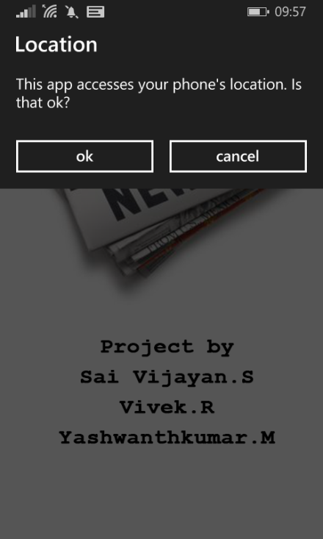 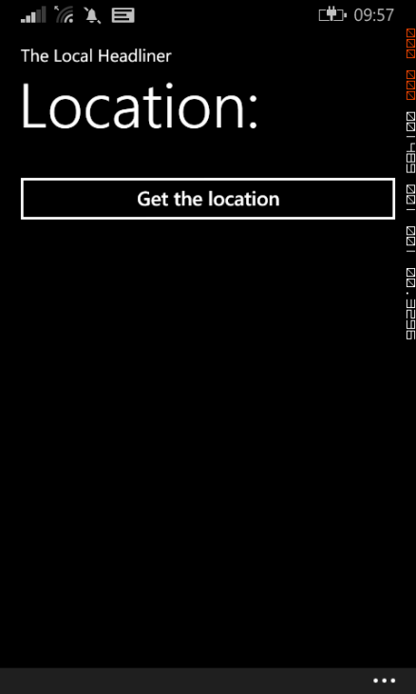

Splash Screen imageMain page to obtain

location

**Fig. B1: Splash Screen Image Fig. B2: Main Page**

**MAIN PAGE MAIN PAGE**

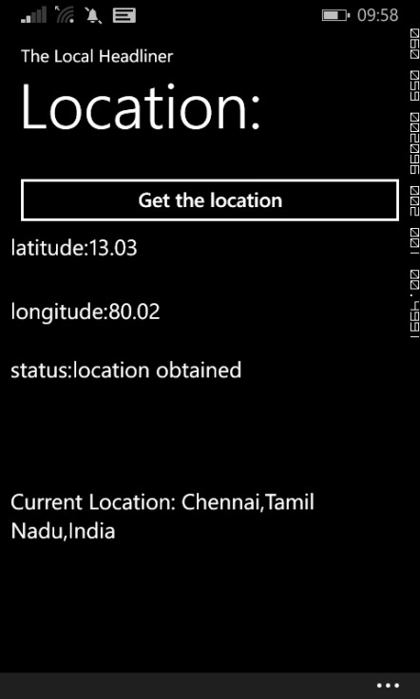 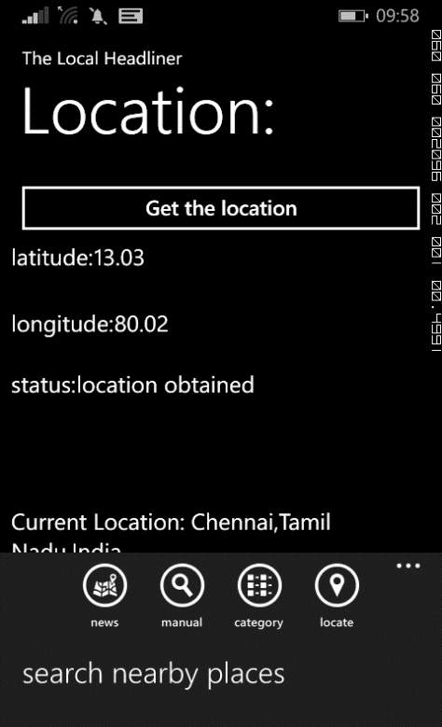

Main Page, when ‘get location’ button is clicked Main page displaying the app bar

**Fig. B3: Main page with location Fig. B4: Main page app bar**

**NEWS PAGE NEWS PAGE**

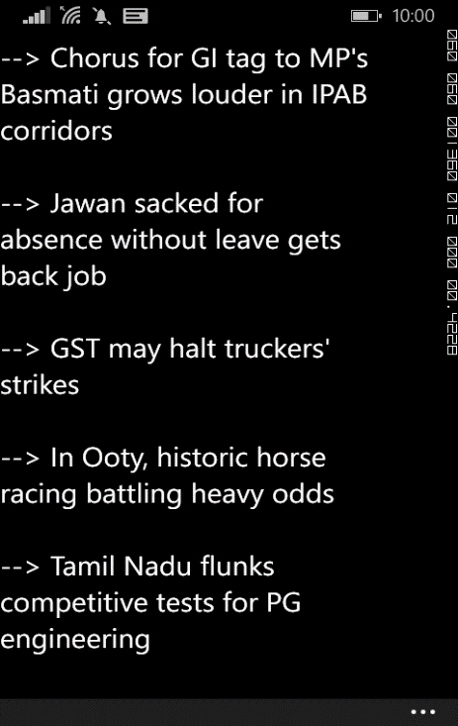 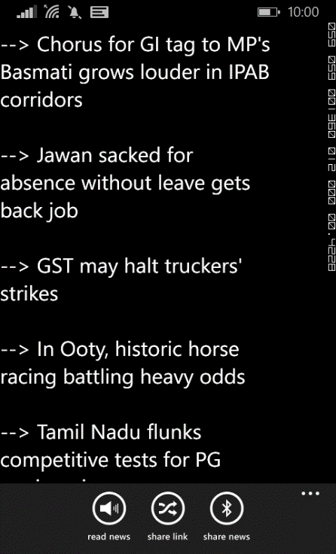

Navigation to News page, when ‘news’ News page displaying the app bar

button is clicked

**Fig. B5: News page Fig. B6: News page app bar**

**SHARE LINK PAGE SHARE NEWS PAGE**

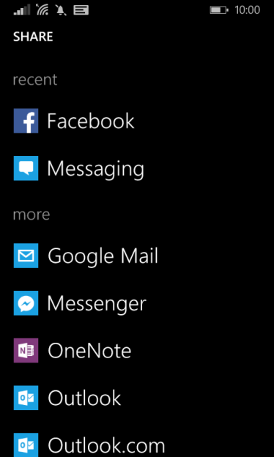 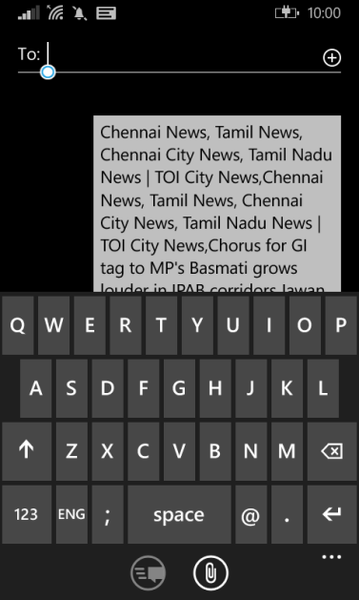

Navigation when ‘share link’ is clicked Navigation when ‘Share news’

is clicked

**Fig. B7: Sharing news via social media Fig. B8: Sharing news via SMS**

**MANUAL PAGE MANUAL PAGE**

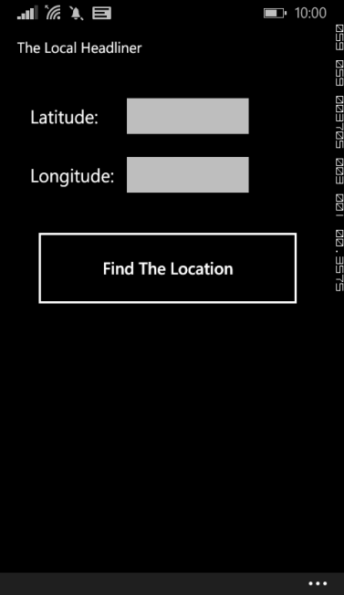 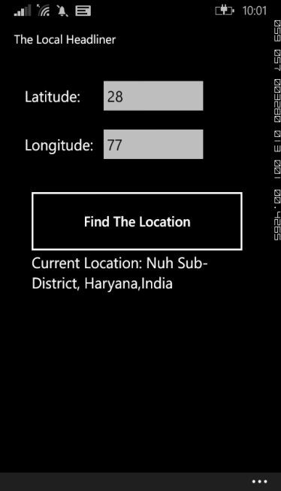

Navigation to manual page when Manual page when

manual button is clicked in main page location is obtained

**Fig. B9: Manual Location page Fig. B10: Manual location page**

**with location**

**NEWS PAGE CATEGORY PAGE**

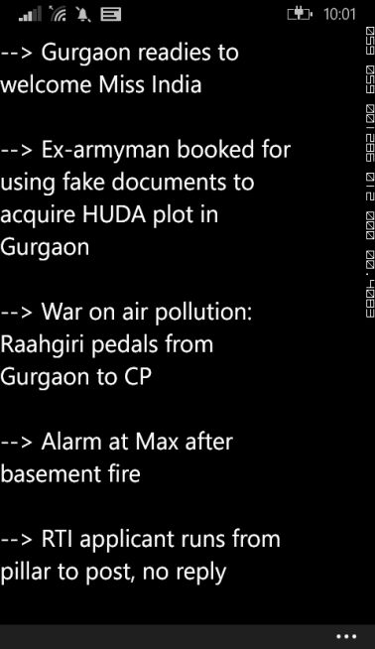 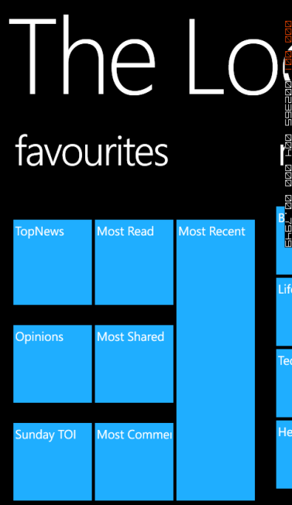

Navigation to News page from manual input Navigation when category button

is clicked in main page

**Fig. B11: News from manual allocation Fig. B12: Category page**

**CATEGORY PAGE MAP PAGE**

 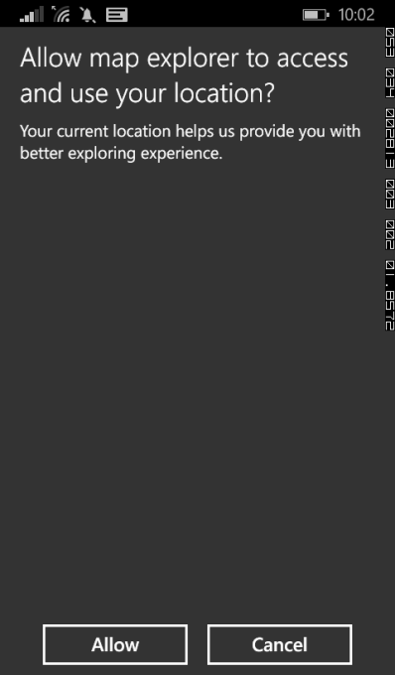

Category page displayed in panoramic view Navigation, when map button is

clicked in main page, to obtain

permission

**Fig. B13: Category page panoramic view Fig. B14: Map permission page**

**MAP PAGE MAP PAGE**

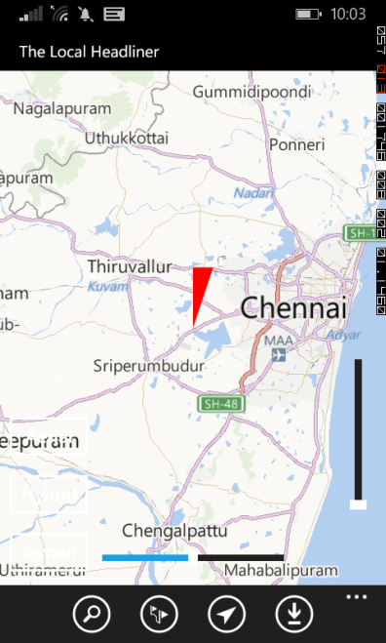 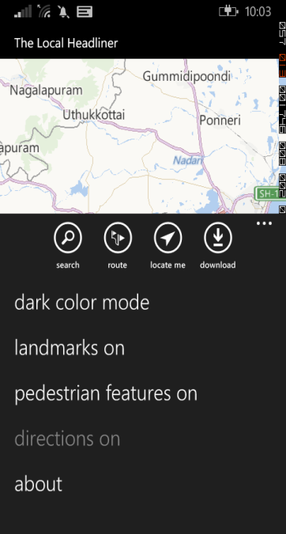

Map page after obtaining permission Map page with app bar

**Fig. B15: Map page Fig. B16: Map page app bar**

**REFERENCES**

[1] J. Grossnickle, T. Board, B. Pickens and M. Bellmont, RSS Crossing into the Mainstream, Yahoo White Paper, October 2005.

[2] R. R. Larson, Geographic Information Retrieval and Spatial Browsing, Smith, L., Gluck, M. (eds.) University of Illinois GIS and Libraries: Patrons, Maps and Spatial Information, pp. 81–124, 1996.

[3] Giles M. Foody, and Ajay Mathur, A Relative Evaluation of Multiclass Image Classification by Support Vector Machines, IEEE Transactions on Geoscience and Remote Sensing, Vol. 42, No. 6, June 2004.

[4] J. Cervantes, X. Li and W. Yu, Support Vector Classification for Large Data Sets by Reducing Training Data with Change of Classes, IEEE International Conference on Systems, Man and Cybernetics, 2008.

[5] G. Salton and C. Buckley, Term-weighting approaches in automatic text retrieval, Information Processing & Management, Volume 24, Issue 5, pp. 513–523, 1988.

[6] Y. Yang and X. Liu, An re-examination of text categorization, 22nd Annual International ACM SIGIR Conference on Research and Development in Information Retrieval, Berkeley, pp. 42-49, 1999.

[8] MSDN forums - Developing for Windows Phone (https://social.msdn.microsoft.com/forums/windowsapps/En-us/home?forum=wpdevelop)

[9] Community – Windows App Development (https://dev.windows.com/en-us/community)