**Output – Browser: Chrome**

|  |  |
| --- | --- |
| **Account Creation for valid credential:** | **Account Creation for Invalid credential:** |
|  |  |

|  |  |
| --- | --- |
| **SignIn with Valid credential:** | **SignIn with Invalid credential:** |
|  |  |

**Bottom Link validation:**

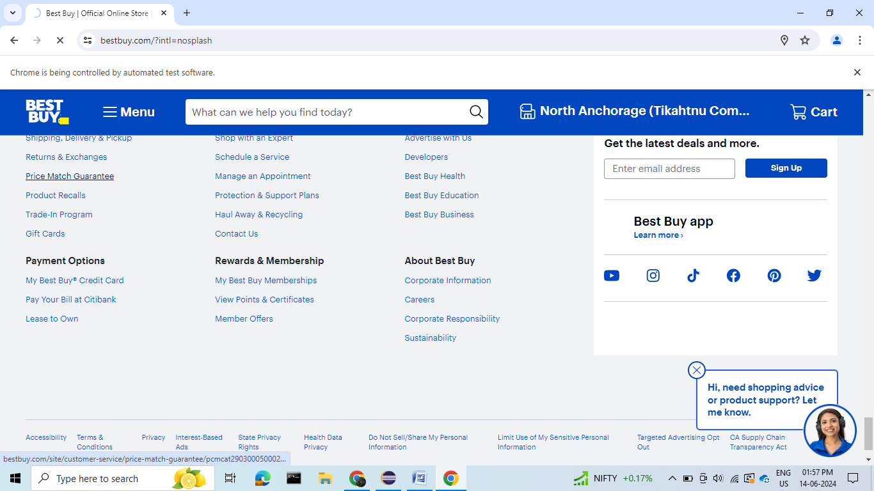

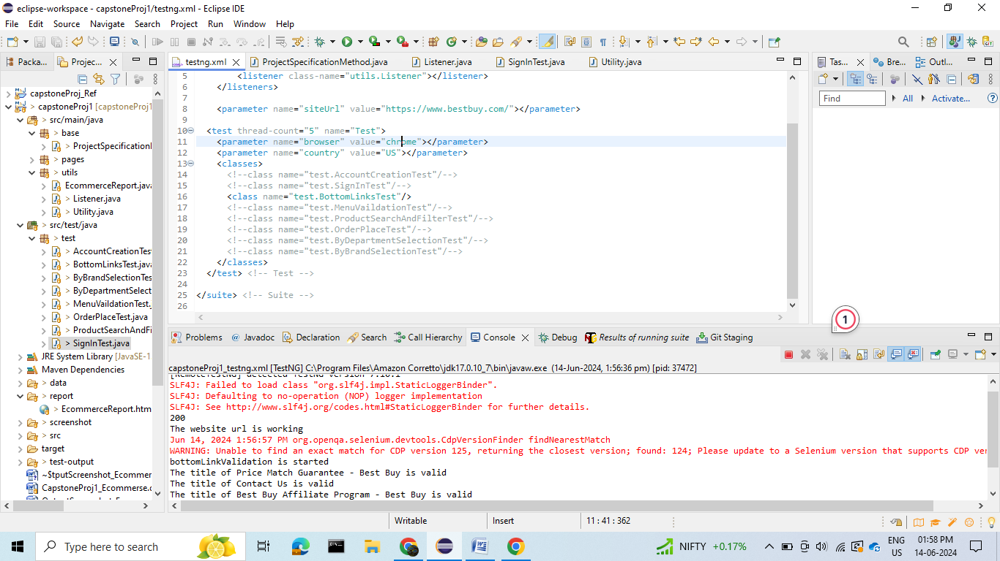

**Menu validation:**

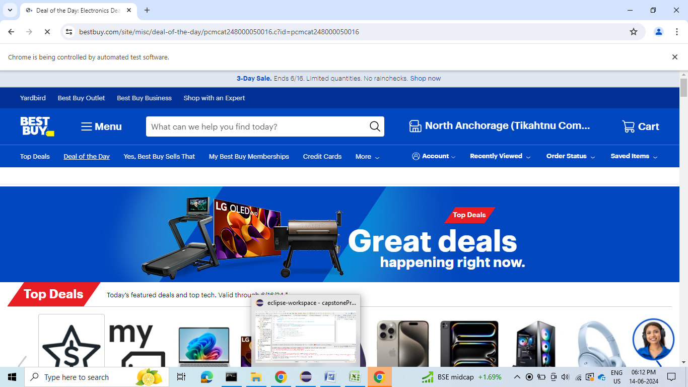

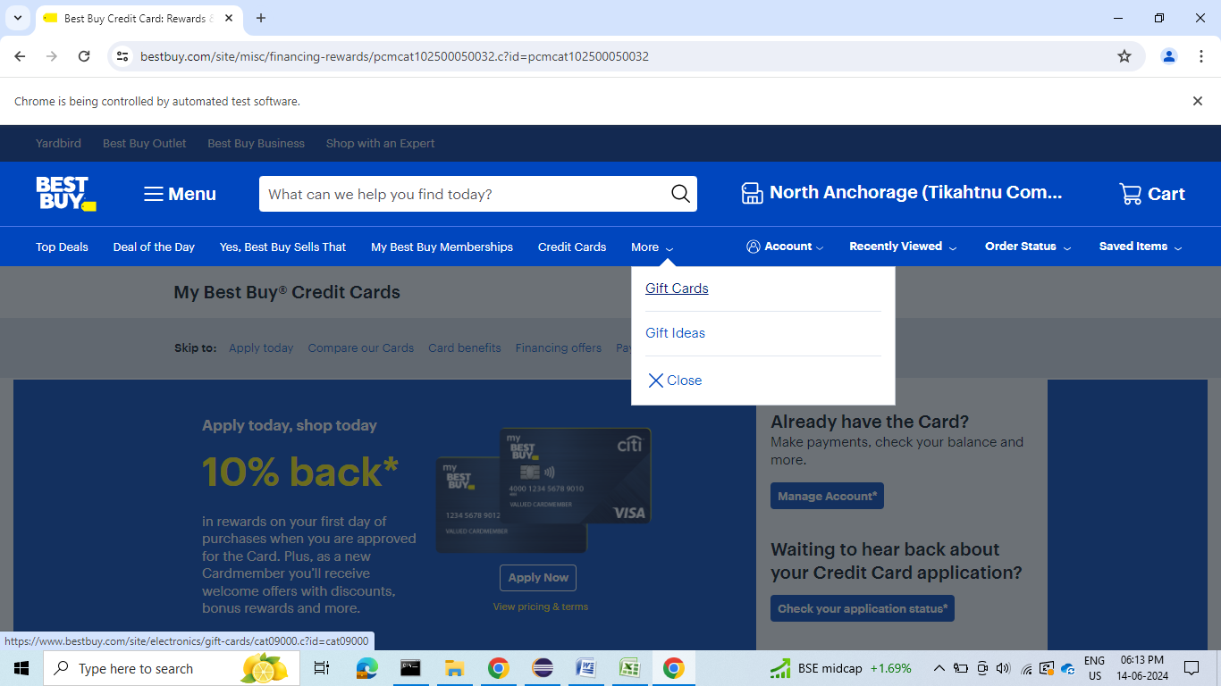

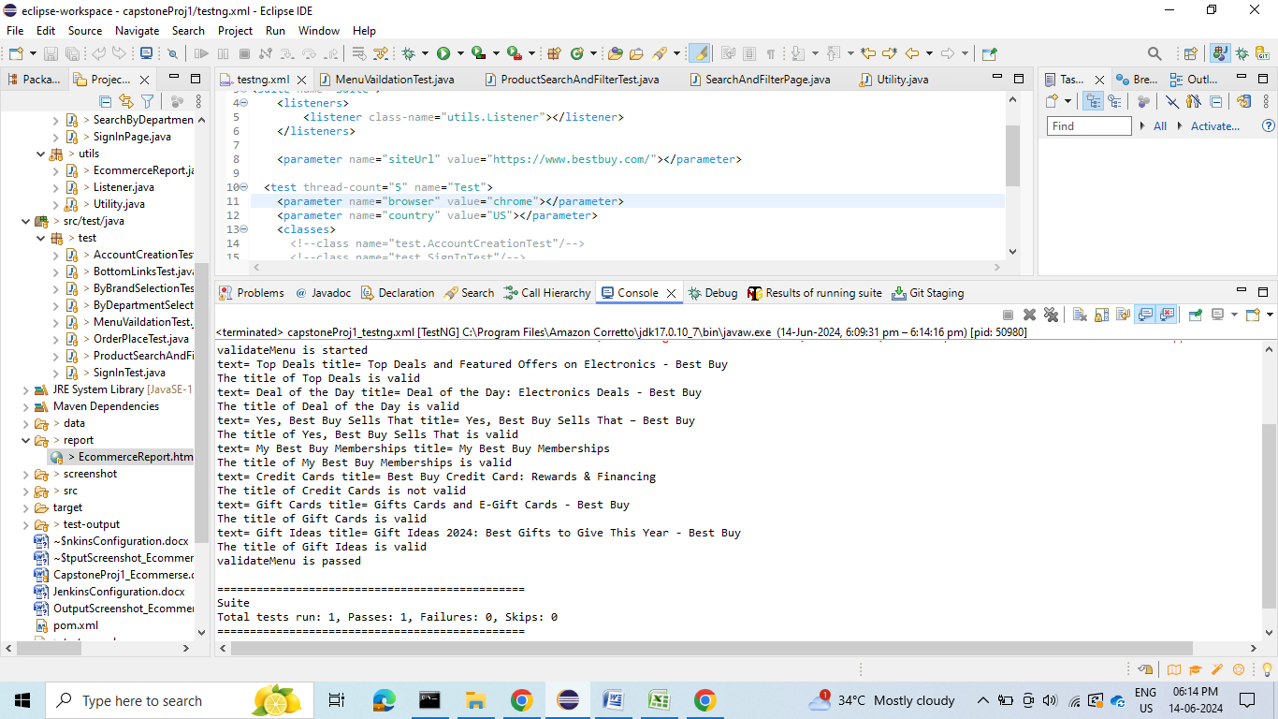

**Product search:**

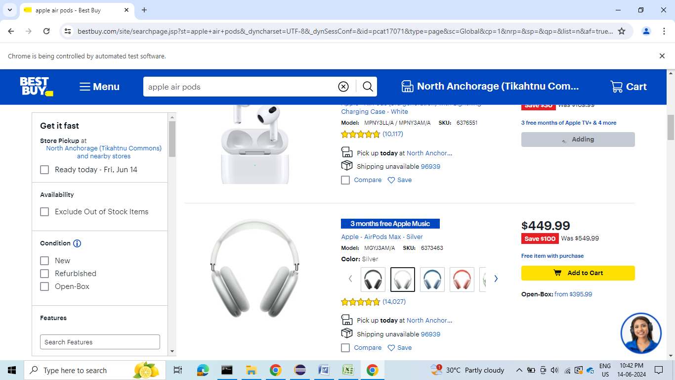

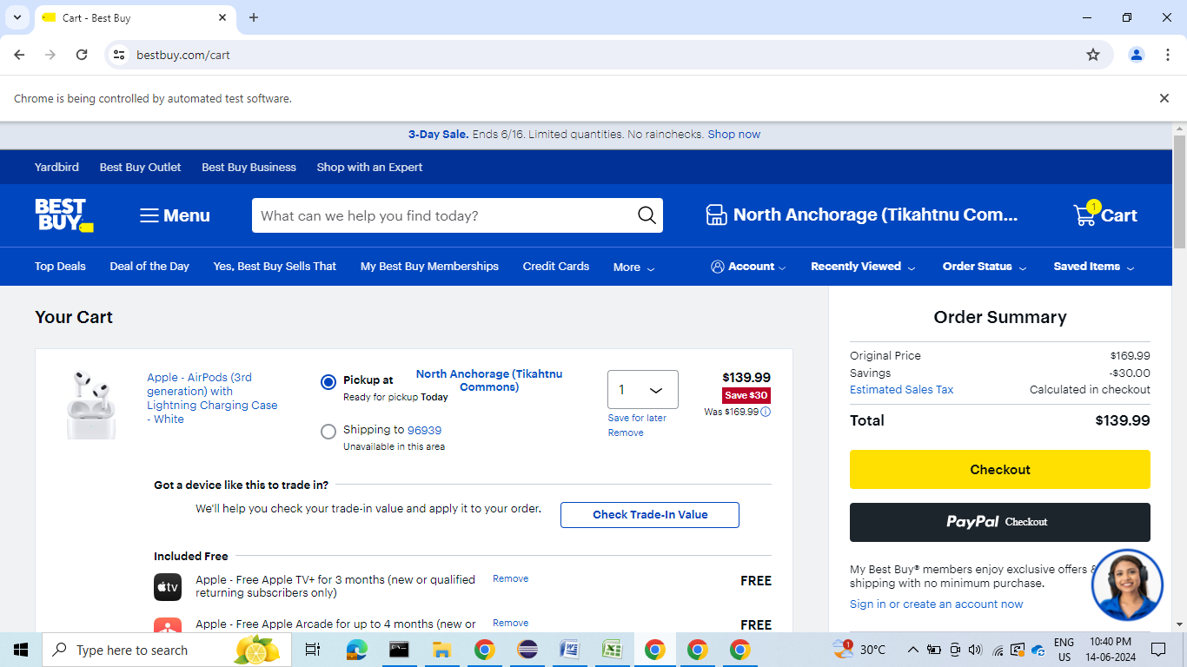

**Filter search Result:**

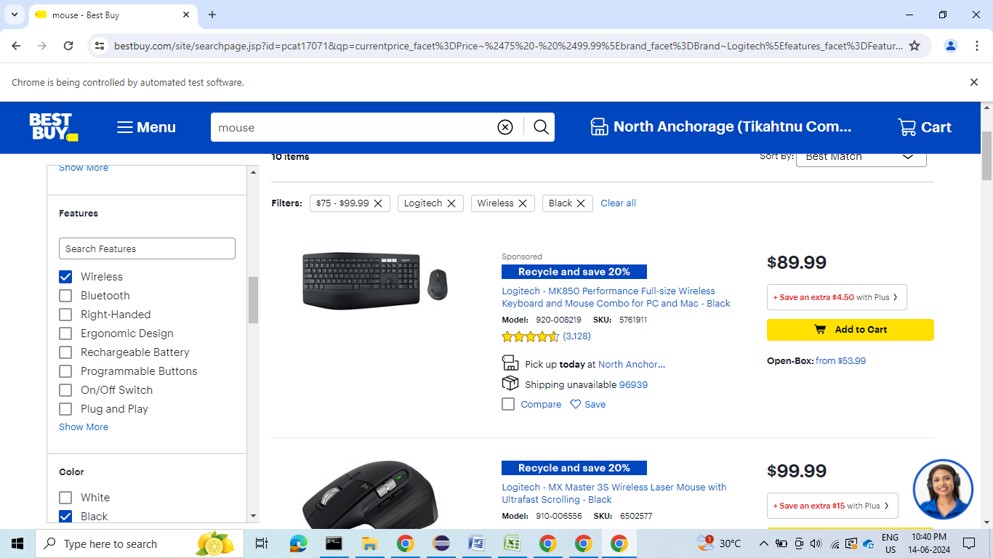

**Place order:**

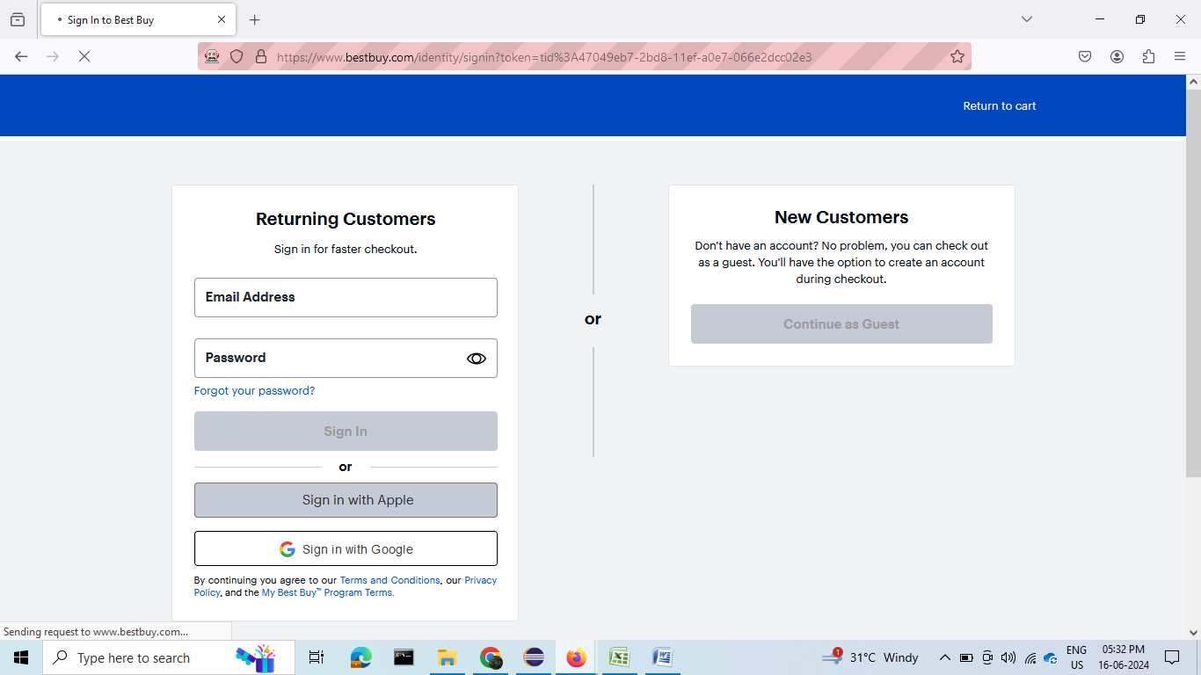

|  |  |
| --- | --- |
|  |  |

**Search By Department:**

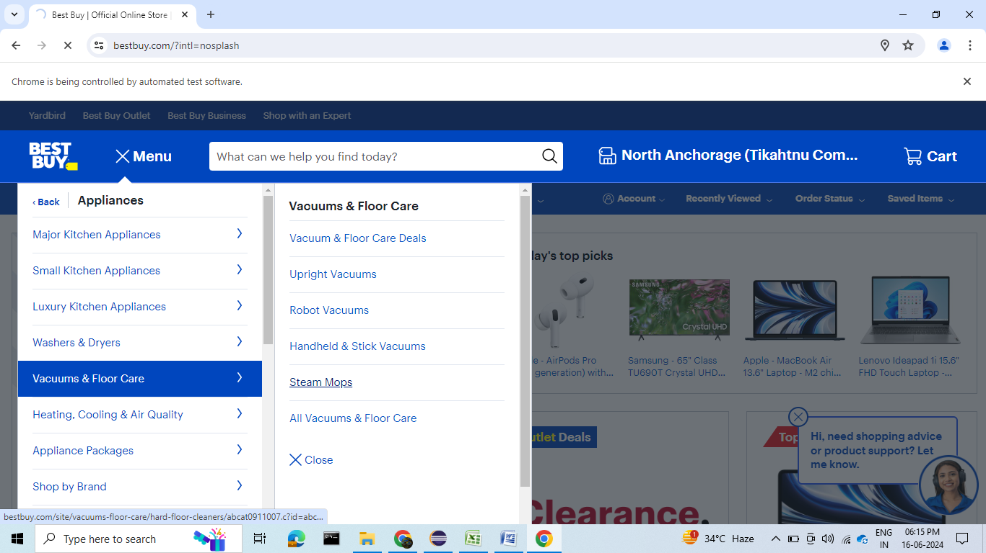

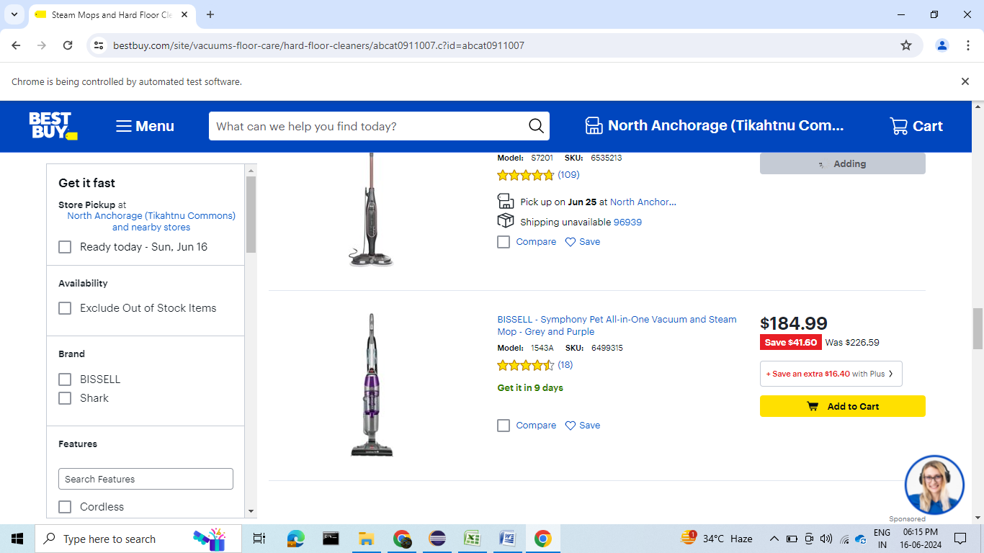

**Search By Brand:**

|  |  |
| --- | --- |
|  |  |

