**Screenshot Evidence:**

**Note:**

Provided the path of the excel file under utils package🡪 Utility class 🡪 method : userCredentials

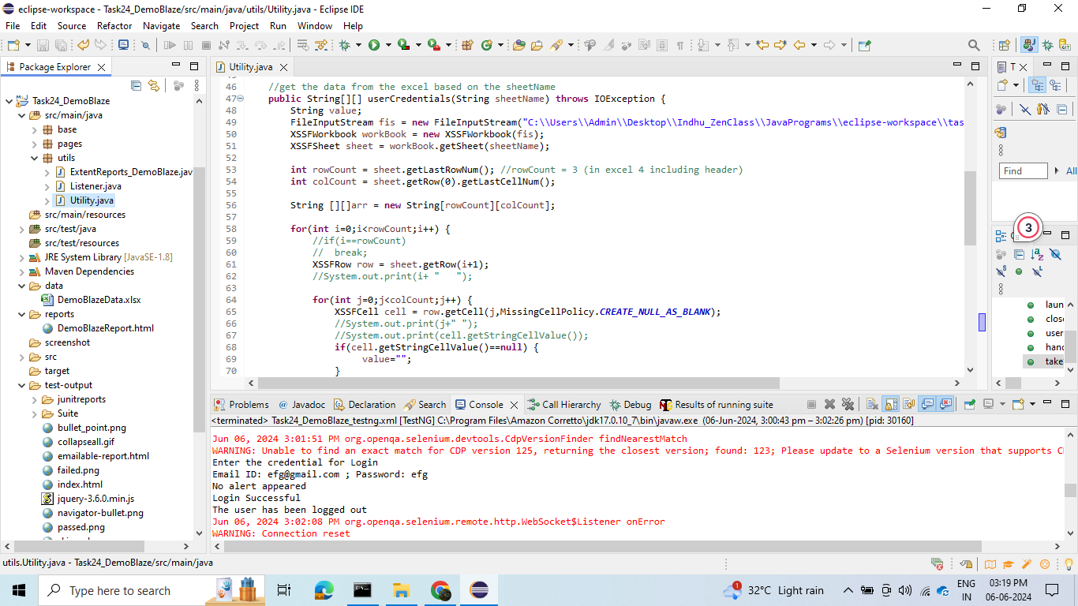

Provided the path of the screenshot under utils package🡪 Utility class 🡪 method: takeScreenshot

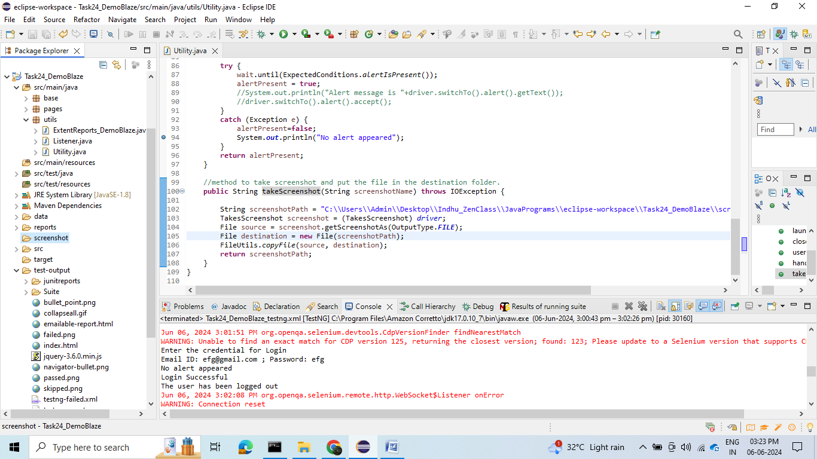

**Output Result shown in Console:**

Test case 1:

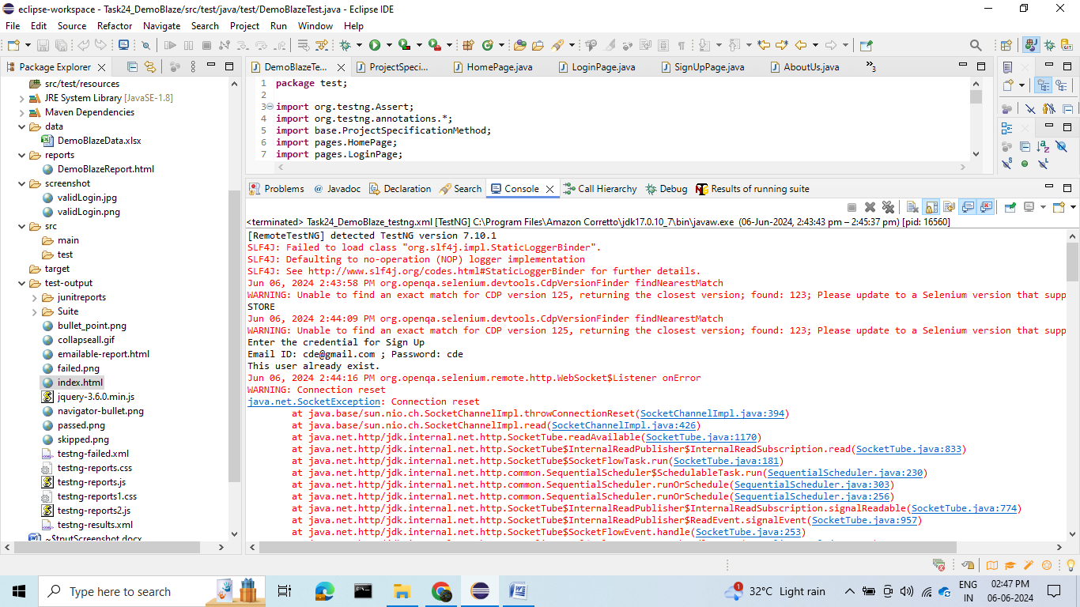

Test case 2:



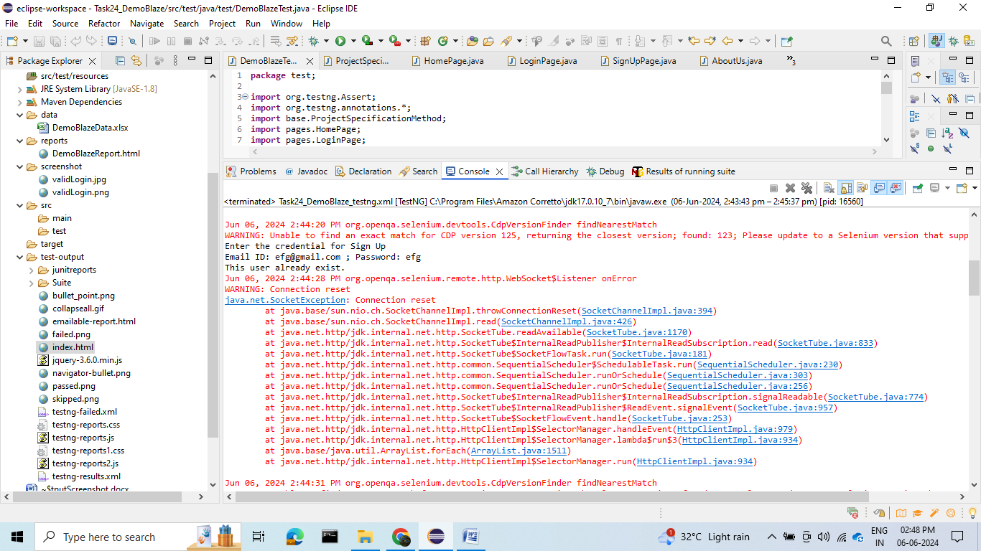

TestCase 3:

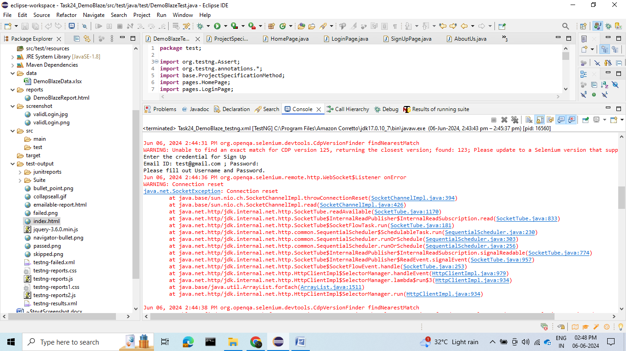

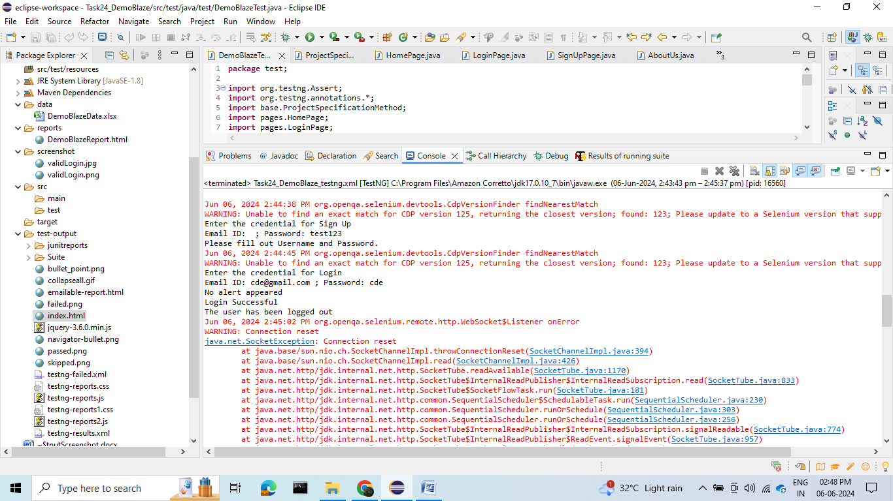

Testcase 4:



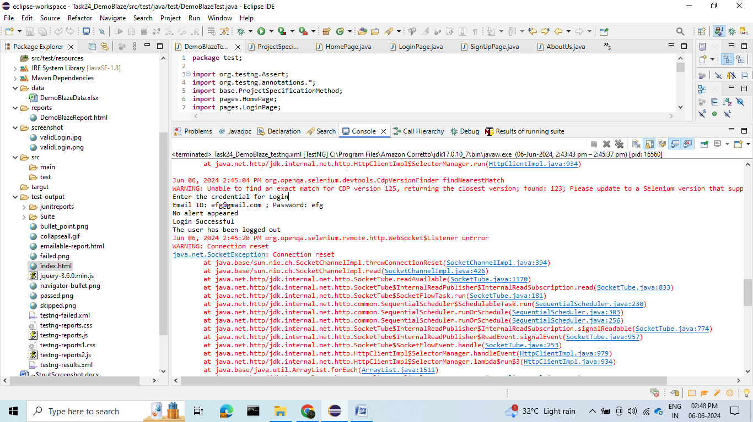

Testcase 5:

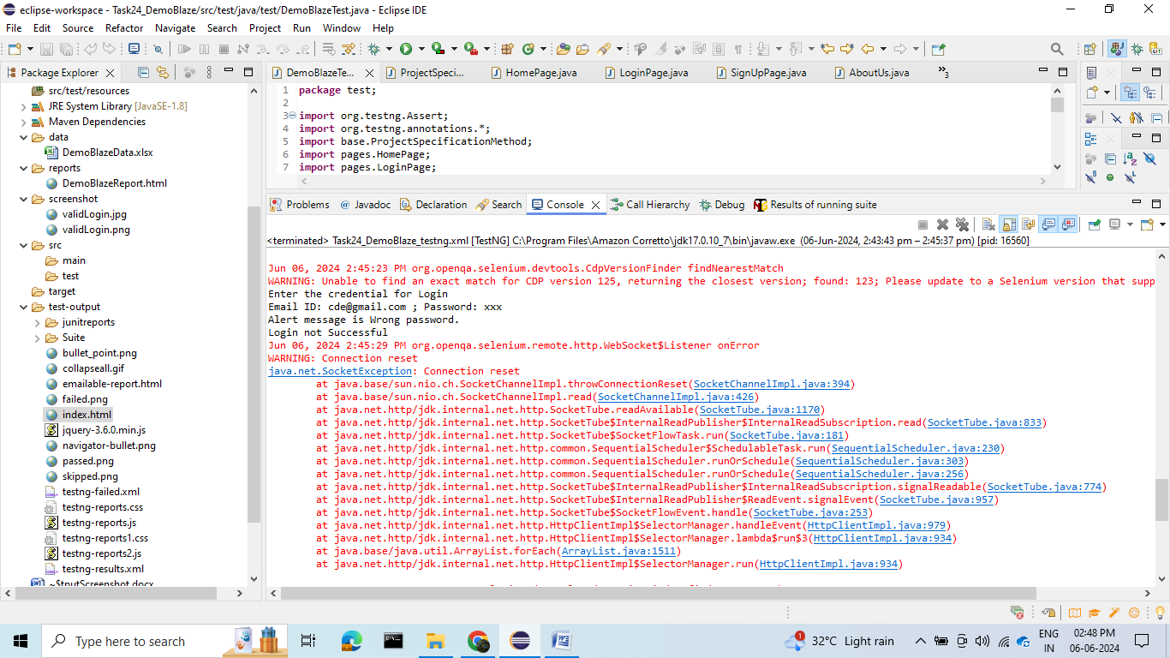

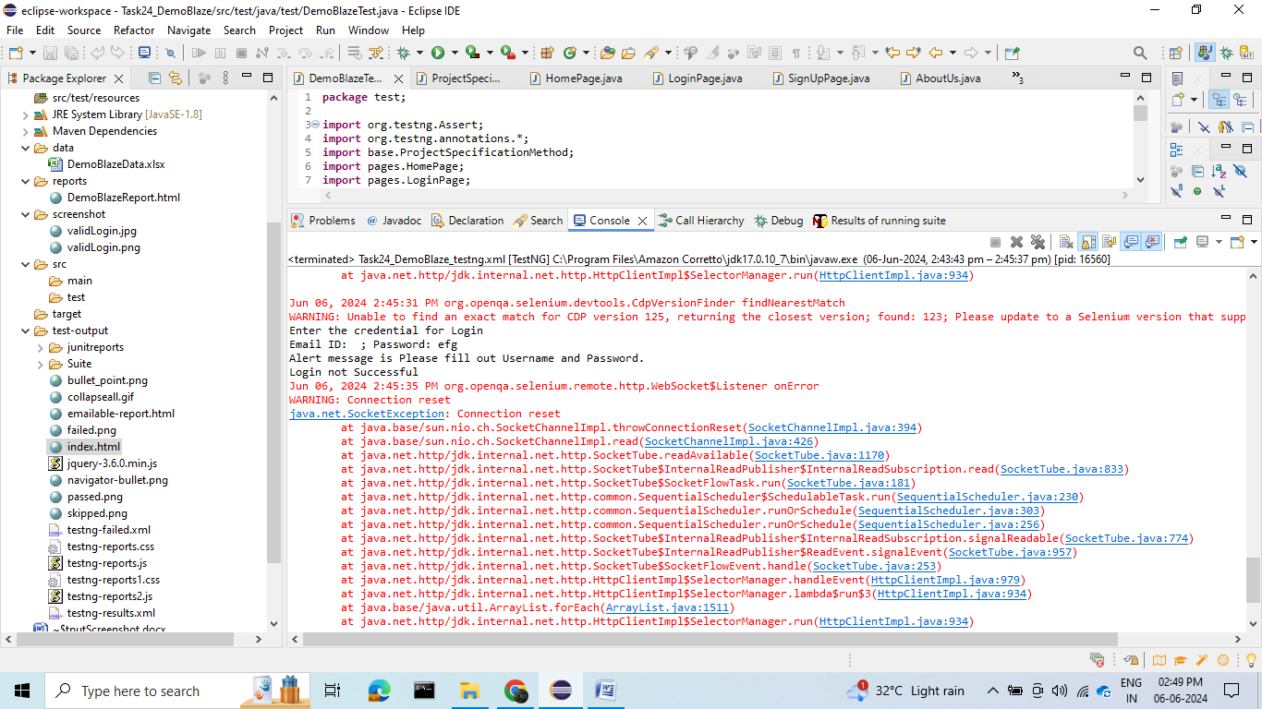

Overall Result:

