Cloud Computing Project
Deploying private Cloud using OpenStack on VirtualBox

TEAM MEMBERS:
Indhumadhi Suryanarayanan
Suneesha Kudipudi

Inferences
- We started the Lab by first installing the Oracle Linux server on the virtual box, because of which we faced lot of issues in network adaptor settings.
- Therefore we switched to the Youtube videos, but the mistake we did was, we installed ubuntu13.03 iso sue to which many of the source lists for the apt get was outdated.
- Therefore, we changed to the Ubuntu 14.10 with which we again faced issues in downloading the mariadb server even after changing kernel.
- Then, we changed to Ubuntu 14.04 trusty flavor.
- Adding the Identity, Image went smoothly.
- While trying to restart Nove api, for Syrose it was giving a http: 404 error, which was resolved by uncommenting the auth_protocol=http in the keystone_authtoken field of the nova.conf of controller and the compute objects.
- After that, the Compute services went smoothly.
- Out of the two choices that we had for the architecture- neutron and nova, we chose the nova architechture.
- Installing the Dashboard also went smoothly
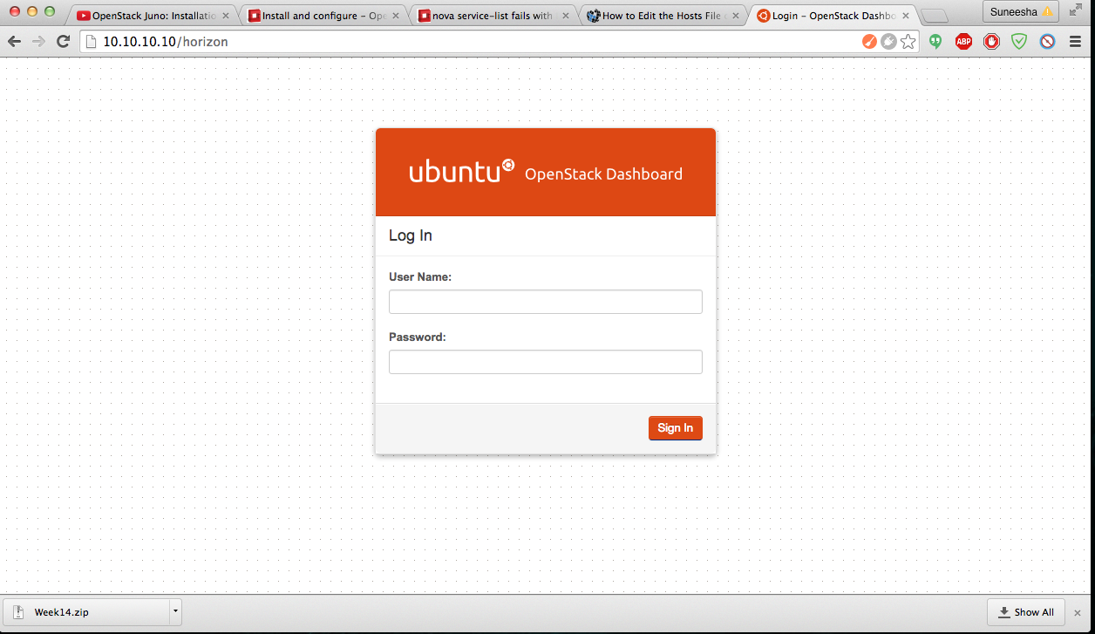
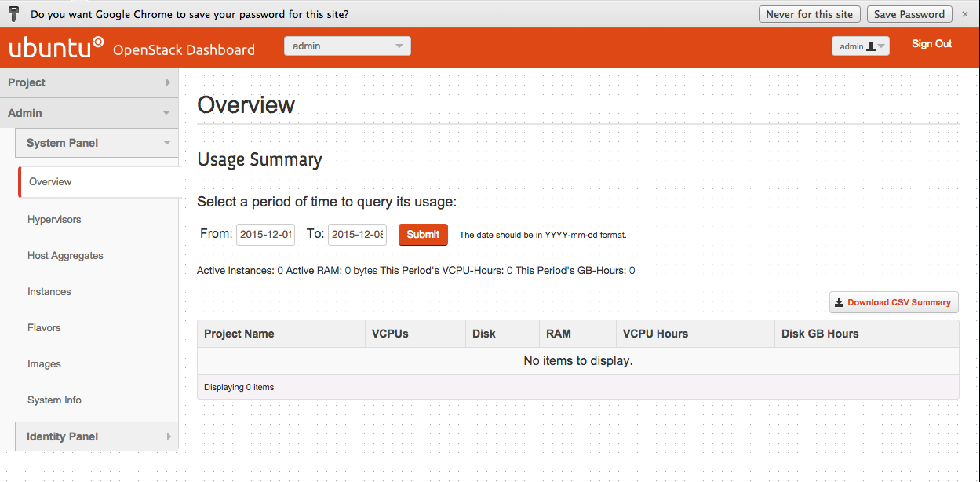

10) Adding the block-storage also went smoothly with the RabbitMQ installed correctly.

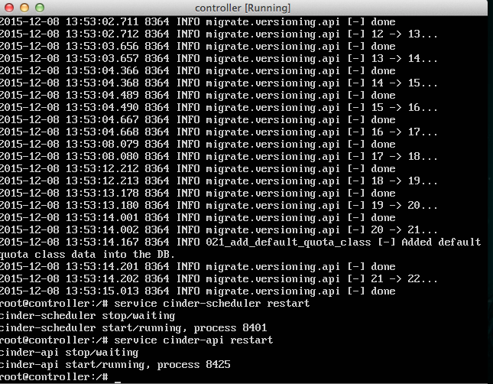

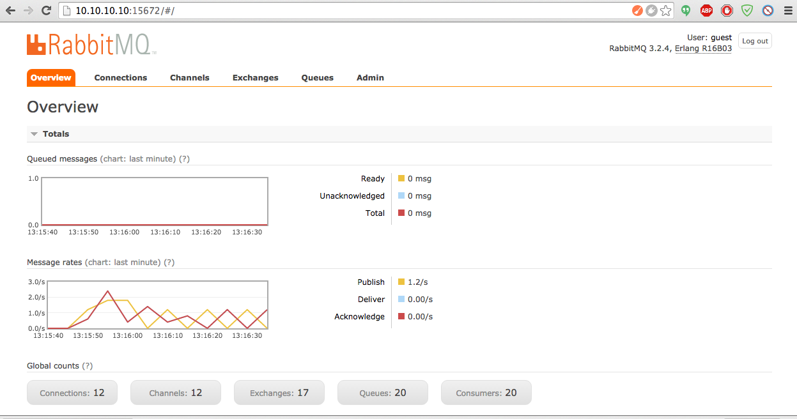

11) Another roadblock in the way came our way when we were trying to install swift. The apt-get function was not able to install python-keystonemiddleware because the trusty flavor did not have it. We tried installing it separately but we were getting ‘broken package’ error. This after much research got resolved when we used the following code.
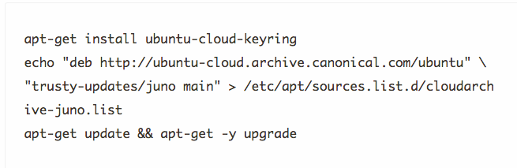

12) When we thought everything was resolved with the swift proxy-server and the memcached service running properly, we faced another problem which we could not resolve at all. This was in the ‘swift stat’ command. It was giving us the following error which after checking the logs and correcting the proxy-server.conf too seems to have a mind of its own.

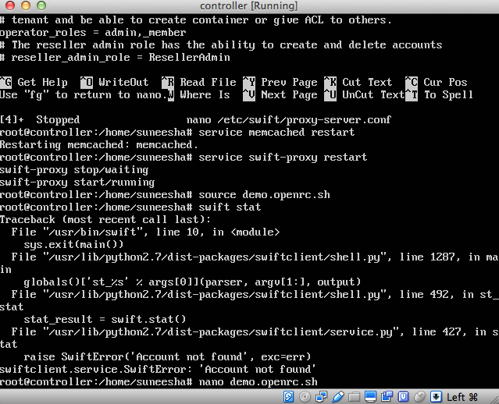
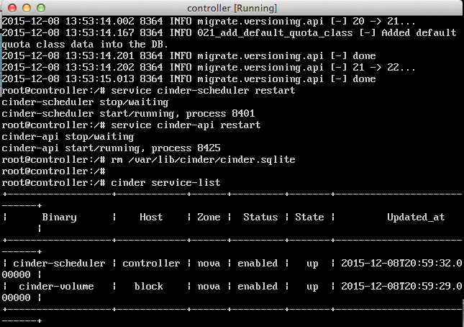
13) Not to get discouraged we went on ahead and tried to launch the instance, it went on ahead smoothly but the only problem was that the build was always resulting in an ERROR status.
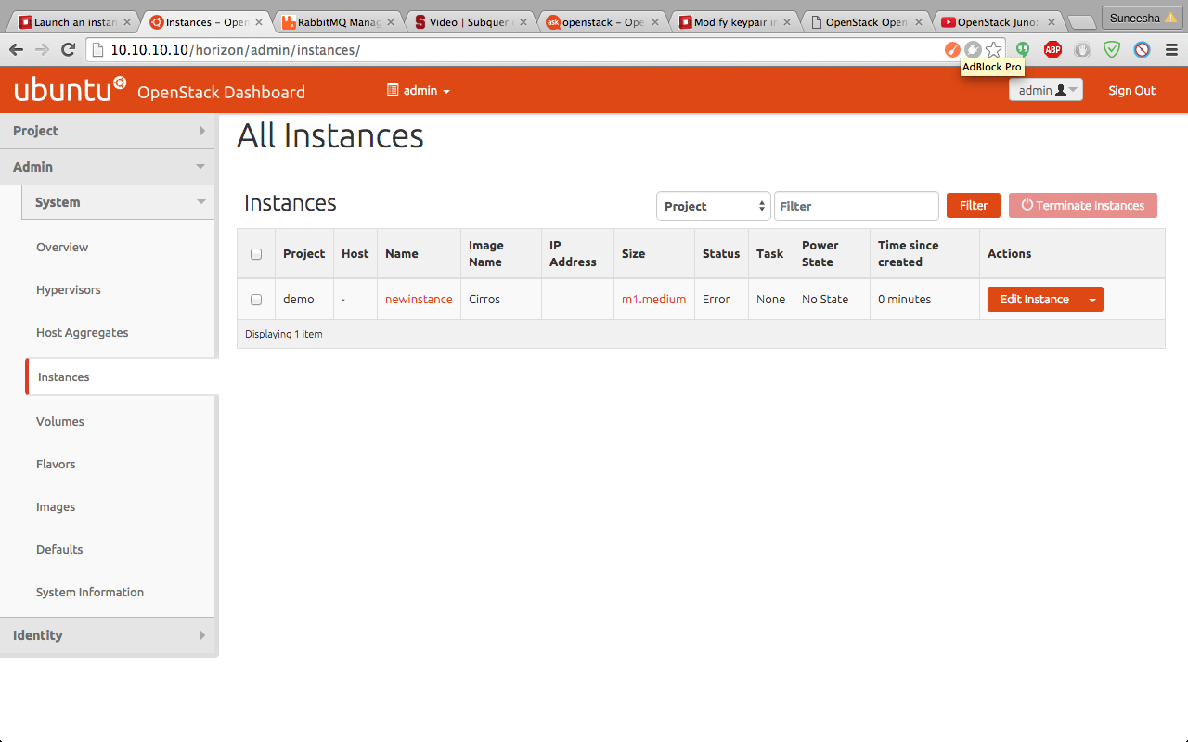
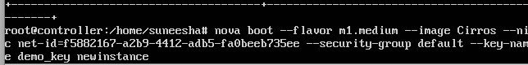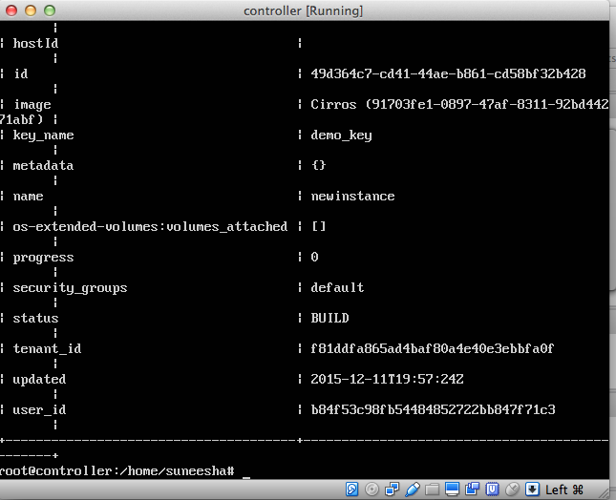

14) We also tried to implement through devstack to get an idea, but even there we faced problems as the horizon is not able to detect the python 3.4 package even though it was available and the change in bashrc file to set python 3.4 as default was done.
