PROJECT CHECK POINT

**TEAM NAME: SW_2016**

**TEAM MEMBERS: INDHUMADHI SURYANARAYANAN**

**SINDHUJAA RANGANATHAN CHANDRA BABU**

**PROJECT TITLE: Bank Activities and Fails.**

**PROJECT TYPE: LOGD**

**Building LOGD Visualizations:**

We have been looking into the Google Visualization APIs. We have zeroed in the use of Line Charts and Bar graphs for data representation.

A line graph with years in x-axis and number of closed banks in y-axis has to be taken and each line representing different states has to be plotted using the chosen datasets. This shows the failure of banks over a period.

A bar graph, with total number of banks and number of closed banks per state over the period of April-June 2009 has to be created by combining the chosen datasets.

**Understanding LOGD Data & Metadata:**

We have been analyzing the triples of the datasets we are handling. “State”, “Year” and “Bank_name” are the two fields that will be acting as the connectors to combine the two datasets. The will be acting as the major filter too in plotting the graph.

**Mashing up LOGD data with SPARQL:**

We have started the initial steps related to Fuseki. The localhost is set up and is in running state.

The data sets have been uploaded into the server from where datasets would be used for testing the SPARQL Query.

**SPARQL query progress:**

We have been querying the required data from the two datasets separately. We are figuring out the query to return combined results in the most meaningful way. We are also figuring out how to handle the query and result transaction from the JS file to the server through AJAX calls.

**Problems encountered:**

We had to go through few iterations with the query to structure it properly. We would not call it to be a problem though. We are also planning to do query result manipulation in the client side so parsing the query results to a program readable form is a place we are expecting to be challenged.

**No change in data sources.**

**No change in the expected results.**

**SUCCESSFULLY UPLOADED:**

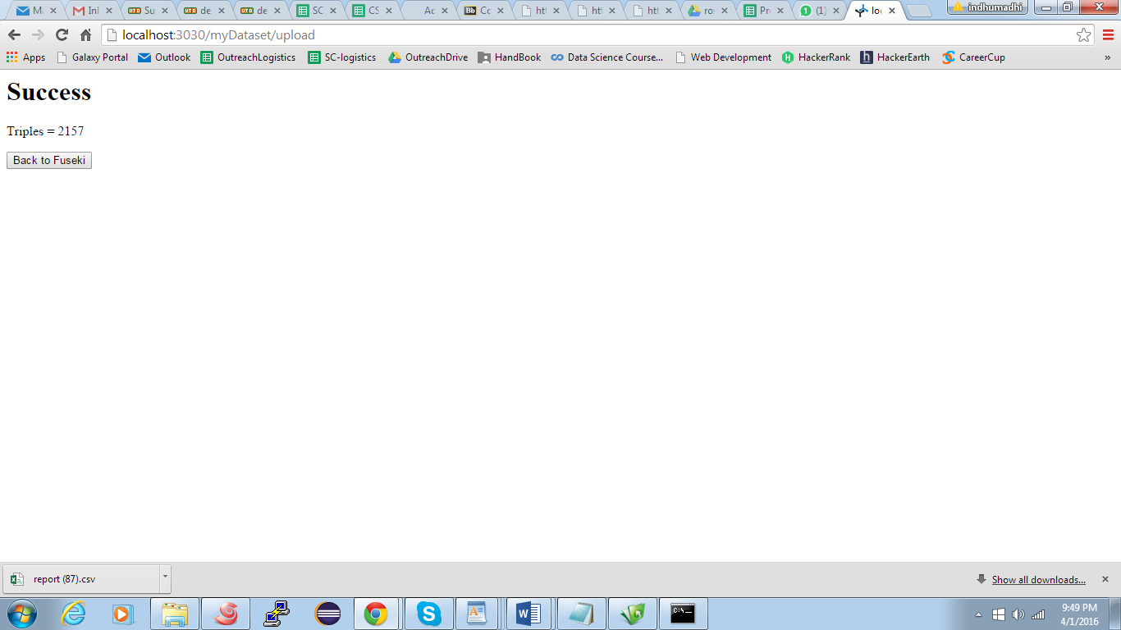

**QUERYING OF DATASETS:**

