Pre-Symptomatic Mango Disease Detection Using VOC Fingerprinting via a Metal Oxide Semiconductor (MOS) Sensor Array and Machine Learning

APPROACH 1: The Closed Chamber System (Micro-Headspace)
Concept Overview
This approach physically isolates a section of the mango tree (leaves, flowers, or young fruit) inside an airtight, chemically inert enclosure. The volatile organic compounds (VOCs) are allowed to build up in this confined space before a miniature vacuum pump forces the concentrated gas cloud directly over the sensor array.
Advantages & Disadvantages
- Advantages:
  - Ultra-High Sensitivity: Concentrates trace-level pre-symptomatic gases (<1 ppm), preventing atmospheric wind dilution.
  - Environmental Isolation: Protects the gas sensors from sudden outdoor humidity changes, wind gusts, and ambient background odors.
  - Cleaner Data: Higher signal-to-noise ratio makes it much easier for machine learning algorithms to accurately classify the disease fingerprint.
- Disadvantages:
  - Labor Intensive: Requires a human operator to physically walk through the orchard, clamp the chamber onto branches tree-by-tree, and wait for sampling.
  - Slow Throughput: Cannot monitor the entire orchard simultaneously in real time.
  - Risk of Cross-Contamination: If a heavily infected leaf is sampled, residual VOCs might stick to the chamber walls, causing a false positive on the next healthy tree if not purged correctly.
Components Used
- Gas Sensor Array: Winsen MP503, Winsen WSP2110, Winsen GM-512B, Alphasense PID-A1, Membrapor C2H4/M-10.
- Sampling Chamber: Custom-built clip-on box or flexible canopy bag made strictly of PTFE (Teflon) or Borosilicate Glass.
- Pneumatics: 5V/12V DC Micro-diaphragm vacuum pump (placed after the sensor array to pull air), 3-way electronic solenoid valve (for switching to clean air purge), and medical-grade PTFE tubing.
- Signal & Processing Electronics: ESP32 Microcontroller, ADS1115 (16-bit I2C External ADC), stable 5V/2A buck converter power module, and an SD card module for offline field data logging.

APPROACH 2: The Open-Air System (Weather-Gated Filtering)
Concept Overview
This approach mounts the sensor array openly on stationary posts or mobile orchard carts without any physical plant enclosure. To bypass the extreme dilution caused by wind, the system utilizes Temporal Gating—monitoring weather parameters 24/7 and only capturing/analyzing gas data when the air is completely still (such as during the dawn inversion window).
Advantages & Disadvantages
- Advantages:
  - Fully Automated / Zero Labor: Operates completely autonomously as stationary "sentinel nodes." No manual tree-by-tree human interaction is needed.
  - Continuous Monitoring: Can run 24/7, tracking long-term chemical trends in the orchard canopy over weeks.
  - Non-Contact: Never physically touches the plant tissues, eliminating any risk of mechanically spreading fungal spores between trees.
- Disadvantages:
  - Extreme Signal Dilution: Pre-symptomatic VOCs are drastically thinned out by the open atmosphere, requiring highly expensive, specialized sensors or massive data exposure windows.
  - High Environmental Noise: Changes in natural outdoor humidity and temperature heavily distort the baseline electrical resistance of gas sensors, causing data drift.
  - Interference Fragility: The sensors will pick up non-disease organic odors like damp soil bacteria (geosmin), grass-cut volatiles, or nearby tractor exhaust fumes.
Components Used
- Gas Sensor Array: Requires higher-grade variants of the same sensors to combat dilution (Winsen MP503, Winsen WSP2110, Winsen GM-512B, Alphasense PID-A1, Membrapor C2H4/M-10).
- Meteorological Sensors (Mandatory): * Anemometer: To measure precise wind speed and direction down to 0.1 m/s.
  - BME280 / SHT31: High-accuracy digital ambient temperature and relative humidity sensor.
- Signal & Processing Electronics: ESP32 or STM32 Microcontroller (running a wind-gated conditional logic loop), ADS1115 (16-bit ADC), wireless telemetry module (LoRaWAN or Wi-Fi to send data across long orchard distances), and a solar panel array with a LiFePO4 battery pack for remote outdoor power.

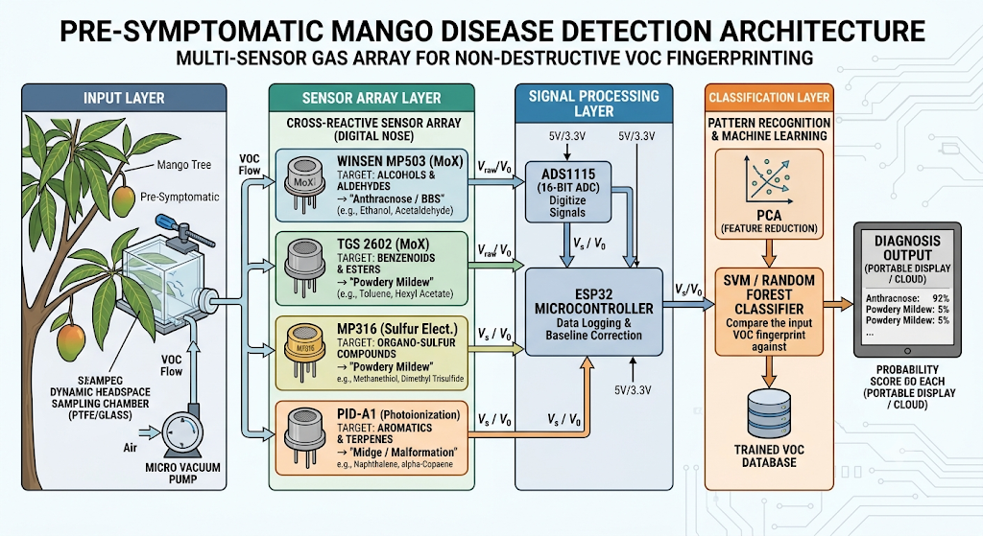
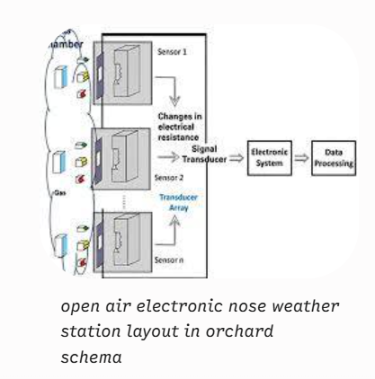

Sensor Model / Option | Core Detection Technology | Target Chemical Families | Specific Mango Disease / Condition Targeted | Exact Purpose in Pre-Symptomatic Architecture
Winsen MP503  (or Winsen GM-502B) | Metal Oxide Semiconductor (MoX / MEMS) | Alcohols (Ethanol), Aldehydes (Acetaldehyde, Propanal) | Anthracnose  Bacterial Black Spot (BBS) | Identifies immediate systemic tissue stress by capturing rapid spikes in low-molecular-weight fermentative and respiratory byproducts.
Winsen WSP2110  (or Figaro TGS 2602) | Metal Oxide Semiconductor (MoX) | Volatile Benzenoids, Esters, Toluene, Acetone | Powdery Mildew  Anthracnose | Maps out variations in secondary plant metabolites (aromatic rings and esters) released during initial fungal spore invasion.
Winsen GM-512B  (or MQ-316) | Metal Oxide Semiconductor (MoX) / Dedicated Sulfur Config. | Organo-Sulfur compounds, Thiols (Methanethiol, Dimethyl Trisulfide) | Powdery Mildew | Detects trace volatile reduced-sulfur compounds that act as distinct metabolic markers for specialized fungal colonization.
Alphasense PID-A1  (or any miniature PID) | Photoionization Detection (UV Krypton Lamp - 10.6 eV) | High-Mass Aromatics, Polycyclic compounds, Terpenes, Sesquiterpenes | Mango Midge Infestation  Mango Malformation | Provides high-precision, sub-parts-per-million (ppb) detection of complex, heavy organic vapors emitted from cellular distortion and leaf galls.
Membrapor C2H4/M-10  (or any electrochemical ethylene sensor) | Amperometric Electrochemical | Ethylene Gas ($C_2H_4$) | Mango Black Tip  (and General Plant Stress Signaling) | Monitors the primary phytohormone of plant panic. Captures early stress triggers from environmental cell damage and systemic pathogen alerts before physical lesions emerge.

