**Superset ID:** **6403222**

**MODULE 6 SOLUTIONS**

**EXERCISE 1-Create a new React Application with the name “myfirstreact”, Run the application to print “welcome to the first session of React” as heading of that page.**

import React from 'react';

function App() {

return (

<div>

<h1>Welcome to the first session of React</h1>

</div>

);

}

export default App;

OUTPUT:

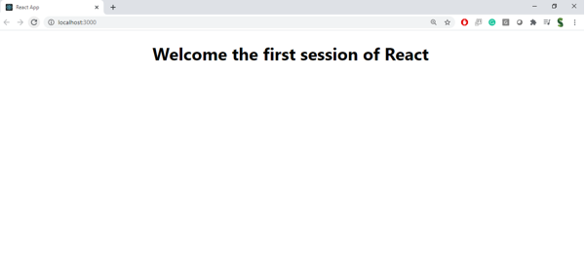

**Exercise-3 Create a react app for Student Management Portal named scorecalculatorapp and create a function component named “CalculateScore” which will accept Name, School, Total and goal in order to calculate the average score of a student and display the same.**

**// src/CalculateScore.js**

import React, { useState } from 'react';

function CalculateScore() {

const [name, setName] = useState('');

const [school, setSchool] = useState('');

const [total, setTotal] = useState('');

const [goal, setGoal] = useState('');

const [average, setAverage] = useState(null);

const handleSubmit = (e) => {

e.preventDefault();

if (!total || !goal || isNaN(total) || isNaN(goal)) {

alert("Please enter valid numeric values for Total and Goal.");

return;

}

const avg = (parseFloat(total) / parseFloat(goal)).toFixed(2);

setAverage(avg);

};

return (

<div style={{ padding: '20px', fontFamily: 'Arial' }}>

<h2>Student Score Calculator</h2>

<form onSubmit={handleSubmit}>

<div>

<label>Name: </label>

<input value={name} onChange={(e) => setName(e.target.value)} required />

</div>

<div>

<label>School: </label>

<input value={school} onChange={(e) => setSchool(e.target.value)} required />

</div>

<div>

<label>Total Marks Obtained: </label>

<input value={total} onChange={(e) => setTotal(e.target.value)} required />

</div>

<div>

<label>Maximum Goal/Total Marks: </label>

<input value={goal} onChange={(e) => setGoal(e.target.value)} required />

</div>

<button type="submit">Calculate Average</button>

</form>

{average !== null && (

<div style={{ marginTop: '20px' }}>

<h3>Result</h3>

<p>Name: {name}</p>

<p>School: {school}</p>

<p>Average Score: {average}</p>

</div>

)}

</div>

);

}

export default CalculateScore;

**//App.js**

import React from 'react';

import CalculateScore from './CalculateScore';

function App() {

return (

<div>

<h1>Welcome to Score Calculator App</h1>

<CalculateScore />

</div>

);

}

export default App;

OUTPUT:

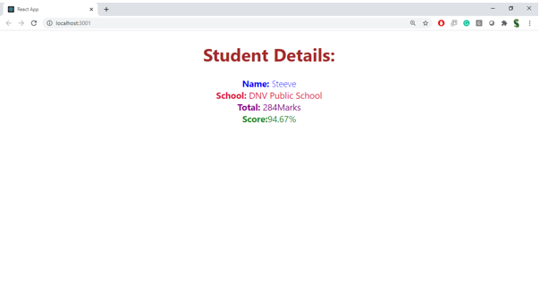

**EXERCISE 5:**

**My Academy team at Cognizant want to create a dashboard containing the details of ongoing and completed cohorts. A react application is created which displays the detail of the cohorts using react component. You are assigned the task of styling these react components.**

**// src/components/CohortCard.js**

import React from 'react';

import './CohortCard.css';

const CohortCard = ({ title, startDate, status, coach, trainer, color }) => {

return (

<div className="cohort-card">

<h3 style={{ color }}>{title}</h3>

<p><strong>Started On</strong><br />{startDate}</p>

<p><strong>Current Status</strong><br />{status}</p>

<p><strong>Coach</strong><br />{coach}</p>

<p><strong>Trainer</strong><br />{trainer}</p>

</div>

);

};

export default CohortCard;

**// src/components/CohortsDashboard.js**

import React from 'react';

import CohortCard from './CohortCard';

import './CohortsDashboard.css';

const CohortsDashboard = () => {

const cohorts = [

{

title: 'INTADMDF10 -.NET FSD',

startDate: '22-Feb-2022',

status: 'Scheduled',

coach: 'Aathma',

trainer: 'Jojo Jose',

color: 'blue',

},

{

title: 'ADM21JF014 - Java FSD',

startDate: '10-Sep-2021',

status: 'Ongoing',

coach: 'Apoorv',

trainer: 'Elisa Smith',

color: 'green',

},

{

title: 'CDBJF21025 - Java FSD',

startDate: '24-Dec-2021',

status: 'Ongoing',

coach: 'Aathma',

trainer: 'John Doe',

color: 'darkgreen',

},

];

return (

<div className="dashboard-container">

<h2>Cohorts Details</h2>

<div className="card-container">

{cohorts.map((cohort, index) => (

<CohortCard key={index} {...cohort} />

))}

</div>

</div>

);

};

export default CohortsDashboard;

.cohort-card {

width: 250px;

border: 1px solid #ccc;

border-radius: 10px;

padding: 15px;

margin: 10px;

box-shadow: 0 2px 5px rgba(0,0,0,0.1);

font-family: 'Segoe UI', sans-serif;

}

.dashboard-container {

padding: 30px;

text-align: center;

}

.dashboard-container h2 {

font-size: 24px;

margin-bottom: 20px;

}

.card-container {

display: flex;

justify-content: center;

flex-wrap: wrap;

gap: 20px;

}

**//App.js**

import React from 'react';

import CohortsDashboard from './components/CohortsDashboard';

function App() {

return (

<div>

<CohortsDashboard />

</div>

);

}

export default App;

OUTPUT:

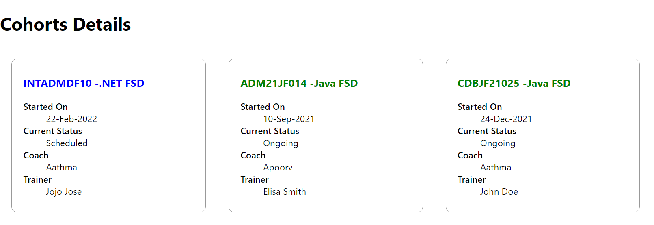

**Excersise-2 Create a react app for Student Management Portal named StudentApp and create a component named Home which will display the Message “Welcome to the Home page of Student Management Portal”. Create another component named About and display the Message “Welcome to the About page of the Student Management Portal”. Create a third component named Contact and display the Message “Welcome to the Contact page of the Student Management Portal”. Call all the three components.**

import React from 'react';

function Home() {

return (

<h2 style={{ textAlign: 'center', fontWeight: 'bold' }}>

Welcome to the Home Page of Student Management Portal

</h2>

);

}

export default Home;

import React from 'react';

function About() {

return (

<h2 style={{ textAlign: 'center', fontWeight: 'bold' }}>

Welcome to the About Page of Student Management Portal

</h2>

);

}

export default About;

import React from 'react';

function Contact() {

return (

<h2 style={{ textAlign: 'center', fontWeight: 'bold' }}>

Welcome to the Contact Page of Student Management Portal

</h2>

);

}

export default Contact;

import React from 'react';

import { BrowserRouter as Router, Routes, Route } from 'react-router-dom';

import Home from './Components/Home';

import About from './Components/About';

import Contact from './Components/Contact';

function App() {

return (

<Router>

<Routes>

<Route path="/" element={<Home />} />

<Route path="/About" element={<About />} />

<Route path="/Contact" element={<Contact />} />

</Routes>

</Router>

);

}

export default App;

OUTPUT:

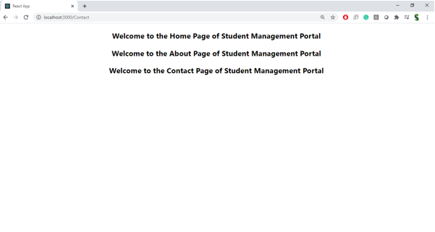

**EXCERCISE-4**

class Post {

constructor(id, title, body) {

this.id = id;

this.title = title;

this.body = body;

}

}

export default Post;

import React from 'react';

import Post from './Post';

class Posts extends React.Component {

constructor(props) {

super(props);

this.state = {

posts: [],

error: null

};

}

loadPosts() {

fetch('https://jsonplaceholder.typicode.com/posts')

.then((response) => response.json())

.then((data) => {

const postList = data.map(p => new Post(p.id, p.title, p.body));

this.setState({ posts: postList });

})

.catch((error) => {

this.setState({ error });

});

}

componentDidMount() {

this.loadPosts();

}

componentDidCatch(error, info) {

alert('An error occurred: ' + error);

}

render() {

const { posts } = this.state;

return (

<div>

<h1>Blog Posts</h1>

{posts.map((post) => (

<div key={post.id} style={{ marginBottom: '20px' }}>

<h3>{post.title}</h3>

<p>{post.body}</p>

<hr />

</div>

))}

</div>

);

}

}

export default Posts;  
import React from 'react';

import Posts from './Posts';

function App() {

return (

<div className="App">

<Posts />

</div>

);

}

export default App;