

**Placement Empowerment Program**

***Cloud Computing and DevOps Centre***

**Set Up a Virtual Machine in the Cloud Create a freetier AWS, Azure, or GCP account. Launch a virtual machine and SSH into it.**

**Name: Indhumathi S Department: CSE**

**Introduction**

Cloud computing has revolutionized how businesses manage IT resources. In this task, we will focus on deploying a virtual machine (VM) in the cloud. This hands-on activity will provide an understanding of cloud platforms, virtual machine provisioning, and secure SSH access.

**Objectives**

1.Understand the concept of cloud computing and VMs.

2.Create a free-tier account on a cloud provider (AWS, Azure, or GCP).

3.Launch a Linux virtual machine.

4.Connect to the VM securely using SSH.

**Step 1:**

Create a Free Tier Account .Go to the official website of **AWS (Amazon Web Services), Microsoft Azure, or Google Cloud Platform (GCP)** and click on "Sign Up."

Log in to your cloud provider’s **management console or portal.**

**Step 2:**

**Launch a Virtual Machine**

**AWS**: Navigate to the **EC2 Dashboard**, click "Launch Instance," and select an AMI (Amazon Machine Image) like **Ubuntu, Windows Server, or Amazon Linux.**

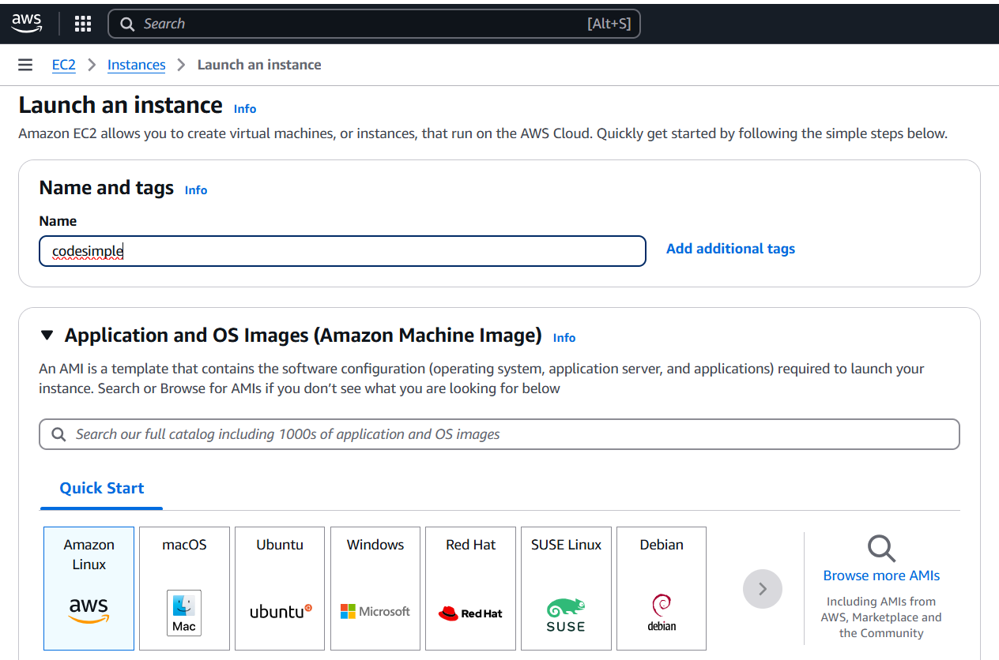

**Step 3:**

Configure instance details such as CPU, RAM, and storage (e.g., t2.micro in AWS, B1s in Azure, f1-micro in GCP for free-tier eligibility).

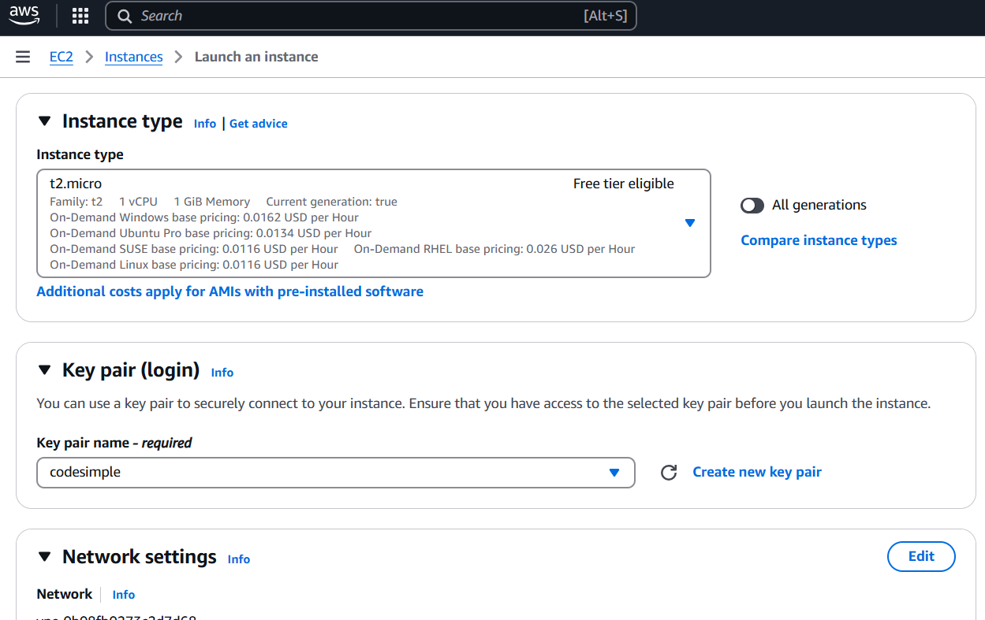

**Step 4:**

Attach an SSH key pair (AWS, GCP) or create a username/password for authentication.

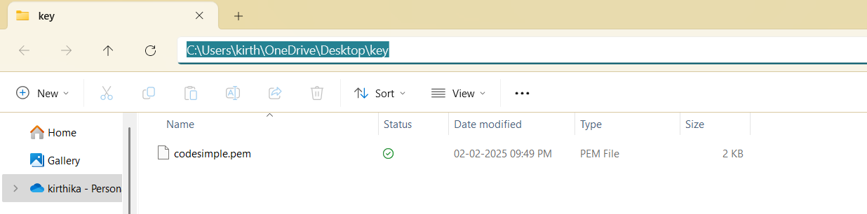

**Step 5:**

Click Launch/Create and wait for the VM to start.

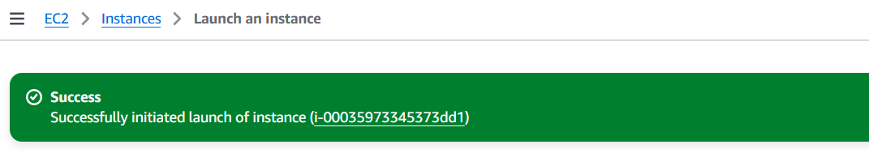

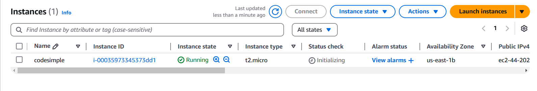

**Step 6:**

Obtain the **public IP address** of your instance from the cloud console.

If you’re using a Terminal or Windows PowerShell, use SSH to connect

ssh -i /path/to/key.pem username@your-vm-public-ip

Replace <user> with the default username for your chosen cloud provider (e.g., ec2-user for AWS) and <IP_address> with your VM’s public IP.



**Overview:**

Setting up a cloud virtual machine involves creating a free-tier account on AWS, Azure, or GCP. You then launch a VM by selecting an OS, configuring resources, and enabling SSH access. Once the VM is running, you obtain its public IP and connect securely using SSH (Linux/macOS). This provides a cloud-based environment for development, hosting, or testing applications.