Studio 5
INZBC AI OPERATING SYSTEM
Evidence Portfolio
India New Zealand Business Council (INZBC) Digital Platform — Industry Placement

Bhanu Gupta (100012452)

August 20, 2026

Table of Contents

1. Introduction 3
1.1 Overview of the project 3
1.2 Goals and objectives 3
2. Project requirements 3
2.1 Tools 3
2.2 Methodology 4
3. Contributions 5
4. Evaluation of Problems and Technologies 9
5. Communication for Sustainable Productivity 10
6. Managing the project 11
7. Issues and Challenges 12
8. Conclusion 12
9. References 13

Introduction

Overview of the project
This report records my individual contribution to the INZBC AI Operating System and Digital Platform during the Studio 5 industry placement. The work combined platform architecture, application security, API and data contracts, Strategic Intelligence Platform (SIP) services, delivery governance, code review, and multi-repository integration for the India New Zealand Business Council.
The placement team divided delivery into clear workstreams. My role was technical lead for foundation, security, and integration. I owned or co-owned the shared contracts, model gateway, authentication and authorisation controls, append-only audit and decision records, the SIP core and orchestrator, deployment and operational documentation, and the quality gates used before work reached the default branch. I also integrated team contributions and supported public-site design work in the separate inzview repository.
The evidence in this portfolio was refreshed directly from the organisation's four GitHub repositories and its private INZBC SIP Platform project board on 20 August 2026. Repository metrics are used as traceability evidence rather than as a substitute for quality: the narrative therefore connects counts to representative pull requests, code controls, review records, and managed project outcomes.

Goals and objectives
The work was guided by the following delivery objectives:
- Give INZBC a maintainable technical foundation with documented boundaries, shared contracts, reproducible environments, and a clear handover path.
- Keep every AI-assisted workflow under named human review and make prohibited or unauthorised actions fail closed rather than merely produce warnings.
- Make trade and FTA outputs traceable to stable, dated sources, with an explicit no-match result when the evidence does not support an answer.
- Protect member and operational data through server-side roles, CSRF protection, separation of duties, redaction and model-boundary controls, append-only evidence records, and security testing.
- Use issues, pull requests, review gates, CI, decision records, and the project board to create an auditable delivery history that another maintainer can continue after placement.

Project requirements

Tools
- Backend and contracts: Python 3.11+, FastAPI, Pydantic, PostgreSQL, SQL, OpenAPI, and generated client types.
- Frontend and web: React, TypeScript, Vite, Tailwind CSS, Astro, HTML/CSS/JavaScript design previews, and Wix integration material.
- Version control and planning: GitHub repositories, protected pull-request workflow, GitHub Actions, CODEOWNERS, issue templates, and GitHub ProjectV2.
- Quality and security: pytest with coverage, Ruff, frontend lint/typecheck/tests/build, Semgrep, gitleaks, actionlint, dependency review, link checking, Docker builds, and endpoint smoke tests.
- AI and intelligence controls: a single model gateway, source-register and scoring contracts, prompt-injection regression cases, redaction policy, and a fail-closed human-gated run state machine.
- Team and client communication: repository decision records, meeting minutes, workstream logs, WhatsApp and client-relayed decision documents, Google Drive references, and Moodle placement reporting.

Methodology
I used a contract-first, issue-led workflow. A task began with context, scope, acceptance criteria, dependencies, lane, priority, and phase. The implementation then moved through a focused branch and pull request, automated checks, human review, and controlled merge. This kept changes attributable and made incomplete or disputed requirements visible rather than burying them in code.
Security-sensitive rules were implemented as server-side invariants and tested at the real boundary. Examples include refusing model calls when no redaction policy exists, refusing prohibited data even if a masking rule could hide it, enforcing roles on business routes, checking separation of duties against recorded acts, requiring CSRF tokens for writes, and making decision and audit evidence append-only. Documentation and the published OpenAPI contract were updated with the implementation so behaviour did not exist only in a developer's memory.
Where delivery depended on an INZBC decision, the item stayed explicit on the project board. This was important for identity, Member Jungle, the named human reviewer, organisation-owned OAuth and secrets, and production ownership. The approach separated genuine technical progress from assumptions the placement team was not authorised to make.

Contributions
My attributable default-branch activity across the organisation totals 312 commits: 202 in inzbc, 86 in inzview, 23 in daily-india-nz-news-agent, and one in demo-repository. I authored 135 pull requests, of which 134 were merged, and created 141 issues. I also performed 187 of the organisation's 189 recorded pull-request merges and reviewed 45 distinct pull requests in the shared inzbc repository. These counts are a current evidence snapshot; the stronger evidence is the set of controls and deliverables represented by that activity.
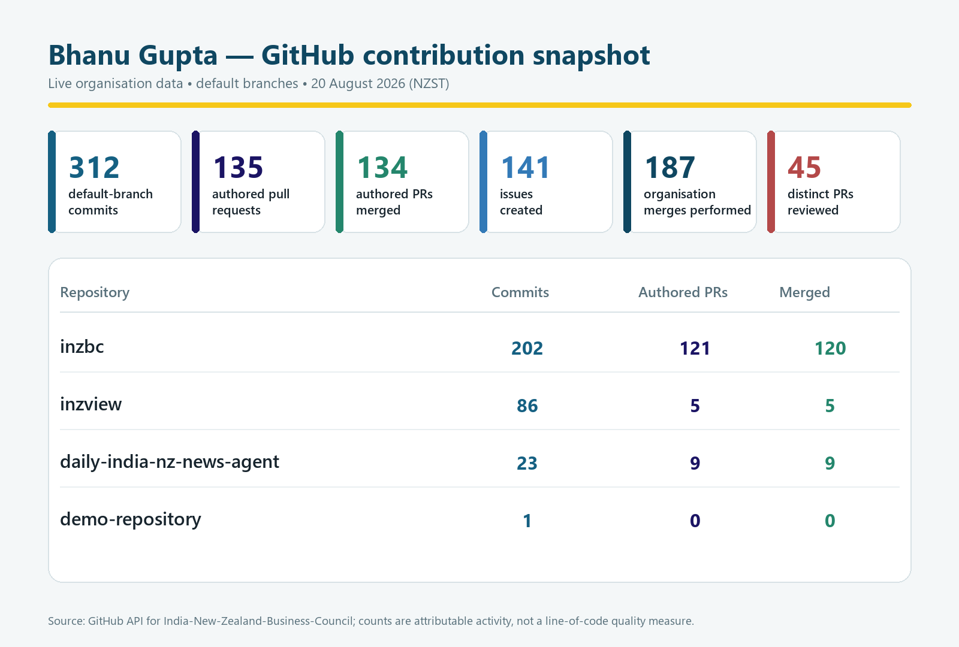
Figure 1. API-derived GitHub contribution snapshot for Bhanu Gupta across all four organisation repositories.
Foundation, contracts and architecture. I established the initial AI architecture and repository operating model, added the README, contribution rules and pull-request templates, scaffolded the monorepo, and published shared contracts. I then added the SIP-185 mandatory source register keyed by stable source identifiers, the model gateway and SIP-050 scoring path, the fail-closed SIP run state machine, system architecture and data-model diagrams, and an operator guide that made inzbc the controlled source for SIP documentation. Representative evidence includes pull requests #1, #3, #16, #27, #34, #67, #71 and #72.
Application services and user-facing contracts. I helped move the project from documents and prototypes into an integrated FastAPI and PostgreSQL service with a generated frontend contract. Work included the distinct FTA no-match outcome, the FTA query endpoint, the React query component and escalation state, public API hardening, report submit/read endpoints, dashboard data, the audit read endpoint, persisted orchestrator rehydration, and GitHub sign-in. Pull requests #83, #85–#87, #240, #296, #302, #305, #308 and #311 show that progression.
Security and trust controls. I treated the safety rules as executable system behaviour. The implementation refuses model use until an approved redaction policy exists, rejects ineffective redaction, blocks unauthorised gated transitions, adds session authentication and role checks, closes separation-of-duties bypasses, records decisions and audit evidence as append-only events, makes Semgrep blocking, and records an adversarial SIP security review. The latest main branch also sends CSRF tokens on every SIP and Communications Assistant write. Representative pull requests are #164, #180, #224, #228, #272, #278–#279, #284–#285, #300, #306–#307 and #315–#316.
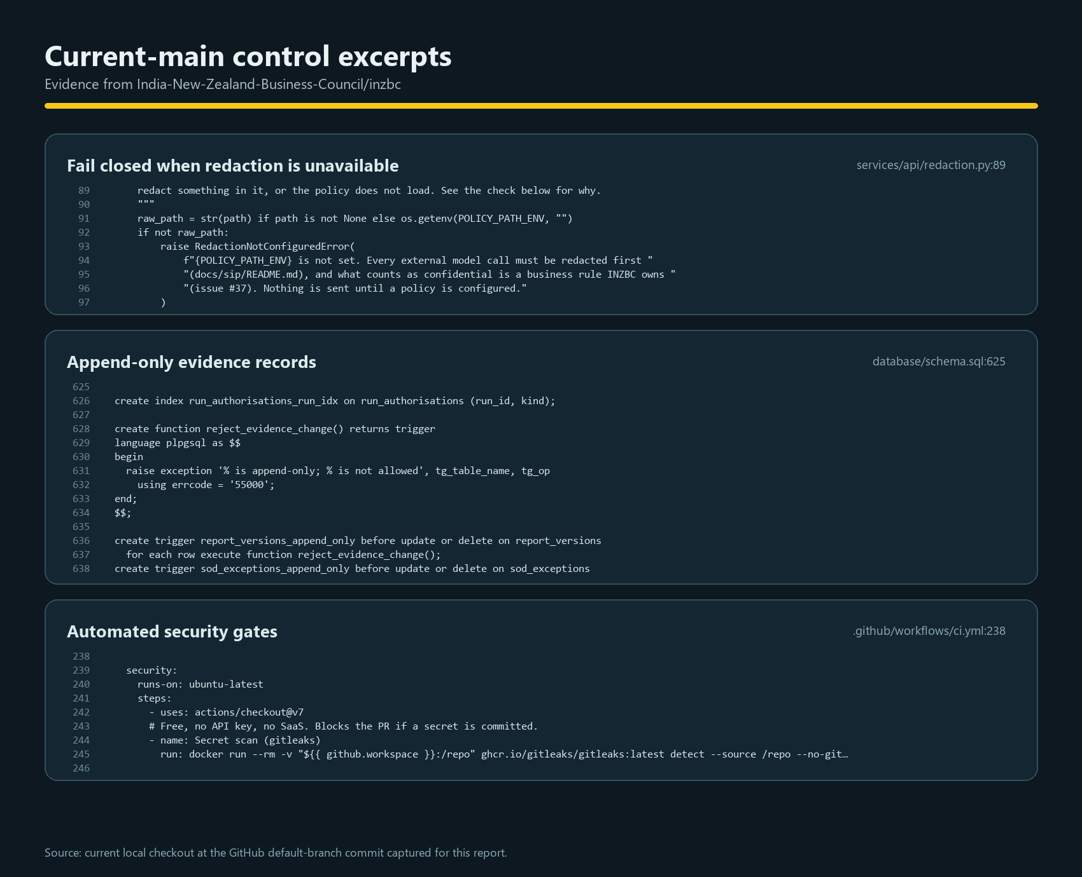
Figure 2. Current-main excerpts showing fail-closed redaction, append-only records, and automated security gates.
Review and integration stewardship. Beyond my own changes, I used the shared pull-request queue to challenge correctness, security, tests, contracts and operational claims before integration. The current history contains 60 review events across 45 distinct pull requests: 25 pull requests received an approval from me and 21 received at least one changes-requested review. Those sets overlap because some pull requests were corrected and reviewed again. I performed 187 of 189 organisation merges; the two exceptions are noted later as a governance learning point.
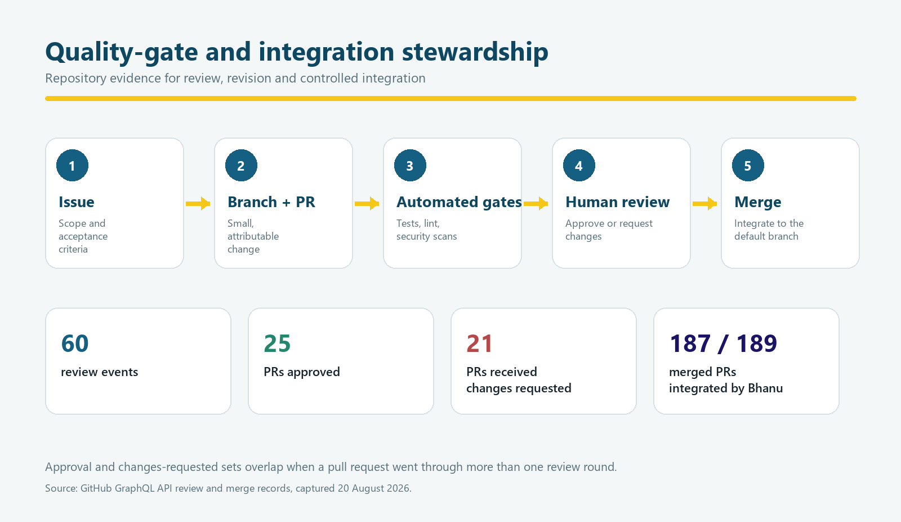
Figure 3. Issue-to-merge quality gate and Bhanu's review/integration evidence.
Cross-repository delivery. In inzview I authored five merged pull requests and contributed 86 default-branch commits covering the cinematic Trade Thread homepage, a future-facing corridor concept, the homepage effects reel, the full effects reel, and motion/readability fixes. The images below are real browser renderings of two design-preview files fetched from the latest private inzview main branch at the time of evidence collection. They demonstrate how the technical work supported the Council's public-facing trade narrative rather than remaining only in backend services.

Figure 4. Cinematic inzview homepage concept rendered from the latest main-branch design preview.

Figure 5. Parallax inzview homepage concept rendered from the latest main-branch design preview.
In daily-india-nz-news-agent I authored nine merged pull requests and contributed 23 default-branch commits. This work added governance documents, a controlled launch and distribution gate, a branded HTML brief, scheduling and backup changes, CI and security checks, dependency maintenance, and links back to the main repository for controlled SIP documents. The small demo-repository contains my initial commit but no substantive placement deliverable; I include it only so the organisation-wide count is complete.

Evaluation of Problems and Technologies
The central technical problem was not simply generating AI content. INZBC needed a system that could use trade evidence without inventing facts, protect member and operational data, preserve accountable human decisions, and remain supportable after a student placement. I therefore evaluated technology against four properties: explicit contracts, enforceable safety rules, testability at the real boundary, and a credible operational handover.
FastAPI, Pydantic and OpenAPI were effective because the same request and response definitions could drive runtime validation, published API documentation, generated TypeScript types and contract-drift checks. The limitation is that generated types create a maintenance obligation: schema changes must be deliberate and regenerated rather than patched in the frontend. The repository's CI enforces that discipline.
PostgreSQL was preferable to a spreadsheet as the operational system of record because transactions, foreign keys, row locking, append-only triggers and role grants could express the audit and decision model directly. It also exposed real design problems early: concurrency, immutable evidence, separation of duties and recovery cannot be solved reliably by UI conventions alone. The trade-off is higher deployment and migration responsibility, which is why backup, monitoring, migration and rollback documents were treated as product work.
React, TypeScript, Vite and Astro supported distinct product needs. React and generated types suited interactive FTA, SIP and Communications Assistant workflows; Astro and focused HTML previews suited public-site composition and motion experiments in inzview. The multi-repository arrangement increased coordination cost, but it also kept a public-site experiment from destabilising the controlled SIP service. Shared brand decisions and client-owned hosting still need to be resolved before a single production experience is claimed.
GitHub Actions and ProjectV2 gave the team a durable audit trail for scope, review and integration. CI catches repeatable problems; it does not replace judgement about business rules, evidence quality, privacy or human approval. The review history shows both automated gates and active human challenge. ProjectV2 made blockers visible, although the status reconciliation described in section 6 shows that a board also needs regular maintenance to remain trustworthy.
The repository metrics have limits. Commit and pull-request counts do not measure design quality, and merge commits can amplify activity. For that reason I report default-branch attribution, distinguish authorship from review and merge stewardship, and pair the counts with representative controls, rendered deliverables, and live project state. This makes the portfolio reproducible without presenting volume as the result by itself.

Communication for Sustainable Productivity
I used written artefacts to make technical discussion sustainable. The project charter defines roles, ownership and non-negotiable business rules; CODEOWNERS identifies who must review sensitive paths; workstream logs record lane-specific work; ADRs preserve decisions; issue descriptions carry context and acceptance criteria; and pull requests explain the proposed change, tests, risks and linked issue. This reduced the need to reconstruct decisions from chat messages or from whichever developer happened to remember them.
My 141 authored issues show how I converted broad requirements into traceable work. Review communication was equally important: 60 review events included both approvals and explicit requests for correction. Changes-requested reviews were not treated as failure; they were a controlled feedback loop for fixing security gaps, contract drift, unsupported claims, missing tests and handover problems before merge.
For client-dependent questions I recorded the consequence as well as the question. For example, choosing an identity model affects every protected page and the separation-of-duties design; naming the human reviewer determines whether AI-drafted content can legally and operationally move forward; and deciding whether to retain Member Jungle changes the membership integration boundary. This made meetings more productive because the decision pack showed what would remain blocked and why.
Sustainable communication also means leaving an operable system. I contributed architecture and data-model diagrams, API and integration specifications, an operator guide, security and privacy registers, backup and monitoring guidance, incident response, migration and rollback plans, environment guidance, governance and RACI material, and controlled links between repositories. The goal was that a future INZBC maintainer could understand both how the software works and which business approvals it still requires.

Managing the project
The private INZBC SIP Platform project contains 138 items. At the evidence date, 79 cards were assigned to me: 54 issues and 25 pull requests. Their lanes were Platform 45, Product & UX 12, Process 10, Client 8, and Intelligence & Data 4. Priorities were 32 Must, 43 Should, and 4 Could. The displayed status was 32 Done, 2 In Progress, 9 Blocked, and 36 Todo.
I reconciled the board fields against the underlying GitHub state rather than accepting the displayed column alone. All 25 assigned pull-request cards were merged. Of the 54 issue cards, 32 were closed and 22 were open. However, 25 of those closed issue cards still displayed Todo or Blocked. Therefore the repository state supports 57 closed-or-merged assigned items, while the board shows only 32 Done. This is a workflow-status hygiene problem: it understates delivery and makes forecasting less reliable, but it does not justify silently rewriting historical evidence.
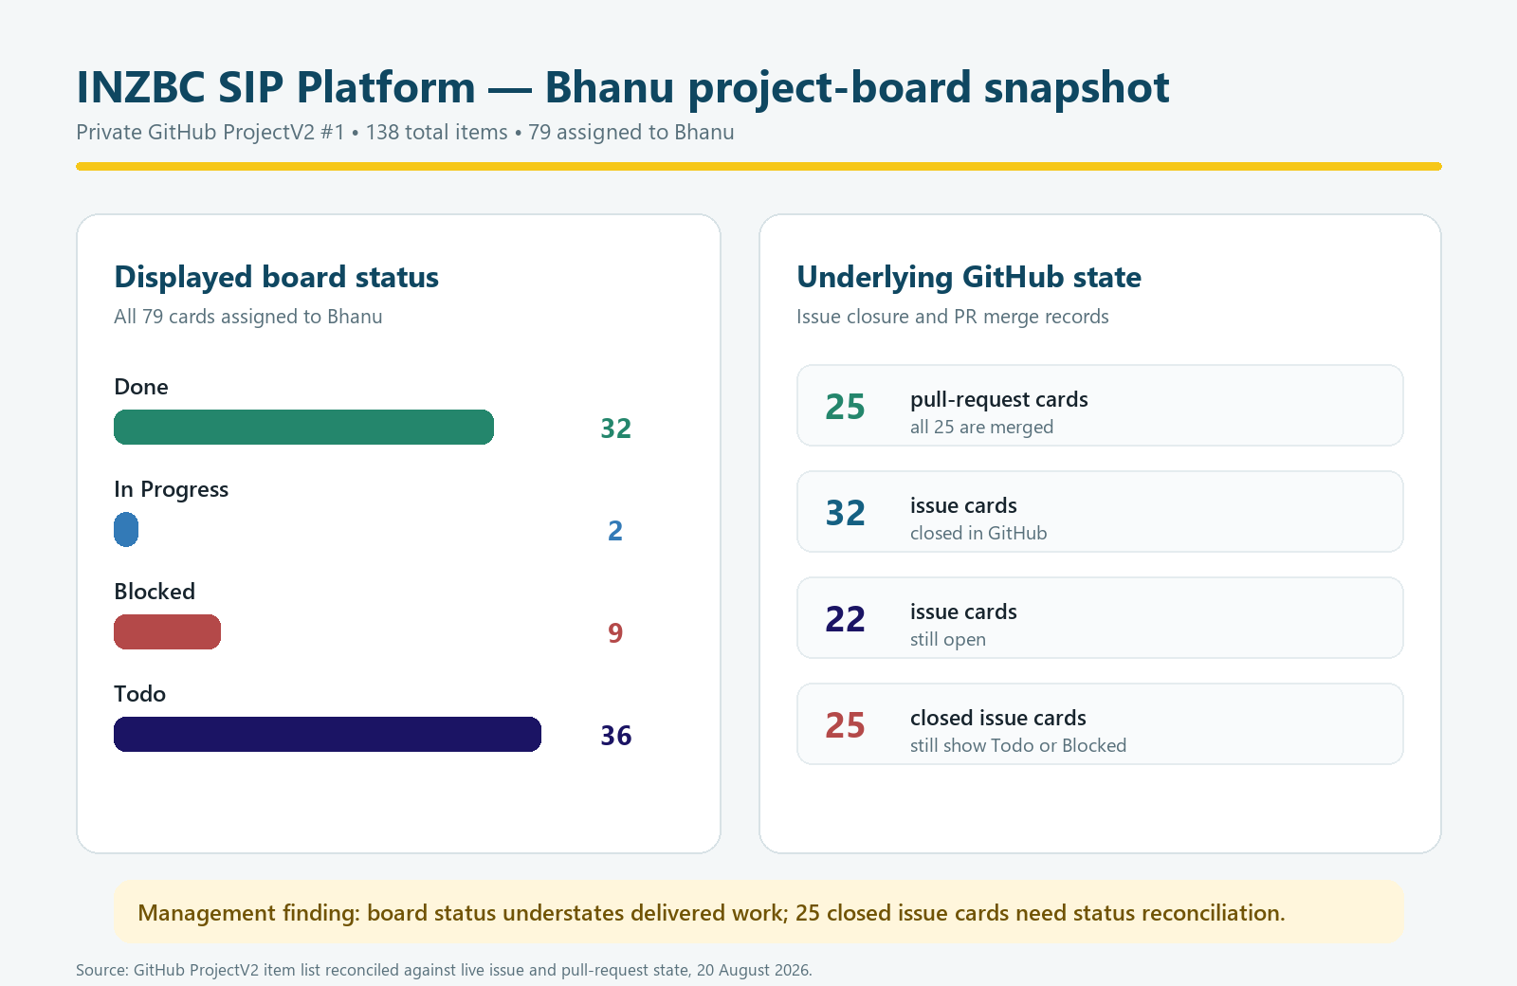
Figure 6. ProjectV2 status snapshot reconciled against live issue and pull-request state.
The two items genuinely marked In Progress were issue #38, the SIP-050 evaluation harness with golden-set, regression and prompt-injection cases, and issue #62, the agentic SIP-184 daily-run orchestrator with tool use and hard human gates. Both are Must-priority Platform work. The nine displayed blockers include real technical dependencies and client decisions; the most consequential Must items are #95 (Member Jungle), #96 (named human reviewer), #115 (organisation secrets and rotation policy), and #213 (identity and login model).
For the next reporting cycle I would run a short reconciliation routine: compare closed issues and merged pull requests to the board, inspect acceptance criteria before changing status, add a dated reason when an apparently closed issue remains blocked, and make phase and status updates part of the definition of done. The repository already contains a safe script for editing board options, which avoids damaging single-select option sets.

Issues and Challenges
Client-owned production decisions. Identity, membership platform boundaries, the named human reviewer, production secrets, OAuth ownership and long-term operations cannot be decided by the placement team. Keeping these items blocked protects the Council from an attractive demonstration being mistaken for an authorised production service.
Board status drift. Twenty-five closed issue cards still display Todo or Blocked. This makes a simple board screenshot misleading and weakens milestone reporting. The practical response is a regular evidence-based reconciliation, not a bulk status change without checking acceptance criteria and dependencies.
Multi-repository and branch coordination. The controlled SIP service, the public-site experiments and the daily collection engine move at different speeds. The latest live GitHub default branches were therefore used as the source of truth for this report. I did not overwrite the existing dirty local inzview checkout; this avoided losing another developer's uncommitted package change while still producing current evidence.
Governance exceptions. The project charter assigns merge stewardship to me. GitHub records show that I merged 187 of 189 merged pull requests; inzbc pull requests #257 and #275 were merged by Roshan. The changes themselves were documented, but the exception should be recorded or the policy revised so the written control matches actual practice.
Dependency and tooling drift. At the evidence date, my only open authored pull request was #270, which upgrades Ruff to 0.16.0 and fixes new findings. This is a useful reminder that a green pipeline is time-bound: locked dependencies, generated-type checks and scheduled maintenance are necessary to keep repeatable quality gates from changing unexpectedly.

Conclusion
My contribution to the INZBC placement is best described as technical foundation and integration stewardship. I converted business safeguards into contracts, database constraints, API checks, user-interface states, tests, CI gates and review decisions; connected those controls to maintainable documentation; and helped integrate work across four repositories. The current evidence includes 312 attributable default-branch commits, 135 authored pull requests with 134 merged, 141 authored issues, 60 review events across 45 pull requests, and 187 of 189 organisation merges performed by me.
The strongest result is not the activity volume. It is the shape of the system: sourced trade answers can return no match, external model calls fail closed, prohibited data is refused at the model boundary, business writes require authenticated roles and CSRF protection, gated actions require authorisation and separation of duties, and decision and audit evidence is append-only. These controls make the project more credible for a membership organisation handling real people, decisions and trade information.
The remaining work is clear. Issues #38 and #62 are the active Must platform items; nine board items are shown as blocked; 25 assigned repository issues remain open overall; and the client must close the identity, reviewer, membership, secrets and ownership decisions before production. The board also needs status reconciliation. Completing those actions, keeping CI green and handing over the operational documents would move the platform from a strong controlled implementation toward an authorised and sustainable INZBC service.

References
- India New Zealand Business Council GitHub organisation
- INZBC AI Operating System repository
- inzview public-site repository
- Daily India–NZ news agent repository
- INZBC SIP Platform ProjectV2 #1
- Bhanu workstream record
- INZBC AI Operating System role and product overview
- Project charter and non-negotiable business rules
- Pull request #315 — CSRF token on every SIP UI write
- Pull request #300 — refuse prohibited data at the model boundary
- Pull request #272 — session auth, role checks and separation of duties
- Pull requests #85–#87 — FastAPI FTA endpoint, generated client and query UI
- FastAPI documentation
- PostgreSQL documentation
- GitHub Actions documentation
- GitHub Projects documentation
Evidence note: live GitHub REST, GraphQL and ProjectV2 data were captured on 20 August 2026. The repository visualisations in this report are labelled as API-derived snapshots; the two inzview figures are browser renderings of design-preview files from the latest private main branch. The retained Paras document supplied by the user was used as the layout and structure authority.

