Below is a desk-level explanation of the JPY swap market and the asset-swap market in Japan, how they actually function under YCC/Rinban, and why traders use swaps when the cash JGB market breaks.

🔄 JAPAN SWAP MARKET & ASSET-SWAP MARKET — HOW THEY REALLY WORK
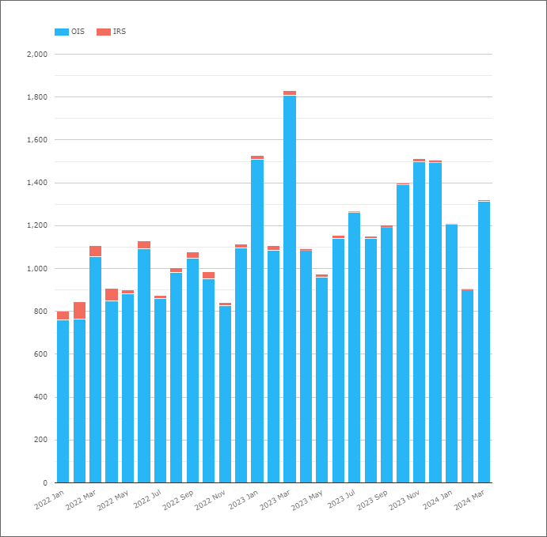
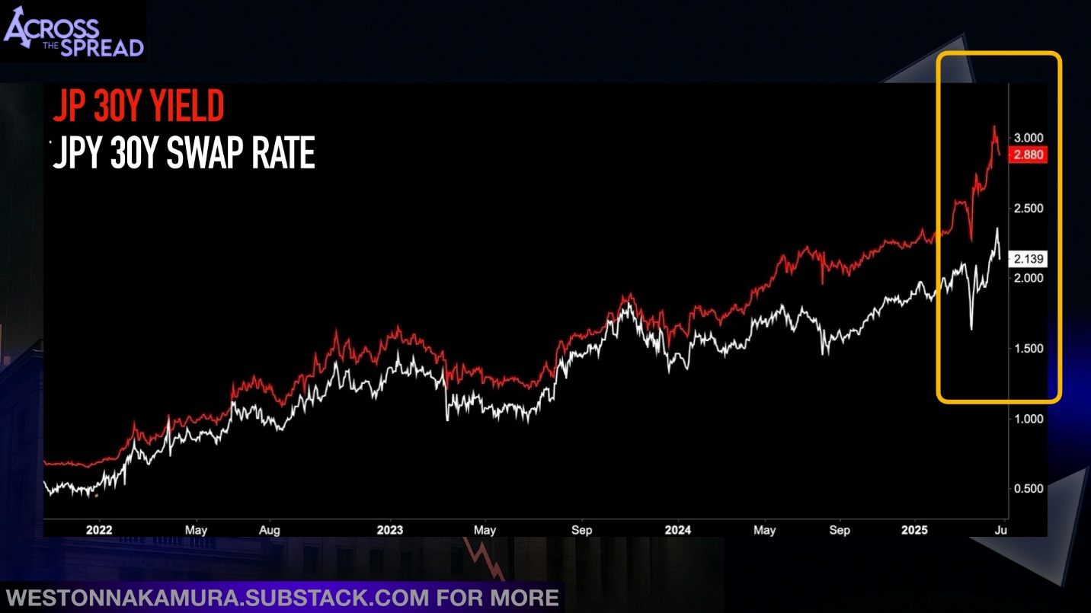
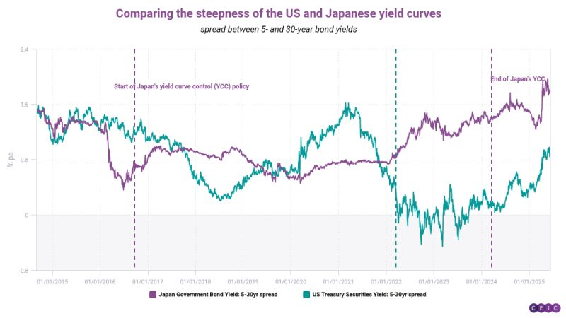

1️⃣ The JPY Interest Rate Swap (IRS) Market

What it is
A JPY IRS exchanges:
- Fixed rate
- vs Floating rate (now almost always TONA compounded)
[
\text{Pay / Receive Fixed JPY} \quad \leftrightarrow \quad \text{Receive / Pay TONA}
]

Key point
👉 Swaps are not constrained by bond supply or repo.
They are balance-sheet + credit instruments, not collateral instruments.

1.1 Why swaps matter more than cash JGBs in Japan
Because:
- BoJ owns >50% of JGBs
- Repo specialness distorts cash pricing
- Futures basis breaks arbitrage
- YCC caps the 10Y cash yield
So price discovery migrates to swaps.
In Japan, swaps = the “true” market rate, not cash bonds.

1.2 JPY swap curve vs JGB curve (stylised)
Curve | What it reflects
JGB curve | Policy + BoJ intervention
Swap curve | Market expectations + funding
Swap spread (JGB − swap) | Liquidity & policy distortion
When YCC is binding:
- JGB yields are pinned
- Swap rates drift higher
- Swap spreads collapse or turn negative

2️⃣ JPY SWAP SPREADS (CRITICAL CONCEPT)
[
\textbf{Swap Spread} = \text{JGB Yield} - \text{Swap Rate}
]

Normal world:
- Swap spreads positive
- Bonds cheaper than swaps (credit + liquidity)

Japan under YCC:
- Swap spreads zero or negative
- Swaps trade above JGBs
- Clear sign of policy distortion
Negative swap spreads = the bond market is no longer free.

2.1 What drives swap spreads in Japan
- Rinban intensity (more buying → tighter spreads)
- Repo specialness (scarce bonds → spreads compress)
- Issuance pressure (weak auctions → spreads widen)
- YCC credibility (more distortion → spreads invert)

3️⃣ The Asset Swap (ASW) Market in Japan

What is an asset swap
You:
- Buy a JGB
- Swap its fixed coupons into floating (TONA)
Net result:
You hold a floating-rate asset, secured by a JGB.

Asset-swap spread (intuition)
[
\text{ASW Spread} \approx \text{JGB yield} - \text{Swap rate}
]
(Same object as the swap spread, viewed from the bond side.)

3.1 Why asset swaps exist
They allow you to isolate:
- Bond liquidity & policy distortions
from
- Pure interest-rate expectations

4️⃣ Why ASW trading is huge in Japan

Reason 1 — Repo specialness
If a JGB is very special:
- Funding it is expensive
- Asset-swapped return deteriorates
- ASW spread tightens or inverts

Reason 2 — Rinban & YCC
When BoJ buys aggressively:
- JGBs richen
- ASW spreads tighten sharply
- Sometimes deeply negative
This is not credit risk — it’s policy plumbing.

5️⃣ Cash JGB vs Futures vs Swaps (who trades what?)
Market | Who uses it | Why
Cash JGB | Banks, BoJ | Policy, balance sheet
JGB Futures | Hedge funds, CTAs | Liquidity, leverage
JPY Swaps | Macro funds, banks | Clean rate signal
Asset Swaps | Dealers, RV desks | Measure distortion
When stress rises:
Cash → Futures → Swaps
(price discovery walks up this ladder)

6️⃣ How YCC distorts swaps & ASWs (step-by-step)
- BoJ caps 10Y JGB yield
- Inflation expectations rise
- Swap rates drift higher
- Swap spreads compress / invert
- Asset swaps look “rich”
- Liquidity migrates to swaps
This is why 10Y JPY swaps often trade above 10Y JGBs.

7️⃣ Macro interpretation (VERY IMPORTANT)

Rising swap rates + pinned JGB yields =
- Market pricing normalisation
- Policy lag
- Event risk rising

Widening ASW spreads =
- Issuance pressure
- Rinban insufficient
- Dealer stress

Collapsing / negative ASW spreads =
- Heavy BoJ buying
- Collateral scarcity
- Liquidity dysfunction

8️⃣ How traders actually use this (playbook)

📈 Trade 1 — YCC stress
- Receive JGBs
- Pay swaps
- Position for YCC break

📉 Trade 2 — Rinban increase
- Buy JGBs
- ASW tighten
- Swap spreads collapse

⚠️ Trade 3 — Liquidity breakdown
- Avoid cash bonds
- Trade swaps outright
- Buy JGB volatility

9️⃣ FX linkage (often overlooked)
When swaps price higher rates but JGBs are pinned:
- Rate differentials vs US remain wide
- JPY weakens
- FX becomes the main transmission channel
This is why swap-JGB divergence matters for USDJPY.

🔟 One-page mental model
Instrument | What it tells you
JGB yield | What BoJ allows
Swap rate | What market believes
Swap spread | How distorted liquidity is
ASW spread | How hard BoJ is leaning
Futures basis | Dealer balance-sheet stress

🧠 Final takeaway
In Japan, swaps are the truth, JGBs are the policy, and asset swaps measure the lie.
If you want next, I can:
- Walk through a numerical JGB → ASW example
- Explain why negative swap spreads are dangerous
- Build a Japan rates market map (issuance → Rinban → repo → basis → swaps)
- Link swap distortions to FX options skew
Just tell me which one.

