OXID eShop Module for Sofort.

**Manual**

Version 7.0.1  
29.08.2017

**For use with  
OXID eShop CE/PE/EE**

tronet GmbH  
Klevstraße 4  
D-53840 Troisdorf

Phone +49 2241 8729-0  
Fax +49 2241 8729-13  
Website www.tronet.media

**Table of contents**

Freeware-License Agreement 3

General 5

Imprint 5

Functional description 5

Requirements 5

Supplied 6

Support and service 6

Frequently Asked Questions 7

Tested OXID eShop-Versions 7

Getting started 8

Requirements 8

Update FROM MODULE-VERSION 4.8 or less 8

Update FROM MODULE-VERSION 6.0 or HIGHER 8

Update FROM MODULE-VERSION 7.0 or HIGHER 8

Installation 9

Testing interface 10

Configuration/Administration 11

Module-Settings 11

Dashboard 12

Orders 13

Tab „Sofortgateway-Log“ 13

DEINSTALLATION 15

Known Problems with ERP’s 16

# Freeware-License Agreement

This is a license agreement between you and the tronet GmbH. By installation and use of the software, you confirm that you have read the license agreement and agree with it. If you do not agree with one or more parts, you are not authorized to install this software, distribute or use it.

**License**

The license agreement legitimates you to install and use the software on one or more computers. The license for the software is free. You are not entitled to technical support of any kind. The tronet GmbH is not obliged to provide maintenance or revision of the software.

**Copyright**

All rights, ownership rights and intellectual property rights in and to the software and all copies thereof and all documentation related thereto are the property of tronet GmbH. All rights are reserved. The tronet GmbH reserves the right to take legal action in the event of a breach of this agreement.

**Restrictions on use**

The license agreement will not allow you to create source derivations, alter, disassemble, or disassemble, decompile, nor to install any proprietary notices or labels on the program without obtaining the prior written consent of tronet GmbH.

**Distribution**

The software may be distributed freely. However, you may not charge costs for the transfer.

**Warranty and Liability**

The software is provided without warranty by the tronet GmbH of any kind, neither explicit nor implied, including, but not limited to implied warranties of suitability, fitness for a particular purpose or non-infringement. The entire risk arising out of the installation, the use or performance of the software remains with you. In no case may the tronet GmbH be held liable for any damages whatsoever (including, but not limited to lost profits, business interruption, loss of business information or any other property or personal injury) that resulting from the installation or use or inability to use the software arise, even if the tronet GmbH has been advised of the possibility of such damages.

**Legal claims**

The law of the Federal Republic of Germany applies. Jurisdiction is Siegburg. If any provision of this agreement is invalid or loses its effectiveness through a later circumstance law, as a result, the validity of the remaining provisions will not be affected. The invalid provision will be replaced by such valid provisions that come closest to the economic purpose.

# General

## Imprint

tronet GmbH

Klevstraße 4

53840 Troisdorf

Phone: +49 (2241) 8729-16

Fax: +49 (2241) 8729-13

E-Mail: [vertrieb@tro.net](mailto:vertrieb@tro.net)

Internet: [www.tronet.media](http://www.tronet.media)

Register court: Amtsgericht Siegburg

Register number: HRB 4852

Sales tax identification number: DE 182 635 057

Managing Director: Oliver Merklinghaus

## Functional description

The OXID eShop interface for Online bank transfer. (further references as Sofort.) extends an existing installation of the software OXID eShop by the payment method Sofort..

OXID eShop is a software by OXID eSales GmbH, Freiburg, Germany. It is available at [www.oxid-esales.com](http://www.oxid-esales.com/).

Sofort. is an online payment service of SOFORT AG, Gauting. The registration / establishment of the service is done at [www.sofort.com](https://www.sofort.com/).

The SOFORT AG charges transaction fees for using the service.

## Requirements

In order to use this interface, OXID eShop with a minimal version of 4.7 is required. The shop has to calculate prices in either Euro (EUR), Swiss Franc (CHF), Great Britain Pounds (GBP), Polish Zloty (PLN), Hungarian Forint (HUF) or Czech Koruna (CZK).

In order to use this interface, the shop operator must be registered with a valid user account for Sofort..

## Supplied

This package is delivered with the following contents:

1. Folder *copy_this*
2. This manual

## Support and service

If you encounter any problems with the installation or operation of the interface, contact us at:

SOFORT AG

Fußbergstr. 1

82131 Gauting

Phone +49 (89) 20 20 889 – 400

E-Mail integration@sofort.com

We also offer the installation of the interface in your online shop for you. Please inquiry such a request to:

tronet GmbH

Klevstraße 4

53840 Troisdorf

Phone +49 (2241) 8729-0

Fax +49 (2241) 8729-13

Website [service.tro.net](https://service.tro.net)

## Frequently Asked Questions

Head over to <http://www.tronet.media> and take a look at the FAQ’s.The FAQ’s are available at ONLINE-SHOP->OXID Schnittstelle Sofortüberweisung. The FAQ is available in german.

If your question cannot be answered, feel free to create a ticket at <http://service.tro.net>.

## Tested OXID eShop-Versions

The interface has been tested on the following versions:

1. OXID eShop CE v4.7.0 - 4.10.0
2. OXID eShop PE, v4.7.2 - 4.10.0
3. OXID eShop EE, v5.0.2 - 5.3.0

# Getting started

## Requirements

If you already have an account at the SOFORT AG, please keep the access data ready for use during the installation.

## Update FROM MODULE-VERSION 4.8 or less

1. In your Shop-Backend, deactivate the module “Sofortüberweisung Classic by tronet”
2. Delete the payment Method “Sofortüberweisung” under Shop Settings > Payment Methods  
   (the new extension comes with its own payment method and its own ID. Deleting the old payment method will prevent confusion)
3. Delete the folder /modules/trosofortueberweisung/
4. Install the new module as described under section “Installation”

## Update FROM MODULE-VERSION 6.0 or HIGHER

1. In your Shop-Backend, deactivate the module “tronet SOFORT.”
2. Delete the folder /modules/tronet/trosofortueberweisung/
3. Copy all files from the directory copy_this with identical paths in your store.

**IMPORTANT: Make sure that the files are transferred in binary mode.**

1. Active the module “tronet Sofort.” again
2. The new version is ready to use. You don’t need to change any other configurations

## Update FROM MODULE-VERSION 7.0 or HIGHER

With the release of the Version 7.0.0, we added a functionality to make the update-process easier. If there is a new version available, you’ll receive a notification in your shop backend.

The message should look like this:

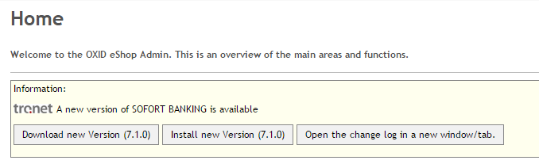

The output may vary depending on your backend-layout or theming.

From here on, you can choose to download the new version to your harddrive. Choose this option, if you want to install the module later manually. If you install manually the update procedure is the same as for the 6.0 versions.

You can also install the new version automatically. If you modified your files, you’ll get a prompt if you really want to continue. You get a list of modified files as well, which may differ from the current ones. This approach helps to update a configured module.

If you are uncertain whether or not to update, you can see the ChangeLog for the new version.

**What happens during an automatic update?**

Before the module update is actually performed it will be checked whether module core files have been adjusted. If files have been adjusted the user will be informed and can decide whether he/she wants to continue or cancel the update process. In case no files have been adjusted or the user decided to continue the new version will be fetched from a tronet server and extracted into the OXID tmp/* directory. Once data are extracted into tmp/* directory a backup of the current module will be created and saved in the OXID export/* directory. If the backup fails for some reasons the user is asked whether to continue or not. In the next step the actual update is performed. After the update is performed successfully a clean-up task is performed.

## Installation

1. Copy all files from the directory copy_this with identical paths in your store.
2. Login to the admin-area of your shop
3. Choose: Extensions->Modules->tronet Sofort.
4. Click on activate. A payment method Sofort. will be created.
5. Choose „settings“
6. Enter your Configuration-key of your SOFORT-GATEWAY-project

**Your configuration-key is located at your account on sofort.com, choose your SOFORT Gateway-Project->Base settings->General settings**

1. Optional edit the reason of the money transfer to your own preferences

**You can use several placeholders that will be replaced by the actual value of the order.  
[BSTNR] will be replaced by the order number  
[KNR] will be replaced by the customer number  
[KNAME] will be replaced by the customer’s name  
[DATUM] will be replaced by the date of the order  
[PRICE] will be replaced by the total price of the order**

1. Click „save“

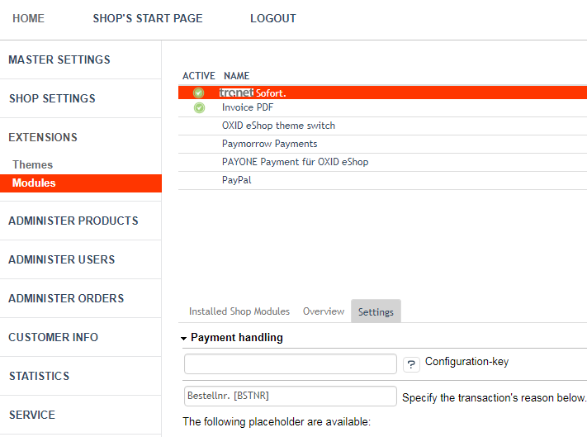

1. Now you can configure your new payment-method SOFORT. in your shop. This contains assignments of countries, user-groups and shipping-methods.   
   In the unlikely event if there is no payment-method SOFORT., you can created it manually by running the SQL-Statements of the file Install.sql

The interface is now ready for use!

## Testing interface

The installation is complete. Please check the interface on your system.

We recommend that you now perform a transfer in test mode, in which there is no genuine transaction. To do this, sign in into your project at sofort.com and activate the test mode for your project in the quick settings (the information that you need for the test order, you will also find here). After a successful test run, you should turn off the test mode.

# Configuration/Administration

After the installation, some new functions are now available in the administration-area of your shop:

## Module-Settings

At Extensions->Modules->tronet Sofort. ->settings you can set a new configuration-key to connect your shop to a different project at SOFORT.



You can enter 2 reasons for your transaction, which will then be displayed in the regarding order. You have access to some placeholders, which you can see below.

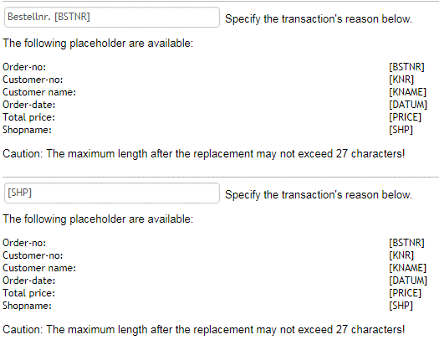

You also have the option to choose, what will happen with canceled orders. Either you choose “Cancel” (default) or “Delete”. Canceled orders will be grayed out in the order overview and will keep the order-number for references. Deleting canceled orders will remove the orders permanently.

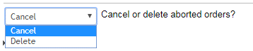

If you want to disable notifications regarding new updates of the module, you can disable the checkbox on the very bottom of the settings. You still can check for new versions manually via menu item "tronet SOFORT Banking” on the left side of the navigation.

## 

## Dashboard

The Dashboard is accessible via the menu item "tronet Pay Now.” and contains in version 7.0.0 and higher a manual update check.

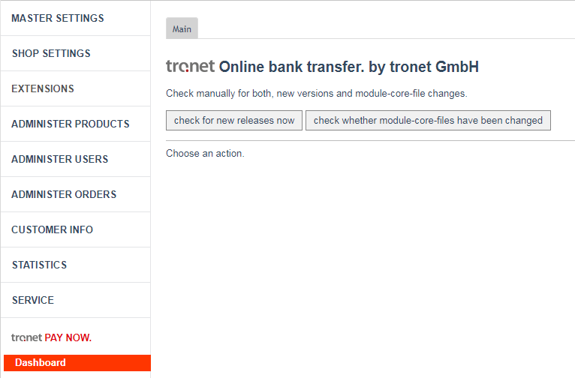

## Orders

At Orders->Orders->Overview you will find the current status of the payment in the parenthesis behind “Paid with: Sofortüberweisung” on the bottom of the overview, if an order paid with Sofortüberweisung was selected.

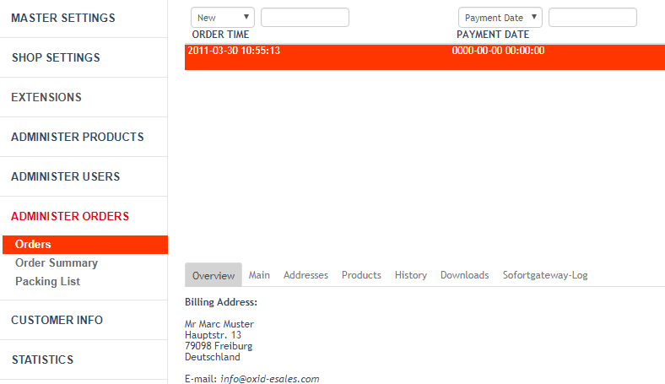

## Tab „Sofortgateway-Log“

At Administer Orders->Orders->Overview you can see a list of status messages that the Payment Network has sent to the shop. Select a message in the list on the left. A detailed description is shown on the right.

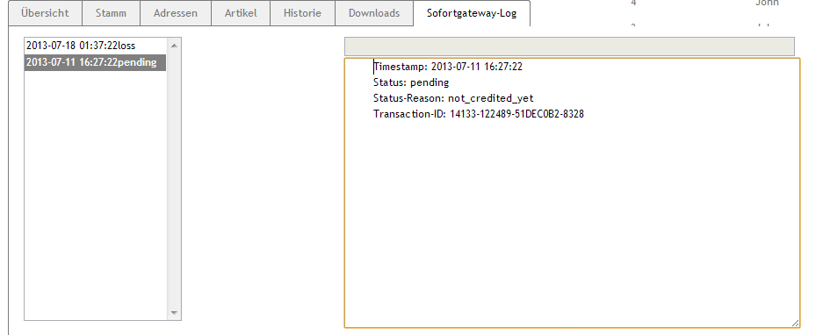

To use this service, log into the backend of the SOFORT AG. Select your Gateway project, select the tab “Extended settings” and choose “Notifications”. There should be at least one entry with the target “(POST) <http://url-to-your-shop/index.php?cl=trosofortueberweisung_notification>”.

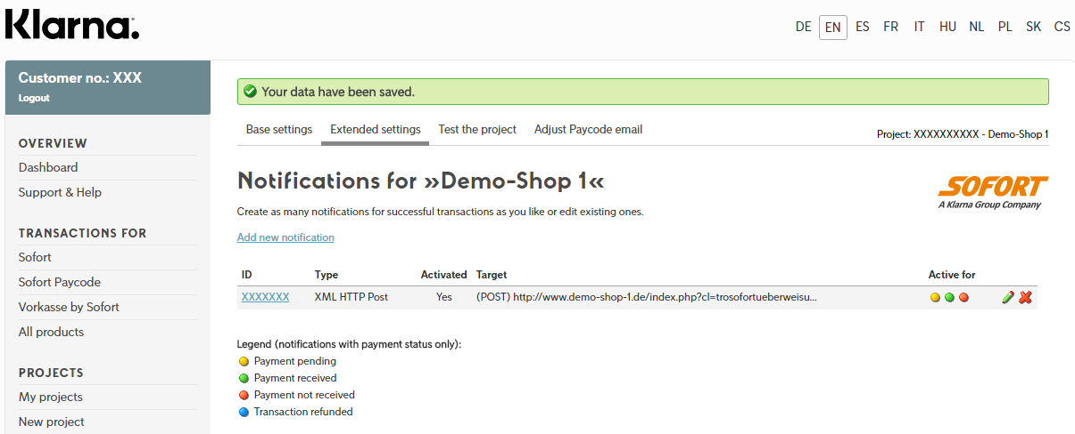

Click on “Edit”.

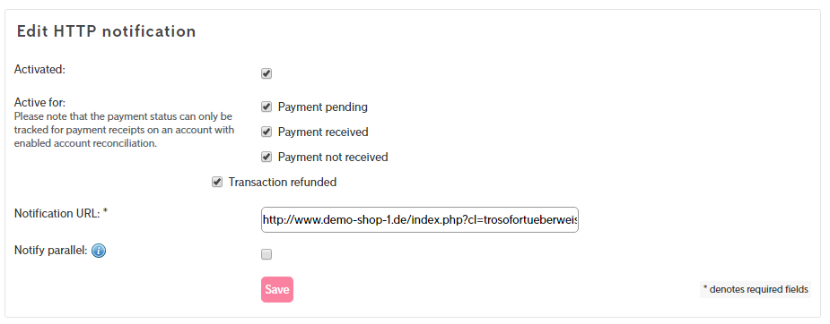

If you have a SOFORT Bank account, you can activate several notifications.

**Please note: Without a SOFORT Bank account, the status will always stay on “pending” in the Oxid-Shop as no further notification will be send to your shop.**

## DEINSTALLATION

If you have to remove the extension, first deactivate the module in the OXID-backend. Now you can delete the payment method SOFORT Überweisung.   
Finally, remove the subfolder /modules/tronet/trosofortueberweisung/ and the MySQL-table trogatewaylog.

## Known Problems with ERP’s

In case the customers closes the browser during his payment-procedure, the generated order will stay with the OXID order-state NOT_FINISHED. Due to restrictions of the SOFORT API, we can’t get rid of these yet.

We advice to setup a cronjob, which takes care of these unwanted (and unfinished) orders.

We provide two basic queries which either deletes or cancels certain orders.

The following query will remove every order which is NOT_FINISHED, older than 1 hour, was paid with SOFORT UEBERWEISUNG and not canceled.

DELETE FROM `oxorder`   
WHERE `OXTRANSSTATUS` = 'NOT_FINISHED'  
AND  
`OXPAYMENTTYPE` = 'trosofortgateway_su'  
AND   
`OXORDERDATE` < DATE_SUB(NOW(),INTERVAL 1 HOUR)

AND

`OXSTORNO` = 0;

The following query will cancel every order which is NOT_FINISHED, older than 1 hour, was paid with SOFORT UEBERWEISUNG and not canceled.

UPDATE `oxorder`

SET `OXSTORNO` = 1  
WHERE `OXTRANSSTATUS` = 'NOT_FINISHED'  
AND  
`OXPAYMENTTYPE` = 'trosofortgateway_su'  
AND   
`OXORDERDATE` < DATE_SUB(NOW(),INTERVAL 1 HOUR)

AND

`OXSTORNO` = 0;

(You mave have to replace the ticks due to the MS Word display)