**Internet Speed Test App**

Project Description: The Internet Speed Test App is a Python-based application that measures internet speed, including ping, download speed, and upload speed. It features a graphical user interface (GUI) built with Tkinter, real-time speed meter animation, and a history graph using Matplotlib.

Unique Features Added:

1. A visually appealing speed gauge dynamically adjusts to the download speed results.
2. Instead of a simple "Loading..." message, the app features a rotating glowing dots animation during speed testing.
3. Users can switch between different UI themes for better accessibility and aesthetics.
4. Automatically detects and displays the user's ISP (Internet Service Provider) using the ipinfo.io API.
5. Stores previous speed test results and showcases it in form of graph for better visualization.

Technologies/Libraries Used:

Core Technologies:

1. Python – Main programming language for logic and execution.
2. Tkinter – GUI framework used to create the user-friendly interface.

Libraries Used:

1. Speedtest-cli
2. Tkinter
3. Matplotlib
4. Requests
5. Socket
6. Threading
7. Math
8. Itertools
9. datetime

Screenshots of the UI: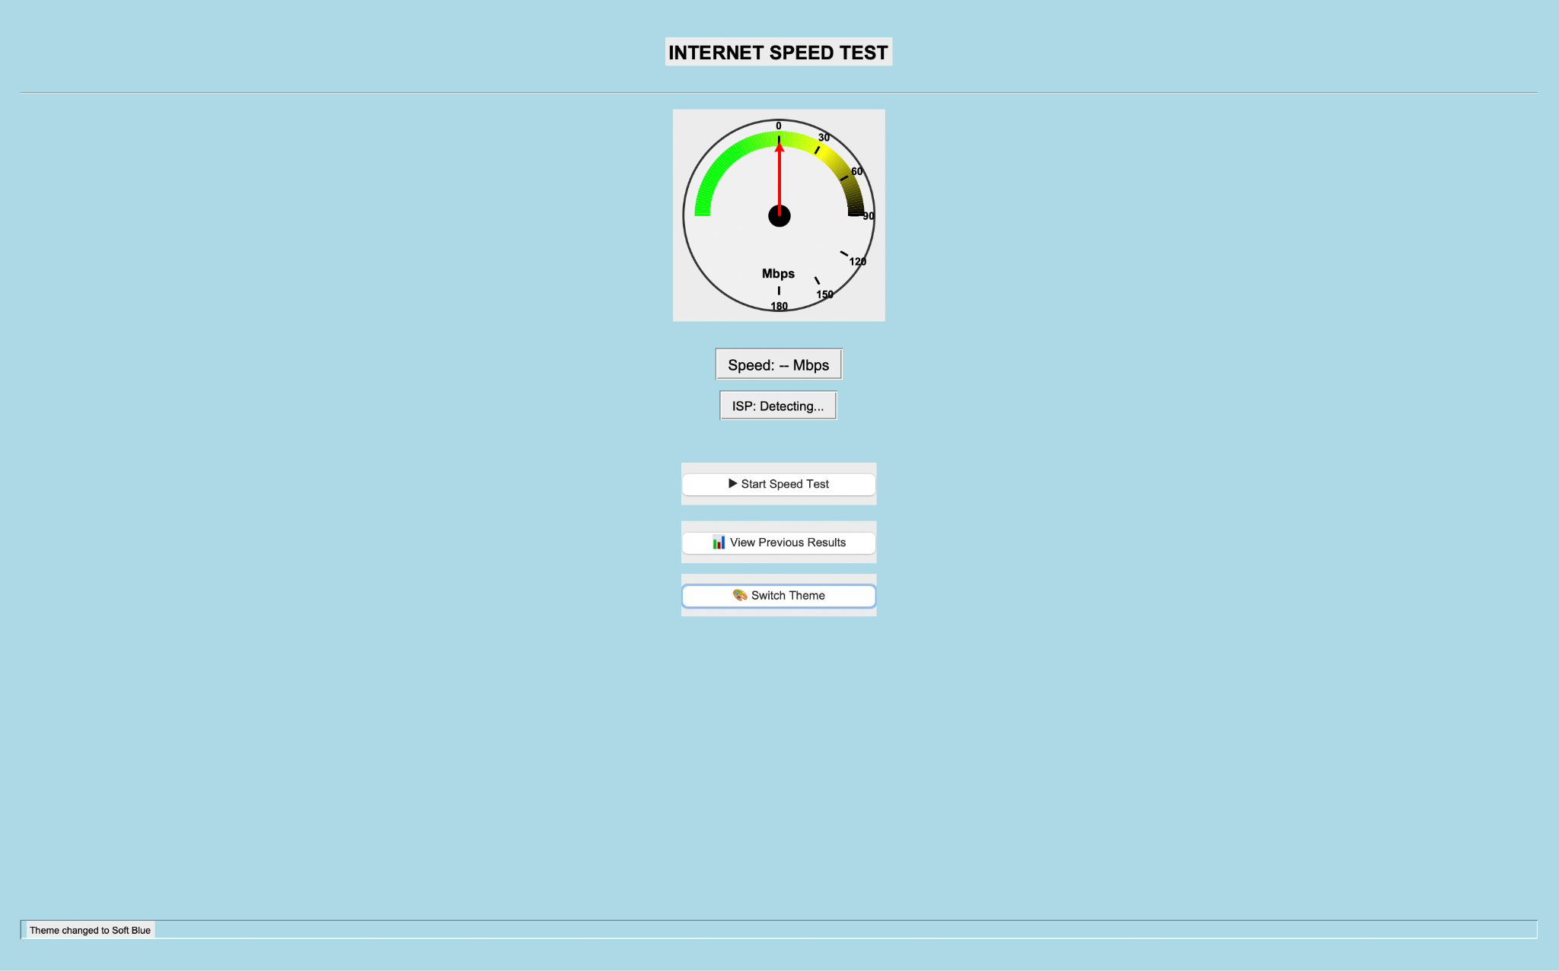

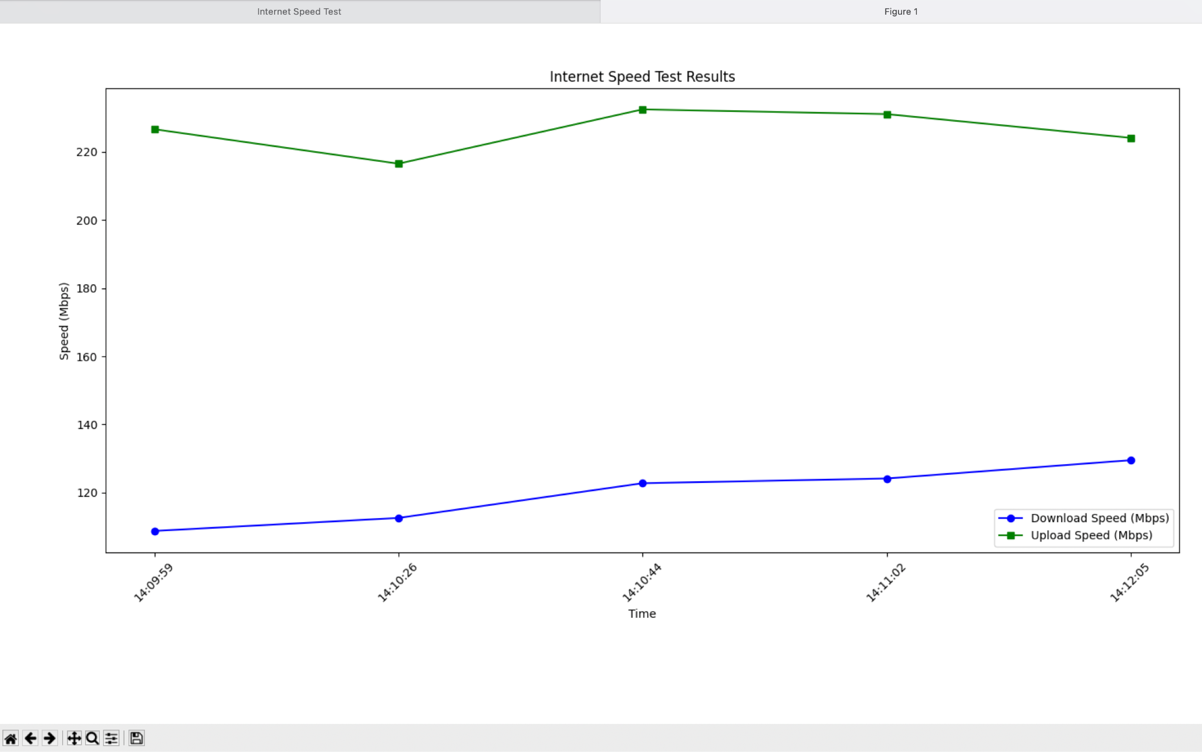

How to Run the Project ?

1. Clone the repository, Repository Link: <https://github.com/Indianworldruler/InternetSpeedTest>
2. Install dependencies, Which is requirements.txt
3. Save all the files in one directory.
4. Navigate to the directory where you have saved all the three files using terminal.
5. Run the application: python person1_ui.py
6. **NOTE !!!:** If not able to download the files from the repository, Download it from here: <https://drive.google.com/drive/folders/1bDM4nto1uF30CTZdSKOgYkCFu4jJoiMu?usp=sharing>
7. Now you have successfully downloaded all the three files!

How to use the app ?

1. Click on the “Start Speed Test” button.
2. It will take some time to load, Please wait patiently.
3. After some time the results will appear.
4. Test the speed three to four times and then click on “View Previous Results” button to get a proper graphical view of the history of the Speed tests.
5. Click on “Switch Theme” Button to switch between the themes.
6. If the app doesn't work, Then close and run it again.

Links of the repositories of my team members who contributed to the application or made the same application:

1. Rohan Samanta: <https://github.com/MapleNori/qr_code_gen.git>
2. Parth Sahani: <https://github.com/Indianworldruler/InternetSpeedTest>
3. Pratima Vanakhade: