Assignment 8 Hierarchical Clustering

Name: Parth Sahani
Cohort: Elon Musk
Roll Number: 150096724135

PLEASE TURN OVER

Screenshots:

This code imports the required libraries, loads the dataset, and checks its basic structure, shape, data types, and summary statistics.
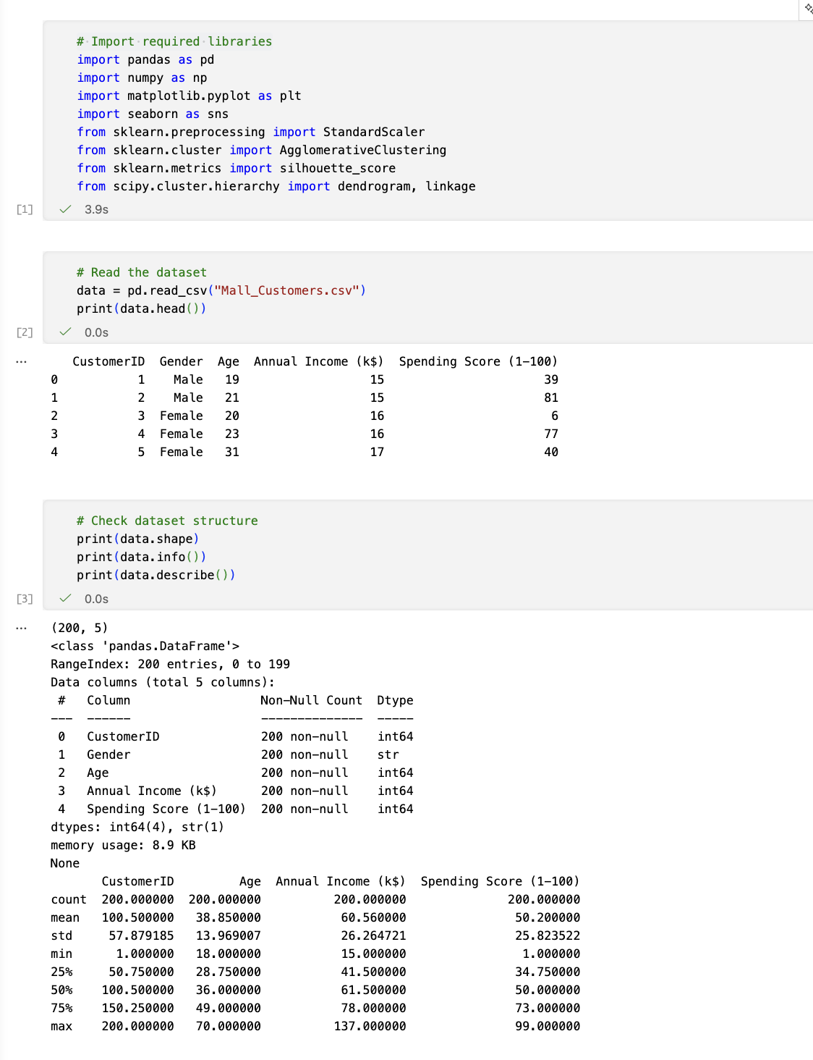
This code checks for missing values in the dataset and then creates a histogram to show the distribution of customer ages.
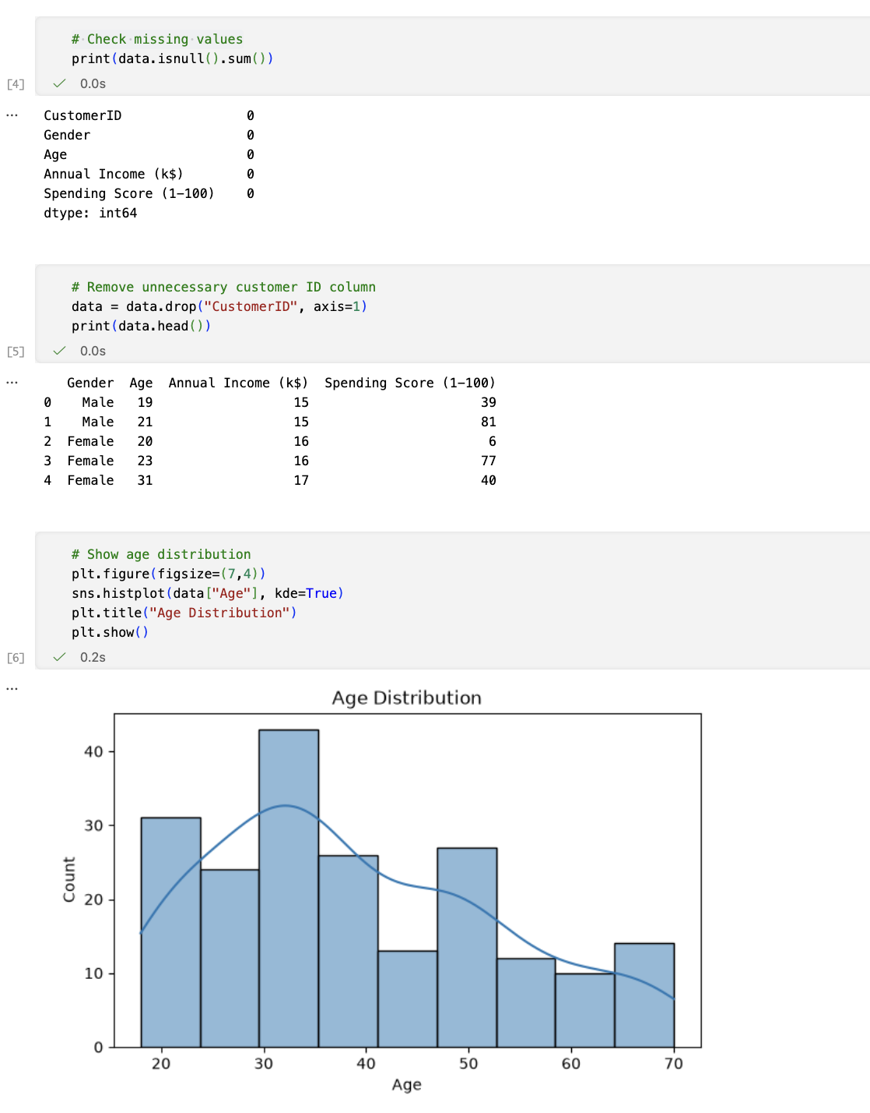
This code creates histograms to show the distributions of annual income and spending scores among the customers.
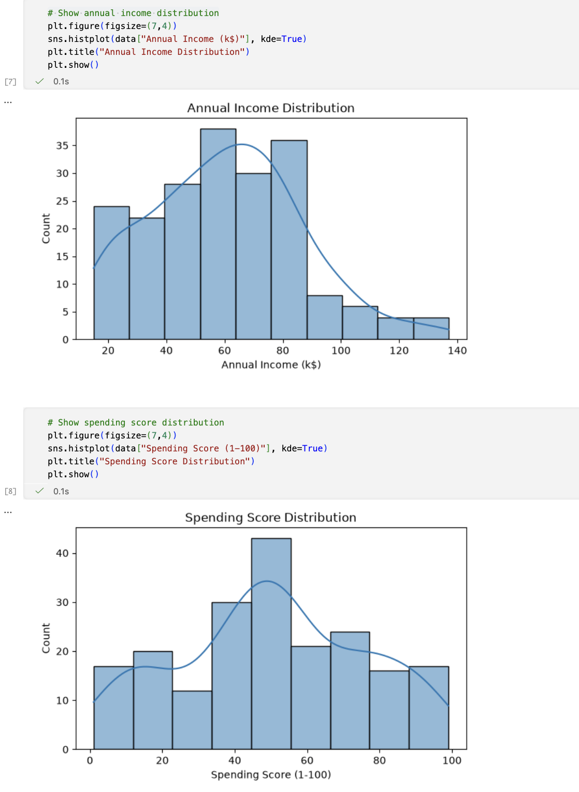
This code creates a scatterplot to compare annual income with spending score and a heatmap to show the correlations between the numerical features.
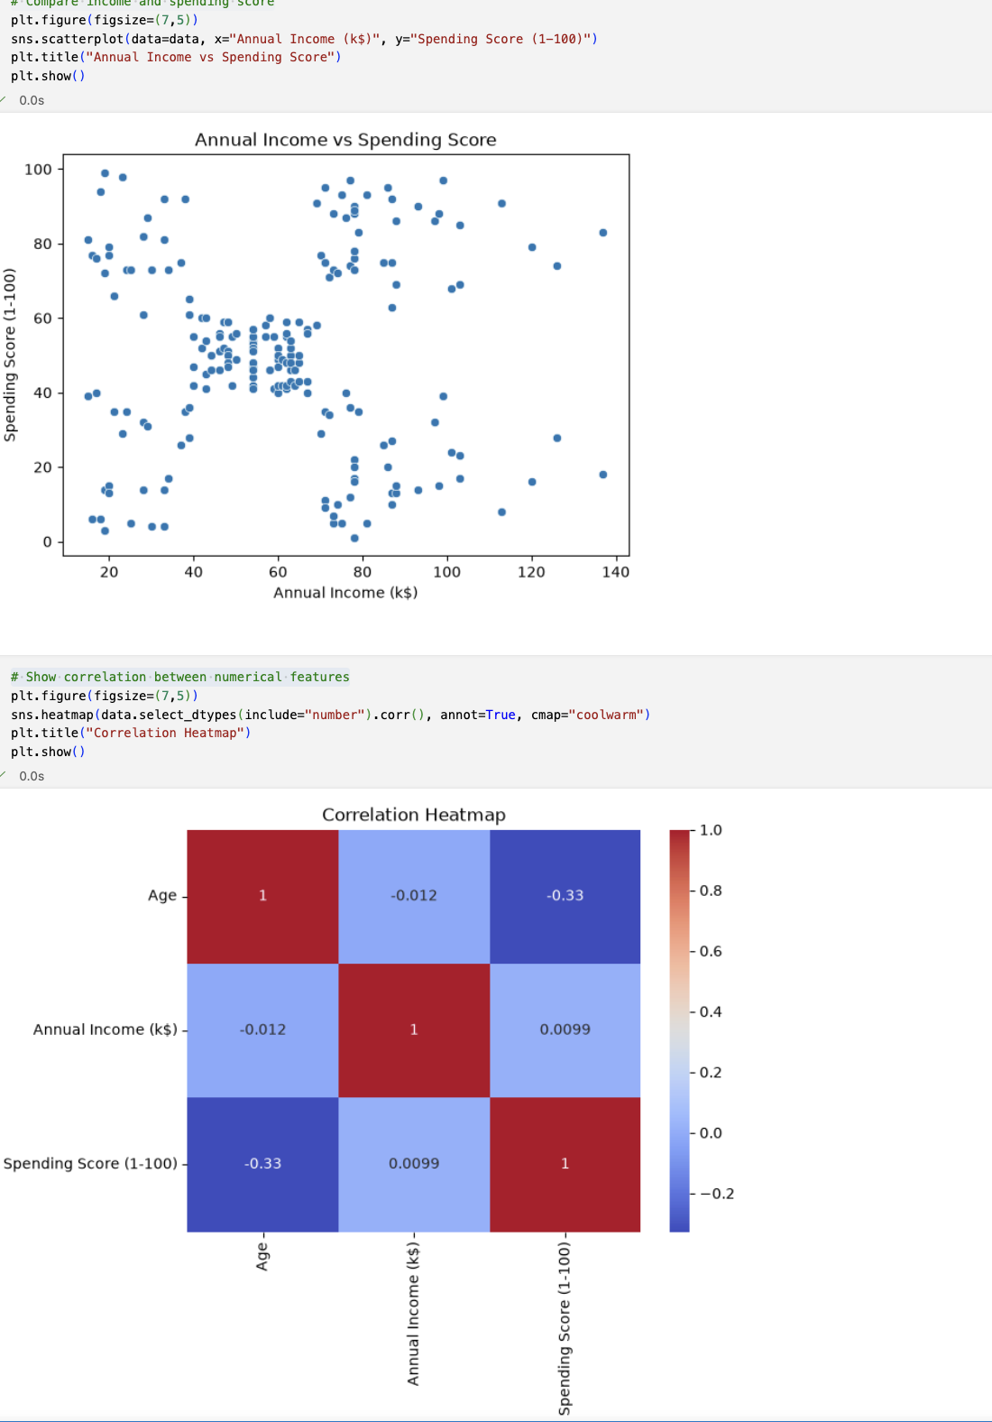
This code selects the relevant features for clustering, standardises the data, creates a dendrogram, and builds the hierarchical clustering model.
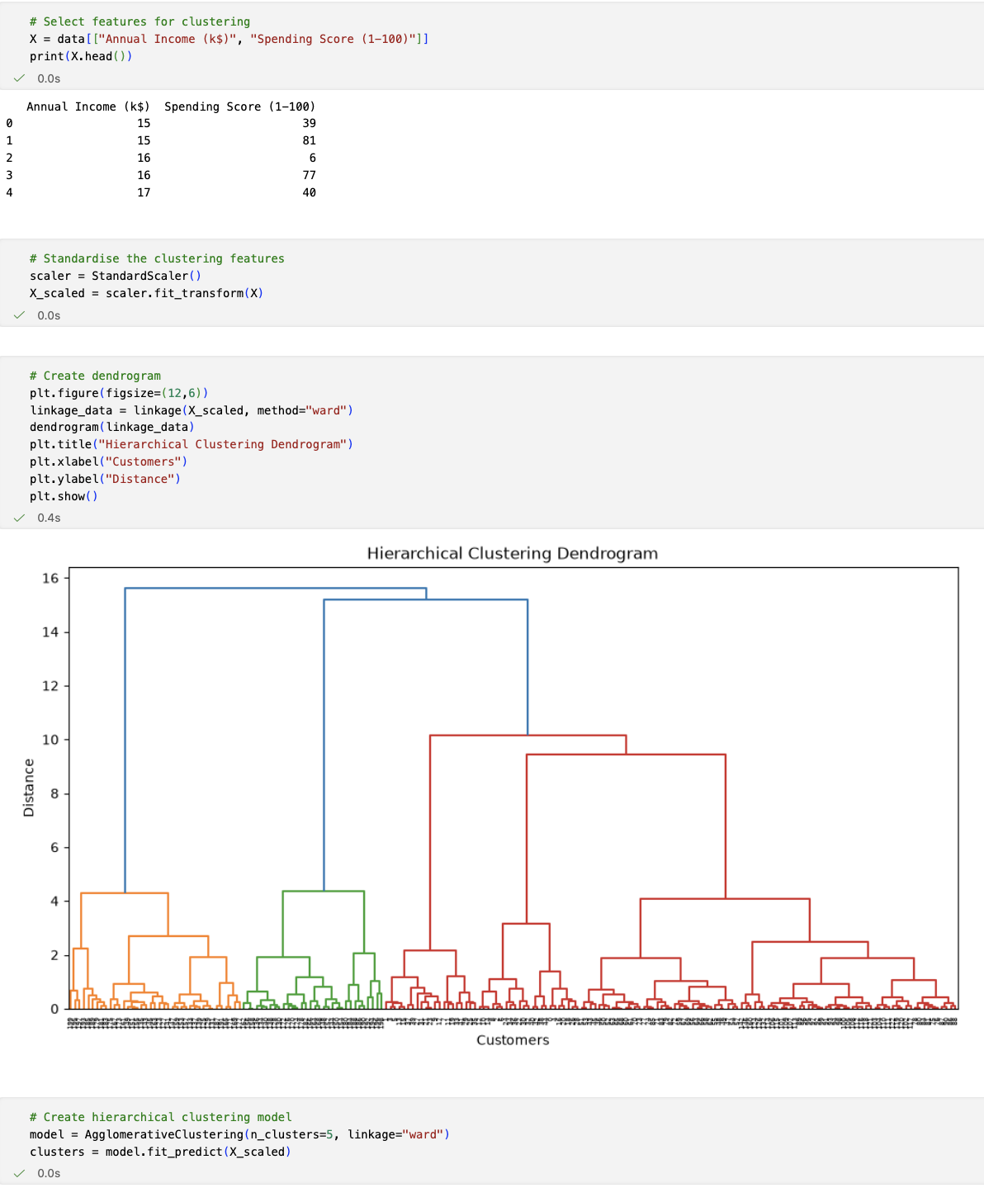
This code visualises the customer clusters, adds the cluster labels to the dataset, calculates cluster averages, and evaluates the clustering using the Silhouette Score.
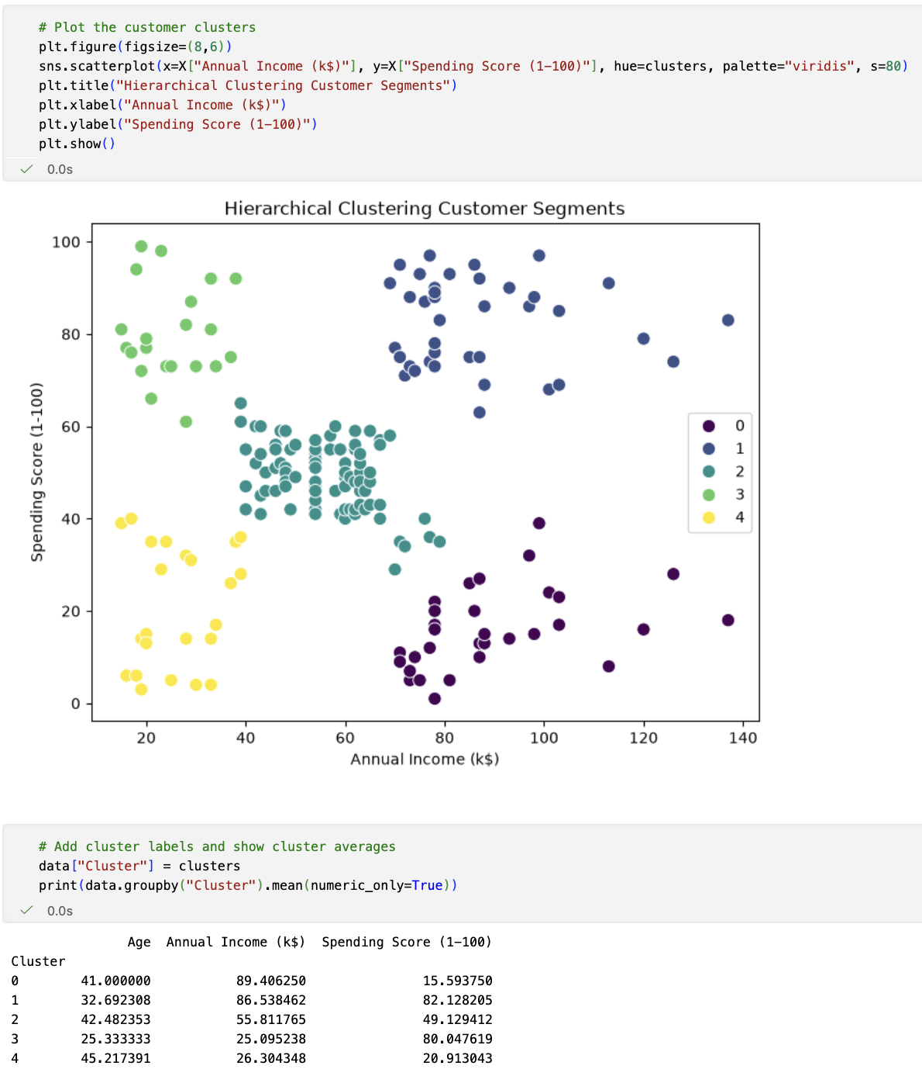

This code tests different numbers of clusters using Silhouette Score and then trains the final hierarchical clustering model with the selected number of clusters.
