1. **App Name:**

**Intelligent Data Analysis and Projection App**

1. **Repository Link:** [**https://github.com/Indianworldruler/Data-Analysis-App**](https://github.com/Indianworldruler/Data-Analysis-App)
2. **App Link:**

**https://data-analysis-app- bzvsozhui3vd3zb68srcbz.streamlit.app/**

1. **Introduction to app:** The Intelligent Data Analysis and Projection App helps you analyze and visualize business data with ease. Upload your files or enter data directly to gain insights and make future projections.
2. How to use ?

• **Select Input Type**: Choose between uploading an Excel file or entering sales data in a paragraph format.

• **Upload Data**: If uploading, select an Excel file containing business data (e.g., sales, financials, inventory).

• **View Data**: The app will display your uploaded data for review.

• **Automatic Data Analysis**: The app detects the data type and performs relevant analysis (e.g., sales, finance, inventory).

• **Generate Projections**: Select a period (Days, Weeks, Months, or Years) and input the number of periods to project future values.

• **View Insights**: Visualize the analysis with charts like bar graphs, line charts, and pie charts.

• **Extract Data from Paragraph**: If entering a paragraph, the app extracts sales data and generates relevant graphs.

• **Download Reports**: Optionally, download the analysis and projections in PDF format for offline viewing.

1. Screen Shots of app

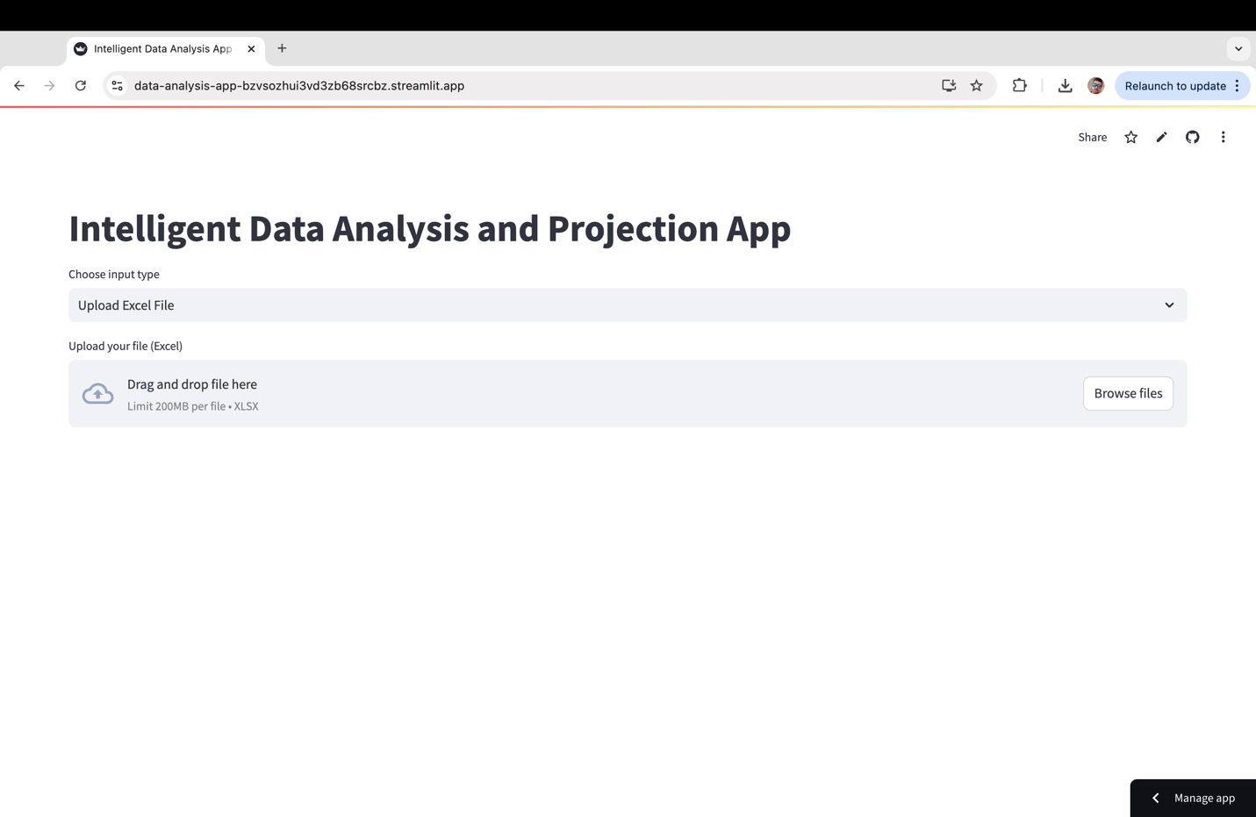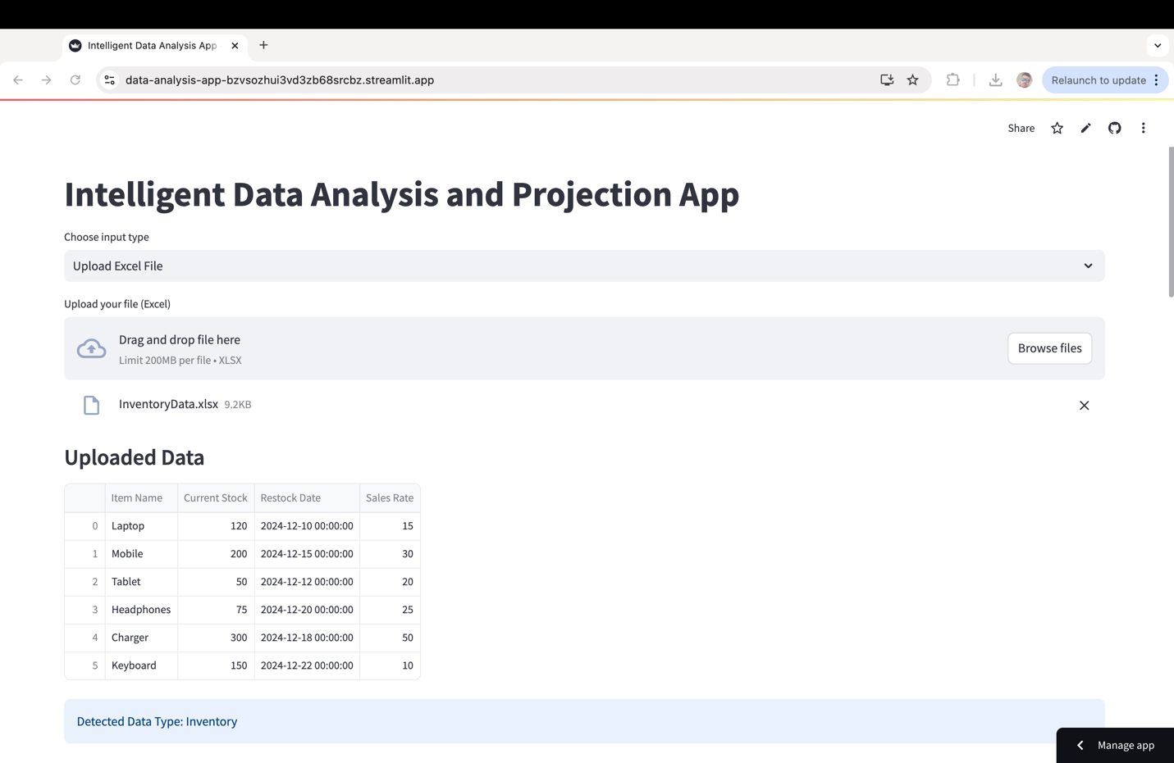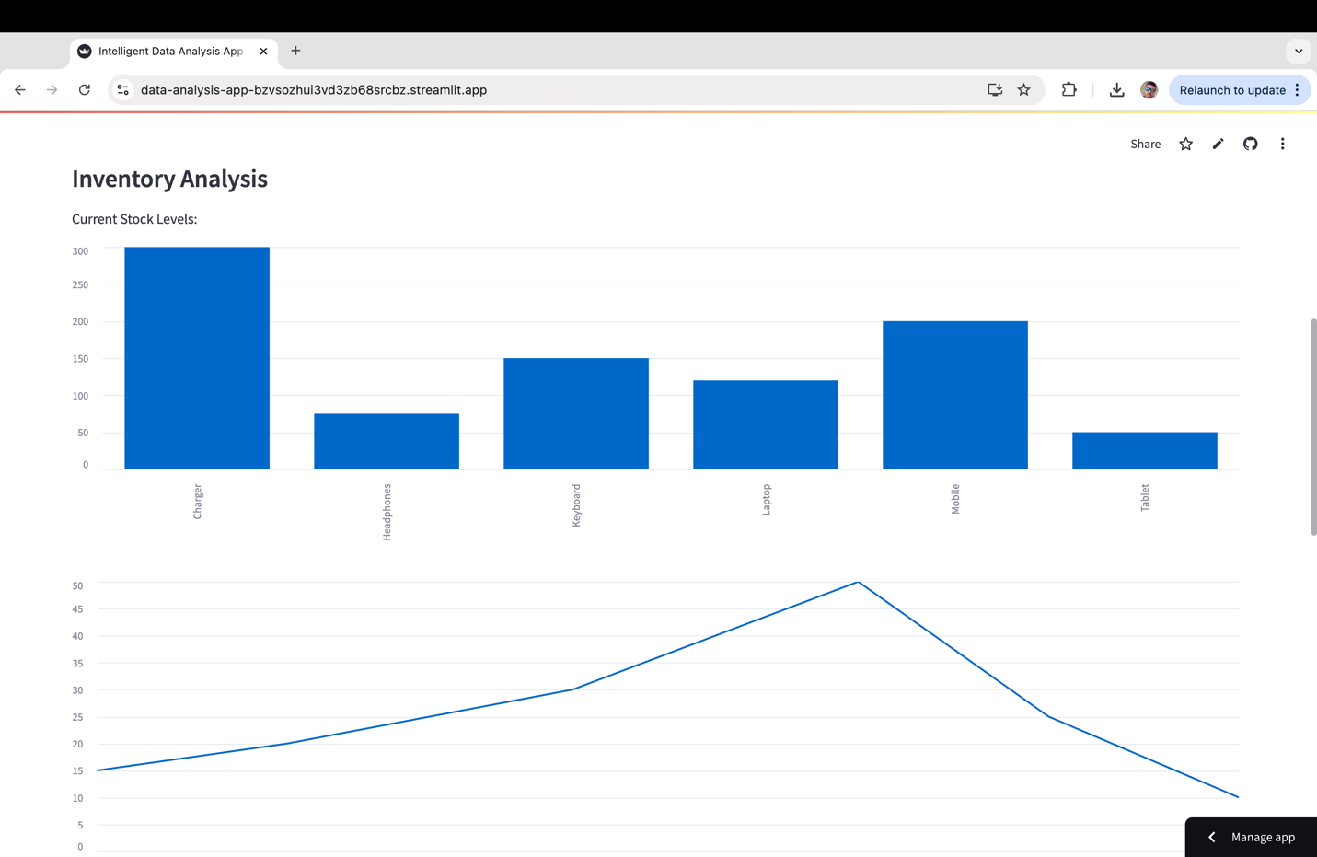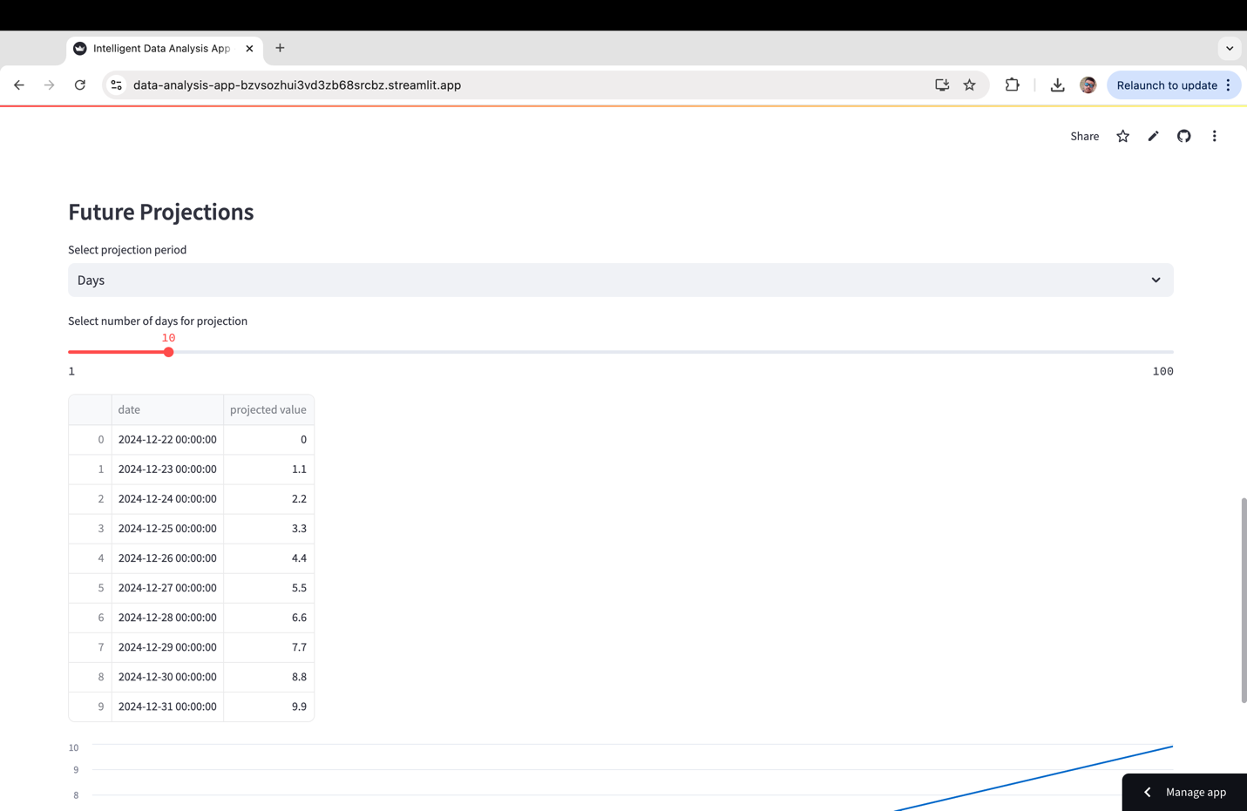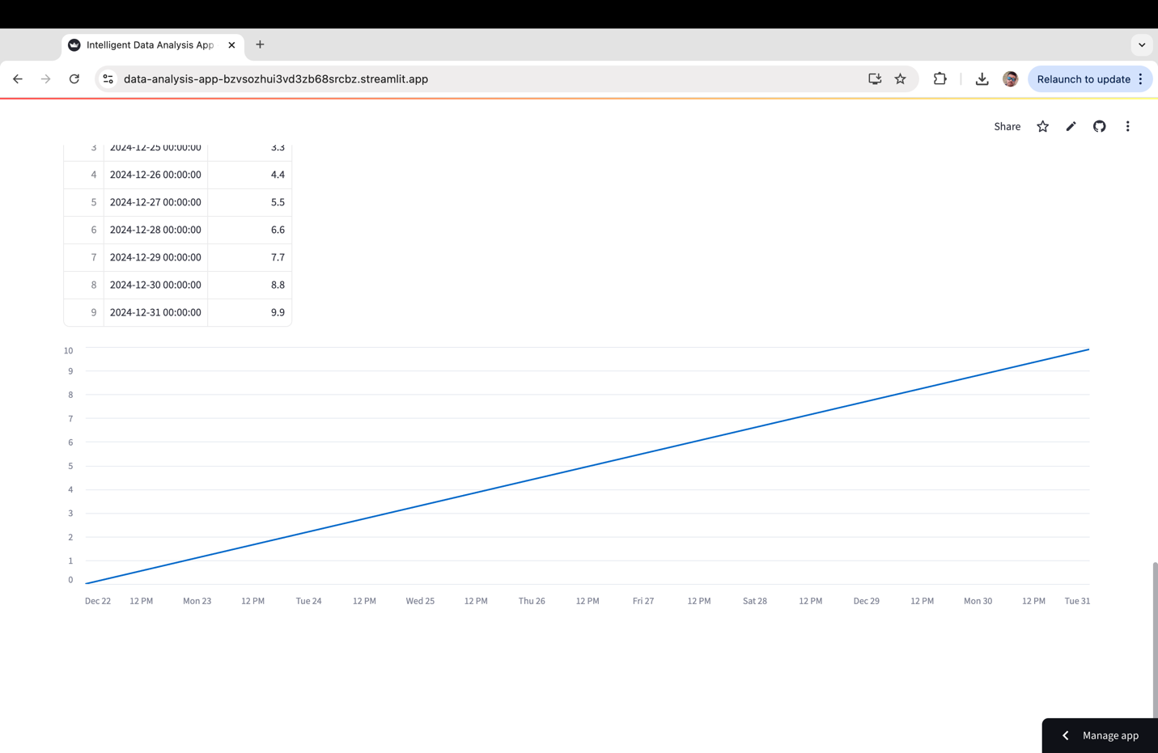

1. **Link for video of the app:**

[**https://drive.google.com/file/d/14mWPshLGLkQi8EgPoPpgfkp12uXd_N9p/view?usp=sharing**](https://drive.google.com/file/d/14mWPshLGLkQi8EgPoPpgfkp12uXd_N9p/view?usp=sharing)