Rogue Card Dungeon
Introductory Game Design Document
Purpose
This document introduces the game to a new designer: what the player does, how a run is structured, what systems drive progression, and which balance tables matter first. It is intentionally more readable than the raw extraction document.

Area | Current design
Genre | Card-driven roguelite dungeon crawler with map routing, tactical reveals, equipment durability, and event choices.
Session shape | A full run spans 45 floors split into three 15-floor acts.
Primary verbs | Choose a route, reveal cards, manage AP, fight enemies, collect gear, repair or merge cards, make event choices.
Progression | In-run power comes from cards, gear, amulets, companions, and events. Cross-run progression comes from death relics.
Economy | Coins buy most shop goods and repairs. Crystals mainly buy amulets and support premium rewards.
Important note | There is no XP system in the current code. Character growth is item-, floor-, and relic-driven.

1. Game Overview
The game is a compact dungeon roguelite built around card reveals. Each floor is a small tactical puzzle: the player spends action points to uncover cards, fight enemies, collect resources, and decide when the board is safe enough to leave.
A useful reference point is Dungeon Raid: both games ask the player to read a compact board, make short tactical decisions, and turn pickups into survival. This game differs by using discrete cards, route-map rooms, equipment durability, temporary amulets, event chains, and death relics instead of a pure tile-matching board.
Rival reference: Dungeon Raid on Steam (provided as the primary comparison target for the design review).
The tension comes from incomplete information. A face-down card might be food, a weapon, a trap, a coin card, or a dangerous enemy. The player is not simply optimizing damage per turn; they are managing risk, AP, durability, inventory space, and route choice.
For story/event tone, another useful reference is Life in Adventure: both games use short fantasy encounters where choices create mechanical consequences, not just flavor text.
Story reference: Life in Adventure on Google Play

Design Pillars
- Risky discovery: revealing cards is both the source of progress and the source of danger.
- Small tactical boards: each floor should resolve quickly but ask a meaningful question.
- Visible build growth: weapons, armor, amulets, gems, companions, and relics should make runs feel different.
- Event choices with mechanical consequences: story rooms matter because they change stats, inventory, unlocks, or future encounters.
- Economy pressure: shops and repairs should be tempting, but not every item should be affordable.

Core Player Loop
- Pick a route node on the act map.
- Enter a combat, shop, rest, anvil, treasure, or event room.
- If in combat, reveal cards and resolve enemies, traps, resources, and pickups.
- Use inventory cards to attack, defend, heal, restore AP, or create combos.
- Earn floor rewards, collect loot, and decide whether to spend resources in support rooms.
- Defeat the act boss to receive a major recovery and reward package.
- On death, unlock relic progression that affects future runs.

Time-Loop Progression And Run Permanence
The core fiction and progression model is a dungeon time loop. The player is expected to die, remember event outcomes, and use that knowledge in later runs to choose better event branches and acquire stronger amulets. A target experience is that an average player dies at least three times before winning, so death should feel like learning plus permanent momentum rather than a simple failure.
Layer | Persists Between Runs? | Design Role
Relics | Yes | Death and milestones grant permanent modifiers that change future runs.
Amulets | No | Acquired during a run from shops, events, and rewards; they shape the current build only.
Event knowledge | Player memory | The player learns which choices hurt, help, unlock chains, or lead to specific amulets.
Win pacing | Across attempts | The game should normally require multiple deaths before a first win, ideally at least three for an average player.
Simple loop: choose a node, reveal and resolve the board, manage inventory/AP/durability pressure, collect temporary run power, die or beat a boss, receive permanent relic progress, then re-enter the dungeon with better knowledge.

Major Pain Points
Pain Point | How The Player Feels It | Current Relief Valve
Inventory size | The player constantly decides which cards to keep, use, sell, or discard. | Extra-slot relics and amulets feel highly valuable because even one slot changes the run.
Action points / hunger | Low AP creates hunger pressure and weakens the player, turning exploration into risk. | Food, rest rooms, AP amulets, and floor-end recovery effects can restore momentum.
Durability | Weapons and armor can break forever at 0 durability. | Merging refills the upgraded card; anvils, repair events, and sturdier items also help.
Ranged enemy reach | Archers can hide behind melee blockers, including face-down blockers the player still has to find. | Clear melee, carry a bow, or use Lightning on melee weapons to chain into far enemies.

2. Run And Map Structure
System | Value | Designer note
Run length | 45 floors | Three acts of 15 floors each.
Boss floors | 15, 30, 45 | Each act ends with a boss node.
Starting stats | 115 HP, 15 AP | AP is both action economy and exploration fuel.
Starting economy | 0 coins, 0 crystals | The economy begins from floor and card pickups.
Starting inventory | 5 slots | Inventory pressure is a major constraint.

Node type | Role in the run | Important rewards or costs
Combat | Standard tactical floor. | Coin payout after all enemies are defeated, plus pickups on the board.
Elite | Harder combat with one mini-boss enemy. | +30% HP/attack mini-boss; lighter revealed card; elite chest after clear.
Shop | Regular economy stop. | Buys potion, weapon, armor, thorns, magic, random duplicate, and amulet.
Rare Shop | Premium economy stop. | Sells amulet, upgraded weapons, thorns, gem, and unlocked companions.
Rest | Recovery node. | +20 HP and full AP.
Anvil | Repair node. | Repairs weapons, armor, and thorns for coins.
Treasure | Chest node. | Coins, crystals, and item card; key or force-open decision.
Event | Choice node. | Mechanical rewards, penalties, unlocks, or future events.
Boss | Act gate. | Boss fight, then boss reward room except final victory.

3. Combat Board
Each combat board is a small cluster of face-down cards. Board size grows by act, and elite rooms use a 1.15x multiplier capped at 16 cards. After the initial weighted roll, the game applies caps and guarantees so floors do not become either pure loot or pure punishment.
Floor band | Normal board size | Elite board size
Act 1, floors 1-15 | 6 to 11 cards | Normal x1.15, max 16
Act 2, floors 16-30 | 11 to 14 cards | Normal x1.15, max 16
Act 3, floors 31-45 | 14 to 16 cards | Normal x1.15, max 16

Board rule | Current value
Trap cap | 1 per floor in Act 1; 2 per floor in Act 2+
Key cap | 1 per floor
Gem cap | 2 per floor
Empty card cap | 1 per floor
Weapon guarantee | 1 early; 2 from floor 10, elite rooms, or boards with 10+ cards
Enemy maximum | 45% through floor 14, 55% after floor 14, +1 enemy in elite rooms
Enemy minimum | At least 2; Act 1 18%, Act 2 28%, Act 3 33%, +1 in elite rooms
Elite mini-boss | Elite rooms select one non-boss enemy as a mini-boss: +30% HP, +30% attack, and a slightly lighter revealed card.

4. Enemies
Normal enemies scale by floor using tier breakpoints. The game has two enemy roles: melee enemies and ranged enemies. Melee enemies act as the front line, while ranged enemies can sit behind them and keep attacking from safety.
This creates a reach puzzle: a face-down melee enemy may be the blocker that protects an archer. The player can solve it by revealing and killing melee guards, carrying a bow, or using Lightning on a melee weapon to chain damage into far enemies.
Elite rooms add one mini-boss enemy: a normal enemy promoted by +30% HP and +30% attack, visually marked with a lighter face-up card so the player can read the threat.
Enemy card | Role | First floor | Attack / HP tiers | Special ability
Skeleton | Melee | 1 | 1: 6/9; 5: 8/12; 10: 8/12; 15: 8/14; 31: 11/20 | None
Spider | Melee | 3 | 3: 5/8; 8: 6/10; 13: 5/9; 16: 6/9; 18: 7/13; 31: 10/18 | Poison 2 for 3 turns, stackable
Goblin | Melee | 4 | 4: 6/10; 11: 8/12; 16: 9/14; 20: 9/14; 31: 11/20 | 50% chance to steal 1 coin
Goblin Archer | Ranged | 2 | 2: 3/5; 7: 4/8; 12: 4/7; 16: 5/7; 22: 7/10; 31: 8/13 | None
Skeleton Archer | Ranged | 6 | 6: 3/6; 11: 4/8; 16: 5/8; 17: 5/8; 25: 7/10; 31: 8/13 | None
Lost Soul | Melee | 16 | 16: 6/8; 24: 7/10; 31: 9/13 | 30% evade
Cerberus Head | Melee | 16 | 16: 7/9; 31: 9/12 | Summon-only enemy
Mimic | Melee | 3+ | HP: 8 + floor/2, attack 2 | Must be killed within 3 turns or escapes

5. Bosses
Each act rolls one boss from its tier. Bosses are normalized inside tiers so the finale stays roughly comparable even when the identity changes.
Act / floor | Boss | HP | Attack | Special abilities
Act 1 / 15 | Giant Skeleton | 36 | 7 | 30% summon 1 Skeleton
Act 1 / 15 | Goblin King | 40 | 8 | 50% steal 3 coins; 30% summon 1 Goblin
Act 1 / 15 | Spider Queen | 36 | 7 | Poison 5 for 5 turns, stackable; 30% summon 1 Spider
Act 2 / 30 | Soul Eater | 110 | 16 | 15% evade; 20% summon 1 Lost Soul; armor break 3; rage below 35% HP for x1.5 damage
Act 2 / 30 | Lich | 84 | 14 | Lifesteal 50%; 20% summon 1 Skeleton
Act 2 / 30 | Cerberus | 118 | 17 | Rage below 40% HP for x1.5 damage; armor break 5; 25% summon 1 Cerberus Head
Act 3 / 45 | Ancient Cerberus | 136 | 22 | Rage below 30% HP for x2 damage; armor break 6; 30% summon 1 Cerberus Head

6. Player Cards And Equipment
The player power curve is card-based. Weapons and armor have rarity ladders, durability, and floor unlock gates. Merging two compatible cards upgrades the result and refreshes its durability to full, so merging is both progression and a repair-like relief valve. Potions and food currently generate at base tier on floor drops, while stronger versions exist through merging.
Weapon | Common | Uncommon | Rare | Epic | Legendary | Notes
Dagger | F1, 3 dmg, 4 dur | F10, 4, 5 | F18, 5, 6 | F26, 6, 7 | F34, 7, 8 | Dual wield
Bow | F8, 4 dmg, 5 dur | F18, 5, 6 | F24, 6, 7 | F30, 7, 8 | F38, 9, 9 | Ranged, block
Sword | F16, 6 dmg, 6 dur | F19, 7, 8 | F22, 8, 10 | F25, 9, 11 | F28, 10, 13 | Core Act 2 weapon
Axe | F31, 7 dmg, 6 dur | F34, 9, 8 | F37, 11, 10 | F40, 13, 12 | F43, 16, 14 | Act 3, special attack

Armor | Common | Uncommon | Rare | Epic | Legendary | Notes
Leather | F1, 1 def, 15 dur | F10, 2, 20 | F18, 3, 25 | F26, 4, 28 | F34, 5, 30 | Dodge 5/8/10/12/15%
Chain | F16, 2 def, 15 dur | F19, 3, 20 | F22, 4, 25 | F25, 5, 28 | F28, 7, 30 | Act 2 armor
Plate | F31, 3 def, 15 dur | F34, 5, 20 | F37, 7, 25 | F40, 9, 28 | F43, 11, 30 | Act 3 armor

Card type | Current generated value | Design purpose
Potion | Minor Healing Potion: 35 HP | Stabilizes HP between fights; stronger tiers exist via merging.
Food | Bread: 25 AP | Restores action economy and lets the player keep exploring.
Thorns | 1 to 5 thorn damage by rarity | Durable defensive/offensive utility card.
Gem | Fire, Poison, or Lightning | Socket-style modifier to create build variation.
Key | Mysterious Key | Opens treasure safely.
Companion | Chick or Skeleton Warrior | Persistent helper card with upgrade hooks.

7. Economy And Rewards
The economy moved away from per-kill coin payouts. Most reliable income now comes from floor clear rewards, coin cards, chests, events, and specific amulets/relics.
Source | Reward
Coin card | 2-5 coins
Crystal card | 1 crystal
All enemies defeated | Non-boss only: floor(24 + floor * 1.2) coins, modified by gold bonuses. This is the single standard combat-clear coin payout.
Boss reward room | Full heal, full AP, 25 + floor coins, 4 + floor/6 crystals, plus 3 reward cards
Mimic kill | 20 + floor * 2 coins and 5 + floor/5 crystals

Chest type | Coins | Crystals | Item rarity
Treasure | 8 + floor/3 | 1 + floor/14 | Uncommon, capped by act
Good treasure | 12 + floor/2 | 1 + floor/12 | Rare, or Epic from floor 38+, capped by act
Elite chest | 15 + floor/2 | 2 + floor/10 | Rare, capped by act
Forced open | 75% of normal | At least 1, around 50% | Downgraded 1 rarity tier
Forced trap | 45% chance | N/A | Deals 5 HP

Shop Pricing
Shop | Stock / formula | Designer note
Regular shop | Potion, weapon, armor, thorns, magic, random duplicate, amulet | Amulets cost crystals; most other items cost coins.
Regular item price | floor((5 + floor * 2) * rarityMultiplier + typeBonus) | Weapon adds damage; armor adds protection x2; thorns adds thorn damage x3; magic price x1.2.
Sell price | 40% of buy price | Supports inventory cleanup without creating a strong money loop.
Rare shop | Amulet, two uncommon weapons, thorns, gem, unlocked companions | Premium stop with steeper prices and special unlock hooks.
Rare shop weapon prices | 20 + floor * 5 and 25 + floor * 5 | Usually a rescue option or build accelerator.
Rare shop gem price | 18 + floor * 4 | Paid in coins.

8. Amulets And Relics
Amulets are in-run modifiers. Relics are cross-run unlocks, usually granted after death. Together they form the game's build identity and long-term progression.
Amulet | Rarity | Unlock / source | Effect
Bottomless Bag | Common | Random, floor 1+ | +2 inventory slots
Amulet of Regeneration | Uncommon | Random, floor 1+ | +1 HP per stack at end of floor
Pouch of Greed | Uncommon | Random, floor 1+ | +30% gold found
Dragon Claw | Rare | Random, floor 8+ | +1 weapon damage
Chronos Heart | Rare | Random, floor 5+ | +3 max AP
Skeleton's Lockpicks | Rare | Random, floor 3+ | Open treasure chests without key
Mask of Hollow Whispers | Rare | Random, floor 5+ | 15% chance enemy death leaves a random card
Tea Room Bell | Rare | Event-only | +4 AP entering non-battle rooms
Moth-Wing Dust | Rare | Event-only | Magic cards have 25% chance to return
Fortune Card | Rare | Event-only | +8% crit; crits can drop coin/crystal

Death or milestone | Relic | Effect
Death to spider | Spider Venom | Weapons have 20% chance to poison enemies.
Later death to spider | Webweaver's Thread | 10% chance a merged card respawns face-down.
Death to skeleton | Bone Armor | Start each run with Common Bone Armor.
Later death to skeleton | Gravebloom Bundle | Heal 2 HP at start of every combat floor.
Death to goblin | Goblin War Horn | First attack each floor deals double damage.
Later death to goblin | Scavenger's Coffer | +20% coins from all sources.
Death to Giant Skeleton | Giant's Morningstar | All weapons deal +1 damage.
Death to Spider Queen | Queen's Antivenom | Poison immunity.
Death to Lich | Lich's Covenant | Heal 1 HP per enemy killed, -10 max HP.
3 total deaths | Ironhide Tonic | Armor loses durability half as often.
5 total deaths | Veteran's Carryall | +1 permanent inventory slot.

9. Events
Events are not just story flavor. They are mechanical choice points that can damage the player, grant amulets, alter future event chains, add companions, train companions, reroll cards, or unlock future shop offers.
Event | Choice pattern | Mechanical outcome
Broken Music Box | Risk open / key open / leave | Damage plus coins, crystal reward, or heal; starts a multi-event chain.
Monster Bird Nest | Take cog / take egg too / leave | Egg path adds future companion potential and Angry Nestmother risk.
Goblin Engineer | Free repair / sacrifice card / pay 30 coins | Chance to gain +1 inventory slot; failure pays coins and crystal.
Too-Nice Room | Rest / inspect / fight fairy | Full heal with theft risk, random amulet, or Tea Room Bell with HP/AP loss.
Book Worm | Feed magic / squish / return it | Three event-only amulets: Moth-Wing Dust, Worm Venom Charm, Stolen Ink Pen.
Briar Room | Offer gear / slash / burn | Permanent gear upgrade, rare thorns, or random amulet.
Old Drill Room | Train qualifying companion | Companion upgrade after 3 rooms fought.
Something Wicked + Brass Wizard | Buy junk/clover, then machine outcomes | Junk, Lucky Clover, Holographic Omen, rerolls, random cards, or Fortune Card.
Well of Almost-You | Trade gear, optionally spend crystal | Convert weapon/armor/thorns into another gear category at same rarity.
Slimy Prison | Free / kill / take amulet | Skeleton Warrior unlock, cursed amulet, or non-cursed amulet with HP loss.

10. First Design Review Questions
- Is the game engaging enough moment to moment?
- How can we make the game more replayable? A full run can currently be finished in about 25 minutes, which may be too short. Dungeon Raid addresses replayability with different starting heroes/classes such as Vampire and Knight; this game currently starts from one hero with no class ability choice.
- What other amulets and relics can be added?
- Should we introduce class/build branches? For example, event choices could start a vampiric, protection, or lightning path, and later events could deepen that path instead of offering unrelated small bonuses.
- How should class branches escalate? A lightning amulet could later gain longer chain range; a protection amulet could later improve armor durability or add thorns.
- Are current amulets and relics too flat? Most give small help, but they do not yet create clear classes or long-term build identities.

11. Visual Reference
These images include the provided Dungeon Raid comparison screenshot, a current in-game screenshot, and current game assets so a new designer can quickly connect the balance tables to the actual visual language.

Narrative Reference
Story reference: Life in Adventure | Design relevance
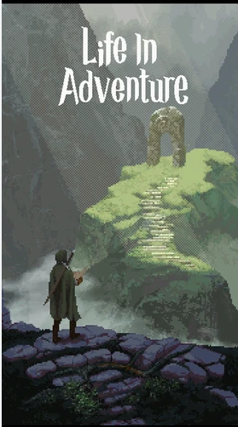 | Story/event reference for mood and structure: short fantasy situations, compact choices, and consequences that matter mechanically. The goal is not to copy its writing, but to use it as a comparable reference for event-driven dungeon storytelling.  Reference link: Life in Adventure on Google Play

Competitive Screenshot Comparison
Rival reference: Dungeon Raid | Current game screenshot
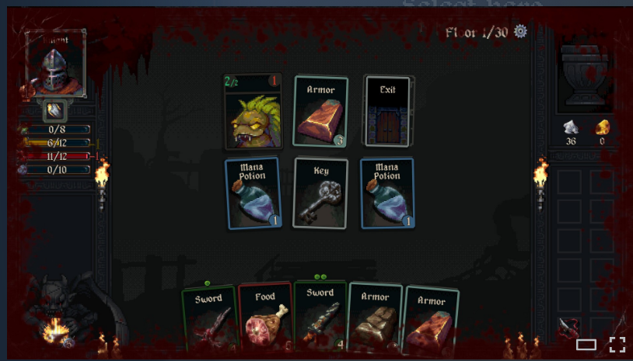 | 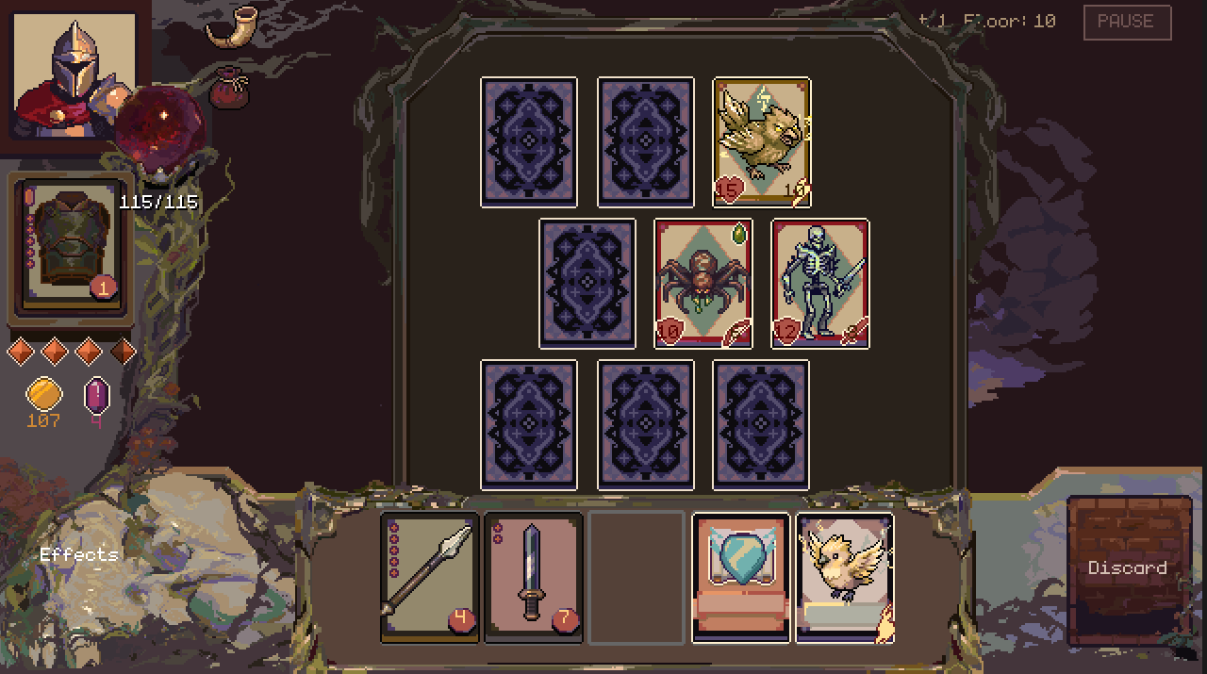
Reference point: compact dungeon survival, short tactical reads, and replay value through different starting heroes/classes. | Current direction: card-reveal dungeon crawl with route nodes, inventory pressure, equipment durability, temporary amulets, and death relics.
The comparison is not meant to copy Dungeon Raid. It is meant to clarify the shared design space: compact tactical reading, survival pressure, and replay hooks.
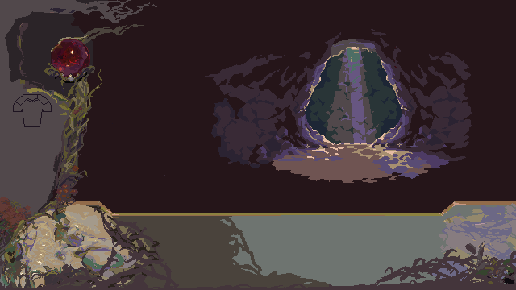  Dungeon backdrop | 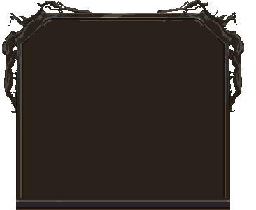  Combat board | 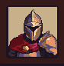  Player avatar
  Face-down card | 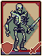  Skeleton enemy | 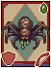  Spider enemy

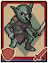  Goblin enemy | 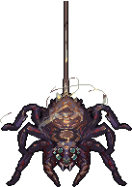  Boss: Spider Queen | 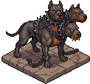  Boss: Cerberus
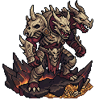  Boss: Ancient Cerberus | 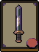  Weapon example | 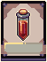  Potion example

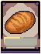  Food example |   Map node sheet | 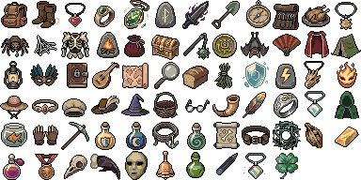  Relics/amulets sheet

Image note: These are raw in-game assets, not marketing art. They are included to help a designer understand the current visual vocabulary and how mechanics are represented in play.
Source note: This document is a readable introduction derived from the extracted balance reference in docs/game-designer-handoff.md. For exhaustive values, use that file as the raw reference.

