**Name:- Sarthak Shandilya**

**Assignment 5**

**Tasks 1: Database Design:**

1. Create the database named "TicketBookingSystem"

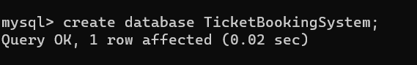

1. Write SQL scripts to create the mentioned tables with appropriate data types, constraints, and relationships.

• Venue

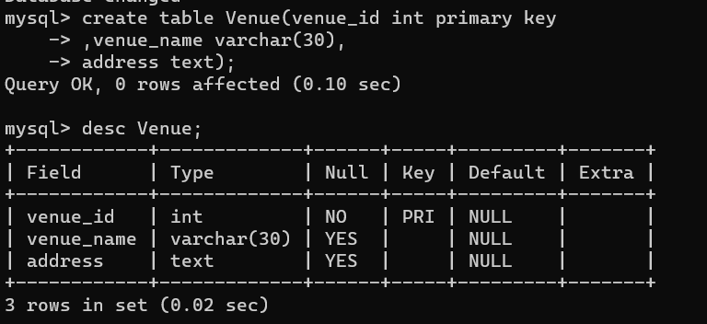

• Events

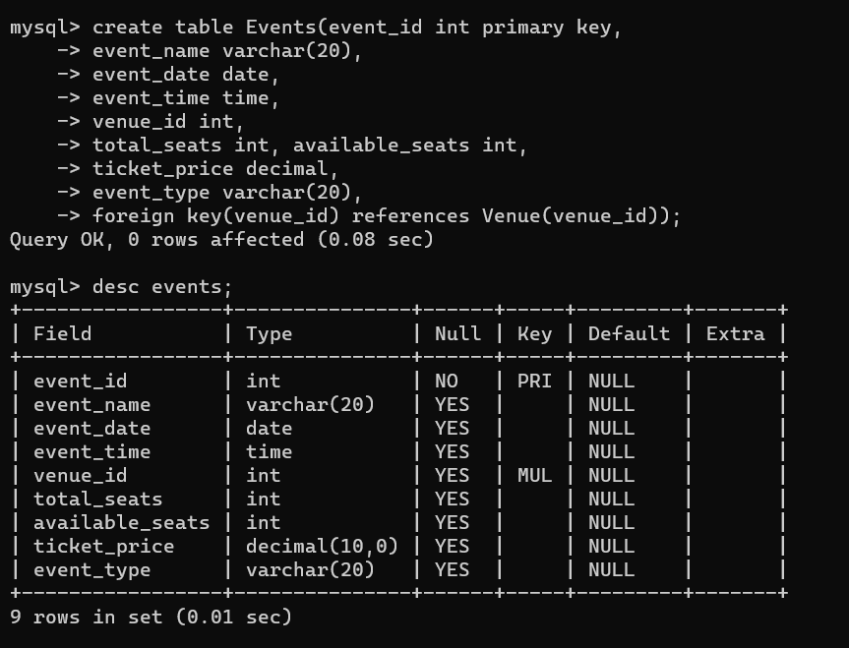

• Customer

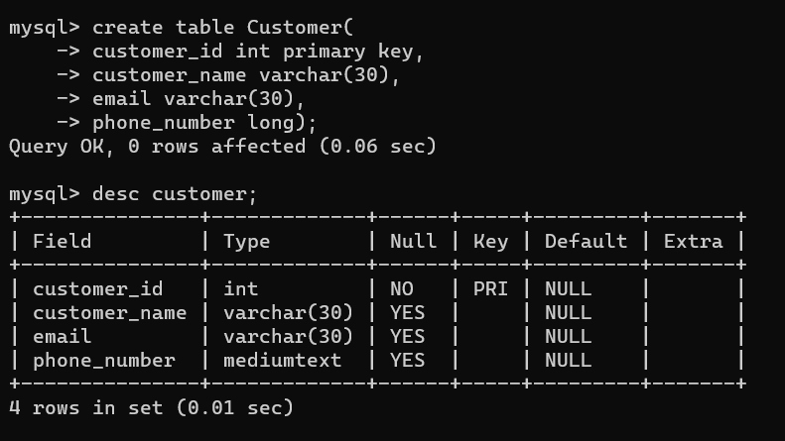

• Bookings

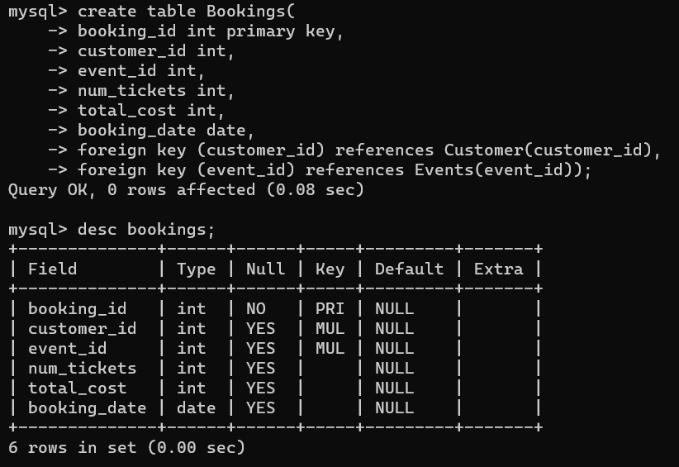

1. Create an ERD (Entity Relationship Diagram) for the database.

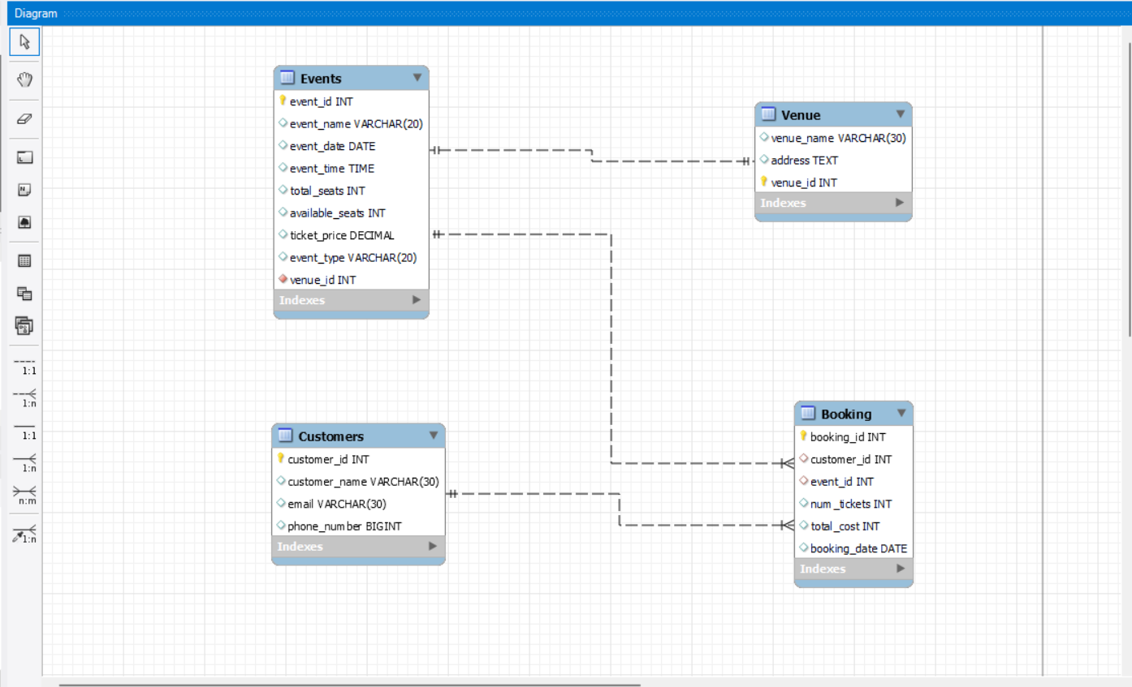

**Tasks 2: Select, Where, Between, AND, LIKE:**

1. Write a SQL query to insert at least 10 sample records into each table.

* Events

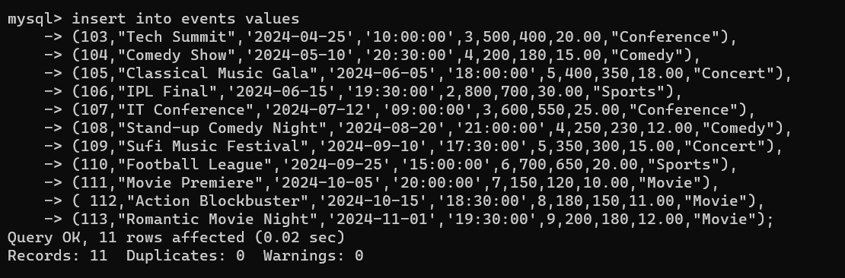

* Venue

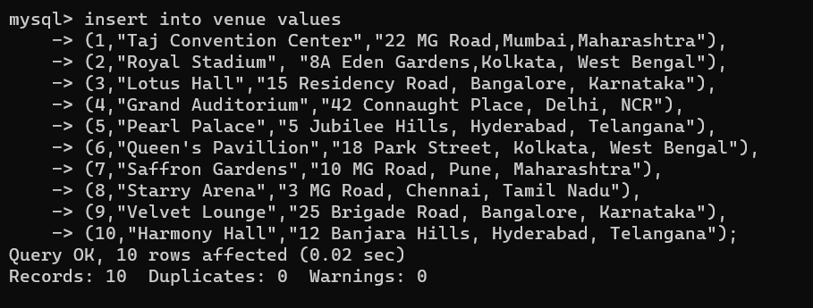

* Customers

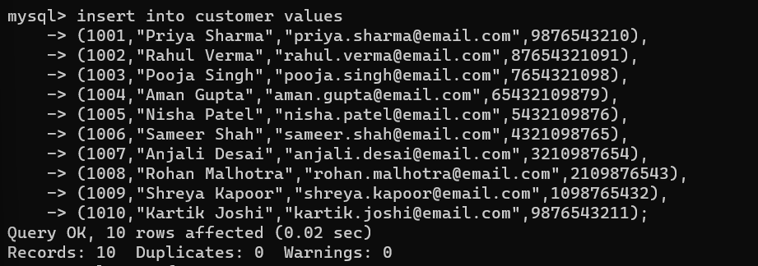

* Booking

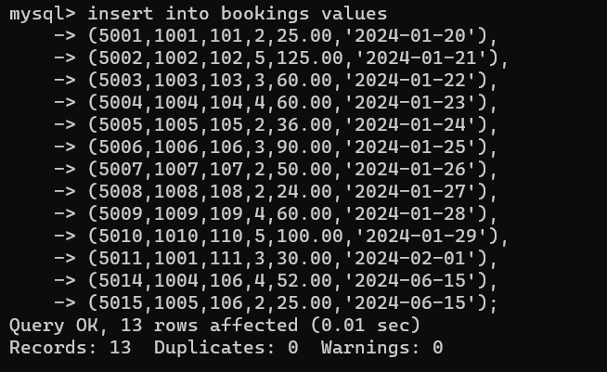

1. Write a SQL query to list all Events.

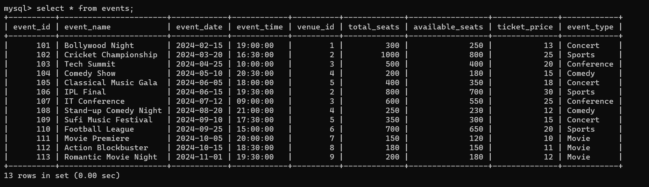

1. Write a SQL query to select events with available tickets.

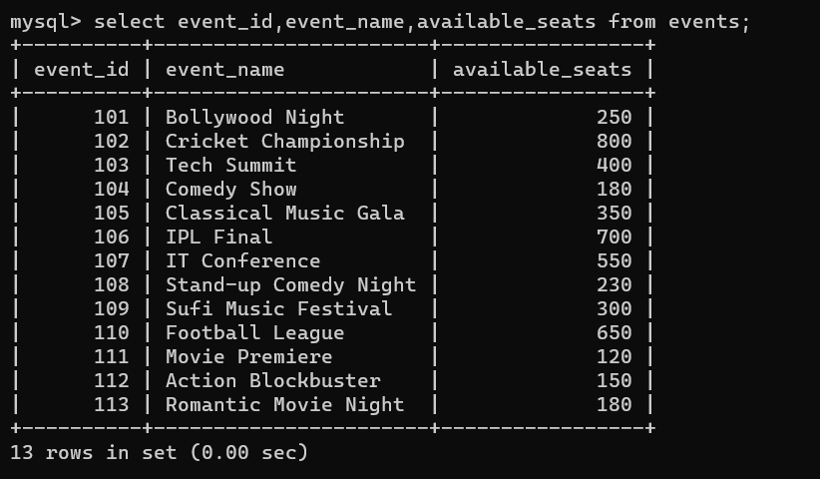

1. Write a SQL query to select events name partial match with ‘cup’.

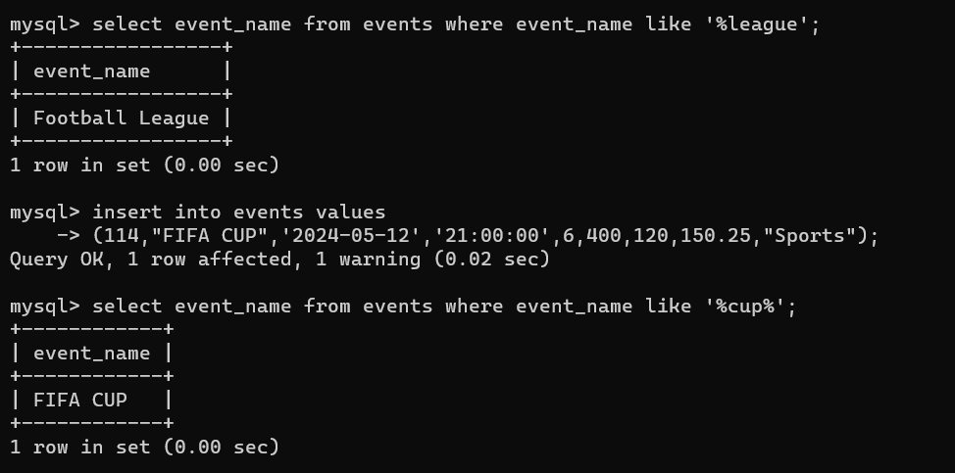

1. Write a SQL query to select events with ticket price range is between 1000 to 2500.

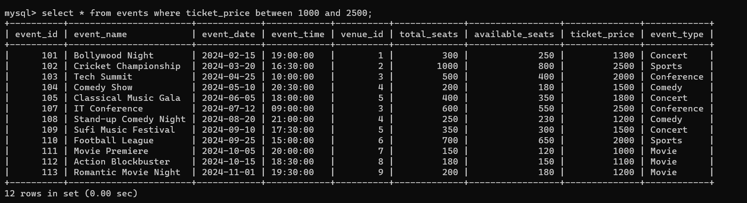

1. Write a SQL query to retrieve events with dates falling within a specific range.

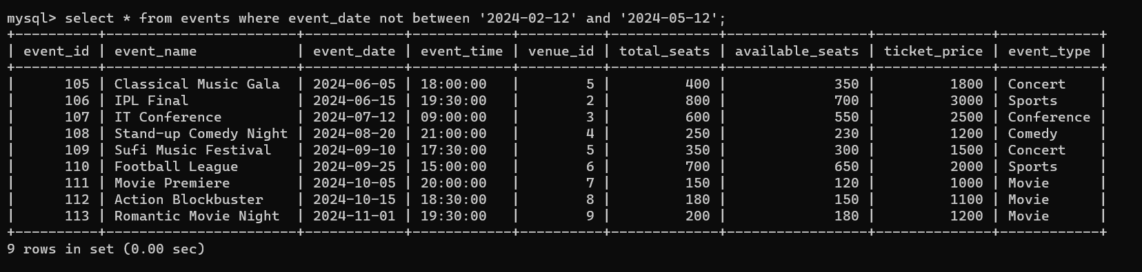

1. Write a SQL query to retrieve events with available tickets that also have "Concert" in their name.

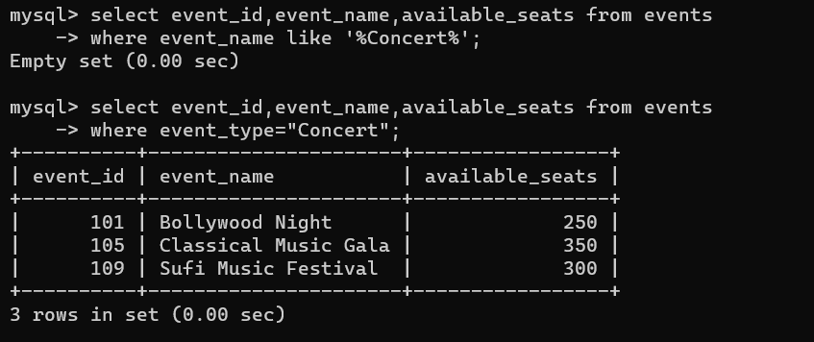

1. Write a SQL query to retrieve users in batches of 5, starting from the 6th user.

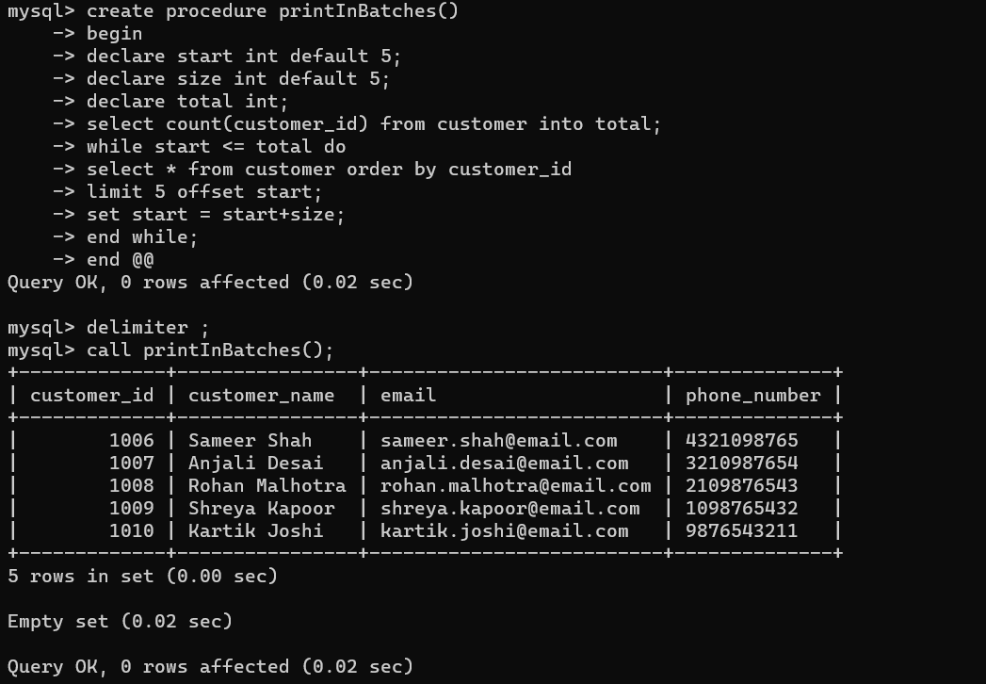

1. Write a SQL query to retrieve bookings details contains booked no of ticket more than 4.

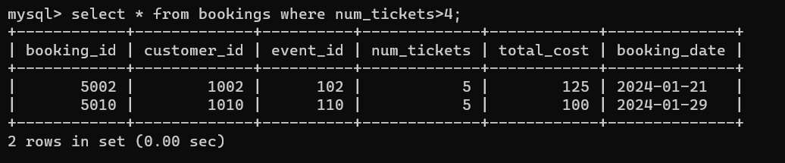

1. Write a SQL query to retrieve customer information whose phone number end with ‘000’

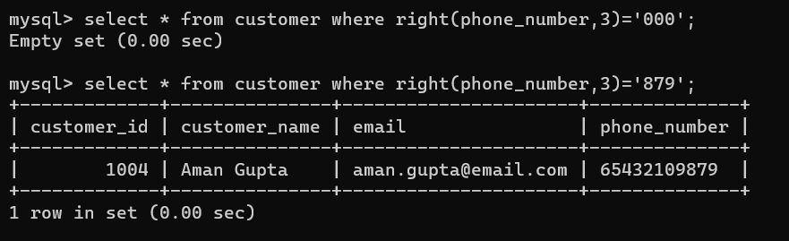

1. Write a SQL query to retrieve the events in order whose seat capacity more than 15000.

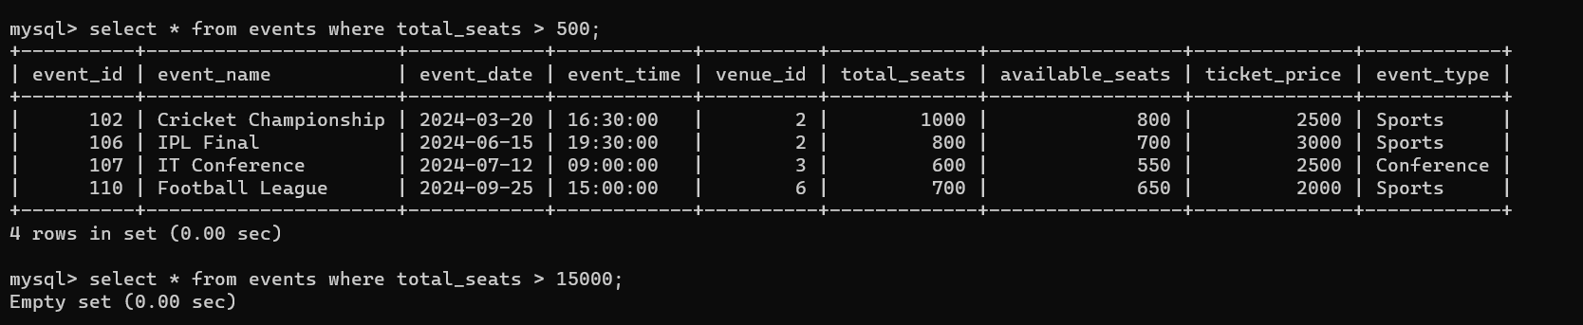

1. Write a SQL query to select events name not start with ‘x’, ‘y’, ‘z’ .

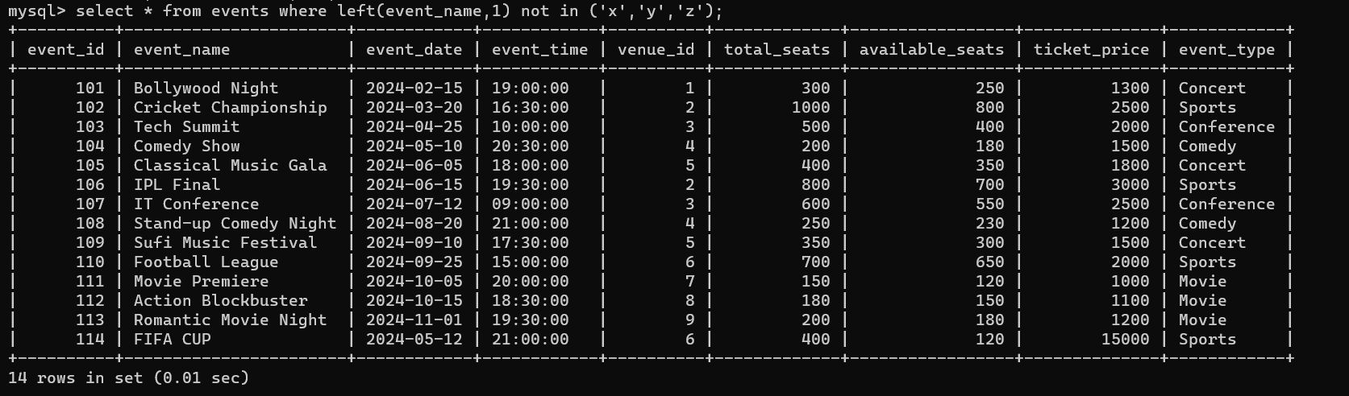

**Tasks 3: Aggregate functions, Having, Order By, GroupBy and Joins:**

1. Write a SQL query to List Events and Their Average Ticket Prices.

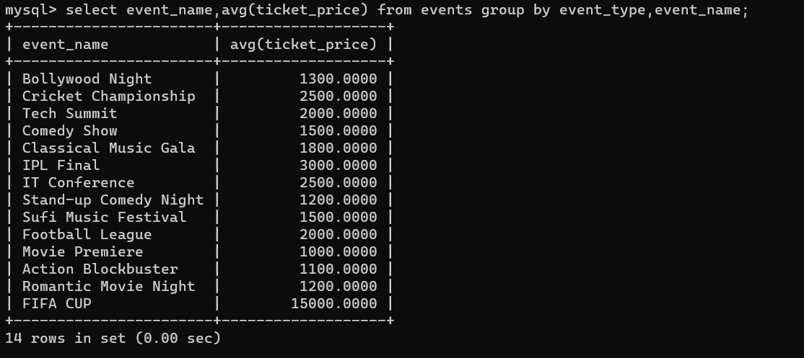

1. Write a SQL query to Calculate the Total Revenue Generated by Events.

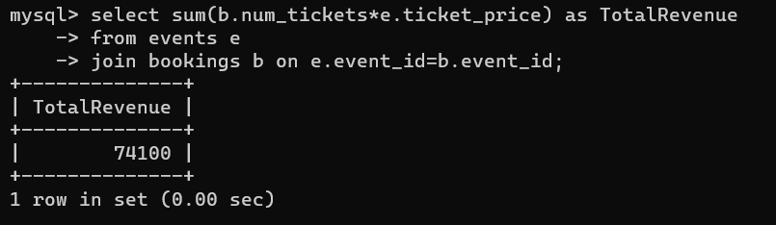

1. Write a SQL query to find the event with the highest ticket sales.

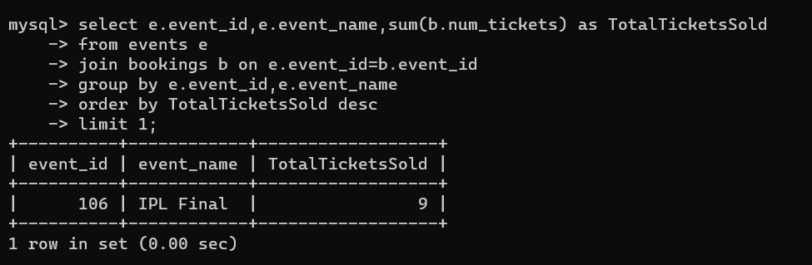

4. Write a SQL query to Calculate the Total Number of Tickets Sold for Each Event.

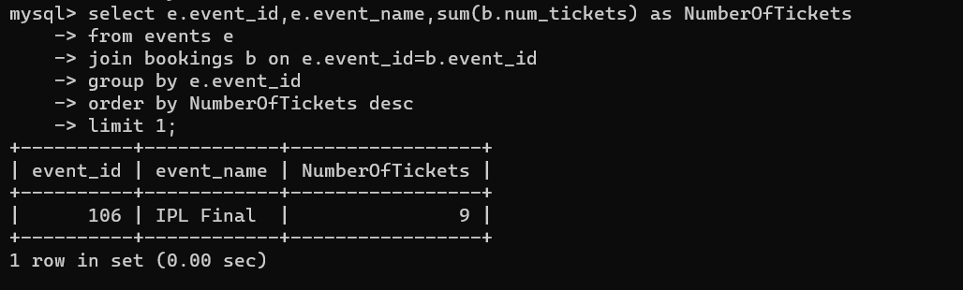

1. Write a SQL query to Find Events with No Ticket Sales.

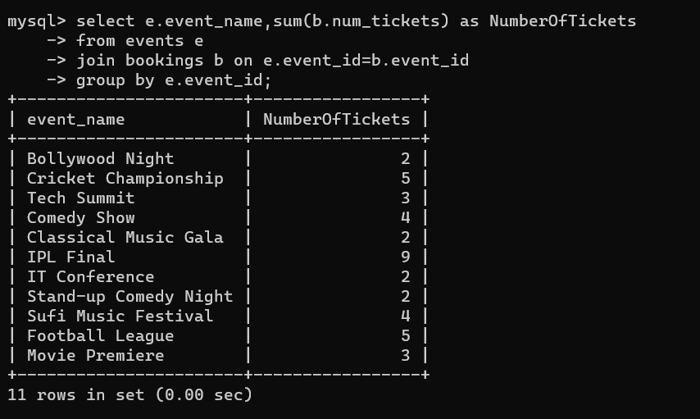

1. Write a SQL query to Find the User Who Has Booked the Most Tickets.

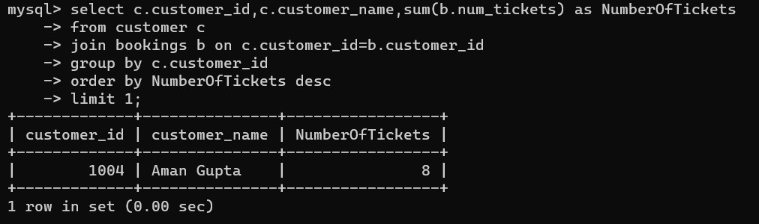

1. Write a SQL query to List Events and the total number of tickets sold for each month.

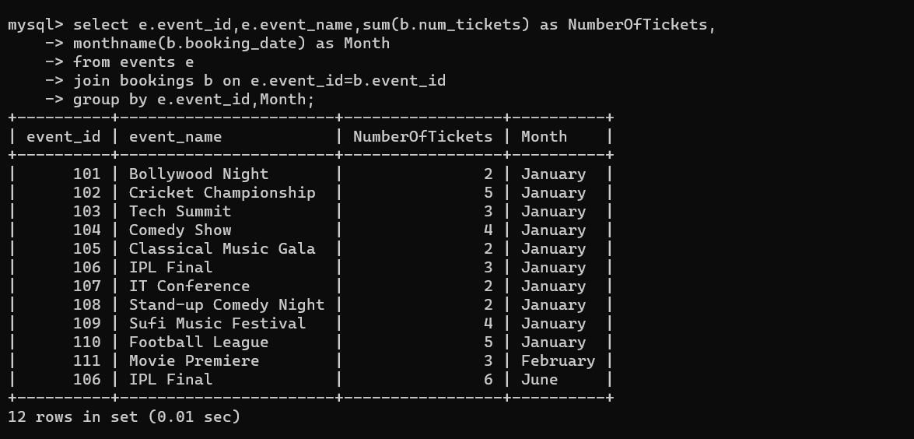

1. Write a SQL query to calculate the average Ticket Price for Events in Each Venue.

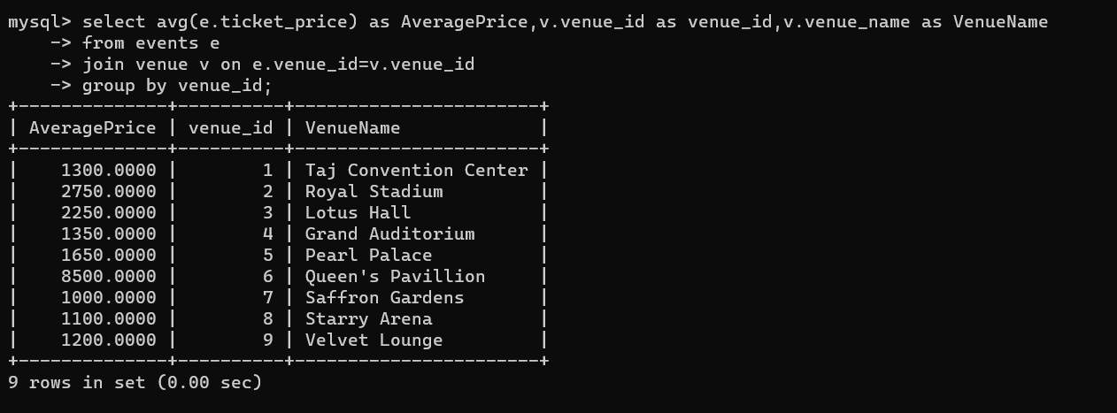

1. Write a SQL query to calculate the total Number of Tickets Sold for Each Event Type.

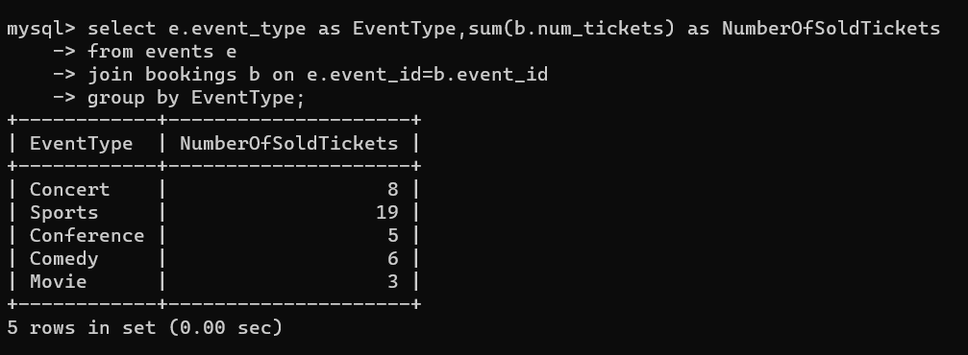

1. Write a SQL query to calculate the total Revenue Generated by Events in Each Year.

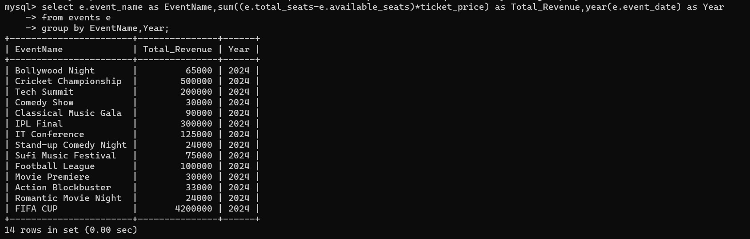

1. Write a SQL query to list users who have booked tickets for multiple events.

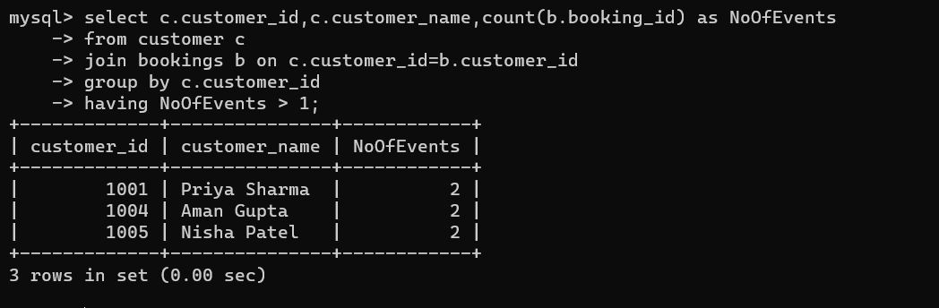

1. Write a SQL query to calculate the Total Revenue Generated by Events for Each User.

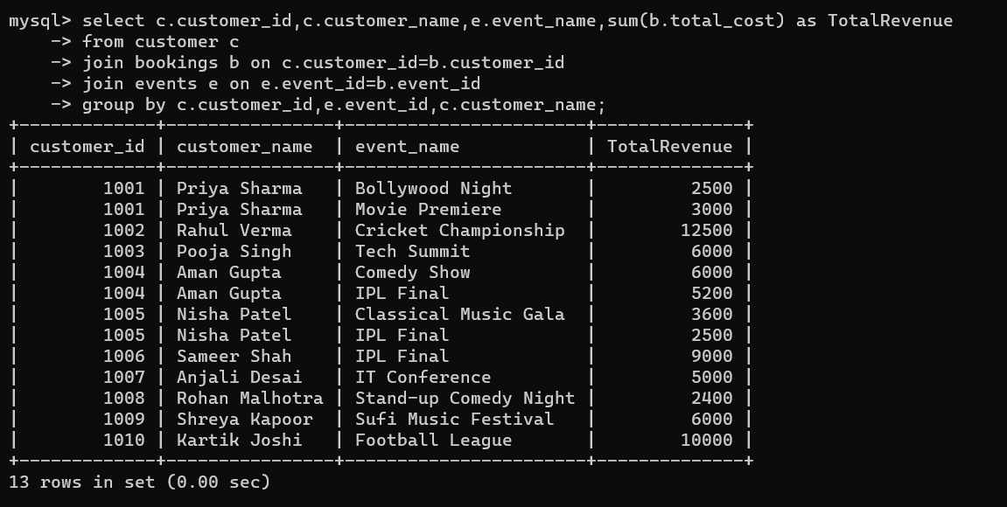

1. Write a SQL query to calculate the Average Ticket Price for Events in Each Category and Venue.

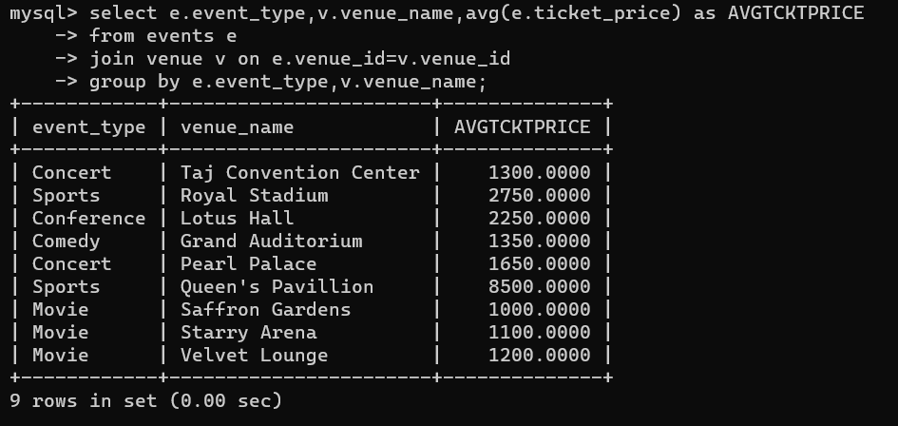

1. Write a SQL query to list Users and the Total Number of Tickets They've Purchased in the Last 30 Days.

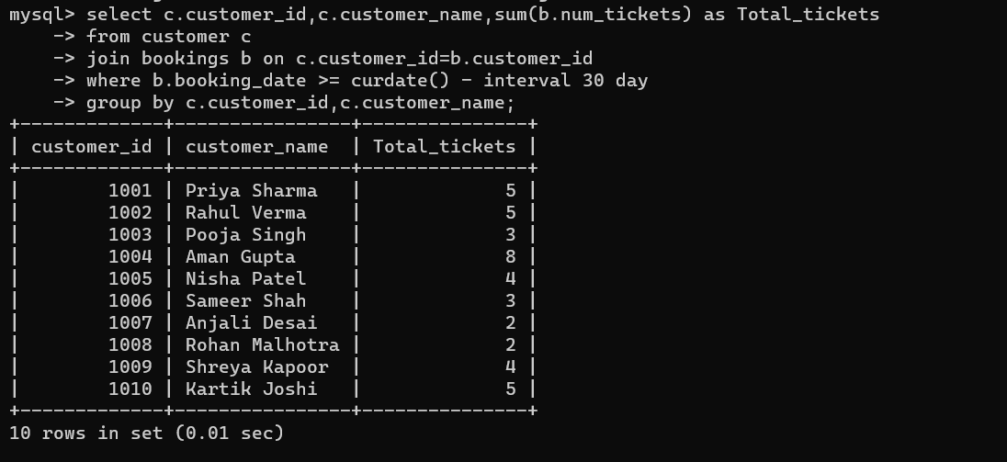

**Tasks 4: Subquery and its types**

1. Calculate the Average Ticket Price for Events in Each Venue Using a Subquery.

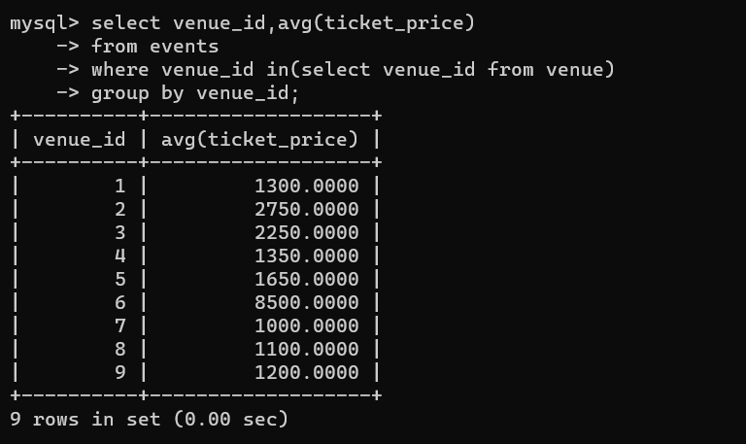

1. Find Events with More Than 50% of Tickets Sold using subquery.

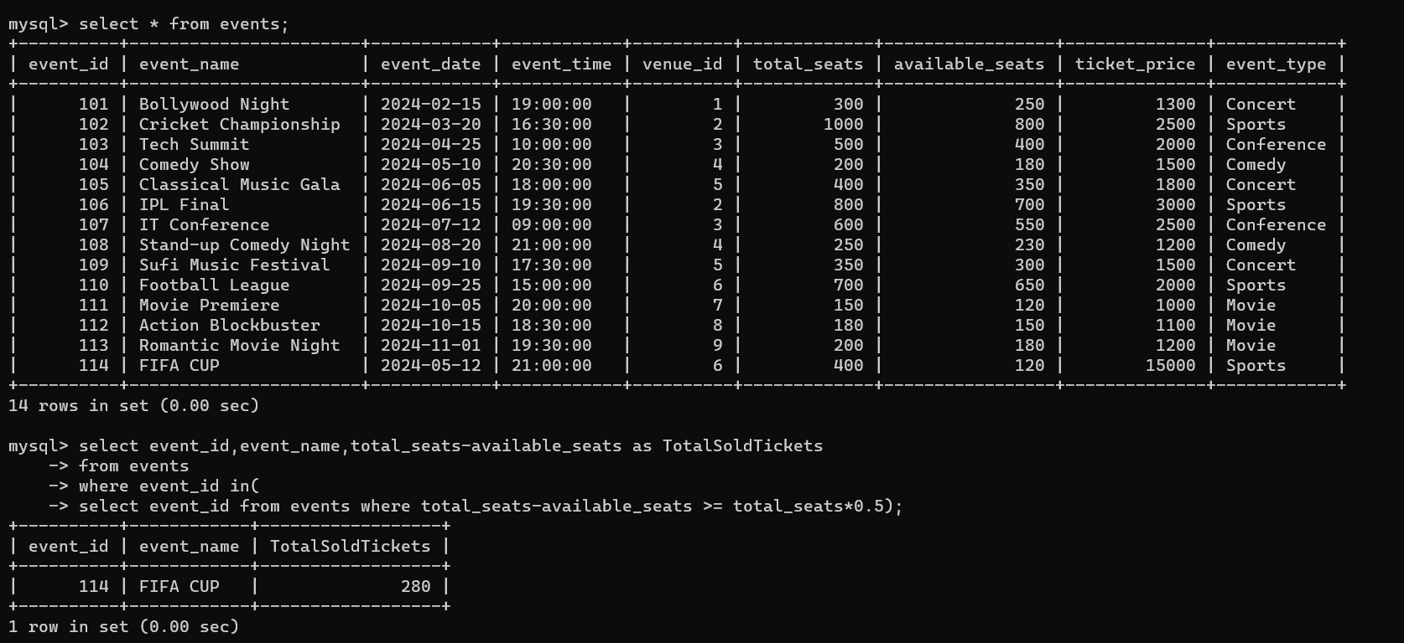

1. Calculate the Total Number of Tickets Sold for Each Event.

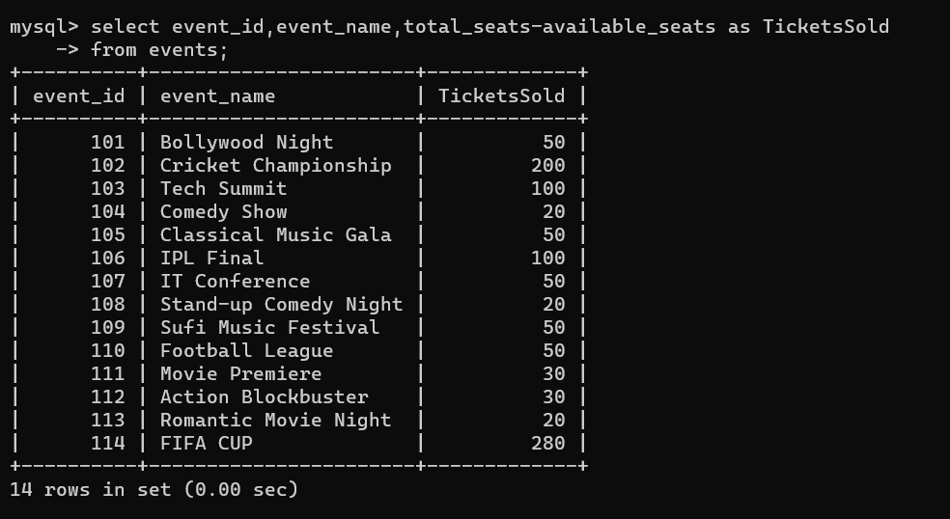

1. Find Users Who Have Not Booked Any Tickets Using a NOT EXISTS Subquery.

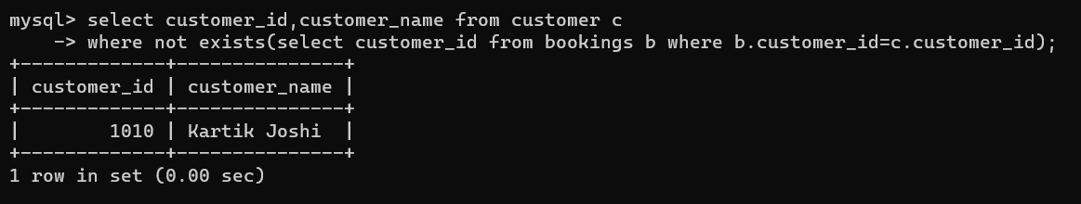

1. List Events with No Ticket Sales Using a NOT IN Subquery.

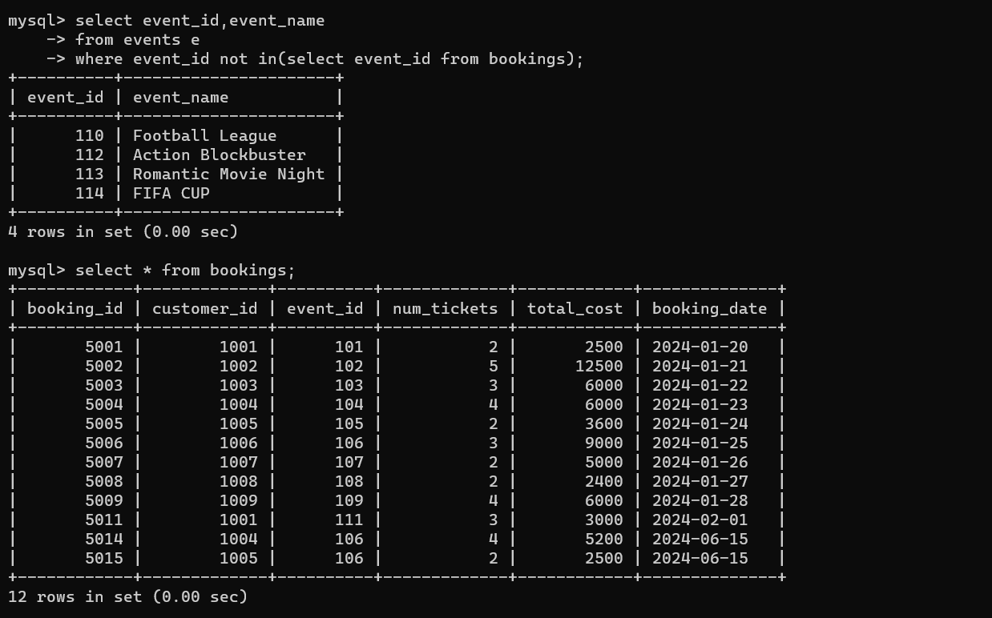

1. Calculate the Total Number of Tickets Sold for Each Event Type Using a Subquery in the FROM Clause.

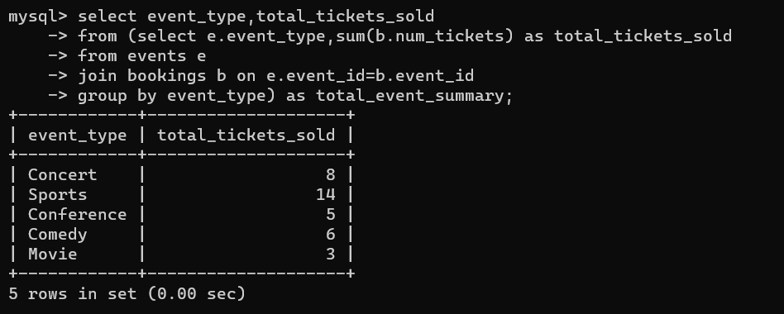

1. Find Events with Ticket Prices Higher Than the Average Ticket Price Using a Subquery in the WHERE Clause.

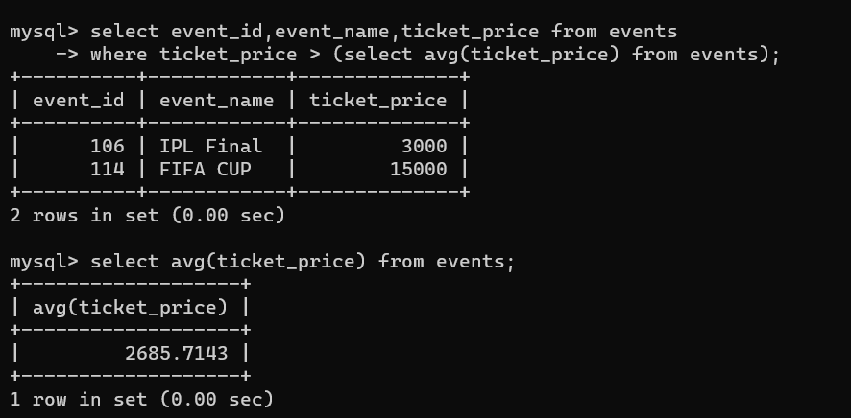

1. Calculate the Total Revenue Generated by Events for Each User Using a Correlated Subquery.

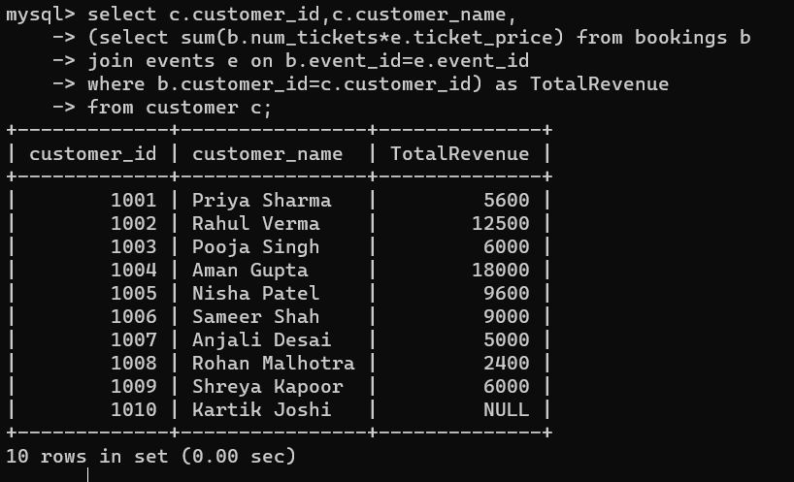

1. List Users Who Have Booked Tickets for Events in a Given Venue Using a Subquery in the WHERE Clause.

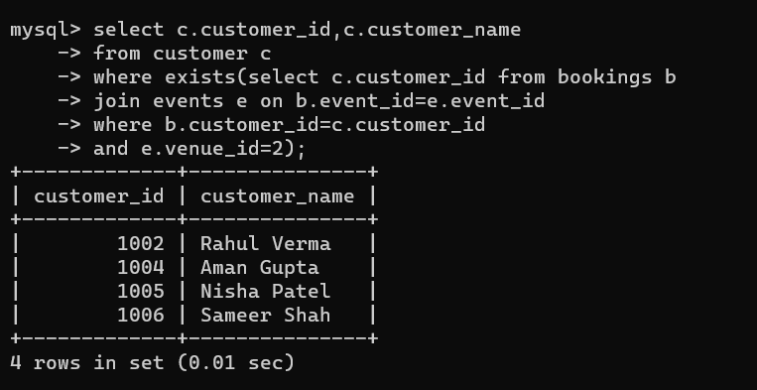

10. Calculate the Total Number of Tickets Sold for Each Event Category Using a Subquery with GROUP BY.

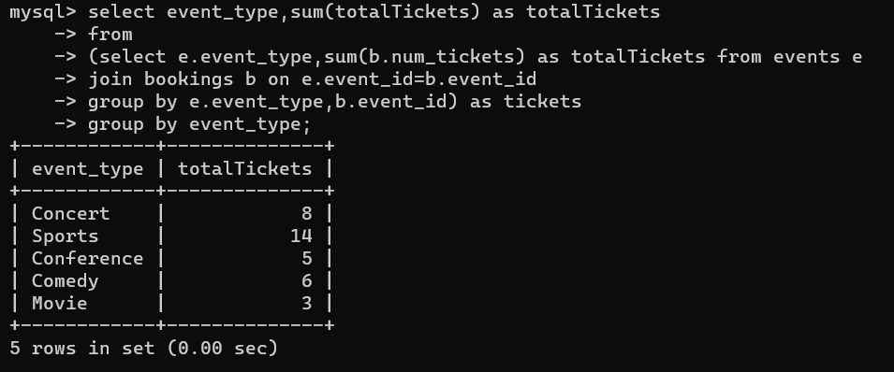

1. Find Users Who Have Booked Tickets for Events in each Month Using a Subquery with DATE_FORMAT.

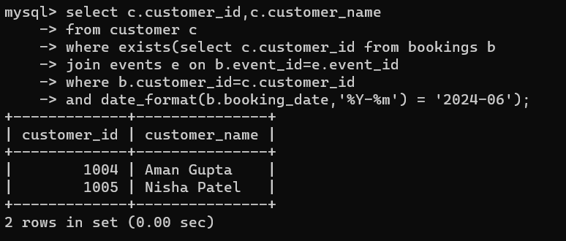

1. Calculate the Average Ticket Price for Events in Each Venue Using a Subquery.

