**Name: Sarthak Shandilya**

**Coding Challenge 5 (Loan Management)**

**Submitted to: Karthika**

Create SQL Schema from the customer and loan class, use the class attributes for table column names.

1. Define a `Customer` class with the following confidential attributes:

a. Customer ID

b. Name

c. Email Address

d. Phone Number

e. Address

f. creditScore

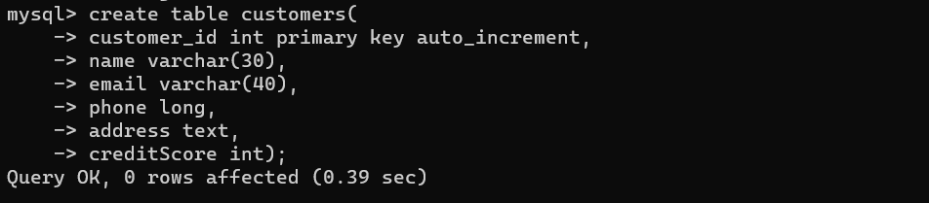

2. Define a base class `Loan` with the following attributes:

a. loanId

b. customer (reference of customer class)

c. principalAmount

d. interestRate

e. loanTerm (Loan Tenure in months)

f. loanType (CarLoan, HomeLoan)

g. loanStatus (Pending, Approved) 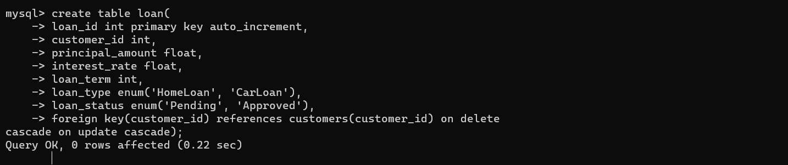

3. Create two subclasses: `HomeLoan` and `CarLoan`. These subclasses should inherit from the Loan class and add attributes specific to their loan types.

For example:

a. HomeLoan should have a propertyAddress (String) and propertyValue (int) attribute. 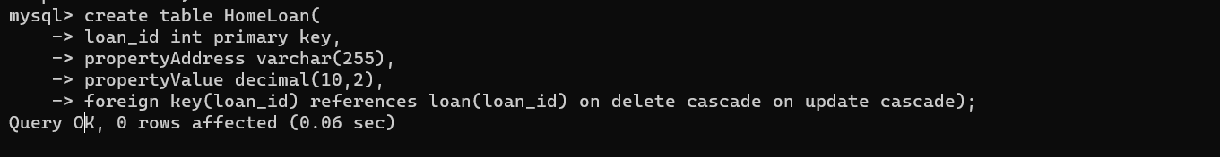

b. CarLoan should have a carModel (String) and carValue (int) attribute.

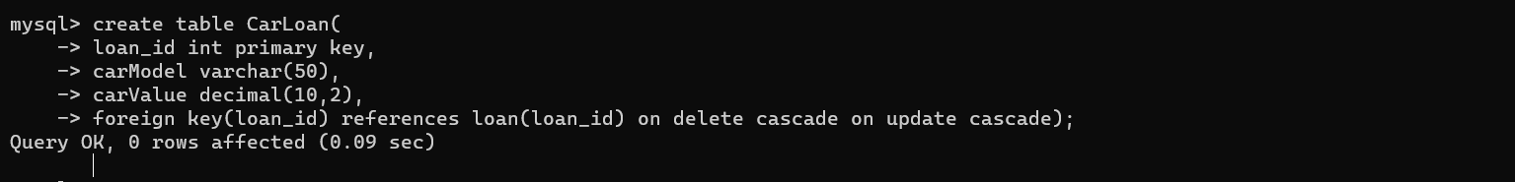

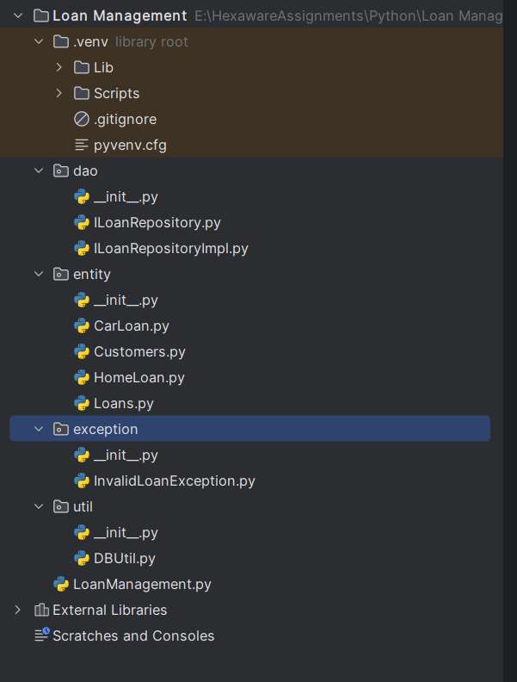

This is the packages and project structure.

Below are the classes implementations:

Customers:

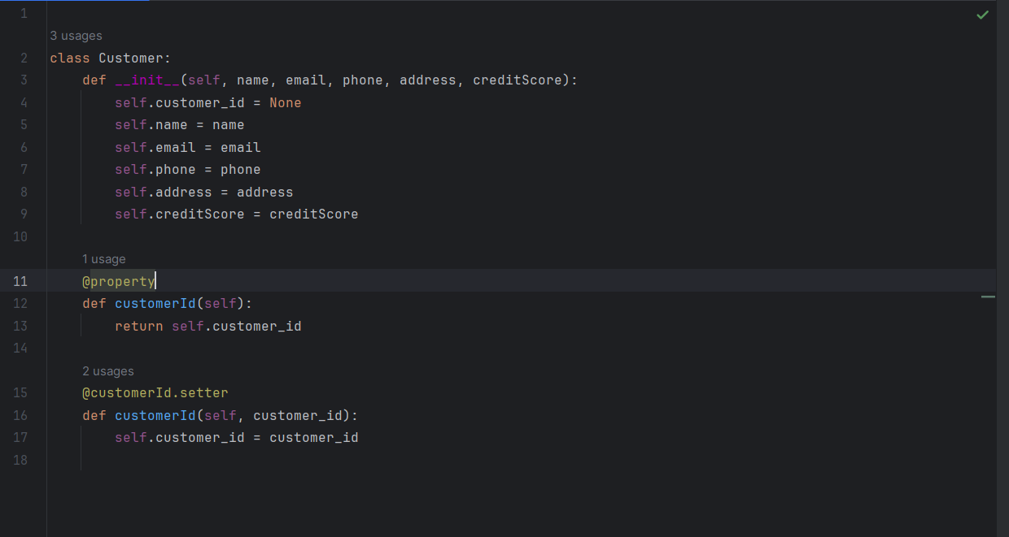

Loans:

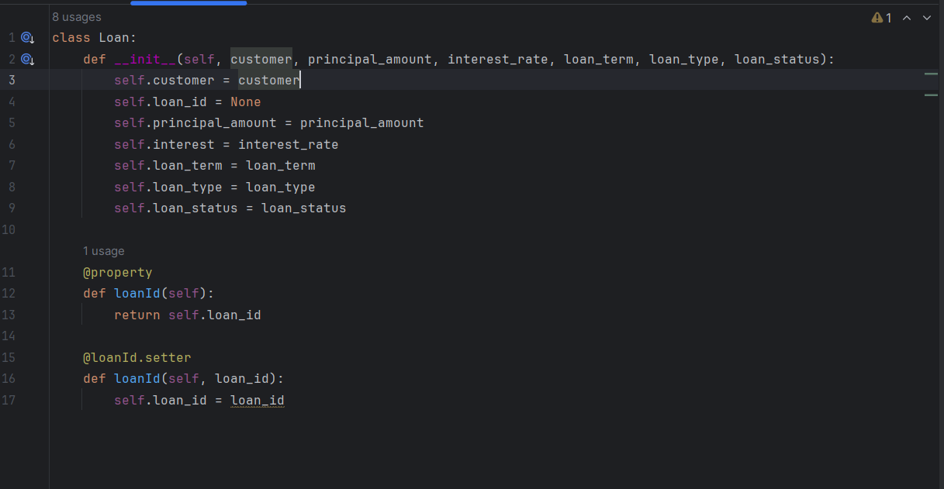

Home Loan:

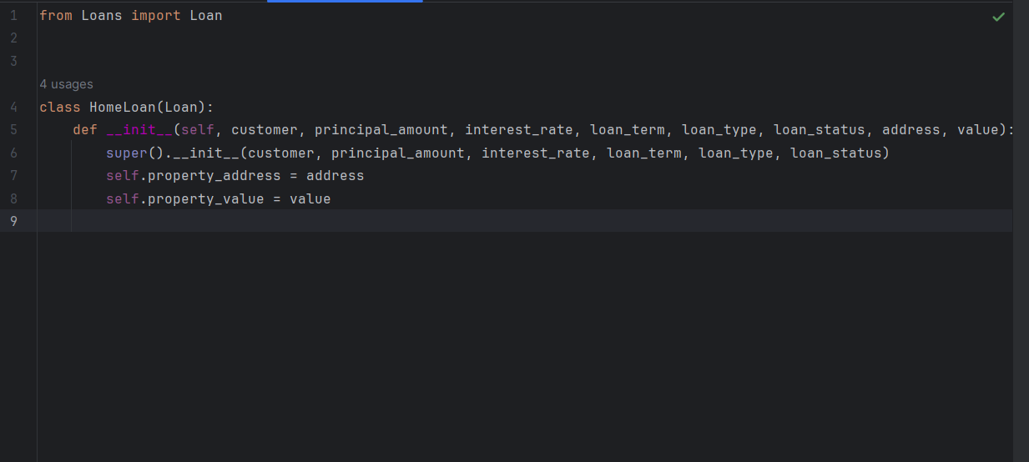

Car Loan:

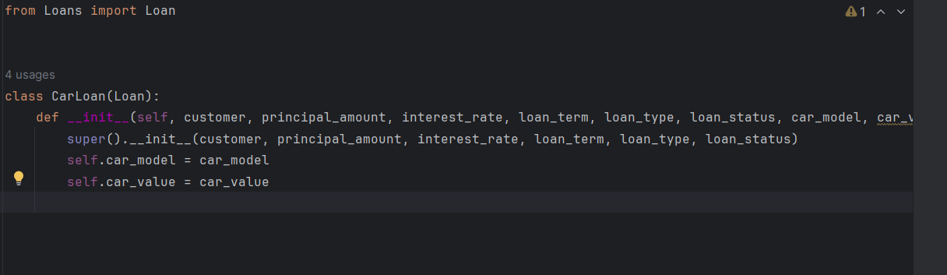

Interface ILoanRepository:

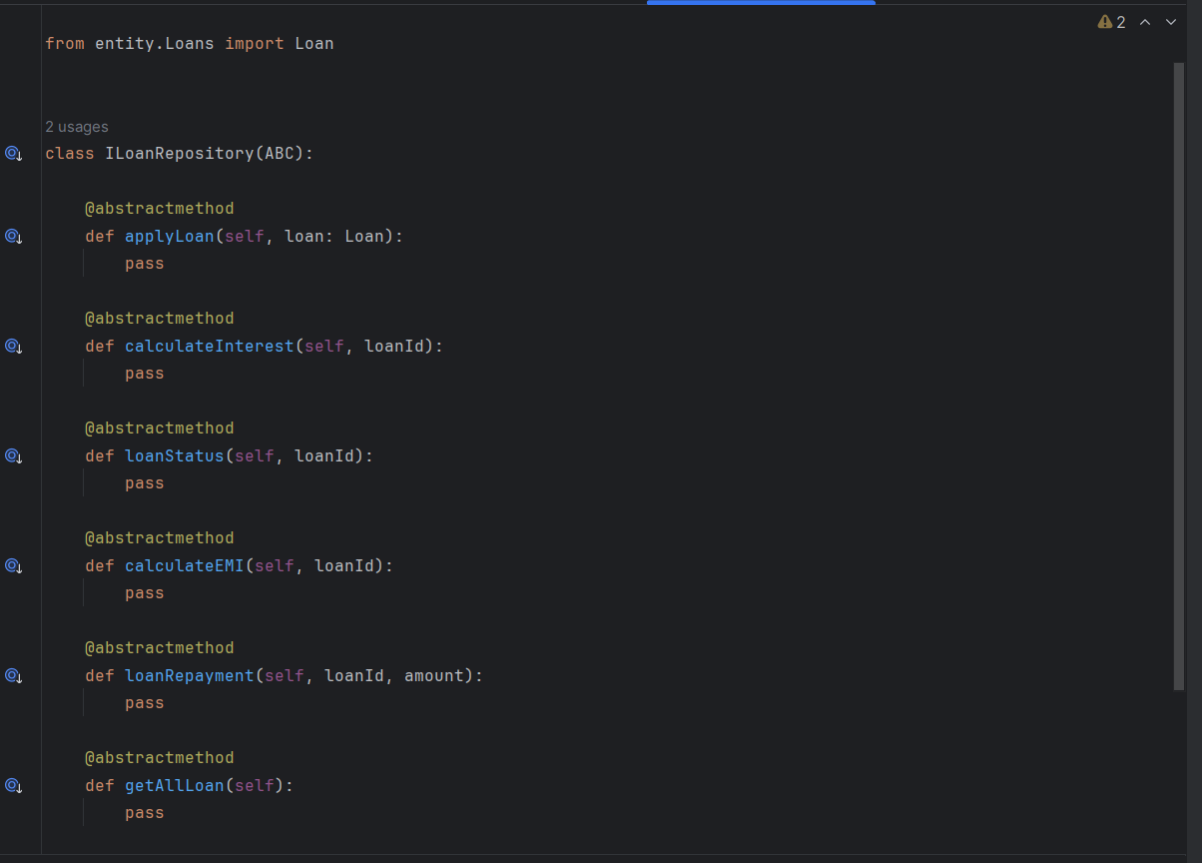

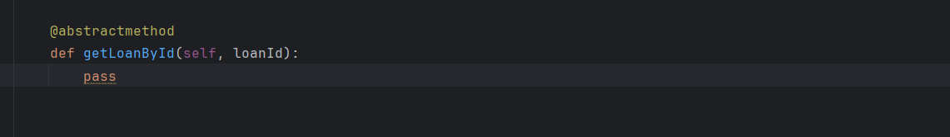

Implementation of ILoanRepositoryImpl:

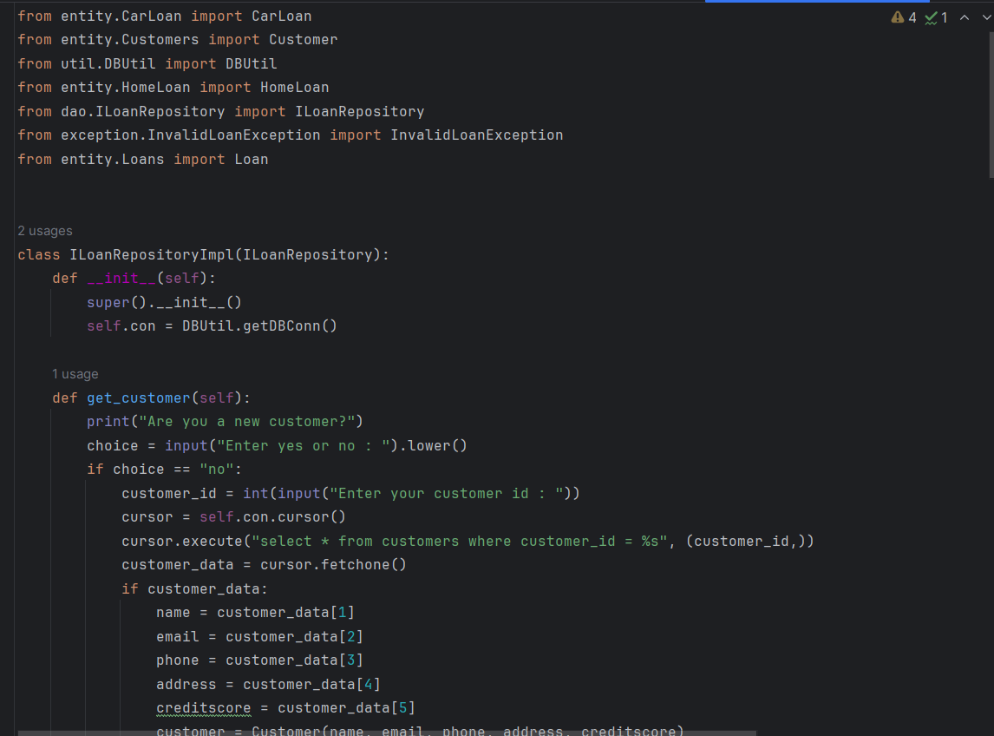

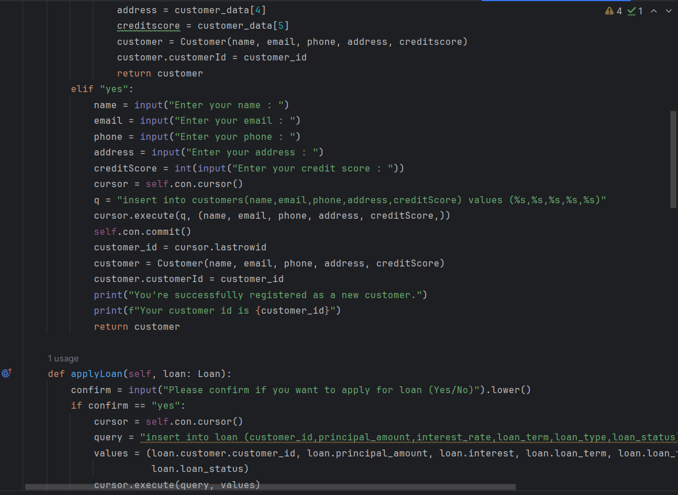

applyLoan():

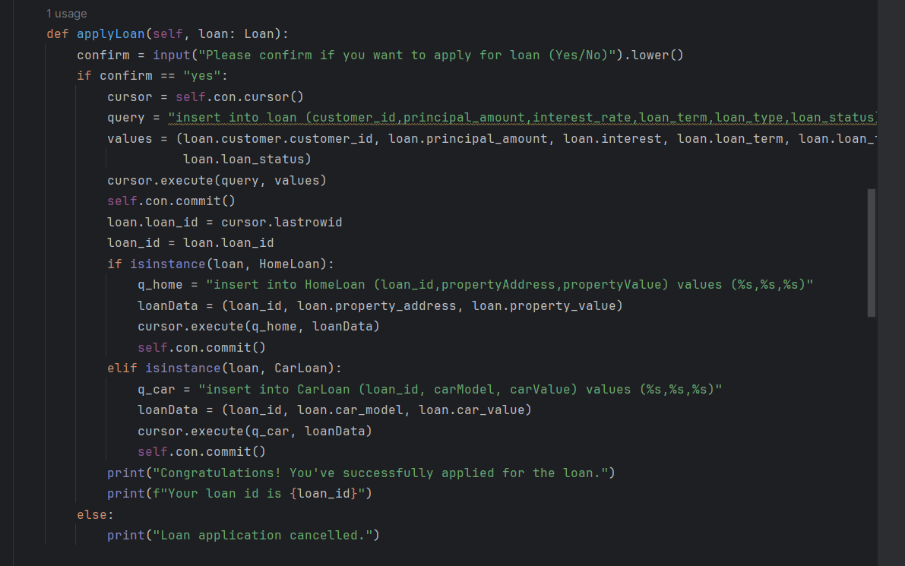

calculateInterest() and loanStatus():

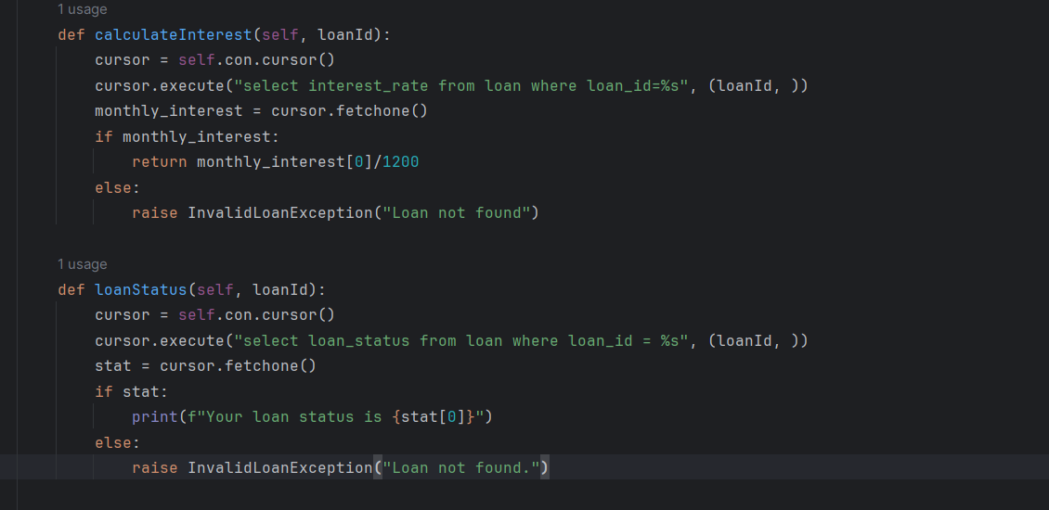

CalculateEMI() and LoanRepayment():

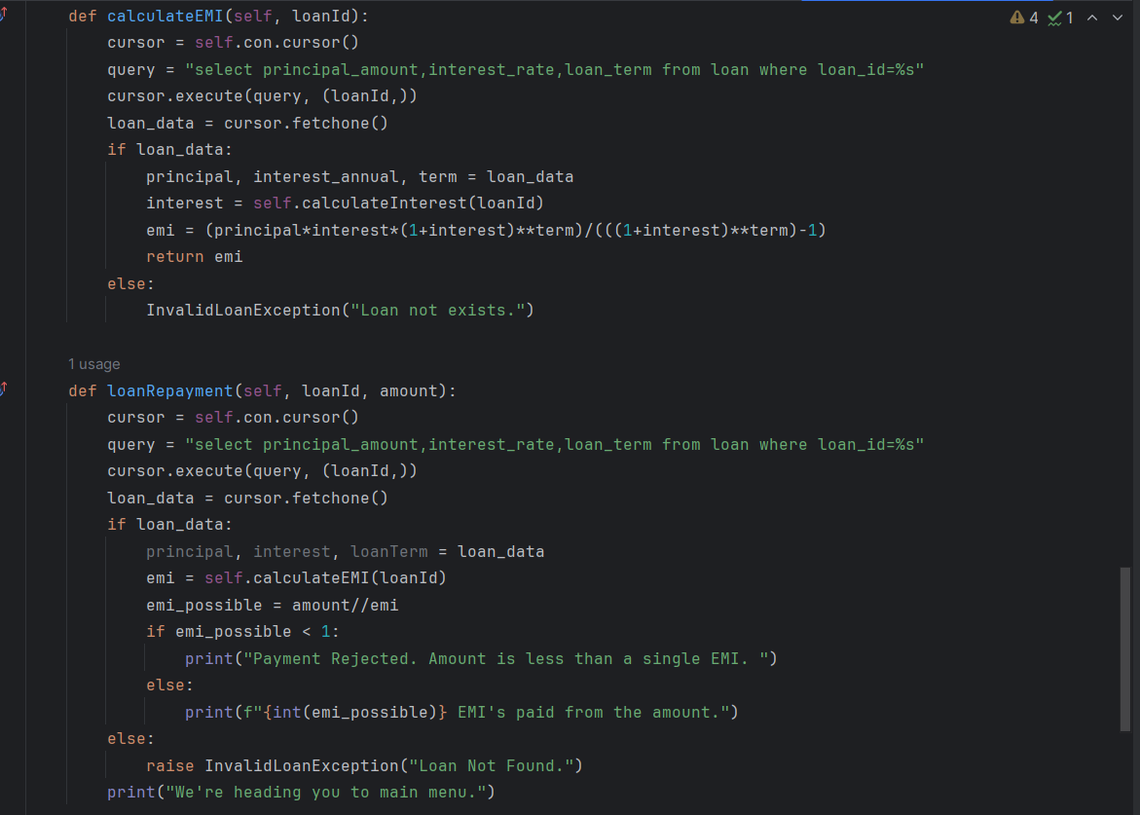

getAllLoan() and getLoanbyId():

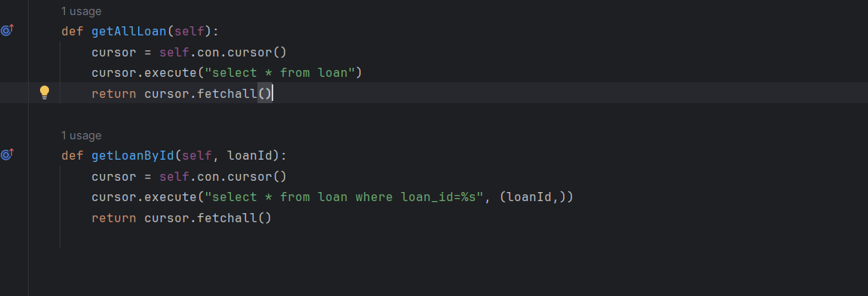

LoanManagement:

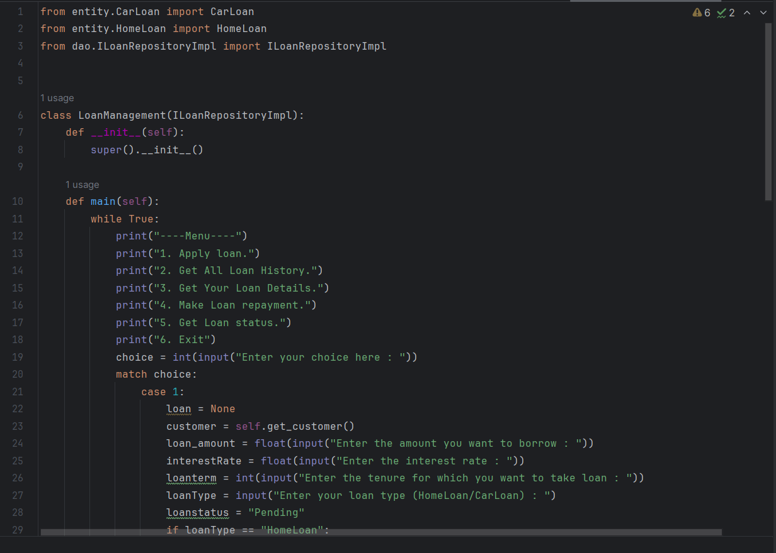

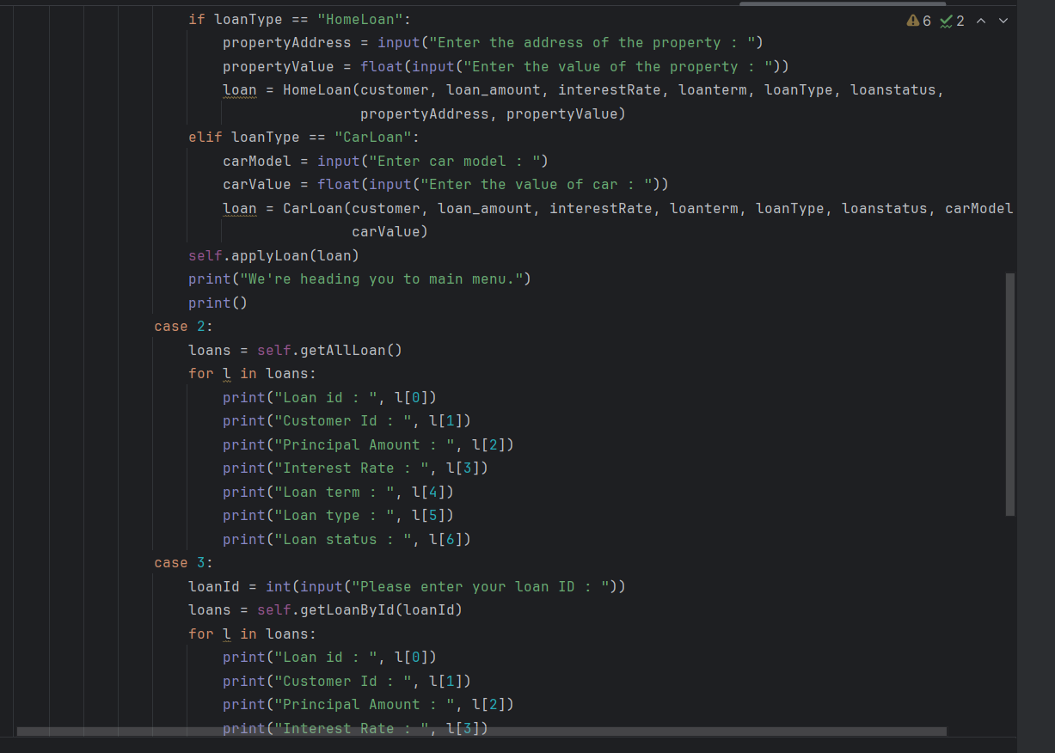

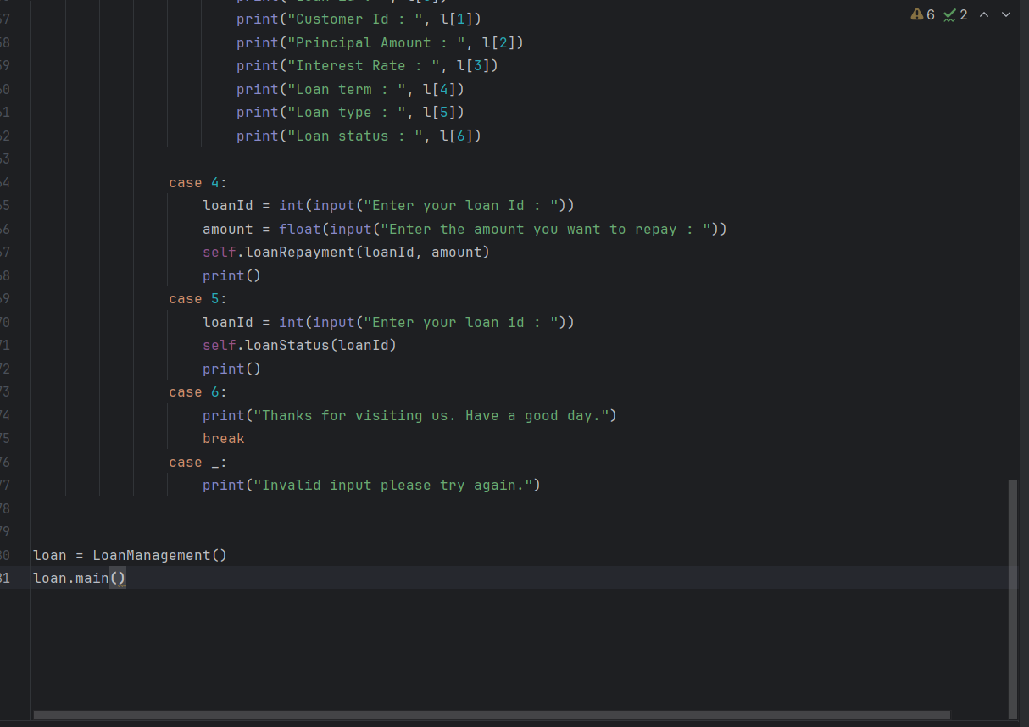

Outputs:

1. Apply Loan (Car/Home) with existing/Not existing customer

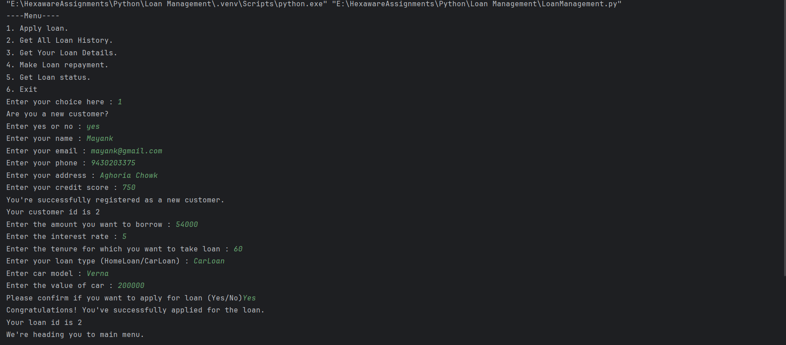

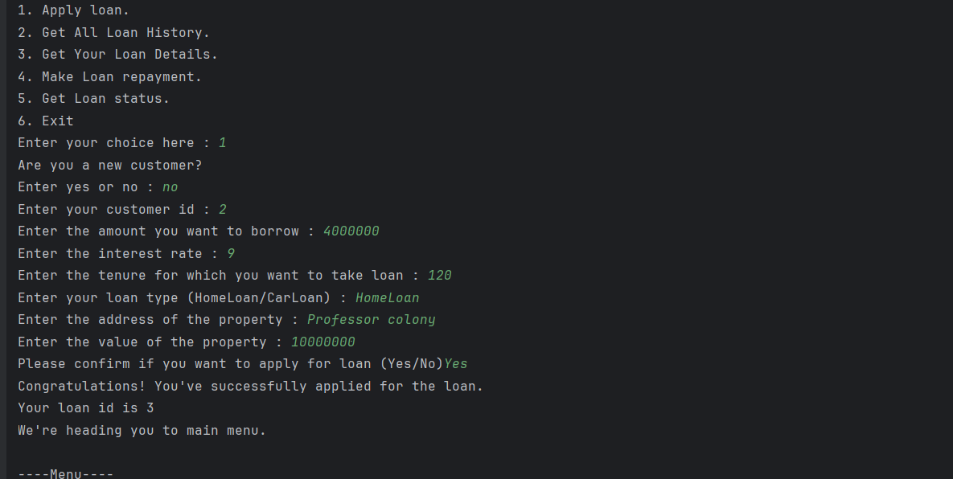

1. GetAll loan histosy:

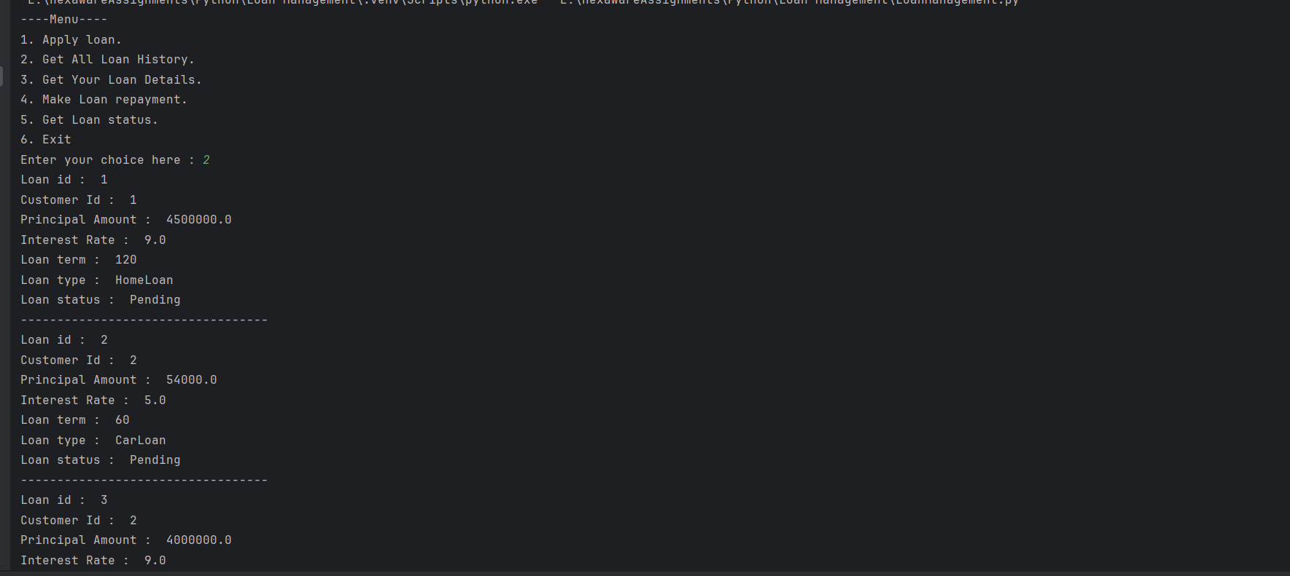

1. Get Loan history by Id

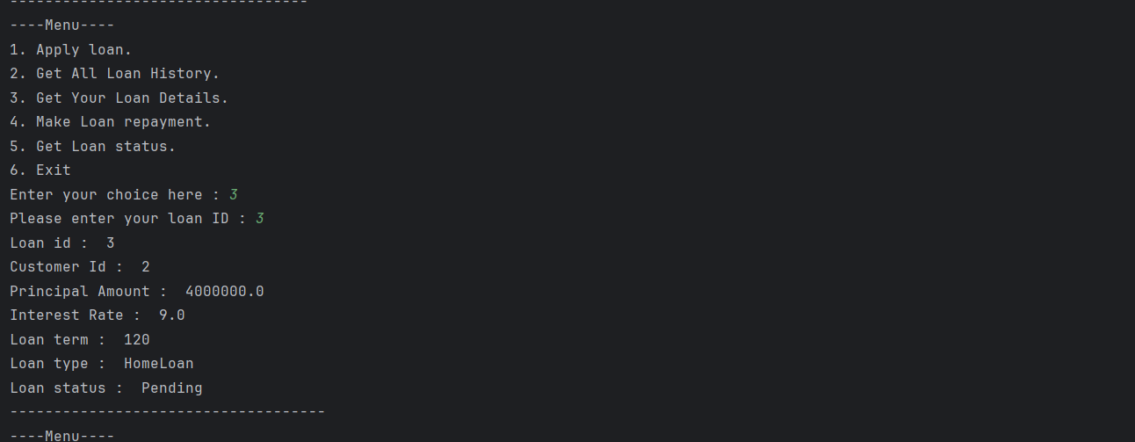

1. Make loan repayment

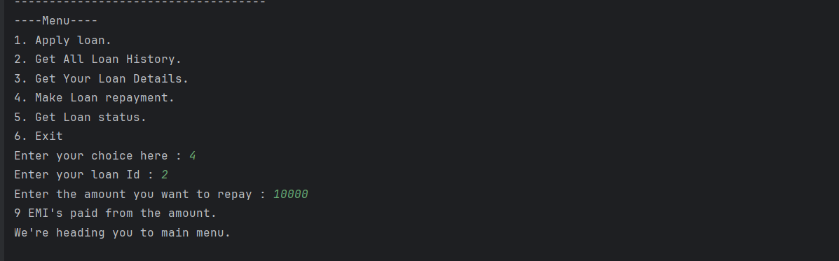

1. Get loan status

