1. mkdir Practice

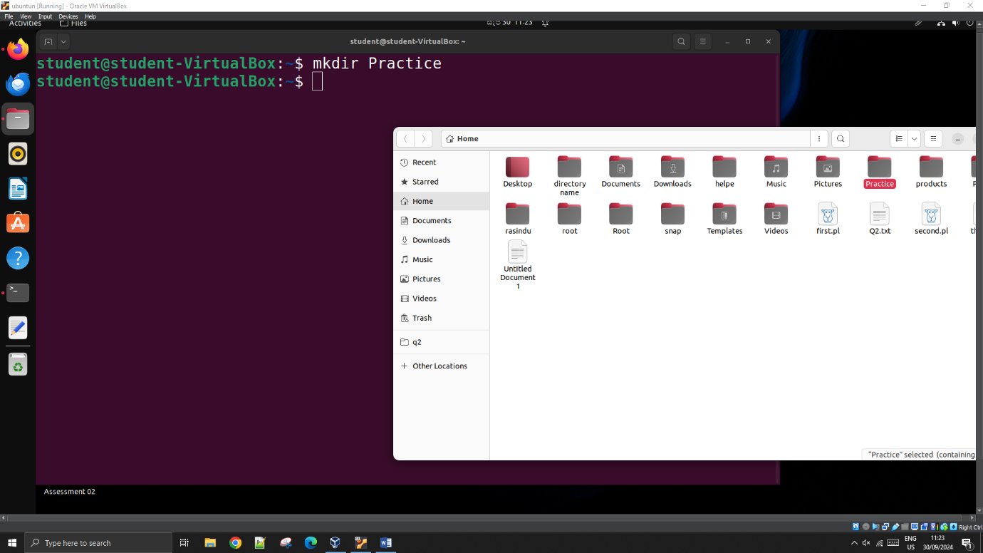

1. cd Practice

mkdir text

mkdir Images

mkdir Videos

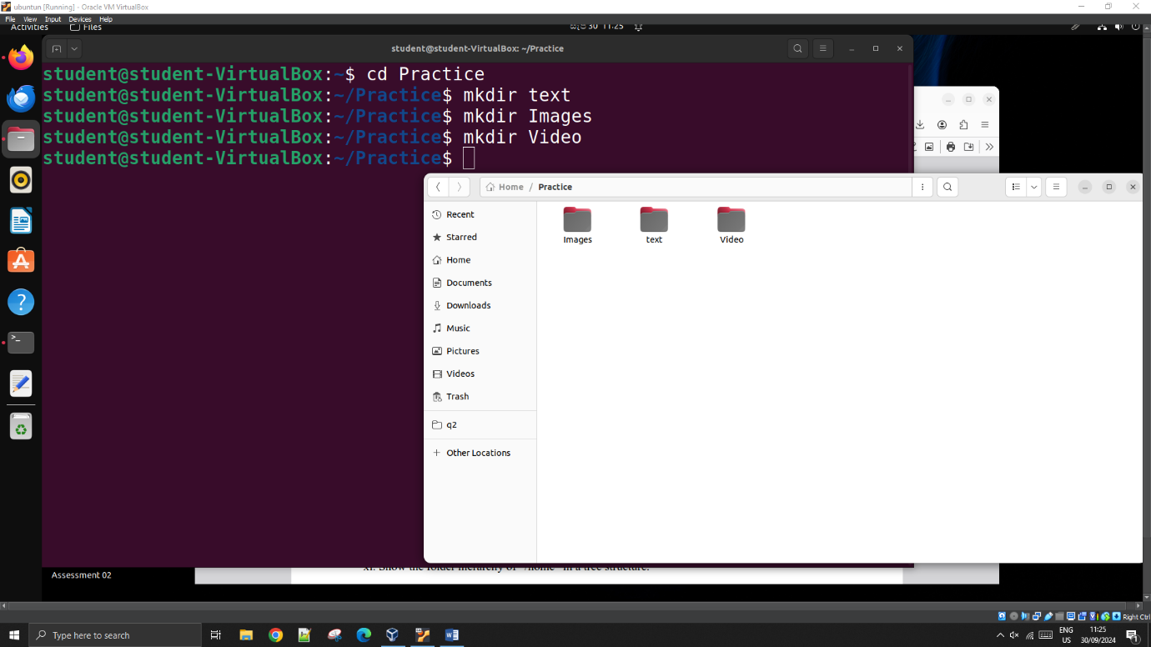

1. cd text

touch myfirstfile.txt

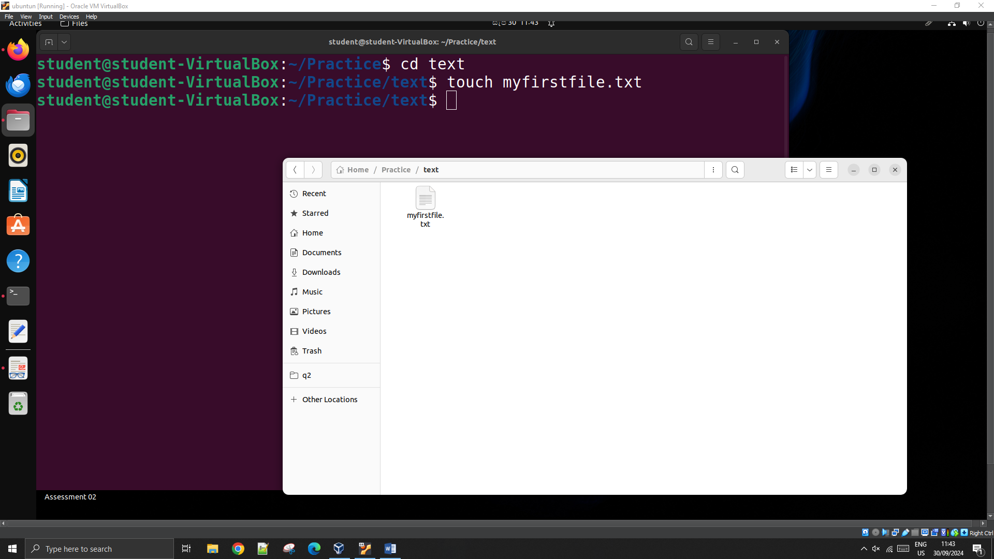

1. cd ../Images

touch mysecondfile.txt

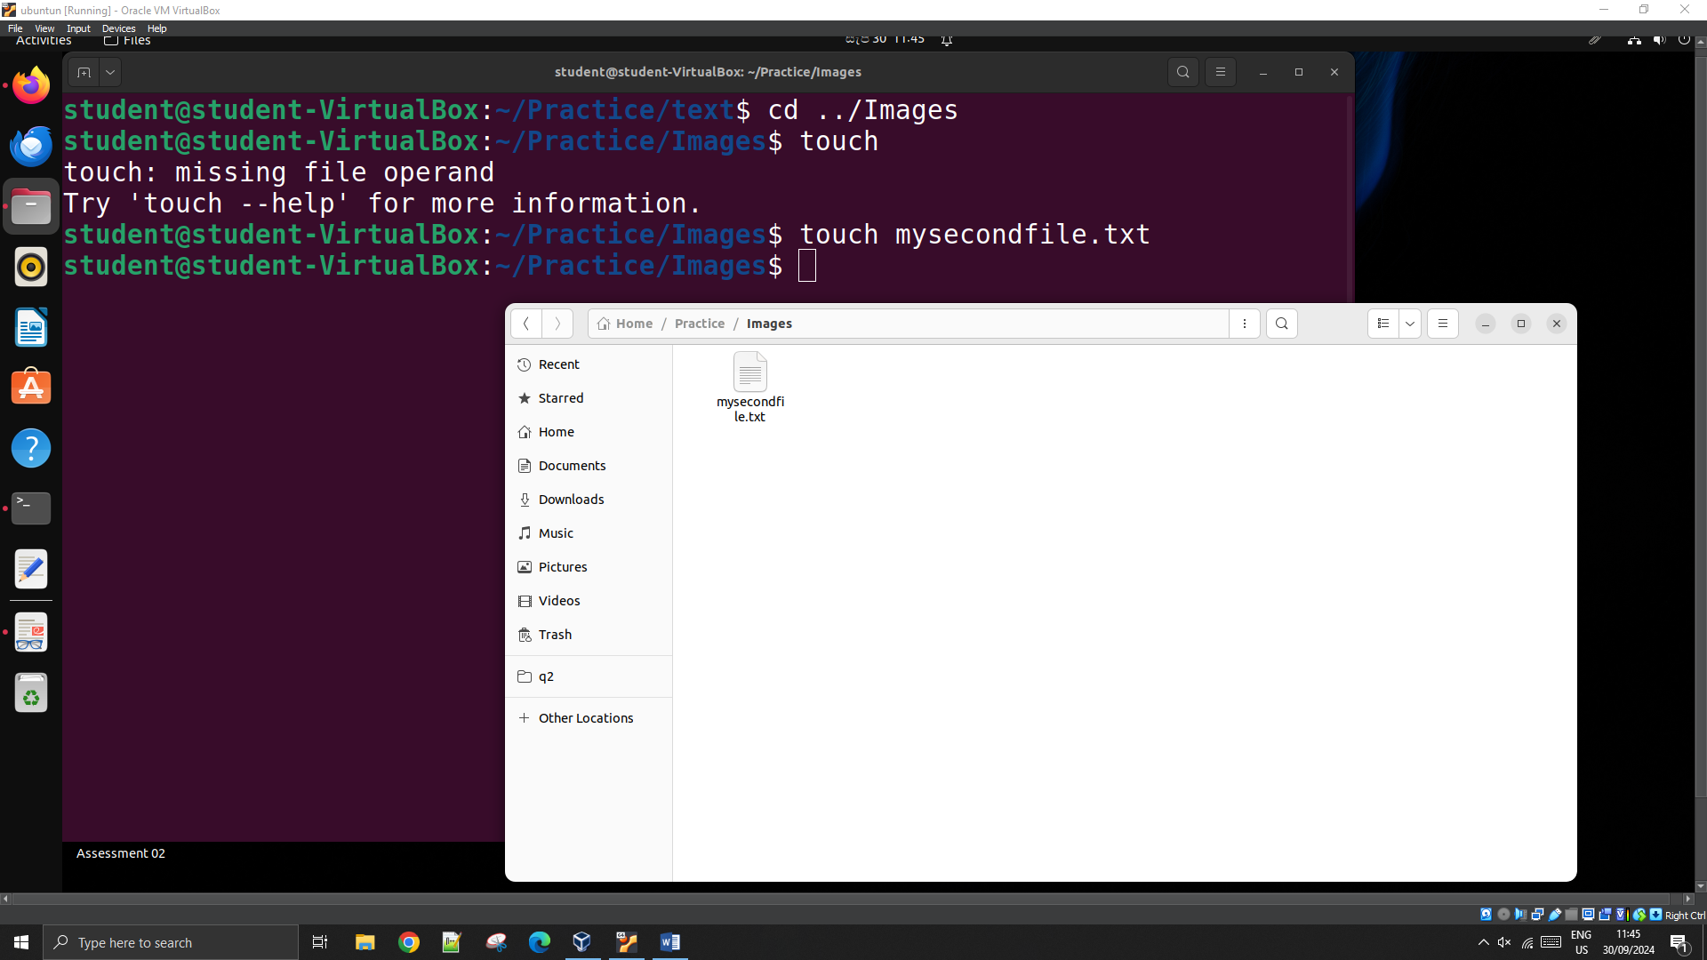

1. cd ../text

nano myfirstfile.txt