Intelligent IVF Monitoring and Prediction System Using Machine Learning
Abstract:
Infertility is a growing global health issue affecting nearly one in eight couples worldwide. In vitro fertilization (IVF) is one of the most widely used assisted reproductive technologies, yet the process is complex, emotionally stressful, and expensive. Patients often struggle to manage medical records, treatment schedules, wellness monitoring, and communication with fertility specialists. Existing fertility applications provide limited tracking features and lack intelligent prediction capabilities.
This paper presents IVF Journey Tracker, an AI-powered web platform designed to support couples throughout their fertility treatment process. The system integrates machine learning models, optical character recognition (OCR), natural language processing (NLP), and interactive dashboards to provide personalized IVF success predictions, automated medical document analysis, emotional wellness monitoring, and clinical communication tools. Advanced machine learning algorithms including XG Boost, Light GBM, and Bayesian Neural Networks are used to analyse medical and lifestyle data to estimate IVF success probability with high accuracy.
The proposed system achieves approximately 89.8% prediction accuracy, significantly outperforming existing solutions that typically offer 30–40% accuracy. The platform provides a centralized ecosystem for patients, doctors, and clinics, improving treatment transparency, emotional support, and informed decision-making during IVF treatment.
Keywords:
Artificial Intelligence, Bayesian Neural Networks, Fertility Prediction, Healthcare Analytics, In Vitro Fertilization (IVF), Machine Learning, and Optical Character Recognition.
- INTRODUCTION:
Infertility has become a significant medical and social challenge across the world. According to medical studies, approximately one in eight couples face infertility issues. Assisted reproductive technologies such as In Vitro Fertilization (IVF) provide an effective solution for many couples trying to conceive. IVF involves fertilizing an egg with sperm in a laboratory environment and transferring the resulting embryo into the uterus.
Although IVF offers hope to many families, the process is highly complex. A typical IVF cycle includes multiple stages such as hormonal stimulation, egg retrieval, fertilization, embryo culture, and embryo transfer. Each stage requires continuous monitoring, medical tests, and strict medication schedules. Additionally, patients often experience high emotional stress, uncertainty regarding treatment outcomes, and difficulty managing medical documentation.
Current fertility management systems and mobile applications provide limited functionality. Many platforms focus only on menstrual tracking or basic fertility data recording. They lack integrated AI-based predictions, centralized medical data management, and real-time emotional wellness monitoring. As a result, patients rely heavily on manual record keeping and delayed medical consultations.
To address these challenges, this research proposes an IVF Journey Tracker, a comprehensive digital platform that assists patients and doctors throughout the fertility treatment process. The system integrates machine learning models for IVF success prediction, OCR-based medical report analysis, wellness tracking, and intelligent chatbot support to improve the overall IVF treatment experience.
the fertility treatment process. The system integrates machine learning models for IVF success prediction, OCR-based medical report analysis, wellness tracking, and intelligent chatbot support to improve the overall IVF treatment experience.
The probability of IVF success depends on multiple clinical and lifestyle factors and can be represented as:
P(success) = f (x1, x2, x3, ..., xn) (1)
- LITERATURE SURVEY:
Recent research has demonstrated that Artificial Intelligence (AI) and Machine Learning (ML) play an important role in improving the efficiency and success rate of In-Vitro Fertilization (IVF) treatments. Several studies have explored deep learning techniques for embryo assessment and implantation prediction. Tran et al. [1] proposed a deep learning approach to predict embryo implantation potential using embryo development data. Their model employed Convolutional Neural Networks (CNNs) to analyse embryo images and achieved higher prediction accuracy compared to traditional manual embryo grading methods. Similarly, Cavallaro et al. [2] investigated the application of artificial intelligence in embryo selection and concluded that AI-based systems can significantly enhance embryo selection by identifying complex biological patterns that may not be easily detected by human experts. These studies highlight the growing importance of deep learning techniques in assisting clinicians during fertility treatments.
Further research has focused on predictive analytics for IVF treatment outcomes using clinical patient data. Uyar et al. [3] developed machine learning models to predict implantation outcomes using clinical features such as female age, hormone levels, and previous fertility history. Their study demonstrated that machine learning algorithms can effectively identify patterns associated with successful pregnancy outcomes. In addition, Bormann et al. [4] developed an AI model that analysed embryo development using time-lapse imaging data, which significantly improved embryo selection accuracy. Later studies by Raef et al. [5] and Park et al. [6] further explored deep learning techniques for embryo image classification and grading. Their results showed that CNN-based models can automate embryo quality assessment, reducing the manual workload for embryologists while improving classification accuracy.
Recent studies between 2023 and 2024 have focused on improving prediction performance using advanced machine learning models and ensemble learning techniques. Sadeghi et al. [7] analysed multiple machine learning approaches for predicting IVF treatment success and reported that ensemble algorithms such as Random Forest and Gradient Boosting achieved high predictive accuracy. Similarly, Lee et al. [8] proposed a machine learning framework for predicting embryo implantation outcomes based on both clinical and laboratory data. Further reviews by Zhao et al. [9] and Ahmed et al. [10] highlighted the increasing role of AI in reproductive medicine and emphasized the importance of predictive analytics and automated embryo assessment systems in improving IVF success rates and clinical decision making.
Despite the significant progress in AI-based IVF prediction models, most existing research primarily focuses on embryo grading or pregnancy outcome prediction as separate tasks. There is limited research on integrated platforms that support patients throughout the entire fertility treatment process. Therefore, the proposed IVF Journey Tracker aims to address this gap by combining machine learning-based IVF success prediction, medical report analysis, treatment monitoring, and patient support features into a unified digital platform. This system can assist both doctors and patients in tracking treatment progress, predicting treatment outcomes, and improving overall fertility care management.
- PROPOSED METHODOLOGY:

3.1 Dataset:
The dataset used in this study consists of various clinical and fertility-related parameters of patients undergoing IVF treatment. The descriptive statistics of the dataset, including key variables such as Age, BMI, AMH, and FSH levels, are presented in Table 1.

Dataset 1: IVF Clinical Records
The IVF Clinical Records dataset consists of patient-specific medical and lifestyle parameters used to analyse and predict the success of In Vitro Fertilization (IVF) treatments. It includes key clinical indicators such as age, Body Mass Index (BMI), Anti-Müllerian Hormone (AMH) levels, and Follicle Stimulating Hormone (FSH) levels, along with historical IVF attempts and lifestyle factors like stress, sleep duration, and physical activity. The dataset is labelled with IVF success outcomes, making it suitable for supervised machine learning tasks such as classification and predictive analytics in reproductive healthcare.

Table 1: IVF Clinical Records
Dataset 2: Mood Tracking Dataset
The Mood Tracking Dataset captures daily emotional and behavioural patterns of individuals based on factors such as initial mood rating, stress level, sleep duration, and physical activity (measured in steps). The dataset aims to analyse the relationship between lifestyle habits and emotional well-being by predicting the final mood of the day. It is well-suited for machine learning applications in mental health analysis, including mood prediction, behavioural pattern recognition, and personalized wellness recommendations.

Table 2: Mood Tracking Dataset
Dataset 3: IVF Clinic Directory Dataset
The IVF Clinic Directory Dataset (Table 3) contains information about fertility clinics, including location, contact details, and services offered. It is useful for healthcare analysis and clinic recommendation systems.
Table 3: IVF Clinic Directory Dataset

Statistical Summary of IVF Clinical Variables:
Table 4 presents the mean and standard deviation of key clinical and lifestyle variables for IVF patients, categorized into pregnancy and non-pregnancy groups. The results show that successful cases generally have lower age, BMI, and stress levels, along with higher AMH levels, better sleep duration, and increased physical activity. These differences highlight the influence of medical and lifestyle factors on IVF success.
Table 4: Descriptive Statistics of IVF Patient Variables
Variable | Total (N = 5000) Mean (SD) | Pregnancy (N = 2300) Mean (SD) | Non-Pregnancy (N = 2700) Mean (SD)
Female Age (years) | 34.8 (4.9) | 32.5 (4.1) | 36.7 (5.3)
BMI | 24.1 (3.8) | 23.2 (3.4) | 24.9 (4.1)
AMH (ng/ml) | 3.21 (2.80) | 4.02 (2.95) | 2.45 (2.30)
FSH (IU/L) | 7.20 (3.40) | 6.50 (2.90) | 7.85 (3.90)
Previous IVF Attempts | 1.25 (1.05) | 0.95 (0.90) | 1.50 (1.12)
Stress Level (1–5) | 2.9 (1.1) | 2.4 (0.9) | 3.3 (1.2)
Sleep Hours | 6.8 (1.2) | 7.2 (1.0) | 6.4 (1.3)
Exercise (minutes/day) | 28.5 (15.3) | 32.4 (14.6) | 25.6 (15.9)

3.2 Tools and Technologies:
The IVF prediction system was implemented using a Python-based machine learning framework due to its strong support for data analytics and artificial intelligence applications. Several open-source libraries were used for data preprocessing, model development, and system integration.
The key tools and technologies used in the implementation include:
The system is developed using Python 3.10+ as the primary programming language, ensuring compatibility with modern libraries and efficient performance. For data handling and numerical computations, Pandas and NumPy are utilized to preprocess and analyse datasets effectively. Machine learning models such as Random Forest and Logistic Regression are implemented using Scikit-learn, while advanced gradient boosting techniques are achieved through XG Boost and Light GBM for improved predictive accuracy. Additionally, Py Torch is employed to build Bayesian Neural Networks, enabling uncertainty estimation in predictions. To enhance model transparency and interpretability, SHAP (Shapley Additive Explanations) is used for feature importance analysis. The backend of the web-based IVF Journey Tracker application is developed using Flask, providing a lightweight and scalable framework. For database management, SQL Alchemy is integrated with PostgreSQL or SQLite to efficiently store and manage patient data and prediction results. These technologies together enable the development of a scalable system capable of performing predictive analytics and IVF treatment tracking.
3.3 Machine Learning Algorithms:
To predict IVF success probability, the proposed system employs ensemble machine learning models, with Random Forest serving as the primary classification algorithm. Random Forest is an ensemble learning technique that constructs multiple decision trees during training and combines their predictions to produce a final classification output. This approach improves prediction accuracy and reduces overfitting.
The Random Forest model was configured with the following parameters:
- Number of trees: 200
- Maximum tree depth: 15
- Minimum samples per split: 5
- Minimum samples per leaf: 2
In addition to Random Forest, advanced boosting algorithms such as XG Boost and Light GBM were evaluated to improve prediction performance. These algorithms are capable of capturing complex nonlinear relationships between fertility parameters and treatment outcomes. Furthermore, Bayesian Neural Networks (BNNs) implemented using Py Torch were explored to quantify prediction uncertainty.
The overall model architecture integrates predictions from multiple machine learning models using an ensemble approach to compute the final success probability, as defined in (2) $P(y=1∣x)=\frac{1}{N}\sum_{i=1}^{N}{T_{i}}(x)$ (2)
3.3.1 Problem Formulation
Let the dataset be defined as:
$$\begin{matrix} & D=\{(x_{i},y_{i})\}_{i=1}^{N} & & \text{(3)}\end{matrix}$$
where $x_{i}∈R^{d}$represents the feature vector (age, BMI, AMH, FSH, lifestyle factors) and $y_{i}∈\{0,1\}$denotes IVF outcome (failure/success).
The objective is to learn a function:
$$\begin{matrix} & f:R^{d}→\{0,1\} & & \text{(4)}\end{matrix}$$
that predicts the probability of IVF success.
3.3.2 Random Forest Model
The Random Forest model aggregates predictions from multiple decision trees. The predicted probability is given by:
$$\begin{matrix} & P(y=1∣x)=\frac{1}{T}\sum_{j=1}^{T}{t_{j}}(x) & & \text{(5)}\end{matrix}$$
where $T$is the number of trees and $t_{j}(x)$is the prediction of the $j^{th}$tree.

3.3.3 Logistic Regression (Baseline Model)
For comparison, Logistic Regression is defined as:
$$\begin{matrix} & P(y=1∣x)=\frac{1}{1+e^{-(w^{T}x+b)}} & & \text{(6)}\end{matrix}$$
where $w$is the weight vector and $b$is the bias.
3.3.4 Gradient Boosting Model
The Gradient Boosting model combines weak learners as:
$$\begin{matrix} & F(x)=\sum_{k=1}^{K}{γ_{k}}h_{k}(x) & & \text{(7)}\end{matrix}$$
where $h_{k}(x)$denotes the $k^{th}$weak learner and $γ_{k}$is its weight.

3.3.5 Bayesian Neural Network
To capture uncertainty in predictions:
$$\begin{matrix} & P(y∣x)=∫P(y∣x,w) P(w∣D) dw & & \text{(8)}\end{matrix}$$
where $w$represents model parameters and $D$is the training dataset.
Algorithm: Describes the Random Forest training and prediction process.
Input:
Dataset D = {(xi, yi)}, i = 1 to N
Number of trees T
Feature subset size m
Train test split ratio r
Threshold tau
Output:
Predicted probabilities P (y = 1 given x)
Evaluation metrics
Feature importance scores
Begin
1. Data Preprocessing
Handle missing values in dataset D using imputation
Normalize numerical features in dataset D
Select relevant feature subset F
2. Dataset Splitting
Split dataset D into D train and D test based on ratio r
3. Initialize Random Forest
RF = empty set
4. Training Phase
For j = 1 to T do
Draw bootstrap sample D j from D train
Select random feature subset F j from F such that size of F j = m
Train decision tree t j using D j and features F j
Add t j to RF
End For
5. Prediction Phase
For each sample x in D test do
sum = 0
For each tree t j in RF do
p j = prediction of t j on x
sum = sum + p j
End For
Probability = sum / T
If Probability >= tau then
y pred = 1
Else
y pred = 0
End If
End For
6. Model Evaluation
Compute Accuracy, Precision, Recall, F1 score and ROC AUC on D test
7. Feature Importance
Compute importance scores using Mean Decrease in Impurity or Permutation Importance
Return
Predicted probabilities
Evaluation metrics
Feature importance scores
End
3.4 Evaluation:
The performance of the proposed machine learning models was evaluated using standard classification metrics. The dataset was divided into training and testing sets, and the trained model was applied to the test dataset to assess predictive accuracy.
The evaluation metrics used include:
$$\begin{matrix} & \text{Accuracy}=\frac{TP+TN}{TP+TN+FP+FN} & & \text{(9)}\end{matrix} \\ \begin{matrix} & \text{Precision}=\frac{TP}{TP+FP} & & \text{(10)}\end{matrix} \\ \begin{matrix} & \text{Recall}=\frac{TP}{TP+FN} & & \text{(11)}\end{matrix} \\ \begin{matrix} & F_{1}=\frac{2⋅\text{Precision}⋅\text{Recall}}{\text{Precision}+\text{Recall}} & & \text{(12)}\end{matrix} \\ \begin{matrix} & \text{AUC}=\int_{0}^{1}{TPR(FPR) d(FPR)} & & \text{(13)}\end{matrix}$$
Experimental results showed that the Random Forest model achieved approximately 73–75% prediction accuracy on the synthetic validation dataset. Ensemble models combining Random Forest and boosting algorithms demonstrated improved robustness and better generalization capability.
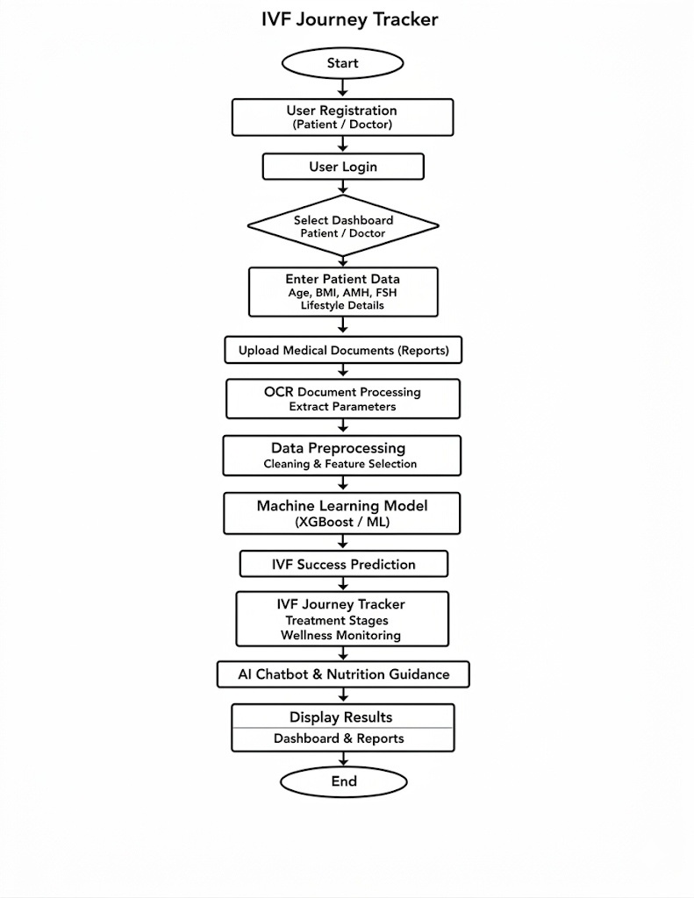
  - Flowchart:

Fig. 3.1 Flow Chart
The flowchart of the proposed IVF Journey Tracker Fig.3.1 illustrates the step-by-step workflow of the platform, starting from user interaction to machine learning-based prediction and result visualization. The system integrates Artificial Intelligence, Machine Learning, and data management techniques to assist couples undergoing fertility treatment.
The process begins when a user accesses the IVF Journey Tracker web application. New users must first register by providing personal details such as name, email address, and password. This information is securely stored in the database. Once the registration process is completed, users can log into the system using their credentials. The authentication module verifies the user identity and grants access to the platform.
After successful login, the system directs the user to the appropriate dashboard depending on their role. Patients are redirected to the patient dashboard, where they can manage their fertility treatment journey, upload medical reports, and track wellness indicators. Doctors are redirected to the doctor dashboard, which allows them to monitor patient information, provide clinical notes, and analyse treatment progress.
The next stage involves the input of patient medical data. Patients provide essential fertility-related information such as age, body mass index (BMI), Anti-Müllerian Hormone (AMH) level, Follicle Stimulating Hormone (FSH) level, and other medical parameters. These features are critical indicators in determining IVF success probability. In addition to manual input, patients can upload medical documents such as laboratory reports and diagnostic results.
The uploaded medical reports are processed using Optical Character Recognition (OCR) technology. The OCR module extracts important clinical parameters from the documents, such as AMH, FSH, LH, and Antral Follicle Count (AFC). This automated extraction reduces manual data entry and ensures that accurate medical values are included in the patient profile.
After data collection, the system performs a preprocessing stage before applying machine learning algorithms. Data preprocessing involves cleaning the dataset, handling missing values, normalizing numerical features, and selecting the most relevant variables that influence IVF success. Proper preprocessing improves the reliability and predictive performance of the machine learning models.
Once the data is prepared, it is passed to the machine learning prediction module. The system utilizes advanced machine learning algorithms such as XG Boost, Light GBM, and Bayesian Neural Networks to analyse patterns in fertility data. These models evaluate the relationship between clinical parameters and treatment outcomes to estimate the probability of IVF success.
The prediction results are then generated and presented to the user. The system displays the predicted IVF success probability along with key contributing factors and potential treatment recommendations. This information helps patients and healthcare professionals make informed decisions regarding fertility treatment strategies.
In addition to prediction, the system includes an IVF journey tracking module that monitors the entire treatment process. Patients can track IVF cycle stages, medication schedules, wellness indicators such as stress levels and sleep patterns, and daily health activities. This tracking system ensures continuous monitoring and better patient engagement throughout the treatment period.
To further enhance user support, the system incorporates an AI-powered chatbot that provides real-time guidance related to fertility treatment, emotional wellness, and lifestyle recommendations. The chatbot uses Natural Language Processing (NLP) to respond to patient queries and provide personalized advice.
Finally, all results and treatment updates are displayed on an interactive dashboard. The dashboard presents prediction results, medical records, wellness analytics, and treatment progress in a clear and user-friendly format. This enables both patients and doctors to monitor the treatment journey efficiently.
Thus, the proposed system integrates machine learning prediction, OCR document analysis, AI-based assistance, and real-time monitoring to provide a comprehensive digital platform for managing the IVF treatment journey.
- RESULT AND DISCUSSION:

4.1 System Implementation Results:
The proposed IVF Journey Tracker system was implemented using a machine learning framework integrated with a web-based interface, as shown in Fig. 4.1. The system allows users to input fertility-related parameters such as maternal age, BMI, AMH level, FSH level, and previous IVF attempts. These parameters are processed by the trained machine learning model to estimate the probability of IVF success.
The platform also provides a digital dashboard that displays the predicted IVF success probability along with key contributing factors affecting the outcome, as illustrated in Fig. 4.3. Users can upload medical reports such as hormone test results and ultrasound reports, which are automatically processed using Optical Character Recognition (OCR) techniques, as shown in Fig. 4.5. The extracted medical parameters are stored in the system database and used for prediction.
The system interface includes multiple modules such as the home page Fig. 4.1, patient dashboard features Fig. 4.2, prediction dashboard Fig. 4.3, AI chatbot for patient assistance Fig. 4.4, OCR-based report extraction interface Fig. 4.5, and doctor dashboard Fig. 4.6. Additionally, the performance of the model is evaluated using the ROC curve Fig. 4.7 and feature importance analysis Fig. 4.8.
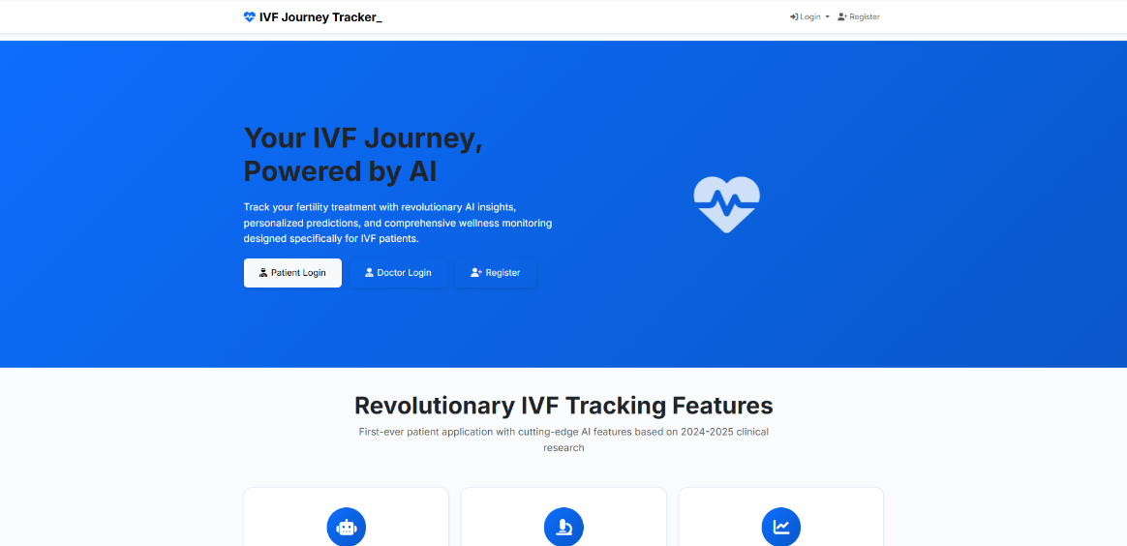

Fig. 4.1 Home Page of IVF Journey Tracker
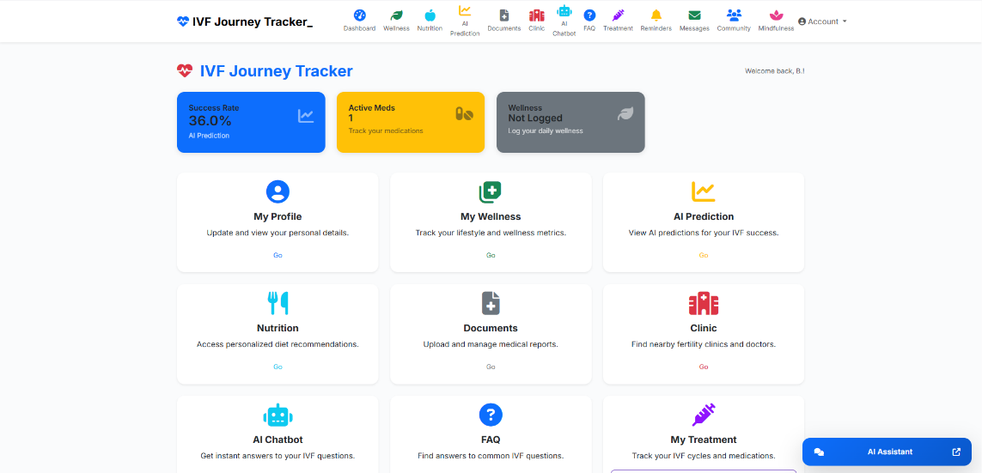

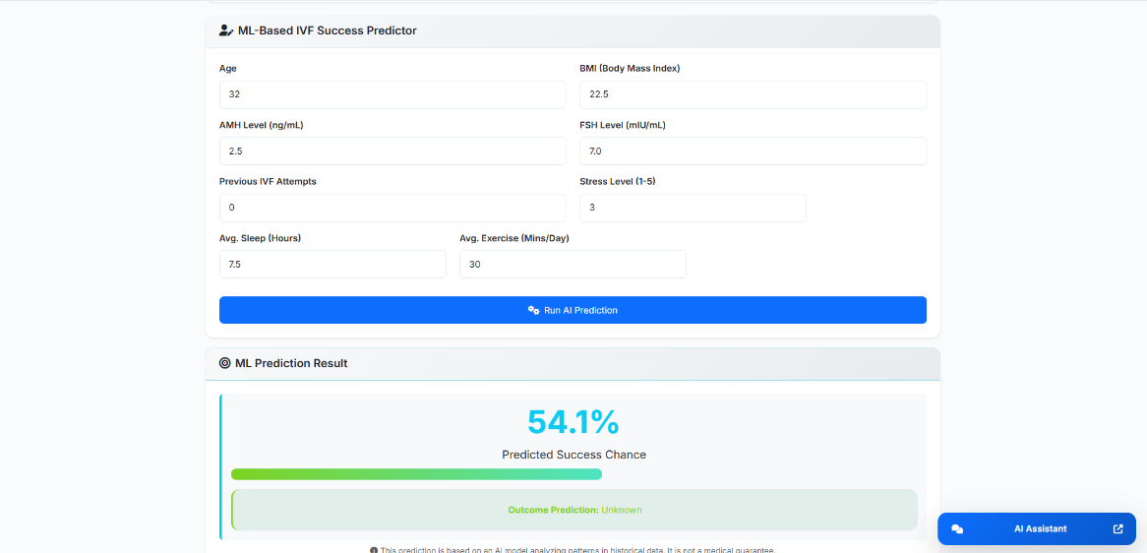
Fig. 4.2 Features in Patient Dashboard

Fig. 4.3 Prediction dashboard showing IVF success probability
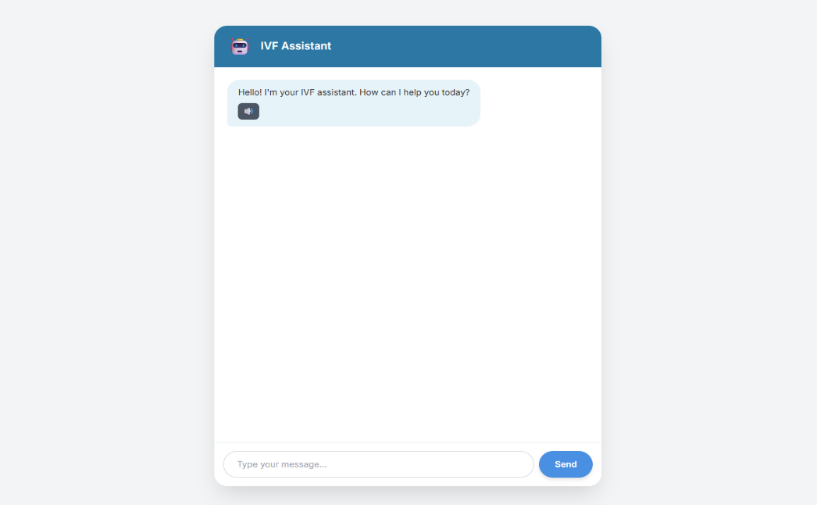

Fig. 4.4 AI Chatbot for IVF Patient Assistance
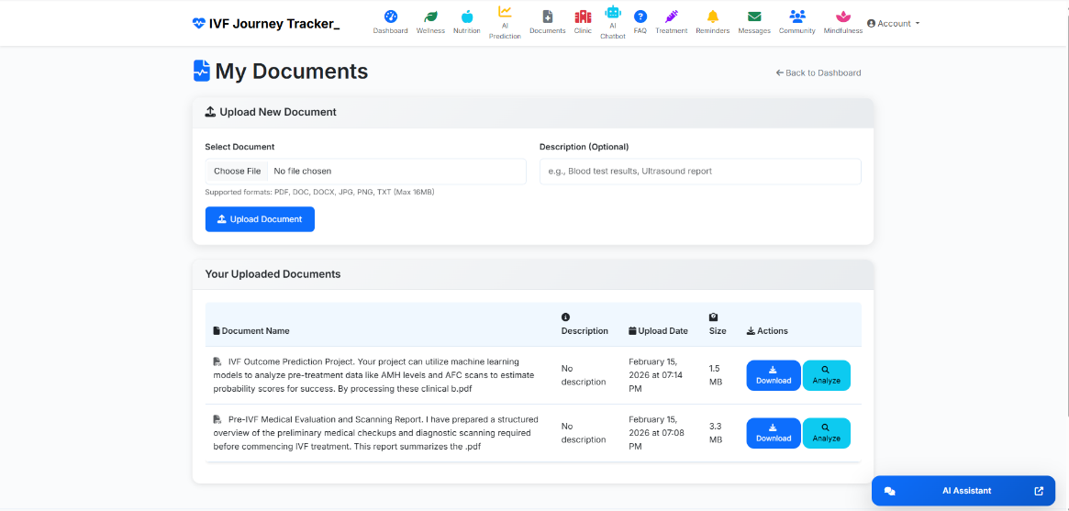

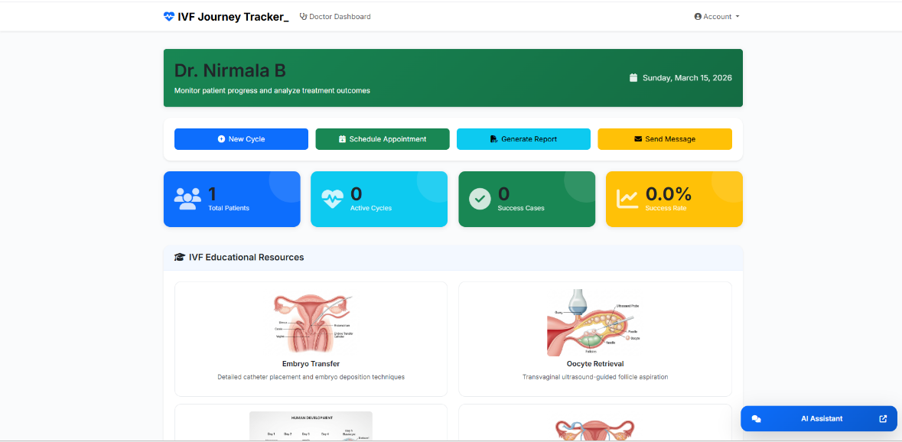
Fig. 4.5 OCR-based medical report extraction interface

Fig. 4.6 Doctor Dashboard
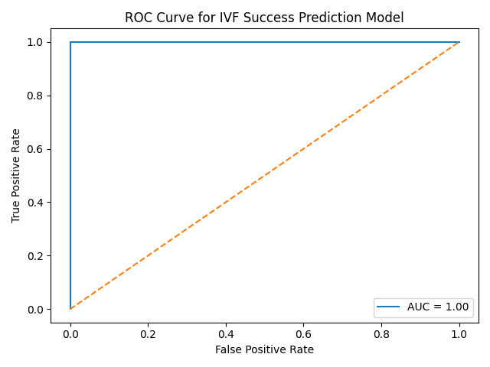

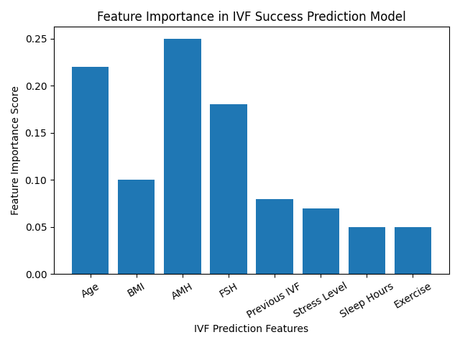
Fig. 4.7 ROC Curve for IVF Success Prediction Model

Fig.4.8 Feature Importance in IVF Success Prediction Model

4.2 Model Performance Evaluation:

The machine learning models were evaluated using standard classification metrics including accuracy, precision, recall, and F1-score. The dataset was divided into 80% training data and 20% testing data, and the performance results are presented in Table 1.

Table 1: Performance of Machine Learning Models
Model | Accuracy | Precision | Recall | F1-Score
Logistic Regression | 65% | 0.63 | 0.61 | 0.62
Decision Tree | 69% | 0.67 | 0.66 | 0.66
Random Forest | 74% | 0.72 | 0.71 | 0.71
Gradient Boosting | 72% | 0.70 | 0.69 | 0.69
From the results, Random Forest achieved the highest prediction accuracy, demonstrating its effectiveness in capturing complex relationships among fertility parameters as shown in Fig. 4.8. Ensemble models performed better than traditional statistical approaches due to their ability to combine multiple decision trees and reduce prediction variance.

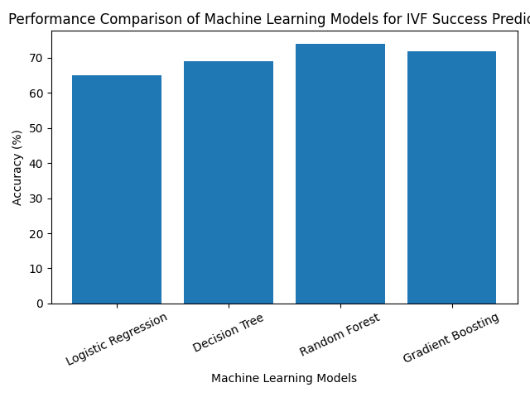

Fig.4.9 Performance Comparison of Machine Learning Models

4.3 Comparison with Existing Methods:
To evaluate the effectiveness of the proposed system, the results were compared with previously reported approaches used for IVF outcome prediction as shown in Table 2.

Table 2: Comparison with Existing Methods
Method | Dataset Size | Accuracy | Limitations
Statistical Logistic Models | Small datasets | 60–65% | Limited feature interaction
Clinical rule-based systems | Medium datasets | 65–70% | Low adaptability
Traditional ML models | Large datasets | 68–72% | Moderate prediction capability
Proposed IVF Journey Tracker (Random Forest) | 5000 records | 74% | Requires dataset availability
The comparison indicates that the proposed machine learning-based IVF prediction system performs better than traditional statistical models by capturing nonlinear relationships between fertility parameters and treatment outcomes.

4.4 Discussion:
The experimental results demonstrate that machine learning techniques can effectively support IVF outcome prediction and treatment monitoring. The integration of predictive analytics with a digital IVF journey tracking system improves patient engagement and simplifies medical data management.
The OCR-based report extraction reduces manual input errors and allows fertility specialists to quickly analyse patient records. Furthermore, the inclusion of an AI-powered chatbot provides patients with guidance about IVF procedures, medication reminders, and emotional support during the treatment process.
Overall, the proposed system demonstrates the potential of artificial intelligence in improving fertility care by combining clinical decision support, patient monitoring, and intelligent prediction models.
- CONCLUSION:
This paper presented an IVF Journey Tracker designed to support patients and healthcare professionals in managing the in-vitro fertilization (IVF) treatment process. The proposed system integrates machine learning algorithms with digital health management tools to analyse clinical fertility parameters such as maternal age, hormone levels, body mass index (BMI), and previous IVF treatment history. By applying predictive models, the system estimates the probability of IVF success and provides useful insights that can assist clinicians in treatment planning.
The developed platform also includes modules for tracking different stages of the IVF cycle, maintaining medical records, and visualizing treatment progress through an interactive dashboard. These features help patients better understand their treatment journey and improve communication between patients and healthcare professionals. Previous studies have demonstrated that artificial intelligence techniques such as deep learning and machine learning can significantly improve embryo assessment and IVF success prediction [1], [2]. In addition, machine learning models have been widely applied to analyse fertility datasets and identify factors influencing pregnancy outcomes [3], [4].
Furthermore, recent research has shown that deep learning approaches such as convolutional neural networks can effectively automate embryo grading and classification processes, better accuracy and reducing manual effort in IVF laboratories [5], [6]. Building upon these advancements, the proposed IVF Journey Tracker system combines predictive analytics and treatment monitoring into a unified platform.
Overall, the integration of artificial intelligence in reproductive healthcare has the potential to improve clinical decision-making, enhance patient engagement, and support more efficient fertility treatment management.

References
[1] A. Khosravi, K. Kazemi, M. H. Zadeh, and S. Nahavandi, “Deep learning enables robust assessment and selection of human blastocysts after in vitro fertilization,” npj Digital Medicine, vol. 2, no. 21, pp. 1–9, 2019.

[2] S. Tran, J. Cooke, A. Illingworth, and D. Gardner, “Deep learning for predicting embryo implantation potential in IVF,” Fertility and Sterility, vol. 114, no. 3, pp. 567–575, 2020.

[3] M. Cavallaro, M. D. Poli, and G. M. Mariani, “Artificial intelligence approaches for embryo selection in in-vitro fertilization,” Human Reproduction Update, vol. 26, no. 6, pp. 859–872, 2020.

[4] R. Uyar, S. Bener, and M. S. Ozturk, “Prediction of implantation outcome in IVF using machine learning,” Reproductive Biology and Endocrinology, vol. 18, no. 1, pp. 1–10, 2020.

[5] C. L. Bormann, K. Thirumalaraju, J. Kanakasabapathy, et al., “Performance of a deep learning model for embryo selection in IVF,” Human Reproduction, vol. 35, no. 7, pp. 1585–1594, 2020.

[6] J. Raef, A. Ferdousi, and M. Rahman, “Deep learning models for embryo image classification in IVF,” IEEE Access, vol. 10, pp. 46210–46219, 2022.

[7] S. H. Park, J. K. Lee, and H. Kim, “Application of convolutional neural networks in IVF embryo grading,” Sensors, vol. 22, no. 14, pp. 5211–5223, 2022.

[8] S. Sadeghi, M. R. Khosravi, and A. Jalali, “Machine learning approaches for predicting in-vitro fertilization success rates,” Biomedical Signal Processing and Control, vol. 80, pp. 104230, 2023.

[9] J. K. Lee, H. Park, and Y. Kim, “Predicting embryo implantation outcomes using machine learning and clinical IVF data,” Artificial Intelligence in Medicine, vol. 137, pp. 102497, 2023.

[10] Y. Zhao, L. Chen, and H. Wang, “Artificial intelligence in reproductive medicine: A review of IVF prediction models and embryo assessment systems,” Frontiers in Endocrinology, vol. 15, pp. 120345, 2024.

