**Part 1 – Data analysis and predictive model**

The following steps were performed to analyze the Bike Sharing Dataset and build a predictive model:

* Descriptive Analysis
* Missing Value Analysis
* Outlier Analysis
* Correlation Analysis
* Model selection
* Random Forest Training and Feature Ranking

1 – Business Case

The hourly prediction of the bike sharing count value is not only important to estimate the expected revenue of the bike sharing service, but also to provide the required amount of bicycles at each station of a distributed bike sharing service. With more information about different stations, you could predict and schedule the rebalance of given back bikes. In this task, I investigate the prediction of the hourly bike count based on the specific hour, expected weather and day information.

2 – Analysis and data preparation

The missing value analysis revealed the data set does not contain any not-a-number or null values which require a replacement for further processing. In the following step, the outliers of the count values were removed using median and interquartile range (IQR)  as the count values do not fit a normal distribution. This reduces the data set from 15641 to 15179 samples.

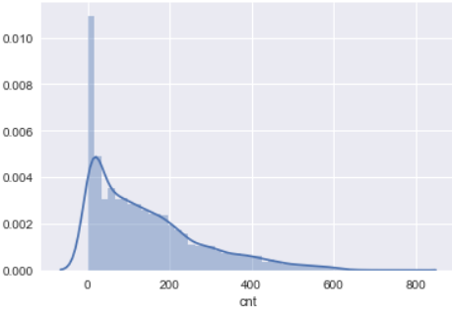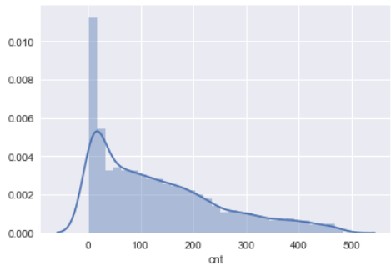

Data with outliers

Data without outliers

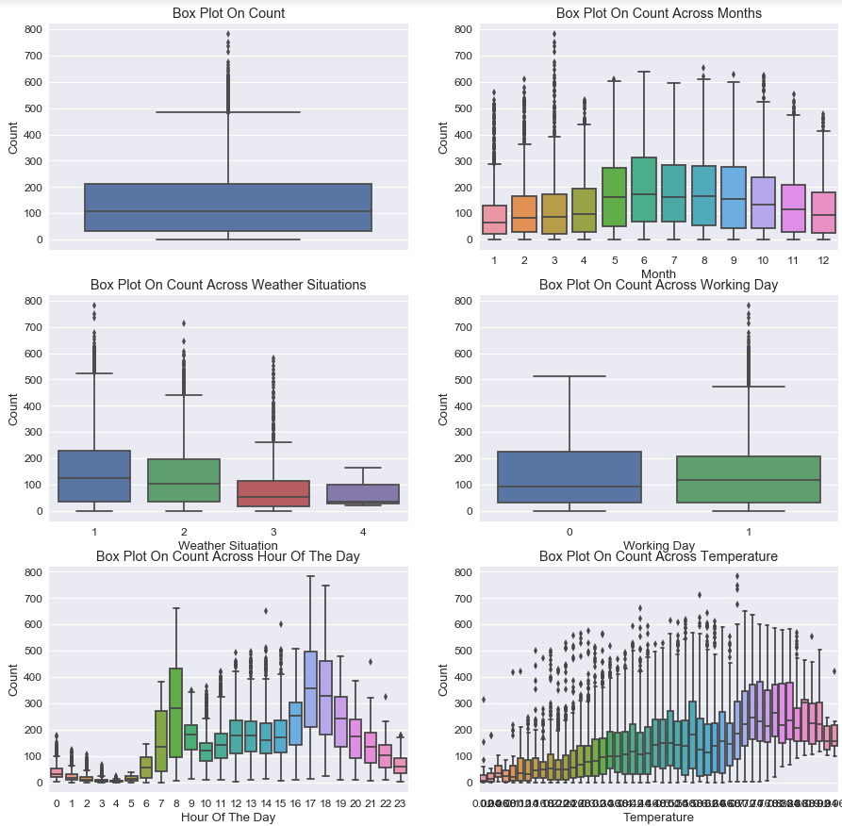

Box plots for different feature variables( before outlier removal).

The box plots and the correlation matrix of the numerical features revealed that the hour and temperature are some promising feature variables to predict the hourly count value. The correlation analysis also revealed that temperature and feeling temperature are highly correlated. To reduce the model complexity and avoid collinearity, the feeling temperature features were dismissed.

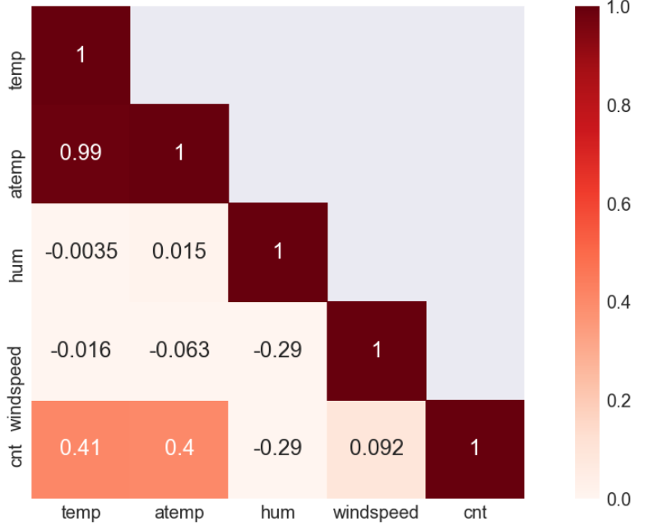

Correlation matrix for numerical features.

3 – Model selection

The prediction of the count values requires a regression algorithm based on categorical and numerical features. The dataset is quite small with less than 20K samples and the analysis steps revealed that a few features could be particularly significant. Based on these characteristics of the task and the data, I evaluated a set of possible algorithms: Lasso, Elastic Net, Support Vector Regression with different kernels, Ridge Regression and Random Forests.

4 – Random Forest

The random forests showed the most promising results on the Bike Sharing Dataset and were picked for the final result. The final random forest model consists of 200 decision trees trained on various-subsamples of the dataset and uses averaging to improve the predictive accuracy and control over-fitting. An internal needs at least four samples to split and the mean squared error was used to estimate the quality of a split.

The final model receives a mean absolute error of 44.30 averaged over three splits using three-fold cross-validation:

|  |  |  |  |  |  |
| --- | --- | --- | --- | --- | --- |
| Model | Split | Mean Squared Error | Mean Absolute Error | RMSLE | R² Score |
| RandomForestRegressor | 1 | 4489.95 | 43.72 | 0.41 | 0.86 |
| RandomForestRegressor | 2 | 4636.60 | 44.60 | 0.41 | 0.86 |
| RandomForestRegressor | 3 | 4691.67 | 44.57 | 0.41 | 0.86 |
| **RandomForestRegressor** | **Mean** | **4606.07** | **44.30** | **0.41** | **0.86** |

Feature ranking of the decision trees in the random forest regressor on the training samples of the first split:

