EXCHANGEMART 2.0

April 2023 Release

SOFTWARE REQUIREMENTS SPECIFICATION

Revision 1 / 14-Mar-2023
Proprietary Information

Revision History

Revision | Release Date | Author | Summary of Changes
1 | 14-Mar-2023 | VSS | Initial development

1. INTRODUCTION 1
1.1. Purpose 1
2. System Requirements 2
2.1. Communities 2
2.1.1. Bids 2
2.1.2. Customer/Buyer 2
2.1.3. Asset Requests 2
2.1.3.1. Asset Response 4
2.1.4. Items 6
2.1.5. Bids 7
2.1.5.1. Buy Now 7
2.1.6. Invoices 7
2.1.7. Tags 7
3. User Requirements 8
3.1. Home Page 8
3.2. Secondary Pages 8
3.2.1. For Buyers 8
3.2.2. For Sellers 8
3.2.3. About Us 8
3.2.4. Careers 8
3.2.5. Contact 8
3.3. Account bar 8
3.4. Notification Bar 8
3.5. Buyer Portal 8
3.5.1. Online Center 8
3.5.1.1. Bid View 8
3.5.1.2. Item View 9
3.5.2. My Asset Requests 9
3.5.2.1. Request View 9
3.5.3. Community Requests 10
3.5.4. Reports 10
3.5.4.1. Offers 10
3.5.4.2. Bids 10
3.5.4.3. Invoices 10
3.5.5. Watchlist 10
3.5.6. Account Settings 10
3.5.6.1. My Account 10
3.5.6.2. User Management 10
3.5.6.3. Email Settings 10

INTRODUCTION

Purpose
The purpose of this document is to provide detailed feature specs and changes proposed in April Release Version of ExchangeMart (2.0) from previous version (1.0). This document will cover in detail the System requirement specs and User requirement specs for the upcoming release.

System Requirements

Communities
“Communities” is a new concept put forth in Version 2.0 and is a way to identify vertical market segments (community) within EXB ecosystem e.g. “Oil & Gas Community”, “Pharmaceuticals Community”. “Communities” allow ExchangeMart to provide more value based services to our end users and help secure better ROI on asset. “Communities” concept is reflected in the Bids and Customer/Buyer workflow.

Bids
- Bid belongs to a community.
- By default, bid belong to the traditional community.

Customer/Buyer
- Based on certain community criteria, EXB members can belong to that community.
- One of the criteria to becoming a community member is that the member has to have both a Customer/Buyer Account.
- Community members can sell items on a private bid or community bid.
- Community members can request an item.
- Community members can buy item only within the community.

Asset Requests
Within a community a customer (Asset Request Purchaser a.k.a “ARP”) can request for an asset.
Asset Request Workflow:
- ARP requests an asset, by filling out asset request form and submitting it to the EXB system.
- The request is sent to the concierge team.
- Concierge then reviews the request and works with the ARP if any additional information is required.
- Once approved, request is made available to community.
- At this phase, request can be:
- Aborted – ARP canceled the request.
- Expired – No relevant response to the request within a specified request time frame. System auto expire the request.
- Sale Pending – response is accepted and invoice is generated.
- In the Sale Pending phase:
- If the transaction is completed successfully, the response is “Fulfilled”.
- If the transaction fails, the request is made available to community.

*Refer to Asset Request Workflow

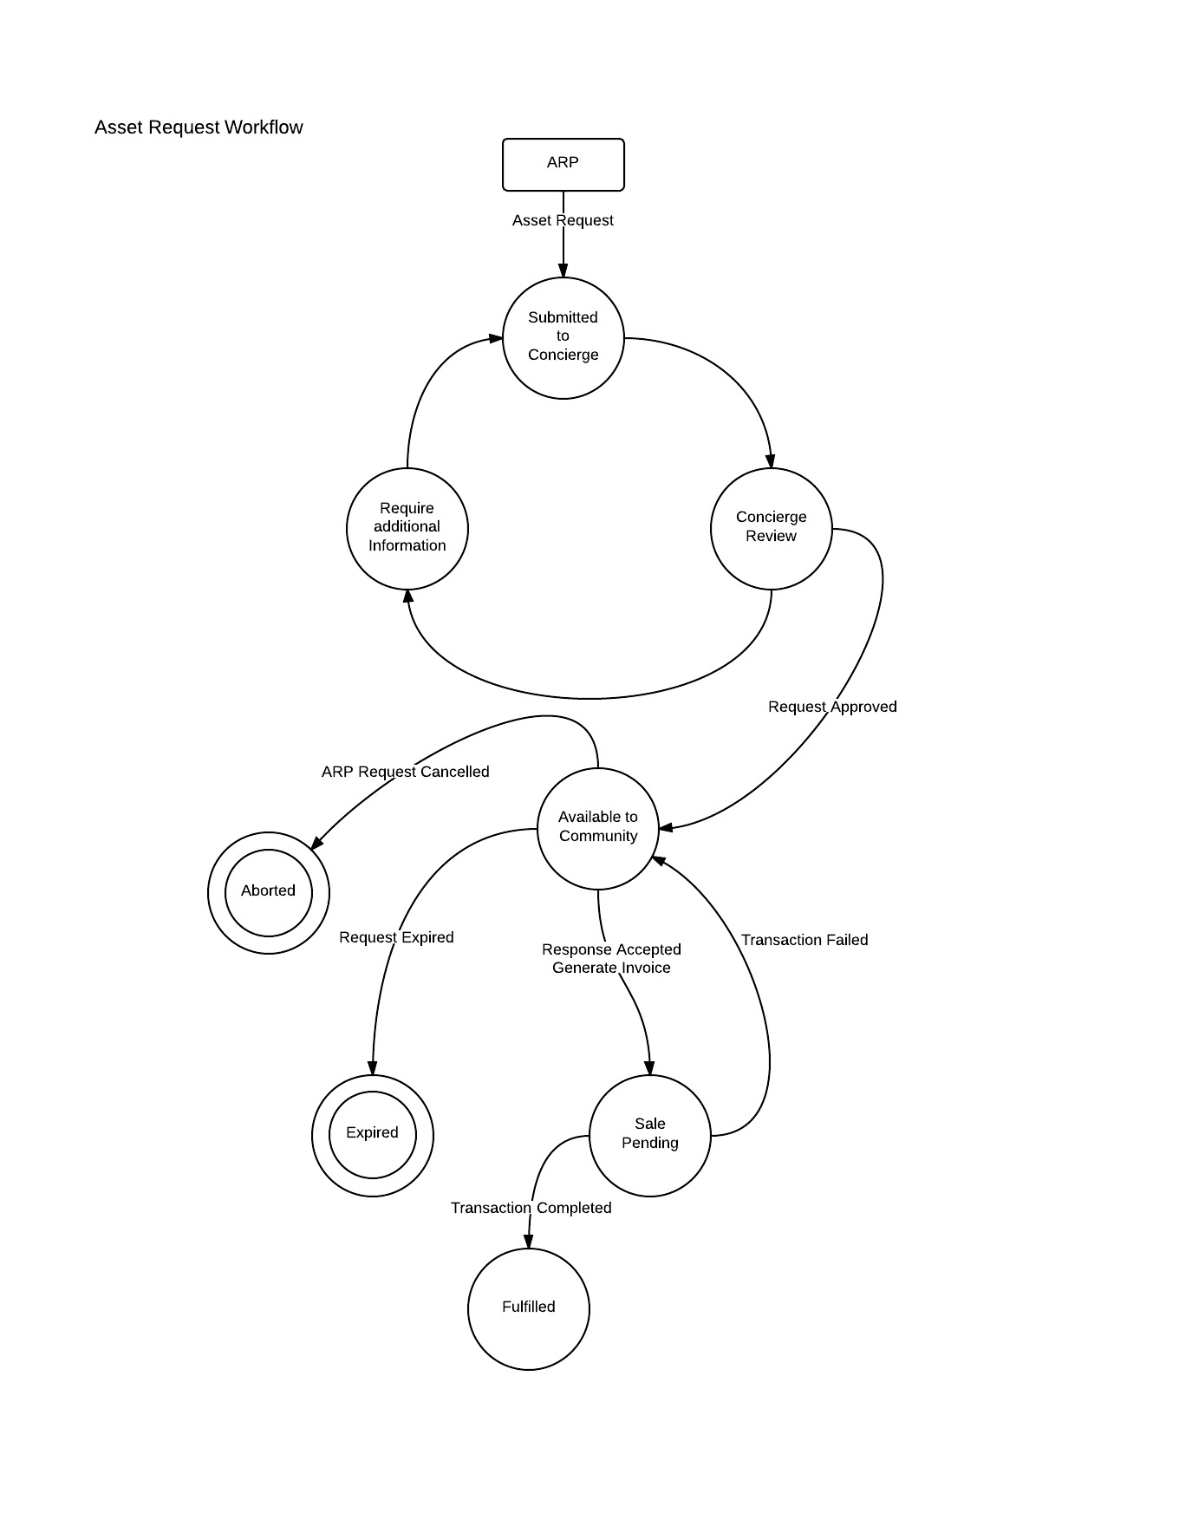

Asset Response
Buyer (Asset Request Seller aka ARS) within the community sees the asset request.
Asset Response Workflow:
- The ARS can take following action on the asset request, :
- Decline – Not interested in fulfilling the request.
- Respond – Fulfill the request by filling out Asset Request Response Form a.k.a ARRF.
- The ARRF is submitted to the EXB system and the concierge is notified via email.
- Concierge will review the response and :
- Reject the response, if the response doesn’t meet the request criteria.
- Work with ARS if additional information is required.
- Once response is approved, the items on the response are bundled into a bid and attached to the response.
- The response is then attached to the corresponding asset request.
- The ARP can then review the responses to his request and take action by:
- Accepting the response and making an offer on items in the bid using “Buy Now”.
- Decline the response.
- Sale Pending – Offer is invoiced.
- If Sale transaction is successful, the request is completed.
- If Sale transaction fails, the Sale is cancelled.

*Refer to Asset Response Workflow
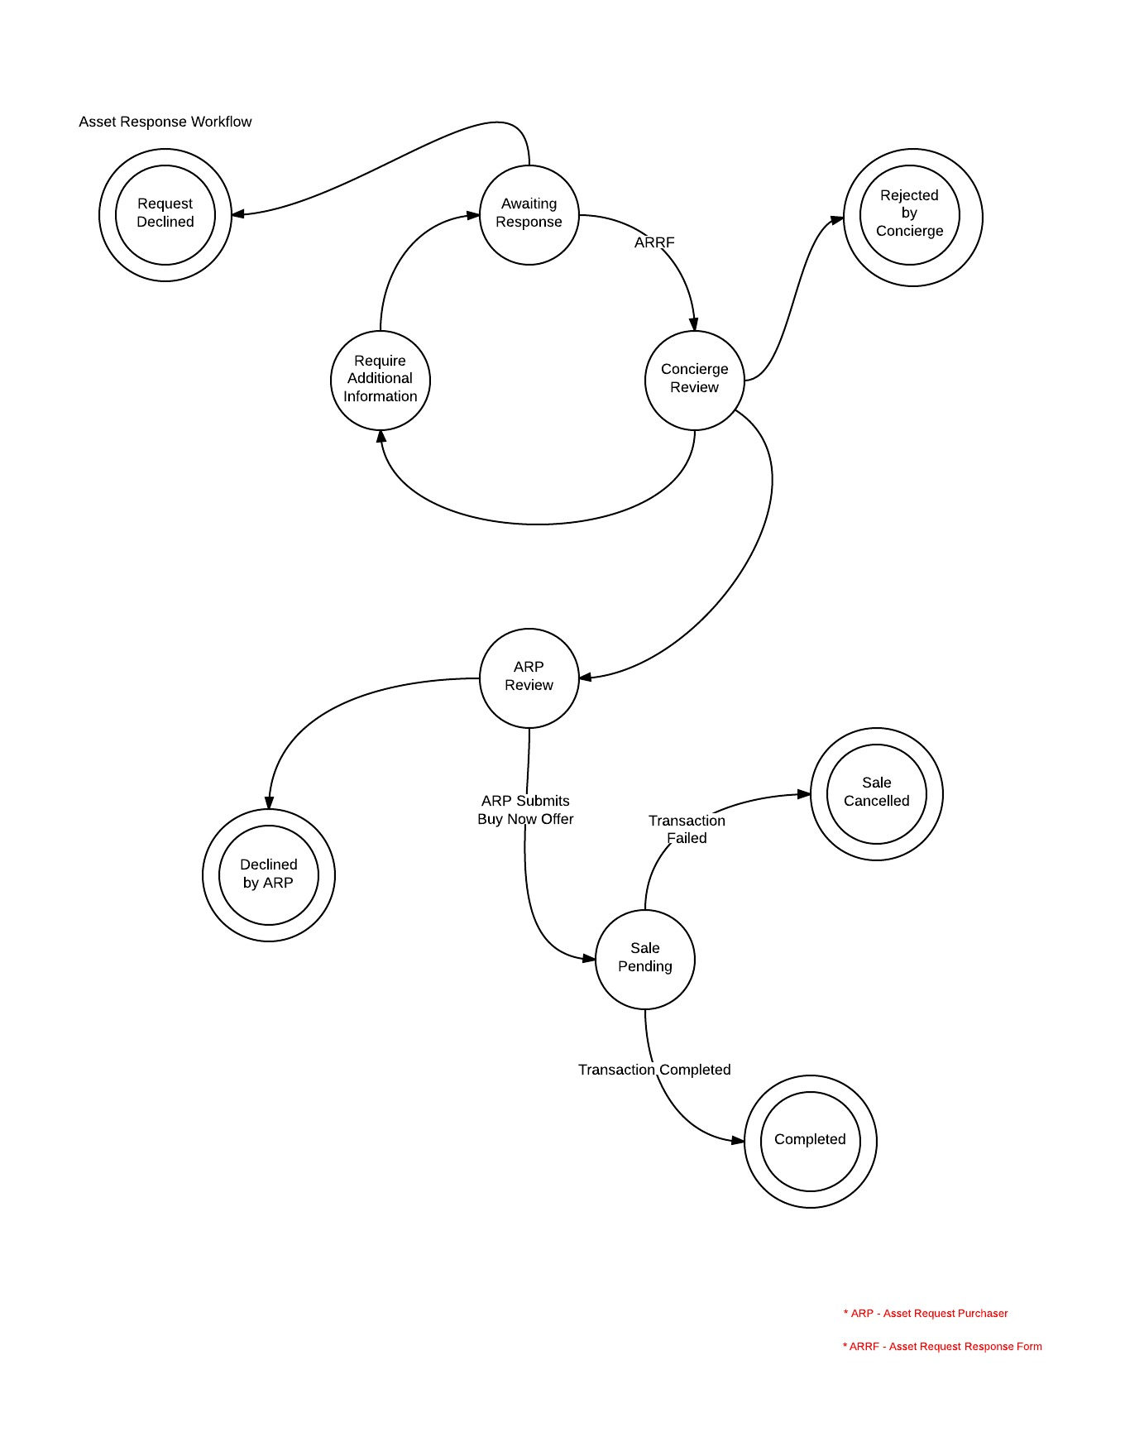

Items
Starting with version 2.0:
- Asset class (used to be Category) shall be added as a field on the Item and is a required field.
- Items will not have a subcategory field.
- A tag ID field shall be added to the Item and will correspond to the Exchangemart Tags. There will be only one tag associated to an Item. Tag ID field is a required field.
- To be part of a Bid, the tagID of the Item should belong to the bid community tagset.
- There shall be a default buyer fee stored on the Item and it will be based of the Item Asset class and pulled from the Deals Table.
- EXM operations team can override the Item buyer fee.

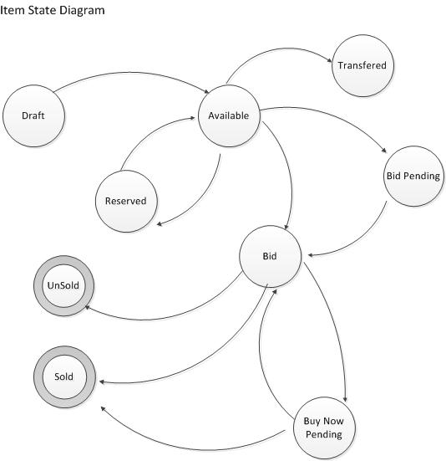

Bids
New features are added to the bid as part of version 2.0 release.
- Bid now belongs to a community as discussed in “Communities” section.
- “Buy Now”, which allows you to buy assets on a bid before the bid closes.

Buy Now
Buy Now workflow:
- EXM operation team enables “Buy Now” option on Item. The Item is displayed on the bid with the asking price and option to make an offer using “Buy Now”
- When a buyer makes offer on an item using “Buy Now”, the system:
- Marks the item as “Buy Now Pending”, thus preventing any more offers to be made on that item.
- The EXM operation team is sent a notification about the pending “Buy Now” offer.
- The pending “Buy Now” offer notification is displayed on the EXM Admin portal.
- The EXM operation team then reviews the offer and works with the buyer to get all the relevant information to complete the transaction.
- If the transaction is successful, then :
- Invoice is generated and sent to the buyer. Item is marked as sold.
- If the transaction failed, then :
- “Buy Now” offer is declined.
- Item status is changed to “Bid” and is available to buyers for bidding.

To support “Buy Now” offer in bid, the:
- “Buy Now” Offers shall be invoiced even the bid is not closed.
- Bid Item shall have the option to accept “Buy Now” offer only.
- “Buy Now” offer shall have the option to allow buyers to buy different Item quantities.

If a “Buy Now” Offer has number of item quantities then available buyer wants to make an offer on. The remaining quantities of items are still available for other buyers to bid on. If the “Buy Now” offer transaction fails then the quantity is made available on the bid.

Invoices
Starting with version 2.0, Buyer Fee on the Invoice is pulled from the Item and not from Customer Commission.

Tags
Starting with version 2.0:
- Exchangemart Tags are grouped into Communities.
- Community members see their community tags when filtering for Bids and Items.

User Requirements

Home Page

Secondary Pages

For Buyers

For Sellers

About Us

Careers
Link to Taleo

Contact

Account bar
- Black bar on top of screen
- Displays Welcome <User Name> e.g. Welcome John Doe
- Display Active Account e.g. Account : Exchangemart, LLC
- Clicking on the Active Account displays a dropdown with an option to change Account Information.
- Sign out

Notification Bar
Display Notification information with counts of:
- My Asset Request Responses
- Community Asset Requests
- Unpaid Invoices
- Active Offers
- Watchlist
Clicking on the notification line item takes you to the respective view e.g. Clicking on Unpaid Invoices, will take you to your Invoice page.

Buyer Portal

Online Center
Starting with version 2.0, the current bids are replaced by all bids the buyer is invited to.
- There shall be filter on the left which is based on the community tag set. Only tags which have an item associated with the buyers current bid set are enabled else they are disabled.
- Clicking on the Tag filter item, displays all item associated with the tag.

Bid View
Clicking on a bid will display the bid view. New features added in Version 2.0:
- There is a badge at the top identifying the community bid belongs to.
- The bid close date will have a reverse countdown, showing time left for the bid to close.
- The buyer is already registered on the bid.
- Available Item Tab will display a Buyer Fee for each line item..

Item View
Clicking on an Item within a bid will display the Item View. New features added in Version 2.0:
- There is a badge at the top identifying the bid community item belongs to.
- If “Buy Now” feature is enabled on Item.
- Display a blue bar at the center with Asking price and “Buy Now” button.
- If the Item is in an Auction style bid:
- Show the current high offer, the no. of offers already made on the item and a textbox for you to enter your offer.
- On the top there is an information bar which shows message in :
  - Green – If your offer is the highest offer on the Item.
  - Red – Your offer is not the highest offer for the Item.

My Asset Requests
Display all Asset Request created by buyer.
The following tabs are displayed on the page:
- Active Requests
- Displays all active requests and are group them by request status.
- If the Item is a critical request for the purchaser, it will be a displayed with a red badge on top.
- If there are open responses on the Asset Request, they are displayed with a green bar with the count on line Item.
- Clicking on the request line item, will take you to the request view.
- Fulfilled
- Display all requests that are fulfilled.
- Cancelled
- Display all requests that are cancelled by the purchaser.
- Expired
- Display all requests that have expired.

Request View
Display your Request.
- Badge on top to display community.
- Show Information about your asset
- Button to email the concierge
- Responses to your request, displayed on the bottom as Tabs
- “Open Asset Request Responses” Tab
- Show all Response to your request as line Items.
- Action button on response line Item “Not Interested” / “View Response”
- “Not Interested Asset Request Responses” Tab
- Show all responses to request that you are not interested in.

Community Requests
Display all community requests.
The following tabs are displayed on the page:
- Active Requests
- Display all active community request grouped by response status.
- Request with no response are displayed as the top group, with buttons :
- I can help
- I can’t help
- The request for which you responded with “I can’t help” falls of the view.
- Once the request is processed you can see your response by clicking “View your response” button.
- Declined By Purchaser
- Display responses which were declined by the purchaser.
- Seller Cancelled Requests
- Display requests which were cancelled by the purchaser. ?
- Completed
- Display responses which were accepted by the purchaser and transaction successfully completed.

Reports

Offers

Bids

Invoices

Watchlist

Account Settings

My Account

User Management

Email Settings

