Testing IFelse

void main()

{

Int x;

x=3;

if(x<4)

{

Cout<<"If satisfied";

}

Else

{cout<<” In else”;}

}

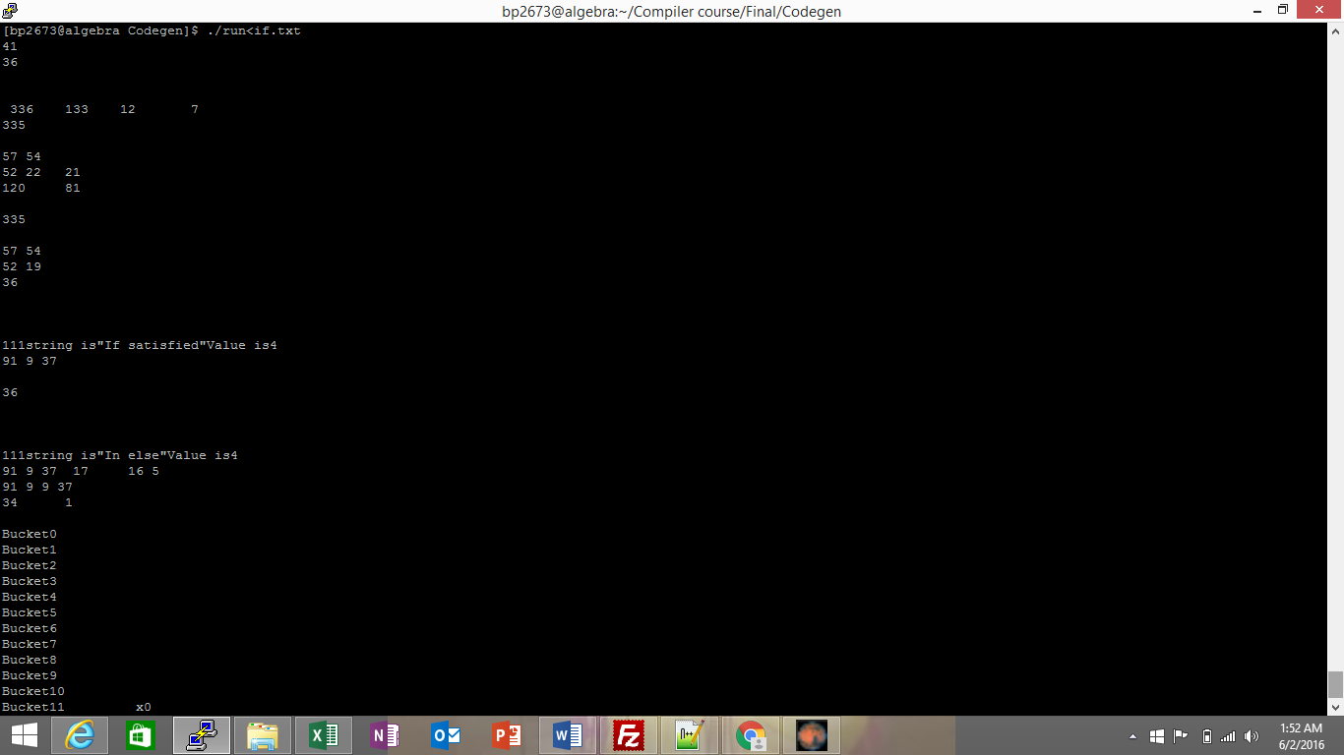

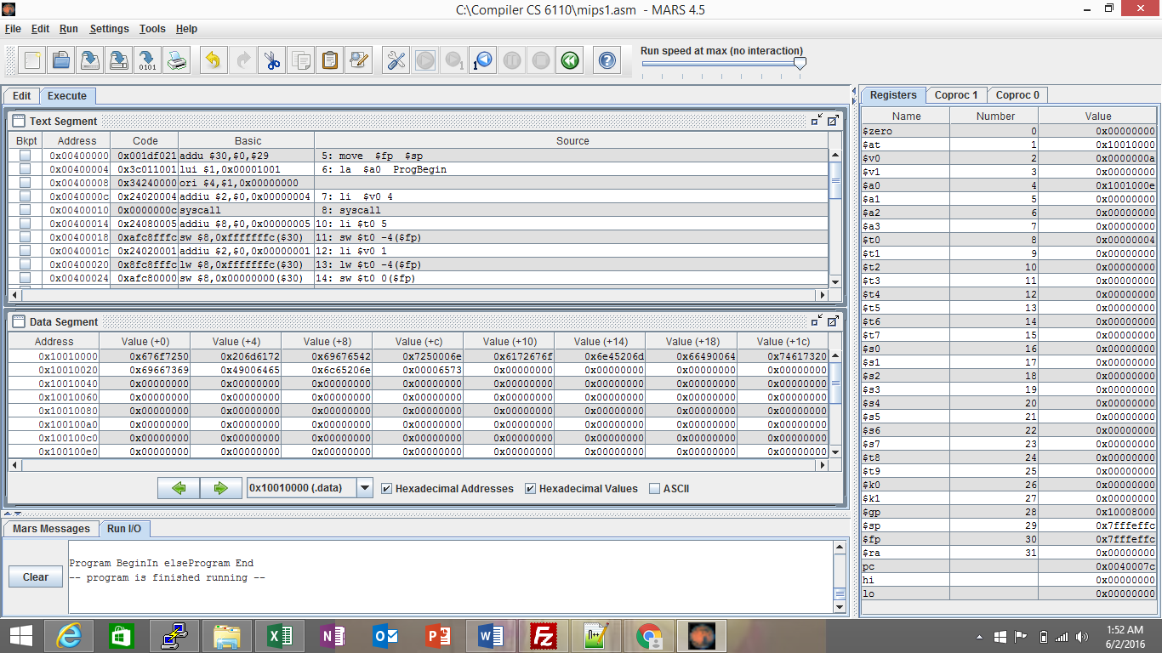

#Prolog:

.text

.globl main

main:

move $fp $sp

la $a0 ProgBegin

li $v0 4

syscall

#End of Prolog

li $t0 5

sw $t0 -4($fp)

li $v0 1

lw $t0 -4($fp)

sw $t0 0($fp)

li $t0 4

sw $t0 -12($fp)

li $v0 1

lw $t0 -12($fp)

sw $t0 -8($fp)

j Labelelse1

li $v0 4

la $a0 Strlabel0

syscall

j Endif

Labelelse1:

li $v0 4

la $a0 Strlabel1

syscall

Endif:

#Postlog:

la $a0 ProgEnd

li $v0 4

syscall

li $v0 10

syscall

.data

ProgBegin : .asciiz "Program Begin"

ProgEnd: .asciiz "Program End"

Strlabel0 : .asciiz "If satisfied"

Strlabel1 : .asciiz "In else"

**Function:**

Int f(int);

void main()

{

Int x;

x=f(3);

}

Int f(int y)

{

y=2;

return y;

}

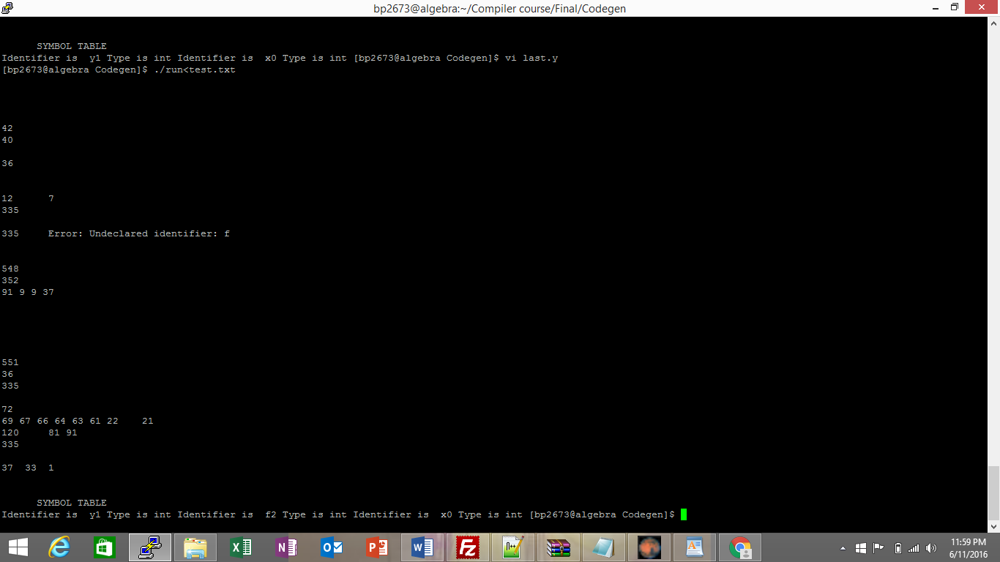

#Prolog:

.text

.globl main

main:

move $fp $sp

la $a0 ProgBegin

li $v0 4

syscall

#End of Prolog

li $t0 2

add $a0 $0 $t0

jal Labelf1

syscall

jr $ra

Labelf1:

li $t0 3

sw $t0 0($fp)

li $v0 1

lw $t0 0($fp)

sw $t0 0($fp)

syscall

addi $sp,$sp,0

sw $t0,-4($sp)

add $v0 $t0 $0

lw $t0, -4($sp)

addi $sp,$sp,-8

#Postlog:

la $a0 ProgEnd

li $v0 4

syscall

li $v0 10

syscall

.data

ProgBegin : .asciiz "Program Begin"

ProgEnd: .asciiz "Program End"

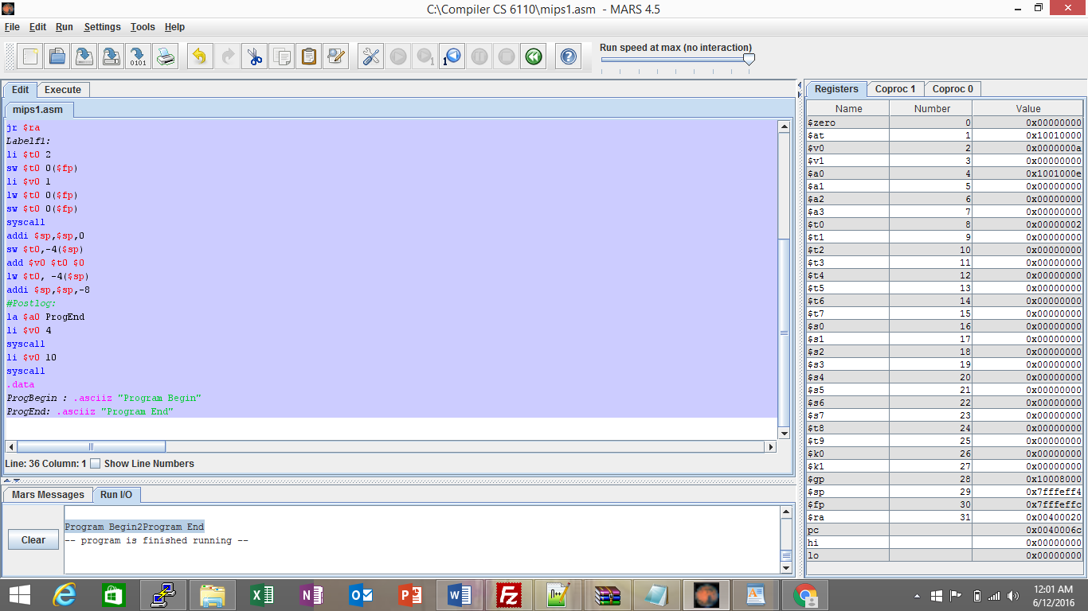

**Array Assignment**

void main()

{

Int a[10];

a[0]=3;

}

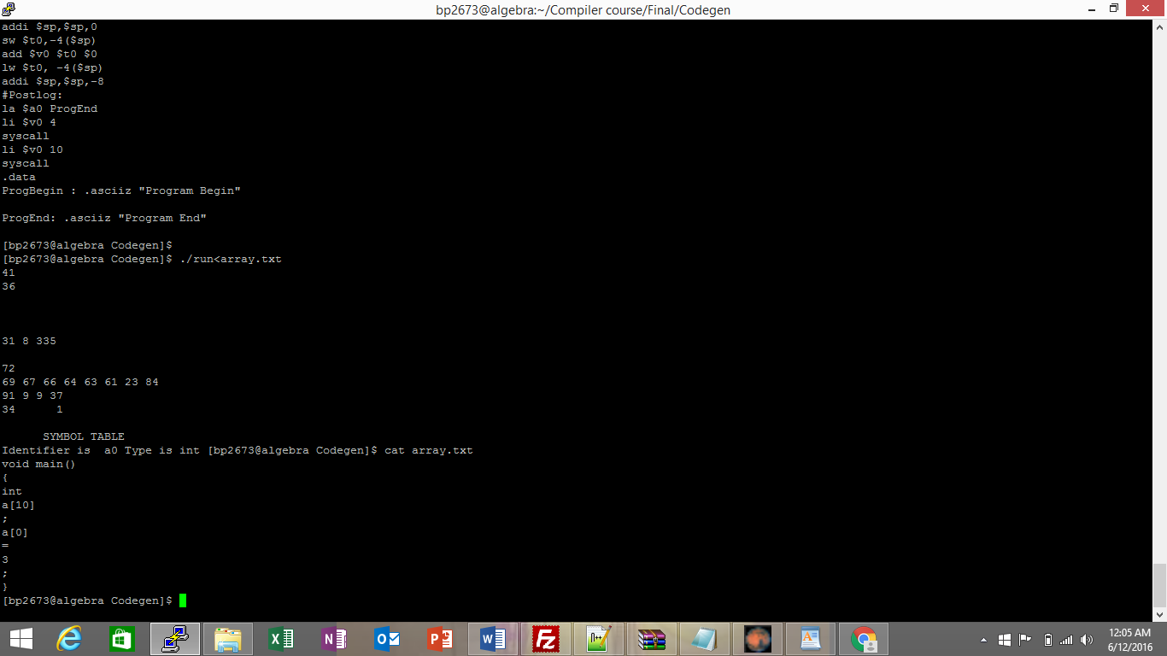

#Prolog:

.text

.globl main

main:

move $fp $sp

la $a0 ProgBegin

li $v0 4

syscall

#End of Prolog

li $t0 3

sw $t0 0($fp)

li $v0 1

lw $t0 0($fp)

sw $t0 0($fp)

la $a0 ($t0)

syscall

#Postlog:

la $a0 ProgEnd

li $v0 4

syscall

li $v0 10

syscall

.data

ProgBegin : .asciiz "Program Begin"

ProgEnd: .asciiz "Program End"

